

CITY OF EDMONTON

BYLAW 14054

EDMONTON DESIGN COMMITTEE BYLAW

(CONSOLIDATED ON JANUARY 30, 2008)

THE CITY OF EDMONTON

BYLAW 14054
Edmonton Design Committee Bylaw

Whereas, pursuant to section 145 of the Municipal Government Act, Council may pass bylaws in relation to the establishment, functions, procedures and conduct of council committees;
Edmonton City Council enacts:

part - purpose, definitions and interpretation

purpose | The purpose of this bylaw is to establish the Edmonton Design Committee and to prescribe powers, duties, functions, structure and procedures.
definitions | In this bylaw, unless the context otherwise requires:  “Chair” means the person who has been chosen pursuant to section 6(2) as head of the Committee;  “City” means the municipal corporation of the City of Edmonton;  “City Manager” means the Chief Administrative Officer of the City within the meaning of the Municipal Government Act or his delegate;  “Committee” means the Edmonton Design Committee;  “Council” means the municipal council of the City of Edmonton; and  “Urban Design” means the design of the city and all its visible components; it addresses how buildings and the spaces between them are integrated and designed together over time to create an attractive and safe city
rules for interpretation | The marginal notes and headings in this bylaw are for reference purposes only.

PART - ESTABLISHMENT AND FUNCTIONS

ESTABLISHMENT | The Edmonton Design Committee is hereby established as a committee of Council to improve the quality of Urban Design in the city of Edmonton.
functions | Subject to the provisions of this bylaw and all other City, Provincial, or Federal laws, the Committee will:  provide input to the City in the formulation of Urban Design principles, guidelines, and policies;  accept submissions and provide recommendations to the Planning and Development Department:  on development permit applications as required by Bylaw 12800, Edmonton Zoning Bylaw; and  on any other developments with potential design impact on the City, at the discretion of the City Manager or Council;  within the geographic area outlined in Schedule A attached hereto and forming part of this bylaw.  accept submissions and provide recommendations to Council on comprehensive rezoning applications, including:  Direct Control Provisions,  Special Areas Zoning; and  Major Commercial Corridor Overlays;  within the geographic area outlined in Schedule A attached hereto and forming part of this bylaw.  review and provide recommendations on development applications, public projects or special projects in the city of Edmonton at the request of Council or the City Manager;  review pre-applications with respect to (b) and (c) and provide recommendations to the Applicant;  make recommendations to Council as to changes to this bylaw; and  make recommendations to Council as to changes to other existing bylaws and City policies relevant to Urban Design.  Repealed (S.2, Bylaw 14844, January 30, 2008)

PART - STRUCTURE AND PROCEDURES
structure | The Committee will consist of up to eleven (11) members appointed by resolution of Council as follows:  three members nominated by the Alberta Association of Architects;  one member nominated by the Association of Professional Engineers, Geologists and Geophysicists of Alberta;  two members nominated by the Alberta Association of Landscape Architects;  one member nominated by the Alberta Association Canadian Institute of Planners;  one member nominated by the Edmonton Arts Council;  one representative of the development industry;  one faculty member from the University of Alberta fine arts or industrial design program; and  one citizen-at-large.  The Committee will annually select from its members, a Chair and one or more Vice-Chairs.  Committee members will be appointed for one year terms for a maximum of six (6) consecutive years.  (S.2. Bylaw No. 14373, September 26, 2006)  No member may serve as Chair for more than two consecutive years.  The City Manager will attend all meetings of the Committee.  If one or more positions on the Committee is not filled or becomes vacant, the Committee may continue with fewer members.  Members may be paid such remuneration, and reimbursed for expenses as may be fixed by Council.  The Committee may request Council to terminate the appointment of any member who is absent for three consecutive meetings unless the absence is authorized by resolution of the Committee.
meetings | The Committee will meet every two weeks and such other times as the Chair considers necessary.  The Committee will meet at the call of the Chair or on a schedule approved by the Committee  Members will be given at least five business day’s written notice of a Committee meeting.  Quorum for the Committee is a majority of the existing appointed members of the Committee.
procedures | Subject to this bylaw, the Committee will follow the procedures prescribed by Bylaw 12300, Procedures and Committees Bylaw.  Agenda and submissions will be distributed and sent to Committee members at least five (5) business days prior to a meeting.  At the hearing of an application:  the Development Officer or the planner will introduce the matter to the Committee;  the Applicant will have five (5) minutes to speak;  the Committee may vote to allow any other person up to five (5) minutes to speak;  every member of the Committee will have five (5) minutes to ask questions.  Any member of the Committee may move:  that the Application be supported;  that the Application not be supported; or  a recommendation relating to Urban Design.  Only one motion can be on the floor at any time.  Each member will have five (5) minutes to speak to a motion.  The Committee may vote to allow a person to respond to a motion.  The Committee may vote to extend the period of time a person is allowed to speak.  A motion is lost when the vote is tied.  The Committee may pass or defeat more than one motion on any submission.
subcommittees | The Committee may establish sub-committees, as required, to assist the Committee in the performance of its duties and to make recommendations to the Committee.  When establishing a sub-committee, the Committee will:  establish a terms of reference;  set out the number of members and term of appointment; and  set out the processes and procedures of the sub-committee.  Sub-committees may solicit input from the public.  Sub-committees must report back to the Committee on all matters except reviews of pre-applications.  (5) The Committee may appoint persons from outside the Committee to a sub-committee, however, a member of the Committee must be the Chair.

PART - finance and administration
fINANCE AND aDMINISTRATION | A budget for expenses arising from the operation of the Committee in the administration of this bylaw will be submitted to Council for approval.  The budget shall be prepared and presented to Council by the Planning and Development Department, in consultation with the Committee.
Resources | Administrative support to the Committee will be provided by the City Manager.

(NOTE: Consolidation made under Section 69 of the Municipal Government Act, R.S.A. 2000, c.L-21 and Bylaw No. 12005, and printed under the City Manager’s authority)

Bylaw 14054, passed by Council July 19, 2005,

Amendments:
Bylaw 14373, September 26, 2006
Bylaw 14844, January 30, 2008

SCHEDULE A

edmonton design committee geographic jurisdiction
A. The following neighbourhoods:
- Queen Mary Park;
- Oliver;
- Portion of the River Valley;
- Rossdale;
- Riverdale;
- Boyle Street;
- McCauley;
- Central McDougall;
- Downtown;
B. The following areas:

- the area bounded by 112 Avenue,
82 Street, 112 Avenue to Jasper Avenue,
Jasper Avenue, 82 Street to 84 Street,
84 Street, Jasper Avenue to 112 Avenue;
- one block on both sides of 99 Street between Argyle Road and Saskatchewan Drive;
- one block on both sides of 103 Street, 104 Street, Calgary Trail and Gateway Boulevard between Saskatchewan Drive and the southern limit of the City of Edmonton;
- one block on both sides of Whyte (82) Avenue between Mill Creek and 112 Street.

If there is an inconsistency between this list and the attached map, the attached map is of no force or effect to the extent of the inconsistency.
ATTACHMENT I to SCHEDULE A

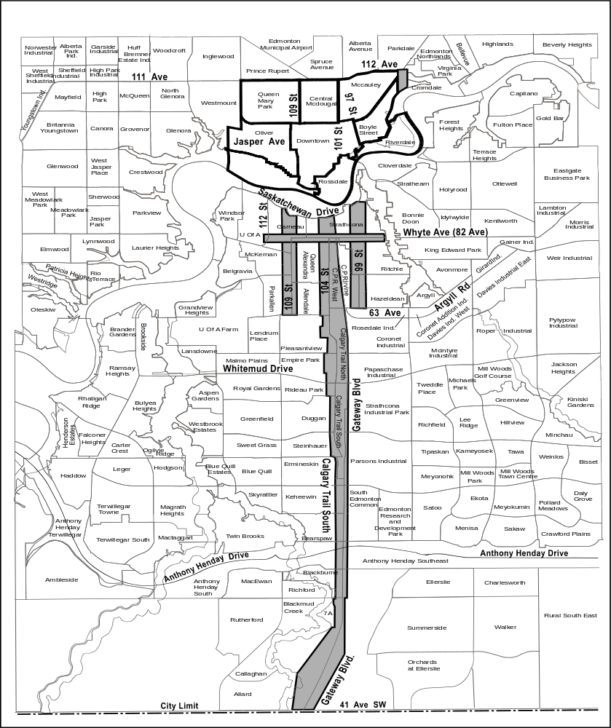
(S.3, Bylaw 14844, January 30, 2008)

