Bylaw 15215

A Bylaw to amend Bylaw 12800, as amended,

The Edmonton Zoning Bylaw
Amendment No. 1073

WHEREAS a portion of Lot 1, Plan 7822211, Lots 3 & 4 Plan 8120945, located at 5610- Ellerslie Road SW, 5350 – Ellerslie Road SW and 5240 – Ellerslie Road SW, Charlesworth, Edmonton, Alberta, are specified on the Zoning Map as (AG) Agricultural Zone; and

WHEREAS an application was made to rezone the above described property to (DC1) Direct Development Control Provision and (NA) Natural Areas Protection Zone;

NOW THEREFORE after due compliance with the relevant provisions of the Municipal Government Act RSA 2000, ch. M-26, as amended, the Municipal Council of the City of Edmonton duly assembled enacts as follows:

1. The Zoning Map, being Part III to Bylaw 12800 The Edmonton Zoning Bylaw is hereby amended by rezoning the lands legally described as a portion of Lot 1, Plan 7822211, Lots 3 & 4 Plan 8120945, located at 5610- Ellerslie Road SW, 5350 – Ellerslie Road SW and 5240 – Ellerslie Road SW, Charlesworth, Edmonton, Alberta, which lands are shown on the sketch plan annexed hereto as Schedule “A”, from (AG) Agricultural Zone to (DC1) Direct Development Control Provision and (NA) Natural Areas Protection Zone.
2/18
- The uses and regulations of the aforementioned DC1 Provision are annexed hereto as Schedule “B”.

READ a first time this day of , A. D. 2009;
READ a second time this day of , A. D. 2009;
READ a third time this day of , A. D. 2009;
SIGNED and PASSED this day of , A. D. 2009.

THE CITY OF EDMONTON
____________________________________
MAYOR

____________________________________
CITY CLERK
3/18
SCHEDULE “A”
15215_SchA.pdf

4/18
SCHEDULE “B”

(DC1) SITE SPECIFIC DEVELOPMENT CONTROL PROVISION

1. General Purpose

The purpose of this DC1 Provision is to facilitate the development of a pedestrian friendly Community Commercial Centre that may accommodate a range of commercial, residential, office, entertainment, cultural and institutional uses such that development is appropriate in appearance and function to a site bounded by two arterial roadways, a collector roadway and a future Transit Priority Corridor; and abutting a natural area, a medium density residential site, and an existing historic religious assembly.

2. Area of Application

This Provision shall apply to a portion of Lot 1, Plan 782 2211 and Lots 3 and 4, Plan 812 0945; containing approximately 14 ha of land, as shown on Schedule “A” of the Bylaw, adopting this Provision.

3. Site Planning and Building Design Objectives

- Ensure on-site development:
  - becomes a focal point for the surrounding area;
  - functions as a walkable commercial centre with a pedestrian friendly commercial node, creating a sense of place for users;
  - relates appropriately to adjacent built forms, roadways, uses, functions and activities;
  - creates an attractive and cohesive visual identity;
  - includes outdoor spaces of interest;
  - presents an attractive streetscape along external roadways; and
  - is sympathetic to the presence and function of future abutting public transit facilities, existing religious assembly and natural area.
- Ensure buildings are developed:
  - in a harmonious architectural theme;
  - with 360 degree architecture and such that all facades are visually attractive and interesting;
  - with clearly defined entrances; and
  - with high quality and durable building materials and finishes.

- Ensure interior access roads and walkways promote contiguous and logical patterns of safe pedestrian and vehicular movement throughout the site and between the site and surrounding development and uses.
- Ensure parking areas:
  - facilitate safe and convenient pedestrian movements
5/18

  - are appropriately landscaped to soften their appearance and add visual interest; and
  - are dispersed and segmented

        - Uses

  - Commercial and Commercial Related Uses

- Apartment Hotels
- Bars and Neighbourhood Pubs
- Broadcasting and Motion Picture Studios
- Business Support Services
- Child Care Services
- Commercial Schools
- Convenience Retail Stores
- Custom Manufacturing Establishments
- Drive-in Food Service
- Gas Bars
- General Retail Stores
- Government Services
- Health Services
- Hotels
- Indoor Participant Recreation Service
- Major Alcohol Sales
- Major Amusement Establishments
- Minor Amusement Establishments
- Minor Home Base Business
- Minor Secondhand Stores
- Minor Service Stations
- Nightclubs
- Personal Service Shops
- Private Clubs
- Private Education Services
- Professional, Financial and Office Support Services
- Public Libraries and Cultural Exhibits
- Rapid Drive-through Vehicle Services
- Religious Assembly
- Restaurants
- Specialty Food Services
- Spectator Entertainment Establishments
- Temporary Flea Markets, limited to farmers market involving the sale of items such as local produce and handicrafts
- Veterinary Services
- Warehouse Sales
- Fascia On-premises Signs
6/18

- Projecting On-premises Signs
- Roof On-premises Signs
- Temporary On-premises Signs

  - Residential and Residential Related Uses

- Apartment Housing as shown in Appendix I
- Live Work Unit

5. Development Regulations

  - General Development Regulations

  - Development shall be in general accordance with the objectives and the attached appendices:
    - Appendix I, Concept Plan; and
    - Appendix II, Pedestrian Connections.
  - At the Development Permit stage, a generalized, non-binding, concept plan shall be submitted for all new building development or substantial redevelopment to illustrate how the proposed development will integrate with existing and future surrounding and on-site development. The concept plans shall show the location of existing and future buildings, parking areas, vehicular and pedestrian routes and amenity areas.
  - The maximum Floor Area Ratio for non-residential uses shall not exceed 0.4 based on the total site area.
  - The maximum building height shall be 20.0 m for non residential uses.
  - Apartment housing may be accommodated in:
- free standing residential building with or without ground floor office, commercial, retail uses and may have row or stacked row housing at the base; or
- part of a comprehensively developed project where buildings are attached and can vary from predominately residential to mixed use.
  - Apartment Housing shall be developed in accordance with Sections 230 of Zoning Bylaw except that the maximum height shall not exceed 45 m.
  - Live Work Units shall comply with the following regulations:
    - the live work units shall be located within the residential locations;
    - each unit shall have individual access at grade;
    - the number of non-resident employees or business partners working on-site shall not exceed two at any one time;
    - there shall be no outdoor business activity, or outdoor storage of material or equipment associated with the Business. Indoor storage
7/18

    - related to the business activity shall be allowed in either the Dwelling or Accessory Building;
    - there shall be no nuisance created by the business by way of electronic interference, dust, noise, odor, smoke, bright light or anything of an offensive or objectionable nature which is detectable to normal sensory perception outside the Live Work unit; and;
    - each application for a Development Permit for the Use Class Live Work shall include a description of the business to be undertaken at the premises, an indication of the estimated number of business visits per week, provision for vehicular and bicycle parking for residents, visitors and employees, and where any material or equipment associated with the business use are to be stored; and
    - Individual business identification signs located on the façades of Live Work units shall be designed to ensure the signage does not detract from the overall appearance of the development and that the signage is not obtrusive, having regard to the scale of the buildings on the Site.

  - A minimum 6.0 m landscaped Yard shall be provided abutting all public roadways (i.e. Ellerslie Road SW, 50 Street SW, 54 Street SW, and 4 Avenue SW).
  - A minimum Amenity area of 1.0 m² shall be provided for every 10 surface parking spaces. An additional Amenity area of 1.0 m² shall be provided for every 100 m² of commercial floor space.
  - A CPTED Assessment shall be completed to guide the design of public and private spaces and facilities, focusing on natural surveillance and access control.
  - Signs for non-residential development shall comply with the regulations in Schedule 59 E.
  - Signs for residential development shall comply with the regulations in Schedule 59 B.
  - The owner shall enter into an Agreement (or Agreements) with the City of Edmonton for the following:
    - Construction of portions of the two adjacent arterial roadways (i.e. 50 Street SW and Ellerslie Road). Construction shall include channelization, accesses intersections, multi-use trails, sidewalks, lighting, landscaping and transitional improvements where applicable;
    - Dedication of the required road right-of-ways for the construction of 50 Street SW and Ellerslie Road as described in the Memorandum of Understanding signed December 2007. Roadway dedication shall be to the satisfaction of the Transportation Department;
    - Payment of the proportionate share of the Arterial Roadway Assessment for the construction of arterial roadways in the catchment
8/18

    - area in accordance with the Arterial Roads for Development Bylaw; and
    - Repair of any damage to the abutting roadways, alleys, sidewalks, and/or boulevards resulting from the construction of the development, to the satisfaction of the Transportation Department. The site must be inspected by the Transportation Department prior to the start of construction and once again when construction is complete.
  - Site Design Regulations

    - Buildings shall generally, to the satisfaction of the Development Officer, be oriented to:
- frame (located at) the corner of the prominent intersection of two private internal roadways;
- frame the pedestrian friendly commercial node as illustrated in Appendix I.
- frame major vehicular/pedestrian entry/exit points to/from the site;
- permit views into the site along the axis of roadways and walkways intersecting the abutting perimeter public roadways; and
- permit views of the abutting natural area identified in Appendix I.

    - Focal points identified in Appendix I and II, shall be designed and intended to provide special features and vistas within the site and promote social interaction. The focal point may include:
- An architectural feature such as a clock tower, spire or interesting roof feature; and
- Public art / water features, a public plaza, open space, street furniture, or landscaped feature.

    - The location of the pedestrian friendly commercial node shown in Appendix I will be determined at the Development Permit stage, however it will be located at the intersection of the two main private internal roads.
    - The pedestrian friendly commercial node, shown in Appendix I, shall be designed in the following manner (see Figure 1):
- clustering of Commercial Retail Units (CRUs) on both sides of the private internal roadway;
- at least 50% of the ground floor fronting the private internal road shall be glazed to the exterior;
- horizontal breaks of uninterrupted façade shall not exceed 12.0 m in length;
- at least 50% of the ground floor commercial premises shall consist of individual shops of not more than 12.0 m frontage;
- an amenity area within each node;
9/18

- allow 4.0 m building breaks to provide access from the private internal roads to the amenity areas by way of a 3.0 m sidewalk;
- decorative paving, stamping or patterned concrete/brick to identify pedestrian crossings as shown in Figure 1.

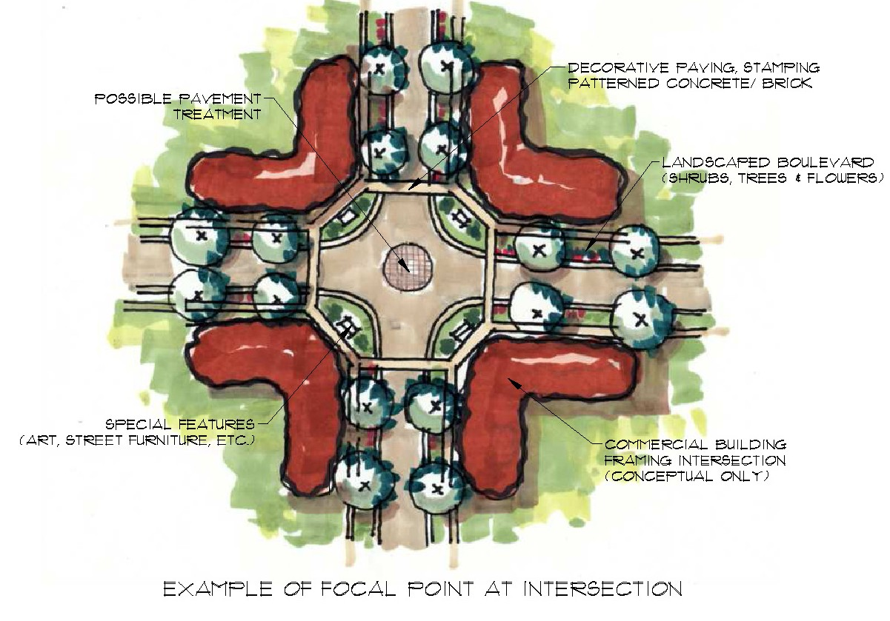
Figure 1: Example of Pedestrian Friendly Commercial Node

    - Along the private internal roadways, the spaces between freestanding structures shall be improved to include landscaped pedestrian connections and:
- Small pockets of landscaped parking areas;
- Public seating areas; and
- Landscaped open spaces.
    - Not including the entrances and access points, a maximum of 40% of the frontages abutting the landscaped Yard along Ellerslie Road and 50 Street SW may be developed with surface parking.
    - Surface parking abutting 4 Avenue SW and 54 Street SW shall be screened from view using berms, and/or landscaping or similar screening features.
    - Service lanes and/or loading areas shall not be permitted to abut the south side of the adjacent multi-family residential site.
10/18

5.3 Building Design Regulations

  - Buildings shall use a variety of architectural elements and treatments, materials and colours, to break up the massing and provide human scale development.

  - The massing of building walls greater than 15.0 m in length shall be reduced through the use of architectural elements such as columns, ribs, pilasters or piers, changes in plane (e.g., recesses and projections), changes in building finishes, materials and textures, or other features that create an identifiable pattern and sense of human scale (see Figure 1.0 – Example of Building Elevation). Landscaping along large format buildings shall be arranged in a manner that reduces and softens the building edge and creates visual relief.

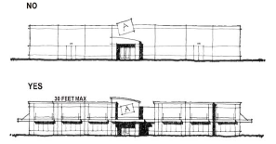
Figure 2.0 – Example of Building Elevation

  - No walls that face a public street, private internal roadways or connecting pedestrian walkway shall have a blank uninterrupted length exceeding 15.0 m.
  - The façade of a building facing a public plaza, focal point or public amenity area shall be designed and finished to create an active streetscape, visual interest, and human scale by use of architectural features such as false entryways or entryways, windows, arcades, arbors, awnings, and trellises.
  - Buildings shall be finished with durable materials of a quality that will retain their appearance over time, including, but not limited to, natural and synthetic stone, brick, acrylic stucco, metal and glazing.
  - Colour schemes shall tie building elements together, relate buildings to one another, and enhance the architectural form of a building.
  - All Buildings, including those whose tenants typically employ “chain architecture”, shall be designed and finished to generally conform to a consistent architectural theme using similar architectural design elements, materials and colours. “Chain architecture” shall generally be limited to corporate logos and signage.
  - All buildings shall be developed with 360 degree architecture such that all facades are visually attractive and interesting.
11/18
  - Buildings shall be designed to include a clearly identifiable primary entrance through the use of recesses, projections, canopies, porticos, overhangs, arcades, peaked roof forms, arches, outdoor patios, display windows, planters, walls, or other similar design elements (See Figure 3)
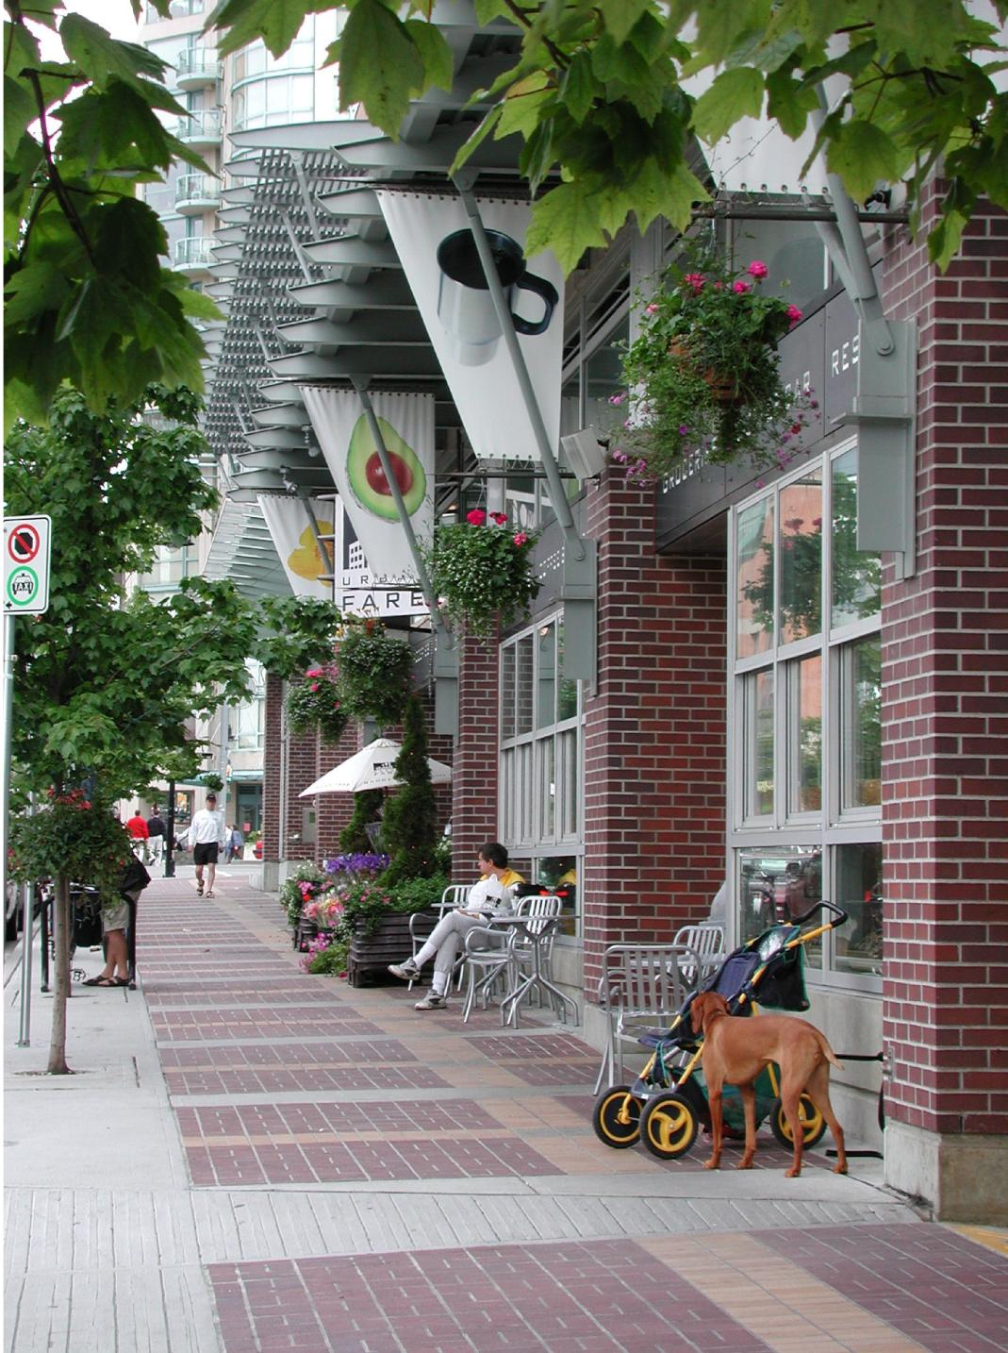
Figure 3.0 – Example of Commercial Retail Unit Frontage

  - Building rooftop mechanical equipment shall be concealed from the public in a manner that is consistent with the character of the building.

  - Vehicular and Pedestrian Circulation

  - Private internal roadways shall be established to accommodate the peak traffic volumes for the site to the satisfaction of the Transportation Department.
  - Pedestrian connections as shown in Appendix II connecting the shopping and amenity areas shall be established through the utilization of clearly demarcated walkways, lighting and signage systems to reduce pedestrian conflict and create a more pedestrian friendly image.
  - The private internal roads as shown on Appendix I where deemed appropriate shall serve as collector streets and shall be developed, in addition to walkways, to the satisfaction of the Development Officer in consultation with the Transportation Department, to encourage pedestrian movement and / or provide access to:
- abutting buildings
- parking areas and / or parking structures
- site amenities and focal points
- sidewalks along public roadways
- transit stops
- defined crossing locations at all arterial and collector intersections
  - Pedestrian connections shall consist of the following types as shown on Appendix II:
- Enhanced multi-use trail
- Multi-use trail
- Enhanced parking island with walkway (Figure 4.0)
12/18

- Pedestrian sidewalk
- Building front sidewalks
  - Pedestrian connections shall be developed generally as shown on Appendix II in the following ways:
- Enhanced multi-use trail – A 12.0 m landscaped yard shall be developed as an enhanced pedestrian corridor as a means of creating an improved interface between the adjacent multi-family residential site and the commercial site. This yard shall include landscaping, pedestrian level lighting, and a 3.0 m hard surfaced multi-use trail with a dividing yellow centerline and ‘Shared Use’ signage;
- Multi-use trails shall include landscaping, pedestrian level lighting, and a 3.0 m hard surfaced multi-use trail with a dividing yellow centerline and ‘Shared Use’ signage;
- Enhanced parking island with walkway shall include landscaped islands with raised curbs and a 1.5 m sidewalk. Remedial treatment such as raised pedestrian crossings, landscaping, forecourts and landings, special paving, light and bollards shall be provided at significant points of pedestrian and vehicular crossings;
- Pedestrian sidewalks shall be a minimum 1.5 m wide and developed along the private internal roadways with boulevard landscaping; and
- Building sidewalks shall be provided in the front of large format buildings at a minimum of 3.0 m in width, the fronts of free standing buildings at a minimum of 2.0 m in width and the fronts of the buildings of the Pedestrian Commercial Shopping Node at a minimum of 3.0 m.

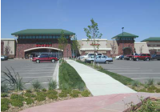
Figure 4.0 – Example of enhanced parking island with walkway

  - The owner shall fund traffic signals at the following potential locations, as shown on Appendix I, if and when warranted by the development:
- the intersection of 50 Street SW and 4 Avenue SW (included in the Arterial Roads for Development Bylaw and shall be funded in accordance with the bylaw);
13/18

- the intersection of 54 Street SW and Ellerslie Road (included in the Arterial Roads for Development Bylaw and shall be funded in accordance with the bylaw);
- the all-directional access to 4 Avenue SW;
- the all-direction access to 54 Street SW; and
- the all-directional access to Ellerslie Road.

  - Allow vehicular and pedestrian cross lot access and circulation to all areas within the commercial precinct to facilitate direct access to shopping.

  - Vehicular Parking and Loading

  - Vehicular and bicycle parking shall be provided in accordance with Section 54 of the Zoning Bylaw and located to the satisfaction of the Development Officer and Transportation Department.
  - Large parking areas shall be “broken up” by means of on site private roads, drive aisles, pedestrian corridors and / or landscaped islands.
  - Garbage collection for all buildings shall be located within a structure or enclosure that is architecturally compatible with the project design and screened from view of any residential site. Gates and/or doors of the garbage enclosures must not open or encroach into public or private road right-of-way.
  - Loading and service areas shall be screened from abutting public roadways and uses and designed to ensure vehicles do not encroach or back onto public road right-of-way or the private internal roadways.

  - Landscaping and Amenities

- A detailed landscaping plan shall be submitted in accordance with Section 55 of the Zoning Bylaw prior to the approval of any development permit. This plan shall illustrate landscaping internal to the site, amenity areas and pedestrian linkages. Outdoor amenity spaces shall be landscaped for the purpose of achieving pedestrian connectivity, opportunities for play and social interaction. Furthermore, outdoor amenity spaces shall create a sense of place, character and identity. In addition to landscaping, this shall be achieved through the use of park benches, pedestrian level lighting, waste receptacles and other means integrated with the landscaping and placed along public walking routes through the site to the satisfaction of the Development Officer.
- Notwithstanding Section 55 of the Zoning Bylaw, landscaping requirements shall exceed the minimum requirements for the number of trees and shrubs required by 10%.
- Landscaped Yards shall not be used in the calculation of amenity areas.
14/18

- Landscaped areas shall utilize the three tiered planting system: 1) grasses and ground covers; 2) shrubs; 3) trees. All areas not covered with structures, yards, walkways, roadways, driveways, and parking spaces shall be landscaped. Low maintenance landscaping or naturalized vegetation types are encouraged.
- All parking areas fronting on to the arterial roadways shall be screened from view primarily by vertical landscaping inclusive of earth berms and trees and shrubs.
- Landscaping at site entrances shall include:
    - the use of ornamental plant material, shrubs, and planting beds
    - planting shall be massed and sized as appropriate for the entryway size and space
    - surface treatments to further enhance the appearance of the entrance

- Coordinated and complementary streetscape enhancements shall be developed through the site, including street trees, fencing, pedestrian scaled lighting, street furniture and other elements.
- Where fences are developed they shall be consistent in design, materials, finishes, and colours with the dominant architectural theme for the site.
- The required Amenity areas may be provided in the form of focal points, courtyards, interior landscaped open spaces, arcades, plazas, parkettes, commons, squares, greens, gathering places and public seating areas. The amenity areas may be developed with landscaping, planting beds, public art, street furniture and water features to facilitate social interaction amongst site users and create a “sense of place”. Amenity areas shall be distributed to be readily accessible to both visitors and on-site employees.
- Landscaping shall be used to highlight major circulation patterns, on-site walkways, pedestrian corridors, multi-use trails and the overall development.

  - Interface with Natural Area

- The focal point on the south side of the natural area shall be open and accessible by a pedestrian corridor or a private internal roadway for a length of 30.0 m.
- Any residential building sited adjacent to the natural area shall be oriented to ensure that residents have direct views of the natural area and active residential frontages. Active residential frontages shall include ground level units with individual unit external accesses and use features such as porches, staircases and stoops.
15/18

- Adjacent to the southern portion of the natural area, a 7.5 m building setback shall be provided, as shown on Appendix II.
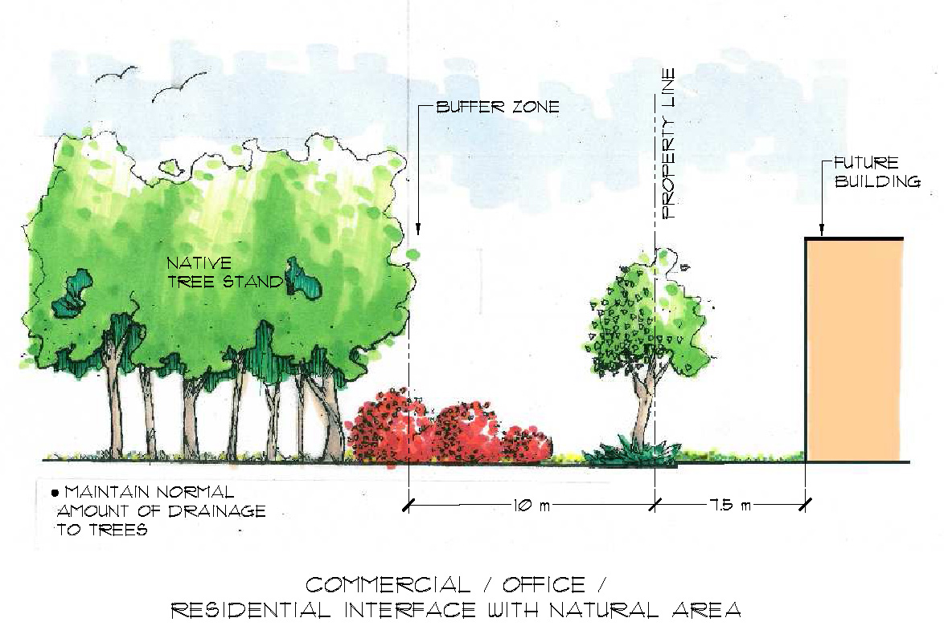
Figure 5

5.8 Interface with existing Historic Religious Assembly

  - A minimum 15.0 m building setback shall be provided abutting Lot 5, Plan 8221657 (historical religious assembly).
  - Within the building setback, a 5.0 m landscaped yard shall be provided on the north and west side of the religious assembly site (See Figure 6).
  - A 1.5 m sidewalk shall be provided within the landscaped yard along a portion of the north boundary of the religious assembly as shown on Appendix II.
  - An appropriate interface / integration shall be created between the site and the existing religious assembly by incorporating similar or sympathetic architectural features (i.e. material, colours) on buildings in proximity to the site. The interface with the west side of the existing historical religious assembly site will incorporate protection of the viewshed corridor of the historical structure.
  - The owner shall register a public access easement, as shown on Appendix I, on all Certificates of Title for the commercial site to ensure vehicular and pedestrian access from Ellerslie Road and 50 Street through the commercial
16/18

  - site to Lot 5, Plan 822 1657 (historic religious assembly) as shown on Appendix I.
  - Major / Minor Alcohol Sales, Nightclubs, Bars and Neighbourhood pubs, and Drive-in Food Service shall not be permitted within 15.0 m of Lot 5, Plan 8221657 (historical religious assembly).

\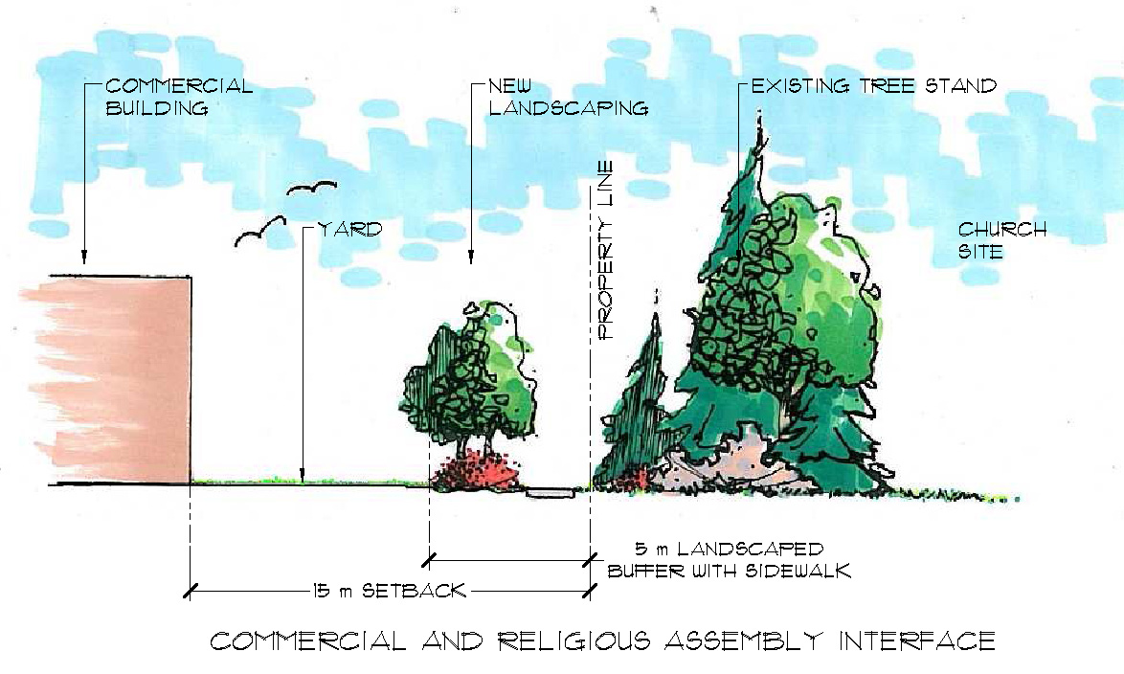
Figure 6:

17/18
APPENDIX 1

15215_app1.pdf

18/18
APPENDIX II
15215_app2.pdf

DESCRIPTION: ZONING BYLAW AMENDMENT from (AG) Agricultural Zone to (DC1) Direct Development Control Provision and (NA) Natural Areas Protection Zone; CHARLESWORTH

LOCATION: Located north of Ellerslie Road and west of 50 Street SW

LEGAL
DESCRIPTION: Portion of Lot 1, Plan 782 2211; 5610 – Ellerslie Road SW
Lot 3, Plan 812 0945; 5350 – Ellerslie Road SW
Lot 4, Plan 812 0945; 5240 – Ellerslie Road SW

APPLICANT: Stantec Consulting Ltd.
10160 – 112 Street
Edmonton AB T5K 2I6

OWNER: 620252 Alberta Ltd
10180 – 111 Street NW
Edmonton, AB T5K 1K6

ACCEPTANCE OF
APPLICATION: April 10, 2006

EXISTING
DEVELOPMENT: Agricultural land with outbuildings and single detached residential houses along with a natural area (tree stand)

PLANNING AND
DEVELOPMENT
DEPARTMENT’S
RECOMMENDATION: That Bylaw 15215 to amend the Zoning Bylaw from (AG) Agricultural Zone to (DC1) Direct Development Control Provision and (NA) Natural Areas Protection Zone be APPROVED.

DISCUSSION

1. The Application

This application proposes to amend the Zoning Bylaw from (AG) Agricultural Zone to (DC1) Direct Development Control Provision and (NA) Natural Areas Protection Zone. The DC1 Provision will facilitate the development of a pedestrian friendly community commercial centre that may accommodate a range of commercial, residential, office, entertainment, cultural and institutional uses. The NA Zone will conserve an existing natural area (tree stand).

The proposed DC1 Provision will ensure appropriate appearance, placement and function of the future commercial site. Highlights of the proposed DC1 Provision are:
- A variety of commercial, retail and office uses developed as larger shopping complexes, a pedestrian friendly commercial node and stand alone pads;
- A maximum Floor Area Ratio (FAR) of 0.4;
- Up to a maximum building height of 20.0 m for non residential uses and a maximum of 45.0 m for residential uses;
- Building and design regulations to ensure compatibility with surrounding land uses and sensitivity to the interface with the natural area and historic religious assembly;
- Enhanced landscaping, focal points and a variety of pedestrian connections to create an attractive, functional and walkable commercial shopping centre that safely accommodates both pedestrian and vehicular traffic; and
- Buildings oriented to create a sense of place and the inclusion of focal points to create gathering spaces (e.g. plazas, landscaping, street furniture, decorative architectural walls, building orientation, etc.).

2. Site and Surrounding Area

The proposed rezoning area is bound by two arterial roads (Ellerslie Road SW and 50 Street) and two collector roads (54 Street SW and 4 Avenue SW). The 14 ha proposed commercial site is currently undeveloped agricultural land with single detached residential housing and various outbuildings. To the west and north are future low, medium and high density residential developments. Across 50 Street SW, is the future City Level Park planned for a multi-sport tournament and recreation site and possible institutional uses. South of Ellerslie Road SW, is a future community commercial site that will be similar to this development. An existing religious assembly, St. Paul’s Evangelical Lutheran Church, is located south-east of the subject property. A possible Transit Priority Corridor Stop is identified on Ellerslie Road adjacent to the proposed rezoning area.

The 1.84 ha tree stand was not identified in the City of Edmonton Table Lands Inventory likely due to the relatively small size of the stand and evidence of prior disturbance. The natural area contains aspen and balsam poplar tress and a semi permanent wetland. This
natural area will provide for a natural amenity within the proposed commercial development, wildlife habitat and potential for a variety of aesthetic, education and recreational opportunities. A 10 m buffer within the NA Zone will be maintained around the natural area.

ANALYSIS

1. Compliance with Approved Plans and Land Use Compatibility

The proposed rezoning conforms to the Southeast Area Structure Plan (ASP) and the Charlesworth Neighbourhood Structure Plan (NSP) which designates the lands as Community Commercial and Natural Area.

Community Commercial - The Community Commercial area is intended to add vibrancy, image and overall sustainability of the community to serve both residents of Charlesworth and adjacent communities. The commercial area is intended to offer a variety of retail and commercial opportunities for residents.

The proposed DC1 Provision meets the development objectives of the Charlesworth NSP for community commercial related to building placement, building design, parking/circulation, landscaping and site amenities and interface with historic religious assembly.

General – The proposed DC1 Provision is generally based on the (CSC) Shopping Centre Zone and proposes compatible buildings heights with surrounding development.

Building Placement – The proposed DC1 Provision requires buildings to frame corners of prominent intersections (i.e. Ellerslie Road and 54 Street SW), frame the pedestrian friendly commercial node, permit views into the site along roadways and walkways intersecting the public roads as well as permit views of the natural area. Spaces between freestanding structures will be improved to include pedestrian connections, pockets of landscaped parking areas, public seating areas and landscaped open spaces.

The pedestrian friendly commercial node will be located at the intersection of the two main private internal roads. The node will be designed by clustering a mix of small to larger scale commercial retail units, providing an amenity area in each node with larger sidewalks and special pedestrian crossings.

Building Design – The proposed DC1 Provision requires color schemes to tie buildings elements together, the use of design elements and landscaping to break up the massing of structures and 360 degree architecture.

Parking/Circulation – The proposed DC1 Provision provides pedestrian connections through multi-use trails, enhanced parking islands, pedestrian sidewalks along landscaped internal roadways and larger sidewalks in front of buildings.
Landscaping and Site Amenities – The proposed DC1 Provision requires enhanced landscaping along public roadways and major circulation routes and focal points where pedestrian connections intersect to provide special features and vistas within the site and to promote social interaction.

Interface with historic religious assembly – The proposed DC1 Provision provides for public access through the commercial site to the religious assembly site because the current access from Ellerslie Road will be removed in the future. Further, a landscaped yard along with an increased building setback will be required. A focal point/amenity area will be developed on the commercial site north of the religious assembly.

Residential and Residential Related Uses – Apartment housing and live/work opportunities are permitted in a free standing building with or without ground floor office, commercial or retail uses or part of a comprehensively developed project. Residential and residential related uses are permitted in the areas adjacent to the natural area.

Natural Area - The natural area (tree stand) will enhance this area’s attractiveness as a focal point while providing an additional land use buffer and transition between residential and commercial development. The 1.84 ha natural area will be dedicated as municipal reserve.

The Natural Area Systems Policy (C-531) approved by Council on July 17, 2007 directs the City to conserve and protect biodiversity throughout Edmonton recognizing the urban context. Conserving the ecological functions of the natural area will allow for a high quality aesthetic and natural experience for industrial employees and residents.

2. Transportation and Utilities

The Transportation Department supports the proposed rezoning and has the following advisements:
- Owners within the Southeast ASP have entered into a Memorandum of Understanding (MOU) to implement a roadway strategy to accommodate growth and development in the Charlesworth and Walker neighbourhoods. Included in the MOU is construction of two urban lanes along 50 Street SW adjacent to the existing two rural lanes from Anthony Henday Drive to 400 m south of Ellerslie Road and construction of four urban lanes along Ellerslie Road from 62 Street SW to 50 Street SW. The Transportation Department may be willing to accept a reduced amount of arterial construction for 50 Street SW and Ellerslie Road. The minimum required arterial roadway construction will include two urban lanes on 50 Street SW adjacent to the existing two rural lanes from Anthony Henday Drive to Ellerslie Road, two urban lanes on Ellerslie Road from 62 Street SW to 50 Street SW and the intersection of 50 Street SW and Ellerslie Road. The owner may wish to coordinate arterial roadway construction with other area developers.
- Upon subdivision, dedication and construction of 54 Street SW/4 Avenue SW will be required from Ellerslie Road to 50 Street SW. Due to traffic volumes, an enhanced collector will be required, including a minimum four lane carriageway from Ellerslie Road to the all-directional commercial access to the north and from 50 Street SW to the all-direction commercial access to the west with an eastbound to westbound double left turn at the 4 Avenue SW access to 50 Street SW.
- Land owners adjacent to the east/west collector roadway, on the east and west side of 50 Street SW, should collectively coordinate the alignment of this roadway. The alignment should be centred on the property line as it approaches 50 Street SW and must be situated to allow for access to all adjacent properties.
- 54 Street SW and 4 Avenue SW are transit routes.

No other City Departments, utility agencies or Leduc County have expressed concerns or objections regarding this application.

3. Smart Choices Assessment

The proposed rezoning advances the Smart Choices Initiative of Walkability and Urban Design. The Smart Choices Initiatives of Neighbourhood Reinvestment, Residential Infill, Transit-Oriented Development and the Redevelopment of Older Commercial and Industrial Lands are not applicable/ relevant to the application.

The proposed DC1 Provision encourages walkability by ensuring connectivity of the private internal roadways and pedestrian network to link major destinations and focal points. Further, sidewalks will be provided along building fronts and be separated from vehicular traffic with landscaping. Public and private spaces will be designed according to Crime Prevention Through Environmental Design (CPTED) principles.

Urban Design is promoted by the proposed DC1 Provision through consideration of appropriate architecture, building materials, scale/massing, height and setbacks/yards. It is also enhanced through the pedestrian friendly commercial node, implementation of CPTED principles, and development of accessible and functional public spaces.

4. Environmental

A Phase I, II and III Environmental Site Assessment reports were completed on the subject sites and there are no further concerns identified by the Planning and Development Department’s Environmental Planning Unit.

A Natural Area Management Plan was completed in November 2008 and approved by City Departments.

5. Surrounding Property Owners’ Concerns

The Planning and Development Department sent a notification letter to 123 surrounding property owners within the Charlesworth neighbourhood, surrounding 60 m of the site and the Ellerslie Recreation and Community League on April 25, 2006. There were no subsequent inquires about the application.

Once the application was finalized, the Planning and Development Department sent another notification letter to 597 surrounding property owners within the Charlesworth neighbourhood, surrounding 60 m of the site and the Millhurst Community League on May 11, 2009. There were no subsequent inquiries about the application.

JUSTIFICATION

The Planning and Development Department recommends that Bylaw 15215 be APPROVED on the basis that it conforms to the Charlesworth Neighbourhood Structure Plan, meets the technical requirements of the affected City Departments and utility agencies and is compatible with planned surrounding land uses. The DC1 Provision provides a variety of commercial, residential, office, entertainment, cultural and institutional uses that are appropriate in appearance and function to a site bound by future low, medium and high density residential. The DC1 Provision also incorporates regulations that will provide for enhanced architectural and landscaping regulations, pedestrian friendly environment and sensitive control to building and site design to integrate the site with surrounding land uses that will create a positive interface with adjacent residential, natural area and historic religious assembly.

ATTACHMENT

2a Maps

Written by: Kim Agar
Approved by: Willard Hughes
Planning and Development Department
June 1, 2009
ATTACHMENT 2a
15215_Att2a.pdf

2

15215_Pg2.pdf

