Bylaw 15284

A Bylaw to amend Bylaw 12800, as amended,

The Edmonton Zoning Bylaw
Amendment No. 1099

WHEREAS Blocks 1 and 2, Plan 8620880, located west of Fort Road NW and north of 167 Avenue NW, Rural North East Horse Hill, Edmonton, Alberta, are specified on the Zoning Map as (AG) Agricultural Zone; and

WHEREAS an application was made to rezone the above described property to (DC2) Site Specific Development Control Provision;

NOW THEREFORE after due compliance with the relevant provisions of the Municipal Government Act RSA 2000, ch. M-26, as amended, the Municipal Council of the City of Edmonton duly assembled enacts as follows:

1. The Zoning Map, being Part III to Bylaw 12800 The Edmonton Zoning Bylaw is hereby amended by rezoning the lands legally described as Blocks 1 and 2, Plan 8620880, located west of Fort Road NW and north of 167 Avenue NW, Rural North East Horse Hill, Edmonton, Alberta, which lands are shown on the sketch plan annexed hereto as Schedule “A”, from (AG) Agricultural Zone to (DC2) Site Specific Development Control Provision.

2. The uses and regulations of the aforementioned DC2 Provision are annexed hereto as Schedule "B".
2/8

- The sketch plan annexed hereto as Schedule “A” and the uses and regulations of the DC2 Provision shown on Schedule “B” annexed hereto are hereby incorporated into the Zoning Bylaw, being Part IV to Bylaw 12800, The Edmonton Zoning Bylaw.

READ a first time this day of , A. D. 2009;
READ a second time this day of , A. D. 2009;
READ a third time this day of , A. D. 2009;
SIGNED and PASSED this day of , A. D. 2009.

THE CITY OF EDMONTON
____________________________________
MAYOR

____________________________________
CITY CLERK

3/8
SCHEDULE “A”

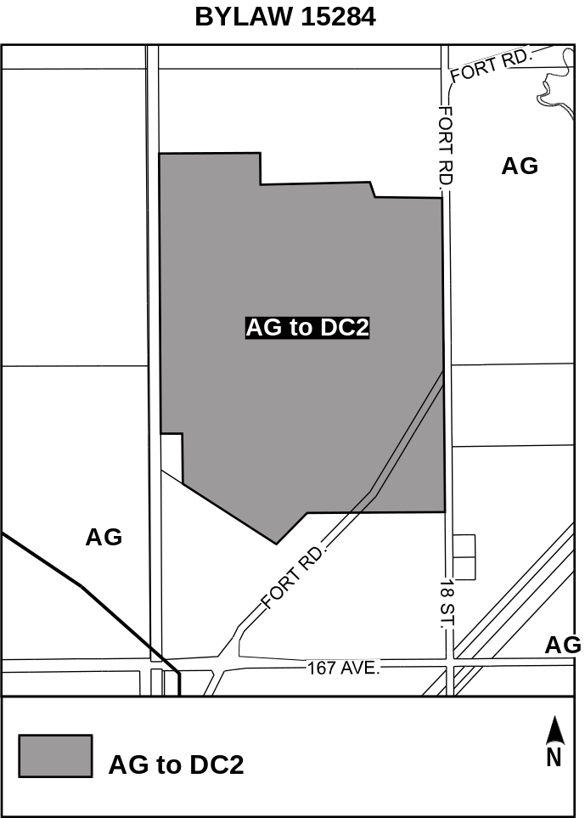

4/8
SCHEDULE “B”

(DC2) Direct Development Control Provision

- General Purpose

To accommodate the redevelopment of a Regional Health Services Campus, providing an opportunity for uses related to the provision of health care, continuing care, extended care treatment, medical treatment and institutional facilities; with ancillary commercial, professional office, research, training, and personal service uses related to the delivery of health care. This Provision also provides regulations for environmental recovery for specific areas of the site.
- Area of Application
This Provision shall apply to Blocks 1 and 2, Plan 862 0880; containing 68.68 ha more or less; as shown on Appendix “1” of the Bylaw adopting this Provision; Rural North East Horse Hill.
- Development Concept
The Alberta Hospital site is envisioned as a comprehensively planned health care facility that would include a variety of complementary and compatible uses related to the provision of health care in a campus setting. Taking advantage of the benefits of inter-relationships between various medical and ancillary uses in close proximity, the site is ideally located to serve the greater Capital Region, with excellent transportation connections to Edmonton and outlying areas via Anthony Henday Drive, Manning Drive and a future high speed transit route.
- Uses
- Government Services
- Public Education Services and Private Education Services
- Religious Assembly
- Boarding and Lodging Houses
- Commercial Schools
- Detention and Correction Services
- Extended Medical Treatment Services
- Group Homes
- Health Services
- Indoor Participant Recreation Services
- Minor Impact Utility Services
- Outdoor Participant Recreation Services
- Protective and Emergency Services
5/8
- Personal Service Shops, Convenience Retail Stores, Professional, Financial and Office Support Services, Specialty Food Services and Restaurants, Non-accessory Parking, when designed as an integral and secondary component of Extended Medical Treatment Services or Health Services
- Temporary Shelter Services
- Fascia On-premises Signs
- Freestanding On-premises Signs
- Projecting On-premises Signs
- Temporary On-premises Signs
- Development Regulations
    - General
- A 6.0 m Landscaped Yard shall be provided around the perimeter of the site.
- The maximum Floor Area Ratio shall be 0.5.
- The maximum Building Height shall be 15.0 m. Where, in the opinion of the Development Officer, additional height is warranted due to characteristics fundamental to the nature of the Use, the Development Officer may relax this condition as required.
- Development Applications for this Site shall be permitted in phases. For context and Development Officer interpretation purposes, a generalized, non-binding, Site plan shall be submitted at Development Permit stage for all new building development or for substantial redevelopment to illustrate how the proposed development will integrate with existing and future surrounding and on-site development.
- This Provision shall only apply to new development. Development legally existing or approved prior to the effective date of this Bylaw shall not be affected unless it is involved in the Development Permit application or includes renovation that change the foot print of the structure.
- Separation Space shall be provided in accordance with Section 48.
- Signs shall comply with the regulations found in Schedule 59C.
- The Development Officer may grant relaxations to this Provision if in their opinion, such a variance will be in keeping with the general purpose of this District, and would not affect the amenities, use and enjoyment of adjacent properties.
II. Landscaping
- Loading, storage, and trash collection areas shall be located in such a manner to be screened from view from adjacent sites, public roadways and the transit centre in accordance with the provisions of Section 55 of the Zoning Bylaw.
6/8
- Landscaping shall be provided in accordance with Section 55 of the Zoning Bylaw.
- Open spaces should include, but are not limited to, a combination of landscape elements such as, trees, shrubs, hedges, berms and street furniture..
- Landscaping of the Site should include plant materials that provide colour and texture throughout the year to enhance the appearance during winter months.
- Landscaping should be used to highlight major circulation patterns, pedestrian pathways and the overall development.
- Site landscaping should be used to soften the building form, and mitigate impacts between buildings.
III. Parking and Access
- The primary vehicular entrance to the site shall be from 18 Street NW and Fort Road.
- Additional Site accesses may be permitted based on the future redevelopment of the site. Access locations will be reviewed at time of Development Permit application, to the satisfaction of the Development Officer in consultation with the Transportation Department.
- Parking shall be provided in accordance with Section 54 of the Zoning Bylaw.
- The applicant must submit a Parking Demand Study in conjunction with an application for Development Permit to rationalize any reduction in the number of parking stalls required for the site.
- In determining the number of applicable parking stalls, the Development Officer shall take into consideration opportunities for shared parking by users with staggered peak hours of demand.
- Service and emergency response vehicles should have clear and effective access to the buildings on site.
- Parking, loading and passenger drop-off areas should be easily accessible and designed to minimize pedestrian-vehicle conflicts.
- Parking for the Site shall be one of, or a combination of underground parking, structured (above ground) parking and/or surface parking.
- Surface parking shall be integrated with the internal circulation network.
- Surface parking lots shall be enhanced with urban design elements such as landscaping and lighting.
7/8
IV. Built Form
- All development shall be designed with universal accessibility.
- New major structures developed on the site should be developed to a LEED® standard.
- High quality finishing materials shall be used in the development of major structures on the site. Recommended materials include, but are not limited to, one or a combination of brick, glass and/or glazed window wall systems, architectural concrete and/or pre-cast coloured concrete, stucco, stone, metal or other materials.
- Building facades on all sides shall include design elements that provide articulation.
- Lighting shall be provided within the development to provide an element of safety and to enhance the appearance of the site and buildings.
- All mechanical equipment, including roof mechanical units, shall be concealed by screening with design elements that are compatible or complement the architectural character and materials of the building, or concealed by incorporating it within the building framework.
- Design techniques including, but not limited to, the use of sloped roofs, variations in building Setbacks and articulation of building façades, shall be employed in order to minimize the perception of massing of the building when viewed from adjacent areas and roadways.
V. Environmental Recovery
- Regulations in this section refer to the attached Appendix 1, “Sub Areas”.
- The following environmental criteria pertaining to the sub areas, as shown on Appendix 1, shall be met prior to the issuance of a development permit, unless otherwise noted in this Provision.
Areas A & B
  - No further environmental review is required for these areas.
Areas C through J inclusive:
ii. No Use, unless otherwise allowed under Section 5.V.c. of this Provision, shall be approved by the Development Officer until letters acceptable to the Development Officer from Alberta Environment and Alberta Health Services have been submitted stating that the site is suitable for the proposed Use having regard for relevant Federal or Provincial environmental criteria.
- Upon the submission of a Development Permit, the applicant may be exempt from Section 5.V.b.ii of this Provision to conduct further environmental investigation, to the satisfaction of the Development Officer in consultation with the Planning and Development Department, Environmental Planning Unit.
8/8
APPENDIX I – Sub Areas
15284_App.pdf

DESCRIPTION: ZONING BYLAW AMENDMENT from (AG) Agricultural Zone to (DC2) Site Specific Development Control Provision; RURAL NORTH EAST HORSE HILL

LOCATION: 17203- Fort Road NW and 17480 – Fort Road NW

LEGAL
DESCRIPTION: Blocks 1 & 2, Plan 8620880

APPLICANT: Chris Dulaba
Stantec Consulting
10160-112 Street
Edmonton, AB T5K 2L6

OWNER: Alberta Health Services
1J2.26 Walter C. Mackenzie Health Science Centre
8440-112 Street
Edmonton
Alberta T6G 2B7

ACCEPTANCE OF
APPLICATION: October 30, 2007

EXISTING
DEVELOPMENT: The Alberta Hospital Site includes over 20 buildings and other outdoor accessory uses.

PLANNING AND
DEVELOPMENT
DEPARTMENT’S
RECOMMENDATION: That Bylaw 15284 to amend the Zoning Bylaw from (AG) Agricultural Zone to (DC2) Site Specific Development Control Provision be APPROVED.

DISCUSSION

1. The Application

The Alberta Hospital opened in 1923 and has been operating as a psychiatric hospital ever since. Before it was annexed by the City of Edmonton in 1982, the hospital site was a part of Sturgeon County. It was believed that at the time of the 1982 annexation, the site had a zoning that was approximately equivalent to the (AG) Agricultural Zone, and therefore adopted the Edmonton (AG) Agricultural Zoning. The hospital then continued the uses with a legal non-conforming use status to the present time.

The application proposes to rezone the Alberta Hospital site from (AG) Agricultural Zone to (DC2) Site Specific Development Control Provision. The application was triggered by the need for the Development Permit of a new food services building to replace the existing building, in order to bring the on-site food services facility up to current standards and a need to put appropriate zoning in place to allow for long term use of this site as a health service facility. The current zoning, (AG) Agricultural Zone, does not allow for the existing institutional and accessory uses. Hence, a development permit cannot be issued.

The applicant has indicated that in the future, a master plan will be developed to ensure a comprehensive design of the site. The process will include public consultation to involve the public and the adjacent land owners in the development process of the master plan.

The application originally proposed to amend the Zoning Bylaw from (AG) Agricultural Zone to (US) Urban Services Zone. However, some of the existing uses, such as Minor Impact Utility uses, are not allowed under the US Zone, and the environmental recovery actions required for future development of the site necessitated the change in the application to a proposed DC2 Provision.

The proposed DC2 Provision is based on the US Zone with the addition of Group Homes, Non-accessory Parking and Minor Impact Utility Services uses. The DC2 Provision recognizes all the existing uses on the Alberta Hospital site and allows for and regulates future redevelopment of the Alberta Hospital site. The DC2 also divides the site into sub-areas to allow Environmental Recovery action to be carried out in phases given the extensive area involved in the site and the need for continuation of the institution’s operations.

2. Site and Surrounding Area

The Alberta Hospital site is located west of 18 Street and north of 167 Avenue in the Rural North East Horse Hill Neighbourhood. It is 68.68 ha in size and comprised of two lots. The site is currently occupied by over 20 buildings, including medical treatment buildings, green house, a power plant etc., and outdoor accessory uses such as a soccer field, a baseball diamond, tennis courts, and surface parking.

Because the Municipal Development Plan Bylaw 11777 (MDP) has designated the area for agricultural uses, the Rural North East Horse Hill Neighbourhood is predominantly agricultural uses. Lands around the Alberta Hospital site are zoned (AG) Agricultural Zone and the Evergreen mobile home park located further east of the subject site and is zoned (RMH) Mobile Home Zone.

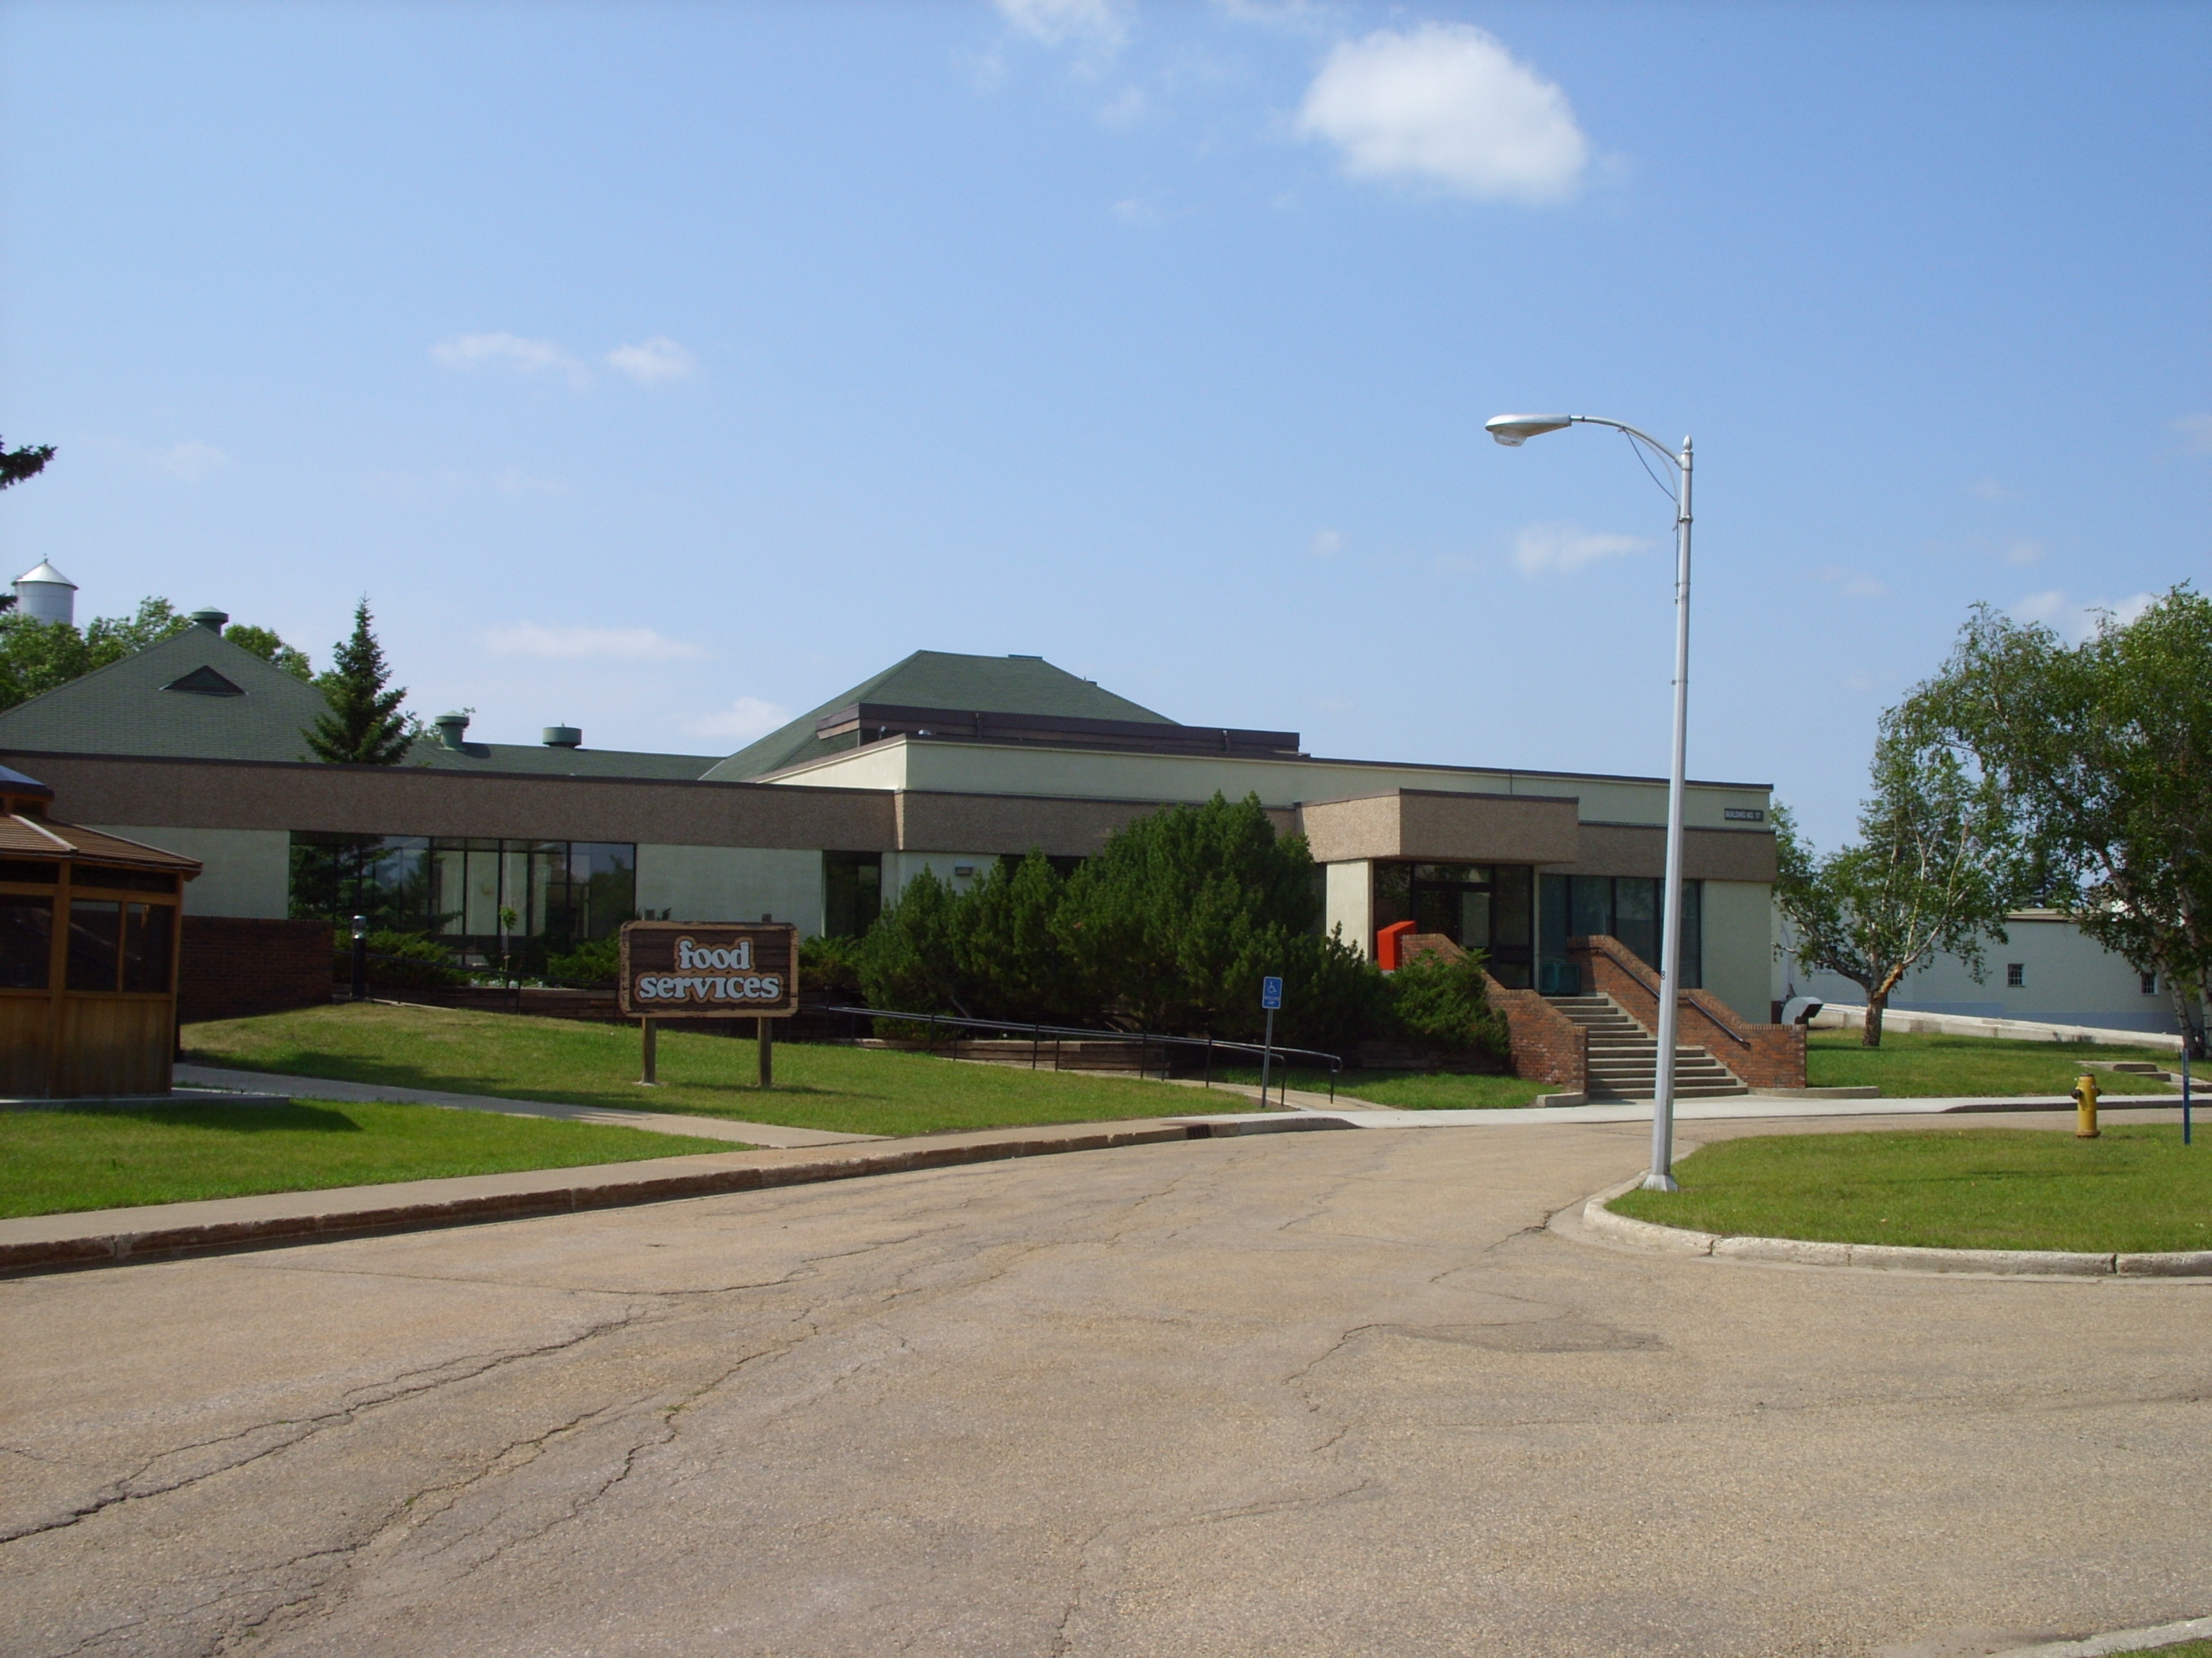
View of existing food services building looking west on Lane 2.

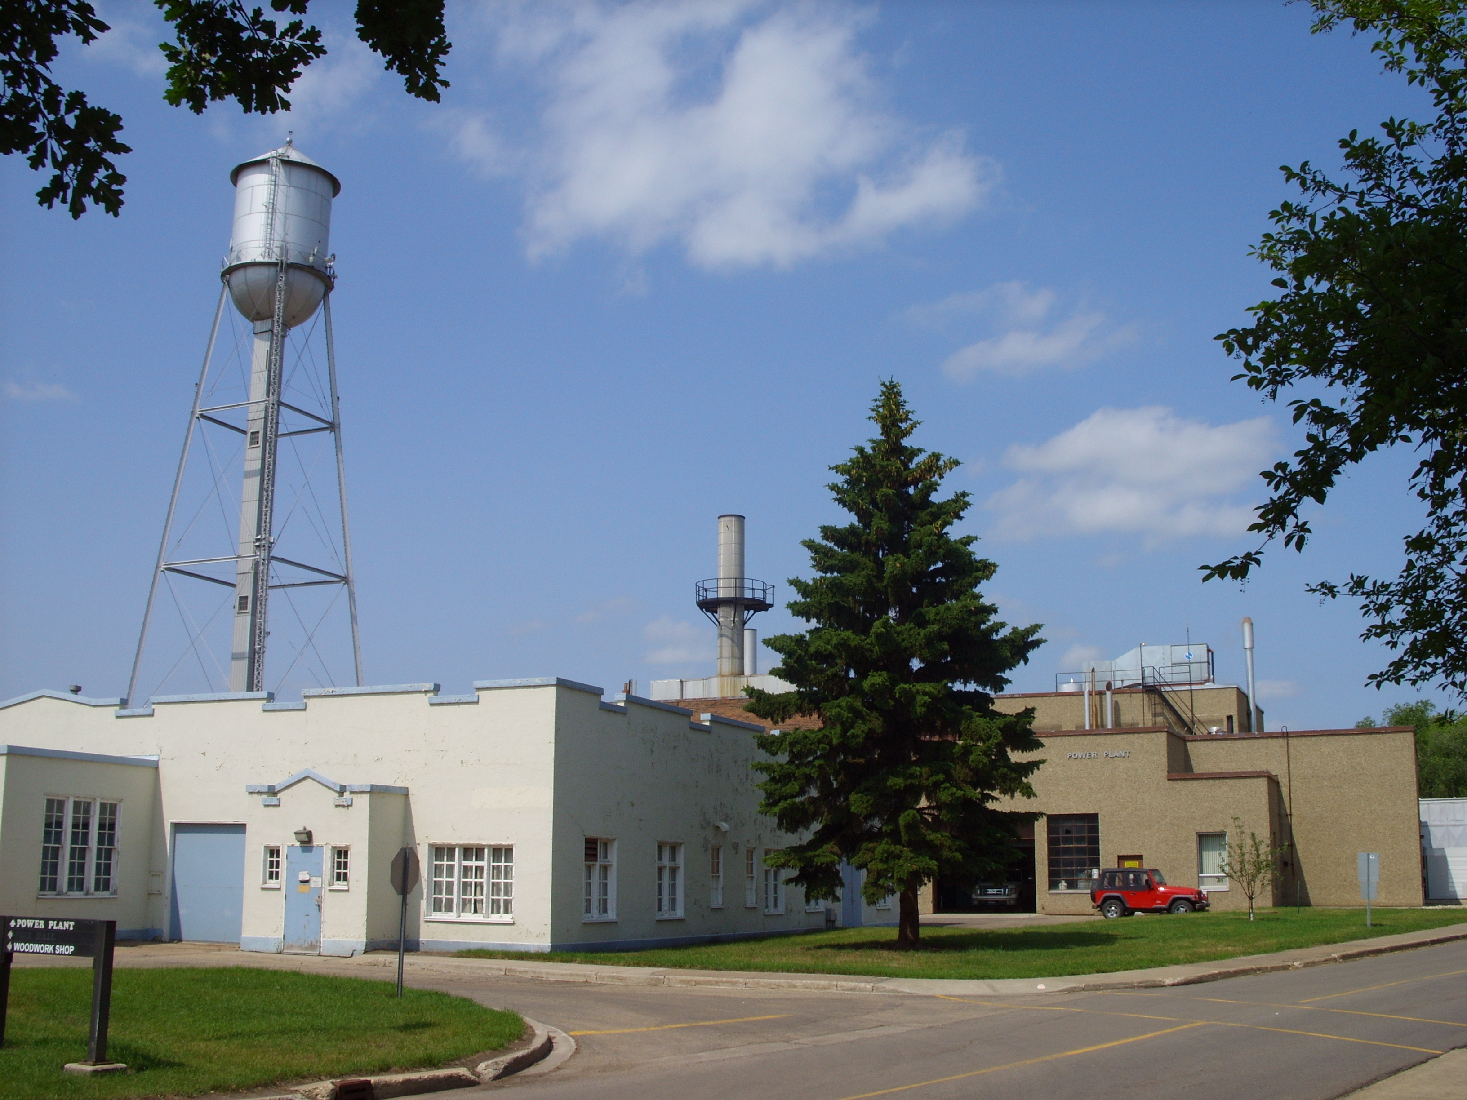
View of Power Plant looking west northwest from Road 1.

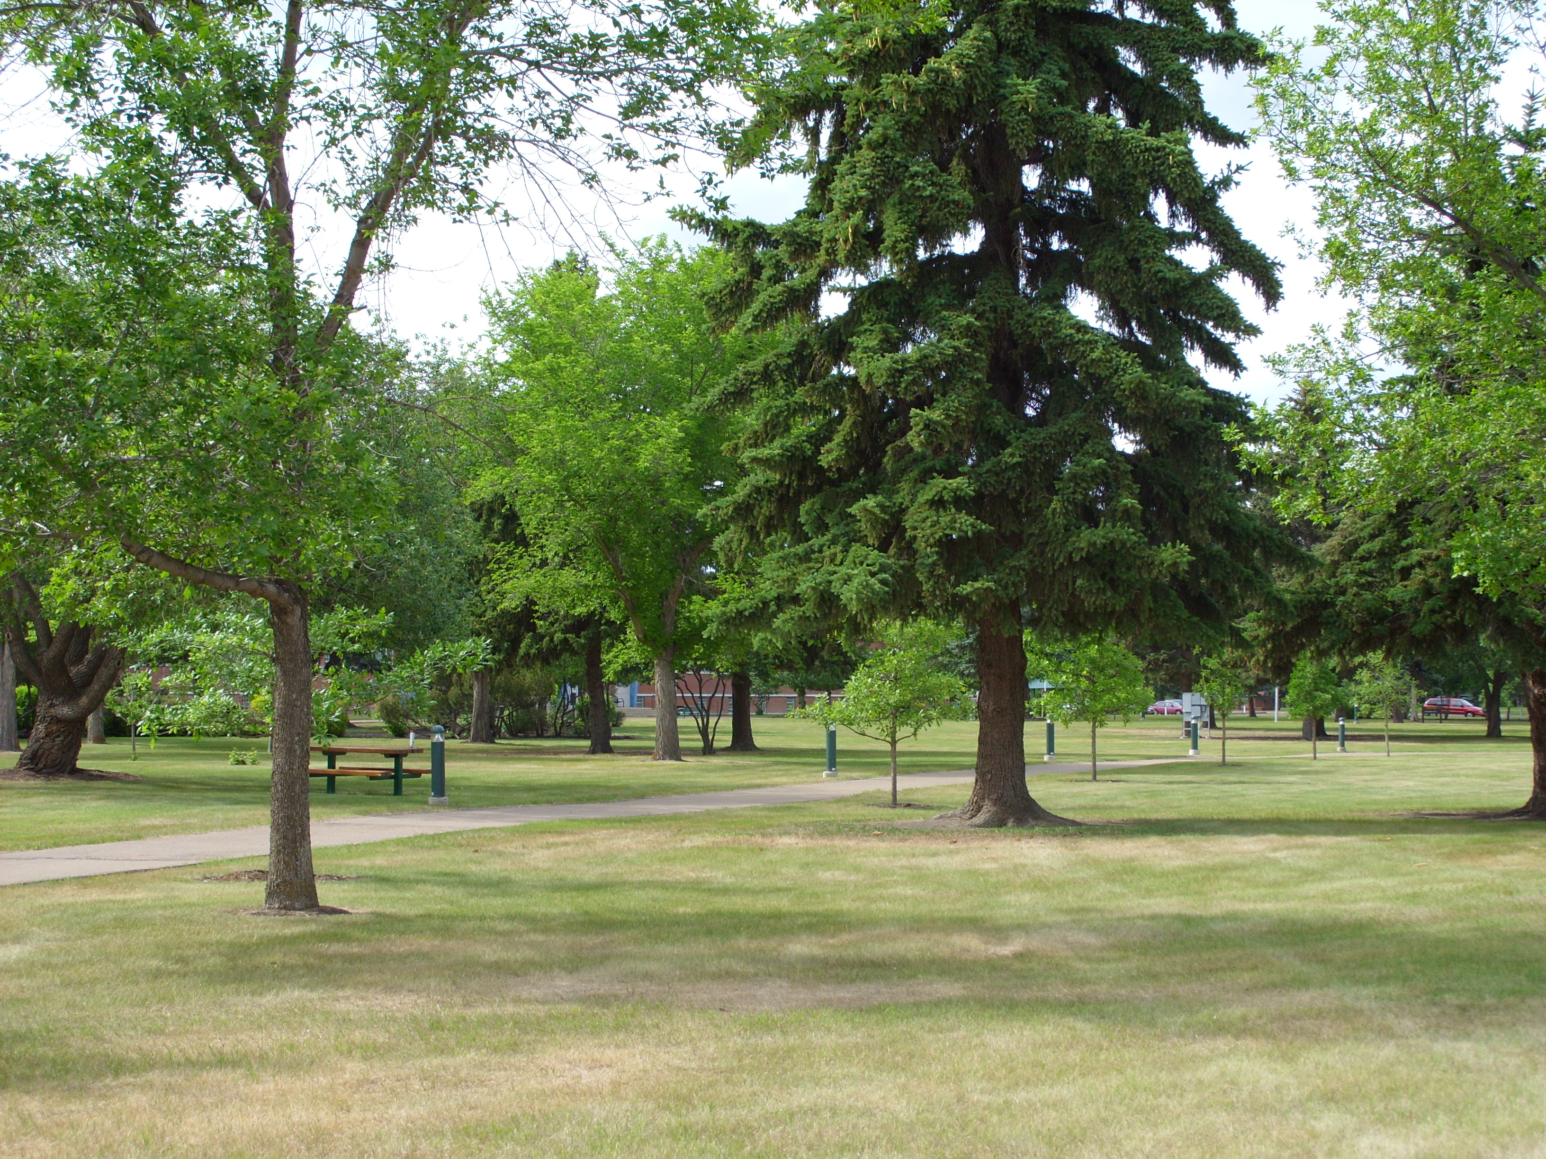
View of open space between Fort Road and Road 2.
ANALYSIS

1. Compliance with Approved Plans and Land Use Compatibility

The site is identified as Agricultural area in the Municipal Development Plan (MDP). It is the objective of the MDP to encourage rehabilitation and renewal through re-investment in public infrastructure and the application of land use regulations that accommodate sensitive redevelopment. Restrictive land use regulations have been incorporated in the proposed DC2 to recognize the longstanding use and to ensure the future redevelopment be carried out sensitively.

There is no local plan for the Rural North East Horse Hill Neighbourhood.

The Alberta Hospital has operated as a psychiatric hospital at the location for over eighty years. Because of its remote location from city services, privately owned utilities and services exist on site. The purpose of the proposed DC2 is to recognize all the different uses that are not available to a (US) Urban Services Zone but essential to the Alberta Hospital Site, such as the power plant, fire hall, and reservoir, to allow redevelopment to occur in the future. The proposed DC2 also divides the site into different sub areas to identify areas of possible environmental concern. This allows the environmental recovery actions to be carried out in phases if redevelopments in specific areas of the hospital site are to occur.

The proposed development of the new Food Services building is compatible with surrounding development since it is considered a supporting use to the Health Services uses.

2. Transportation and Utilities

The Transportation Department supports the proposed rezoning but advises that the alignment of the future Fort Road may have an effect on access to the Alberta Hospital.

Drainage Services of the Asset Management and Public Works Department has no objection to the proposed rezoning. Drainage Services advises that a downstream portion of the sanitary sewer previously established by the Province was transferred to and is currently owned and operated by the City. Any redevelopment of the site would be limited to the existing available capacity of the current private servicing and the downstream City-owned sanitary sewer system. Any major development of the rezoning site would require the applicant to undertake a sewer servicing study to determine proposed servicing of the development and confirm the available capacity of the downstream systems.

EPCOR Water does not object to the proposed rezoning but advises that since Alberta Hospital is in a remote service area it is required to maintain adequate water storage to provide sufficient fire protection and domestic peak requirement as condition of services.
ATCO Gas does not object the proposed rezoning but advises that no part of ATCO pipelines right-of-way is to be in road rights-of-way other than at perpendicular crossings if future development is to occur.

3. Environmental Review
An Environmental Assessment Report was submitted in support of the proposed rezoning application and was signed off by the Environmental Planning Group on March 25, 2009. This Group supports the inclusion of regulations in the DC2 Provision which will address Environmental Recovery actions in stages.

4. Surrounding Property Owners’ Concerns
On December 3, 2007, a notification was send to the Evergreen Community Association, the Horse Hill Community League and the Clareveiw and District Area Council and surrounding property owners. In response to the notification, the Planning and Development Department received 5 phone calls and 1 letter all in support of the proposed rezoning.

Subsequent to the first notification sent on December 3, 2007, a notification for the revised application (DC2) was sent to the Evergreen Community Association, the Horse Hill Community League and the Clareview and District Area Council and an expanded list of property owners was sent on May 28, 2009. In response to the revised application, one fax was submitted. The respondents provided comments regarding medical services provided by Alberta Hospital and object to the rezoning for reasons that are not land use related.

A public meeting was held on July 24, 2009 at the Evergreen Community Hall. The meeting was attended by the two Ward Councillors, the representatives of Alberta Health Services but no citizens.

JUSTIFICATION
The Planning and Development Department recommends that Bylaw 15284 be APPROVED, on the basis that the proposed Zoning Bylaw amendment applies appropriate zoning to the existing Alberta Hospital site, accommodates future development of the institutional and associated uses on the site, and is compatible with surrounding existing and planned development.

ATTACHMENT

2a Maps

Written by: Carman Yeung
Approved by: Willard Hughes
Planning and Development Department
August 24, 2009
15284_Att2a.pdf

15284_Pg2.pdf

