Notice of Intention to Designate
E
3

The George Harcourt Residence as a Municipal Historic Resource

Recommendations:
That Executive Committee recommend to City Council:
- That a Notice of Intention to Designate a Municipal Historic Resource, as outlined in Attachment 1 of the February 4, 2009, Planning and Development Department report 2009PLU107 be served to the owner of the property occupied by the George Harcourt Residence located at 9127-117 Street NW, in accordance with Section 26 of the Historical Resources Act.
- That the funding of $136,483.33 for this project be provided from the Heritage Reserve Fund (Internal Order # 174101).
Report Summary
The action recommended in this report initiates the process of designating a heritage building at the owner’s request as a Municipal Historic Resource in accordance with the Alberta Historical Resources Act.
Report
- The George Harcourt Residence is on the Inventory of Historic Resources in Edmonton and merits designation under City Policy- C450B - “A Policy to Encourage the Designation and Rehabilitation of Municipal Historic Resources in Edmonton. The property is currently owned by Tom Schneider and Susan Smith.
- On January 12, 2009, the owners completed the application requirements to have the George Harcourt Residence designated as a Municipal Historic Resource under the provisions of City Policy C450B.
- Any future restoration or renovation will meet the Standards and Guidelines for the Conservation of Historic Places in Canada.
- The designation of this property will ensure its proper restoration and protection in the future.
Policy
- The Municipal Historic Resource Designation of the George Harcourt Residence complies with and advances the goals of City Policy C450B.
Budget/Financial Implications
- Upon completion of the project phases as outlined in Attachment 5, the owner will be paid up to $136,483.33 as a rehabilitation incentive from Internal Order # 174101- Heritage Reserve Fund. This funding scheme is based on 50% of the total cost of restoration work.
- Should the owner receive funding from the Alberta Historic Resources Foundation for restoration work, the owner will only receive up to 33% ($68,251) of the allocated funding from the Historic Resource Management Program.
- The cost for the restoration work is $272,966.65 while the budget for renovating the entire house (electrical, plumbing, furnace etc.) is $520,340.50

Justification of Recommendation
- Issuance of a Notice of Intention to Designate and subsequent approval of the designation bylaw will give Administration the authority to ensure that the building is restored and maintained in accordance with sound principles of conservation.
- Rehabilitation Incentive funds will be available from Internal Order #174101 - Heritage Reserve Fund.
Attachments
- Notice of Intention to Designate the George Harcourt Residence as a Municipal Historic Resource
- Location of the George Harcourt Residence, 9127 – 117 Street NW
- Photograph of the George Harcourt Residence
- Heritage Planner’s Summary of Architectural and Historical Information
- Description of City Funded Work on the George Harcourt Residence

Notice of Intention to Designate the George Harcourt Residence as a Municipal Historic Resource

NOTICE OF INTENTION TO DESIGNATE THE GEORGE HARCOURT RESIDENCE AS A MUNICIPAL HISTORIC RESOURCE

HISTORICAL RESOURCES ACT

Section 26 H.R.A., R.S.A. 1980, c.H-8, as amended

TO: Thomas Schneider and Susan Smith
9127 117 Street NW
Edmonton, AB
T6G 1S1

Notice is hereby given that sixty (60 days) from the date of service of this Notice, The Municipal Council of the City of Edmonton intends to pass a Bylaw that the site legally described as:

Plan 1252AH, Block 28, Lot Numbers 15.

Excepting thereout all mines and minerals.

and located at 9127 - 117 Street NW and containing the original circa 1909 building known as the George Harcourt Residence located on the site be designated a MUNICIPAL HISTORIC RESOURCE under Section 26 of the Historical Resources Act, as amended from time to time.

AND TAKE FURTHER NOTICE THAT the Municipal Council of the City of Edmonton has appointed the General Manager of the Planning and Development Department to implement matters arising from the issuance of the Notice of Intention to Designate a Municipal Historic Resource.

DATED this day of 2009.

_______________________________
General Manager
Planning and Development Department
Agent for the City of Edmonton

Location of the George Harcourt Residence, 9127 – 117 Street NW

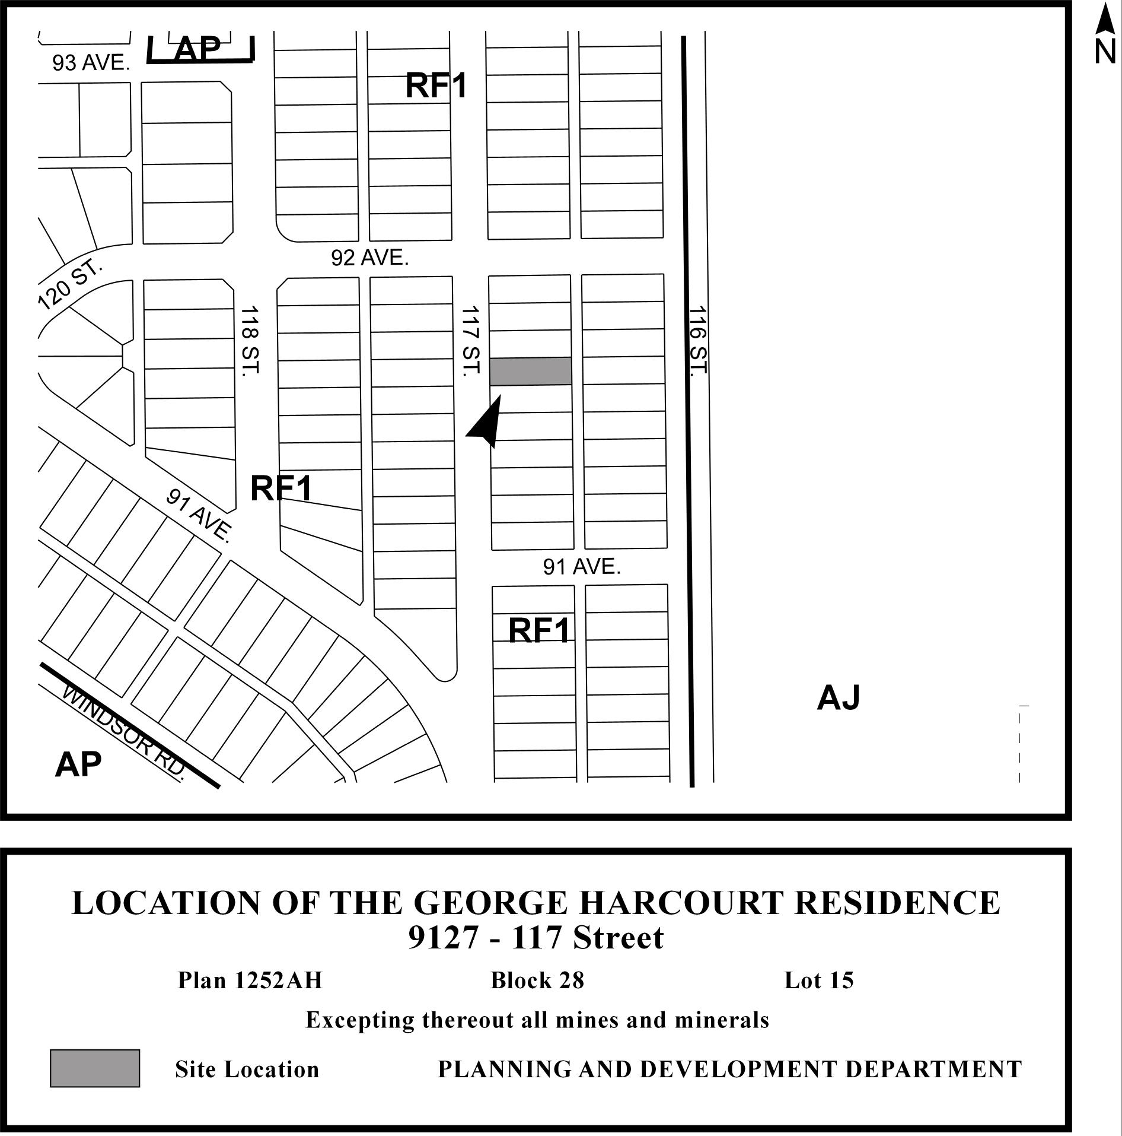

Photograph of the George Harcourt Residence

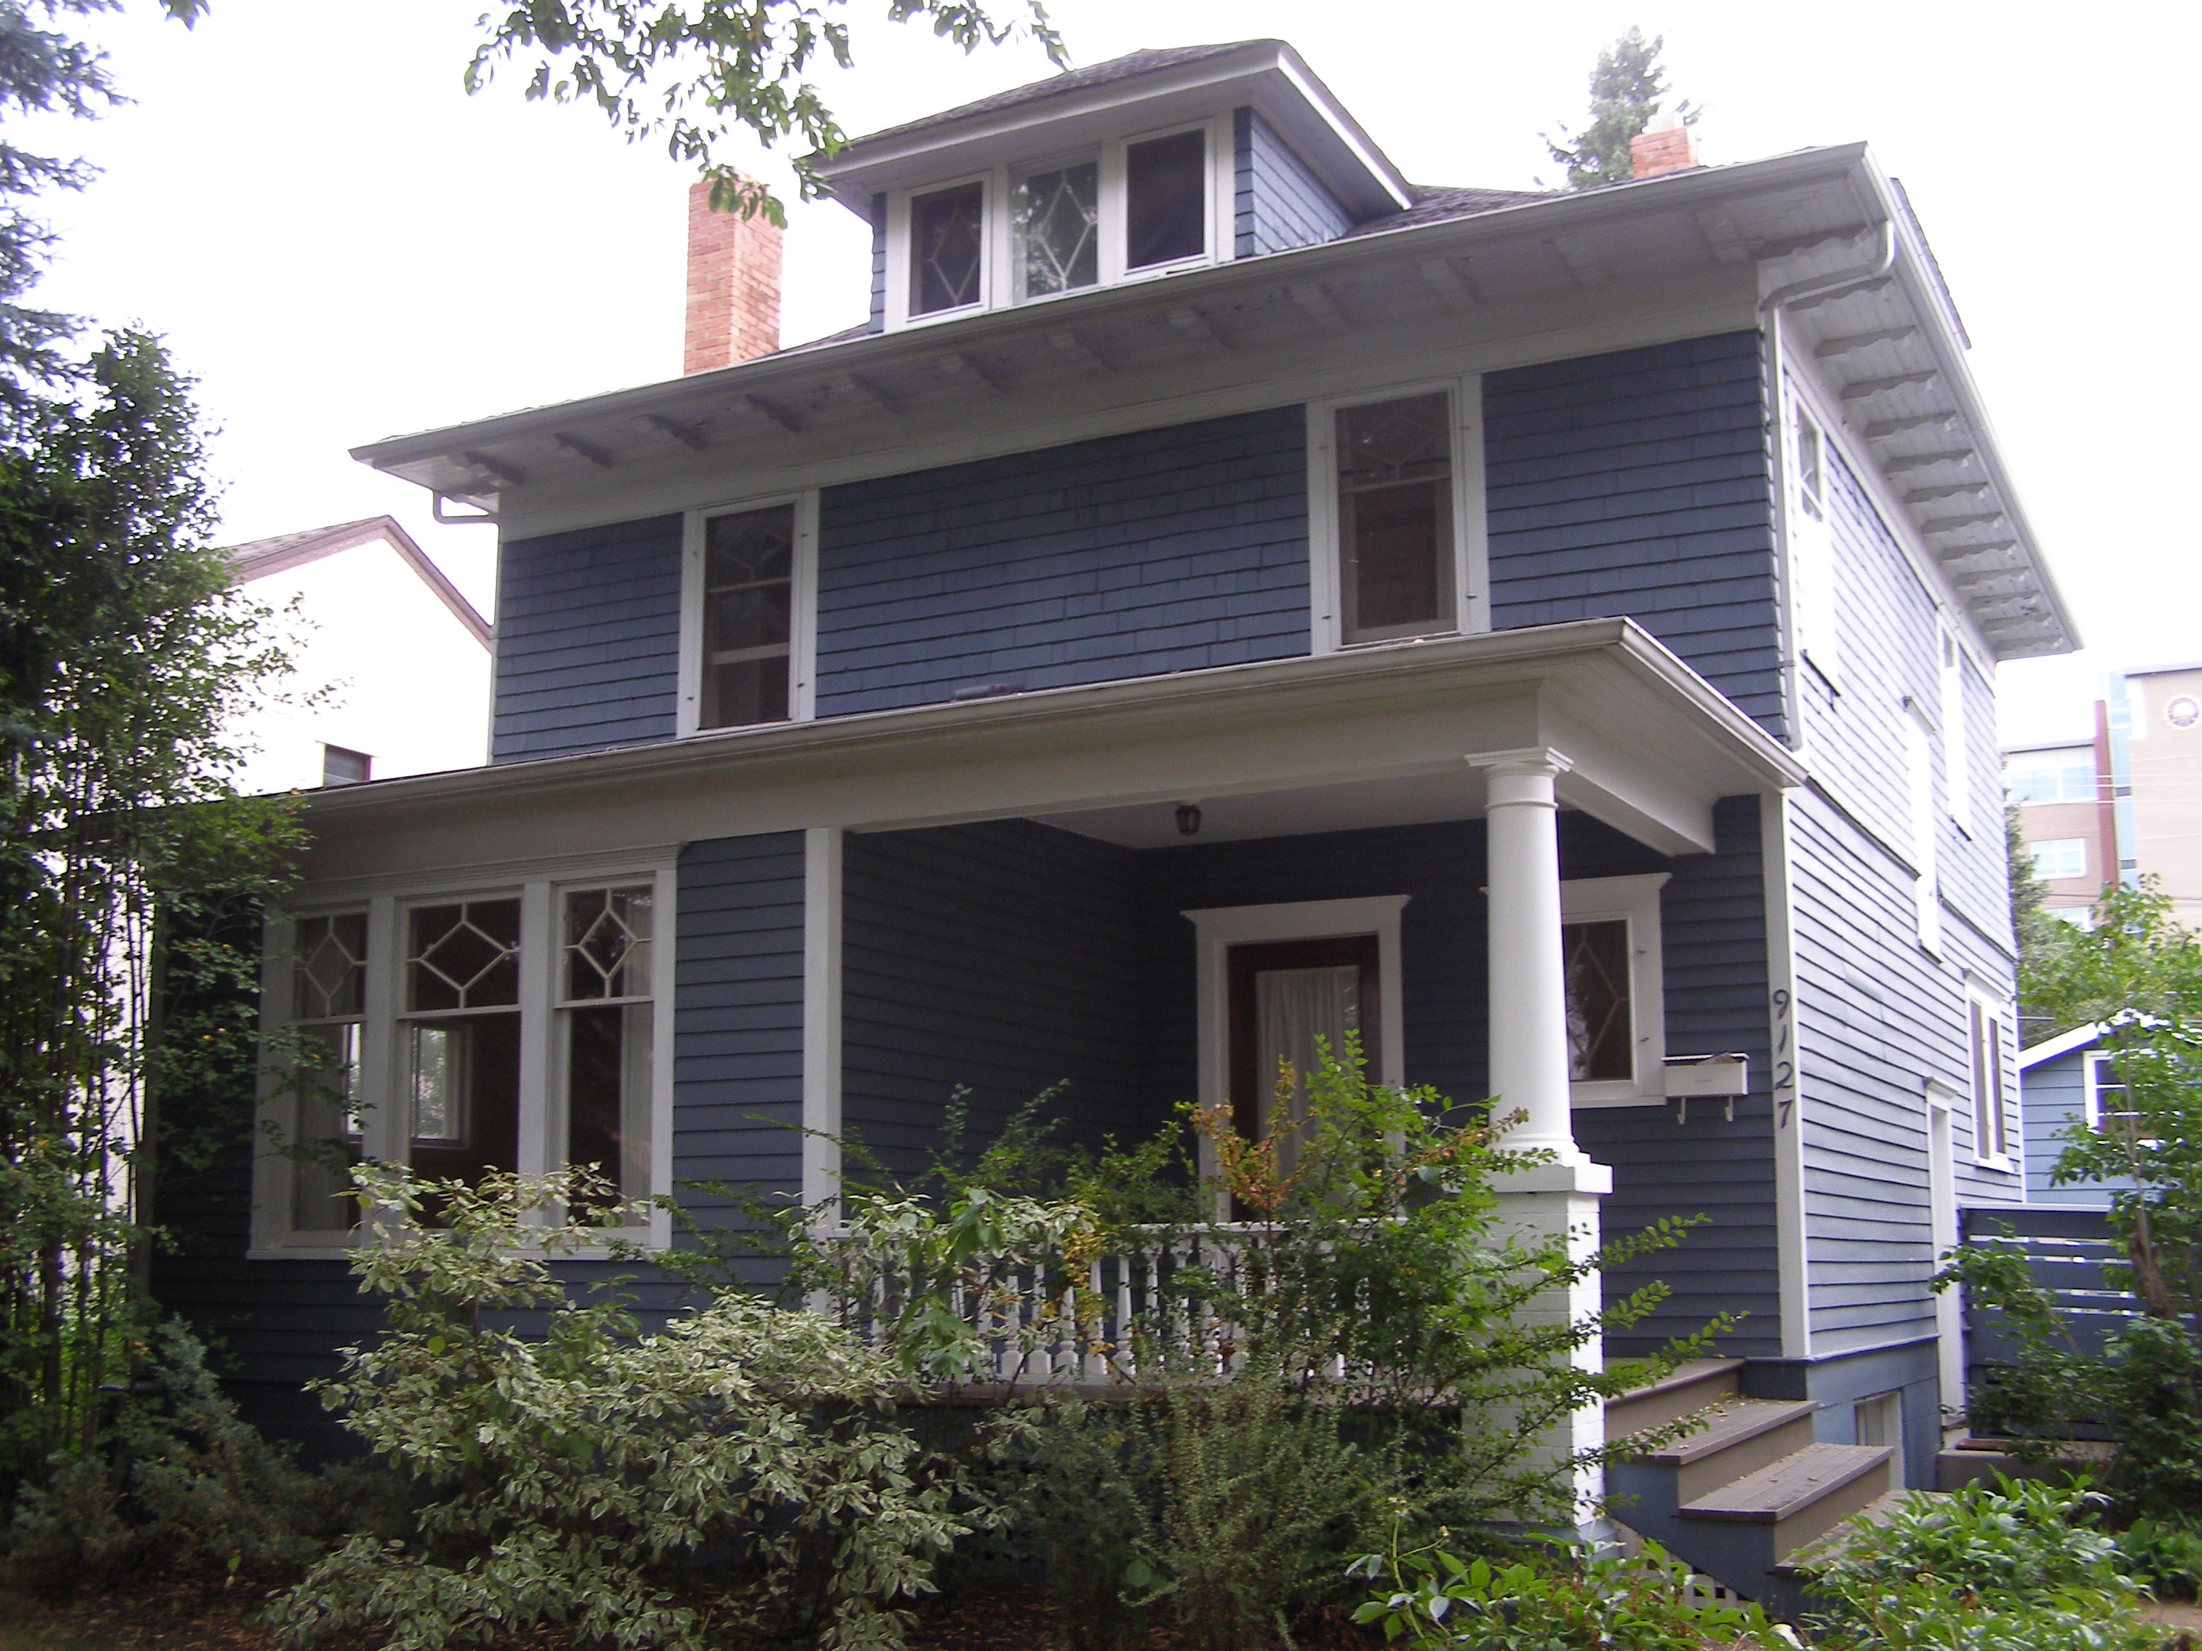

Heritage Planner’s Summary of Historical and Architectural Information

HERITAGE PLANNER’S SUMMARY OF HISTORICAL
AND ARCHITECTURAL INFORMATION

BUILDING NAME AND ADDRESS - George Harcourt Residence
9127 - 117 Street NW

STATUS

The George Harcourt Residence is currently listed on the Inventory of Historic Resources in Edmonton.

RECOMMENDATION

The George Harcourt Residence is recommended for designation as a Municipal Historic Resource because of its historical and architectural significance.

ARCHITECTURAL HISTORY

Style/Type

The George Harcourt Residence was built circa 1909 and is an excellent example of a large scale four square house. The house is 2 ½ storeys with a wood frame and roof structure.

Design

The George Harcourt Residence is a four square style house typical of Edmonton during the period of construction. The house features the typical characteristics of the four square style including a hipped roof with a hipped dormer at the front of the house. The house features wide overhanging eaves with decorative eaves brackets and is clad on the upper storey with cedar shakes and the lower storey with beveled wood siding. All of the windows in the house are wood framed and operate as single hung or casement (as in the case of the front dormer). The windows have a distinctive diamond pattern in the mullions at the top of the window. The George Harcourt Residence features two red brick chimneys; one chimney is exposed on the north façade of the house, while the other is only visible from the roof. The front of the house features a verandah supported by one ionic column.

Construction

The building was constructed upon a cinder block foundation and wood frame construction. The exterior cladding is cedar shake and bevelled wood clapboard. The house was constructed as a single family dwelling and follows the general floor plan of a typical four square house.

CULTURAL HISTORY

Historical Value

The George Harcourt Residence is historically significance for its association with George Harcourt and the development of the neighbourhood of Windsor Park.

George Harcourt was born in 1863 in Ontario and graduated with a B.S.A. from the Ontario Agricultural College in 1899. After graduating, he served as a Professor of Chemistry at Charlottetown College before coming to Alberta in the early 20th Century. In 1905, Dr. George Harcourt became the first Deputy Minister of Agriculture for the Province of Alberta. Harcourt held this position until 1915 when he was appointed to the newly formed University of Alberta Faculty of Agriculture. Harcourt was appointed the first Professor of Horticulture. Harcourt remained at the U of A until his retirement in 1935. Harcourt taught courses in horticulture at a basic level in his early years at the University. By 1927, Dr. Harcourt had further developed the degree program in agriculture from three years to a traditional four year degree program including three mandatory courses in horticulture. Harcourt also developed a series of test plantings around the university campus of fruits, vegetables and ornamentals. He ultimately developed and published lists of recommended plantings for Alberta. During his time at the U of A, Harcourt was a champion of the Vacant Lots Garden Program in Edmonton. This program was meant to encourage urban food production for residents of Edmonton during WWI and through the Great Depression.

The George Harcourt Residence is also historically significant for its association with the development of the Windsor Park neighbourhood. The Harcourt Residence was built circa 1909 and historic photographs show it as one of the earliest houses in the area. The Windsor Park District first appears in the Henderson’s directory in 1919 and Dr. George Harcourt is listed as a resident at 9127 - 117 Street NW during this time.

CONTEXT

Site

The George Harcourt Residence is located at 9127 -117 Street NW, on one city lot approximately mid-block between 91 Avenue and 92 Avenue in Edmonton’s Windsor Park Neighbourhood.

Neighbourhood

The George Harcourt Residence is located in the Windsor Park neighbourhood. Windsor Park was purchased for residential development in 1910 but remained largely undeveloped until after WWII. The George Harcourt Residence appears to be one of the older homes in the area. The origin of the name is unclear but it may have been named after Windsor, England or Windsor Castle, the only English castle to be continually occupied by royalty since the Middle Ages.

INTEGRITY

The overall integrity of the George Harcourt Residence is very high and the building includes the original cladding and windows. The house features its original form, scale and massing and the interior layout is typical of a four square style.

Description of City Funded Restoration Work on the George Harcourt Residence

Phase | Description of City Funded Work | Total Cost | Amount Allocated
1 | Roof: Remove and dispose of asphalt shingles and install new cedar shingles. | $27,833.00 | $13,916.50
2 | Windows: Remove and restore (strip, repair, replace broken pieces, reglaze, prime, paint and reinstall) 50 windows and storms (25 windows, 25 storm windows). Rebuild 3 replica windows to match the existing.  Doors: Construct two new historically accurate storm doors. | $108,223.50 | $54,111.75
3 | Foundation: Repair foundation wall, dig around foundation to install weeping tile and gravel to alleviate lateral pressure on foundation walls. Repair foundation floor and walls in basement where cracked. | $53,945.00 | $26,972.50
4 | Exterior Repair:  Cladding: Clean and Scrape all exterior cladding and repair or replace as necessary rotten cedar shakes or clapboard.  Soffits/Fascia: Repair water damage to all soffits and fascia as required. Replace rotted wood as necessary. | $19,700.00 | $9,850.00
5 | Exterior Painting: Clean, scrape and paint all facades and trim. Paint colours and type will be decided on in discussion with the Heritage Officer. | $25,000.00 | $13,750.00
6 | Chimney: Repair chimney to safe working order including repointing of brickwork. | $13,450.00 | $ 6,725.00
 | Sub total | $248,151.50 | $124,075.75
 | 10% Contingency(if necessary) | $ 24,815.15 | $ 12,407.58
 | Total | $272,966.65 | $136,483.33

Note: Should the owners receive restoration funding from the Alberta Historic Resources Foundation, the total grant will be reduced to up to 33%($90,988) of the total.

