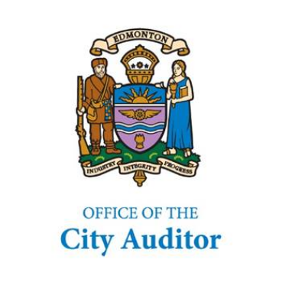

P3 Benefits & Risks
June 9, 2008



The Office of the City Auditor conducted this project in accordance with the International Standards for the Professional Practice of Internal Auditing
P3 Benefits & Risks
Table of Contents

Summary for City Council 1
1. Background and Introduction 2
2. Objective 2
3. Scope and Methodology 2
4. Observations and Analysis 3
4.1. P3 Definition 3
4.2. City of Edmonton Service Delivery Continuum 4
4.3. P3 Benefits 6
4.4. P3 Risks 9
4.5. Learnings From Research 13
4.6. City of Edmonton P3 Learnings 14
4.7. Guiding Principles for P3 Implementation 17
4.8. Moving Forward with P3s 21
4.8.1. P3 Maturity Model 21
4.8.2. City of Edmonton Maturity 22
4.8.3. A Sample P3 Framework 22
4.8.4. Enablers 24
4.8.5. Barriers 25
5. Conclusion 26
6. Bibliography 27

This page is intentionally blank.

Summary for City Council
At its December 18, 2007 meeting, City Council passed the following motion: “That the Office of the City Auditor, in conjunction with the City Manager, assess the use of P3s by municipalities and provide a report to Council advising of the benefits and risks that should be considered as part of P3 arrangements.” The City Auditor added the P3 project to the Office of the City Auditor’s (OCA) 2008 Annual Work Plan, allocating resources assigned to emerging issues. We prepared the report and have discussed it with the City Manager and members of the Senior Management Team.

After our initial review of relevant P3 information, we determined that P3s are strategic in nature and complex in application. As such, in addition to advising on the benefits and risks of P3s, we have expanded the content of this report to provide insight into what we believe are the key elements for the City to be aware of when considering P3 partnerships for the provision of public services.

P3s represent a fundamental shift in how the City can deliver services. It all starts with the overriding question:

Is the provision of public services through a partnership with private enterprise an acceptable service delivery model for the City of Edmonton?

If it is an acceptable service delivery option, then it is another alternative that the City can consider when determining the Optimal Service Delivery model for approved and prioritized municipal services. It is simply a service delivery option that can be appropriate to explore under pre-established conditions. The exploration requires due diligence and rigorous analysis to determine whether the P3 business case demonstrates best value for money and, as such, is the Optimal Service Delivery model to provide that service. This analysis should also consider additional criteria such as environmental, social, quality and safety considerations.

This report does not contain any recommendations. However, in the event that Council wants the Administration to consider P3 partnerships for service delivery, we believe that the creation of a Service Delivery Policy would be the natural next step. A Service Delivery Policy is necessary to confirm authority and intent for the Administration to consider P3s as a service delivery option. Such a policy would provide consistency and transparency, and need to ensure fairness in assessing, managing, implementing, and monitoring P3 service delivery projects.

We believe the information compiled in this report will assist Council in making an informed decision on whether P3s are right for Edmonton. If Council determines that they are an appropriate service delivery method, the content of the report will also assist the Administration with establishing a fair and transparent process to determine under what circumstances a P3 is the service delivery option that provides best value.

P3 Benefits & Risks

Background and Introduction
At its December 18, 2007 meeting, City Council passed the following motion: “That the Office of the City Auditor, in conjunction with the City Manager, assess the use of P3s by municipalities and provide a report to Council advising of the benefits and risks that should be considered as part of P3 arrangements.” The City Auditor added the P3 project to the Office of the City Auditor’s (OCA) 2008 Annual Work Plan, allocating resources assigned to emerging issues.

“P3” stands for Public Private Partnership. Public Private Partnership is a generic term for a “cooperative venture between the public and private sectors, built on the expertise of each partner, that best meets clearly defined public needs through the appropriate allocation of resources, risks and rewards.”

Objective
Initially our objective was to respond to City Council’s motion by providing a list of benefits and risks pertaining to P3 arrangements. However, after our initial review of relevant P3 information, it became clear that P3 use by municipalities is a complex and strategic issue, requiring consideration of more than just the risks and benefits of this service delivery model. As such, we expanded our objective to include reviewing and assessing the current knowledge and experience regarding the use of P3s by municipalities and other levels of government and to bring forward the key elements to consider if the City of Edmonton (City) decides to use P3s for service delivery.

Scope and Methodology
The scope of this project included researching available information that could provide a basis to identify the risks, benefits, advantages, and disadvantages of P3 methodologies. Our research included gathering and assessing information from a variety of sources from around the world as listed in the bibliography. In some cases, the references simply provided context and helped develop our perspective, while other references were incorporated into our report.

Our methodology included reviewing published information regarding P3s; gathering existing City policy, procedure, and practice information regarding capital projects; and interviewing City staff to gather insight and perspectives and to leverage their capital project experience.

We then integrated global best practices and City practices and experience to create a sample P3 framework for the City of Edmonton. This included engaging the City’s Senior Management Team to ensure that the sample P3 framework could work for the City. We also obtained feedback and input from an external P3 consultant on the completeness and applicability of the sample P3 framework.

Developing a City Policy and/or Administrative Directive regarding P3s was outside the scope of this project.

Observations and Analysis

P3 Definition
Public-Private partnerships are legal agreements which are generally long-term in nature (20-30 years). P3’s typically provide for partners disclosing and sharing risks, responsibilities, investments and rewards. Although a transfer in risk and investment may occur to the private partner, the public partner retains accountability for service delivery. In this relationship, the public partner controls the “what” and the private partner typically controls the “how.”

The City does not have its own definition of a P3. Generally such definitions would be developed and approved by Council and the Administration by means of a corporate policy and/or administrative directive. The most commonly discussed definition for the City is the one provided by the Canadian Council for Public-Private Partnerships:

A cooperative venture between the public and private sectors, built on the expertise of each partner, that best meets clearly defined public needs through the appropriate allocation of resources, risks and rewards.

Public sector experience with P3s is growing as is the interest in them from all levels of government. Governments are looking at innovative ways to address financing needs and internal resourcing issues. Some examples of P3 definitions of other organizations are as follows:

Government of Alberta: “A Public Private Partnership (P3) is defined as a form of procurement for the provision of capital assets and associated long term operations that includes a component of private finance. Payment to the contractor is performance based.”

Partnerships, British Columbia: “A public private partnership is a partnership arrangement in the form of a long-term performance-based contract between the public sector (any level of government) and the private sector (usually a team of private sector companies working together) to deliver public infrastructure for citizens.”

City of Ottawa: “Public-Private Partnerships (P3s) are contracts between government and private-sector partners that use creative approaches to enable the design, building, financing, operation and/or maintenance of facilities that serve the public.”

Partnerships Victoria, Australia: “Partnership projects bring public and private parties together for long-term mutual benefit. Partnerships focus on ensuring improved services to the community through the provision of better infrastructure.”

Within these various definitions there are several common characteristics. These common characteristics are useful in understanding the nature of P3s and are discussed below.

Alternate Service Delivery
P3s represent an alternative approach to the traditional method of internal and external sourcing of services. This alternative approach may not fit many of the City’s existing processes of planning, financing, and procurement.

Partnerships
An enhanced emphasis on partnership is a new approach to conducting business. These partnerships are based on win-win principles that require both parties to maintain and nourish a relationship of trust.

Risk
Under traditional service delivery methods, the public partner assumes the majority of risk with very little risk transferring to the private partner. P3s require a great deal of work to identify, quantify, and assign operational, design, and construction risks to the party who can best manage them. In developing P3s, an opportunity exists to transfer and share risk with a partner who may be better able to manage the risk.

Term of Contract
P3s generally include a long-term commitment by both parties, often as long as 30 years. A common approach used to protect both parties, is to negotiate contract terms for shorter periods of time, with renewal options. Generally, the renewal terms extend the overall contract to include at least one major rehabilitation of the asset.

Private Investment
P3s can be based on private partners providing investment capital to develop infrastructure projects and/or deliver services for which they expect to receive reasonable returns on their investment. Generally, the P3 partnership can be strengthened if the private partner has a vested interest.

City of Edmonton Service Delivery Continuum
The City has done considerable work in understanding P3s. Figure 1 is an illustration of the spectrum of service/project delivery options available to the City. As the City moves away from traditional service delivery models, it will transfer more operational risk and responsibility to the private partners. Associated with this increased private risk and responsibility is also increased private capital investment and expected return on investment.

Figure 1 – City of Edmonton P3 Continuum
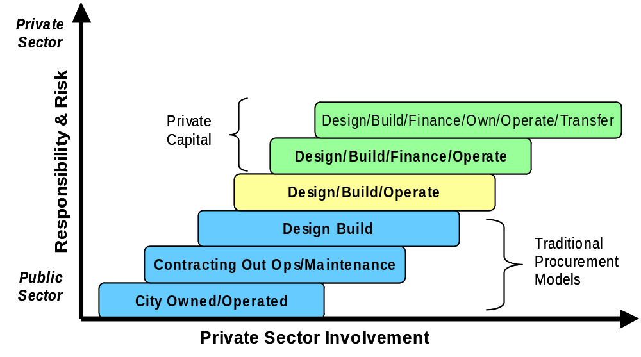
P3s
Source: Adapted from P3 Decision Process and Selection Criteria as presented to SMT December 5, 2007

Traditional Service Delivery Models
City Owned/Operated
Under this service delivery model, the City owns the assets and provides service delivery using internal resources.

Contracting Out Ops/Maintenance
Under this service delivery model, the City services are contracted out to an external service provider.

Design Build
Under this model, the City defines the service need and contracts with a private partner to design and build infrastructure in accordance with requirements set by the City. After completing the project, the City assumes responsibility for operating and maintaining the infrastructure. Under this model, the private partner only assumes financial risks associated with delivery of the project.

P3 Service Delivery Models
Design/Build/Operate
Under this model, the City defines the service need and the private sector designs and builds the infrastructure. Once the infrastructure is completed, the title may be transferred to the City. The private sector partner operates the facility for the contracted term and assumes the associated operational risks.

Design/Build/Finance/Operate
Under this model, the City defines the service need and the private sector designs, builds, finances, and operates the infrastructure under a long-term lease arrangement with the City. At the end of the lease term, the infrastructure is transferred to the City. The private partner bears the project and operating risks for the duration of the lease.

Design/Build/Finance/Own/Operate/Transfer
Under this model the City defines the service need and grants the right to the private sector to design, build, finance, and operate the infrastructure for a specified period after which the ownership is transferred back to the City. The City does not make any lease payments, but the private partner receives all revenues from the operations for the specified lease term and bears all the project and operating risks for the duration of the lease. Risk is highest to the private partner under this service delivery model as the private partner is reliant on revenue streams and subject to market conditions.

P3 Benefits
P3s offer a number of potential benefits to municipalities. We recognize that for each benefit outlined below there may be counter arguments around whether the benefit will or will not materialize. Our intent is to provide insight into each potential benefit through a short discussion of common benefits identified through our P3 research.

Value for Money

Consideration of a P3 requires rigorous financial and risk analysis and the development detailed business cases for alternative service delivery methods. Through this analysis the City will be able to demonstrate that the chosen service delivery model provides the best opportunity to achieve value for money. This required rigour improves the information available and supports the City’s decision, regardless of whether a P3 is the best service delivery option or not. This can promote transparency and accountability as interested parties scrutinize the City’s determination of the Optimal Service Delivery model.

Full Costing Information
The full costs of providing a service will be known or projected. To determine whether a P3 partnership offers the best value, the P3 business case requires that the full cost of capital, operating, and asset refurbishment to provide the service at the required service levels over the life of the partnership be weighed against the cost of alternative service delivery models. The evaluation is performed on a Net Present Value basis to ensure an “apples to apples” comparison. This provides the City with a complete picture of the true cost to offer this service.

Full life-cycle costing also offers predictability of costs and funding throughout the life of the partnership. In partnerships where the municipality makes annual payments, there is the additional advantage of spreading the costs of the investment over its life, improving its ability to match costs to service delivery.

Construction Cost Savings and Faster Implementation
Using a private partner can result in a shorter construction schedule, faster procurement, reduced interim financing, reduced overhead, and a reduction in the risk of cost and time overruns.

Operational Savings
Private partners may be able to reduce operating costs through specialized technology, sharing specialized labour, more flexible compensation arrangements, or other operational efficiencies.

Preserved/Improved Levels of Service
Economies of scale, access to new expertise and facilities, as well the introduction of new technologies may result in improved service offerings.

Risk Sharing
P3s encourage the transfer of some of the risks the City would typically assume alone. Analysing a P3 as an option requires risk identification, risk assessment, and optimal risk allocation. The idea is for each partner to leverage its strengths and offset each others’ weaknesses to offer an improved service. Typical areas where risks are shared include liabilities, cost overruns, market fluctuation, ongoing maintenance, weather delays, and environmental and regulatory compliance.

Financing Options
P3s represent an alternative form of financing for projects. P3s include the option of using private capital to finance the City’s infrastructure and in return the City must provide the lease payments through operating expenditures.

Enhanced Public Management
By allowing a partner to offer the service, City managers can spend more time planning and monitoring results as opposed to directly managing the service delivery.

Greater Performance Measurement
Service delivery performance specifications will be pre-established, monitored, and reported. The increased rigour and detailed analysis required to assess P3 opportunities results in performance standards being a mandatory part of the partnership. The operating aspect of the partnership is outcome based, requiring service delivery requirements to be determined early in the process. Since P3 payments are to be issued based upon performance, the key performance indicators must be regularly monitored, and reported on.

Increased Public Sector Revenues
Depending on the P3 delivery model chosen, increased revenue opportunities may result through increased property taxes, lease or franchise payments, or profit sharing agreements.

Enhanced Economic Development
A P3 may provide the City with the opportunity to offer services to other jurisdictions, attract international private investment, provide expanded lines of business to local businesses, enhance the quality and expertise of local labour forces, create a new business climate, improve rapport between the City and the commercial sector, and create exportable technologies. Through P3s, the City can offer investors a source of a steady revenue stream linked to secure contracts. P3s can also help to stimulate a stagnant local economy.

Innovative Solutions
Market competition to establish a P3 can encourage the pursuit to find more creative ways to offer a service more efficiently. Innovation can be the key component for improved service delivery for the City and profit for the private partner.

Realize the Value of Under-Utilized Assets
Under-utilized City assets may be used to their full potential. A P3 may offer new ways to utilize City assets during times when the assets may sit idle. Improved utilization of public assets can result from improved marketing and expanded service offerings.

Enhanced Facility Maintenance
P3 agreements can ensure that assets are properly maintained and meet specified conditions throughout the partnership, including the condition of the assets at the end of the partnership term. Private partners are motivated to maintain and protect the assets to extend their life and to invest in equipment and machinery that leads to increased efficiency and profit. At the end of the partnership, the City can rely on assets being at a pre-specified minimum condition.

Arms-Length Independence
Service delivery efficiency may be enhanced as the partnership is removed from political interference on a day-to-day operational level. Council’s interaction is critical in the identification of a service delivery needs and the setting of service expectations (program delivery) through Strategic or Master Plans. Authorization of the partnership and budget are also key touch points for Council, however, for day-to-day service delivery, Council’s role should be limited to normal corporate performance monitoring and oversight.

Improved Corporate Practices
At a strategic level, the rigour required to evaluate P3 options can be applied to assessment and pursuit of other City service delivery options. Improvements may include: identification and approval of service delivery priorities; identification of how to provide best value; identification and assessment of risks; and full costing for service provision.

P3 Risks
Our research indicates that discussion of risk and its effective allocation or sharing is a core consideration for P3 evaluation. We recognize that for each risk outlined below there may be counter arguments indicating how the risk will or will not materialize. Our intent is to provide insight into each potential risk through a short discussion of common risks identified through our P3 research.

P3 Value for Money
The Value-for-Money of P3s is based on long-term forecasted results. We did not find examples where the partnership went the entire duration and was concluded. Without this evidence it is not possible to conclude whether P3s represent an opportunity to obtain best value for public money. In our view, the value for money success of the partnership can only be determined once the partnership has been completed. P3s are publicized as successes because a partnership has been formed and is operating. The ultimate determination of value for money success however, will not be confirmed for years into the future.

The question of whether P3s are worth the effort remains unanswered. A KPMG survey of Canadian government executives reported “Although 53 percent of Canadian Executives surveyed had already implemented some form of partnerships with private sector, and 18 percent intend to do so in the next two years, only 2 percent believe that greater private-sector involvement will actually help improve public service efficiency.”

Loss of Control
Depending on the terms of the partnership and the level of detail in and enforcement of performance specifications, the City could lose direct control over the types of services offered, service levels, timing and pricing.

The City may also lose flexibility to adjust its service offering with a P3. In the event of an economic downturn or change in service need, the City’s ability to downsize or adjust the service need may be restricted due to a commitment made in the P3 agreement.

Confused Lines of Accountability
The City may continue to be seen as accountable to the public for the services offered, even though the services may be the responsibility of the private partner. This may require the City to increase resources to address public concerns and ensure that the partner is fulfilling its contractual service requirements.

Corporate Capacity to Partner
The City must consider whether it has the resources and expertise to explore, pursue, and actively manage a partnership. Each phase of the P3 process commands significant time and effort that requires full-time dedication. The investment of time and effort to complete the rigorous analysis required to explore P3 options must be carefully managed and accounted for, even though the ultimate result may not favour a P3. Typically a team of various subject experts (project management, finance, legal, and operations) will be brought together to explore a P3 opportunity. As the City matures and gains expertise regarding P3s, it may require organizational structure changes, such as the creation of a P3 office, which leverages these specialized skill sets to maximize P3 opportunities.

Increased Citizen Costs
Users may face increased costs to use City services. Since the City does not typically set user fees at a level that will fully recover the costs of providing a service, entering into a private partnership may result in higher prices for the end user.

Taxpayers may face increasing tax levy burdens as City costs to manage and monitor the contract increase as well as covering the costs for conflict resolution when issues arise. The City should pay special attention to programs requiring user fees to ensure that fees are not so high that they exclude certain segments of society.

Loss of Municipal Jobs
City employees may face job losses or changes to their job descriptions. This may strain relationships with the unions and affect service offerings outside of the service delivery being offered by the P3.

Service Interruption
Business related issues facing the private partner could result in service interruptions (e.g., labour issues, bankruptcy or breaking the contract). The City must have a business interruption plan to ensure that services continue to be offered.

Limited Competition
The City must be cautious not to replace a public monopoly with a private partnership monopoly, potentially nullifying many advantages of the partnership. Increased process efficiency can come at the cost of open competition as partnerships provide ease and speed to expand service offerings.

Where bidding processes are used, P3s may result in decreased competition as it is expensive and time consuming to prepare a P3 bid. To address this, it is becoming more common to issue payments to unsuccessful bidders to offset their bid preparation costs in an attempt to encourage sufficient competition.

Decreased Service Quality and Efficiency
As private partners are motivated to ensure a reasonable rate of return on investment, they may be motivated to reduce costs at the expense of the program offering, service quality, preventative maintenance, or even public safety. The City, on the other hand, generally has implied or explicit goals addressing social benefit programs, public access, safety, and service delivery. The City must be an active partner to ensure service delivery standards are met and the asset is protected while allowing the partner to earn an acceptable return on its investment.

Limited Control over Public Policy
City standards such as equal opportunity employment, levels of service, or guaranteed minimum wages may be compromised. Imposition of City policy would likely be seen as a barrier to the private partner’s flexibility and would come at a cost.

Long Term Commitments
P3s are generally long term partnerships with durations of 20 to 30 years. Longer contracts increase the risk of legal disputes, service interruptions, and the gradual elimination of in-house expertise in delivering the service. A critical part of the P3 business case is to accurately forecast the service delivery requirements over the duration of the partnership. It is unlikely that either partner will be able to accurately forecast citizen expectations that far in the future, creating the need to build flexibility into the partnership agreement. Without some degree of flexibility, the ability of future Councils to influence the service delivery will be reduced.

Budget Approval
The budget process for P3s requires the integration of both capital and operating budget components. Currently, City Council approves funding of infrastructure projects through the Capital Budgeting process and the funding of operations related to the infrastructure based services through the Operating Budget process. P3 budget approvals include full life cycle costing figures (both capital and operating) that will significantly exceed the amounts Council is accustomed to authorizing for similar projects using more traditional delivery methods.

Financial accounting and reporting of P3 arrangements are dependant on the contract negotiated. These arrangements are generally financing in nature, resulting in a long term commitment reported in the financial statements. Approval of a P3 project should comply with regulations under the MGA for borrowing as well as additional requirements outlined in the City’s Debt Management Fiscal Policy.

Perception of Bias in the Selection Process
Favouritism is a common concern about the partner selection process. P3 procurement differs from the typical City procurement process in that there may be trade secrets or competitive advantage information that must be protected as potential partners strive for innovative service delivery. This protection of information may cause the perception that the City is compromising its obligation for fair, open, accountable, and objective procurement practices.

Transfer of Assets
In the event that the partnership is structured so that the City owns the asset at the end of the contract, the risk arises that appropriate ongoing and preventative maintenance may not be performed in an attempt to decrease the partner’s costs. Also, the transition of service provision could impact the public as some changes will likely occur.

Confidential Information
Entering into a partnership requires that both parties have access to privileged and confidential information. Safeguards must be in place to ensure that confidential information is safeguarded and that applicable privacy legislation is adhered to.

Project Risks
Much of the guidance we reviewed also provided the following specific project risks that the municipality should consider as part of its risk identification, assessment, and allocation exercise. Many of these risks exist whether the project is completed as a P3 or not.

- Site risks - Standard insurable risks
- Design, construction and commissioning risk - Contractual risk
- Delayed completion or start up date - Failure to supply product or service
- Directors’ and officers’ liability - Insufficient demand
- Environmental liability - Financial
- Labour relations - Employment practices liability
- Technology risk - Force Majeure
- Business interruption - Bankruptcy of partner or subcontractor
- Inflation or currency fluctuation - Permit compliance
- Residual value of asset - Market risk
- Operating and performance risk - Political risk

Council Political Risk
There is a political risk to members of City Council. Support for P3s varies around the world as reports of failures and successes are published and hotly debated. The key to assessing and managing this risk is to actively engage the citizens with a focus on determining priority service needs. Once the service delivery need has been determined, citizen engagement should evolve from consultation to providing appropriate information. The City should then determine whether to deliver that service through a P3 in a publicly transparent way so citizens can be assured that their dollars are used to obtain the maximum value.

Question of meaningful risk transfer
There is debate about whether any meaningful risk transfer actually occurs through a P3 if the City is ultimately responsible as a result of a partner’s insolvency. There are many examples where governments have had to step in and cover the remaining costs of a P3. A report from bond rating agency Standard and Poor states: “If a government were to guarantee a PFI [Private Finance Initiative] in part or in full, this would unambiguously signal an incomplete transfer of risk to the private sector and the contracted debt would be consolidated within the government…”

Learnings From Research
Our research found that the maturity of the P3 concept varies around the world. In Canada, the Federal Government has recently announced plans to establish a $1.25 billion Public Private Partnerships Fund and committed $25 million over five years to establish a federal P3 office.

In our attempt to find out how other municipalities considered P3 opportunities, we looked for established policies and found only a few municipal policies. We then expanded our research to other levels of government and did find guidance from some Canadian Provinces and the Federal Government. We also reviewed a number of reports from a variety of consulting firms and special interest groups to help us understand how a municipality should best explore P3s as a service delivery option.

While the individual policies and guidance vary by source, there are some consistent threads of guidance to consider.

Support from Council to engage in P3s for service delivery
Public service delivery through private partnerships has both proponents and opponents. The decision of whether P3s are philosophically acceptable for the City of Edmonton is a political one. The consideration and exploration of P3s as a service delivery option is a time consuming and rigorous exercise. Without Council providing high level support for the Administration to evaluate this delivery option, significant time, energy, and money may be wasted. The political issues should be resolved and Council should clearly articulate whether this service delivery option is suitable for the City before the Administration gives it any further consideration.

Citizen communication and consultation
Citizen acceptance and support for private delivery of public services is critical to a successful partnership. Active consultation prior to any P3 considerations can provide Council and the Administration with information to determine whether P3s are seen as an acceptable use of taxpayers’ money. In the event that P3s are determined to be acceptable, the City needs to consult with citizens to determine service delivery needs and priorities. Once the need has been confirmed, the communication changes from consultation to providing information as the City works to fulfill the service need. This helps to clarify the citizens’ role and allows for a more streamlined implementation process as the service delivery needs are defined early and remain constant throughout the project.

Need for a policy
Some municipalities have created Policies specific to P3s. In our view, this is too narrow a focus for a Council Policy. We believe that an overriding policy around an acceptable framework for the City’s service delivery models, of which P3s may be one, would be more appropriate. In the event that P3s are acceptable for the City, it is imperative that an Administrative Directive be established to provide clarity and consistency as opportunities are explored. The creation of a Directive and its accompanying Administrative Procedures will require a significant investment in time and resources as the entire P3 process is complex and many of the processes will be new for the City. Fortunately, policies and guidance from other municipalities can serve as an initial reference point and then be adapted for the City’s specific purposes.

Need for a mechanism to address unsolicited proposals
In the event that P3s are acceptable for the City, it needs to publicly indicate to the market that the City is willing to partner with the private sector to provide public services. While the City will establish a consistent process to identify and evaluate P3 opportunities, private sector companies may come forward with unsolicited proposals to use their expertise to help the City address a service need. The P3 Administrative Directive must include guidance on how these proposals will be assessed in light of the City’s approved priorities. Publicly stating how unsolicited proposals will be handled beforehand will confirm the fair, open, and competitive nature of P3 evaluations.

Government retains service delivery responsibility
A P3 does not replace government responsibility. The Province of Nova Scotia provides this statement to its municipalities: “Under no circumstances should PPPs be seen as a substitute for strong, accountable, and effective governance. Ensuring that the services are provided in a manner that is fair, affordable, safe, and environmentally friendly, remains the exclusive responsibility of the municipality.”

P3s require significant effort and time
Proponents of P3s often promote speed as a benefit of P3 partnerships. However, the time and investment of resources to develop effective P3s is significant. Our illustration in Figure 2 provides a general sense of the timelines applicable to P3s. Significant time and effort is required in all stages including exploring, pursuing, implementing, managing, and concluding a P3 partnership. To illustrate further, the Partnerships Victoria Policy includes the following timelines:
Project Planning Stage 12+ months
Project Tendering/procurement 12-18 months
Design, Construction & Commissioning 24-36 months
Operational Service Delivery 20+ years
Contract Expiry or termination 6-12 months

City of Edmonton P3 Learnings
During this project we met with City staff who have experience in implementing and managing various forms of P3s. Following are the key learnings from these discussions.

P3 Definition and Process
As discussed earlier, the City has not formally defined what P3s represent or mean to the City. Most staff recognize that P3s are about partnerships with the private sector, but some staff members also believe that not-for-profit partnerships are legitimately classified as P3s. Similarly we heard varying rationales or objectives as to why the City should seek out P3s. Most staff discussed P3 objectives as risk sharing and also as an opportunity to get private investment into city projects. These varying definitions support the need for clear direction and evaluation processes if the City wants to consider P3s.

P3 Decision Framework
A significant amount of work has already been performed by the Administration in developing a P3 Decision Framework. This Framework was presented to SMT on December 5, 2007 and identifies a model for selecting and implementing P3 opportunities. We believe this framework is a good start in moving the City forward in selecting and implementing P3s.

P3 Ventures
The City has had some experience and success developing various forms of P3s. Following are examples provided to us through our meetings with City staff:

- Waste Management Composter – The Composter was built, financed, maintained and operated by TransAlta Utilities from 1994 to 2001. During this period, the City successfully partnered with TransAlta. The Waste Management Branch assigned a liaison to work with TransAlta staff during construction and operation of the composter. Both parties saw the need for this one primary contact and the partnership worked well. Several years later the Waste Management Branch had more staff on site partnering and learning the operations. In December of 2000 TransAlta decided to divest of this venture and put the operation up for sale. The City made a successful bid and took back the operations. Having staff on site and working with the private partner was a good strategic move because the City was well-positioned to assume operations. Several lessons were identified from this experience:
a) You can never be entirely certain that your P3 partner will not change their business focus and divest. This is an ongoing P3 risk for which the City would need to be prepared.
b) Having a primary contact or liaison is important to monitoring the performance of the P3 and also to transfer knowledge. This decision proved to be an effective mitigation strategy for the divestment risk.
c) It is a necessity for the City to have and make available the proper resources to devote to P3 evaluations and negotiations.
d) The City must allow sufficient time to negotiate P3 agreements. The agreements are complex and require considerable staff time and the private partners also need time to fully understand the implications of the proposed agreements.

- Kinsmen and YMCA Recreation Centres – The City has brokered several successful partnerships with the Kinsmen Club as well as the YMCA. Although these groups are not-for-profit, they demonstrate the City’s ability to partner with other groups, seek outside investment, and manage external relationships to meet citizen needs. Reported lessons from these partnerships include:
a) The City has the skill sets to broker deals with outside parties and attract outside investment.
b) There is a risk appetite within the City’s culture to seek out new opportunities and do things differently.
c) Long term partnerships to meet citizens’ needs are possible.

- Southwest Recreation Centre – After many months of preparation by both the City and the private proponent, a workable partnership could not be established. This does not signify failure, since a significant learning opportunity was created for the organization. After careful consideration and analysis of both tangible and intangible factors by the City as it calculated the Public Sector Comparator, the Administration recommended to Council that this was not the right service delivery model for this project. City staff identified the following lessons:
a) Let the process work and recognize that reaching a deal is not the objective; rather, identifying the best service delivery option should be the objective.
b) P3s require substantial negotiations. The procurement process needs to be flexible to accommodate these negotiations.
c) The P3 process required considerable time of staff members who were already busy with their regular duties. Staff gained knowledge from involvement in this project that should be leveraged for future P3 endeavours. It is important for the City to have and make available the appropriate level of committed resources to devote to P3 projects.

Criteria for Successful P3s
City staff also provided the following insights and general comments for successful P3’s from their current learnings:
- It is important that we define our needs first then decide how best to deliver the services to meet those needs.
- We need to be sure we are not taking on all the risk. We need to be clear in what risk we bear and what risk the private partner bears.
- Do not tie the hands of our partner. They will seek out additional revenue streams and if we overly restrict them, we limit their opportunities.
- Contracts need to be specific so that we can enforce construction, maintenance, and operating standards. In particular we need to clearly specify how much public access is required and how much subsidy the City is prepared to provide.
- Market timing must be right for P3s to work. There is currently too much opportunity for private firms on other projects for them to easily accept the risk of P3 ventures. Without capacity in the marketplace to take on additional work there is less aggressive bidding and subsequently less willingness to accept risk. If we take on all the risk, then don’t bother with a P3.
- Standard processes are necessary to better handle the P3 process.
- We need a dedicated P3 team. Our partners are also looking for experienced staff to work through these deals. If we lose their confidence they may not come back to look again.
- One of the keys to P3s is to get the right outside help. We are new to P3 agreements and we need help on how to prepare and broker P3 agreements.

Guiding Principles for P3 Implementation
Through our research and interviews with staff we have identified several guiding principles for successful P3 implementation within the City.

1. Accountability
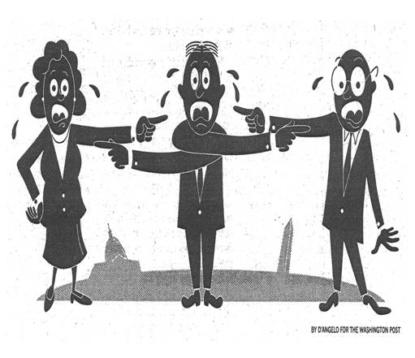 | The City must retain full accountability throughout the life of the P3 agreement including:  - Protect the City’s interests during P3 project selection.  - Oversee project development during design and construction.  - Enforce contract compliance during the life of the P3 agreement.  - Enforce service delivery to the identified performance standards within the agreement.  - Ensure smooth transfer of assets and services at the end of the P3 agreement.

2. Transparency
 | The City should ensure that all P3 projects have open and transparent processes:  - During selection, management, and conclusion of P3 projects.  - By demonstrating adherence to existing City policies and procedures.  - By demonstrating adherence to external legislation such as the Municipal Government Act and agreements such as the Agreement on Internal Trade.
3. Screening Potential Projects
 | The City should use a checklist of conditions to determine whether partnership with the private sector should be considered for a given project. These conditions will include such criteria as:  - Project cost is significant enough to warrant the effort.  - Risk allocation opportunities exist  - Private interest exists in forming partnerships  - City’s ability to manage performance-based contracts.  - There is historical evidence of successful P3s for similar projects.  - There are no legal or regulatory impediments.  - Public acceptance of project is likely.  - Bundling of design, build, operate, and finance will likely result in cost savings.

Note: The current P3 Decision Framework developed by the Administration already includes these criteria for screening potential P3 projects.

4. Communication
 | The City must ensure all major stakeholders are kept informed throughout each P3 project. Communication is a key to successful project management and to maintaining open and trusting relationships.  - Issues must be identified and discussed early.  - Community acceptance is essential and a plan is necessary to get community input at the right times.  - Effective communications will increase buy-in for all stakeholders.

5. Responsibility and Approvals
 | The City should assign responsibility for the P3 approval process and for P3 implementation.  - The City should assign staff responsible to seek out P3 opportunities, develop business cases, prepare and evaluate market proposals, and implement and manage P3 agreements.  - City Council and City officials must review and approve or reject P3 opportunities presented.
6. Value for Money (VFM)
 | The City must ensure that Value for Money (VFM) is demonstrated when choosing to proceed with P3 proposals. Optimizing VFM is the driving force behind identifying alternative service delivery models such as P3s.  - Demonstrate VFM by evaluating the cost of public delivery against private proposals submitted.  - All proposals include full life-cycle costing that includes identified risks and costs assumed (see Figure 2). Life-cycle costing includes the identification of all costs including design, build, operations, maintenance, and risk costs.  - All costs are expressed in Net Present Value terms for comparison. Net Present Value is the discounted valuation in present day dollars of all these life-cycle costs. Through this type of financial analysis, the City can perform a fair comparison of multiple options with varying life cycle costs and determine the best financial option (See Figure 3).

Figure 2 - Life-Cycle Costing Analysis in Demonstrating VFM
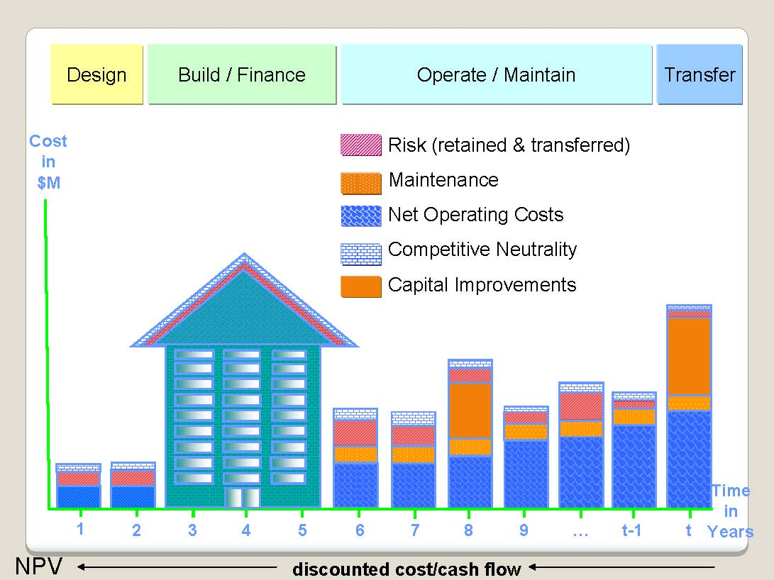
Source: Adapted from presentation to COE on May 6, 2008 by J.R. Huggett Co. (Innovation in Project Delivery)

Figure 3 Comparing Multiple Proposals
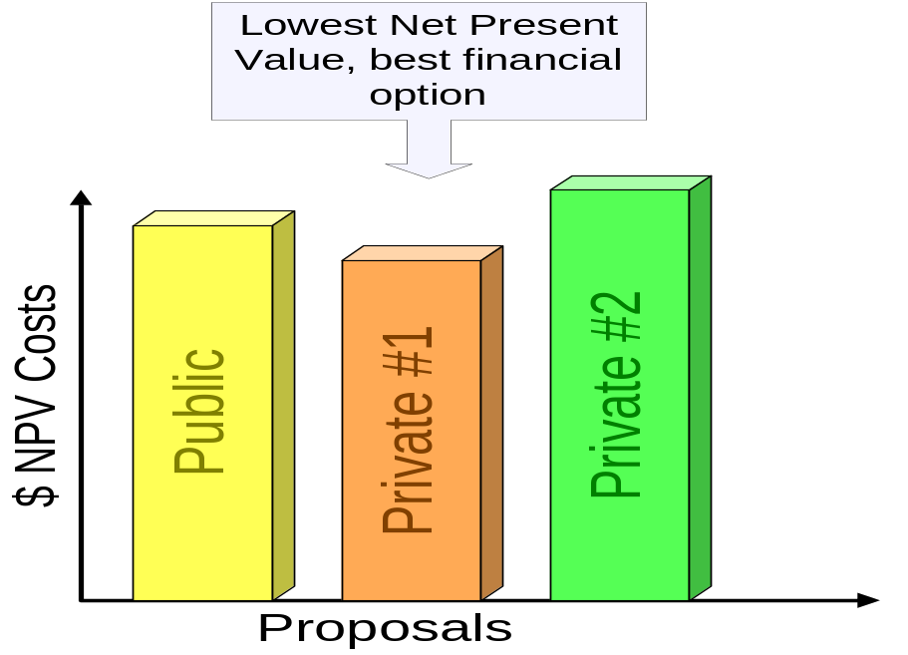

7. Additional Assessment Criteria
 | The City should use additional assessment criteria to the VFM assessment in determining the optimal service delivery method. A weighted evaluation is necessary in which these additional assessment criteria and the financial assessment (VFM) are used to determine the best option. Additional assessment criteria to consider are:  - Proponents’ experience in providing projects and services.  - Innovation presented by the proponent.  - Quality of proposal.  - Industrial relations.  - Public interests (Access, Safety, Privacy, and Quality).  - Broader economic benefits.  - Environmental and social benefits.  - Solvency and financial health of proponent

8. Win-Win Objectives
 | The City must always maintain a win-win objective throughout the P3 partnership.  - All negotiations must be conducted in good faith with the aim of a win-win result.  - On-going P3 management must recognize the need for both parties to win and that adjustments may be necessary.  - Be fair; long-term relationships will only endure in a win-win scenario.

Moving Forward with P3s

P3 Maturity Model
The City is currently challenged with the task of blending a P3 business model with existing project and service delivery models. Through our research we have learned that many organizations have evolved to higher levels of sophistication in managing P3s. Following is a maturity model developed by Deloitte Research that illustrates the developmental path in the use of P3s.

Stage One
- Establish a policy and legislative framework.
- Initiate central P3 policy to guide P3 implementation.
- Develop deal structures.
- Get transactions right and develop public sector comparator model.
- Begin to build marketplace.
- Apply early lessons from P3s successes to other projects.
Stage Two
- Establish dedicated P3 units within the organization.
- Begin developing alternative service delivery models.
- Expand and help shape the P3 marketplace.
- Leverage new sources of funds from capital markets.
- Use P3s to drive service innovation.
- P3 marketplace gains depth – use is expanded to multiple projects and sectors.
Stage Three
- Refine new innovative models.
- More creative, flexible approaches applied to roles of public and private sector.
- Use of more sophisticated risk models.
- Greater focus on total lifecycle of project.
- Sophisticated infrastructure marketplace with pension funds and private funds.
- Public sector learns from private partner methods as competition changes the way government operations function.
- Underutilized assets leveraged into financial assets.
- Organizational and skill sets changes in government implemented to support greater roles of P3s.

City of Edmonton Maturity
While we believe the City is at Stage One of the P3 Maturity model, the City has several key strengths we believe can be leveraged to move forward if Council determines that it wants to pursue P3 relationships.

1) Experience in Building Partnerships: The City has extensive background knowledge and experience in working with partners such as the YMCA, Kinsmen Club, and others in joint ventures. This experience in developing these partnerships could be leveraged for P3 partnerships.

2) Community Consultation: P3s would require significant public consultation to build confidence and buy-in. The City is experienced in conducting community meetings and other forms of public consultation.

3) Direct P3 Experience: The City’s overall P3 experience is limited, but the City does have some experience that can be leveraged. The recent work on the Southwest Recreation Centre opportunity furthered the knowledge base to help assess P3 proposals. The City also has experience in managing and assuming a P3 project through their partnership with TransAlta and the City’s Composter.

A Sample P3 Framework
In the event that the City moves forward in the consideration of P3s, they should develop a high level framework or model that identifies how P3s will be implemented within the City of Edmonton. Figure 4 (next page) is a sample P3 Framework that integrates P3 theory with the City’s practices.

Figure 4 - Sample P3 Framework
Phase | City Administration Role | Council Role
1 | P3 Opportunities  Identification of potential P3 projects through City Business Planning processes such as:  - Capital and Operating Budgets  - Infrastructure Plan  - Transportation Master Plan  - Other Major Plans | Approve Strategic and Master Plans  Approve Capital and Operating Budgets
2 | P3 Business Case  Preparation and presentation of the business case, which provides direction on the optimal service delivery model.  - Market sounding to determine private sector interest  - High level business case preparation  - Public Sector Comparator (PSC) calculation, which includes life-cycle costing and net present value comparisons (estimates) | Consider evaluation of the Optimal Service Delivery Model  Approve pursuit of P3 when it is the best model
3 | Procurement  The Administration will engage in formal procurement practices including:  - Request for Expression of Interest to test private interest  - Request for Proposal for detailed bids from proponents  - Re-evaluate Public Sector Comparator with new information from bids  - Perform multi-criteria assessment of bids  - Negotiate on behalf of the City | Approve borrowing, if necessary  Approval of contracts that exceed signing authority level identified within City Administration Bylaw.
4 | P3 Implementation  - Administration will work with private partner to ensure infrastructure meets identified specifications.  - Administration will monitor performance of service delivery and report results to Council on an ongoing basis. | Perform oversight role in monitoring performance of service delivery throughout the P3 agreement.
5 | Transfer  The Administration facilitates the transfer of assets and services at the closure of P3 agreement, including:  - Premature contract terms where the P3 agreement is broken sooner than expected.  - P3s ending as stated in the P3 agreement. | Approve new service delivery options:  - Another P3 agreement  - Traditional service delivery

Enablers
The maturity model presents several insights into what must be done to evolve through phase 1 into phases 2 and 3. Following is a discussion of some of the key enablers we believe are necessary if the City chooses to move forward towards best practice in P3 implementation.

Council and Senior Management Support
A fundamental first step in moving forward in the implementation of P3s is to ensure that both Council and Senior Management support Public-Private Partnering. The creation and endorsement of a complete P3 framework is the critical first step towards confirming support for the consideration of P3s as a service delivery option.

Develop a P3 Policy and/or Administrative Directive
We believe that the Administration should work with Council to prepare a Service Delivery policy which would include P3s as one of the City’s service delivery options. The Policy would define what P3s represent to the City and detail the expected process, roles, and responsibilities. The policy would then need to be supported by an Administrative Directive that should be kept simple and flexible since it will be necessary to make adjustments along the way. A Directive that is too tightly written will hamper the P3 process and its likelihood of success. Detailed Administrative Procedures would then guide the many stages of P3 consideration and execution.

Start with smaller P3 projects
While contradictory to typical P3 definitions or promoted philosophies, selecting smaller P3 projects can offer as much opportunity to learn about P3s as large projects. More importantly, the growth mistakes will also be smaller.

Potential P3 Office
The City should consider the creation of a designated P3 office at some point in the P3 maturity progression. The P3 process is fairly complex and a dedicated office would have the advantage of serving as a knowledge base to lead the corporation through these equally complex decisions. There are many unique skill sets required to develop P3 partnerships such as negotiation, marketing, communications, and project management. Consolidating and building on these skill sets is an effective approach to advancing the knowledge and expertise in P3s and will ensure that staff resources are dedicated to these initiatives rather than pursuing P3s from the “side of their desk.”

Learn More
It is incumbent on the City Administration and Council to learn more about P3s if Council determines that they are an acceptable service delivery option. P3s represent a fundamental shift in how governments currently conduct business. The more the City learns, the better its P3 selections and the results of its P3 partnerships.

Barriers
Equally, there are barriers to successful P3 implementation that need to be recognized and addressed. Following is a discussion of some of the key barriers we believe that the City must address if it moves forward towards best practice in P3 implementation.

Culture
Implementing P3s represents a fundamental shift in how the City will conduct its business and must be based on a thorough understanding of opportunities and risks. P3s represent a partnership in sharing both opportunity and risk. Governments tend to be very risk adverse in their stewardship of public money and this conservatism is typically engrained in their culture. To be successful in P3 partnerships, the City culture needs to evolve to be better brokers of opportunity and risk management with the goal of ensuring that public monies obtain the best value.

Delegation of Authority
Brokering P3 arrangements will require the ability to negotiate freely and in a timely manner on behalf of the City. Appropriately controlled, yet streamlined processes will facilitate timely exploration of P3 opportunities and encourage potential private partners to assist the City to obtain best value.

Marketplace Maturity
The P3 marketplace may not be responsive or ready to address the City’s P3 opportunities. Markets may need to be fostered and developed over a period of years.

Marketplace Patience
A major concern expressed by both internal staff and consultants is that the City only has a limited number of chances to get these deals right. The market will have limited interest if the City processes make it difficult, lengthy, and expensive to explore and enter into these arrangements.

Learning Process
Developing successful P3 partnerships will be an evolving process which will be built on the City’s learnings from P3 projects. Demonstrating the success of P3s will require patience on the part of both the Administration and City Council.

Conclusion
This report was prepared by the Office of the City Auditor in response to Council’s direction to the City Auditor to advise Council, in conjunction with the City Manager, of the benefits and risks of P3s. The report has been shared with the City Manager and members of the Senior Management Team.

During our initial review of relevant P3 information, we observed that P3s are both strategic in nature and complex in application. As such, we expanded the content of this report to provide insight into what we believe are the key elements for the City to be aware of when considering P3 partnerships for the provision of public services.

P3s represent a fundamental shift in how the City can deliver services. It all starts with the overriding question: Is the provision of public services through a partnership with private enterprise an acceptable service delivery model for the City of Edmonton? If not, then don’t spend any more time and effort discussing the option.

If it is an acceptable service delivery option, then it is another alternative that the City can consider when determining the Optimal Service Delivery model for approved and prioritized municipal services.

P3s should not be promoted as the answer to public infrastructure and service delivery challenges. P3s are simply a service delivery option that can be appropriate to explore under pre-established conditions. The exploration requires due diligence and rigorous analysis to determine whether or not the P3 business case demonstrates best value for money and, as such, is the Optimal Service Delivery model to provide that service. This analysis should also consider additional criteria such as environmental, social, quality and safety considerations.

This report does not contain any recommendations. However, in the event that Council supports the Administration in considering P3 partnerships for service delivery, we believe that this should be confirmed in a Service Delivery Policy. This would authorize P3s as a service delivery option and confirm the Administration’s authority and intent to consider P3s and to bring consistency, transparency, and fairness to assessing, managing, implementing, and monitoring P3 service delivery projects.

We thank the many people who assisted us in gathering and interpreting the vast amount of P3-related information available from around the world. This includes members of Council, and City management and staff, including the City Manager and members of the City’s Senior Management Team.

Bibliography
Abi-Karam, Talal. Design/Build Selection Process – Art or Science? Cost Engineering Magazine. May 2005
Capital Works Inc. Public Sector Comparator Analysis: Oshawa Sports and Entertainment Facility. Vancouver: April 29, 2004.
Capital Works Inc. Public Sector Comparator Update Addendum: Oshawa Sports and Entertainment Facility. Vancouver: January 13, 2004.
City Auditor Department. City of Phoenix Public/Private Competitive Process Overview. ftp://phoenix.gov/pub/AUDITOR/process.pdf. 2008.
City of Edmonton. P3 Decision Process and Selection Criteria. Edmonton: Senior Management Team, Dec. 5, 2007
City of Ottawa. About Public-Private Partnerships (P3s). Ottawa: http://www.ottawa.ca/
business/bids_contracts/p3/about/index_en.html. 2008.
City of Ottawa. City of Ottawa P3 Procedures Handbook Appendices. Draft. Ottawa: June 18, 2007.
City of Ottawa. City of Ottawa P3 Procedures. Ottawa: Draft for review Sept 4, 2007.
City of Ottawa. Corporate Policy on Public-Private Partnerships (Draft). Ottawa: 2007.
Deluz, Catherine. P3s in Canada: Review and Outlook for 2008. Toronto: Moody’s Global Project Finance. http://moodys.com/moodys/cust/Upgrade_Your_
Service.aspx?doc_id=2007000000457979. November 27, 2007. 2008.
Eggers, William D. and Tom Startup. Closing the Infrastructure Gap: The Role of Public Private Partnerships. New York: 2006. http://www.deloitte.com/dtt/cda/doc/
content/us_re_DR_closinggap061307.pdf. 2008.
Feller, Gordon. Partnering-By-Numbers. ReNew Canada: November/December 2007.
Government of Canada. Building Canada – Modern Infrastructure for a Strong Canada. Ottawa: 2007. http://www.buildingcanada-chantierscanada.gc.ca/alt-format/pdf/booklet-livret-eng.pdf?wt.ad=plan-eng. 2008.
Hamel, Pierre J. Public-Private Partnerships and Municipalities: Beyond Principles, a Brief Overview of Practices. Quebec City: Institut national e la recherché scientifique, 2007.
Huggett, Jonathan R. City of Edmonton Public-private Partnership Workshop. Surrey, BC: J.R. Huggett Co., May 6, 2008.
KPMG. Alternative Service Delivery Internal Audit Guide. Ottawa: Treasury Board Secretariat. http://www.tbs-sct.gc.ca/ia-vi/policies-politiques/guide/guide_e.pdf. 2008.
KPMG. Government Performance Agenda: An International Government Survey – Canadian Edition. Toronto: 2008. http://www.kpmg.ca/en/industries/ps/
documents/3623_PerformanceAgenda_v8b_WEB.pdf. 2008.
Mackenzie, Hugh. Doing the Math: Why P3’s for Alberta Schools Don’t Add Up. CUPE Alberta: December 2007.
Mehra, Natalie. Flawed Failed Abandoned. 100 P3s: Canadian & International Evidence. Toronto: Ontario Health Coalition, March 2005.
Murray, Stuart. Value for Money? Cautionary lessons about P3s from British Columbia. Vancouver: Canadian Centre for Policy Alternatives, BC Office. June 2006
Office of Statewide Project Management Improvement. Project Risk Management Handbook: Threats and Opportunities. Sacramento: May 2, 2007.
Office of the Auditor General. Audit of Public/Private Partnerships (P3) Processes. 2006 Report, Chapter 5. Ottawa: City of Ottawa, 2006.
Osborne, Coulter A. Report to Toronto City Council: Union Station Review. Toronto: May 22, 2003. http://www.toronto.ca/union_station/pdf/union_station_report_
may22_03.pdf. 2008.
Partnerships British Columbia. http://www.partnershipsbc.ca. 2008.
Pollock, Allyson, David Price and Steward Player. The Private Finance Initiative: A Policy Build on Sand. An examination of the UK Treasury’s evidence base for cost and time overrun data in UK value for money policy and appraisal. London: Unison, October 2005.
PriceWaterhouseCoopers Corporate Finance. P3 Overview: Presentation to Officials of the City of Edmonton. Edmonton: April 1, 2004.
PriceWaterhouseCoopers. Public Private Partnerships: A Clearer View. October 2001.
Province of Alberta. Alberta Infrastructure and Transportation: Consultant Selection Policy for Building Infrastructure Consulting Services. Edmonton: April 1, 2007.
Province of Alberta. Alberta Infrastructure and Transportation-Management Framework: Procurement Process. Edmonton: September 2006.
Province of Alberta. Alberta Infrastructure and Transportation-Management Framework: Assessment Process. Edmonton: September 2006.
Province of British Columbia. Ministry of Municipal Affairs. Public Private Partnership – A Guide for Local Government. Victoria: May 1999.
Province of Nova Scotia. Strategic Public Private Partnering – A guide for Nova Scotia Municipalities. Halifax: 2008. http://www.gov.ns.ca/snsmr/muns/fin/ppguide.asp. 2008.
State Government of Victoria, Australia. Partnerships Victoria – Overview. Melbourne: July 2006.
State Government of Victoria, Australia. Partnerships Victoria – Practitioner’s Guide. Melbourne: June 2001.
State Government of Victoria, Australia. Partnerships Victoria. Melbourne: June 2000.
State Government of Victoria. Partnerships Victoria. Risk Allocation and Contractual Issues. Appendix A: Risk Matrix. Melbourne: June 2001.
The Canadian Council for Public-Private Partnerships. http://www.pppcouncil.ca. 2008.
University College of the Fraser Valley. Market Sounding on the Redevelopment of the Existing UCFV Chilliwack Campus Site. Chilliwack: March 20, 2008.
US Department of Transportation. Risk Assessment and Allocation for Highway Construction Management. Chapter 6 – Risk Allocation. Washington: Federal Highway Administration, October 2006. http://international/fhwa.dot.gov/
riskassess/risk_hcm06_06.htm#61. 2008.
Vander Ploeg, Casey G. Delivering the Goods: Infrastructure and Alternative Revenue Sources for the City of Edmonton. Calgary: Canada West Foundation, January 2007.

The Canadian Council for Public-Private Partnerships, http://www.pppcouncil.ca/aboutPPP_definition.asp.
Any unforeseen event outside either party’s control, whether insurable or not, causing loss, damage or delay in construction or service delivery.
Discussion included in report prepared by the Canadian Centre for Policy Alternatives – BC Office: Value for Money? Cautionary Lessons About P3s From British Columbia.
The Partnerships Victoria policy, introduced in 2000, provides the framework for a whole of government approach to providing public infrastructure and related ancillary services through public-private partnerships in the State of Victoria, Australia.
A Public Service Comparator is a risk adjusted calculation to determine the full life cycle cost for the City to provide the service. This calculated cost is the benchmark against which private bids are assessed to determine value for money.
Source: Deloitte Research publication “Closing the Infrastructure Gap – The Role of Public-Private Partnerships” 2006

