Bylaw 14887

Bylaw to amend Bylaw 10704, as amended,
being the Boyle Street/McCauley Area Redevelopment Plan
WHEREAS pursuant to the authority granted to it, City Council on July 18, 1994, passed Bylaw 10704, as amended, being a bylaw to adopt the Boyle Street/McCauley Area Redevelopment Plan; and
WHEREAS an application was received by the Planning and Development Department to amend Bylaw 10704, as amended, the Boyle Street/McCauley Area Redevelopment Plan;
WHEREAS City Council considers it desirable to amend the Boyle Street/McCauley Area Redevelopment Plan;

NOW THEREFORE after due compliance with the relevant provisions of the Municipal Government Act RSA 2000, ch. M-26, as amended, the Municipal Council of the City of Edmonton duly assembled enacts as follows:

- The Boyle Street/McCauley Area Redevelopment Plan is hereby further amended by:

- Deleting “Map 13 - Boyle Street West Mixed-Use Sub-Area Generalized Land Use Concept” and substituting therefore the new “Map 13 - Boyle Street West Mixed-Use Sub-Area Generalized Land Use Concept”, attached hereto as Schedule “A”, and forming a part of this Bylaw.
2/3
- Replacing the fifth bullet of Policy 1(iv) of the “Boyle Street West Mixed Use Sub Area” (Sub Area 4) with:
“- commercial mixed uses on the south side of Jasper Avenue will be supported up to 6 storeys, excepting a 16 storey (59 metres) mixed use development on Lots 24 to 26 and Lots 28 to 31, Block 1, Plan D and Lot 27A, Block 1, Plan 9022334.”

READ a first time this day of , A. D. 2008;
READ a second time this day of , A. D. 2008;
READ a third time this day of , A. D. 2008;
SIGNED and PASSED this day of , A. D. 2008.

THE CITY OF EDMONTON
_______________________________________
MAYOR

_______________________________________
CITY CLERK
3/3
SCHEDULE “A”
14887_SchA.pdf

DESCRIPTION: AMENDMENT TO BOYLE STREET/ MCCAULEY AREA REDEVELOPMENT PLAN

ZONING BYLAW AMENDMENT from (DC1) Direct Development Control Provision to (DC2) Site Specific Development Control Provision; BOYLE STREET;

LOCATION: Southeast corner of Jasper Avenue and 96 Street.

Municipal addresses: 10113 96 – Street NW, 9555 – 101A Avenue NW, 9561 – 101A Avenue NW, 9563 – 101A Avenue NW,
9579 – Jasper Avenue NW.

LEGAL
DESCRIPTION: Lots 24 to 26 and Lots 28 to 31, Block 1, Plan D and
Lot 27A, Block 1, Plan 9022334.

APPLICANT: David Schoor
ISL Engineering and Land Services
100, 7909 – 51 Avenue,
Edmonton, AB T6E 5L9

OWNER: Norama Properties Ltd.
308, 11523 – 100 Avenue,
Edmonton, AB T5K 0J8

ACCEPTANCE OF
APPLICATION: July 4, 2007

EXISTING
DEVELOPMENT: Surface Parking Lot.

PLANNING AND
DEVELOPMENT
DEPARTMENT’S
RECOMMENDATION: That Bylaw 14887 to amend the Boyle Street/ McCauley Area Redevelopment Plan be APPROVED.
That Bylaw 14888 to amend the Zoning Bylaw from (DC1) Direct Development Control Provision to (DC2) Site Specific Development Control Provision be APPROVED.
DISCUSSION

1. The Application

This application concerns two bylaws.

Bylaw 14887 proposes to amend the Boyle Street/ McCauley Area Redevelopment Plan (ARP) to accommodate a proposed development on the subject properties by exempting the properties from Policy 1 (iv) of the “Boyle Street West Mixed Use Sub Area” (Sub Area 4) and amending Map 13.

Policy 1 (iv) of Sub Area 4 (fifth bullet) is proposed to read:
“- commercial mixed uses on the south side of Jasper Avenue will be supported up to 6 storeys, excepting a 16 storey (59 metres) mixed use development on Lots 24 to 26 and Lots 28 to 31, Block 1, Plan D and Lot 27A, Block 1, Plan 9022334.”

Map 13, “Boyle Street West Mixed-Use Sub-Area Generalized Land Use Concept” is proposed to be amended to accommodate a 16 storey (59 metres) mixed use development. The text referring to the subject site will read:
“commercial mixed uses (6 storeys), excepting a 16 storey (59 metres) development on Lots 24 to 26 and Lots 28 to 31, Block 1, Plan D and Lot 27A, Block 1, Plan 9022334”

Bylaw 14888 proposes to amend the Zoning Bylaw from (DC1) Direct Development Control Provision (Area 11) “Jasper Avenue Commercial Mixed Use Direct Development Control”, Section 8.4.19c in the Boyle Street/ McCauley ARP to (DC2) Site Specific Development Control Provision for the 0.20 hectare subject property in the Boyle Street neighbourhood.

The proposed DC2 Provision accommodates the development of a 16 storey (59m high) mixed-use building consisting of 14 residential floors above a two storey (11.2m high) podium containing commercial uses, with underground parking. The application proposes 62 residential units at a density equivalent to 310 dwelling per hectare and a Floor Area Ratio of 6.2. The proposed development is designed as a high quality, pedestrian-oriented development with sustainability features, sensitive to the surrounding context.
2. Site and Surrounding Area

The 0.20 hectare site is located at the southeast corner of Jasper Avenue and 96 Street. The site is currently developed as a surface parking lot.

The lands surrounding the site are primarily zoned DC1, with the exception of the lands to the east that are zoned (AJ) Alternative Jurisdiction Zone. Several prominent historic buildings surround the site, including the four storey St. Barbara’s Russian Orthodox Cathedral to the south, the Correctional Service of Canada’s two-and-a-half storey Grierson Complex to the east and the four storey Gibson Block building located northwest of the site. Three and four storey walk-up apartment buildings occupy the lands south of the site. The lands to the north and west of the site are developed as surface parking lots and small scale commercial buildings. This project is in proximity to a number of amenities, including the nearby Heritage Trail, Louise McKinney Park and the Downtown’s Commercial/ Cultural Core precinct.

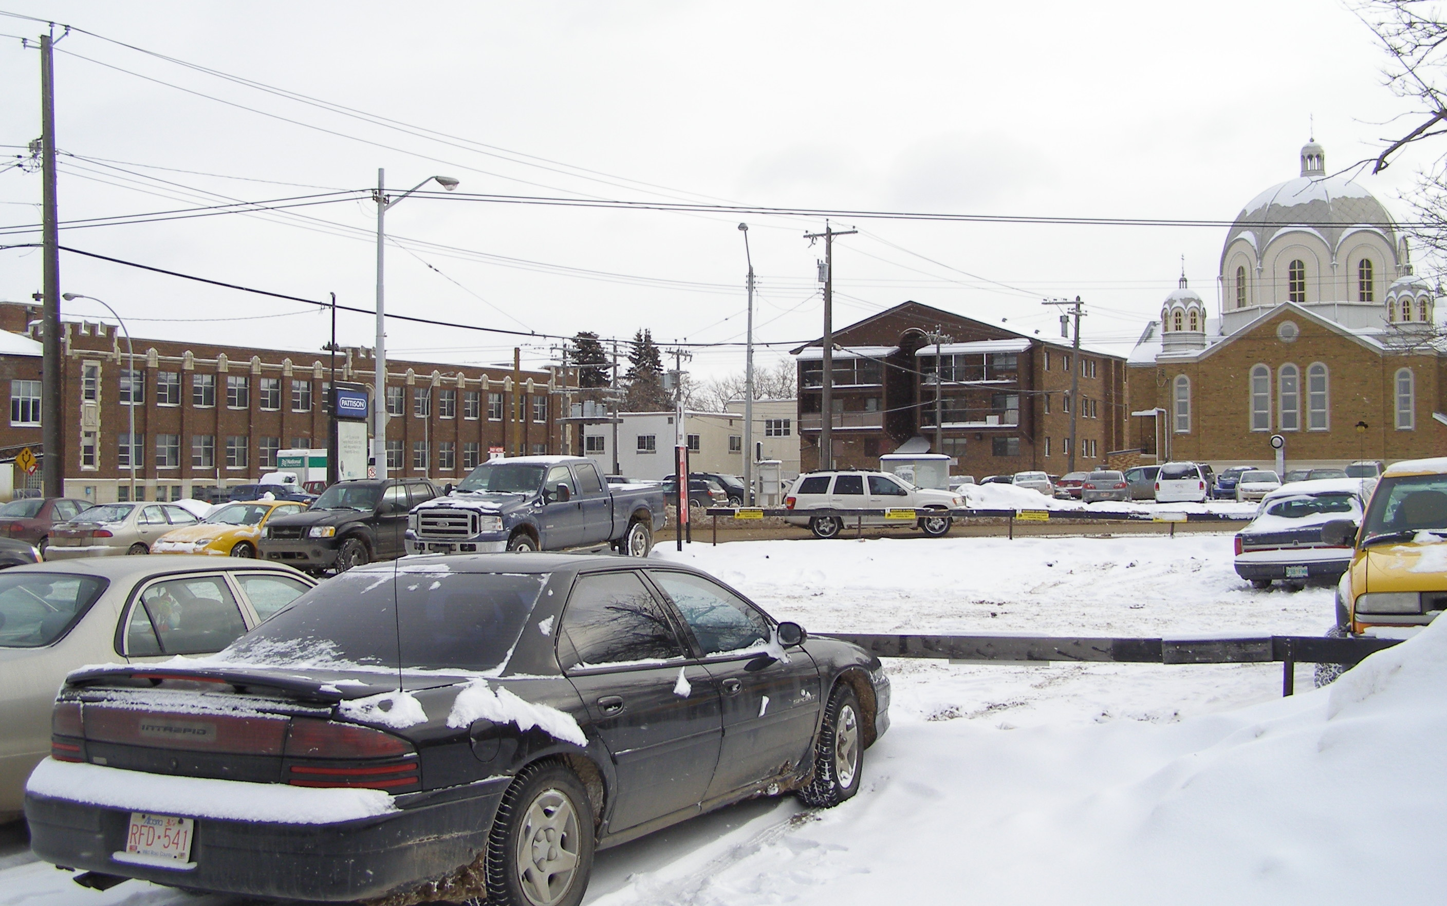
View of Site looking southeast across Jasper Avenue with St. Barbara’s Cathedral at right.

ANALYSIS

1. Compliance with Approved Plans and Policies

a) Plan Edmonton

The proposed amendments comply with the priorities of Plan Edmonton by utilizing existing infrastructure and reinvestment in a mature neighbourhood. The application will accommodate infill development that is sensitive to existing development on a major arterial roadway, increase the amount and quality of housing and renew infrastructure in a mature neighbourhood. The proposed development also places a high priority on effective and efficient use of land and incorporates urban design principles that enhance the quality of the urban environment.

b) The Boyle Street/McCauley Area Redevelopment Plan and The Quarters Downtown

The site is located within Section 7.2.6, the “Boyle Street West Mixed Use Sub-Area (Sub-Area 4)” of the Boyle Street/ McCauley Area Redevelopment Plan (ARP), approved by City Council in July 1994. The proposed development conforms to the generalized land use concept contemplated for Sub Area 4, which allows mixed use, street oriented, pedestrian-friendly infill development that is sympathetic to heritage buildings and serves as a transition in height, scale and development intensity from the Downtown. The proposed development however, is not in conformance with the intensity of development as prescribed in the DC1 (Area 11) regulations under Section 8.4.19c in The Boyle Street/ McCauley ARP. The application proposes an increase in maximum building height from 20 m to 59 m (6 storeys to 16 storeys); an increase in the maximum density from 224 dwellings/ha to 310 dwellings/ha (45 units to 62 units) and an increase in Floor Area Ratio from 5.0 to 6.2. Thus, Bylaw 14887 proposes to exempt this site from the development regulations as prescribed in The Boyle Street/McCauley Area Redevelopment Plan.

The increase in the proposed development conform to the Vision for Downtown East (rebranded The Quarters Downtown), approved by City Council on September 26, 2006, by recognizing the area’s distinct qualities and complementing the adjacent districts; namely the historic character of the Heritage Quarter, the mixed-use focus of the 96 Street Corridor, and the proposed higher densities and taller buildings recommended for the Five Corners Quarter. The proposed development is considered a catalyst for the regeneration of The Quarters Downtown area.

To address the effect of the increased building height and mass on the pedestrian experience along the street, the proposed DC2 Provision ensures the tower portion of the development is recessed from the podium and includes multiple building setbacks above the podium, which create visual interest and preserve views for adjacent developments. The setbacks along with the provision of canopies along the 96 street, Jasper Avenue and 95 Street façade also help to mitigate the perceived building mass. Architectural features and building finishes were selected
to reflect the styles and finishes of historic buildings, such as the Gibson Block and St. Barbara’s Cathedral, in the neighbourhood.

The proposed development provides the following improvements and amenities which assist in providing a better designed building:
- streetscape improvements that include new sidewalks, streetlights, boulevard landscaping and street furniture;
- a landscaped plaza at the building’s west façade;
- the provision of public art on the site;
- an upgraded bus stop and shelter pad on Jasper Avenue and 95A Street; and the provision of a paved lane, south of the proposed development.
The developer has agreed to coordinate all proposed off-site landscape design with The Quarters plan.

c) Smart Choices

The proposal achieves an overall score of 90%, four stars out of a possible five stars on the Smart Choices Scorecard. A score of five stars was not achieved as the proposed development does not include a contribution to affordable housing. The Smart Choices Initiatives pertaining to Neighbourhood Re-investment, Residential Infill, Urban Design and Walkability are supported by the application. The proposed mixed-use development involves reinvestment in a mature neighbourhood through residential intensification, thus leading to a greater choice of housing types within the area. In addition, the development has the potential to act as a catalyst for further re-investment and offers a number of improvements to the public realm. Walkability is encouraged through streetscape improvements and the site’s proximity to Downtown, which serves as a major commercial, entertainment and employment centre. Furthermore, the property is well serviced by existing bus routes and parking requirements have been reduced to reflect those in the Downtown, to encourage alternative modes of transportation. Active pedestrian-oriented frontages, high quality building materials and finishes, the provision of underground parking and the addition of green roofs on all roof decks are examples of Urban Design Initiatives advanced by the development.

The Smart Choices Initiative of Redevelopment of Older Commercial & Industrial Lands is not applicable to this application. This proposal does not qualify as Transit Oriented Development however, it is supportive of transit.

2. Edmonton Design Committee

The Edmonton Design Committee (EDC) reviewed this application on July 23, 2007, November 13, 2007 and again on January 21, 2008. The EDC subsequently recommended support for the proposal subject to a number of conditions including:
- increased sustainability targets for the building energy performance;
- increased glazing and decreased heavy cladding materials of the podium; and
- a re-examination of the method of display of public art.

The proposed DC2 Provision has incorporated these recommendations as follows:
- the proposed development will exceed the requirements of the Model National Energy Code for Buildings by reducing thermal transmittance values by 25%.
- the podium of the building has been redesigned; and
- the owner will contribute $100,000 toward public art.

3. Affordable Housing

The owner has declined to address affordable housing through this proposal. The owner believes his non-participation in affordable housing for this project is off-set by his partnership with the Edmonton Inner City Housing Society to provide affordable housing in several neighbourhoods surrounding Downtown Edmonton.

4. Sustainability

The proposed DC2 development incorporates sustainable initiatives in its design as recommended by the Edmonton Design Committee including:
- the provision of green roofs on every deck to reduce storm water flows, and reduce cooling demand and the creation of an urban heat island;
- the use of recycled and regional building materials;
- the building energy envelope exceeds the requirements in the Model National Energy Code for Buildings by 25%; and
- the use of energy efficient appliances, lighting, windows and doors.
In the DC2 regulations, these initiatives have been quantified as numerical targets from regulated standards such as LEED.

5. Environmental Considerations

Phase I and Phase II Environmental Site Assessments (ESA) have been submitted and reviewed by the Administration. The proposed DC2 Provision requires that a Phase III ESA must be submitted subsequent to an approved development permit, but prior to the physical release of the Development Permit for the purposes of a Building Permit, excepting the parkade excavation Building Permit. Remediation of the contaminated site will occur concurrently with the parkade excavation of the site.

6. Transportation and Utilities

The Transportation Department has no objection to the proposal. Department recommendations regarding the location of parkade entrances, specifications of driveway ramps, the location of garbage enclosures, and agreements to be made between the owner with the City of Edmonton for proposed awnings/ overhangs and off-site improvements have been incorporated into the DC2 regulations and reflected in the associated Appendices. The Transportation Department approved a reduction in the number of required commercial parking stalls, as recommended by the Edmonton Design Committee, based on the proposed development’s proximity to Downtown. Parking for the residential component of the development will meet Section 54 of the Edmonton Zoning Bylaw. The proposed DC2 Provision requires 149 parking stalls be provided for the development - approximately 100 parking stalls for the residential component and 50 parking stalls for the commercial component.

Other affected civic departments and utility agencies had no concerns regarding this proposal.

7. Surrounding Public’s Concerns

As part of the requirements for a DC2 Provision, the applicant mailed an information package to 24 surrounding property owners within 60 metres of the site, the Boyle Street and Riverdale Community Leagues, and the Downtown Business Revitalization Zone (BRZ) on May 23, 2007. Of the five responses received, four supported the proposed development. One respondent supported a four storey mixed use development on the site, and was concerned that the proposed development would increase traffic congestion in the area. The resident was advised that under existing zoning, a six storey building was permitted and that the Transportation Department had no concerns regarding the traffic volumes generated by the proposed development.

On July 18, 2007, the Planning and Development Department notified 26 surrounding property owners as well as the Boyle Street and Riverdale Community Leagues, and the Downtown BRZ. The Planning and Development Department also held a public meeting on October 2, 2007 which was attended by four residents. Two supported the application, encouraging more developments similar to the proposal; while the other two offered no comments. Following up on a commitment made at the Public Meeting, as part of the ARP amendment process, notification was sent to 26 surrounding property owners on October 18, 2007 and the respective
Community Leagues. Planning also held an additional meeting with the applicant and parishioners of the St. Barbara’s Russian Orthodox Cathedral on October 24, 2007, which was attended by 23 people. While the attendees endorsed the design of the building, they had several major concerns with the application:
- the proposed development would block the views of the Cathedral;
- the six storey development under the existing DC1 regulations was a more appropriate scale for the site;
- the parking lot for the church would be illegally used by residents or visitors of the proposed development; and
- the costs for paving the back lane between the church and the proposed development should by covered by the developer.
These concerns were conveyed to the applicant who met with the church November 7, 2007 and responded to several of the concerns raised by the parishioners, advising that:
- The scale of the building complements the proposed heights contemplated by the Five Corners Quarter in the Quarters project.
- The building cascades down from 16 storeys on the east property line, to 1 storey on the west property line, allowing for views of the west, south and most of the east façade of the cathedral. In addition, the building is setback from the west property line to provide a view of the cathedral from the northwest approach; under the existing DC1 zoning, a six storey building with no setbacks would be permitted, such that any views of the cathedral’s four storey north façade would be eliminated. The design was supported by the Edmonton Design Committee.
- Parking provisions for the proposed development have been approved by the Transportation Department.
- The developer will be responsible for the construction of the lane south of the proposed development, to a commercial standard.
The parishioners supported the addition of market housing in the neighbourhood and the building design, but remained concerned with the height of the building and the potential illegal use of the Church parking lot.

JUSTIFICATION

The Planning and Development Department recommends that Bylaw 14887 and Bylaw 14888 be APPROVED on the basis of the following:
- The proposed development complies with the priorities of Plan Edmonton and advances several Smart Choices Initiatives by constructing a higher density, pedestrian friendly, sustainable development in proximity to the downtown and within a mature neighbourhood.
- The proposed mixed-use development generally conforms to the generalized land use of the Boyle Street/McCauley ARP and is consistent with the proposed vision for The Quarters Downtown.
- The proposed development has committed to several sustainable initiatives based on quantifiable targets and has the potential to act as a catalyst for further reinvestment in the Boyle Street Neighbourhood.
- Architectural features and building finishes for the proposed development respect the surrounding historic buildings, demonstrating sensitivity to the context.
- There are no outstanding technical concerns.

ATTACHMENT

2a Maps

Written by: Janice Chan
Approved by: Peter Ohm
Planning and Development Department
March 10, 2008
ATTACHMENT 2a
14887_Att2a.pdf

2
14887_pg2.pdf

