Summary of TMP Directions

Transportation and land use integration
- The transportation system and land uses and urban design complement and support each other in creating a more compact, healthy and sustainable city.
- Medium and higher density residential and employment growth focused around key transit nodes and corridors to promote Transit Oriented Development.
- Industrial areas located in consideration of transportation facilities that will accommodate goods and services movement and labour force mobility.
Public transportation as a cornerstone
- Significant investment in premium transit with a goal to provide LRT in all sectors of the city in conjunction with a supporting, comprehensive bus network.
- Public transportation will optimize and expand the carrying capacity of the transportation system.
Manage the transportation system more effectively
- Use traffic management and transportation supply measures to optimize the operation of the roadways.
- Implement a Transit System Priority program on key transit corridors.
- Encourage Transportation Demand management (TDM) programs to promote alternative, non-driving modes of transportation
Roadway improvements focus on efficient goods movement
- Diminished focus on catering to commuter traffic
- Major roadway expansion projects focused on goods movement corridors or areas of transit priority.
- Roadway and intersection improvement projects undertaken to address safety concerns, transit priority or goods movement.
Encouragement of active transportation
- Increased opportunities for active transportation modes to provide an improved range of attractive travel options.
Well-maintained and managed infrastructure
- The transportation system is planned, developed and managed so that the City is able to keep it in a good state of repair.
- A robust maintenance practice facilitates year round transportation for all modes.
Regional interface
- Work as part of Capital Region Board to facilitate Regional improvements

Preface

Edmonton is a city in transition. We are taking our place as one of the important economic centres in Canada and the world. Edmonton is the gateway to natural resources in northern Alberta and is at the heart of a value-added petroleum refining and upgrading industrial centre. Edmonton is Alberta’s capital city and home to some of Canada’s leading thinkers and artists.

Last year, Edmontonians contributed to the preparation of a vision for Edmonton. They called for decisions that recognize the interdependencies of quality of life, quality of environment and our ability to sustain investment in essential physical infrastructure. In 2008, City Council adopted a City Vision which provides a 30-year picture of success for the City.

As we look to the future, we must chart a new course for the way we grow and the way we move in Edmonton. We have several challenges:

- Edmonton’s current population of 750,000 is expected to grow by 400,000 people by 2040. To accommodate our expanding population, we cannot continue to develop our city as we have been in the past. Our growth is currently scattered across many developing neighbourhoods without the provision of full public services. The low density development form we share with other Canadian cities is financially, socially and environmentally unsustainable. A new plan for growth in Edmonton is needed, which will be described in our new Municipal Development Plan “The Way We Grow” and supported by our Transportation Master Plan “The Way We Move”.

- The City of Edmonton currently has more than $32.6 billion of City-owned infrastructure, providing the essential services that maintain Edmonton’s quality of life. Most infrastructure has a life cycle of 50 years, all requiring operating and maintenance costs and eventual replacement. As Edmonton continues to grow, we expand our infrastructure assets and the corresponding requirement to fund new operating, maintenance and eventual replacement costs. Edmonton has acknowledged that this is unaffordable and we must maximize the use of new and existing infrastructure. To continue to build without acknowledging the long term financial impacts is contrary to the City’s goal for financial sustainability.

- Edmontonians are now making longer trips and driving more. The trips on the road have increased in greater proportion than the population increase as we now have to drive farther due to the expansion of the city. This has resulted in more road congestion. Edmontonians and those living in our region are the Canadians among the most reliant on single passenger car trips in their daily lives. This is contrary to the City’s goal of preserving and sustaining Edmonton’s environment.

- The economic vitality and the sustainability of the Capital Region depends on Edmonton and its neighbours functioning as an integrated whole when it comes to transportation, land use, economic development and community services.

- Globally, it’s been acknowledged that community design and access to transportation opportunities affect health. How we grow and how we move are determinants of individual health and wellbeing. Relationships between public health and planning can assist in the prevention of public health concerns such as obesity, cardio vascular disease, diabetes, asthma, injury, depression, violence and social inequities.

- Edmontonians are calling for a holistic view of Edmonton, an approach to development that recognizes the interdependencies our development decisions have on our quality of life, environmental impact and our long term ability to sustain our investment in essential social and physical infrastructure.

- The majority of the world’s people now live in cities. Cities are increasingly acknowledging the important role they have in addressing climate change and supporting a biologically diverse eco-system. Nothing short of human sustainability is at stake. The tendency of cities to eat up the world’s resources and habitat is unsustainable. Edmontonians know this and are demanding we act to address climate change and conserve and protect natural habitat in the city and the region

The integration of the Municipal Development Plan and Transportation Master Plan is a key step toward achieving a holistic approach to strategic planning. Both plans are being updated in response to these challenges.

In tandem with these plans we need to develop a more cooperative regional approach to integrating infrastructure development in an environmentally and fiscally sustainable way with the 25 separate communities within the Capital Region. Edmonton’s leadership role as the urban centre of the region and the educational, employment, financial and cultural hub for the growing regional population informs this regional planning.

The City of Edmonton is moving to actively promote a denser urban form based on premium transit. We are:

- Emphasizing the role urban design plays in a world class city.
- Recognizing the need to address Edmonton’s financial sustainability by integrating land use and transportation decisions with city infrastructure and lifecycle costing.
- Shifting from an auto-oriented transportation system to a system offering citizens more choice of transportation modes.
- Focusing investment to transportation corridors that facilitate the movement of goods within the City and throughout the region.
- Promoting integration of ecological networks and biodiversity in our approach to land use.

Change takes time.

These plans propose a long term strategy with changes experienced incrementally. Over time, implementing the direction of the Municipal Development Plan and Transportation Master Plan in tandem with key strategic City plans (Infrastructure Strategy, Environmental Strategic Plan)will make Edmonton a more financially, environmentally and socially sustainable city.

Table of Contents

Summary of TMP Directions i
Preface iii
Table of Contents vi
1.0 Introduction 1
1.1 Purpose of the Transportation Master Plan 1
1.2 Developing the Transportation Master Plan 1
1.3 Achieving the City Vision 1
1.4 City of Edmonton 10-Year Strategic Plan 2
1.5 Aligning with Edmonton’s Other Strategic Plans 3
2.0 Strategic Goals 4
3.0 Current and Future Conditions 12
3.1 Current conditions 12
3.2 Future Conditions 17
4.0 Transportation and Land Use Integration 23
4.1 Background 23
4.2 Integrating Transit with Land Use 24
4.3 Integrating Roadways with Land Use 26
4.4 Corporate Approach to Community Building 26
4.5 Regional Context 27
5.0 Public Transportation 28
5.1 Background 28
5.2 Light Rail Transit (LRT) Network 30
5.3 Bus System 33
5.4 Park and Ride 35
5.5 Regional Connections 36
5.6 Services for Customers with Mobility Challenges 37
5.7 Transit Priority in Traffic 38
5.8 Taxis 41
6.0 Active Transportation 42
6.1 Background 42
6.2 Walking 43
6.3 Cycling 44
6.4 Shared-Use Facilities 45
6.5 Regional Connections 46
7.0 Roads 47
7.1 Background 47
7.2 Road System and Responsibilities 48
7.3 Management of the Road System 51
7.4 Car Parking 59
7.5 Road Safety 61
7.6 Transportation Impacts on Communities 62
8.0 Goods and Services Movement 64
8.1 Background 64
8.2 Existing Road System 64
8.3 Key Industrial Areas 67
8.4 Rail 68
8.5 Air 69
9.0 Regional Interface 72
9.1 Background 72
9.2 Public Transportation 74
9.3 Roads 75
9.4 Other Modes 76
10.0 Asset Management & Maintenance 78
10.1 Background 78
10.2 Asset Management 79
10.3 Maintenance 82
11.0 Implementation 84
11.1 Background 84
11.2 Performance Measurement 84
11.3 Review and Progress Reporting 84
GLOSSARY 86
APPENDIX 95
Appendix 1: City Vision, Principles and Strategic Goals 96
Appendix 2: Alignment of City, MDP, and TMP Strategic Goals 100
TMP POLICY DIRECTIONS 102

- Introduction

  - Purpose of the Transportation Master Plan

The Transportation Master Plan (TMP) establishes a framework for how the City of Edmonton will address its future transportation needs. Edmonton is the fifth largest of Canada’s municipalities with a population of approximately 750,000 people. It is at the heart of a thriving Region which currently includes over one million people in the Census Metropolitan Area (CMA).

Over the next 30 years, the City of Edmonton’s population is expected to exceed one million people, while the CMA will exceed 1.6 million people. This growth will bring about enormous levels of change and challenge as the City delivers services to many new populations and industries.

The TMP reflects citizen’s values and directs appropriate decision making while considering the long term and often indirect impacts of those decisions. Its policies give direction for the management of the transportation system, and provide a basis for making strategic planning and budgetary decisions.

  - Developing the Transportation Master Plan

The Province of Alberta’s City Transportation Act requires the City of Edmonton to prepare a comprehensive report (TMP) for an integrated transportation system to serve the city’s needs. This document is an update and replaces the 1999 TMP and responds to the rapid growth and changes the City has experienced over a decade. It has been developed with a view to the horizon year of 2040. The TMP is informed by:

- The comments, experiences and insights expressed by Edmontonians in public focus groups and stakeholder workshops
- A review of best practices from other municipal jurisdictions
- An evaluation of best practices to local conditions

This plan has its roots in the City of Edmonton Vision and Strategic Plan. Transportation’s strategic goals are designed to achieve the City Vision. This strategic plan conveys intent and direction. An implementation plan will be created as a separate document and will detail individual projects, cost estimates, schedules and other key and specific details.

  - Achieving the City Vision

This plan is guided by and meant to achieve the City Vision. The City Vision helps us set direction and encourages us to align our priorities as we work to make the city Edmontonians want it to become in 2040.

The City Vision is included in the Appendix.

  - City of Edmonton 10-Year Strategic Plan

The City of Edmonton Strategic Plan - 2009-2018 gives direction towards achieving the City Vision. It provides a focus to the City’s efforts to deliver the greatest value of services and infrastructure that are most important to Edmontonians, while managing the opportunities and challenges of our rapidly growing and changing city.

Four principles underpin the development and implementation of the City of Edmonton Strategic Plan (see Appendix for elaboration):

- Integration
- Sustainability
- Livability
- Innovation

To further focus the City’s efforts on achieving the vision, Council identified six 10-year strategic goals. These goals will direct long-term planning for the City and help set priorities for the delivery and improvement of services, programs and infrastructure.

The 10-year strategic goals are (See Appendix for elaboration):

- Preserve and Sustain Edmonton’s Environment
- Improve Edmonton’s Livability
- Transform Edmonton’s Urban Form
- Shift Edmonton’s Transportation Modes
- Diversify Edmonton’s Economy
- Ensure Edmonton’s Financial Sustainability

  - Aligning with Edmonton’s Other Strategic Plans

The City of Edmonton is currently aligning its strategic planning processes to ensure an integrated and holistic approach toward city building over the next three decades. This Transportation Master Plan aligns with:

- The Way We Grow: The Municipal Development Plan - This plan establishes Council’s policy direction for future land development and redevelopment decisions. It parallels the 30-year timeframe of this document.
- Infrastructure Strategy – A comprehensive and sustainable long-term financial strategy that allows the City of Edmonton to address its increasing infrastructure gap. The SIFS will identify the infrastructure demand for the next 30 years and estimates the associated costs including; renewal, asset operation, maintenance and service delivery.
- EcoVision Edmonton – Edmonton’s vision for an environmentally sustainable city. It includes the Environmental Strategic Plan and the Natural Connections Strategic Plan.

The Transportation Master Plan and the Municipal Development Plan have been developed concurrently in acknowledgment that land use and transportation are inextricably linked. The planning of both statutory plans must be approached in an integrated manner and be informed by the Infrastructure Strategy to successfully achieve the City’s goals.

- Strategic Goals

The Transportation Strategic Goals were specifically developed to express the intent for the future of Edmonton’s transportation system. These seven goals express the holistic, city-wide, long-term vision for the future of the transportation system. They support and align with the City Vision, and the City of Edmonton’s 10-year strategic goals.

The seven Transportation Strategic Goals are:
- Transportation and Land Use Integration
- Access and Mobility
- Sustainability
- Transportation Mode Shift
- Health and Safety
- Economic Vitality
- Well-Maintained Infrastructure

Each Transportation Strategic Goal is expanded, on its own page, in the remainder of this Chapter.

The Transportation Strategic Goals have been applied to each mode of transportation in the City of Edmonton, in Chapters 4 through 8, to create policy directions that the City will use to direct and enhance current and future policies.

The Transportation Master Plan policy directions, together with the proposed Municipal Development Plan policies will guide and shape the transportation system and land use patterns to achieve the sustainable, livable city that Edmontonians envision.

Strategic Goal: Transportation and Land Use Integration

- The transportation system and land uses/urban design complement and support each other.
- Transit Oriented Development will optimize use of transit infrastructure, and transportation infrastructure will strategically support best land use practices and Edmonton’s urban center.

Transportation and land use are inextricably linked and impact Edmonton’s environmental, financial and social sustainability. New approaches to land-use planning and development will bring people closer to where they want to go and closer to the high-quality transit service they need to get there. Building communities around major transit infrastructure helps encourage transit use, develops a more compact city, maximizes public infrastructure investment and minimizes Edmonton’s carbon footprint.

Designing complete communities where citizens can work, live, and access services and recreation reduces the need for travel.

Ensuring regional coordination of public transportation contributes to labour force mobility.

Focusing business and industrial developments in close proximity to corridors that move goods and services is efficient, adds to the economic vitality of the city and region and reduces goods movement traffic through residential areas.

Strategic Goal: Access and Mobility

- People and goods are able to move efficiently throughout the city.
- An interconnected transportation network, in its variety of modes, provides reasonable access across demographic, geographic, socio-economic, and mobility spectrums.

Edmontonians’ ability to move efficiently through the city helps define the city’s livability. The economic prospects of both the city and the Region are affected by the efficient movement of people, goods and services. Edmonton’s continuing role as a distribution and logistics centre is contingent upon an accessible and highly mobile transportation system.

Access and mobility means Edmontonians’ access to essential opportunities such as employment, education, health care, childcare, shopping, recreation and other daily needs can be met regardless of car ownership.

An accessible transportation system addresses the transportation needs of a diverse urban population. The twelve year old who needs to travel alone, the person living with physical or cognitive abilities or a senior citizen will feel confident that their city’s transportation system meets their needs. The ability of the growing senior population to age in place is dependent upon a transportation system that offers them a continuum of options that are connected and integrated with each other.

Creating more livable complete communities where job, retail, medical, recreational and entertainment services are integrated within residential areas will help minimize the need to travel greater distances and will help reduce overall traffic volumes.

Strategic Goal: Sustainability

- Transportation decisions reflect an integrated approach to environmental, financial, and social factors, and consider indirect and long-term impacts.
- Sustainable, livable communities minimize transportation’s environmental impacts, reduce the need for new infrastructure, and increase quality of life.

The way a city moves and grows impacts its short and long term environmental, financial and social sustainability. The way a city is built determines its future sustainability and livability for generations.

The most effective way to minimize the transportation system’s environmental impact is to reduce the scope and scale of that system. How a city designs its transportation facilities and the way people choose to travel affects a city’s air and land quality and impacts the natural environment.

Capital construction is the beginning of an ongoing financial commitment to operate and maintain a transportation system. Creating a more compact city requires less of a transportation system. Integrating land use and transit planning maximizes taxpayer investment in infrastructure.

Completing and servicing communities in succession rather than in parallel is a more efficient method of providing city infrastructure and services. Promoting the reuse and redevelopment of underutilized facilities that already exist will rejuvenate our neighbourhoods and help to optimize use of infrastructure.

Creating livable, complete communities where people of all ages and abilities are able to access social, educational, recreational, employment and medical opportunities reduces the need to travel outside the community and adds to the social sustainability of individual neighbourhoods and the City as a whole.

Strategic Goal: Transportation Mode Shift

- The transportation system enables more people to move more efficiently in fewer vehicles.
- Public transportation and active transportation modes will be the preferred mobility choice for more people.

Peak period traffic volumes stress a transportation system. Encouraging fewer single occupancy vehicle trips reduces the pressure on the roadway system and defers the need for increased roadway investment. Moving more people in proportionately fewer vehicles adds to overall transportation system efficiency, minimizes environmental impact and maximizes financial investment in transportation system.

This is an incremental shift. For example, more families could choose to own one car instead of two, confident that other transport modes enable them to move efficiently throughout the city. Even a small percentage shift in transportation modes will yield a significant benefit to personal and urban health and environmental sustainability.

Strategic Goal: Health and Safety

- The transportation system supports healthy, active lifestyles, and addresses user safety and security.
- Increasing active transportation networks and partnering with communities, workplaces and schools to support safety, walkability and active lifestyles contribute to Edmonton’s livability.

Community design and access to transportation opportunities affect individual, community and environmental health. Cities that provide opportunities to safely incorporate physical exercise as part of daily activities in all four seasons contribute to their livability and environmental sustainability.

Creating a city conducive to active transportation contributes to a strong sense of community. Increasing density and creating human scale, walkable communities increases citizen safety by adding more eyes on the street. Walkable communities also appeal to a broad range of ages and abilities.

Over the past several decades the number pf children who walk to school has declined significantly. Between 1994 and 2005, the number of students driven to school by their parents or guardians has increased. Creating and keeping more walkable, complete communities will encourage healthy, active lifestyles for the next generation.

Edmonton’s transportation system is one of the city’s largest asset. The transportation system is public space. When designed to promote the movement of people rather than just vehicles, our transportation system can have a positive impact on health and safety and add to the enjoyment of urban living.

Strategic Goal: Economic Vitality

- The transportation system enhances the economic vitality and competitive advantage of Edmonton and the region.
- Efficient goods movement, convenient labour force mobility, and an accessible vibrant city centre will contribute to Edmonton’s prosperity.

Effective and efficient transportation systems are essential to the economic vitality of Edmonton and the Region. Businesses must attract employees to the city and employees must be able to efficiently and affordably travel to their workplaces. Industry is dependent on the efficient movement of raw and finished goods by rail, truck and/or air transport. We are now in a globally competitive environment. The businesses in the service sector need to bring their services to customers and/or have their customers come to them. We must be leaders in collaborating with other interests in our region.

A major contributor of a city’s economic vitality is its downtown. Downtown is the heart of any great city. It is the showpiece, the magnet - it defines the city’s image. Supporting a robust transit system with a downtown hub and efficient access from the Edmonton International Airport to the city’s downtown are essential to the ongoing success of the urban core, the city as a whole and the region.

Strategic Goal: Well-Maintained Infrastructure

- The transportation system is planned and developed so that the city is able to keep it in a good state of repair.
- Future growth is accommodated in a fiscally responsible and sustainable manner.

A well maintained transportation system in all seasons is not only an expectation; it promotes economic vitality and a positive city image. Maintenance of our transportation system means keeping busses, roads, sidewalks and public spaces in good repair, clean and free from litter. This adds to Edmonton’s ability to compete globally for people, investment and visitors.

The state of a city’s transportation system also impacts the safety and mobility of its citizens. Sidewalks that are kept in good condition throughout all seasons greatly enhance the walkability of a city. Given the aging and diverse population, the need to ensure well maintained sidewalks and curb ramps is imperative for a continued quality of life and safety.

Planning a transportation network with life cycle costing in mind will help meet citizen expectations for a well maintained system now and into the future. Maintaining the current inventory is a primary focus and must be considered before adding new infrastructure. The future vitality and quality of life of our existing neighbourhoods depend upon it. Creating a compact city will minimize the need for the addition of new infrastructure and the associated maintenance. It also minimizes the city’s environmental footprint.

- Current and Future Conditions

  - Current conditions

Current Transportation System

The City of Edmonton is currently home to approximately 750,000 people and the Edmonton region as a whole includes just over 1,000,000 people. There are presently about 425,000 jobs in Edmonton, with 100,000 more in the Edmonton region. These people and jobs generate travel throughout the Edmonton area.

Edmonton is served by an extensive multi-modal transportation system that includes:

- An active transportation system for walking and cycling
- A public transportation system (Edmonton Transit System - buses, LRT, and DATS service)
- A hierarchal road system of arterial, collector and local roads
- A railway system
- Two airports (Edmonton City Centre and Edmonton International)

The City of Edmonton owns, operates and maintains the active transportation system, the public transportation system and the majority of the road system. The Province of Alberta has responsibility for key strategic highways including Anthony Henday Drive. The rail and airport systems are operated by private enterprises (Canadian National Railways, Canadian Pacific Railways and the Edmonton Airport Authority).

Current Transportation Demand

Transportation planning for the City of Edmonton and region requires a thorough understanding of:

- How, why, when and where people travel. (Figures 3.1, 3.2, 3.3, 3.4)
- Goods and commercial movements and how these are generated to support the economic activity of the City and Region. (Figure 3.5)

Figure 3.1 How people travel (Mode of Travel)
Source: 2005 Edmonton Household Travel Survey

City residents make around 2.5 million trips on a typical fall weekday (an average person trip rate of 3.6 trips per day).

Figure 3.2 Why people travel (Trip Purpose, From Home)
Source: 2005 Edmonton Household Travel Survey
Figure 3.3 When people travel (Time of Travel)
Source: 2005 Edmonton Household Travel Survey
The AM peak period is from 7-9 am and the PM peak period is from 4-6 pm.
Note: These are daily trips. Other trips include those such as personal business, and pickup and drop off of family members.

Figure 3.4 Where people travel (Trip Destinations)

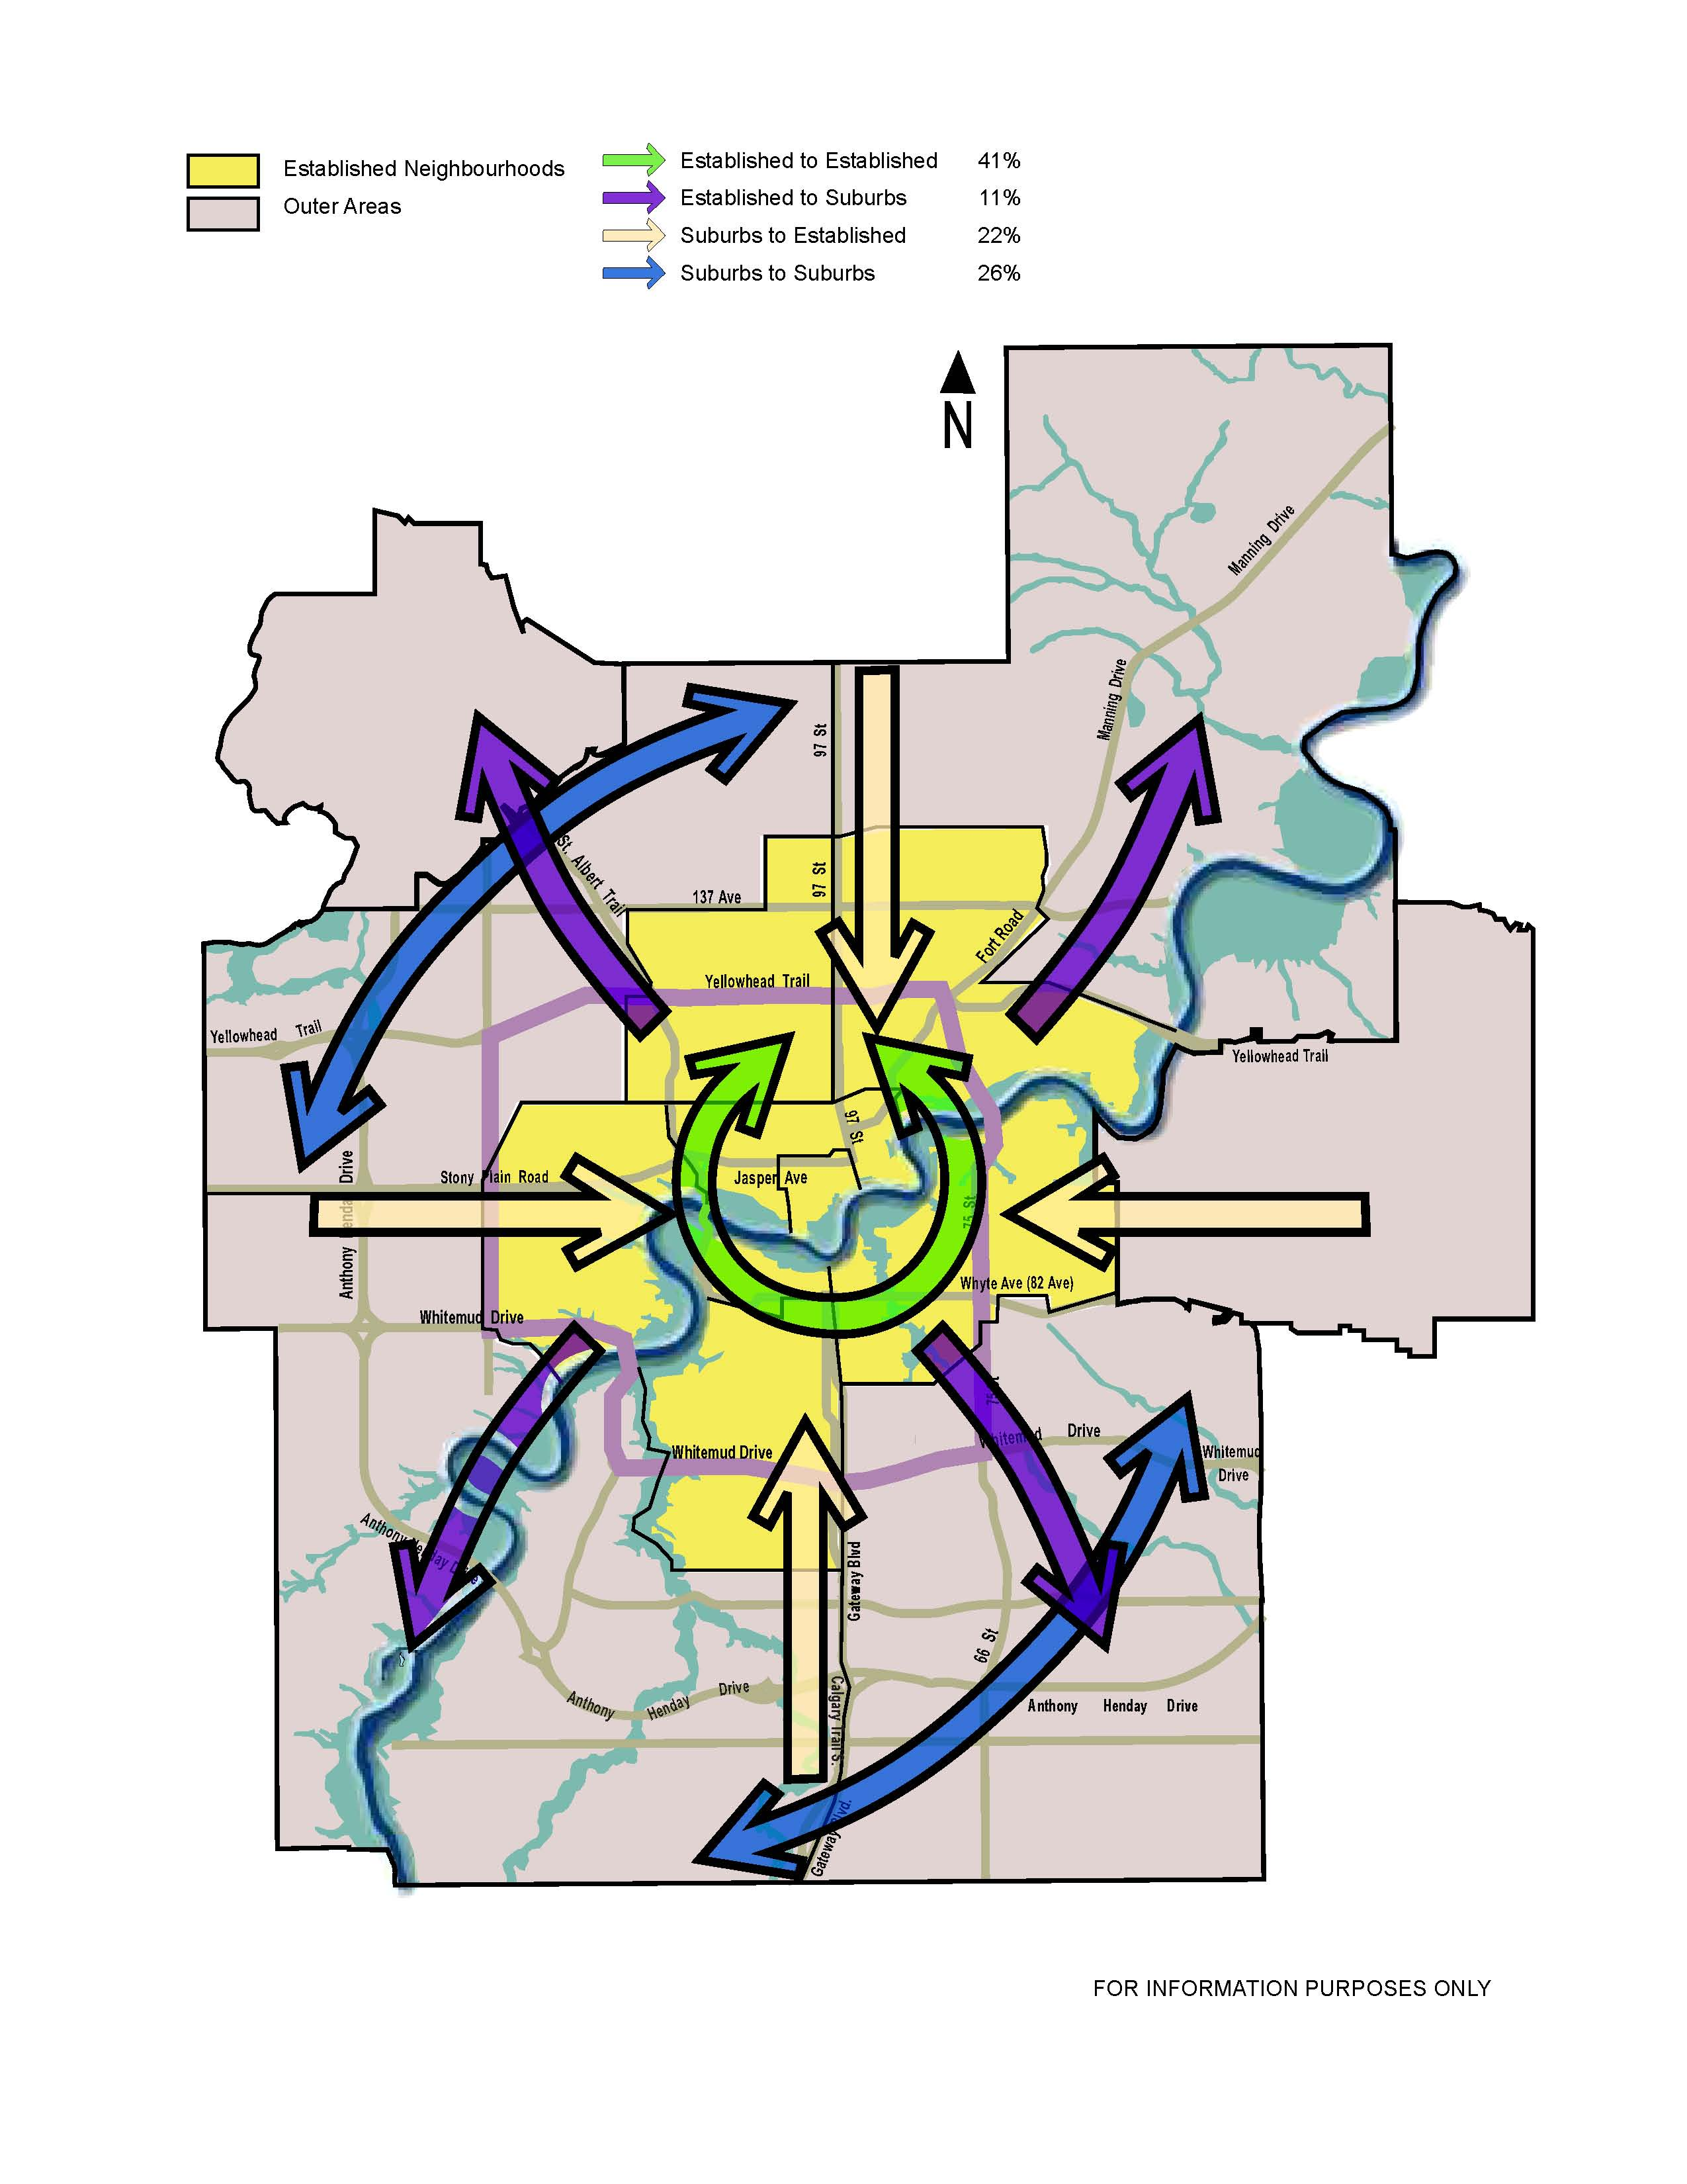
Source: 2005 Edmonton Household Travel Survey
Note: These represent daily trips from home for all purposes by all modes.
Established neighborhoods are those built by 1970.
52% of the population lives in the established Neighborhoods (2005).

The Edmonton Region Commodity Flow Survey (2002) collected information on all commercial vehicle movements generated by Edmonton region businesses. Figure 2.5 shows the major movements of commercial vehicles between industrial areas within the City.

Figure 3.5 2002 Daily Commercial Vehicle Trips within Edmonton

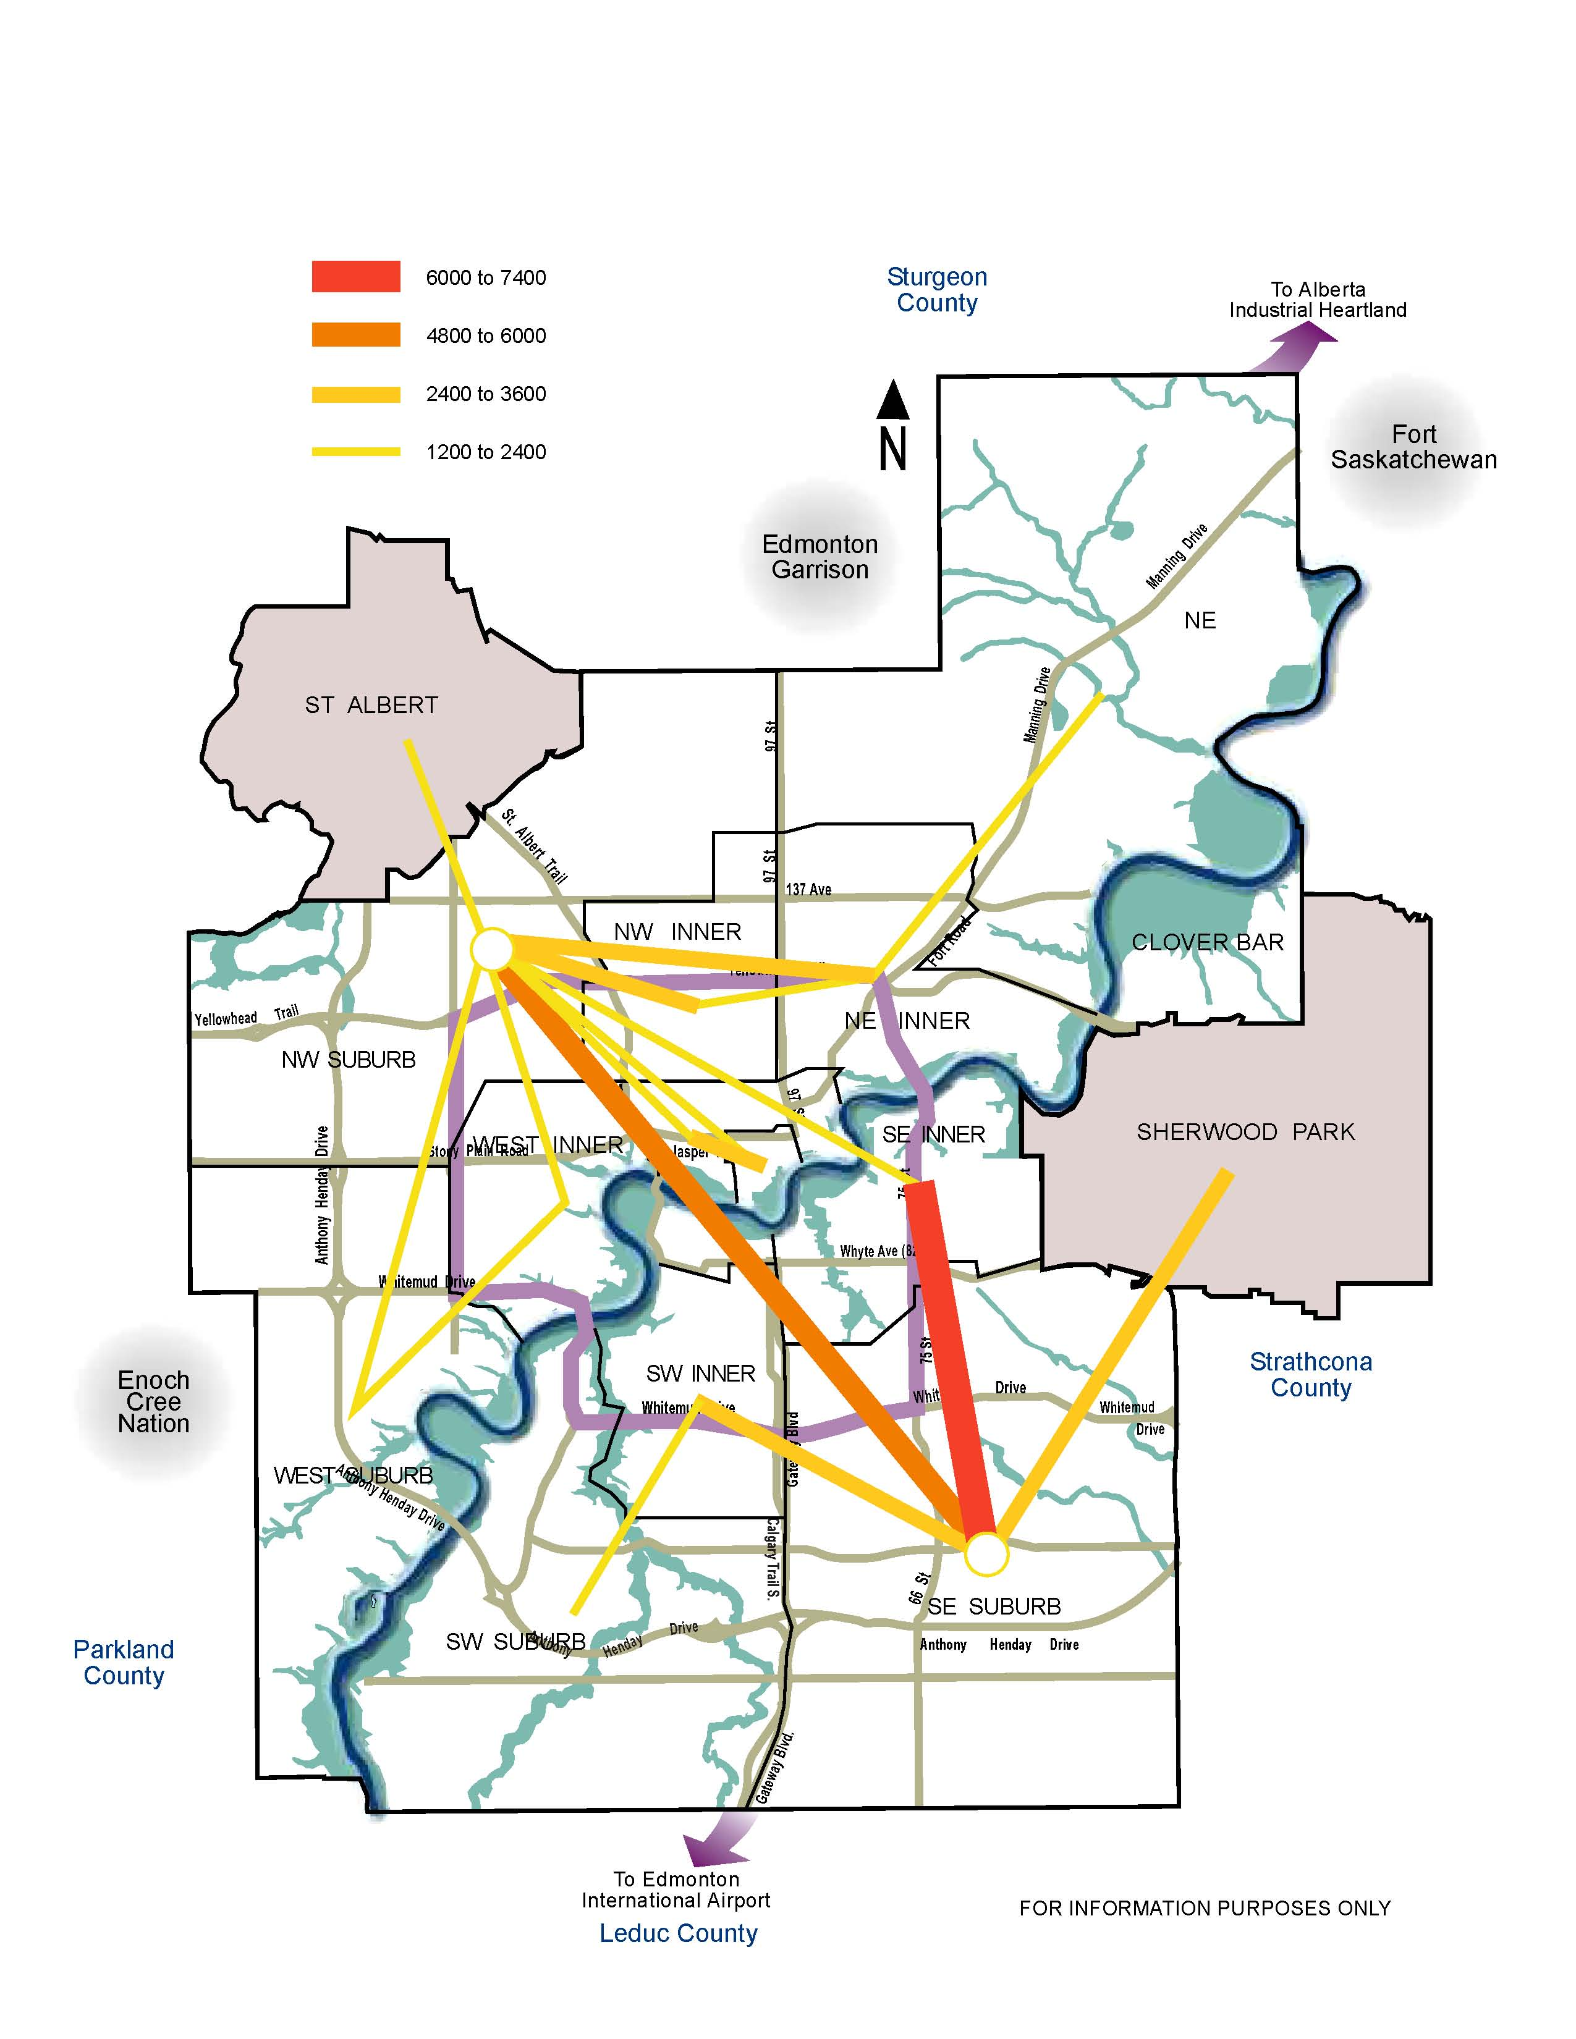

  - Future Conditions

Future Transportation Demand

Future transportation demand will depend upon:

- Demographic factors, including the number of people, their ages, and where they live, work and play (Figure 3.6)
- Economic and employment growth (Figure 3.7)
- Transportation network supply and operating conditions (Figure 3.8)
- Transportation policy, including cost of travel

Demographic Factors

By 2040, the City of Edmonton’s population is expected to grow by over 50% to approximately 1,150,000 people. The entire Edmonton region population as a whole is expected to grow by about 60% to approximately 1.6 million people.

Figure 3.6: Population by Age Profile
The age profile shows that there is significant growth projected in the 65+ age group and less growth projected for children and youth.

In terms of percentages, children aged 0-14 years made up about one quarter of the population in 1987 (22.7%). This percentage decreased to 18.3% in 2007 and is forecasted to decrease to 14.6% in 2040. (Source: How healthy are we, 2007).

Currently, seniors aged 65 years and older make up 11.6% of the population, and will represent 20% of the population in 2040.

Specifically, the seniors population 75 years and older has increased by 122% over the last 20 years. It will further increase by another 80% by 2040.

This demographic shift will have a significant impact on future travel patterns and associated transportation facility requirements. As seniors make up an increasing proportion of the population, the transportation system will need to respond to their changing needs. Indications are that many seniors will continue to drive until they are medically unable to do so. The proportion of seniors who drive will increase. However, those seniors who do not drive will require a range of public and private transportation services. The ability of the growing senior population to age in place is dependent upon a transportation system that offers them a continuum of options. To offer this, changes in our land use and transportation system are needed.

The financial sustainability of the transportation system will also be further stretched as a larger proportion of the population will retire from working life (and paying higher income taxes to the Province, a major source of transportation funding).

Economic and Employment Growth

The city’s employment growth rate is projected to be similar to the population growth projections of over 50% by the year 2040.

Some of the larger employment areas within the region will be in the industrial heartland and port Alberta (see Chapter 8, Figure 8.2 - Regional Industrial Areas). Expansion of post-secondary education is also expected to contribute to future economic and employment growth.

More than 80% of the population growth by 2040 is expected to occur in suburban areas. And 75% of employment growth by 2040 will occur in the suburban and industrial areas.

Figure 3.7 outlines the land development proposed by the Municipal Development Plan.

Figure 3.7 – Proposed Land Development Concept (MDP)
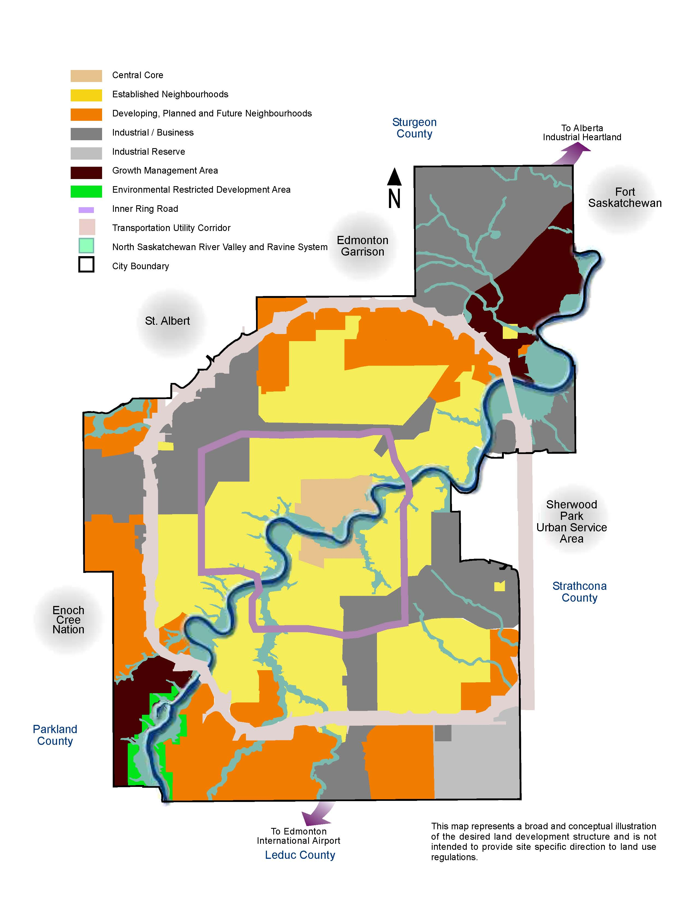

Transportation Network Supply and Operating Conditions

Figure 3.8 shows the expected traffic volume increases between 2006 and 2040. The Anthony Henday Drive, although not complete today, will be complete (by 2016), and therefore shows a large increase in traffic volume over 2006. The Yellowhead Trail, Whitemud Drive, inner ring loop, and highway connectors also carry a significant amount of the traffic growth.

Figure 3.8 2040 Daily 2 way Vehicle Volume Increases from 2006

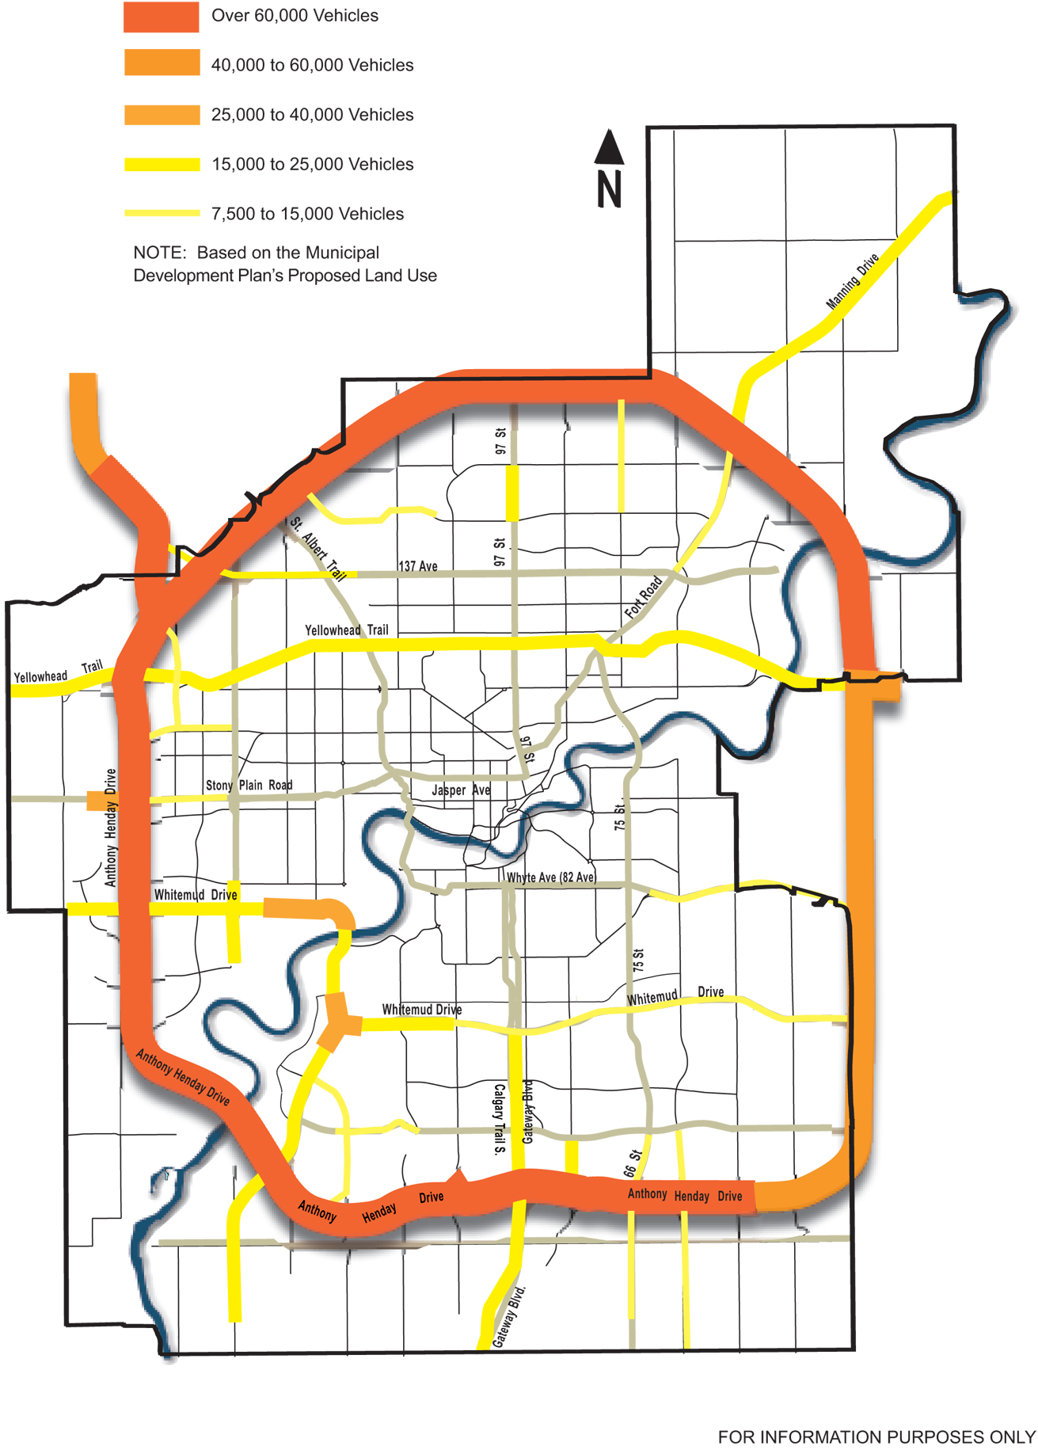
Transportation Policy and Direction

The transportation policies and direction that Edmonton chooses will impact the future transportation system and have significant effects on the daily lives of Edmonton’s future citizens. These impacts, which can be long-term and indirect, have implications over generations.

Edmontonians are spending more time in their cars, driving longer distances and dealing with increasingly congested streets. Between 1994 and 2005, Edmonton’s population increased 13%. At the same time, the total amount of kilometers traveled by automobile in the city (vehicle*kilometers) increased 32%. This shows that the amount of automobile travel is increasing at a much faster rate than the population. The result is increased roadway congestion that impedes the efficient movement of goods movement and emergency services.

The transportation system is inextricably linked with land-use policy. Vehicle kilometers traveled will consistently increase if the city continues to grow outwards. Edmonton’s suburban population has grown markedly over the last decade. Between 1992 and 2005 Edmonton, when compared with other major Canadian cities, showed the greatest proportional increase in the share of workers with a round trip commute of 60 minutes or more. Commute times increased both for those who used private vehicles, and for those who used public transportation. Edmonton currently has the lowest population density of the eight largest metro areas in Canada. Based on recent Statistics Canada data, Edmonton CMA is also the most auto-dependent of these areas. (Source: How Healthy are We? 2007)

Each addition of a new suburban neighbourhood further increases reliance on cars and single passenger trips. Edmontonians living in suburban developments are the least likely to take public transportation, as shown by City studies. The vast majority of Edmontonians currently drive a motor vehicle or ride as a passenger in one. This consistent reliance on cars, combined with suburban expansion of the city, means that people’s car trip lengths will become longer even though the number of trips they make may not change. According to Alberta Transportation statistics, in the Edmonton region there are now more registered motor vehicles than there are licensed drivers. This compounds the cycle of increased kilometers traveled, road congestion and the perceived need to build more roadways which will require more taxpayer dollars for operation and maintenance. The result is a fiscally and environmentally unsustainable cycle.

Edmonton’s health authority, in its report called “How Healthy Are We? 2007”, identifies four major health risks associated with urban sprawl and car dependence - physical inactivity, air pollution, motor vehicle collisions, and mental health effects.

Low population density development and transportation infrastructure that emphasizes automobile travel decrease opportunities for physical activity. As increased time is spent commuting, daily opportunities for widely accessible and inexpensive forms of exercise such as walking or biking decrease. Walking to work or shopping areas, sending children to school on their bicycles, or traveling to other destinations by bus or LRT, are all made more difficult and/or dangerous when distances are great because of low density neighborhoods, when streets are not well-connected, or when public transit is less frequent because population density is insufficient to support higher service.

There are strong links between low physical activity and health. About half of people in the Edmonton region do not get enough physical activity to obtain any health benefits. It is also clear that the more time and kilometers traveled in a personal vehicle, the higher the risk.

Transportation and land use can affect mental health and social well being. “Low-density development with little mixing of residential, commercial, and public space may contribute to social isolation, especially for those without ready access to an automobile and/or those who face cultural, physical, or economic barriers to social integration.” (Source: How Healthy are We? 2007)

The City of Edmonton is facing important choices about how it will develop its overall infrastructure and transportation system in the years ahead – choices that will affect the health, sustainability, and livability of our future city.

The Transportation Strategic Goals will guide policy development. Policy Directions for each component of the transportation are included in Chapters 4 though 8. Together, the proposed Municipal Development Plan and the proposed Transportation Master Plan will guide and shape the future land use patterns and transportation system to achieve the City Vision.

- Transportation and Land Use Integration

The integration of Transportation and Land Use supports TMP strategic goals:

- Transportation and Land Use Integration
- Access and Mobility
- Sustainability
- Transportation Modal Shift

  - Background

Edmonton’s settlement pattern and urban form have always been influenced by its transportation infrastructure, including railways, roadways, public transportation and airports. Transportation provides access to land, thereby affecting its desirability and value, while the mix and intensity of land uses result in activities that generate demands on the transportation system. Edmonton’s continued growth will increase pressure on its transportation system, other civic infrastructure and public services.

It is well recognized that major roadway and highway investments tend to support and be consistent with a dispersed urban form and lower density development. Conversely, it is well understood that effective, well used transit investments both rely on and help encourage more concentrated and denser patterns of development. Continued growth of dispersed, low-density land uses in Edmonton makes the provision of effective transit service very difficult and costly. The inability to serve dispersed land uses effectively has and continues to result in a high dependence on private automobiles as well as pressures to expand existing roads and build new ones.

A major expansion of the LRT system is proposed to help move the city towards achieving the City Vision of becoming more compact, healthy and sustainable. Land use policies and decisions to complement and support this system will be essential for success. Transit along with transit oriented development will lesson the need for other public infrastructure investment throughout the Region. It will provide viable alternative transportation modes that lower Edmonton’s carbon footprint and lessen demand on energy and natural resources.

  - Integrating Transit with Land Use

Building an integrated land use and transportation system is key to managing the future growth of Edmonton. To accommodate the growth in a way that will enhance rather than degrade, the Region’s economy and appeal, the City of Edmonton can invigorate existing and future communities and make them better places to live and work.

Effective integration of land use and transportation infrastructure requires land use, roadway and transit policies and actions that are mutually supportive. To that end, the City’s desired urban form, and the land uses used to define it, must be supported by a roadway and transit network in a way that reinforces the City’s broader economic, social and cultural objectives.

An Integrated Transit and Land Use Framework

An integrated transit and land use framework focuses higher density residential and employment growth around transit nodes (transit centres and LRT stations) and along transit corridors where it can be best supported by a variety of transportation services and other public facilities. This approach promotes “Transit-Oriented Development”. Transit Oriented Development (TOD) refers to intensified development around premium transit nodes with progressively lower density development spreading outwards from the centre. Premium transit refers to LRT nodes, transit centres or high frequency transit corridors. TOD creates attractive, livable, compact neighbourhoods with housing, jobs, shopping, community services and recreational opportunities within convenient walking distance of a node. The intent is to create well designed communities that facilitate walking, cycling, transit and car-pooling, rather than reliance on the automobiles as the only viable mode of travel.

Planning efforts to support transit oriented communities include:

- Designing for public transportation initially, as opposed to fitting it in later.
- Encouraging a diverse mix of land uses at transit nodes and along high frequency transit corridors. This allows people to live and shop near their jobs, and leads to more balanced ridership levels and day-long transit use.
- Locating major trip generators (office towers, shopping centres, entertainment facilities, post-secondary education and major health-care facilities) close to transit nodes and high frequency corridors. These facilities should be designed to be pedestrian friendly and compatible with transit.
- Moderating the supply of on-site and on-street parking at selected, higher density trip destinations to encourage the use of transit and other alternative modes.
- Avoiding or minimizing land uses near transit nodes that are auto oriented or that require significant amounts of parking.

In order to move towards creating a more compact, healthy and sustainable city, a major expansion of the LRT system is proposed. Land use policies and decisions to complement and support this system will be essential for success.

The concepts of Smart Growth and Transit Oriented Development have been prevalent across North America for a number of years. The application of these concepts in Edmonton must however recognize the local Edmonton context and the reality that different parts of the city may require different approaches. These concepts can be most effective where the city has provided premium transit. Areas of the city that are served by or will be served by premium transit should have higher development intensity. The diversity of the current development patterns and built forms indicate that the integration of transit with land use will vary throughout the city and be influenced by the local context.

Edmonton can promote different development expectations at premium transit locations:

LRT Stations
Central Area – Downtown and the surrounding area is well established as a walkable, intensely developed area that tends to have a strong transit oriented market. This area will continue to develop at high densities with a wide variety of uses that encompass a rich spectrum of economic, social and cultural activities.

Town Centre/Mixed Use Stations – These station areas can be mixed-use communities that will develop in character over time.

Employment Centre Stations – These station areas can be employment-focused with a mixture of land uses.

Residential Area Stations – These stations located in predominantly residential areas, will generally be developed less intensively and should be developed sensitively to respect the existing or planned neighbourhoods.

Other Premium Transit Locations
Transit Centres – Areas around transit centres benefit from their proximity to transit services and can develop to a moderate intensity.

High Frequency Transit Corridors – Linear corridors that are served by frequent core transit service are well situated to intensify to moderate levels of development as there can be significant synergies between such development and the adjoining transit corridor.

Areas not Adjacent to Premium Transit Locations.
Areas between the transit nodes and premium transit corridors will not have the same transit accessibility options as other areas and therefore should not intensify to the same extent as those served by premium transit .

  - Integrating Roadways with Land Use

The previous section outlined the steps needed to effectively integrate transit with land use to ensure that they are mutually supportive. As noted at the outset of this chapter, all the components that help shape an urban form must be in alignment in order for the City to reach its goals. As with transit, there is a need to develop roadway related policies and actions that support the City’s land use goals, and by extension, also support the transit policies and measures that are aligned with the land use directions.

Planning efforts to support appropriate land use and roadway integration include:

- Locating land uses and forms of development that are inherently reliant on vehicular access such that they have access to appropriate and supporting roadway infrastructure; this would include areas of industrial and/or office park development that are highly dispersed, have high levels of free parking, serve commercial heavy vehicles and are inherently very difficult and costly to serve with public transit.
- Roadways that serve more concentrated travel patterns and more compact and dense areas of development should be developed and or enhanced to support enhanced transit operations, be it bus based transit, or LRT.
- Avoiding the construction or enhancement of roadways that would compete with or diminish the effectiveness of adjoining (parallel) transit infrastructure, or high intensity land uses.

  - Corporate Approach to Community Building

The integration of transportation and land use is more complex than simply placing the correct land uses around the appropriate transportation investments. It incorporates all the diverse elements of community-building that influence land use and transportation infrastructure and the overall urban fabric.

Land Use and Community Character – The creation of a sustainable community involves a mix of land use and intensity of development, as well the elements of land use features and design that promote the development of walkable communities.

Transportation Mobility and Access – Transportation facilities should be designed for the movement of goods and people balanced by the need to design the transportation system to fit with the surrounding/desired land use context and support development opportunities.

Parks, Public Spaces and Civic Infrastructure – Parks and civic infrastructure are community investments that have a significant impact on adjoining land uses. A system that considers transit/transportation infrastructure to a greater extent than the current system will be necessary to develop liveable, transit-friendly communities. The frequency of use, public safety and public acceptance of parks, public spaces and civic infrastructure increases significantly when the access and visibility is improved.

Economic Development and Development Incentives – The City has the ability to provide incentives, encourage and potentially share risk with the private developers to create the community’s desired pattern of development. Economic development and development incentives play a critical role in shaping the pattern of development in Edmonton and placing demands on the transportation system.

  - Regional Context

Coordination of land use and transportation decisions within the City of Edmonton will affect Edmonton’s urban form. However, to maximize effectiveness, similar policies should be implemented within the entire Capital Region.

POLICY DIRECTION:

- The City will integrate land-use planning and transportation decisions to create a more accessible, efficient and compact urban form.

What This Means

- Developing and executing an implementation plan for integrated transit and land-use guidelines.
- Working with regional partners to implement complementary policies in adjacent municipalities.
- Encouraging land uses that are compatible and complementary to the surrounding transportation network.
- Locating business employment areas relying heavily on goods movement in the vicinity of the inner or outer ring road or highway connectors.
- Public Transportation

A comprehensive public transportation system supports TMP strategic goals:
- Transportation and Land Use Integration
- Access and Mobility
- Sustainability
- Transportation Modal Shift
- Health and Safety
- Economic Vitality

  - Background

Public Transportation is a cornerstone of Edmonton’s transportation system. Edmonton’s strong economy and population growth will continue to exert significant pressure on transportation systems, civic infrastructure, and public services. Growing environmental and energy concerns make the development and expansion of the existing public transportation system and facilities paramount. Due to high energy prices, indications are that Canada is at a tipping point of opportunity to support a shift to more sustainable transit options. Canadians are saying that they want better transit to help cope with high gas prices.

The Transportation Master Plan places an emphasis on developing and expanding the existing public transportation system while capitalizing on new opportunities for public transportation within the greater Edmonton area. It is recognized that transit is a public service that does not recover all costs through the farebox, but is provided for the common good.

To make public transportation the preferred choice of more people, Edmonton must make a large series of improvements to the transit system as well as to its physical, social and economic context. A comprehensive public transportation system is key to the successful achievement of the City’s vision and strategic goals.

Successful Public Transportation

Implementing a public transportation strategy, including substantial infrastructure improvements, will not be sufficient if done in isolation. The performance and attractiveness of Edmonton’s public transportation system will be heavily influenced by a number of other policy driven issues. Substantial increases in ridership call for greater availability, reliability, speed and comfort of transit service. Ensuring that travel demand can be managed in a manner that best supports and strengthens the public transportation system is also very important.

Service Strategy

Edmonton’s public transportation service strategy is based upon the following core objectives:

- To improve the competitive position of public transportation (including accessibility, frequency, reliability, quality and information) to create a public transportation system that provides a viable alternative to the private automobile.
- To provide a safe, accessible, affordable, integrated public transportation system that enables mobility around the city and region.
- To provide a public transportation system that encourages and supports land use to help deliver sustainable development to the community.
- To provide a public transportation system that supports economic development and activity.
- To develop a public transportation system that contributes towards delivery of the wider strategic vision and objectives for Edmonton and the region.

  - Light Rail Transit (LRT) Network

Role of LRT

In defining the vision for the future Edmonton, the City has identified a goal to transform its urban form. The successful implementation of an expanded rapid transit network will be a critical element in the achievement of the City’s objectives to shape and define a 21st century city.

LRT requires significant capital investment to develop. It has many features that make it a worthwhile investment for Edmonton:

- LRT provides a proven, high quality, high capacity, efficient and environmentally friendly means to move people.
- LRT is quick, reliable, accessible and not susceptible to traffic congestion, so it is an attractive alternative for car users.
- LRT is a permanent, high profile investment that encourages regeneration and creates compact, urban communities

Existing LRT

Edmonton currently has one LRT line that operates from Clareview station in the northeast on the CN rail alignment, through the downtown to the University in tunnel, and surfacing at the Health Sciences station at the University Hospital. Edmonton’s original northeast LRT was designed and constructed in the late 1970’s, when vehicle and platform designs reflected heavy rail infrastructure. The current Edmonton LRT system operates with more of a rail focus than street level focus in terms of design and operation (high floor trains and platforms, up to 5 car trains operating in gated/segregated right of way).

LRT Expansion

Expansion of the LRT network to all sectors of the City, as shown on Exhibit 5.1, would develop a city-wide system with the potential to extend to neighbouring municipalities. As the LRT network expands, high quality transit travel will be available to an increasing number of destinations, thereby increasing the attractiveness of the system to users.

Expansion of the LRT network is at various stages of planning and construction. The South LRT extension from Health Sciences to Century Park will be open in 2010. Planning studies are completed or underway for further expansion to the west, northwest, southeast and extensions to the existing lines.

Planning studies for the future LRT expansion involve extensive assessment and will be done consultation with the communities. Planning will be completed to a level that will identify any right-of-way requirements to be dedicated, protected or purchased on an opportunity basis.

LRT Stations

LRT stations are meeting points between the LRT system and the surrounding community. Their environments can help to generate transit ridership from nearby workers and residents. However, poor planning of surrounding land use can limit the ability of transit passengers to access these opportunities. Land use policies as outlined in Chapter 4 can help promote Transit Oriented Development. This would result in compact mixed-use neighbourhoods within a reasonable walking distance of transit, thereby reducing the need for bus transfer services for those passengers.

A further item to consider is the number of LRT stations to be built on each route. While a reduced number of stations will improve LRT run times, this also means that potential riders will face greater distances and time to access the LRT system and therefore additional bus services may be required. A best balance of door-to-door trip time that maximizes the number of people using LRT is the goal. The current rail style of the LRT system will be reviewed for the various corridors under consideration to maximize opportunity to achieve the wider ‘city shaping’ role required from Edmonton’s LRT investment program.

POLICY DIRECTION
The City will pursue expansion of the LRT to all sectors of the city with a goal to increase ridership and spur the development of compact, urban communities.

What This Means:

- Developing the LRT as shown on Exhibit 5.1, in consideration of balancing objectives such as service, economy and redevelopment opportunities.
- Implementing land use policies as outlined in Chapter 4.
- Pursuing opportunities, alone or in partnership with others, to provide and improve pedestrian and cycling connections between LRT stations/transit centres and adjacent developments through TOD and other measures.

Figure 5.1 Potential LRT Expansion - 2040
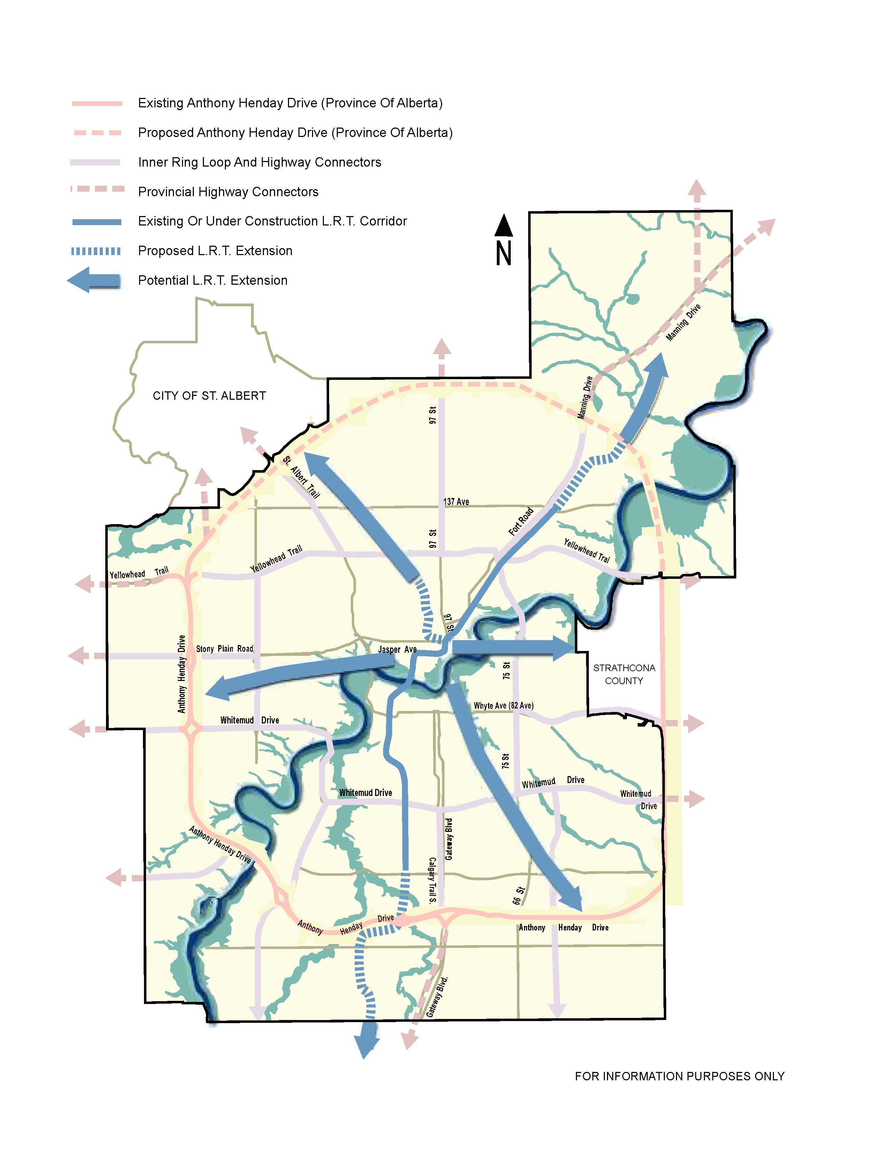

  - Bus System

Edmonton Transit, and the network of bus routes in particular is part of an integrated service that transports people where they need or want to travel. Transit service plays a key role in student transportation, which is critical to the educational and program goals of the school boards. It will become increasingly important as the number of seniors grow over the next 30 years. Effective bus service to growing industrial, retail and commercial areas outside the core of the city will also be important for businesses to attract workers. Following the services standards and strategies outlined in the Edmonton Transit System Ridership Growth Strategy and Planning Review will allow the public transportation system to meet the challenges.

The improvement and further development of the existing bus network will be crucial in capitalizing on all public transportation opportunities, including connection with the LRT system. In planning the level of service on public transportation routes, Edmonton must balance passenger comfort and convenience with the need to deliver services cost-effectively. However, it is also necessary to “put the passenger first” through various passenger initiatives. Some example include: passenger information using latest technology, user–friendly and flexible ticketing systems, vehicles and facilities that are clean and of good quality, good access to the transit system by all modes and easy and convenient transfers.
Factors such as speed/reliability/punctuality and “softer” service improvements (modern fleet, comfort & safety etc.) are important.

As outlined in Chapter 4, an integrated land use and transit policy framework promotes transit-supportive sustainable development where future growth is best accommodated: around LRT stations, transit centres and high capacity bus transit corridors. The bus network will evolve within the context of the LRT Expansion Plan. An important function of the bus network should be to provide direct and frequent links into the LRT to maximize the investment in LRT. Transit centres should be used to maximise the ability for passengers to connect easily and effectively, both for LRT-to-bus and bus-to-bus connections. Satellite Park and Ride at transit centres may be beneficial in locations where land is available and there are direct connect to LRT or major destinations.

Existing high frequency transit corridors should be maintained, and land use policies should be developed for areas adjacent to the corridors as discussed in Chapter 4. In addition, a series of cross town routes should be introduced when justified by demand. The transit network currently focuses on providing radial service from outlying largely residential suburbs to the downtown area. It is expected that this area will see a modest amount of growth over the next 20-25 years while the Edmonton region continues to grow to include a number of regional centres outside the downtown. As such, a number of potential east-west routes and cross-town corridors warrant investigation to ensure that some bus travel can be made without the need for transfer, and in some cases, spur development along the routes.

Existing transit centres will continue to be served by bus routes to facilitate bus to bus transfer. Consideration should also be given to the provision of additional transit centres. Wherever possible, higher frequencies on bus routes should be implemented: this results in a more convenient network, and also will improve the operation of transit centres.

POLICY DIRECTION

- The City will develop an efficient, effective, accessible bus and LRT network to serve Edmonton with connections to the Region.

What This Means

- Expanding the transit route network as the city grows to service an increasing number of destinations, based on service guidelines using a range of transit service types.
- Optimizing route design and level of service to increase competitiveness with private vehicle.
- Adopting a ‘Putting the Passenger First’ philosophy, and implement measures to cater to transit traveler’s needs
- Improving the reliability of transit service through new technologies and other operational measures.
- Providing clear, accurate and effective information to passengers using the latest technology and best practices (such as routes, scheduling, and real-time arrival information).

  - Park and Ride

Park and Ride is an integral component of the broader transportation plan where the goal is to increase the accessibility and utilization of the regional transit system. Park and Ride facilities can be located at strategic points throughout the regional transportation network to attract and encourage people to integrate public transit into their trip decisions. This may free up capacity on the roadway network and provide a choice where local bus feeders have not yet been provided. Park and Ride may attract riders who would not take transit with a bus - LRT transfer. It is also effective for accommodating transportation to special events.

While Park and Ride can enhance accessibility to transit and encourage transit ridership, it can be a costly service for the City to construct and operate. Also it can compete with bus service and encourage the outward growth of low density suburban development. The large amount of land next to a transit station used for Park and Ride renders the land unproductive for other beneficial transit supportive development. A Transit Oriented Development (TOD) next to a high frequency rapid transit service has potential to generate a greater number of transit trips than a Park and Ride facility.

In Edmonton, Park and Ride has historically been developed at most LRT stations outside the central area. As planning of the LRT has progressed to the south and into other quadrants of the city, land for Park and Ride has become more expensive and more difficult to acquire.

In keeping with the City’s direction to move to a more compact, sustainable city with more intense development around transit facilities, the planning for future Park and Ride lots in Edmonton should be focused in areas that are currently have infrequent or not bus service due to low demand. This would provide the greatest opportunity to capture additional transit riders. Locations within the Transportation and Utility Corridor (TUC) or low density industrial areas are ideal locations as this land cannot be used for more intensive TOD developments, and the Park and Ride could capture transit ridership from outlying areas in the city or Region that are not well served by transit. While Park and Ride is typically focused on LRT lines, there are key transit centres that provide direct service to LRT or major destination where Park and Ride is beneficial.

Currently, the City of Edmonton does not charge a fee at any Park and Ride facility, as is the case in most other jurisdictions. Fees for Park and Ride may be a deterrent for transit use and may encourage users to drive, unless there is a very high demand for Park-and-Ride at a particular location or ancillary services are provided such as plug-ins, covered parking or preferred/reserved stalls.

POLICY DIRECTION

- The City will develop Park and Ride lots located towards the extremities of the LRT line or at key transit centres where land cannot be used for more intensive transit oriented development.

What This Means:

- Developing Park and Ride lots in conjunction with LRT extension in locations where the land cannot be used for TOD, particularly within the TUC
- As LRT lines are extended and additional Park and Ride lots constructed, existing Park and Ride lots should be redeveloped as TOD sites over time.
- Fees for parking could be considered facilities where demand exceeds supply and/or ancillary service provided.
- Park and Ride lots will be considered at key transit centres where direct service to LRT or major destinations is provided.

  - Regional Connections

As the Edmonton region continues to expand, it will become increasingly important to service more areas of the Region with public transportation. While some transit systems and service exist, a more coordinated approach will be necessary to support the Region’s economic and social wellbeing. As part of the Capital Region Board, the City will work with its regional partners to develop public transportation, including bus, LRT and specialized services for disabled persons on a regional level. In addition, a Capital Region TDM Committee has been established to carry out TDM measures within the Region on a coordinated basis. The regional interface is discussed in Chapter 8.

  - Services for Customers with Mobility Challenges

The accessibility of public transportation for those passengers with mobility challenges is an important consideration in the design and development of any transit system. This includes not only people with physical, sensory or cognitive disabilities, but those who are elderly and people with young children. Decisions to use the public transportation network will be increasingly defined by its accessibility. “Access for All” is the over-riding principle that is adopted for the development of Edmonton’s public transportation network.

Factors to consider for the physical infrastructure of the public transit system include ease of transfer (for Park and Ride users and those transferring from other public transportation modes), low floor/low level boarding accessibility, information and ticketing systems, quality and consistency of sidewalk provision, personal safety, street crossing points, low curbs at intersections, crossing points, personal safety, and others.

Specialized transit service for those who cannot travel on the regular transit system will continue to be provided.

POLICY DIRECTION

- The City will provide a comprehensive network of transit options for persons with mobility challenges.

What This Means:

- Operating DATS system for those unable to use the regular transit system.
- Designing all new and, where possible, retrofitting existing public transportation vehicles and facilities to accommodate people with mobility challenges, including consideration of passengers from the time they leave their homes.
- Encouraging neighbourhood design that locates facilities such as high density residential or seniors housing on or near bus routes.
- Providing high-quality passenger access for those with mobility challenges.

  - Transit Priority in Traffic

The majority of public transportation services are delivered on existing roads through the use of busses. Traffic congestion on roadways causes delays and reduces reliability of buses. Giving priority to buses on the road network through physical and operational measures can be extremely advantageous in reducing delay and increasing reliability for passengers. The significant time-savings from bus priority measures can help attract and maintain transit users.

Bus priority measures include dedicated bus lanes, bus contra-flow lanes, traffic signal priority at intersections, bus queue jumps, bus only gates, intelligent transportation systems, traffic signal enhancements, accessible bus stop arrangements, queue relocation and a number of other traffic management techniques. The City will develop a system of transit priority measures that will improve the reliability and efficiency of transit service to make public transit a more competitive mode of travel. Creation of transit priority corridors along key high passenger transit routes will use a variety of measures to enhance transit service along the length of the corridor. Section 7.3 also discusses transit priority measures.

Essential Supporting Measures

Successful public transportation systems are not simply based on having a good public transportation network, or even on delivering good public transportation services. Success is the result of many factors. Two of major ones are land use policies and wider transportation policies. Bold, innovative leadership in addressing these issues, picking up on many of the measures and approach suggestions in this chapter, will be necessary if Edmonton’s public transportation system is going to support the wider City Vision in the future.

To achieve a successful public transportation system relative to the current dominance of the car, a number of supporting measures are required. These measures include a number of areas:

Transit Oriented Development (TOD)

Transit Oriented Development (TOD) is the creation of compact, walkable communities centered around high quality transit systems. There is a major focus on TOD policies to support LRT in the TMP as outlined in Chapter 4.

Transit Fares and Financial Issues

Transit faces several disadvantages related to the price of travel, although recent environmental issues and energy prices may reduce this disadvantage. Free parking (especially at workplaces) is the most significant, since it often reduces the perceived costs for most car trips to below the cost of a transit fare. The considerable fixed costs of car ownership and operation do not influence individual trip-making decisions, particularly in Edmonton where traffic congestion is not significant.

In ensuring that transit fares become attractive and easy to understand, the broad principles for transit fares should be:

- An easy to use and understand system
- A move towards a cashless system
- A regionally integrated system
- Provide price incentives for more frequent use
- Affordable, priced to make transit an attractive alternative to the private automobile

Transit Safety & Security

Safety and security issues are a high priority for all public transportation systems and must maintain a high priority in Edmonton if the City is to achieve its transit objectives. Decisions to use the public transportation network will be influenced by its safety and security as well as its accessibility.

Edmonton must continue to work to foster greater safety and security on the transit system through innovative physical and operational measures, as well as through public awareness.

Public Transportation Integration with Other Modes

Public transportation passengers rely on connections with other modes to make their trips. Improvements to active transportation (walking, cycling, in-line skating, etc.) facilities and Park and Ride facilities are important to system enhancement. Transit facilities need to be made accessible to the public through the provision of sidewalks for walking, facilities for cycling (including bike parking at transit stations and provisions for buses to carry bicycles) and car use (via Park and Ride lots at some locations and passenger drop-off zones (kiss & ride) at LRT and transit centres). The provision of all these also needs to include accessibility for those with mobility challenges.

Car Parking

The availability and price of car parking are significant determinants of the attractiveness of public transportation. It may be desirable that Edmonton limit parking at key locations to promote public transit. Examples of possible measures include land use policies that would limit parking supply in the central areas and at major facilities or institutions as well as in the vicinity of LRT stations. Encouraging shared and/or structured parking to enable more compact development patterns, developing a parking authority to control parking or pursuing the ability to impose levies on non-residential parking spaces are other possible measures.

POLICY DIRECTION:

- The City will implement essential supporting measures to enhance the viability of the public transportation system.

What This Means:

- Developing and implementing transit priority corridors and other transit priority measures that will improve the reliability and efficiency of transit service to make public transit a more competitive mode of travel.
- Implementing a car parking policy in support of public transportation.
- Progressing towards a regionally integrated, easily understood cashless fare system.
- Enhancing safety and security measures.
- Integrating transit with active modes, including enhanced bike parking and bikes on buses.

  - Taxis

Taxis provide a form of public transportation and are an important mobility option for residents and visitors within the city and region, particularly seniors, persons with disabilities and when other choices are unavailable such as those who choose not to own a vehicle. Accessible vehicles are available for persons with disabilities and supplement the City-operated DATS service.

In Edmonton, the Vehicle for Hire Commission (formerly the Edmonton Taxi Cab Commission) licenses, regulates and controls the operation of taxis and related taxi business licenses. There are currently about 1,220 taxis, including accessible vehicles, permitted to operate in Edmonton.

Given the extended operation of taxis and the large size of most taxi vehicles, the vehicle emissions generated may be greater than other vehicles. The City will encourage the use of fuel efficient, low emission vehicles for the taxi fleet in support of environmental stewardship.

- Active Transportation

Encouraging Active Transportation supports TMP strategic goals:
- Access and Mobility
- Sustainability
- Transportation Modal Shift
- Health and Safety

  - Background

Active transportation is described as any mode of transportation by which someone uses their own energy to power their motion. There are many forms of active transportation. Some examples are walking, cycling and inline skating. There is a growing variety of active transportation commuting options every year.

The many benefits of active modes of transportation include not only building health and exercise into one’s daily routine, but also a large number of social, environmental and financial benefits to the user and to society at large. With increasing international concern about obesity and growing rates of diabetes in affluent countries, a more coordinated approach is needed when addressing health, land-use and transportation planning. The age of designing transportation systems on an engineering basis alone has passed, and it is essential that a combination of human factors be considered when designing the city we live in and its transportation system.

Studies have shown that building a nominal level of exercise into daily routine can have enormous benefits to one’s health and happiness. Creating a city that is conducive to active transportation can also contribute to creating a strong sense of community in Edmonton neighbourhoods.

Active transportation helps to conserve energy. There is movement on a local and global scale to reduce dependency on oil consumption as well as greenhouse gas emissions, especially in sectors such as the transportation industry. Active transportation contributes to the potential for reducing vehicle volumes and maximizes the effective use of existing infrastructure.

Edmonton’s Active Transportation system is multi-faceted. It consists of sidewalks (<2m wide), multi-use and shared use trails (>2.5m wide), and roadways. These systems can include granular, wooden, asphalt or concrete construction. Some sidewalks and paths are in road rights-of-way and some are through parks. The City currently has some separate bike lanes (contra-flow) on roadways, with the remainder of cycling on shared-use trails or on roadways in the direction of travel.
  - Walking

Walking is the most fundamental form of transportation as almost all travel begins and ends with a walking trip. Walkability describes the extent to which citizens have the opportunity to walk to get to everyday destinations for work, shopping, education and recreation. Universally accessible (barrier-free) sidewalks, walkways, and multi-use trails are the basic infrastructure necessary to enable walking in the public realm. Combining this basic infrastructure within a mix of land uses, the design of complete neighbourhoods with a full complement of destinations and higher residential densities will provide for a more walkable environment.

Since there are practical limitations to the range of walking trips, access to a good public transit system is essential to transport pedestrians over long distances. Public transportation and pedestrian infrastructure should be well integrated.

The level of maintenance provided is an important factor in determining the accessibility of a facility. This will become increasingly important for the aging population and it will be a factor in mode choices of individuals.

Policy Direction:

- The City will create a more walkable environment.
What this means?

- Adopting and implementing a strategy for sidewalk infrastructure to prioritize and construct missing links in the pedestrian network.
- Adopting and implementing of a comprehensive strategy to improve walkability through community design, education and walkability initiatives.
- Promoting ‘Sustainable Transportation Through Site Design’ principles.
- All pedestrian facilities support safe, direct, and convenient routes for people of varying abilities.
- Providing well-integrated transitions between sidewalks, the multi-use trail corridor network, other pedestrian networks, and transit facilities.
- Designing and constructing sidewalk infrastructure in accordance to Crime Prevention Through Environmental Design principles.
- Including maintenance and snow clearing for the active transportation system to ensure year-round mobility

  - Cycling

Bicycles are a highly energy-efficient mode of transportation. Many of the trips Edmontonians make every day by car are of a length that may be reasonably accomplished by bicycle. Throughout the city, safe and convenient cycling routes are provided along wide curb lanes, bike lanes, multi-use trails and granular trails. Encouraging cycling, and constructing its related facilities, can help to create well-connected, livable communities - an essential part of Edmonton’s urban fabric. Maintenance of roadways, bike lanes and trails is a key factor to the accessibility of the bicycle network in all seasons.

Bicycling and transit are well suited as complementary modes of transportation. Transit service and bicycle facilities should be integrated to provide cyclists with reasonable alternatives for moderate and long distance trips.

Policy Direction

- The city will create a cycle-friendly city.
What this means?

- Adopting and implementing a bicycle transportation plan to:
  - Develop and maintain a city-wide bicycle transportation network
  - Integrate bicycles with transit facilities and services
  - Provide secure and functional end-of-trip facilities
  - Connect bicycle infrastructure throughout the Capital Region
  - Address the maintenance of bicycle transportation facilities
  - Support the education and promotion of cycling
- Designing and constructing bicycle facilities in accordance to Crime Prevention Through Environmental Design principles.
- Developing and reviewing best practices and adapt to Edmonton to increase attractiveness and safety of cycling.

  - Shared-Use Facilities

Multi-use trails accommodate a variety of activities year round, from cycling and walking to inline skating, skateboarding, dog walking and many others. They typically consist of a hard-surfaced trail (asphalt or concrete), and are commonly found along rail and utility corridors, parks and the river valley as well as along arterial road rights-of-way. These trails provide an opportunity for long stretches of uninterrupted travel by active modes of transportation, and form a key link in both the city-wide bicycle and pedestrian networks. As a facility for cycling, multi-use trails also offer the opportunity for less-confident cyclists to gain the skills necessary to navigate other types of facilities in the city-wide system.

The Multi-Use Trail Corridor Study was approved by City Council in 2002 to provide an “innovative multi-use trail network plan and implementation strategy that offers convenient access and linkage opportunities to all sectors of Edmonton.”

Policy Direction:

- The City will create an integrated network of multi-use trail facilities.

What this means?

- Constructing the network described in the 2002 Multi-use Trail Corridor Study, and expansion of these trail corridors outward as the city expands.
- Planning, constructing and maintaining multi-use trails along existing, new or widened arterial roadways within the city.
- Integrating multi-use trails along LRT and transit corridor expansions wherever feasible.
- Providing safe and secure multi-use trails designed and constructed in accordance to Crime Prevention Through Environmental Design principles.
- Developing of a coordinated network of multi-use trails throughout the city, including integration with Edmonton’s river valley, parkland and utility corridors, as well as regional connections.

  - Regional Connections

Active transportation has great potential for trips between Edmonton and adjacent communities, particularly when combined with transit. It is important to co-ordinate the planning and implementation of a network of facilities for active modes that meets the needs of users throughout the Capital Region.

- Roads

The development and management of Edmonton’s roadway network supports TMP strategic goals:
- Access and Mobility
- Sustainability
- Transportation Mode Shift
- Health and Safety
- Economic Vitality

  - Background

Roads are the foundation of Edmonton’s transportation system. They represent one of the largest public infrastructure investments within the city. Roads significantly affect the economic vitality and competitiveness of Edmonton and the Region, as they facilitate the movement of goods and services, emergency services, and people using public transit, cars, taxis, bicycles and walking.

Roads serve a variety of functions and transportation modes. The needs of these various modes often compete for the same limited resources such as physical space and funding. As Edmonton continues to grow, demands and pressures on the road system increase. In managing this public resource to achieve the greatest possible public benefit, the City of Edmonton must frequently make choices and trade-offs.

  - Road System and Responsibilities

Road Classification

Roads function to move people, goods and services as well as to provide access to properties. The City of Edmonton generally adheres to the classification system in use in most North American cities where roads follow a hierarchy of local, collector and arterial roadways. The hierarchy of roads is intended to allow the road network to perform efficiently and safely from both the traffic operations and safety perspectives.

Local Roads provide direct access to adjacent lands and serve neighbourhood travel.

Collector Roads provide neighbourhood travel between local and arterial roads and direct access to adjacent lands. Buses generally operate on collector roads within neighbourhoods.

Arterial Roads serve through travel with fewer access opportunities. Arterial roadways are intended to function with higher volume of traffic and have a range of design characteristics that affect operating speeds and access to the road.

Road Design

Roads are designed with standard criteria based on roadway classification. However, not all situations are identical. The City should consider flexibility in design to develop roads that fulfill their intended purpose based on factors such as traffic volumes, speed and adjacent land uses with consideration for natural areas, natural areas connectivity and environmental factors such as water and air quality. Innovations in design must not degrade safety nor hinder maintenance of the roadways.

Road right-of-way makes up a significant portion of Edmonton’s public space and as such should be designed not only to be safe and functional, but also to provide attractive and comfortable space for pedestrians, cyclists and all types of vehicles.

Roadway Network Structure

The basic structure of Edmonton’s major roadways was defined in the 1999 Transportation Master Plan and remains unchanged. The Transportation Master Plan Concept outlines the high standard arterial roadway network within the city.

Figure 7.1 Transportation Master Plan Concept - 2040

- Anthony Henday Drive – a high standard, ultimately completely grade separated, free flow facility that forms an outer ring road near the periphery of the city. It is intended to play a key role in the efficient movement of people, goods and services throughout the greater Edmonton region.

- Inner Ring Road: - intended to cater to cross-town movements on a higher standard facility within Edmonton city limits. Enhancements to existing facilities will focus on raising their service levels to a more free-flowing standard, with a minimum of six through lanes and a posted speed of at least 70 km per hour. The City will strive to reduce and control direct access to these facilities, wherever practical. These roadways include:
  - Yellowhead Trail
  - 75 Street/Wayne Gretzky Drive
  - Whitemud Drive
  - 170 Street

Highway Connectors – high standard roadways connecting Anthony Henday Drive to the Inner Ring Road as well as to provincial/national highways outside Edmonton’s boundaries. These roadways are intended to have similar characteristics as the Inner Ring Road, including a more free-flowing standard, a posted speed of 70 km per hour and limited access. The roadways include:
  - Calgary Trail/Gateway Boulevard/QE II Highway south of Whitemud Dr.
  - Whitemud Drive, east of 75 Street and west of 170 Street
  - Yellowhead Trail, east of Capilano Drive and west of 170 Street
  - 50 Street, south of Whitemud Drive and north of Yellowhead Trail to Manning Drive
  - Manning Drive, north of 137 Avenue
  - Fort Road, north of Yellowhead Trail
  - 97 Street, north of Yellowhead Trail
  - St. Albert Trail, north of Yellowhead Trail
  - 23 Avenue, west of Anthony Henday Drive
  - Stony Plain Road/100 Avenue, west of 170 Street
  - Terwillegar Drive
  - Sherwood Park Freeway

These major facilities are important not only for Edmontonians, but also in the regional context as facilities of significance for regional traffic patterns to accommodate the movement of both people and goods.

Responsibilities for Roads

The City of Edmonton owns and is responsible to manage and maintain the majority of the road network within the city. Since the 1999 TMP, some of the major high standard facilities have been taken over and are now owned and operated by the Province of Alberta. Anthony Henday Drive and the Highway connectors, as shown on Figure 7.1, fall under the control of the provincial government.

Construction of the south and west sections of Anthony Henday Drive from Highway 14 on the east to Yellowhead Trail on the north has had an enormous impact on land development patterns and has had significant impact on accessibility of cross-town trips in the and around the city. The Province of Alberta has committed to construction of the north leg of Anthony Henday Drive between Yellowhead Trail and Manning Drive, with expected completion by 2011.

Arterial Roads for Development Bylaw

Local, collector and arterial roadways in developing areas, both residential and commercial/industrial, are constructed by the developer of the land. Under the Arterial Roads for Development Bylaw, land owners are required to build four lanes of arterial roadways required to service their land. As such, basic roadways infrastructure is constructed by the owners as land develops and is turned over to the City for maintenance. In some cases, the City is responsible for widening from two to four lanes in developing areas where development existed prior to the bylaw.

  - Management of the Road System

The management of the roadway system is becoming increasingly important as the city continues to expand and traffic increases. As Edmonton moves from a mid-size prairie city to a large metropolitan area, it is inevitable that traffic congestion levels will increase, particularly during the peak periods. Physical, financial and community constraints in many areas make it infeasible or even undesirable to build or expand roads to alleviate congestion. As such, the City of Edmonton will need to place greater emphasis on strategies to optimize the use of the existing road system.

From an overall policy perspective there are a number of strategies for managing the existing road system including:

- Land use development strategies
- Promoting use of alternative modes
- Operating existing roadways more efficiently
- Transportation Demand Management (TDM )
- Selectively adding more roadway capacity

In all of these areas, the City will face considerable challenges. Changes in travel behaviour will take years to occur, and the financial resources required to add extensive new facilities will not necessarily be available. As they reach capacity, transportation systems must be carefully managed to prevent unacceptable trends in congestion, safety, and even the daily travel choices of individuals. With proper planning, relatively minor actions that resolve localized barriers and bottlenecks can have a large benefit for the overall system. Proactive efforts to extract the greatest possible efficiency from today’s transportation system can help to achieve modal shift objectives, minimize the costs of congestion, and preserve public health.

Land use development strategies

As discussed in Chapter 4, encouraging mixed use intensified land uses around premium transit corridors can create walkable, transit friendly communities which enable residents to function with a reduced need for auto trips. Municipal Development Plan policies and the Smart Choices program support this philosophy.

Promoting use of alternative modes

The use of travel modes other than single occupant vehicles will reduce demand on the road network. Chapter 5 (Transit) and Chapter 6 (Active Modes) discuss promotion of these modes.

Transportation System Management (Operating existing roadways more efficiently)

Optimizing the operational efficiency of the City’s existing roadway infrastructure benefits all modes of travel. Traffic management measures are a means of gaining the greatest benefit from the City’s existing roadway infrastructure. While the majority of these measures are traffic control system related, some localized infrastructure improvements at specific intersections or along a corridor may be included to obtain the greatest benefit from such measures.

Using traffic management measures can:

- Reduce delays to transit vehicles in mixed traffic, thus maximizing the speed and reliability of transit service.
- Reduce delays to vehicles on arterial roads, thus reducing overall air emissions, discouraging through traffic infiltration of residential areas and reducing the cost of moving goods and services.
- Reduce the number of traffic bottlenecks and enable a rapid response to traffic incidents, thus decreasing the level of congestion, delay and road safety risks.

A variety of traffic management initiatives used in Edmonton will be expanded to include:

- A signal management system that uses computerized traffic signal coordination and progression.
- Transit priority systems that use a combination of physical roadway improvements and communication between the traffic signals and the transit vehicles.
- Traveler information systems that give real-time traffic and roadway information to travelers, allowing them to make informed decisions.
- Incident management systems that can direct traffic away from an incident and lead to faster response to the incident and a reduced impact on travelers in the immediate area.
- Traffic/congestion monitoring systems using remote cameras and vehicle detection systems to alert the control systems and effectively deal with traffic flow.
- Communications systems to link these components.
- Localized upgrades to roadways such as turn lanes at intersections.

Edmonton’s traffic management program will focus on key transit and goods movement corridors using a combination of technology and localized roadway improvements. This framework will ultimately provide the City with an integrated, multi-modal, traffic management system that is needs driven, technology based, and capable of accommodating changing traffic management needs and evolving technologies. The program will enable migration from the City’s current traffic control systems to an advanced multi-modal traffic management system that proactively manages congestion.

A further aspect of operating roadways efficiently is controlling and optimizing the supply of transportation system capacity. The City must manage the allocation of road space using a variety of coordinated strategies to make the best use of its facilities as part of prioritizing transportation. Available roadway capacity can be directed to maximize the people-moving ability of the existing network and to reduce the costs of operation. Supply management strategies can:

- Maximize people movement
- Maintain or improve safety for all users
- Reduce or defer the need for new infrastructure and services
- Contribute to modal shift objectives
- Minimize the costs of congestion

Supply management strategies include options such as one-way streets, access management, reversible lanes, ramp metering, High Occupancy Vehicle (HOV) and bus lanes, bicycle lanes and time controlled parking/travel lanes. It could involve the reallocation of existing road space for other users such as transit, car-sharing vehicles, bicycles or taxis in order to maximize the people moving capacity of a corridor.

Policy Direction

- The City will develop a comprehensive program to optimize the efficiency of the existing roadway system using traffic management and transportation supply measures.

What This Means:

- Developing a program to proactively identify, evaluate and design projects to optimize the operation of the roadways in key corridors and areas of congestion using traffic management and transportation supply measures.
- Developing and implementing Transit Priority Corridors using transit signal and intersection improvement to improve reliability and efficiency of transit service with a focus on key corridors.
- Using transportation supply management strategies to promote increased use of travel modes other than the single occupant vehicle, including reallocation of existing road space.
- Supporting the continued development of the Traffic Management Centre with linkages to transit, roadway operations and emergency response (i.e. police, fire, ambulance, 911, 311, etc.) control centres.

Transportation Demand Management (TDM)

Transportation Demand Management (TDM) includes a wide range of policies, programs, services, and products that influence when, where and how people travel, with the goal of reducing single occupant vehicle travel and, as a result, increasing the efficiency of the transportation network.

A well-balanced transportation network is planned and built to take advantage of the inherent potential of each of the modes of travel, including walking, cycling, public transit and driving. By working towards providing a full range of travel options for all Edmontonians, the Transportation Demand Management program will support a modal shift, thus realizing benefits in public health, affordability, access and mobility, and environmental and economic sustainability.

Some of the key TDM initiatives encourage individuals to reduce the number of trips they make, to travel more often by non-driving alternative modes, to travel with others, to travel outside peak periods and to reduce the length of their trips. This is complemented by the increasing role of information technology as a substitute for travel. While it is desirable to reduce automobile travel in general, a focus on peak hour travel reduction provides the benefit of reducing roadway congestion and the need for more or wider roads.

Strategies for Transportation Demand Management include programs that:

- Offer travel incentives and disincentives that provide a benefit or disbenefit related to travel choices.
- Educate and promote to build awareness, understanding and positive attitudes about travel options.

Without supportive land use planning, infrastructure and policies, most TDM programs are largely ineffective. In particular, disincentives to automobile use can be counterproductive when reasonable and convenient alternative travel options are not supplied. Success in Transportation Demand Management requires both a philosophical and financial investment in making walking, cycling, carpooling and public transit more practical and desirable.
Policy Direction
- The City will initiate and support coherent and comprehensive programs for Transportation Demand Management to encourage a reduction in single occupant vehicle use.

What This Means:

- Initiating and coordinating coherent and comprehensive programs for TDM for both the City as a corporate entity and municipality as well as for major employers and institutions.
- Systematically undertaking and expanding TDM pilot projects to:
  - Identify and overcome barriers to greater public adoption of travel modes other than the single occupant vehicle;
  - Develop effective means of promoting and encouraging greater public adoption of travel modes other than the single-occupant vehicle.
  - Develop measures to mitigate the environmental, affordability and congestion impacts of existing and planned automobile use, including, but not limited to programs supporting and encouraging walking, cycling, public transit, carpooling, and tele-working.

Selectively adding more roadway capacity

As Edmonton continues to grow, the efficient operation of the City’s transportation system will require additional roadway infrastructure despite improvements in traffic and roadway management of the transportation system. Roadways in developing areas will be constructed by the developers under the Arterial Roads for Development Bylaw. The Province has committed to the continued construction of Anthony Henday Drive. However, given limited financial resources and the City’s goal to develop a more compact, sustainable and livable city, an extensive road-building program will not be part of the TMP direction. While the TMP strategic goals advocate accessibility and mobility for all transportation modes, the process will involve balancing competing objectives.

Traffic congestion during peak travel periods is an inevitable condition in any major city. Many municipalities have recognized that it is not possible to build their way out of congestion, and have adopted strategies to ‘manage’ congestion rather than attempt to eliminate it. The objective of a roadway management strategy is to balance the desire to achieve reasonable roadway operational levels (levels of service) with other system objectives. It is recognized that congestion tolerance increases over time as the public compensates by adjusting their travel behaviour.

The City will attempt to maintain or improve the level of service for transit and goods and services movement by giving priority to roadway projects that enhance these functions. Adding roadway capacity to serve commuter mobility will not be a priority for major road projects. The focus of improvements for commuter traffic will be on optimizing the existing roadway operations. However, the City will fulfill its obligations for the staged completion of four-lane arterial roadways to provide a basic level of suburban road infrastructure.

Policy Direction:

- The City will focus major roadway improvements on the efficient movement of goods and services and/or improvements to transit.

What This Means:

- Giving priority to maintaining or improving the level of service for transit and goods and services movement.
- Focusing road capacity improvements on the Inner Ring Road and Highway Connectors.
- Giving diminished focus on catering to commuter traffic growth through the roadway expansion program.
- Completing City obligations for staged construction of 4-lane arterial roadways to provide basic access.
- Undertaking roadway and intersection improvement projects to address safety concerns, transit priority or good and services movement.
- Updating the roadway planning and design objectives and guidelines to reflect the TMP direction. This will outline appropriate levels of service for new residential development, infill and overall transportation system improvements.

  - Car Parking

Parking is an integral part of the City’s balanced transportation system. An appropriate supply and pricing of parking is necessary to support the viability of businesses and integrity of residential neighbourhoods. Management of the supply, location and price of parking can be an effective way to influence travel behaviour and encourage alternative travel modes.

Parking in Edmonton is provided either on-street or within on-site facilities. On-street parking is a public amenity, as it is provided within the public road right-of-way. On-site parking facilities, with the exception of parking lots on City land, are private assets held and maintained by landowners.

Within the commercial areas of Edmonton, on-street parking serves two purposes: to facilitate access to businesses by customers, and to allow the delivery and pick-up of goods. In this context, parking is typically shorter-term, and turnover of vehicles is encouraged through limited duration parking meters and time-limited parking and loading zones. On-street parking in residential areas, on the other hand, typically serves as longer-term accommodation for vehicles of residents and their guests.

On-site parking is influenced by the City through its land use planning functions. The Zoning Bylaw stipulates parking regulations for new developments based on land use type. Currently, standard zoning requires a minimum number of parking stalls, but there is no maximum limit on the number of stalls that can be provided. A review of these standards is appropriate to align with policy directions.

In transit oriented residential areas and high employment areas such as the downtown, Transportation Demand Management initiatives may be supported by regulating both on-street and on-site parking to encourage reduced automobile reliance. This may include limitations on the supply of parking at both the origin and destination of commuter trips, as well as pricing controls on destination parking.

Where residential areas are near major parking generators such as the University of Alberta, downtown, Commonwealth Stadium and Northlands, residential parking programs have been implemented to restrict non-residential parking in the area. There may be a need for additional areas of restriction near future LRT station to discourage the use of residential streets for the purpose of Park and Ride.

Policy Direction:

- The City will develop a parking management strategy through a combination of Bylaws and Policies to ensure the livability and economic vitality of the city and to promote appropriate land use and public transit initiatives.

What This Means:

- Managing on-street and on-site parking to strategically anticipate and respond to projected parking supply constraints or surpluses, provide convenient business access, improve customer convenience, and influence sustainable travel choices.
- Developing land use and parking policies that manage the supply of parking that can be provided for a development with a focus on providing only essential parking and supporting Transportation Demand Management.
- Developing parking pricing strategies to discourage the use of single-occupancy vehicle in appropriate locations in favour of other modes.
- Recognizing winter city requirements within parking policies, particularly as it relates to snow clearing.

  - Road Safety

The City has a strong commitment to a safe transportation system and pursuing initiatives to improve safety. The City’s philosophy of traffic safety reflects a systemic approach that integrates the elements of education, engineering, enforcement, and evaluation.

Engineering design standards and improvements to existing facilities are intended to provide positive guidance and information to roadway and other rights of way users, leading them to behave in a predictable manner. Design standards and operational elements such as signing and lighting will need to be responsive to the aging driving population.

Factors such as roadway lighting, maintenance service levels, design and operation of the roadway “space” for the different modes of travel, reflecting Edmonton’s status as a winter city, will be considerations to enable safety improvements to have an impact on a year-round basis.

Education and enforcement campaigns on traffic safety issues may be coordinated with engineering changes for greater impact. Traffic safety education also is an important consideration in dealing with communities and stakeholder groups interested in improving safety on city roads and transportation facilities.

With this approach, the City has taken a significant step in improving traffic safety on its roadways. The launch of the Office of Traffic Safety, the first such municipal office in Canada, provides a comprehensive and coordinated multi-agency effort to improve the safety on city roads.

Policy Direction:

- The City will promote and undertake the safe planning, design and operation of the transportation system.

What does this mean:
- Providing leadership in traffic safety through effective engineering, enforcement, education, and evaluation programs.
- Focusing on improving safety of all modes of travel and all roadway users. Initiatives will be evidence based and follow the basic marketing principles of target marketing, user preferences and behaviour modification

  - Transportation Impacts on Communities

Community Traffic Management

In order to support liveable and healthy communities, intrusion of non-local traffic through communities must be properly managed.

As the City of Edmonton continues to grow, additional demands are being placed on the existing transportation network. In order to avoid the increased traffic congestion, some motorists are finding their way through communities along interior community streets. This is particularly evident in older inner-city communities. As a result, many residents have become concerned for the safety of pedestrians, cyclists and motorists on their streets as well as their quality of life due to shortcutting and speeding traffic. Through the use of community traffic management plans with input from the public, these traffic issues may be address with traffic calming measures.

Local destinations within communities must be properly designed to address traffic safety and strongly support active modes of transportation and transit use.

Noise

Part of the support for livable and healthy communities is the management of ongoing exposure to traffic-related noise. Exposure to excessive noise negatively impacts quality of life and may lead to health risks.

The Urban Traffic Noise Policy seeks to provide acceptable noise level thresholds for residential land uses within the City of Edmonton as well as the implementation strategies for traffic noise mitigation that are technically, economically, and administratively feasible. Noise mitigation may be achieved through the use of noise barriers to reduce the amount of noise received by interrupting the path of the noise. There are essentially three types of noise barrier designs: earthen berm, noise wall, and a berm/wall combination.

Policy Direction:

- The City will appropriately mitigate the impacts of the transportation network on existing and future residential communities.

What this means
- Maintaining an Urban Traffic Noise Policy to mitigate the negative impacts of traffic noise in existing residential areas and to ensure that land is development to minimize the effects of noise on new residential areas.
- Undertaking Community Traffic Management Plans to address community speeding and shortcutting traffic issues as part of community safety initiatives in response to redevelopment pressures or for consideration on an opportunity basis as part of neighbourhood rehabilitation.
- Addressing isolated incidents of speeding and shortcutting traffic within communities through education, enforcement and the use of physical barriers and signing.
- Addressing traffic safety at schools with the support of partnerships through education, engineering and enforcement.
- Ensuring that infill developments are well integrated within existing communities and strongly support active modes of transportation and transit use.

- Goods and Services Movement

The efficient movement of goods and services supports TMP Goals:
- Access and Mobility
- Economic Vitality

  - Background

Edmonton is a major manufacturing, logistics and distribution center for the surrounding region, making commercial transportation important for the local economy. Commercial transportation is the movement of people, goods and services by a variety of modes including car, truck, rail and air, for the purpose of conducting business. Safe, efficient and effective movement of people, goods and services is essential to supporting and fostering the economic vitality and competitive advantage of Edmonton and the Region. An efficient system is cost effective in terms of time, energy consumption and infrastructure needs.

  - Existing Road System

The City of Edmonton is responsible for designing the truck route network in Edmonton, including a network for dangerous goods. When designing truck routes, it important to balance the need to provide direct access for trucks with the needs of the communities impacted by the routes. Truck routes and urban goods and services movement within Edmonton are reviewed at the policy level in the transportation system bylaw; but, essentially, truck routes in Edmonton are designated routes as defined in the Council approved Traffic Bylaw 5590, Section 303. Heavy vehicles, defined as vehicles greater than 8,000 GVW, must stay on these routes while traveling within Edmonton’s city limits. Heavy vehicles may only use roads that are not designated as truck routes to access their destinations using the shortest path to and from designated truck routes. Trucks less than 8,000 GVW are allowed to operate on an unrestricted basis on Edmonton’s roadway network.

Government Responsibilities

Goods and services movement issues rarely involve only one order of government. For example, in the report “Sustainable Urban Transportation: A Winning Strategy for Canada”, the Conference Board of Canada recommendations that provincial and municipal governments consider pilot programs and other incentives to promote higher load factors (i.e. operating trucks at full load capacity) for private and commercial urban trucking. This report also notes that it is challenging to find solutions that meet the needs of both freight companies and the environment, due to the just-in-time delivery demands of today’s businesses. Therefore, it is imperative that all orders of government work together to find solutions.

City Responsibilities

The City of Edmonton’s primary direct responsibility is to provide roadways that facilitate the movement of goods and services. Although the City of Edmonton does not have direct control over the other modes of transportation such as railways and air, these modes also have a major role to play in meeting Edmonton’s commercial transportation needs. However, the City of Edmonton does have a role in assessing changes to land use within or around facilities associated with these modes. In addition, the City of Edmonton works together with the Province to plan for an integrated system, recognizing the importance of multi-modalism and the relationship between commercial transportation and the region’s economic health.

Key Goods and Services Movement Corridors
There are two types of major goods and services movement in the Edmonton: external vehicle movements (vehicles passing through) and internal vehicle movements (vehicles moving from one point to another within the city limits). Some of the key corridors for both types of movements are:

- Outer Ring Road - Anthony Henday Drive (Provincial responsibility)
- Yellowhead Trail
- Whitemud Drive

From the 2002 Edmonton Region Commodity Flow Survey, the major internal truck movements were found to be concentrated between the northwest industrial area and the southeast industrial area, as well as movements within the southeast industrial areas inner areas of the City as shown in Chapter 3. Additional key goods and services movement corridors used by internal vehicle movement are:

- Inner Ring Road – Consists of Yellowhead Trail, 170 Street, 75 St/ Wayne Gretzky Drive (Note: currently, trucks must detour via 50 Street in place of portions of 75 Street)
- Gateway Boulevard

Figure 8.1 illustrates daily truck movements on Edmonton’s roadway network for the year 2006 and projected truck movements for the year 2040. These figures indicate that while Anthony Henday Drive is a major facility for truck movements, there is still significant demand on the key corridors within the outer ring road.

Figure 8.1 Daily Truck Movements – 2040
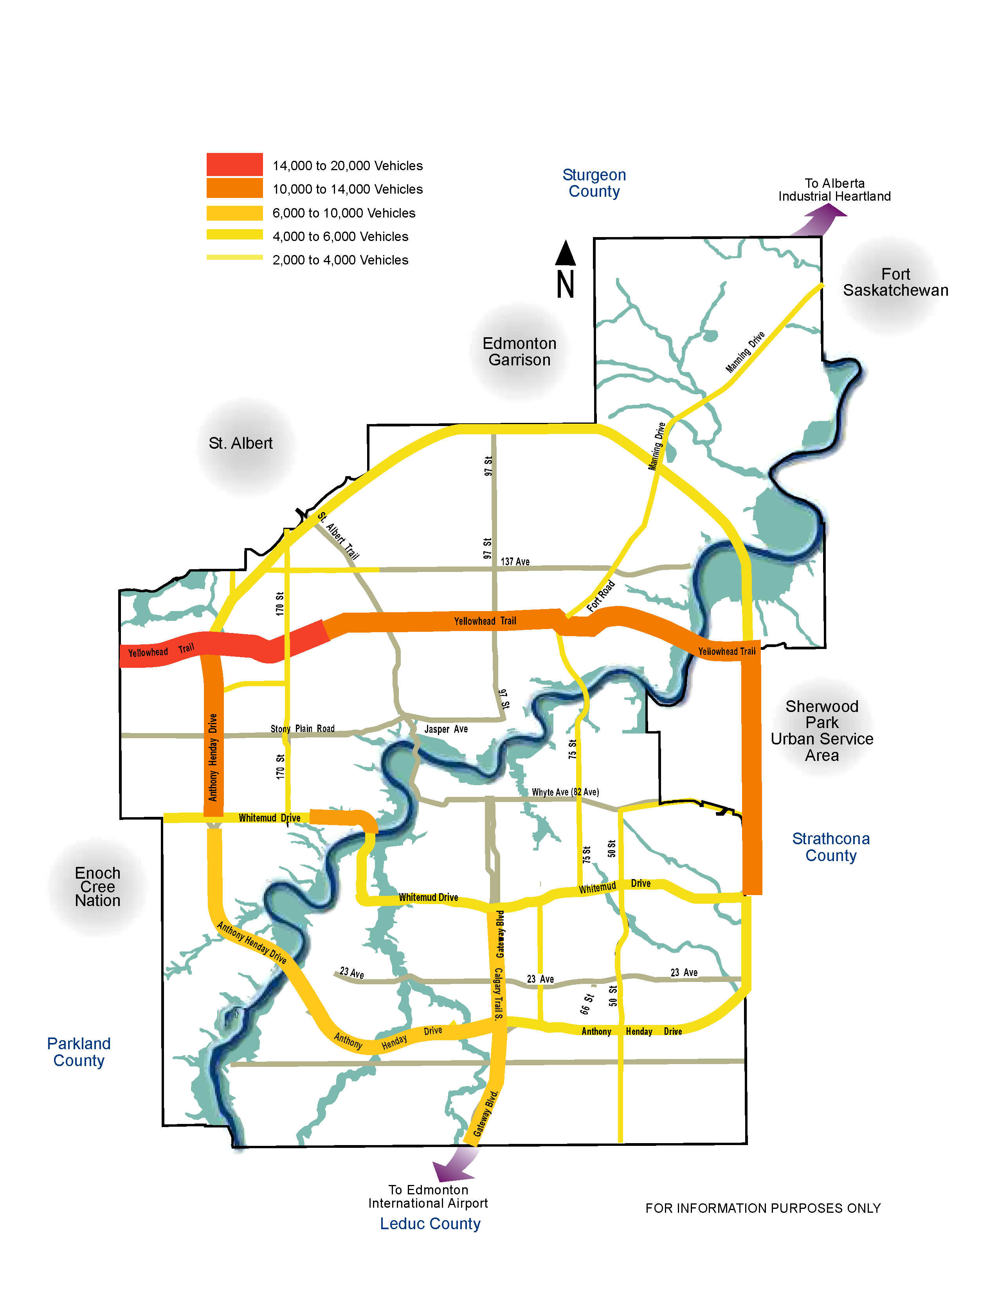

  - Key Industrial Areas

Some of the key existing industrial areas and projects that are emerging within the city and Region will require an effective goods and services movement network.

- The northwest and southeast industrial areas within Edmonton.
- Refinery Row east of Edmonton.
- Highway 2 corridor – a growing industrial complex focused along the highway corridor.
- Northeast Industrial Area - a large undeveloped area north of Manning Drive is planned for eco-industrial development.
- Alberta's Industrial Heartland
Also known as Upgrader Alley, this is a joint land-use and planning project between several municipalities in the Edmonton Capital Region to attract oilsands upgraders and other industrial projects to the region. This is the largest concentration of industrial development in Canada west of Toronto.
- Port Alberta
This is a strategy for developing an efficient cargo environment with a significant focus at the international airport. Port Alberta will be a major North American inland trade and transportation hub. It has the potential to transform the Edmonton Region into a major North American warehousing and distribution hub that combines air, rail and road transportation infrastructure with links to Asia and the United States.

Although much of the transportation network needed to service these areas is under the control of the Province, the City will endeavor to provide supporting infrastructure to encourage development of these areas.

  - Rail

Rail transportation is a key component of the logistics and distribution sector in the Edmonton region. It is a critical link of the supply chain for many businesses. Canadian National Railways (CN) and Canadian Pacific Railways (CP) have major rail operations in Edmonton. CN has an intermodal yard in northwest Edmonton (Yellowhead Trail and 184 Street); and CP will be constructing a large intermodal facility at the south boundary of the City of Edmonton (41 Avenue SW and QE II Highway south) to replace its current intermodal yard on Calgary Trail and 34 Avenue NW.

Rail shipments are increasing and will continue to do so, resulting in longer and more frequent trains. Resource development in the north is a major driver of increased rail traffic, as are petroleum and petrochemical complexes in the Edmonton region. Prince Rupert seaport opened in late 2007 to provide additional capacity for Asian shipments. It is expected that Edmonton will play an increasing role as a distribution centre, particularly for reloading opportunities of empty containers en route back to Asia.

As trains operating in urban areas cross roadways, the needs of the users of those two facilities come into conflict. There are 37 intersections of railway tracks and city roadways in Edmonton. Railway operations are impacted by growth in traffic volumes and the expansion of our roadway system.

While the grade separation of rail from roadways is ideal solution to address safety and capacity, it is an expensive capital expenditure. Construction cost of grade separation is generally a shared expense, paid for largely by the party constructing the new route. The ultimate responsibility to apportion design and construction costs is held by the Canadian Transportation Agency. The City of Edmonton has developed a system to assess the priority of upgrades to rail crossings, and will construct improvements to the crossings over time, particularly along high-demand goods and services movement corridors.

  - Air

Airports are a critical component of the Edmonton region’s public and industrial infrastructure and services. Passenger transportation has dominated air transportation growth in Edmonton for several decades, and increases in passenger levels are expected to continue. However, air cargo demands are increasing as well: air cargo is one of the fastest growing modes of transportation for high priority, time sensitive shipments.

Edmonton is currently served by two airports: the Municipal and the International. The Edmonton Municipal Airport, in the north-central area of the city, serves as the medium-industrial aviation site. Passenger traffic is limited, managed under the Edmonton Airports Access Policy

The Edmonton International Airport, located in Leduc County south of the city, accommodates the majority of air passenger and cargo traffic. Airport expansion plans are being developed to serve an increasing number of passengers and cargo shipments. The Port Alberta initiative is focused largely at this airport.

Good connection from the Edmonton International Airport to the downtown is an important factor in attracting business, investment and tourism to Edmonton and the surrounding region. Transit service from the airport to the city is being reviewed by the City of Edmonton, the City of Leduc and Leduc County through the newly established Capital Regional Board. Over the long term, a strategic LRT line to the airport may be desirable.

Figure 8.2 Regional Industrial Areas

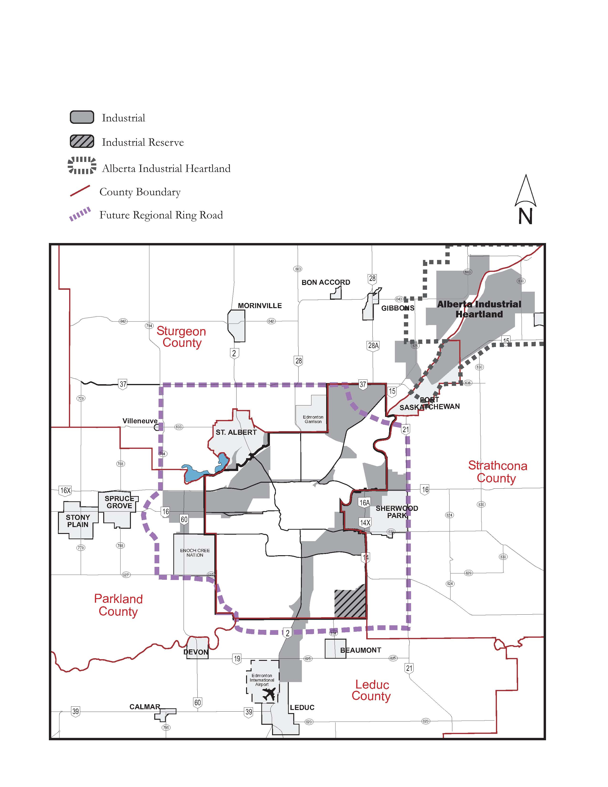
POLICY DIRECTION:

- The City will work with other jurisdictions, the Province and external service providers to ensure that Edmonton has a safe and efficient goods movement network that connects and interchanges well with other transportation modes and facilities.

What This Means:

- Maintaining a comprehensive network of truck routes, including Dangerous Goods Routes, that relies primarily on freeways, highways and arterial roadways.
- Protecting the integrity major goods movement corridors through the encouragement of appropriate land use planning and control of direct access.
- Giving priority to road construction projects that enhance goods and services movement and that facilitate access to developing and established business and industrial areas.
- Working with rail companies and regulatory agencies to address operational issues and selectively upgrade rail crossings within the city.
- Recognizing the importance of rail transportation to the economic health of the Region and the importance of incorporating the impact of railways on future land development, roadway planning and traffic growth.
- Recognizing the importance of air transportation and multimodal facilities in our city.
- Working with agencies planning rail and air facilities to participate in facilitating effective interchange of goods and services.
- Conducting surveys of goods and services movement to understand the travel patterns within the city and Region to adequately plan for the needs of the community.
- Consulting with industry and the public to resolve goods and services movement issues.
- Working with the Province to have facilities located within the City of Edmonton (such as Yellowhead Trail) that function as part of the Provincial or Federal highway system and serve the regional population recognized as such, and secure funding for their improvements.

- Regional Interface

Regional cooperative planning supports TMP strategic goals
- Access and Mobility
- Economic Vitality

  - Background

As Alberta’s capital city and the major urban centre within the Capital Region, Edmonton has become the focus of complex growth issues that demand a regional perspective. A new regional governance structure has been developed to address the impact of Alberta’s economic boom and associated growth pressures on the Capital Region as well as to protect the future economic viability of the Region.

The Capital Region Board was established by Provincial legislation in April 2008. This board is a decision-making body made up of the City of Edmonton and the twenty-four surrounding cities, towns, villages and counties. The Board's mandate is to create a comprehensive plan to manage regional growth, the Capital Region Growth Plan, with completion expected in 2009. The Capital Regional Growth Plan will cover land use, transportation and public transit and it will be binding on all municipalities in the Region. As of this writing, the Capital Regional Growth Plan is not yet in existence. The purpose of this chapter is to describe the way the City of Edmonton sees its role in the Region and the way it might work with its neighbours. Ultimately, the Capital Regional Growth Plan will govern these issues. If this TMP is inconsistent with the Capital Regional Growth Plan, the TMP must be amended to conform to it.

The Transportation Master Plan reflects the need and opportunity for more integrated planning and intermunicipal co-operation that the Capital Region Growth Plan brings. The strong economic growth within the Edmonton Region is generating changing demands for infrastructure and services and spurring investment in support of population and employment growth. The City of Edmonton is responding to these pressures by addressing land use and transportation issues through an integrated approach to the Transportation Master Plan and the Municipal Development Plan. Together these plans propose to build on Edmonton’s strengths as a major city and will show leadership in responding to growth pressures by accommodating growth in a more environmentally progressive way, based on land use and transportation integration and more efficient use of infrastructure. The result will be a more compact city, with an emphasis on transit. This approach will establish a strong urban core for Edmonton within the region and will be the basis for an efficient regional transportation system. Coordinated planning of the regional transportation system will ensure that major regional employment areas and education centres are well-served by a range of travel modes.

Edmonton will support the Capital Regional Growth Plan by planning within the regional context and anticipating integration with regional plans and infrastructure.

  - Public Transportation

Within the Capital Region, the City of Edmonton, the City of St. Albert and Strathcona County operate full transit systems. In addition, Edmonton currently provides commuter service on a contract basis to other small municipalities. While the existing transit systems coordinate and cooperate, there is no common mandate, vision, goal, strategy or standards for the provision of public transportation within the Region.

The Capital Regional Board has recognized the importance of regional public transportation in supporting the wellbeing of the Region. The Board has set regional transit as one of four priorities for the Capital Region Growth Plan and is pursuing an initiative to establish a mechanism for the planning, prioritization and implementation of inter-municipal transit within the Region.

The City of Edmonton will continue to participate in the development of a coordinated and integrated approach to regional transit. The focus of regional transit will be on centres or nodes where regional services, commercial development and more intensive land uses are concentrated. As the City of Edmonton plans extensions to LRT, alignments will be designed with the consideration for potential extension to adjacent municipalities. Edmonton will work with its regional partners and the Province to identify corridors to be protected for future high- speed transit. Transit priority corridors to improve transit service from neighbouring municipalities into the City will be considered in cooperation with those municipalities. Edmonton will also encourage regional partners to undertake land use planning in support of transit, including the principles around the integration of transit and land use to create higher density, walkable community nodes around major transit facilities.

Edmonton anticipates developing Park and Ride facilities at the extremities of LRT lines or at key transit centres, particularly within the Transportation Utility Corridor. These lots will provide accessibility to LRT for those within the Region with no or limited transit service. Park and Ride lots on the outskirts of neighbouring municipalities may encourage use of inter-municipal transit service or car-pooling.

  - Roads

The Province of Alberta is largely responsible for major roadway facilities within the Region. However, there are a number of roadways under the control of the City that are of regional significance as they serve the regional population. These consist of the Inner Ring Road (170 Street, Whitemud Drive, 75 Street/Wayne Gretzky Drive and Yellowhead Trail) and the highway connectors feeding the Inner Ring Road. Roadways of significance within the City of Edmonton that fall under the control of the Province include the Outer Ring Road (Anthony Henday Drive) and the highway connectors from Anthony Henday Drive connecting to highways within the Region.

In addition to the existing Provincial Highways within the Region, the Province is also considering the development of a Regional Ring Road. This will impact future traffic patterns in Edmonton as it will provide additional route options for regional trips.

Regional Commuter Traffic

While the highway connectors and Inner Ring Road are the city facilities of significance used by the regional population, all roads within the city are available for use by the regional population and will be affected by regional growth. The city’s roadways will be managed as outlined in chapter 7, with a focus on managing the existing transportation system more effectively.

A Capital Region TDM Committee made up of representatives from Edmonton and the surrounding municipalities has been developed to ensure that the planning, development, implementation and monitoring of Transportation Demand Management initiatives within the Capital Region are done in a coordinated fashion.

  - Other Modes

Inter-City Rail

The Province of Alberta is considering planning a high-speed inter-city rail between Edmonton and Calgary. This is in the preliminary stages of planning, and definitive information is not yet available.

Rail

The rail network within the Capital Region is a significant aspect of the regional transportation system and it is expected to increase in importance for the logics and distribution business sector over time. For effective rail movements, efficient inter-modal facilities and travel throughout the city and Region are required. The City will work cooperatively with its regional partners to facilitate this. Within Edmonton, the City will encourage appropriate land use and access to inter-modal facilities and will prioritize grade separation of key rail crossings.

Air

Air passenger and cargo traffic is another major contributor to the regional transportation system. Increases in air traffic and the focus of Port Alberta at the International Airport amplify the need to provide good accessibility between this airport and major nodes within the Region, particularly the central area of Edmonton. To this end, the City will actively pursue and plan cooperatively with regional partners to improve both roadway and transit access to Edmonton’s central core.

Active Modes

Active transportation such as walking or cycling has great potential for trips between Edmonton and adjacent communities, particularly when combined with transit. It is important to co-ordinate the planning and implementation of a network of facilities for active modes that meets the needs of users throughout the Capital Region.

POLICY DIRECTION:

- The City will work with neighbouring municipalities as part of the Capital Region Board to facilitate and implement improvements to the transportation system within the Region.

What This Means:
- Working constructively with the Capital Region Board as it prepares the Capital Region Growth Plan and will abide by the terms of the plan once it is formally adopted.
- Cooperatively planning and implementing system improvements, including:
  - Transit network: Work with the Region Board to coordinate and implement a region-wide system of inter-municipal transit service.
  - Land Use Planning: Encourage the development of high-density nodes around transit facilities. Protect corridors for future high-speed transit.
  - Rail: Encourage appropriate land use and access to inter-modal facilities. Prioritize grade separation of key rail crossings within the city.
  - Air: In cooperation with other agencies, improve connections to the International Airport for both roads and transit.
  - Road: In cooperation with the Province, improve roads of regional significance, particularly the Inner Ring Road and Highway Connectors
  - Active Modes: Pursue opportunities for developing a network of regional multi-use facilities.
  - TDM: Ensure that TDM initiatives in Edmonton are coordinated with adjacent communities within the Capital Region.
- Working with the Province to ensure needs of the City will be considered in the planning and design of Provincial highway facilities.

- Asset Management & Maintenance

Asset Management and Maintenance supports TMP strategic goals:
- Access and Mobility
- Sustainability
- Health and Safety
- Well-Maintained Infrastructure

  - Background

There is over $32.6 billion of City-owned infrastructure all around us, providing the essential systems that maintain Edmonton’s quality of life. The estimated replacement value of the City of Edmonton’s transportation infrastructure — including roads, bridges, traffic and street lights, walkways and LRT and transit facilities — is about $13.5 billion. These assets are continuously deteriorating, and all will eventually require rehabilitation or replacement. With limited budgets and increasing demands on the transportation network, the City is challenged to manage its assets in a way that minimizes total life-cycle costs yet sustains expected levels of service and safety.

In 2008, the City of Edmonton estimates its infrastructure funding “gap” – the difference between funding needs and available funds – at $19.2 billion over the 2008-2017 period. Transportation infrastructure constitutes 60% of this funding gap (source: Delivering the Goods, June 2008). Currently, over one-third of City roads are in need of rehabilitation or reconstruction. And another third of the City-owned bridges and bridge structures are also need rehabilitation or replacement.

Clearly, the City is facing huge challenges with its infrastructure, and must focus on a proactive approach to ensure the long term viability of the transportation system.

  - Asset Management

Asset Management refers to a set of policies and programs which take a proactive approach to decision making for infrastructure. This strategy emphasizes careful planning, identification of maintenance and repair requirements and optimizes investment through a mix of preventative maintenance, renewal and reconstruction.

Asset management may result in higher design, construction and repair standards so that equipment and facilities last longer, with reduced maintenance cost. In some instances, increased funding for maintenance and minor repairs are prudent in order to prevent minor deterioration from becoming severe. Identification of all costs related to the capital and on-going operation of the facility are vital for determining the true cost of a facility. Detailed life-cycle cost analysis (that is, taking into account total costs over each assets operating life) should occur during planning and procurement, so that options with the lowest overall long-term costs can be identified.

An asset management approach which uses life-cycle cost analysis requires:

- An evaluation and maintenance/replacement and reinvestment system.
- A link between asset’s initial cost outlay and its on-going funding requirement in the City budget. This will ensure that critical maintenance and repairs schedules and activities are adhered to and not subject to compromise due to insufficient funding levels.
- A ‘maintenance-priority’ policy, which means that maintenance, operations and incremental improvements to existing infrastructure are given priority.

ASSETS

Roads and Sidewalks

Edmonton’s road network consists of more than 4,500 km of roadway. The City collects condition assessment information to monitor the condition of the roadway and sidewalks for comparison with their stage in service life and for monitoring performance. The City has developed a Pavement Investment Strategy that is used for asset management planning and budgeting to maintain roads in a good or fair condition.

Bridges

The City of Edmonton is responsible to maintain about 170 bridge structures to ensure the safety of the users and to monitor the structural integrity of the infrastructure. The City’s Bridge Investment Strategy outlines the annual inspections and repair requirements for these structures and also the scheduling and need for maintenance and major rehabilitation. Priority is given to all crossing of the North Saskatchewan River and other major bridge structures on the arterial roadway, transit, and goods movement corridors.

Signs, Signals, and Street Lighting

The physical assets in this category that are monitored in Edmonton include streetlights traffic control signals, traffic control signs and road pavement markings.

Public Transportation

Edmonton Transit has a fleet of buses, LRT vehicles and vehicles serving persons with mobility challenges and facilities to store and maintain this fleet.

In keeping with the Transportation Strategic Goal of sustainability, the asset management procedures for City infrastructure procurement and maintenance should consider ways to lesson environmental footprint. For example, a sustainable fleet management plan could evaluate fuel efficient vehicles to save both cost and impact such as air emissions and non-renewable resource usage.

While all of transportation assets are monitored and programs in place to identify maintenance requirements, adequate funding has not been available to carry out all maintenance programs. The condition or state of repair of transportation assets affect mobility choices for Edmontonian’s. For example, an effective transit system is dependent upon adequate sidewalk connections and good roads on which to operate buses. Likewise, an effective cycling network required smooth surface free of road damage and hazards.

POLICY DIRECTION:

- The City will fully utilize best Asset Management practices to achieve a safe, enjoyable, well-maintained transportation system.

What This Means:

- Using an Asset Management Strategy that preserves infrastructure and minimizes the total life-cycle cost of implementation, operation and renewal while providing continuous, safe and reliable services.
- As infrastructure is added, full cost of operating, renewing and maintenance are recognized.
- Planning and implementing infrastructure, including modifications, in a manner that recognizes implications for maintenance service level standards, operating practices and costs.
- Recognizing implications of a winter city in design standards and asset management practices.
- Coordination with other agencies regarding construction. infrastructure renewal practices, and planning details (i.e. pavement restoration practices
- Assessing alternative materials, design standards and maintenance renewal practices to ensure that best practices are applied to life-cycle maintenance are in sync with drainage work).

  - Maintenance

Infrastructure maintenance services essentially fall into two categories - activities for:

- Preservation of the service life of the asset (Preservation-related)
- The safety and enjoyment of users of the infrastructure (Operation-related)

The aim of both types of activities is to keep capacity at intended levels while keeping users moving safely. These types of preventive maintenance tend to reduce lifecycle costs as well as improve safety, reliability, travel conditions, and can help to protect the environment.

Preservation of the infrastructure’s service life involves repair and renewal. Infrastructure maintenance services related to safety and enjoyment include winter snow and ice control, and road and walkway lighting. Some activities are conducted for both preservation and safety/enjoyment reasons. For example, sweeping and litter control will preserve the storm sewer capacity, as well as improve travel conditions and overall city image through establishing standards of cleanliness.

As a winter city, Edmonton’s specified standards for snow plowing are a key to ensure mobility and safety for all users of the transportation system. The Snow Policy approved by City Council in 2007 outlines expected performance.

Active Transportation

Active transportation such as, walking, cycling, manual wheel chair use etc., should be available year round for all citizens. In inclement weather, particularly during the winter months, using such modes can be a challenge. Therefore it is not enough to simply build facilities for active transportation – the City must have a robust maintenance policy. The level of maintenance provided affects the accessibility for active modes. Sidewalks that are not cleared make transit stops difficult to access. Roads or bike lanes with gravel and debris in them make cycling difficult.

POLICY DIRECTION:

The City will have robust maintenance practices to facilitate year round transportation.

What This Means:
- Establishing written procedures that specify maintenance standards, schedule, quality control, and follow-up that will be used for pedestrian, bicycle and multi-use facilities, based on “current best practices”, and encouraging the safety of users.
- Maintaining a high standard of cleanliness, and will encourage citizens to report pedestrian and bicycle facility maintenance needs, garbage and graffiti, and other problems to a publicized central telephone number (311).
- Partnering with volunteers and sponsors to help patrol, clean and maintain public trails and related facilities.
- Maintaining a snow removal policy that outlines service standards to maintain mobility and safety for all the users of the transportation system.

- Implementation

  - Background

The Transportation Master Plan provides a long-term view of the future transportation system within the City and Region. Policies contained in the TMP are strategic in nature. To maximize the effectiveness of the TMP, an implementation plan will be developed to outline specific areas of action that will be completed.

Each Policy Direction includes an expanded explanation under “What This Means” to give an indication of the plans, programs and action items that will be included in the Implementation Plan and subsequently in Department work programs. A significant aspect of implementing the TMP will be project construction, carried out through the City’s capital planning and budgeting process.

The implementation plan will review evaluation criteria to consider a system for prioritizing projects based on the TMP strategic goals

  - Performance Measurement

The success of the TMP as a long-range plan depends on a number of variables. The City must be aware of its progress towards its strategic goals so that it can add or modify priorities as needed. An evaluation system for selecting projects based on performance measurement would enable the City to improve its ability to effectively plan, and manage the transportation system. Such an evaluation system will be reviewed.

An effective monitoring framework for the TMP must closely consider the TMP strategic goals and objectives, and manage their implementation. Performance measurement for the City’s transportation system requires a consistent approach for systematically collecting, analyzing, utilizing and reporting the measures. Difficulties include that some data may not be available or accurate, or the cost of obtaining some information may outweigh the benefits that the information could provide. Therefore information that is already collected and available should be utilized wherever possible, as this is a cost-effective, practical approach to integrating performance measurement into transportation planning. Emphasis is placed on strategic performance indicators that measure system-wide, long-term changes and that are easily understood by the public.

  - Review and Progress Reporting

While the Transportation Master Plan has been developed in view of a horizon of the year 2040, it is expected that a review and update of the plan will be completed in approximately 10 years. The implementation plan that will be developed will be updated more frequently to reflect current trends, budget and financial changes and political direction. Performance measures that monitor progress towards achievement of the TMP strategic goals will be reported regularly.

Policy Direction:

- The City will develop an implementation plan and performance measures that will monitor progress towards achieving the strategic goals of the TMP and will inform the City’s decision making process.

What This Means:

- Developing an implementation plan that outlines plans, programs and activities to be incorporated into the Departmental work program.
- Developing and maintaining a comprehensive monitoring and reporting program.

GLOSSARY
Glossary
Accessibility: The ease of accessing desired goods, services, activities and destinations (together called opportunities).
Active Transportation: Any mode of transportation by which people use their own energy to power their motion. It includes modes such as manual wheel chair use, walking, in-line skating, jogging, cycling, skateboarding, and cross-country skiing and snowshoeing in winter months.
Area traffic management: Processes and techniques to preserve neighbourhood livability by mitigating undesirable effects of vehicle travel including excessive volumes and speeds, aggressive driver behaviours and the creation of unfavourable conditions for walking, cycling, and other active transportation.
Asset management: A set of policies and programs which take a proactive approach to optimizing investment in assets, through a mix of careful planning, selection of appropriate construction standards, and managing condition through the identification of appropriate operation, maintenance, and renewal requirements and schedules. Detailed life-cycle cost analysis is used during planning and procurement so that options with the lowest overall long-term costs can be identified.
Barrier-free: A design characteristic that maximizes accessibility for persons with physical or cognitive difficulties.
Bike Lane: A designated roadway lane for cyclists only (also referred to as a Class II Bikeway), includes ‘contra-flow lanes’.
Biodiversity: Capability of supporting entire populations of plants and animals and associated ecological processes.
Built Environment: The arrangement of buildings, networks of open spaces, and transportation systems within urban settings, and the nature of the physical connections between these places and systems.
Bus lane: A roadway lane dedicated for use by public transit vehicles that may be open to mixed traffic at some hours of the day or days of the week, and that may also be open to other vehicles such as carpools, taxis or bicycles
Capacity: Maximum hourly rate at which vehicles can reasonably be expected to pass a given point given prevailing roadway, traffic, and control conditions.
Carpool/Rideshare: Shared use of a motor vehicle by two or more persons to make a trip, when they would otherwise travel separately.
Carpool lanes: A roadway lane dedicated for use by carpools (i.e. vehicles meeting minimum occupancy criteria, usually two or three persons) and buses that may be open to mixed traffic at some hours of the day or days of the week, and that may also be open to other vehicles such as taxis or bicycles.
City Council: City Council is comprised of the Mayor and 12 City Councillors.
Community/Public – Any person or group of people living or working in the City of Edmonton.
Complete Community: A complete community is a community that is fully developed and meets the needs of the local residents through an entire lifetime. Complete communities include a range of housing, commerce, recreational, institutional and public spaces. A complete community provides a physical and social environment where residents and visitors can live, learn, work and play.
Complete Streets: Streets designed to enable safe and efficient access for people using a variety of transportation modes (car, truck, transit, walking, wheel chair use, jogging, cycling) and for users with varying levels of physical and cognitive abilities.
Connectivity: The directness of links and the density of connections in a path or road network. A connected transportation system allows for more direct travel between destinations, offers more route options, and makes active transportation more feasible.
Contra Flow Lane –A designated bike lane allowing travel in the opposite direction to vehicular travel on a one-way roadway.
Dangerous Goods Route (DGR): A specialized route which is part of the City’s Truck Route system, designated for heavy vehicles carrying specified hazardous materials.
Dedicated travel lane: A roadway designed for the exclusive use of buses, rapid transit and other authorized vehicles.
Delay: Delay is the average “wait” time for a vehicle stopped at a stop sign or a red light.
Density: The number of dwelling units, square meters of floor space, or people per acre or hectare of land.
Developers – Often companies owning or representing owners of large areas of land with the intent of developing residential, commercial or industrial infrastructure or buildings.
Disabled Adult Transit Service (DATS): A City of Edmonton door-to-door public transportation service for adults who cannot use regular transit service for all trips because of a physical, sensory or cognitive disability. DATS is not a taxi service – it is a shared-ride public transportation service where trips are scheduled to make maximum use of this shared ride service while staying within its budget.
Edmonton Region: A region which encompasses over 1.2 million hectares and currently home to 1.05 million people. The 25 municipalities in the region include Edmonton – with over 70 percent of the population – combined with four smaller cities, five counties (one of which is a specialized municipality), eleven towns, and four villages. The geographical region also includes another twelve small urban municipalities (mostly summer villages), several hamlets, three First Nation reserves and a major military base.
The municipalities that make up the Edmonton Region are:
Beaumont, Bon Accord, Bruderheim, Calmar, Devon, Edmonton, Fort Saskatchewan, Gibbons, Lamont, Lamont County, Leduc, Leduc County, Legal, Morinville, New Sarepta, Parkland County, Redwater, St. Albert, Spruce Grove, Stony Plain, Strathcona County, Sturgeon County, Thorsby, Wabamun and Warburg.
Goods Movement: The transportation of goods, usually freight, by road, rail or air.
Healthy Communities: These are defined by (Adapted from WHO (Europe, 1986):
- A clean, safe, high-quality physical environment (including housing quality)
- An ecosystem that is currently stable and is sustainable in the long term
- A strong, mutually supportive and nonexploitative community
- A high degree of public participation in and control over the decisions affecting one's life, health, and well-being
- The meeting of basic needs (food, water, shelter, income, safety, work) for all the city's people
- Access to a wide variety of experiences and resources with the possibility of multiple contacts, interaction, and communication
- A diverse, vital, and innovative city economy
- Encouragement of connectedness with the past, with the cultural and biological heritage, and with other groups and individuals
- A city form that is compatible with and enhances the above parameters and behaviors 10. An optimum level of appropriate public health and sick care services accessible to all
- High health status (both high positive health status and low disease status)
Freeway: A high standard, high speed arterial roadway with no direct access to adjacent properties; intersections are fully grade-separated.
Granular Trail: Generally describes a multi-use trail, often in parkland, constructed of granular material (gravel).
Health and Safety: Whereas ‘health’ is a state of complete physical, mental and social well-being and not merely the absence of disease or infirmity, and ‘safety’ is the condition of being protected against physical, mental, and social consequences of failure, accidents, or harm. Together public ‘health and safety’ objectives need to be integrated into transportation decision-making because traditional transportation planning tends to overlook negative health impacts resulting from increased motor vehicle travel which causes physical activity decreases, motor vehicle collisions, air pollution emissions and, mental health effects.
High Frequency Transit: Any form of public transportation designed to move people quickly and efficiently with high frequency between service - includes light rail transit, and buses in dedicated travel lanes.
Highway Connectors: Strategically located, higher standard arterial roadways connecting the Inner Ring Loop to the Outer Ring Road and the provincial/national highway system.
Infill Development: Development in the existing areas of a city, occurring on vacant or underutilized lands, or behind or between existing developments.
Infrastructure (municipal): The services and facilities in which Edmonton has capital investment and maintenance responsibilities, including roadways, sidewalks, bridges, street lights and traffic signals, transit facilities, solid waste and water management systems, potable water distribution systems, storm sewers, sanitary sewers, sports fields, playgrounds, arenas, pools, police and emergency response stations, civic buildings, parks and boulevard trees.
Inner City: Neighborhoods within the Inner Ring Road.
Inner Ring Road: A network of higher standard arterial roadways, together forming a connected loop within the city (Yellowhead Trail, 75 Street, Whitemud Drive, 170 Street).
Innovation: One of four Principles defined in the Edmonton Strategic Plan, 2009-2018. Defined as a planning approach and operational culture within a municipality which encourages and enables continuous improvement and the exploration and adoption of new techniques, technologies, products and ways of operating in order to improve results and lead progressive change.
Integration: One of 4 Principles defined in the Edmonton Strategic Plan, 2009-2018. Defined as a holistic view of strategic planning that acknowledges the inter-related and inter-dependent reality of complex urban environments. Goals and priorities set for different elements in urban planning are as inter-related ecosystems and considered in terms of how they impact, support and drive each other.
Intensification: The development of a site at a higher density than currently exists. It can be achieved through redevelopment, development of vacant/underutilized lots, the conversion of existing buildings, or through infill development in previously developed areas.
Inter-modal Transportation Facility: A transportation facility where transfers between modes can be made. For instance, freight inter-modal facilities feature a rail yard where containers are transferred between trains and trucks.
Land Use Bylaw: The bylaw that divides the city into land use zones and establishes procedures for processing and deciding upon development applications. It sets out rules which affect how each parcel of land in the city may be used and developed and also includes a zoning map.
Level of Service (LOS): An indicator of the quality of operating conditions for the transportation system that may be applied to cycling or walking facilities (to reflect connectivity, convenience and comfort), transit service (to reflect speed, reliability and frequency) or roadways (to reflect the ratio of vehicle demand to roadway capacity, and resultant delay).
Light Rail Transit (LRT): Edmonton’s electrically powered fixed-rail public transportation system, which runs both below and above ground. There are currently 11 LRT stations in Edmonton with 4 additional stations in construction for the south LRT extension project.
Livability: One of four Principles defined in the Edmonton Strategic Plan, 2009-2018. Defined as an interrelated set of factors that influences people to choose a place to live and reinforces their sense of well-being there. The concept of livability is based on the knowledge that the economic and social life of the community is intimately linked to its natural and built environment, and together these elements impact social and cultural goals. Livability factors include:
- Social capital: The human capital of the people within a city in all their diversity and potential, together with an urban culture that reflects people’s social values and makes them feel included and respected.
- Amenities: A clean and well-designed community that allows many choices of lifestyle and includes open and green spaces, respect for historic features and intangibles such as a sense of place and fostering community character.
- Economic prosperity: Sustainable economic and employment opportunities.
- Safety: A sense of personal and community safety and overall social order.
- Access to social services and infrastructure: such as healthcare, education, recreation and arts and culture.
- Environment: An environment sustained for current and future generations through responsible practices. Clean air and water, access to local food supplies and the healthy co-existence of natural and urban environments.
- Affordability: The ability of people of all incomes to have access to affordable core needs such as housing, food, transit and core social services. The recognition as well that affordability of other amenities affects the overall competitiveness of a city in attracting and retaining residents and impacts the quality of life of those who live there.
- Ease of mobility and movement: Accessible roads and transportation modes that meet the requirements and choices of society, communities and people of all ages and needs.
- Participation: Political and democratic processes that allow people to participate in decisions that affect them.
Maintenance (of Infrastructure): Services and activities which preserve the service life of the asset (preservation-related) or improve the safety and enjoyment of users of the infrastructure (operation-related).
Mature Neighbourhoods: Edmonton’s mature neighbourhoods are the neighbourhoods within the Mature Neighbourhood Overlay (MNO), are well-established and were effectively built out by 1970.
Major Trip Generator: Something which is predicted to generate a high number of total trips to/from a site relative to other land uses.
Mobility: Physical travel that provides basic access to essentials such as employment and education, health care, basic food and clothing, public services and important social or recreational activities.
Modal Share: The percentage of person-trips made by one travel mode, relative to the total number of person-trips made by all modes.
Modal Shift: The shift away from high automobile use and dependency, to an increased variety of transportation mode usage for various types of trip.
Multi-Use Trail (MUT): A facility for active transportation modes (including walking, wheel chair use, jogging, cycling, and in-line skating) which is generally constructed to a wider, asphalt standard, but may be concrete or granular. There are currently 190 km of MUTs in Edmonton, 115 km of which are in the river valley and ravine system.
Municipal Development Plan (MDP): The senior strategic planning document guiding growth and development in Edmonton which contains policies relating land use, housing, economic activity, recreation, environment, transportation and social issues. It also provides the strategic framework for more detailed and specific plans, policies and programs.
Neighbourhood: A small, stable geographic area, usually with a population between 2500 and 8000, with an appropriate mix of housing types, with convenience-type commercial facilities, and where appropriate, schools or park facilities.
Nodes (Transit): Key area of transit accessibility such as an LRT station or transit centre.
Noise Attenuation: Using facilities such as earth berms, screen fences (typically wood), and/or noise walls (typically concrete, wood, metal) to reflect traffic noise.
On-Site parking: Car parking stalls provided within the current/proposed development site that are privately owned and maintained.
Off-Site Parking: Car parking stalls (usually within 120 metres) that are used to meet the car parking requirements for a proposed development.
Outer Ring Road (Anthony Henday Drive) – A high standard provincial roadway in the Transportation and Utility Corridor, forming a connected ring around the outer fringe of the city.
Park & Ride lots: Parking lots, usually located at LRT stations or transit centres, that allow automobile users to transfer to and from public transportation service in a convenient manner.
Peak period: A period of high person-trip demand, generally on weekday mornings and afternoons, which includes what are commonly referred to as ‘rush hours’.
Pedestrian Oriented, Pedestrian Friendly, or Walkable: An environment designed to make travel on foot convenient, attractive, and comfortable for people of various ages and physical or cognitive abilities. Considerations include the directness of the route, safety, amount of street activity, separation of pedestrian and auto circulation, street furniture, surface material, sidewalk width, prevailing wind direction, intersection treatment, curb cuts, ramps and landscaping.
Performance measurement: Monitoring of indicators that enable an understanding of conditions, actions and impacts that describe progress towards key objectives.
Premium Transit: High frequency transit service provided throughout the day, consisting of LRT and high frequency bus
Public/Community – Any person or group of people living or working in the City of Edmonton.
Public Transportation (also, Transit): A transportation system that transports members of the general public, while charging set fares. In Edmonton, Edmonton Transit is the public transportation body, and the system is comprised of bus, DATS, and LRT services. In Edmonton, the Vehicle for Hire Commission oversees the operation of taxis and related businesses.
Queue: A lineup of vehicles, generally stopped at an intersection or access.
Regional Connections: Connections between the transportation systems of the City of Edmonton and the surrounding region. A coordinated, integrated approach is required to connect the transportation systems effectively.
Security (Personal Security): The condition of being protected from criminal activity such as assault, theft, and vandalism. Crime Prevention Through Environmental Design (CPTED), as well as Neighborhood Watch, community policing programs, and special transit programs can increase personal security regarding the transportation system. Although the perception of security is not directly related to actual security.
Shortcutting: Through traffic having no origin or destination within a neighbourhood, usually where drivers perceive a shortcut route as shorter in time or distance than the alternative arterial route.
Smart Choices for Developing Our Community: A program comprised of a group of six initiatives to change the way Edmonton grows and develops, so that the city will be more fiscally and environmentally sustainable. The initiatives are:
- neighbourhood reinvestment
- residential infill
- transit-oriented development
- walkability
- urban design
- redevelopment of older commercial and industrial lands.
Stakeholder: A group or individual that is impacted by a transportation issue or will be impacted by any option being considered to resolve a transportation issue. Stakeholders may be external (a member of the public) or internal (a member of a civic department or agency).
Streetscape: All the elements making up the physical environment of a street including the road, boulevard, sidewalk, building setbacks, height and style. It also includes paving treatments, trees, lighting, pedestrian amenities and street furniture.
Sustainability: One of 4 Principles defined in the Edmonton Strategic Plan, 2009-2018. Defined as a way of living which meets the needs of the present and does not compromise the ability of future generations to meet their own needs. It requires an integrated, holistic view. Sustainability includes environmental, financial, and social sustainability, and refers to long-term and indirect impacts of current decisions.
Traffic Calming: The elements of a streetscape that are designed to slow the speed of traffic.
Transit: see Public Transportation
Transit Centre/ Transit Station: There are connection points where multiple busses (centres) or LRT vehicles (stations) can stop simultaneously, to allow cross-route transfers.
Transit Corridor: A corridor along which buses or LRT travel. These corridors may be dedicated bus lanes or give transit priority, and along which infill development and intensification is beneficial and encouraged.
Transit Oriented Development (TOD): Intensified development around premium transit nodes with progressively lower density development spreading outwards from the centre. TOD creates attractive, livable and compact neighbourhoods with housing, jobs, shopping, community services and recreational opportunities all within convenient walking distance of a transit node. All TODs are not the same. Each development has a unique context and may serve different purposes. Some intensified and mixed use development will also occur along high frequency transit corridors at a lower level of magnitude
Transit Priority Measures: Strategies to increase transit operating speeds and transit travel time reliability in mixed traffic, such as traffic signal priority or queue jumps.
Transportation Demand Management (TDM): A range of strategies that encourage individuals to reduce the number of trips they make, to travel more often by non-driving alternatives, to travel outside peak periods and to reduce the length of their trips.
Transportation Facility: A facility or infrastructure related to the city’s transportation system, including roads, including roads, bridges, traffic and street lights, walkways, LRT vehicles, garages and maintenance buildings)
Transportation System Management (TSM): A range of strategies that maximize the efficient operation of the overall transportation system through operational measures and localized infrastructure modifications, for the benefit of all modes of travel.
Transportation Strategic Goals: Seven high-level goals which express what a desirable future transportation system might look like, and how it can benefit residents.
Transportation Utility Corridor (TUC): A ribbon of land around the city, under the direct control of the Province of Alberta, which is intended to be used for the Outer Ring Road (Anthony Henday Drive), power lines, and sewers.
Travel Mode: The method of travel, such as car use (driver or passenger), public transportation (bus, LRT, DATS), or active transportation (including walking, wheel chair use, jogging, cycling, and in-line skating).
Truck Route System: A network of designated roadways that have been designed and constructed to permit and withstand use by heavy trucks.
Urban Traffic Noise Policy: Thresholds under which daily noise due to vehicular traffic on major transportation facilities is deemed to be acceptable, and above which the UTNP designates the responsibility for noise attenuation.
Universal Design: Transportation systems designed to accommodate a wide range of users, including people with physical and cognitive disabilities and other special needs.
Walkable, Pedestrian Oriented, or Pedestrian Friendly: An environment designed to make travel on foot convenient, attractive, and comfortable for people of various ages and physical or cognitive abilities. Considerations include the directness of the route, safety, amount of street activity, separation of pedestrian and auto circulation, street furniture, surface material, sidewalk width, prevailing wind direction, intersection treatment, curb cuts, ramps and landscaping.
Walkable Community: A form of community design that focuses on creating enjoyable places to walk and desirable destinations within close distances, with a goal to create communities where people do not have to rely on their automobiles to get around.

Walkway: A hard surfaced, off street trail that makes use of park areas and utility rights-of-way within residential neighborhoods.

APPENDIX
Appendix 1: City Vision, Principles and Strategic Goals

City Vision

A creative description of Edmonton's future, the vision guides our decisions, helps us set direction and encourages us to align our priorities as we work to make Edmonton the city we want it to become in 2040.

Take a river boat from one shore of the world’s largest urban park to the other, from the university to the legislature. From the water, look up and consider the skyline, the bustling core and the towers and urban villages to the east and west. The people on the sidewalks and trails, from First Nations to new Canadians, linked by a common purpose — to learn, to prosper, to celebrate. Take the LRT in any direction from here and you’ll be in the heart of somewhere special. Welcome to Edmonton, the capital of Alberta, a northern city of art and ideas, research and energy.

- Edmonton is an energy city. Energy drawn from the ground and from above; from the sun and wind. But the true power of Edmonton is the democratic spark in its people.
- Edmonton is a city of design — urban design, architectural design, and environmental design. Walk its safe, leafy neighbourhoods, ride its efficient and accessible transportation system. The city has grown up; now we’re building smarter.
- Edmonton links the continent with the north and with Asia. This cooperative regional economy is powerful and diverse, oriented toward the future. Visit the universities and colleges, the humming research parks, the downtown office towers: Edmonton is a destination for advanced technologies, health care, and green energy.
- Edmonton is a recreation city, an arts city. It is a city that embraces all seasons. Run, ride or ski on its trails and fields, cheer in its arenas and stadiums. Enjoy the museums, galleries, clubs, and theatres. Read its novels, watch its films. Spend an hour or a week in the glorious North Saskatchewan River Valley, the world’s largest preserved park.
- Edmonton is a city of many cultures, educational opportunities, and all political and social orientations; yet its citizens are inspired by a shared vision and the certainty that this city on a river is one of the most special places on earth.

City Strategic Plan’s Principles

The City of Edmonton Strategic Plan - 2009-2018 provides a focus to the City’s efforts to deliver the greatest value of services and infrastructure that are most important to Edmontonians, while managing the opportunities and challenges of our rapidly growing and changing city.

Four principles underpin the development and implementation of the City of Edmonton Strategic Plan:

- Integration
A holistic view of strategic planning that acknowledges the inter-related and inter-dependent reality of complex urban environments. Goals and priorities set for different elements in urban planning are as inter-related ecosystems and considered in terms of how they impact, support and drive each other.

- Sustainability
A way of living which meets the needs of the present and does not compromise the ability of future generations to meet their own needs. Urban planning takes an integrated, holistic view of urban environments and defines sustainability in the context of interrelated ecosystems encompassing economic, social, environmental and cultural sustainability.
The principle of sustainability also includes financial sustainability, ensuring urban planning recognizes and addresses resource constraints and capacities.

- Livability
An interrelated set of factors that influences people to choose a place to live and reinforces their sense of well-being there. The concept of livability is based on the knowledge that the economic and social life of the community is intimately linked to its natural and built environment, and together these elements impact social and cultural goals.
Livability factors include:

  - Social capital: The human capital of the people within a city in all their diversity and potential, together with an urban culture that reflects people’s social values and makes them feel included and respected.
  - Amenities: A clean and well-designed community that allows many choices of lifestyle and includes open and green spaces, respect for historic features and intangibles such as a sense of place and fostering community character.
  - Economic prosperity: Sustainable economic and employment opportunities.
  - Safety: A sense of personal and community safety and overall social order.
  - Access to social services and infrastructure: such as healthcare, education, recreation and arts and culture.
  - Environment: An environment sustained for current and future generations through responsible practices. Clean air and water, access to local food supplies and the healthy co-existence of natural and urban environments.
  - Affordability: The ability of people of all incomes to have access to affordable core needs such as housing, food, transit and core social services. The recognition as well that affordability of other amenities affects the overall competitiveness of a city in attracting and retaining residents and impacts the quality of life of those who live there.
  - Ease of mobility and movement: Accessible roads and transportation modes that meet the requirements and choices of society, communities and people of all ages and needs.
  - Participation: Political and democratic processes that allow people to participate in decisions that affect them.

- Innovation
A planning approach and operational culture within a municipality which encourages and enables continuous improvement and the exploration and adoption of new techniques, technologies, products and ways of operating in order to improve results and lead progressive change.
City Strategic Plan’s 10-Year Goals

To focus the City’s efforts on achieving the vision, Council identified six 10-year strategic goals. These goals will direct long-term planning for the City and help set priorities for the delivery and improvement of services, programs and infrastructure.

The 10-year strategic goals are:

- Preserve and Sustain Edmonton’s Environment
Ten-year strategic goal: In partnership with its citizens, businesses and institutions, Edmonton is the nation’s leader in setting and achieving the highest standards of environmental preservation and sustainability both in its own practices, and by encouraging and enabling the practices of its partners.

- Improve Edmonton’s Livability
Edmonton is one of Canada’s most livable cities because it is welcoming to all; is safe and clean; fosters its heritage and supports its arts and multicultural communities; encourages active lifestyles through recreational opportunities; and engages its citizen’s in the city’s vision and directions.

- Transform Edmonton’s Urban Form
Edmonton has increased its density and optimized existing infrastructure while maintaining and revitalizing strong, vibrant neighborhoods; ensuring high standards of urban design; adopting best land use practices; and preserving natural areas and public spaces.

- Shift Edmonton’s Transportation modes
Modes of transportation shift to “fit” Edmonton’s urban form and enhanced density while supporting the city’s planning, financial and environmental sustainability goals.

- Diversify Edmonton’s Economy
Edmonton is recognized as an economic powerhouse, maximizing the diversity of its economic advantages, including its location as Port Alberta and as a portal to the north; as the urban centre of regional industrial development; as a knowledge and innovation centre for value-added and green technologies and products; and as a place that attracts and supports entrepreneurs.

- Ensure Edmonton’s Financial Sustainability
Edmonton is financially sustainable, with the revenue resources required to support its plans and provide the infrastructure performance and services citizens need.
Appendix 2: Alignment of City, MDP, and TMP Strategic Goals

City Strategic Plan  10 Year Strategic Goals | Municipal Development Plan  Strategic Goals | Transportation Master Plan  Strategic Goals
- Preserve and Sustain Edmonton’s Environment  In partnership with its citizens, businesses and institutions, Edmonton is the nation’s leader in setting and achieving the highest standards of environmental preservation and sustainability both in its own practices, and by encouraging and enabling the practices of its partners. | Natural Environment  Edmonton protects, preserves and enhances its natural environment by maintaining the integrity and interconnectivity of its natural areas, river valley, water resources, parks and open spaces, recognizing that these elements form a functioning ecological network within the Capital Region. | Sustainability  Transportation decisions reflect an integrated approach to environmental, financial, and social factors, and consider indirect and long-term impacts.  Sustainable, livable communities minimize transportation’s environmental impacts, reduce the need for new infrastructure, and increase quality of life.
- Improve Edmonton’s Livability  Edmonton is one of Canada’s most livable cities because it is welcoming to all; is safe and clean; fosters its heritage and supports its arts and multicultural communities; encourages active lifestyles through recreational opportunities; and engages its citizen’s in the city’s vision and directions. | Complete, Healthy and Livable Communities  Communities designed to encourage healthy lifestyles and social interaction for people, which provide the services necessary for livability.  Urban Design  High quality urban spaces, buildings and streets make Edmonton a great place to live and visit.  Managing Land and Resources  Edmonton promotes the safety and security of its citizens by mitigating negative impacts caused by the extraction of natural resources, contaminated lands and hazardous land uses. | Health and Safety  The transportation system supports healthy, active lifestyles and addresses user safety and security.  Increasing active transportation networks and partnering with communities, workplaces and schools to support safety, walkability and active lifestyles contribute to Edmonton’s livability.
- Transform Edmonton’s Urban Form  Edmonton has increased its density and optimized existing infrastructure while maintaining and revitalizing strong, vibrant neighborhoods; ensuring high standards of urban design; adopting best land use practices; and preserving natural areas and public spaces. | Sustainable Urban Form  Edmonton manages growth to ensure the City becomes more financially, environmentally and socially sustainable.  Working Within our Region  Edmonton’s planning reflects the city's role as the major urban centre in the region, supporting regional transportation, service delivery, housing and infrastructure planning. Edmonton maximizes the value of regional assets, with commitment to the success of the Capital Region Growth Plan, and a cooperative approach to intermunicipal planning.  Integrated Land Use & Transportation  Land use and design complements and supports the transportation system, while the transportation network supports areas of increased density and employment. | Transportation and Land Use Integration  The transportation system and land uses/urban design complement and support each other.  Transit Oriented Development will optimize use of transit infrastructure, and transportation infrastructure will strategically support best land use practices and Edmonton’s urban centre.

City Strategic Plan  10 Year Strategic Goals | Municipal Development Plan  Strategic Goals | Transportation Master Plan  Strategic Goals
- Shifting Edmonton’s Transportation Modes  Modes of transportation shift to “fit” Edmonton’s urban form and enhanced density while supporting the city’s planning, financial and environmental sustainability goals. | Integrated Land Use & Transportation  Land use and design complements and supports the transportation system, while the transportation network supports areas of increased density and employment. | Transportation Mode Shift  The transportation system enables more people to move more efficiently in fewer vehicles.  Public transportation and active transportation modes will be the preferred mobility choice for more people.  Access and Mobility  People and goods are able to move efficiently throughout the city.  An interconnected transportation network, in its variety of modes, provides reasonable access across demographic, geographic, socio-economic, and mobility spectrums.
- Ensure Edmonton’s Financial Sustainability  Edmonton is financially sustainable, with the revenue resources required to support its plans and provide the infrastructure and services citizens need. | Sustainable Urban Form  Edmonton manages growth to ensure the City becomes more financially, environmentally and socially sustainable. | Well-Maintained  The transportation system is planned and developed so that the city is able to keep it in a good state of repair.  Future growth is accommodated in a fiscally responsible and sustainable manner.
- Diversify Edmonton’s Economy  Edmonton is recognized as an economic powerhouse, maximizing the diversity of its economic advantages, including its location as Port Alberta and as a portal to the north; as the urban centre of regional industrial development; as a knowledge and innovation centre for value-added and green technologies and products; and as a place that attracts and supports entrepreneurs. | Supporting Prosperity  Edmonton is home to an innovative and diverse business environment that fosters economic development and supports prosperity. | Economic Vitality  The transportation system enhances the economic vitality and competitive advantage of Edmonton and the region.  Efficient goods movement, convenient labour force mobility, and an accessible vibrant city centre will contribute to Edmonton’s prosperity.

TMP POLICY DIRECTIONS
List of TMP Policies

Transportation and Land Use Integration (Chapter 4)

- The City will integrate land-use planning and transportation decisions to create a more accessible, efficient and compact urban form.

Public Transportation (Chapter 5)

- The City will pursue expansion of the LRT to all sectors of the city with a goal to increase ridership and spur the development of compact, urban communities.
- The City will develop an efficient, effective, accessible bus and LRT network to serve Edmonton with connections to the Region.
- The City will develop Park and Ride lots located towards the extremities of the LRT line or at key transit centres where land cannot be used for more intensive transit oriented development.
- The City will provide a comprehensive network of transit options for persons with mobility challenges.
- The City will implement essential supporting measures to enhance the viability of the public transportation system.

Active Transportation (Chapter 6)

- The City will create a more walkable environment.
- The City will create a cycle-friendly city.
- The City will create an integrated network of multi-use trail facilities.

Roads (Chapter 7)

- The City will develop a comprehensive program to optimize the efficiency of the existing roadway system using traffic management and transportation supply measures.
- The City will initiate and support coherent and comprehensive programs for Transportation Demand Management to encourage a reduction in single occupant vehicle use.
- The City will focus major roadway improvements on the efficient movement of goods and services and/or improvements to transit.
- The City will develop a parking management strategy through a combination of Bylaws and Policies to ensure the livability and economic vitality of the city and to promote appropriate land use and public transit initiatives.
- The City will promote and undertake the safe planning, design and operation of the transportation system.
- The City will appropriately mitigate the impacts of the transportation network on existing and future residential communities.
Goods and Services Movement (Chapter 8)

- The City will work with other jurisdictions, the Province and private sector service providers to ensure that Edmonton has a safe and efficient goods movement network that connects and interchanges well with other transportation modes and facilities.

Regional Interface (Chapter 9)

- The City will work with neighbouring municipalities as part of the Capital Region Board to facilitate and implement improvements to the transportation system within the Region.

Asset Management and Maintenance (Chapter 10)

- The City will fully utilize best Asset Management practices to achieve a safe, enjoyable, well-maintained transportation system.
- The City will have robust maintenance practices to facilitate year round transportation.

Implementation (Chapter 11)

- The City will develop an implementation plan and performance measures that will monitor progress towards achieving the strategic goals of the TMP and will inform the City’s decision making process.

