Notice of Intention to Designate
The James Rutherford House as a Municipal Historic Resource

Recommendation:
That Executive Committee recommend to City Council:
- That a Notice of Intention to Designate a Municipal Historic Resource, as outlined in Attachment 1 of the February 9, 2009, Planning and Development Department report 2009PLU108 be served to the owner of the property occupied by the James Rutherford House located at 11701 - 96 Street NW, in accordance with Section 26 of the Historical Resources Act.
- That the funding of $36,236.87 for this project be provided from the Heritage Reserve Fund (#174101).
Report Summary
The action recommended in this report initiates the process of designating a heritage building at the owner’s request as a Municipal Historic Resource in accordance with the Alberta Historical Resources Act.
Report
- The James Rutherford House is on the Inventory of Historic Resources in Edmonton and merits designation under City Policy
C-450B - “A Policy to Encourage the Designation and Rehabilitation of Municipal Historic Resources in Edmonton.”
- The property is currently owned by Conrad Murphy who has requested that the property be designated as a Municipal Historic Resource.
- On January 16, 2009, the owner completed the application requirements to have the James Rutherford House designated as a Municipal Historic Resource under the provisions of City Policy C-450B.
- Any future restoration or renovation will meet the Standards and Guidelines for the Conservation of Historic Places in Canada.
Policy
- The Municipal Historic Resource Designation of the James Rutherford House complies with and advances the goals of City Policy C-450B.
Budget/Financial Implications
- Upon completion of the project phases as outlined in Attachment 5, the owner will be paid up to $36,235.87 as a rehabilitation incentive from the Heritage Reserve Fund (#174101). This funding scheme is based on 50% of the total cost of restoration work.
- Should the owner receive funding from the Alberta Historic Resources Foundation for restoration work, the owner will only receive up to 33% ($24,157.25) of the allocated funding from the Historic Resource Management Program.
- The total cost for the restoration work is $72,471.74 while the budget for renovating the entire house is much higher as the owner is completing additional work not covered under the Historic Resource Management Program (ie. Electrical, plumbing).
Justification of Recommendation
- Issuance of a Notice of Intention to Designate and subsequent approval of the designation bylaw will give Administration the authority to ensure that the building is restored and maintained in accordance with sound principles of conservation.
- Rehabilitation Incentive funds will be Internal Order #174101 - Heritage Reserve Fund.
Attachments
- Notice of Intention to Designate the James Rutherford House as a Municipal Historic Resource
- Location of the James Rutherford House at 11701 - 96 Street NW
- Photograph of the James Rutherford House
- Heritage Planner’s Summary of Architectural and Historical Information
- Description of City Funded Work on the James Rutherford House

Notice of Intention to Designate the James Rutherford House as a Municipal Historic Resource

NOTICE OF INTENTION TO DESIGNATE THE JAMES RUTHERFORD HOUSE AS A MUNICIPAL HISTORIC RESOURCE

HISTORICAL RESOURCES ACT

Section 26 H.R.A., R.S.A. 1980, c.H-8, as amended

TO: Conrad Murphy
11707 - 96 Street NW
Edmonton AB
T5G 1V1

Notice is hereby given that sixty (60 days) from the date of service of this Notice, The Municipal Council of the City of Edmonton intends to pass a Bylaw that the site legally described as:

Plan RN43, Block 19, Lot Number 1

Excepting thereout all mines and minerals.

and located at 11701 - 96 Street NW and containing the original 1927 building known as the James Rutherford House located on the site be designated a MUNICIPAL HISTORIC RESOURCE under Section 26 of the Historical Resources Act, as amended from time to time.

AND TAKE FURTHER NOTICE THAT the Municipal Council of the City of Edmonton has appointed the General Manager of the Planning and Development Department to implement matters arising from the issuance of the Notice of Intention to Designate a Municipal Historic Resource.

DATED this day of 2009.

________________________________
General Manager
Planning and Development Department
Agent for the City of Edmonton

Location of the James Rutherford House, 11701 96 Street NW

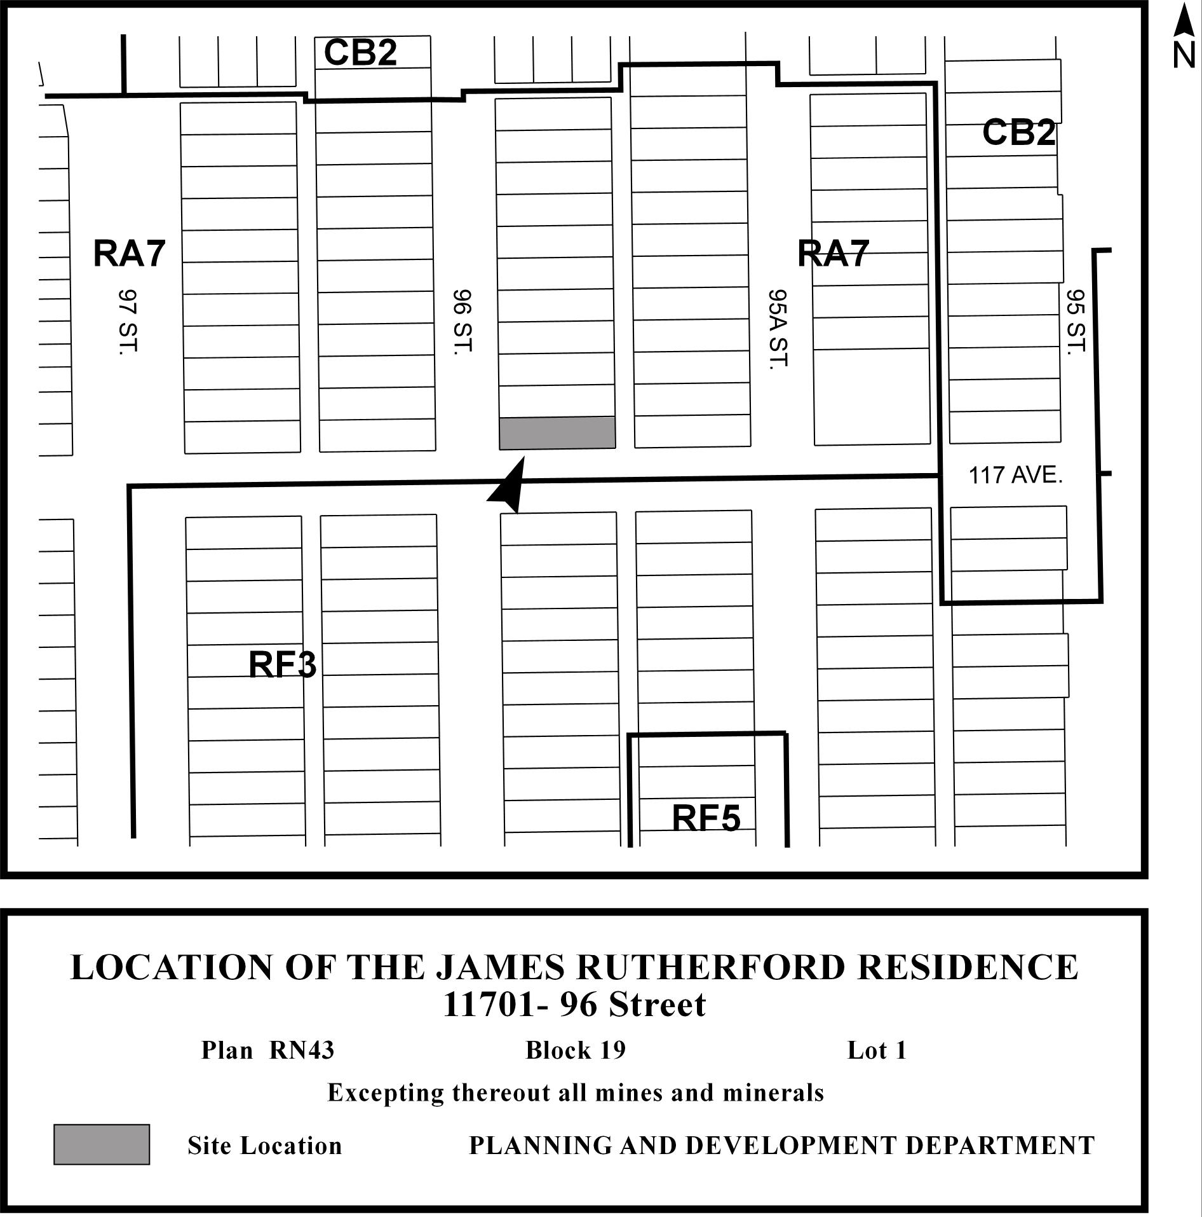

Photograph of the James Rutherford House

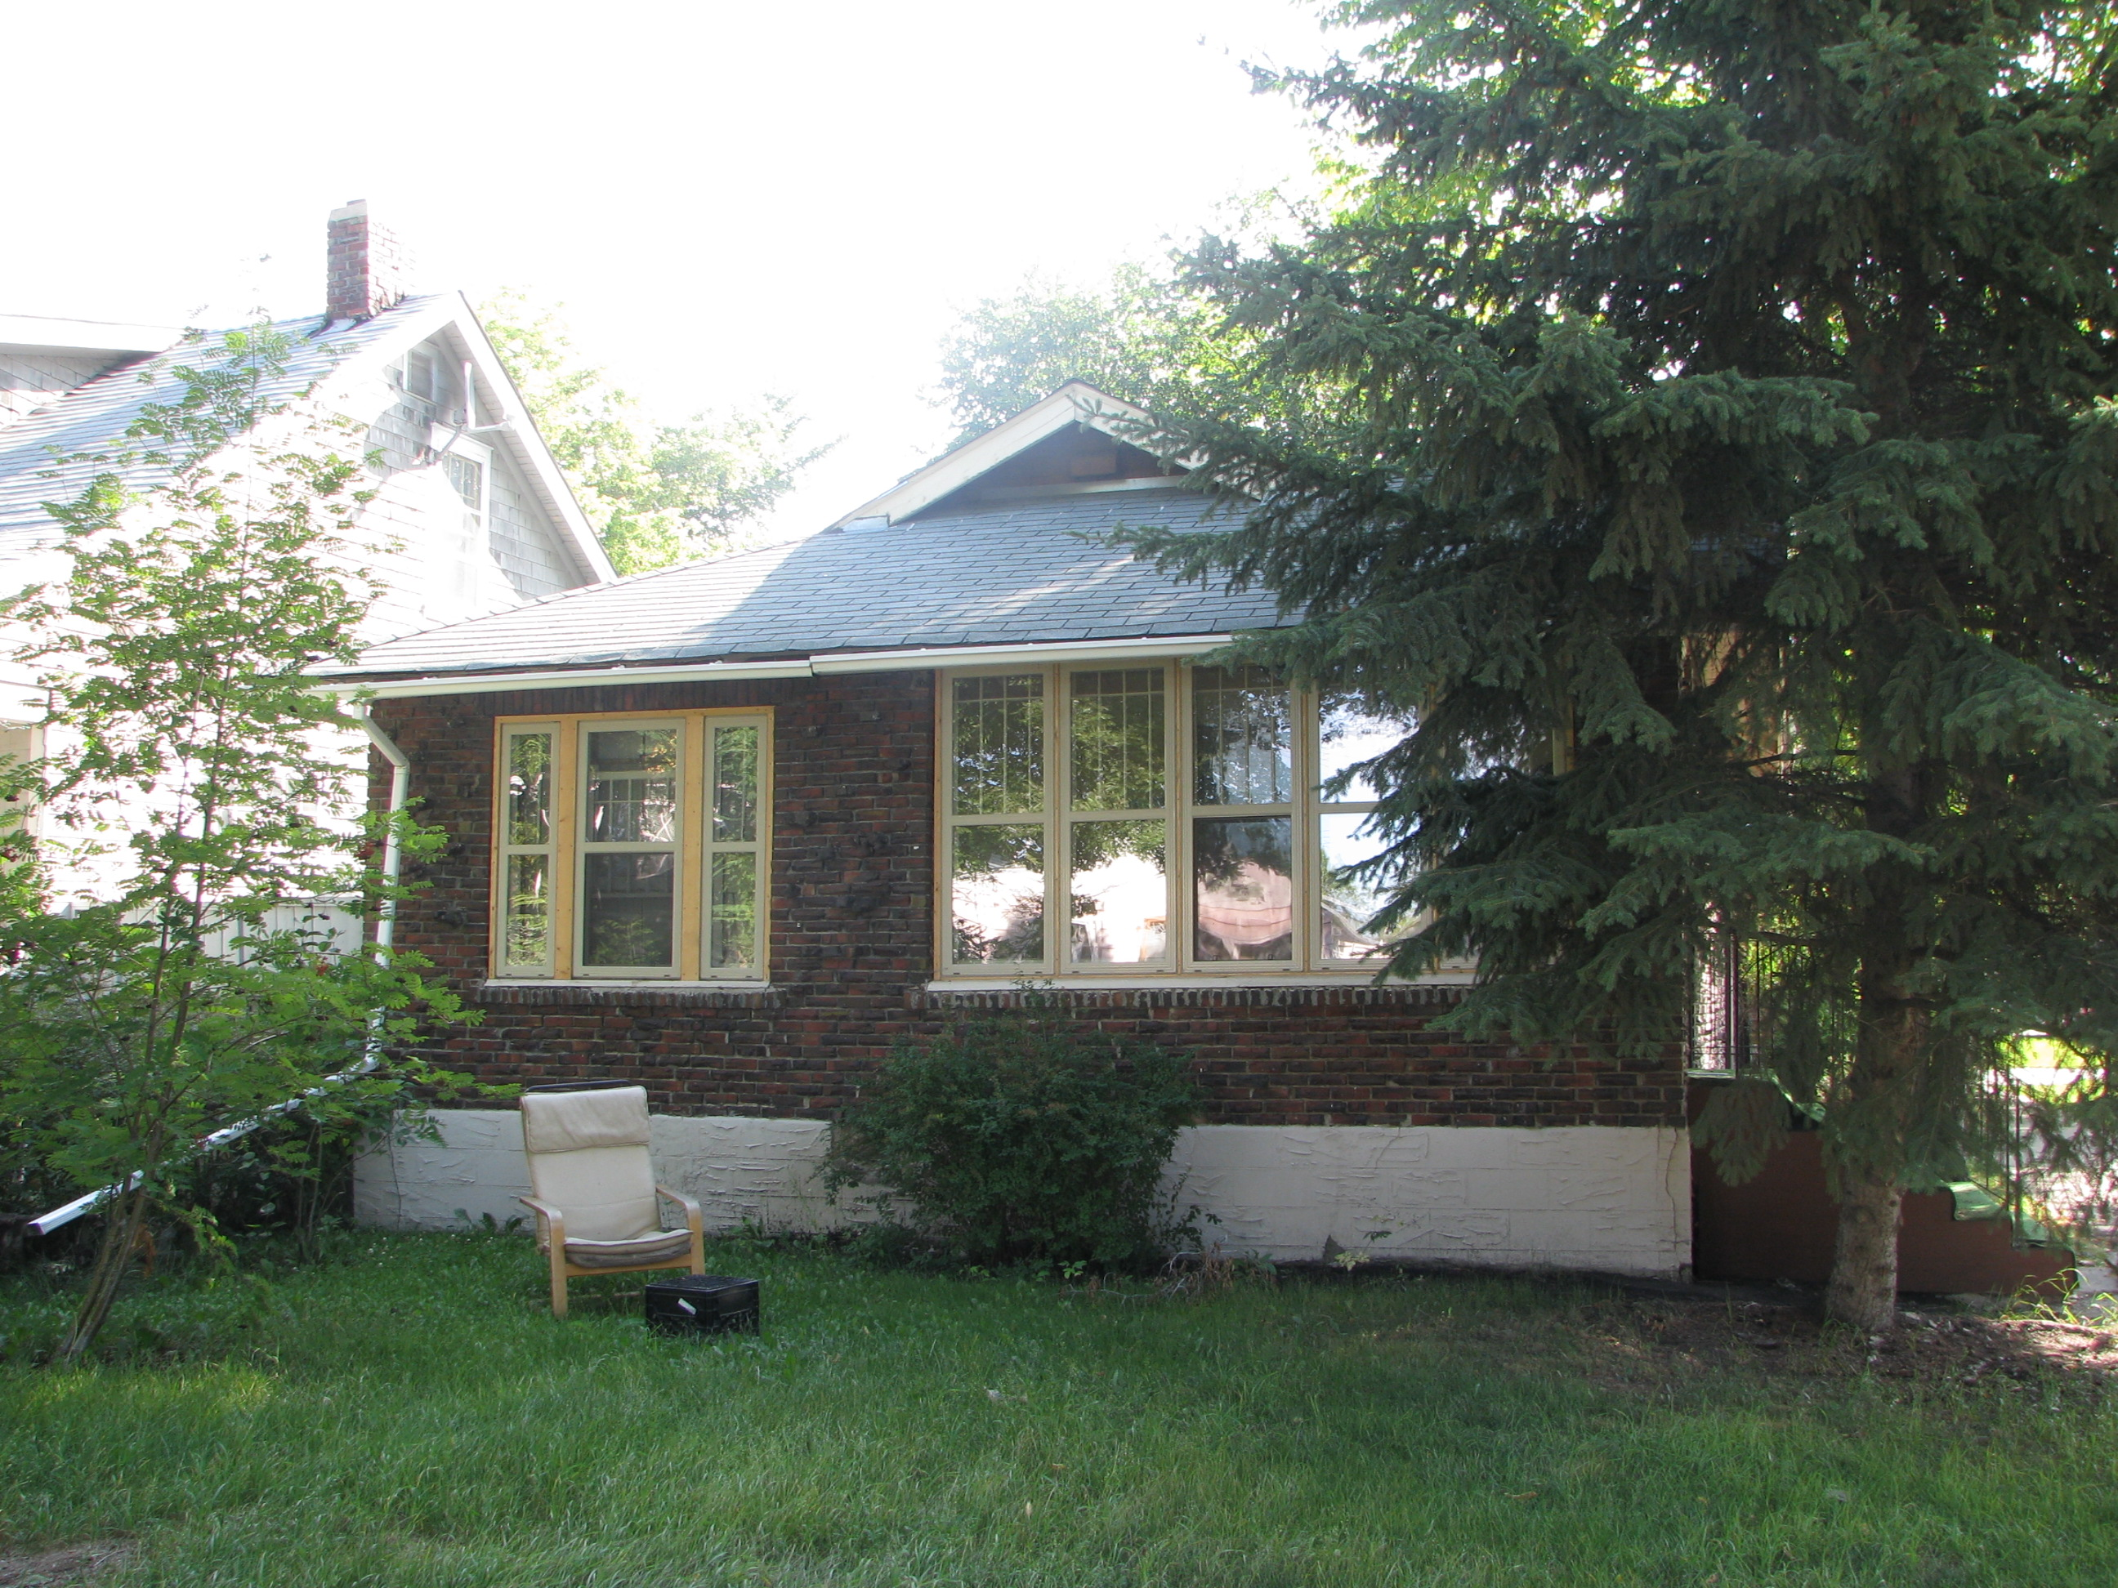

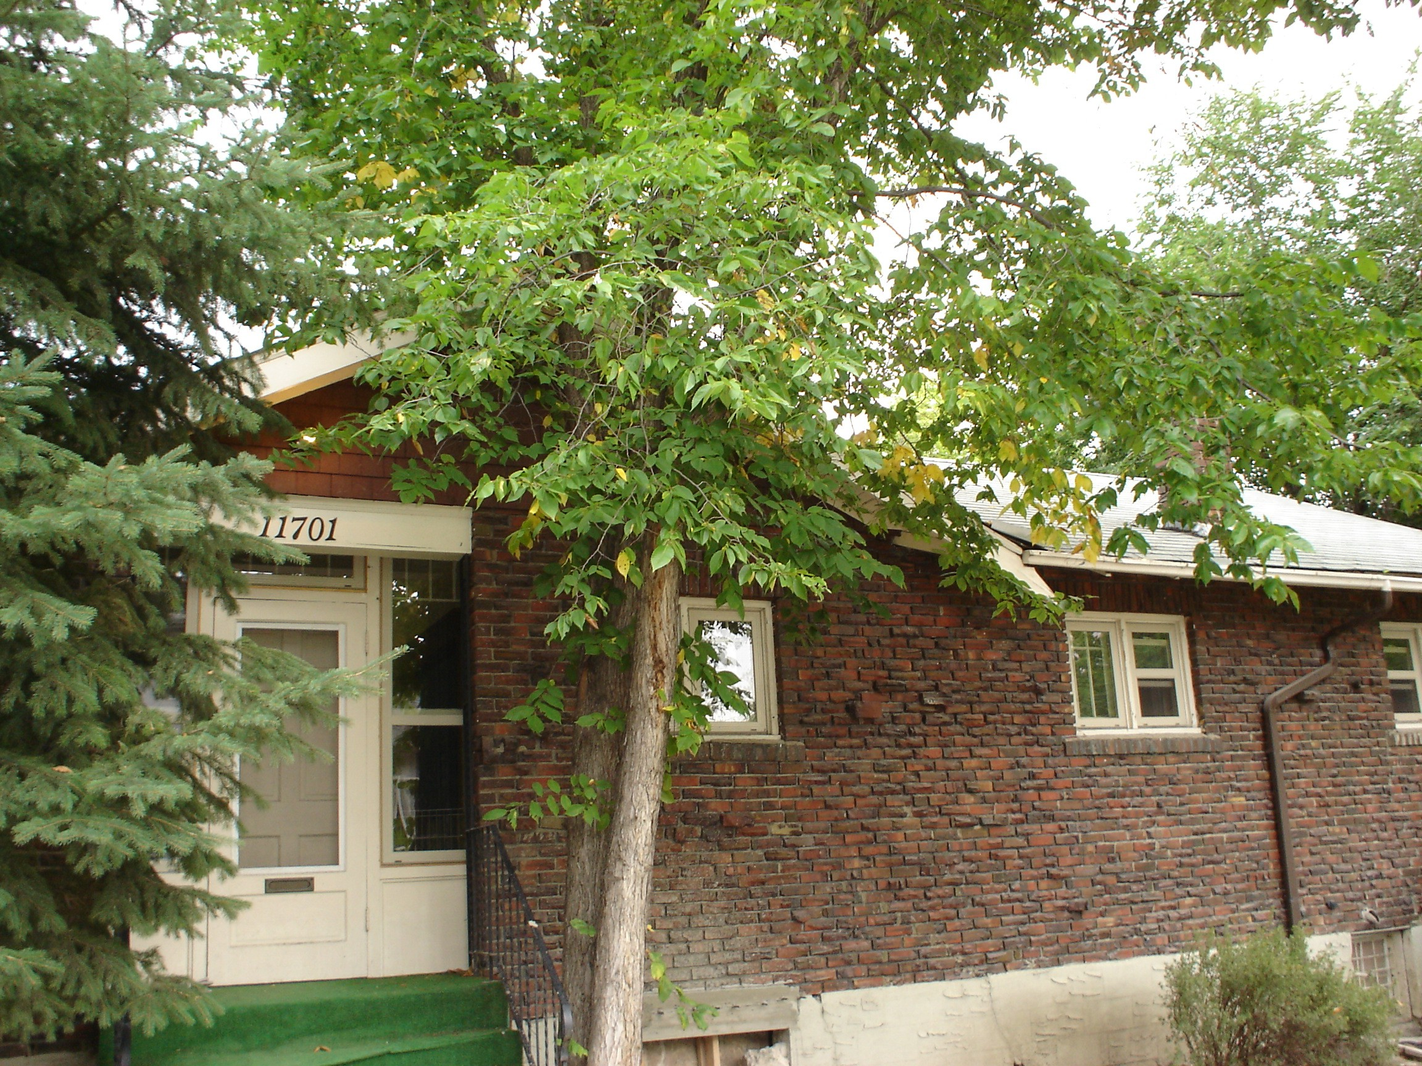

Heritage Planner’s Summary of Architectural and Historical Information

BUILDING NAME AND ADDRESS James Rutherford House
11707 - 96 Street NW

Currently listed on the Inventory of Historic Resources in Edmonton

Recommendation

The James Rutherford House is recommended for designation as a Municipal Historic Resource because of its historical and architectural significance.

Architectural History:

Style/Type

This house is a one storey clinker brick house built in 1927 with Craftsman influences.

Design

This building is a modest single-storey clinker brick residence with an intersecting gabled hip roof. The house is significant for its use of clinker brick. Clinker bricks were not desired in building construction for many years as they were over fired, burnt and misshapen. In most cases the clinker bricks were discarded, but in the 1920s the bricks became valued for their unique appearance and design enhancing capability. This home employs clinker bricks on the exterior, an unusual and increasingly rare material found in Edmonton homes.

The house features large windows on its west façade with decorative brick sills and lintels. All windows on the front facade are single hung wood framed windows with decorative vertical and horizontal mullions. Windows on the sides are both single hung and small casement windows. The house also features influences of the Craftsman Style popular in Edmonton during this period. Some of these features include the exposed rafter tails and the intersecting gable roof.

Construction

This house is brick construction with a concrete foundation.

Historical Information

The James Rutherford House is historically significant for its association with the development of Alberta Avenue neighbourhood. This house is indicative of the modest home of a local business owner who operated on 118 Avenue during this period.

James Rutherford was the home’s first owner. Rutherford was the owner of a local hardware store at 9574 - 118 Avenue NW, a major commercial intersection in the area and only a few blocks from his home. Rutherford operated the hardware store and lived in the house from its construction in 1927 until 1935. As a local merchant, Rutherford would have been an important local resident, especially during the Depression when the kindness and generosity of local merchants helped many to survive.

Context

Site

The James Rutherford House is located on the northeast corner lot at 96 Street and 117 Avenue NW. The main entrance to the home is on 117 Avenue.

Neighbourhood

This house is located in the Alberta Avenue Neighbourhood and was identified through the Alberta Avenue Heritage Inventory. The name Alberta Avenue first came into use in 1904, shortly before Alberta became a province. The name is derived from the wife of the Marquess of Lorne, Governor General for Canada, from 1878 to 1883. Her name was HRH Princess Louise Caroline Alberta and she was the fourth daughter of Queen Victoria.

Description of City Funded Work on the James Rutherford House

Phase | Description of City Funded Work | Total Cost | Amount Allocated
1. | Roof: Remove and dispose of asphalt shingles and install new cedar shingles. | $ 14,275.00 | $ 7,137.50
2. | Foundation: Dig down from basement floor level and install new concrete footing around the perimeter of the house. Install new perimeter concrete walls. Repair existing cracks in concrete basement walls and perimeter wall. Dig around foundation to install weeping tile system. | $ 35,000.00 | $ 17,500.00
3. | Exterior Repair:  Repointing: Repointing of all brick facades, chimney and window sills. Cleaning and preparation of brick, removal and replacement of existing mortar. Repair of existing parging and cracks in existing foundation.  Fascia/Rafter Tails: Repair/restore existing fascia board and rafter tails. | $ 12,250.00 | $ 6,125.00
4. | Exterior Painting: Clean, scrape and paint all windows, rafter tails, and trim. Paint colours and type will be decided on in discussion with the Heritage Officer. | $ 4,194.75 | $ 2,097.38
 | Sub total | $ 65,719.75 | $ 32,859.88
 | 10% Contingency(if necessary) | $ 6,751.98 | $ 3,376.00
 | Total | $ 72,471.73 | $ 36,235.87

