Notice of Intention to Designate
Immigration Hall as a Municipal Historic Resource

Recommendation:
That the Executive Committee recommend to City Council:
- That a Notice of Intention to Designate a Municipal Historic Resource, as outlined in Attachment 1 of the April 27, 2009, Planning and Development Department report 2009PPP18, be served to the owner of the property occupied by the Immigration Hall located at 10007 - 105A Avenue NW, in accordance with section 26 of the Historical Resources Act R.S.A. 2000.
- That the funding of $583,720.30 for this project be provided from the Heritage Reserve Fund (Internal Order #174101).
Report Summary
The action recommended in this report initiates the process of designating a heritage building as a Municipal Historic Resource in accordance with the Historical Resources Act.
Report
- Immigration Hall is on the Inventory of Historic Resources in Edmonton and merits designation under City Policy C450B - A Policy to Encourage the Designation and Rehabilitation of Municipal Historic Resources in Edmonton. The property is currently owned by Hope Mission.
- On March 2, 2009, the owners completed the application requirements to have Immigration Hall designated as a Municipal Historic Resource under the provisions of City Policy C450B.
- Any future restoration or rehabilitation shall meet the Standards and Guidelines for the Conservation of Historic Places in Canada.
- The designation of this property will ensure its proper restoration and protection in the future.
Policy
The Municipal Historic Resource Designation of Immigration Hall complies with and advances the goals of City Policy C450B.

Budget/Financial Implications
- Upon completion of the project phases as outlined in Attachment 5, the owner will be paid up to $583,720.30 as a rehabilitation incentive from Internal Order # 174101- Heritage Reserve Fund. This funding scheme is based on 50% of the total cost of restoration work.
- Should the owner receive funding from the Alberta Historical Resources Foundation for restoration work, the owner may only receive up to 33% ($194,573.43) from the Historic Resource Management Program.
- The cost for the restoration work is $1,182,441.60 while the budget for renovating the entire building not considered historic including interior work, electrical, mechanical, etc. is $6,217,009.

Justification of Recommendation
- Issuance of a Notice of Intention to Designate and subsequent approval of the designation bylaw will give Administration the authority to ensure that the building is restored and maintained in accordance with sound principles of conservation.
- Rehabilitation incentive funds will be available from Internal Order # 174101 - Heritage Reserve Fund.
Attachments
- Notice of Intention to Designate Immigration Hall as a Municipal Historic Resource
- Location of Immigration Hall, 10534 - 100 Street NW
- Photograph of Immigration Hall
- Statement of Significance for Immigration Hall
- Description of City Funded Restoration Work on Immigration Hall

Notice of Intention to Designate Immigration Hall as a Municipal Historic Resource

NOTICE OF INTENTION TO DESIGNATE IMMIGRATION HALL AS A MUNICIPAL HISTORIC RESOURCE

HISTORICAL RESOURCES ACT

Section 26 H.R.A., R.S.A. 1980, c.H-8, as amended

TO: Hope Mission
P.O. Box 953
Edmonton AB T5J 2L8

Notice is hereby given that sixty (60 days) from the date of service of this Notice, The Municipal Council of the City of Edmonton intends to pass a Bylaw that the site legally described as:

Plan EF, Lot Numbers 137-138

Excepting thereout all mines and minerals.

and located at 10534 - 100 Street NW and containing the original 1930 and 1954 building known as Immigration Hall located on the site be designated a MUNICIPAL HISTORIC RESOURCE under Section 26 of the Historical Resources Act, as amended from time to time.

AND TAKE FURTHER NOTICE THAT the Municipal Council of the City of Edmonton has appointed the General Manager of the Planning and Development Department to implement matters arising from the issuance of the Notice of Intention to Designate a Municipal Historic Resource.

DATED this day of 2009.

_______________________________
General Manager
Planning and Development Department
Agent for the City of Edmonton

Location of Immigration Hall – 10534- 100 Street NW

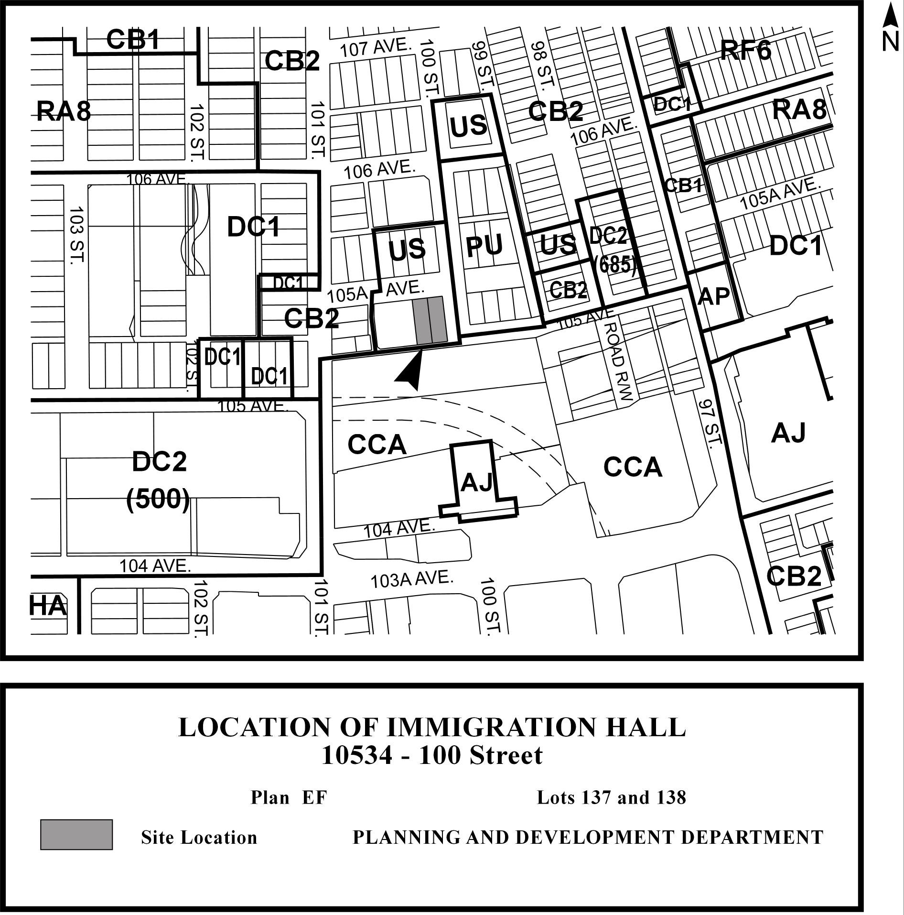

Photographs of Immigration Hall

Historic Photo taken in 1931 by McDermid Studio

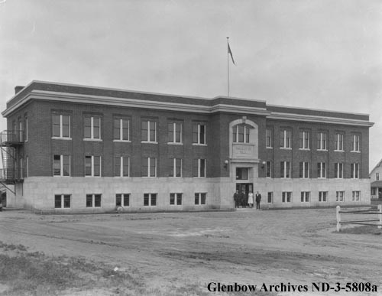

Immigration Hall in 2009
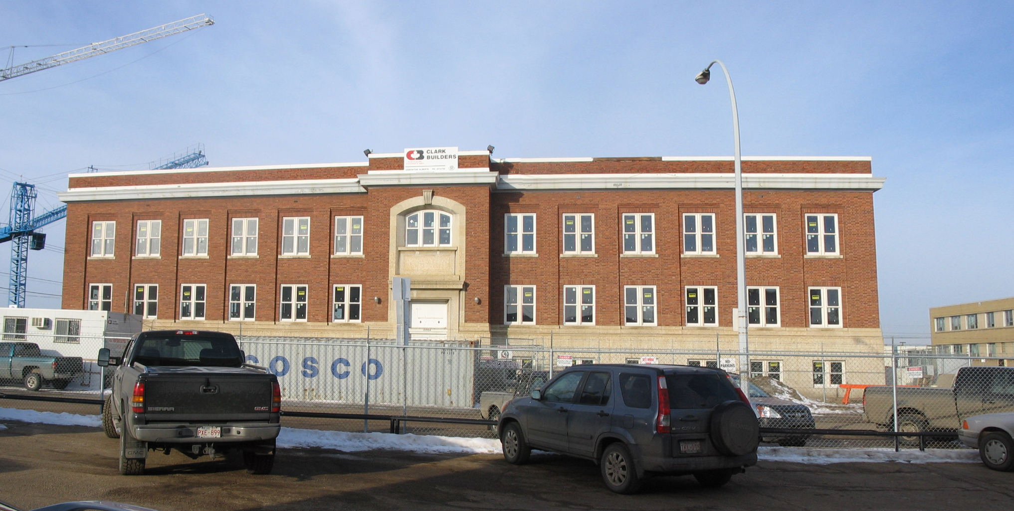

Rendering
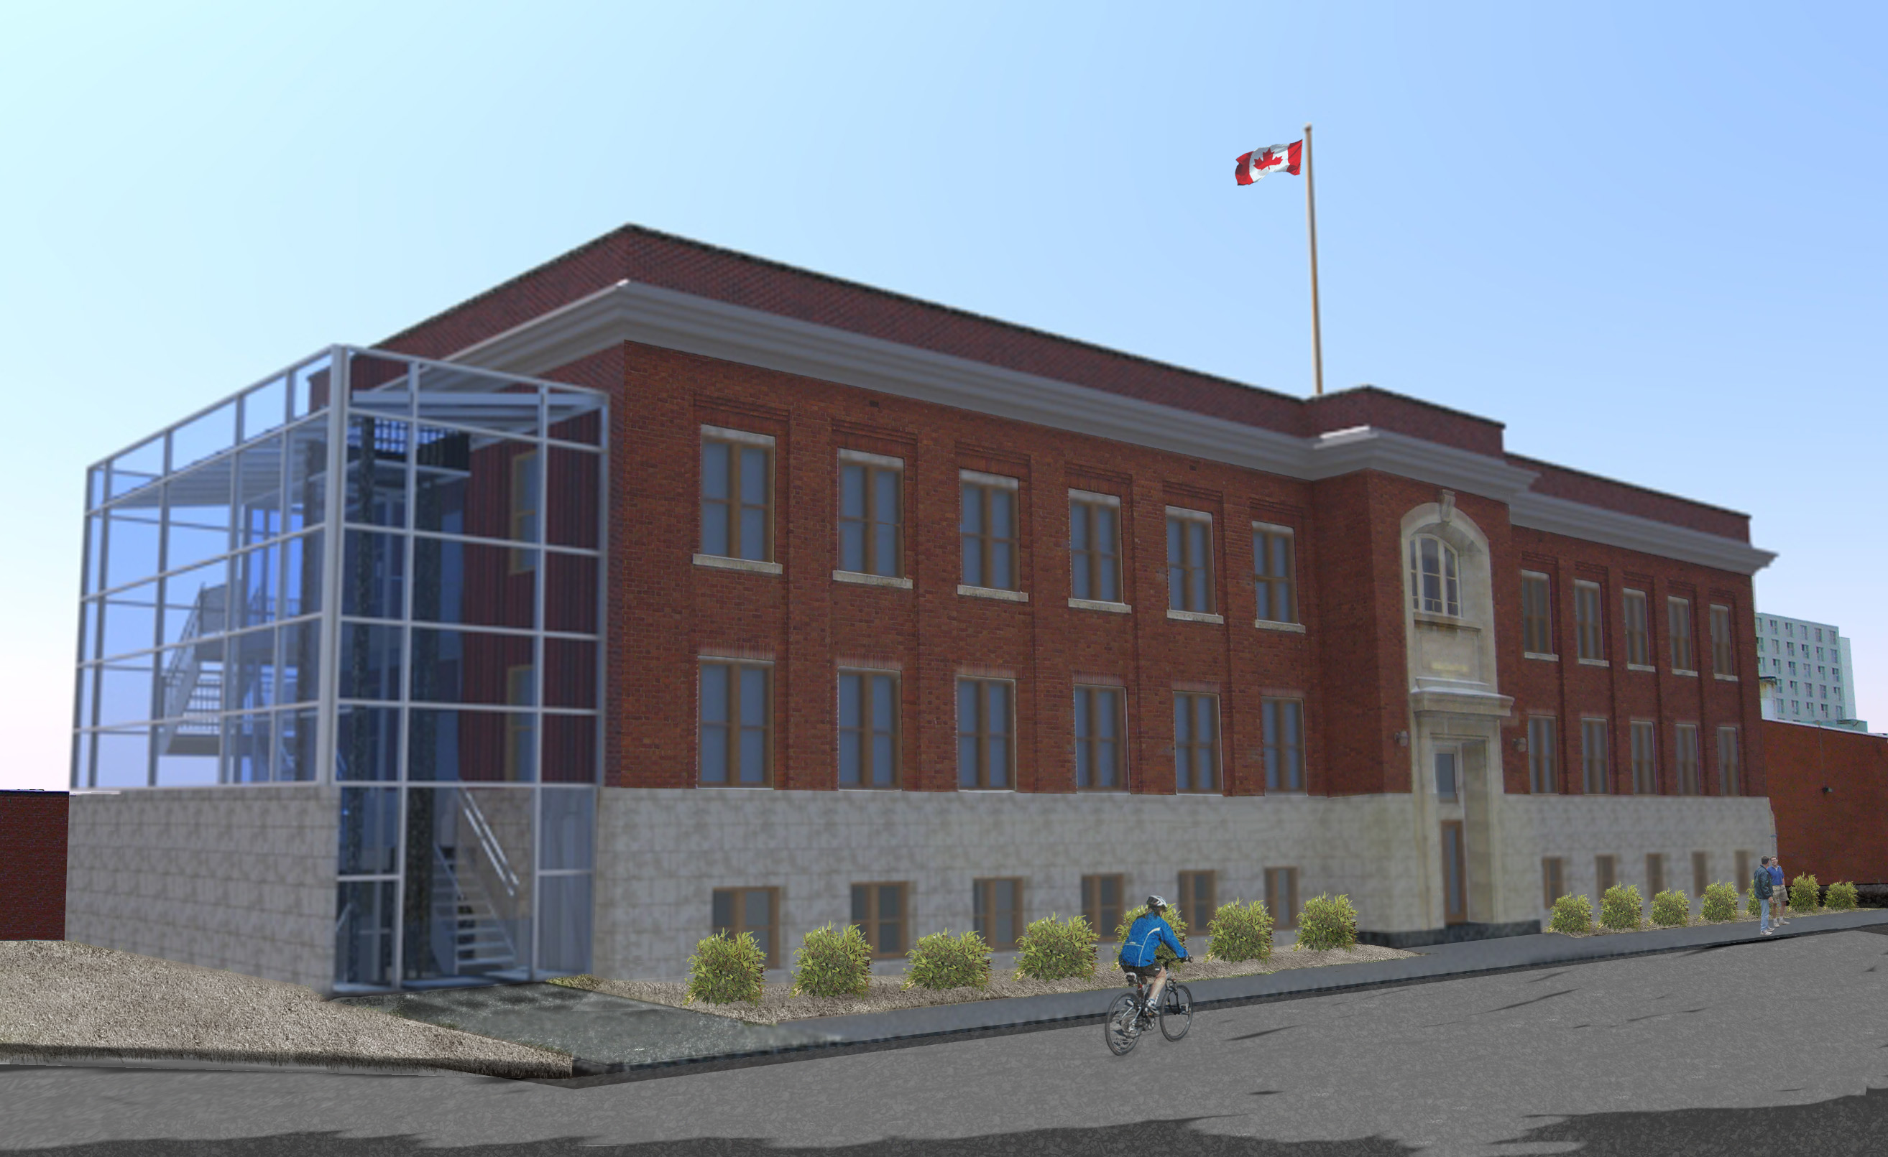

Statement of Significance for Immigration Hall

Description of Historic Place

Immigration Hall is a two-storey plus basement institutional structure, identifiable for its classically proportioned symmetrical facade and flat roof. The building is situated on two city lots, in a prominent corner location at 100 Street and 105A Avenue and is separated from the downtown core by the former Canadian National Railway yard.

Heritage Value

Immigration Hall is a local landmark that has heritage value as one of the three surviving post World War One immigration halls in western Canada and as a representation of the immigration history of the province. Additionally, it is an excellent example of the influence of the Federal Department of Public Works, reflecting the work of its architect Thomas William Fuller.

Immigration Hall reflects Edmonton's central role within national settlement policy. Designed in 1927 and constructed in 1930, it is valued as the last and most elaborate of a series of functionally similar buildings erected across the Prairies over a 50-year period, reflecting the federal government's immigration policy, which encouraged western settlement. This building was constructed as a result of an ambitious federal immigration policy, but was only nominally utilized due to the onset of the Depression, and a reversal in 1930 of the previous 'open-door' policy. Later, the building received greater use at the time of the opening of the Peace River Region, and after the discovery of oil near Leduc in 1947. Its significance remains into the 1960's. The location of Immigration Hall north of the downtown core and the former CNR railway yard illustrates how these facilities were strategically constructed near main railway stations to accommodate the influx of new immigrants.

Furthermore, Immigration Hall is a very good example of the conservative architectural expression of the federal government during this time period. Traditional architectural styles remained popular during the interwar period and this design demonstrates the late persistence of the Classical Revival style that had been introduced at the turn of the nineteenth century. Here, classicism has been stripped to its essentials, with strictly ordered symmetry, minimal ornamentation and superior cladding materials providing dignity to an otherwise utilitarian structure. The interior continues the austere expression with a relatively grand entrance lobby.

Immigration Hall has additional heritage value for its association with the Chief Architect of the Federal DPW, Thomas William Fuller (1865-1951). Fuller, the son of previous Chief Architect Thomas Fuller, had a life-long career with the DPW, and assumed the role of Chief Architect from 1918 to 1936. He was responsible for the design of many military buildings and armouries across the country, as Canada prepared for, and then fought in, World War One. Throughout the 1920s and 1930s, the DPW remained very conservative in its design approach, as demonstrated in this building by the late persistence of the influence of the Classical Revival styles. The 1954 addition was also designed by the office of the Chief Architect's branch of the Federal Department of Public Works.

Character Defining Elements

Key elements that define the heritage character of Immigration Hall include its:

- prominent corner location, near the Canadian National Railway yard;
dignified form, scale and massing as expressed by its flat roof, two storey height, above-ground basement that provides a podium for the building, and symmetrical composition with central entry;
- use of superior building materials including Flemish-bond, variegated colour combed brick, smooth-faced Tyndall stone and granite steps;
- continuous sheet metal projecting cornice with simple brick parapet above;
- double height central entrance detailed in Tyndall stone, with shallow projecting cornice above the entrance doors, a blank panel above, capped with an arched window surround with keystone;
- fenestration, with the use of double-hung 1-over-1 wooden sash windows, including a segmental arched Chicago window above central entry, regular banks of double-assembly windows, those on the upper floors set between broad, shallow brick pilasters and those in the basement inserted into the Tyndall stone base;
- wooden flag pole above central entry;
- 1954 addition that matches very closely the style and details of the original building, but with a large feature window above secondary entry and with slight variations in the fenestration; and
- interior elements such as its double-height entrance hall with split staircase, use of high quality materials including marble and terrazzo stair and floor finishes.

Description of City Funded Restoration Work on Immigration Hall

Phase | Description of City Funded Work for Immigration Hall | Total Cost | Amount Allocated
1 | External windows and doors; Cornice: Replace windows as determined by the Existing Window Survey and Refurbishment/  Replacement Strategy. Repair or replace front doors. Exterior painting of windows and cornice. | $ 362,236.60 | $ 181,118.30
2 | Roof structure: Repair and replace where necessary due to extensive water damage.  Roof repair/replacement and parapet repairs and bracing. | $ 489,555.00 | $ 244,777.50
3 | Masonry restoration. | $ 120,560.00 | $ 60,280.00
4 | Foundation: Restoration and seismic upgrade. | $ 47,597.00 | $ 23,798.00
5 | Interior Lobby/Vestibule/Staircase Restoration | $ 87,483.00 | $ 43,741.50
6 | Flagpole | $ 10,010.00 | $ 5,005.00
 | Architectural Services and fees. | $ 65,000.00 | $ 25,000.00
 | Total | $1,182,441.60 | $ 583,720.30

