Responses to Councillors’ Questions on the Edmonton City Centre Airport Impact Assessment Results – July 7, 2009

Councillor Sloan

- How many requests have there been to exceed the height limits on downtown buildings in the last 5 years?

Response
- Development proposals in and around the Downtown have generally respected the Airport Protection Overlay (APO) height limitations/restrictions. However, in some cases, proposals were modified and in other cases proposals did not materialize into applications for development.

- Current Planners and Development Officers have had numerous discussions with developers regarding the height limitations imposed by the APO when approached for rezoning proposals and development permit applications. The height allowances or limitations form part of the discussion and negotiation for all tall buildings in the Downtown and surrounding area, affected by the flight paths and regulations of the APO.

- Examples of major past projects that were reduced in height or could have developed higher were it not for the APO height limitations include the EPCOR Tower (101 Street/105 Avenue), the AMA Building (109 Street/118 Avenue, the Royal Alexandra Hospital Expansion, two residential towers in Railtown, and Aurora Developments (105 Avenue/101 Street).

- Examples of proposals which did not materialize into development applications for various reasons, including the APO height restrictions, economical considerations or the need for significant design compromises include a commercial office tower and residential tower at 102 Street and Jasper Avenue, a residential tower at 101 Street and 105A Avenue, a residential tower at 116 Street and Jasper Avenue and a hotel on the north edge of Downtown under the flight path.

- If closing the airport to achieve more city centre density and public transport is a serious policy goal, why is council considering a southward extension of the LRT rather than the NAIT line?

Response (prepared by administration)
- The Transportation Department is currently involved in LRT planning and design projects in all quadrants of the City.

- The engineering for the extension from Downtown to NAIT is furthest along with detailed engineering about to begin. The NAIT extension is currently the Department's highest priority and efforts are underway to seek funding from the Federal and Provincial Government to continue this work

- Preliminary engineering is being completed for the extension from Century Park to Ellerslie Road and 127 Street and for the NE line from Claireview to Gorman.

- Route planning is taking place for LRT to the west end, Mill Woods and the eventual Northwest line to St. Albert. The route recommendations are for the west and SE lines are planned to be presented in November of this year with the St. Albert line recommendation being presented in 2010.

3. On June 26th, Mayor and Council received a letter from Canadian Helicopters Senior Executive VP Don Wall. In this letter, the following statement is made:

“Canadian Helicopters believes that if indeed the airport is closed, the City is bound to be fair with its tenants in compensating for the cost of the closure. Many businesses will face substantial costs in relocating their businesses to alternative locations (if indeed they can), as well as the loss of valuable facilities, and they must be compensated fairly for that. If the airport were closed, Canadian Helicopters would review its operations in western Canada to determine the best location to relocate. The loss of a large 50,000 plus square foot hangar/office facility and the cost of relocating employees and functions would be very expensive and it is our expectation that the city must recognize this as a cost of closure. The City should not assume that businesses would merely relocate to Edmonton International, Villeneuve or Cooking Lake each of which may not be appropriate for different reasons.”
My questions to Administration are as follows:

3.1 Has an inventory been compiled of the privately held infrastructure on ECCA lands?

Response (prepared by administration)
- Edmonton Airports retained an appraiser to determine the value of existing buildings that have aviation related uses as the permitted use in the sublease.

3.2 Have these facilities/infrastructure been appraised?

Response (prepared by administration)
- The summary value of the buildings that permit aviation uses, reflecting different appraisal calculations are provided on page E-9 of Attachment 2 to Report 2009DCM032.

3.3 Has the City estimated compensation that would be required to facilitate the relocation of employees and functions of private companies who are currently lease holders on ECCA lands?

Response (prepared by administration)
- No calculation of possible compensation for business losses or relocation costs were undertaken since these would be the outcome of negotiations with each affected party.

4. How did Administration/Consultant weigh the professional opinions provided by Drs Allan de Caen, Blair O’Neill, Mary vanWijngaarden-Stephens, D.J. Kutsogiannis and K.P. Pawluski in framing the conclusions contained within the Medevac Report?

Response (prepared by Donna Towers, Donna L. Towers, Inc)
- The consultant interviewed clinician and administrative leaders in critical care and trauma leadership roles in the Edmonton area to gather input on the potential changes contemplated to the ECCA. The consultant reviewed the letters submitted by Clinicians such as Alan de Caen and Mary vanWijngaarden-Stephens and others. Clinicians stated that there is risk to some patients with a longer transport time. Transport time includes the full continuum of transport and not just the last leg of the journey as stated in the consultant’s report. Clinicians noted that not all medevac would be placed at risk with the longer transport time as many are stable patients on their arrival to Edmonton. Some of the clinicians suggested ways to mitigate the risk of longer transport time such as the helicopter from the EIA to the UAH and dedicated ambulances to move specialty teams. K.P. Pawluski spoke at the public hearing which was after the report was submitted.

5. Why was data compiled utilizing the YXD airport tower as a primary source versus accessing numbers from the Governments/agencies that fund medevac transport? Why was it not disclosed as a limitation that flights only declare their medevac status when they have an on board emergency thereby resulting in the report potentially understating the actual numbers?
Response (prepared by Donna Towers, Donna L. Towers, Inc)
- The Edmonton Airport data was used to capture the medevac volumes because it was understood by the consultant that all medevac flights arriving at ECCA would be captured (in province and out of province) using this methodology.

- Most incoming medevac flights declare status if they have patients on board; NWT disclosed at the hearing that they do not declare medevac status as many of the patients they transport are arriving for booked procedures and do not require immediate landing and transport of their patients. The numbers in the report do reflect many stable medevac patients originating elsewhere. The practice of NWT flights not declaring medevac status was unknown to the consultant.

- Please also see the response to question 6 for added information on medevac flights from the NWT.

6. Please provide the rationale for including only Alberta specific data when the ECAA also serves as a medevac destination for the NWT, Yukon, Nunavut, Northern BC, Saskatchewan and Manitoba? How were the Out of Province stats for fixed wing and rotary determined? Please provide the analysis of how Northern flights specifically would be additionally impacted by ECCA closure?
Response (prepared by Donna Towers, Donna L. Towers, Inc)
- Data provided in the report (Report 2009DCM032, Attachment 5, page 39 of 42) included out of province volumes and unknown volumes for both fixed wing and rotary as reported by ECCA tower for the 2008 calendar year. Data that was “only specific to Alberta” was not provided; data noting flights originating in Alberta were included. Total declared medevac status flights were reported. Out of province would primarily be fixed wing volumes as the rotary wing is limited in range of flight to and from Edmonton. The clinicians did note that out of province trips were included in their statistics. PICU and NICU numbers would include both in and out of province medevacs.

  - The consultant and EA have reviewed the medevac numbers. The consultant’s report used data for the 2008 calendar year and the NWT statistics (1080) quoted by Councilor Sloan were for the fiscal year (April 2007 – March 31 2008). We have rerun the numbers using fiscal year April 08 – March 31 2009 (note: more recent than Councilor Sloan figures) and using additional search criteria to ensure out of province numbers are captured. The total medevac volumes using the most recent fiscal (not calendar year) and additional search criteria yield a total number of 4143 flights (compared to 3993 for calendar year 2008). Northwest Territory medevacs for fiscal year 2008/09 are 1049. The majority of these flights are within the NWT. Of the 1049 NWT medevacs, only 313 were sent to Edmonton. Of the 313, 108 were deemed critical and would be captured in the medevac numbers from ECCA.

  - Also when we compare NWT Health Authority numbers with Airport/Control Tower registered Medevac flights, it is consistent with a difference of approximately 13 flights for the Fiscal year 08/09:
  - Explanation: EA tracks flight activity by aircraft and identifiers provided by the Control Tower. Flights that are identified as Medevac, either with STARS, or when the flight is filed (-M), or when the flight is in air (-MED) can be captured and counted as Medevac flights. As discussed, those flights that do not identify as Medevac cannot be tracked. To understand the relative scale of the difference, we have used Medevac flights from NWT during the fiscal year 2008/09.
  - Airport/Control Tower Tracking: The Control Tower and therefore the Airport Authority can report that close to 300 medevac flights arrived to ECCA from NWT.
  - NWT Government Tracking: By comparison, the NWT Health Authority CEO (Stanton) estimates approximately 313 flights, of which 108 were deemed critical.
  - Difference: Approximately 13 flights in the 2008/09 fiscal year had no medevac identifier

7. Submissions were made by First Nations Métis peoples and medevac providers indicating that they see this issue as inherent to their treaty rights: Why did the report not address the timely access to care as is contained within the Canada Health Act and the inherent role medevacs play in the provision of such access? Were any First Nations and/or Métis consulted in relation to the medevac transport report and its implications? If not why?

Response (prepared by administration)
- Medevac flights for First Nations peoples were included in the overall totals for medevac flights.

- The report did not address First Nations access to health care because the City is not responsible for the provision of such access to health care. Instead, the report spoke to alternative transportation arrangements that would permit a replacement of the current system operating from the ECCA. Part of the process of closing the ECCA, therefore, would entail working with Edmonton Airports and Alberta Health Services to permit a seamless transition to a functioning alternative transportation arrangement from the EIA.

Response (prepared by Stephani Roy McCallum, Dialogue Partners Inc)
- First Nations and Métis organizations, businesses and peoples were contacted and participated throughout the public involvement process. Comments and input relating to governance, economic impact, northern access, transportation and environmental issues were raised and documented. In addition, specific comments relating to concerns about quality and accessible healthcare were provided by some of these participants. These comments were provided to City Administration, and documented throughout the process.

8. Please provide any brief or legal analysis regarding alterations to medevac services and liabilities arising from potentially increasing transport times. Is there a legal basis for the inference that only “350” adult critical trauma patients; “15” of the 290 PICU and NICU patients would be impacted by the relocation to the EIA? Why did the Administration/Consultant feel it necessary to make this distinction? Why was there not a corresponding distinction that any medevac flight can become “critical” if the patient’s condition changes in flight?
Response (prepared by Donna Towers, Donna L. Towers, Inc)
- The clinicians interviewed noted that these volumes were the very time critical patients that would potentially be impacted on by the relocation; these are the unstable patients needing immediate medical attention where additional time will put the patient at risk. The clinicians indicated risk was difficult to quantify which is noted in Attachment 5 of Report 2009DCM032.

- The numbers were the clinicians best estimate based on historical volumes. The 350 is included in one of the physician letters included in Attachment 5 of Report 2009DCM032.

- Patients declared critical in flight in the past would be in the historical data (arriving medevacs).

- Patient status can change anytime in flight (Report 2009DCM032, Attachment 5, page 8 of 42),noting that the medical crew can link in through the Critical care line to get further advice from the receiving physician or specialists in Edmonton should status change in flight.

- The assumption used in the preparation of Attachment 5 to Report 2009DCM032 was that all medevac flights would be recorded as such by air tower so did not make the distinction regarding a change in status during flight.

Response (prepared by administration)
- Assessing potential legal claims is at this juncture highly speculative. Focus should be placed on potential alternative transport arrangements from the EIA if the ECCA should close, including the length of time required to develop and implement such alternative arrangements.

9. What was the rationale for containing research relating to the use of helicopter/ground ambulance transport while not including comparable research on the increased incidence of operational/mechanical difficulties with helicopter medevacs? Please provide the provincial government reference which formulated references to the potential provision and funding of an integrated medevac facility. Please also provide any submissions or proposals that the Edmonton Airport Authority has received from private developers proposing the creation of such a facility.
Response (prepared by Donna Towers, Donna L. Towers, Inc)
- Alberta Health and Wellness had recently commissioned the report on use of fixed wing and rotary wing aircraft on patient outcomes. The consultant believed the research added to the understanding of the use of these two types of aircraft to move patients in the medevac environment. The executive summary was included as an Appendix.

- With respect to the use of helicopter medevacs, the consultant is familiar with the safety record of STARS, the organization that holds the rotary wing contract for medevac in Alberta. From 1985 – 2008, STARS has flown 17,478 patient missions with a clear safety record – no accidents.

- The Safety culture in the business of flying is carefully scrutinized, for both fixed wing and rotary aircraft. National Safety Boards are in place and every accident and the more serious incidents are fully investigated by a third party. All flying organizations are required to obtain a flying operational certificate which clearly states the parameters under which that organization can operate. Regular (annual) check-rides on pilots, audits of engineering practices and general organizational audits are conducted to ensure compliance. Violations are dealt with in a swift and clear-cut manner and exceptions are not permitted.

- STARS must operate in accordance with existing Transport Canada guidelines as it pertains to weather limits both for day and night operations. For STARS the number of weather turn-downs by year is as follows:

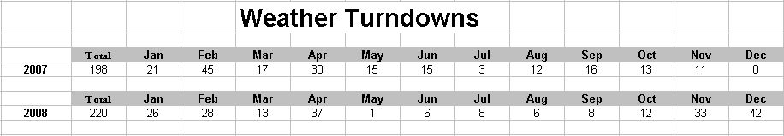

- Administrative staff interviewed noted that with ground and rotary wing air ambulance now under AHS as if April 1, and with planned consolidated dispatch for all ambulances for the province, there was an opportunity to look at integration of services to better meet the needs of the patients. The observation was related to the need to improve care for patients. There was no reference made to funding of a facility.

10. Please provide an outline of the approximate costs and timelines that would be incurred to shift medevac services to alternate airports.
Response (prepared by Donna Towers, Donna L. Towers, Inc)
- Costs would be addressed in a future report on the medevac system should there be a decision on use of lands at ECCA. ERAA has noted they would work with stakeholders such as Alberta Health Services and Alberta Health and Wellness to plan the future of medevac should the ECCA status change. The scope of this consultant’s report was to identify risks and potential opportunities related to medevac flights should the lands at ECCA be repurposed. It was not within the scope of this report to outline costs and timelines in advance of a decision about ECCA.

11. How would an integrated medevac facility be governed and funded? Would this be a municipal entity? If it were a private entity how would it be funded and taxed? (These questions may be addressed within any proposals the EIAA has received either from Government or private sector.)
Response (prepared by administration)
- Responsibility for the governance and funding of medevac services rests with Alberta Health Services. It is expected that Alberta Health Services would work with the medevac provider(s) regarding the operational standards for the service provision and facility operation. If the facility is a private operation, it is assumed it would financed privately and pay property taxes.

12 What steps would be required to facilitate the creation of a separate board for the operation of the ECCA as a general aviation facility?

Response (prepared by administration)
- The Board of Directors of Edmonton Airports approved a resolution on June 20, 2009 that “For as long as the Edmonton City Centre Airport lands are used as an airport, Edmonton Airport is committed to manage the Edmonton City Centre Airport as an airport in accordance with the lease to the expiry of the lease term.” Therefore, the option of having the ECCA separately managed is not available for consideration.

13. What steps would be required to delineate the funding (both operating and capital) from the EIAA operations?

Response (prepared by Edmonton Airports)
- Financial statements specific to the City Centre Airport are prepared annually, and provided to the City of Edmonton at the fall General Meeting. Attached is the information provided for 2007. The 2008 information will be available and provided to the City this fall.
- Page 43 provides the 2007 net income and accumulated deficit for the Edmonton City Centre Airport

14. What are the current operating costs of the ECCA? What are the current operating costs for the medevac component of the ECCA?

Response (prepared by Edmonton Airports)
- The operating costs for the City Centre Airport are contained in the annual report provided to the city (as noted in the question13 above). There is no segregation of costs specific to Medevac, as the costs noted are to operate and maintain the airport as a whole.

15. I am not convinced that adequate justification or basis exists for the conversion of these lands from there current use.

Response (prepared by administration)
- Previous reports to Council (report 2008COG2007) and Executive Committee (2008DCM032) identified a series of challenges and opportunities for the ECCA. Based on these, the need was identified for added research and analysis of the possibilities and challenges for the ECCA Lands. The current report 2009DCM032 presents impact assessments regarding the possibilities and challenges associated with current use of the ECCA and one possible scenario for redevelopment. The impact assessment concludes that “Based on the land use, market feasibility, transportation and servicing impact assessment completed, the redevelopment of the ECCA Lands into a new mixed-use residential and employment based neighbourhood represents a significant opportunity for the City to achieve long term visions regarding sustainable development and a more compact urban form.” (Report 2009DCM032, Attachment 2, page 13 or 299).

- The Economic Impact Analysis concludes that “Redevelopment of the ECCA Lands, as defined in the Demonstration Plan, is estimated to result in a net fiscal benefit to the City of Edmonton. This benefit, as measured by the equivalent to an average reduction in municipal taxes, averages 2.4% over the forecast period…. The overall benefit to the City of Edmonton resulting from development of the ECCA Lands is estimated to total $93 million (2009 $ net present value over 35 years using a 10% discount rate.” These comparisons are all compared versus the base case of the current ECCA operations. (Report 2009DCM032, Attachment 4, page 4 of 51).

- The results of the public involvement activities indicate that “Status Quo is not an option. The existing situation is working for almost no one we spoke with. Improved governance, economic opportunities, transportation, infrastructure, support for heritage, etc need to be addressed regardless of the final decision.” Report 2009DCM032, Attachment 7, page 5 of 30)

16. Where is the source of "developmental" pressure originating from? (Please do not respond Council's vision because this is an over application and radically expedited implementation of what Council discussed in our visioning session).

Response (prepared by Gordon Easton, Colliers)
- Development pressure in the City of Edmonton is coming from the dual processes of population growth and population change. The population of Edmonton is expected to increase by approximately 400,000 people by 2041. The population is also aging, which creates demand for additional dwelling units, including high density. Our housing demand report showed that between 2016 and 2041 there will be a minimum of 45,107 apartments and 16,212 other multi family homes required to house the expected population. Certainly there are other developments and other sites that can and will accommodate some of this growth. Armin Preiksitis & Associates estimates that the current major development sites underway or expected in the City will contribute almost 35,000 multi-family units. If no other developments come on-line, those units will be completely absorbed in 2019, and there will be 2,453 multi family units needed each year thereafter. That is the equivalent of over 8 30-story condo towers and 650 townhouses per year. As part of the City's multi family dwelling supply, the ECCA lands would reduce the rate of absorption at competing properties and lengthening the development timing. If ECCA were not developed with multi family residential, the rate of absorption at other sites would be higher, and development pressures (prices) on other sites throughout the city would increase as the market responds to the demand.

17. Why is it a necessity to pursue the conversion now when there remains a great deal of land in the downtown core that could be more readily densified with less risk?

Response (prepared by Armin Preiksaitis, Armin A. Preiksaitis & Associates)
- It needs to be recognized that potential redevelopment of the ECCA lands is a mid-term to long-term proposition. If you refer to the report (Report 2009DCM032, Attachment 2, pages 10 of 299 and) it is assumed that the earliest redevelopment on the ECCA lands would begin in 2016 - seven years from now. Colliers International, based upon market conditions and competing developments, estimates a 23-28 year build out period. A considerable amount of lead time is required to do the necessary planning (i.e. prepare and adopt an area redevelopment plan, detailed zoning / design guidelines, engineering and servicing agreements, site remediation etc.).

- We would also suggest the downtown residential development would be serving a different market. A primary market for downtown would be downtown employees, “empty nesters”, students from Grant McEwen and University of Alberta. The potential market for residential units on redeveloped ECCA Lands could include staff at the Royal Alexander Hospital and related medical facilities, service employees at Kingsway Garden Mall, ‘blue collar’ workers in industrial areas in Northwest Edmonton and the Northeast (given direct access via the Yellowhead), students and faculty at NAIT. Also with the development of LRT, easy access would be available for people working downtown, at the University of Alberta or Walter Mackenzie Health Services Centre.

18. High vacancy rates in the downtown core have persisted and on average ranged around 15% since the 1980"s. What is the basis for Administration's assertion that the height restrictions arising from the airport's location have impeded development of the downtown given this fact?

Response (prepared by Armin Preiksaitis, Armin A. Preiksaitis & Associates)
- It is unclear about what kind of vacancy rates Councillor Sloan is referring to when referencing 15% vacancy. There are various kinds of vacancy rates – office space, rental apartment, retail space.
  - The current downtown office vacancy rate as of the first quarter of 2009 is 6.19% (Source Colliers International)
  - The current retail space vacancy rate in Central Edmonton is approximately 4% (Source Colliers International)
  - The rental apartment vacancy rate for Downtown is 1.8% as of October 2008 (Source CMHC Rental Market Report).

Response (prepared administration)
- The consultant notes “The APO (Airport Protection Overlay) restricts development within portions of the Central Core, which consists of the Downtown and the neighbourhoods that have a strong inter-relationship with the Downtown …” (Report 2009DCM032, Attachment 2, page 134 of 299) and identifies the intensification potential in the Downtown and Oliver without the APO.

19. What are the risks/implications of developing the Airport lands in advance of developing the 80 acres of developable land within the downtown core? Does this potentially not impede progress and Councils vision to densify and revitalize the downtown and Jasper East?

Response (prepared by Armin Preiksaitis, Armin A. Preiksaitis & Associates)
- As part of the ECCA Land Impact Assessment, the Technical Report - Selected Competing Redevelopment and Intensification Efforts in Other Parts of Edmonton, included existing available development capacities in not only Downtown but also The Quarters, North Edge, Oliver, and West Rossdale, Station Pointe, and Stadium Station TOD area. Considering all the competing development areas, Colliers International estimated the potential for approximately 35,000 multi-family residential units that have been approved or planned. At the projected of new demand for multi-family units, it is anticipated that only 7,718 units will remain by 2016, which is when the potential redevelopment of the airport lands may start. (Refer to Report 2009DCM032, Attachment 2, Page 153 of 299).

20. Is there a sound economic basis for development of the airport lands today? Given the effective use of the lands as an aviation facility for well over 50 years is it not prudent to continue this usage until growth/population density in adjacent inner city areas and downtown are maximized?

Response (prepared by administration)
- The response to Question 16 outlines the demographic and housing development opportunities at the ECCA Lands and implications on the housing opportunity in the rest of the City. Attachment 4 to Report 2009DCM032 outlines the positive net fiscal benefit from the possible redevelopment of the ECCA Lands

21 How much of the population density in the proposed ECCA lands is related to high rise? Is it not unrealistic to relay on a concept that places an over reliance on high rise development?
Response (prepared by Armin Preiksaitis, Armin A. Preiksaitis & Associates)
- It is important to note that the demonstration plan for the ECCA Lands provides for a range of residential building forms from high-rise apartments to single family housing. There is a difference between “high density” and “high-rise development”.

- “High Rise” development is usually considered to be in the form of a “point tower” , usually 8 storeys or taller. “High Density” development refers to residential densities in excess of 225 dwelling units per hectare comparable to the RA-8 Medium Rise Apartment District. This density can be achieved with a mix of high and medium-rise built forms.

- Based on Table 1 Land Use and Population Statistics Demonstration Plan (Report 2009DCM032, Attachment 2, page 46 of 299), 6,423 units of the 13,529 residential units anticipated would be built as “High Density” development.

22 I cannot reconcile the variances between the Land value brief prepared by Colliers and the brief provided by Mr. Brian Frost of Frost and Associates.

Response (prepared by Gordon Easton, Colliers)
- Mr. Brian Frost is agreeing with Colliers' methodology, but disagrees with the 20% developer's profit, suggesting it should be 25% to 30%, which would bring the value down. Developer's profit is arguable and opinions will differ from expert to expert. Colliers stand by the 20% allocation, although if the City is viewed as the developer, any differences are moot as City's typically do not look at profit necessarily the same way as the private sector.

23 How does Administration explain the differences in residual land value between these two appraisals?

Response (prepared by Gordon Easton, Colliers)
- Mr. Frost did not provide an appraisal; there is no concluded value, so there is no difference in residual land value to explain. Mr. Frost endorsed Colliers' approach but disagreed with Colliers' assumption of developer's profit. As suggested previously, assumptions are bound to differ between experts regarding the appropriate level of developer profit.

24. Colliers appeared to underestimate the "development" expenses by providing estimates in the 20% range. What affect on residual land value would there have been if Colliers used a 25% to 30% developer profit? Would you not agree that the residual land value estimate would have been significantly lower than $40 - 60,000.00? If not why?

Response (prepared by Gordon Easton, Colliers)
- Clearly if the developer's profit increased to 25% then the value goes down as it is essentially treated as a cost. However, by using a 12% discount this may account for any differences of opinion relative to developer's profit. As acknowledged in our report, the values represented are June 2009 in a "soft" market and over time we would envision these values increasing.

25. Unresolved issues remain relating to potential contamination, cost of buying out leases, the cost to remove site improvements including hangars, runways and other potential infrastructure costs.

Response (prepared by administration)
- There are a number of contingent values that are not included in the net revenue or economic impact assessment calculations. Contingent values are costs, revenues or savings that are possible but not certain to occur, or have an unknown value at this time or which may be affected by the phasing of the possible redevelopment. As a result of these uncertainties, the contingent values could not be quantified at this time to include in the analysis. Examples of possible contingent values include:
  - Contingent Costs
    - Remediation of site contamination (dependent on a policy decision whether to remediate any contamination if the Airport remains or is redeveloped)
    - Building acquisition and demolition
    - Business loss compensation
    - Yellowhead Trail relocation.

  - Contingent Revenues/Savings
    - Greater flexibility and possible cost savings in LRT alignment options from Kingsway north including the crossing the CN Walker Yards
    - Increase potential for transit ridership along the NW LRT through the development of a centrally located TOD station
    - May expedite the construction of the NW LRT Line
    - Provide greater flexibility in options for upgrading of Yellowhead Trail to free flow facility
    - Revenues from leases dependent on phasing of possible redevelopment of facilities.

26. Can Administration defend urging Council to make this decision now in the absence of factual analysis and appraisals of these costs?

Response (prepared by administration)
- Many of the contingent values can only be determined through processes such as business negotiations, legal process or more detailed engineering or market assessments. The Impact Assessment documents provides a comprehensive analysis of the possibilities and challenges for the current Airport use and possible redevelopment using available information under a series of conservative assumptions.

- Administration has not urged Council to make a decision on this issue and has not recommended a specific direction on the future of the Airport Lands. The reports outline challenges and potential opportunities for Council to evaluate.

27. Has Administration quantified the legal liability arising from this decision? If so what is it? Considering the submissions made during the public process can Administration defend the legal risk that the City is potentially facing by arbitrarily ceasing the commitment made within the lease to current lease holders?

Response (prepared by administration)
- The report clearly stated that the City cannot unilaterally deprive Edmonton Airports of its rights under the lease, nor can Edmonton Airports unilaterally deprive its subtenants of their rights under the subleases. The process that is envisioned is one of a consensual, negotiated surrender of all of the affected leases.

28. Allegations have been made that the process has been prejudiced. I personally believe the medevac report was biased, understated the implications and recurrently diminished the impacts to patient care, timely access and medical opinions and submissions by injecting the advantages of proposals that have never been publically disclosed. Huge omissions in statistics surrounding the numbers of medevacs were also evident arising from the fact that only tower logs were utilized rather than going to governmental or territorial sources who were funding medevac services.

Response (prepared by Donna Towers, Donna L. Towers Inc)
- The consultant preparing the medevac report talked to many stakeholders to ensure the report was factual and not biased in any direction. The consultant did not receive any political pressure with respect to the content of the report. The report clearly identified risks with relocation of medevac flights from the ECCA to the EIA, noting that changes in transport time did pose a risk to some patients arriving by medevac. The concerns of the practitioners were reflected throughout the report and their letters - where available – were appended to the report. Some stakeholders had identified possible ways to mitigate the risks with increased transport time; these suggestions were also reflected within the report.

- Many stakeholders noted that the medevac system needs improvement, whether or not there are changes to ECCA. They also noted with all ambulances (ground, fixed wing and rotary wing) potentially being managed by Alberta Health Services, an opportunity exists for improvement of patient care. This was included in the report. It was not within the scope of the consultant report to design a new system for medevac as no decision has been made on the future of the ECCA. The proposal for a facility at EIA was developed in response to questions from stakeholders regarding how medevac flights might be managed at the EIA. There is an opportunity for improved patient care that has been stated by both clinical and administrative leaders in the system.

- The tower logs were used as it was the understanding of the consultant that this would identify the time critical patients that would be the most impacted by the potential relocation of those fights to EIA from ECCA.

29. I have personally been told by two separate citizens that the Mayor publically stated the municipal airport was closed in public (one occurrence was at an EIA event) well in advance of the non statutory process beginning. Further disclosures of information in advance of the non statutory hearing process occurred with the medevac report being leaked to a city columnist (before the Clerk's office had even received the report) and resulted in a front page story dismissing the validity and merits of the medevac function at the ECCA. In a follow-up investigation conducted by the City Manager the leak source was isolated with relative certainty to the Mayor's office.

Response
- No response by administration

30. Not only is the closure of the City Center Airport irreversible it's closure creates enormous risk and potential liability for the City. Has the Auditors office reviewed the materials provided to Council by Administration and is there sufficient comfort that the information has been relatively fair, accurate, unbiased and not prejudiced towards closure?

Response (prepared by Office of the City Auditor)
- The City Auditor's Office has had no involvement in the Municipal Airport issue.

- We have not reviewed any of the material and have not provided any assurance regarding the fairness, accuracy, or objectivity of the material presented as part of City Council's deliberations.

Councillor Leibovici
31. Can you provide an analysis of the Ascend report by Peter Morris, as well as integrate the statistics about best use of the Municipal Airport in one chart (keep as airport or develop land)?

Response (prepared by Darryl Howery, Applications Management)
- Airports as generators of economic activity: “Airports bolster economies. They create jobs, not only at the airport, but for the wider community.” (page 3) Aviation services are a derived demand. Without this intrinsic demand, there would be no aviation services. To say that Airports Create Jobs, leaves you with the wrong impression, that if you develop an airport, you will create economic activity. This is only true to the extent that the demand for these services already exists. If you took the statement that aviation creates jobs at face value, you would consider building another airport in Edmonton as a measure for generating economic growth. This of course is not something anyone would actively promote. As a result, closing an airport does not “destroy” the underlying demand for aviation services. In all likelihood, the majority of services currently at the City Centre Airport would relocate to another airport in the Edmonton region. This may create some additional costs and inconvenience for some users, and improve convenience and reduce costs of other users. There is nothing in the ASCEND report that addresses these tradeoffs.

- Airport Competition: “We then suggest that it is by allowing these airports to compete that Edmonton will be best able to see that support in action. That will then allow Edmonton to assess what the value of ECCA is to the community, and whether it is able to address the concern that it is an airport lacing purpose. To date, that proposition has never been tested.” (page 3) This is not the case. as prior to the 1995 referendum, this is exactly an example of the competitive airport model suggested in the ASCEND report. The issue of splitting scheduled air service was analyzed, debated and decided in that referendum. As to the economic impact component associated with this issue, it was determined at the time that consolidation of air service had a net economic benefit to the City of Edmonton and Edmonton region over the splitting of scheduled air service that existed at the time.

- Efficient Delivery of Aviation Services: “Cities large enough and lucky enough to have the capacity to offer both airports are in the ‘sweet spot’. They can offer a range of services at a range of prices - and thus achieve the best and most efficient outcome for all. ” (page 4) The question of efficient delivery of aviation services was addressed in the run up to the 1995 referendum. Having two competing airports duplicates private and public infrastructure, which is not an ‘efficient’ use of resources. Public infrastructure is duplicated and paid for by taxes or users of the airport. Similarly, private operators (e.g. rental car companies) in many cases have to duplicate their operations in two locations, which made Edmonton a high cost location to provide service.

- Economic Impact of ECCA: “... the value that InterVISTAS attributes to ECCA was greater than the value Council anticipated receiving from the redevelopment work that was planned. Those figures are clear from the face of the documents.” (page 19) This is not correct. Our analysis incorporates the potential loss of all direct employment and economic aviation activity at the ECCA and found that, on a net basis, redevelopment generates a positive benefit cost result. It would appear that ASCEND is taking the total economic activity estimated by InterVISTAS to be associated with the ECCA and comparing it to our NPV result, which already includes the loss of the direct aviation activity. This is an inappropriate comparison. It should be noted that it is also NOT reasonable to assume that all, or even most of the aviation activity associated with the ECCA will be lost. Rather, it will be relocated. We assumed 100% of the direct aviation activity would be relocated outside of Edmonton to points elsewhere in the region. We did not reallocate any of the indirect or induced activity associated with ECAA aviation activity, because the geographic location of this activity was not identified in the InterVISTAS report. However, it can be reasonably be expected that some of this activity may move, but the majority of the indirect activity likely provides products and services to other clients/customers other than those currently located at the ECCA. Thus it is unlikely these businesses would tie the geographic location of their business just to ECCA clients. As for the induced impacts, which are ‘income’ related benefits associated with wages and salaries earned by employees involved in both direct and indirect activity. It is unlikely there would be any significant redistribution of how and where these employees spend their income as a result of the relocation of aviation services currently at the ECCA.

- Estimated Loss of User Benefits from Closure of ECCA (page 46-47): The analysis of “estimated loss of user benefits from closure of ECCA” suggests there would be a $26 million loss to current users of air services provided at ECCA. Based on the documentation of assumptions used in this analysis, it would appear this would substantially overstate these losses. The average additional time per user and total number of users is not supported with data. The average value of travel time (assumed to be $100/hr) is significantly higher than that used in most transportation benefit-cost models. Any factoring of these values down will result in a commensurate reduction in the estimated loss. Two other significant errors in the approach to the analysis are worthy of note. First, there will be some users that benefit from the services being located elsewhere in the region because of the very proximity issue they are making for the so called ‘average’ user at the ECCA. These benefits would have to be applied against the cost estimate. Second, including transfers, such as the payment of taxi fares, is not an item to be included in the benefit cost analysis. A transfer of income (from the tax passenger to driver) does not result in any net change in regional income - but rather is a transfer. This cannot reasonably be considered in a benefit cost analysis.

- Finally, from a non-economic point of view, the report states on page 5, “ASCEND has been asked by AEG to provide an objective view of the case for ECCA based on international experience relating to the benefits of airports to cities, and the economic value of airports.” If this is what ASCEND undertook to complete, you would expect that there would be quotes that considered both the pros and the cons of the ECCA to a range of users and other stakeholders in the City. However, all the quotes in the report are in support of keeping the airport open and perhaps expanding the range and scope of aviation services at the airport.

Response (prepared by Edmonton Airports)
Background
- Alberta Enterprise Group (AEG) engaged Ascend Aviation Insight to prepare a report on the potential value of ECCA. The Ascend Report was issued to the public on June 23, 2009. There are inaccuracies contained within the Ascend Report and there are issues with the comparisons used to support the arguments in the report.

Summary Points
Cooperation
Ascend indicates that Edmonton Airports refused to make available information in the 2005 ECCA Economic Impact Study.
- Edmonton Airports was not contacted by Ascend or AEG to provide additional information on the 2005 Economic Impact Study or on any matter discussed in the Ascend Report.

- The AEG has made available on their website the 2005 ECCA Economic Impact Study, and Edmonton Airports has always made it available on the Edmonton Airports website since it was issued.

- Edmonton Airports respects the privacy of its tenants and subtenants, and as such some commercially sensitive information contained in the detailed 2005 Economic Impact Study has not been made available in the public domain.

Data Inaccuracy
The Ascend Report makes various assertions based on a limited data set or in some cases incorrect information.
- The Edmonton Region has a number of airports, not just the two referenced in the Ascend Report, that provide different levels of service to the general aviation community. Some of the major airports that provide general aviation services include: Edmonton International, Edmonton City Centre, Villeneuve, Cooking Lake and Josephburg.

- The Ascend Report has inaccurate information on the commercial scheduled destinations served by EIA by referencing 41 commercial scheduled destinations and only 24 with daily service. On a year round basis there are 50 commercial scheduled destinations serviced by EIA (varies by season), with 32 destinations serviced at least daily. EIA’s non-stop service includes 10 US non-stop destinations and year-round international service to London, Heathrow and Mexico City.

- The Ascend Report compares EIA commercial scheduled destinations to ECCA destinations in general. This does not recognize the wide variety of destinations served by both airports outside of the commercial scheduled destinations. In terms of total airports served, EIA served 416 different destinations compared to ECCA serving 380 in 2008.

- The Ascend Report indicates that there is a table that compares destinations served by EIA and ECCA but does not provide a table. Only a table showing destinations served by ECCA for May is provided.

- The Ascend Report takes a limited view of activity at EIA and ECCA by only examining aircraft movements for one month (May 2009) rather than looking at a whole year. This does not provide a complete picture for any airport and does not consider the breadth of activity (i.e. seasonality) as it would occur over a full year.

- The Ascend Report only looks at aircraft movements and makes the assumption that a movement is representative of the number of passengers using a facility. For example, it references a chart on ECCA movements and draws the conclusion “What this chart shows is that when passengers want to travel to/from Edmonton city, to do business, or for whatever other reason, they fly to/from ECCA.” The chart only shows the numbers of aircraft movements, not passengers, from ECCA to the top 15 airports listed for May. It provides no information on the number of passengers and/or if they are destined only to Edmonton.

Comparisons
The Ascend Report makes many comparisons to other airports and studies that are out of context and are not applicable to the current situation with ECCA.
- The Ascend Report references an ACI Europe study on the economic impact on airports. The report does talk to the importance of connectivity and the importance of airports for a community. However this study is focused primarily on scheduled passenger type airports such as EIA and the economic benefit and connectivity that these types of airports provide to a community.

- The Ascend Report references the Eurocontrol Airport Study which looks at the location and need for airports in Europe. This report talks about the need for a variety of airports in large European centers. The population densities and level of development in areas that this report looked at are not comparable to the Edmonton region or even to Canada, except for the area around Toronto. The Edmonton region has a far greater number of airports of varying sizes than does another comparable area, such as Calgary, which has one international airport and one general aviation airport.

Competing Airports
The Ascend Report states “EIA is not threatened by competition from Calgary, or any other Canadian airport, for Edmonton’s passengers.” This is patently incorrect. There is significant competition among Canadian airports, particularly between Edmonton and Calgary, for both passengers that drive to the airport and those that choose to connect through an airport instead of using a gateway or non-stop flight that already exists from EIA. In addition, the comparisons used to provide substance to the Ascend arguments are either not applicable and/or they are not necessarily good comparators.
- The Ascend Report uses the British Airport Authority (BAA) competition ruling as the key argument that the governance of EIA and ECCA be separated. This example is not applicable here. The British Competition Commission ordered that BAA, the for profit operator of several airports in Great Britain (such as Heathrow and Gatwick), had to divest of some airports to allow for greater competition. The scale and type of airports operated by BAA is not similar at all to the airports operated by Edmonton Airports.

- The comparison to the Toronto Island airport used in the Ascend Report is misrepresented. The operator forced Jazz from the island. Further, when Jazz operated, it continually reduced services so that in the end they only had a handful of flights to Montreal. All other destinations were dropped.

- The use of Montreal Mirabel as a reason to have scheduled service competition between EIA and ECCA raises several questions. This is the classic example throughout the world of the folly of a market with only 5 million passengers, at that time, trying to have two airports splitting scheduled service. With two Montreal airports splitting scheduled traffic, the level of service and connectivity for the community degraded significantly. Montreal is still struggling to recover and has since moved all scheduled passenger service to one airport. A community the size of Montreal or an even smaller community like Edmonton cannot have two airports providing scheduled service.
- Vancouver Harbour “airport” only serves Victoria harbour and Nanaimo harbour, with any scheduled service with almost all other float plane connections operated from the seaplane terminal located at the Vancouver International Airport.

Consolidation
The report states “Any decision to force passengers to use services to EIA will result in a loss of choice and both current and future customer benefits.” They acknowledge the growth of EIA, but don't understand that consolidation was a major contributor, and that consumer choice has improved significantly.
- The greater range of destinations and more flights per day are due to the ability to transfer passengers from regional flights onto EIA mainline services. In the past ECCA merely transferred these to Calgary International Airport.

- EIA is growing faster than Calgary International Airport for a reason - recovering its long haul traffic from Calgary diversion. This process takes time and is not complete as is evident by the number of people that still either connect through Calgary or drive to Calgary instead of using the services at EIA.

- The consolidation of scheduled passenger traffic has significantly increased the level of choice for the Edmonton Region and travelers connecting through EIA in terms of the choice of destinations and in the frequency of service.

Market Power
The Ascend Report suggests that EIA has significant market power and the ability to impose costs on users without restraint. This is simply not true.
- If EIA had significant market power and operated in a monopolistic manner, the rates and fees for aviation users and the traveling public would have increased significantly.

- EIA has not changed fees for aviation customers since 2005, even when competing airports have increased charges. In addition, the Airport Improvement Fee (called “new building levy” in the report) was not changed since 2002, and only changed after all other alternatives were exhausted. This is in stark contrast to other airports that tied new building programs with an increase in the AIF at the same time.

- The report calls the current moratorium on development at ECCA a reduction in competition. The moratorium was only put in place when the City issued its report on alternate uses of the lands that put uncertainty on the viability of aeronautical development. Edmonton Airports has always been open for additional aeronautical development but it is not practical to allow this to occur when the future use of the airport is being questioned by its landlord.

Response (prepared by administration)
- Attachment 2 (page 46 of 299) of report 2000DCM047 provides the land use statistics for the Demonstration Plan.

32a) Is it possible to update the InterVistas 2005 Economic Impact Study?

Response (prepared by Daryl Howery, Applications Management)
- Yes, however, the results will not change much. At the Public Hearing we heard Edmonton Airports say that the economic activity is actually lower now. The more appropriate analysis to address the question before Council is the one we dealt with in our report. It should be noted that the InterVistas report is an analysis of the economic ‘activity’ associated with the airport, not the impact on the Edmonton economy of moving aviation activity elsewhere in the region

32b) Can business and personal expenditures from the North be quantified?

Response (prepared by Darryl Howery, Applications Management)
- Yes, this can be estimated. But the more difficult question is how much this would change if the ECCA were closed to aviation activity. I think the answer is very little. Aviation activity is a derived demand, and changing the location of these services will not change the inherent demand for them, but may make them less viable or attractive to some users. How much economic activity is at risk is the real question here. Because of the relative volume of aviation activity from the North to Edmonton at the City Centre Airport is small relation to that at the International Airport, the volume of economic activity at risk is also relatively small. At the margin, it is likely that some current users of the City Centre Airport would bypass Edmonton if the ECCA lands were redeveloped, but the businesses in the Edmonton region benefiting from the North business would also likely react to the change to encourage a continuation of the current business relationship. As a result, it is unlikely that any net loss to the Edmonton Region economy would be significant.

Response (prepared by Gordon Easton, Colliers)
- We assume that this is pertaining to expenditures on retail goods. There is no 'good' way of quantifying this, other than by conducting a survey of a sample of passengers and asking how much they spent. However, we can approximate it. Our retail demand model does not differentiate between "business" and "personal" expenditures. According to data from EIA, there were 17,578 passengers from the north in 2008. We will assume these are all either unique visits or not greater than 1 trip every 2 months per individual, and that these trips have shopping as one of the main purposes. We would expect those individuals to spend a maximum of $10.75 million in Edmonton on retail goods. As a comparison, we estimate that if one half of this spending accrued to Kingsway Garden Mall, it would represent approximately 1.5% of mall sales.

33. Please list the aviation Related Businesses on the ECCA site as well as their lease expiry dates and employment numbers.

Response (based on information provided by Edmonton Airports)
- Page 50 provides a list of the aviation tenants at the ECCA. Lease expiry dates are not provided for tenant privacy. Current employment numbers are not available, but the response to question 71 provides a general listing of employment by type of industry.
- Tab 15 to the Briefing Material provided by Edmonton Airports at the June 24/25/26, 2009, Non-statutory public hearing describes the general employment situation at ECCA at the current time.

34a) 1. Is it possible to quantify the following that could occur as a result of the Muni
Airport closing:

- Number of direct and indirect aviation related jobs lost?

Response (prepared by Darryl Howery, Applications Management)
- The question is the jobs to the City of Edmonton? To the Edmonton Region? I think most of the direct aviation activity jobs will be lost to Edmonton, but captured in the region. We have assumed in our economic impact analysis that all the direct jobs (910 person years of employment) would relocate outside Edmonton to other places in the Edmonton region. This is a ‘conservative’ assumption which likely over states the cost to the City of Edmonton of redeveloping the ECCA lands. The geographic location of indirect jobs is not known (and perhaps difficult to quantify). However, because many of these economic agents provide services to clients other than businesses at the ECCA, their geographic location will not likely be affected by a change in the location of direct aviation activity at the ECCA.

- Number of businesses who would leave Edmonton as a result of the ECCA Airport closing?

Response (prepared by Darryl Howery, Applications Management)
  - The response to this question is the same as the ‘jobs lost’ question. In our economic impact analysis we have assumed that all of the direct aviation businesses at the ECCA will be lost to Edmonton, but captured at the air facilities in the region. It is likely that this overstates the economic loss to the City of Edmonton, as some businesses will likely find a suitable location elsewhere in the City of Edmonton.

34b) 1. Is it possible to quantify the number of businesses who would be attracted to
Edmonton as a result of having the ECCA?

Response (prepared by Darryl Howery, Applications Management)
- This is a difficult number to estimate, but is expected to be very small. In looking at the reverse of this question, ‘how much economic activity would be lost if the City Centre Airport were closed’ it is expected that the real economic loss to the City of Edmonton would be small.

2. Number of direct and indirect jobs maintained and gained.

Response (prepared by Darryl Howery, Applications Management)
  - This is a difficult number to estimate, but is expected to be very small. Business location (for some businesses) is influenced by access to aviation services, but it is only one of several factors. To quantify with precision the impact of the ECCA’s role in businesses choosing to located in Edmonton is very difficult.

34c) 1. Number of businesses that could be accommodated if ECCA site is developed?

2. Number of jobs created if ECCA site is developed? )

Response (prepared by Darryl Howery, Applications Management)
  - Page 23 to Attachment 4 of Report 2009DCM032 provides the employment estimates from the Demonstration Plan. The figures are 5,130 jobs will be relocated as result of the ECCA redevelopment, including 600 which are estimated to be incremental to the City of Edmonton and Edmonton Region.

35. Explain the difference in statistics re: the number of medevac flights from the N.W.T.?

Response
  - Please see the answer to question 6.

36. Explain if there is a difference between Charter medevac flights and emergency ambulance flights?

Response (prepared by Donna Towers, Donna L. Towers Inc)
  - The definition of medevac used in the consultant’s report was “the removal of injured people from the scene of their injury to the nearest hospital or place of treatment by helicopter or airplane” which implies an immediacy that would not be found with stable patients arriving by airplane for some booked diagnostic procedures. However, it appears that some jurisdictions are using the term medevac to encompass the charter flights with medical crews on board to care for the patient during the flight to Edmonton and the emergency ambulance flights. Both types of flights use charter airplanes with medical crews on board. The emergency flights are declaring medevac status on arrival at ECCA to obtain priority landing ; as stated by the NWT presenters at the public hearings, some charter flights with patients on board are not declaring themselves as medevac on arrival at ECCA as they do not require priority landing and immediate offload of the patient.

37. How many airports does the ERAA manage?

Response (prepared by Edmonton Airports)
  - Edmonton Airports owns and/or operates four airports: Cooking Lake (own and operate), Villeneuve (own and operate), International (operate under a lease), and City Centre (operate under a lease).

38. Can you explain the legislation that established the Edmonton Regional Airports Authority and what is the Authority’s function as per the legislation?

Response (prepared by Edmonton Airports)
  - The Edmonton Regional Airports Authority (“Edmonton Airports”) was incorporated on July 26, 1990 under the provisions of the Regional Airports Authorities Act (Alberta) for the purposes of managing the airports for which it is responsible in a safe, secure and efficient manner, and to advance economic and community development by promoting improved airline and transportation service and an expanded aviation industry. In accordance with the provisions of the Act, all of Edmonton Airports’ surpluses shall be applied towards promoting its purposes and no dividends may be paid out of the surpluses.

  - Edmonton Airports’ public accountability requirements with respect to planning, reporting, conduct and operational effectiveness are documented in its leases with the Government of Canada and the City of Edmonton, and the appropriate Provincial Legislation, including the Regional Airports Authorities Act. These agreements and legislation set out specific requirements with respect to such matters as business ethics, conflict of interest, audit, periodic performance reviews and disclosure.

39. Quantify the number of passengers using EIA vs ECCA and extrapolate, if possible, to the number of individuals.

Response (prepared by Edmonton Airports)
  - Passengers and Individuals are the same unless individuals refer to unique people that use an airport. If the latter, there is no data source available to identify the number of unique individuals. Passengers are defined as those people that use scheduled services at either airport; the passenger definition does not include any person that uses a private, government or charter aircraft at any airport. There is no information available that can be used to either estimate or determine accurately the number of people that utilize private, government or charter aircraft (or other aircraft commonly defined as general or business aviation). The only information on this activity would be the aircraft movements and seats on these aircraft. The following table illustrates the scheduled passengers as reported by the air carriers at both EIA and ECCA.

Scheduled Service Passengers
 | 2007 | 2008
Edmonton International Airport | 6,064,610 | 6,437,334
City Centre Airport | 14,683 | 17,578

40. At the non-stat public hearing Mr. Milley explained that on July 1, 2009 scheduled service from two locations that currently fly into ECCA will be discontinued. Explain what prompted this decision?

Response (prepared by Edmonton Airports)
  - Nor-Alta ceased operation of the High Level route on December 28, 2007. At that time Edmonton Airports approached Swanberg Air to take over the route because they were the only other carrier to bid on the route during the initial RFP (through a public process). Swanberg decided not to take on the High Level route, and there has been no subsequent interest.

  - Swanberg ceased operation of the Grande Prairie route on February 4, 2008. Airco has been operating the Grande Prairie route since June 16, 2008, although they suspend the route during slower times. For example, Airco has just informed Edmonton Airports, that they are ceasing operations until September 1, 2009.

41 We have heard that the “Muni does not cost the Citizens of Edmonton anything to run”. Do you agree with this statement? Can you quantify any opportunity lost?

Response (prepared by Edmonton Airports)
  - There is a cost. The quantum of the fees assessed at City Centre Airport are set to ensure that all operating costs are covered and a contribution is made towards its capital costs. Like most general aviation airports, the City Centre Airport cannot fully pay for its capital costs. Those costs are subsidized by the users of EIA. Also, the ten year capital requirements of the airport approximate $35M and one of the more significant items is storm water improvements. It is expected that the city’s contribution towards the completion of that component is up to $10M. We are not in a position to quantify the lost opportunity but information of this nature is contained in the consultant’s report provided to administration.

Response (prepared by administration)
  - Any improvements to the drainage services for the ECCA lands would be determined in accordance with the terms of lease with Edmonton Airports and the City's policies for utility funding. The Drainage utilities expect new development or redevelopment projects to fund any drainage assessments, new infrastructure and any upgrading required downstream.

42. Explain the current governance model and what possible improvements, if any, can be made.

Response (prepared by Edmonton Airports)
  - Edmonton Airports is governed by a 15 member Board of Directors, 13 of whom are appointed by seven governmental bodies. Edmonton Airports is responsible for air service in the region, an important economic enabler of growth. Edmonton Airports oversees the operations of the City Centre Airport through our Vice-President of Operations and an operational committee which meets quarterly and is comprised of tenants and operators from the City Centre Airport. Edmonton Airports is also responsible for satisfying the terms of the Lease, ensuring that the City Centre Airport is managed and maintained in accordance with the Lease and with Transport Canada’s legislated requirements. Improvements could include more active participation and/or additional representatives on the operational committee and perhaps more frequent meetings.

Response (prepared by Stephani Roy McCallum, Dialogue Partners Inc)
  - Throughout the public involvement project a number of comments were made about governance of the airport. These comments were shared with administration and the Edmonton Airport Authority, for their information, and were published in “What Was Said” Reports. Suggestions for improvement to governance included:
- Have a separate Board responsible for management and operations of the City Centre Airport [this includes concerns about conflict of interest and fulfillment of obligations];

- Transparent sharing of information in a timely manner and responsive consultation with City Centre tenants and businesses on issues of importance to them;

- Implementation of improvements and maintenance at the City Centre Airport;

- Collaboration and partnership by the Edmonton Airport Authority and other organizations – businesses, the City, citizens, other levels of government – to work together;

- Encourage businesses and develop an economic development strategy that specifically supports the City Centre airport;

- Provide some certainty and finality to whatever decision is made so that a forward looking plan can be developed and implemented.

43. How many members are there in the Kingsway Business Association? What % are directly airport related, what % are indirect and what % have no airport affiliation?

Response
- Awaiting response from Kingsway Business Association.

44. I understand that a new West Jet Service from Yellowknife will be flying to EIA. What scheduled services are provided from the North to EIA and to ECCA? How many flights currently fly from Medicine Hat and Lethbridge to EIA?

Response (prepared by Edmonton Airports)
  - The following tables outline the scheduled service to the North from EIA and from ECCA:

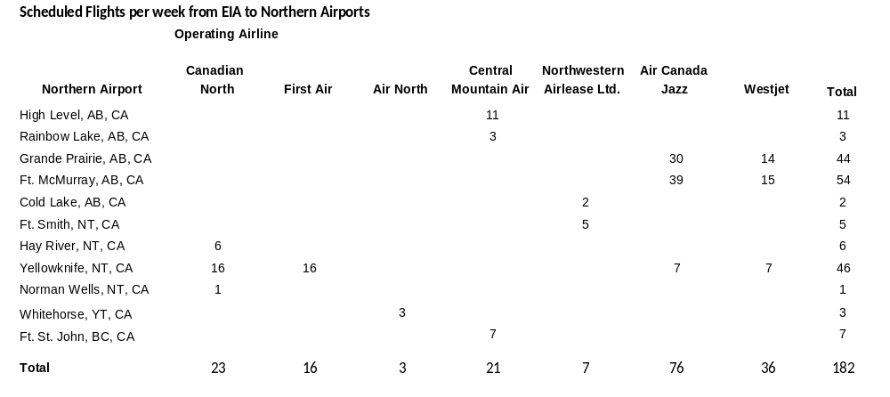

  - Integra Air provides scheduled service from Lethbridge to EIA (daily Sun – Fri, twice on Tue, Thur, and Fri). There is no scheduled service from Medicine Hat to EIA.

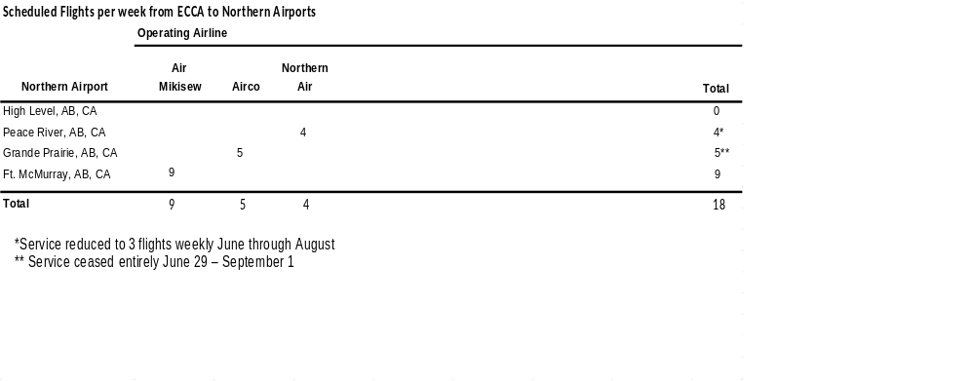

45. What options are possible if the ECCA were to be kept open to allow for development as a centre of excellence and transportation hub?

Response (prepared by Edmonton Airports)
- Since assuming operation of the City Centre Airport, Edmonton Airports has been pursuing our stated vision of developing the airport as a Centre of Excellence for general aviation, capitalizing on its convenient location. The airport’s convenient location has been marketed nationally and internationally at aviation conferences, in aviation publications and through other media.

- Landing fees for flight training and light private aircraft have been waived to support the increased use of the airport for these groups and to help promote pilot training. We continue to explore with Canada Border Services Agency, the opportunity for reinstatement of some level of customs clearance at the airport.

- With necessitated limited scheduled service, the opportunities to develop a transportation hub are limited. VIA Rail has located to the north west of the airport; however discussions with Greyhound to relocate their terminal were not successful. The area would also require a full service bus service combined with a full service light rapid rail system incorporated to truly become a transportation hub. Without a significant dedicated population base this in unlikely to happen.

46. What would be an adequate amount of time to see if this is feasible – 5 years/10years?

Response (prepared by Edmonton Airports)
- Since 1996, after assuming management of City Centre Airport, Edmonton Airports has worked actively on developing ECCA as a general aviation centre of excellence. We have facilitated working sessions bringing together NAIT, NavCanada, Spar / L3 Communications , Air Canada and WestJet to explore mutual business needs and educational opportunities. To date these discussions have not resulted in development. Of note, BCIT Aerospace Campus, located at Vancouver International Airport is not fully dedicated to aviation related education due to lack of sufficient demand. With the major aerospace company, SPAR / L3 Communications now having left Edmonton, the opportunity to move forward on this initiative has diminished significantly.

47. Has NAIT ever expressed an interest to develop an aviation related curriculum?

Response
- The following response was received from Mr. David Janzen, Vice-President and CFO, NAIT:
- “NAIT has three programs related to the aviation industry, namely Avionics, Aircraft Skin and Structure, and Pilot Training. The latter has been suspended due to low enrolment, while the Avionics program is located at our Distribution Centre facility, and the Aircraft Skin and Structure program is located at our Patricia Campus, and consequently, NAIT does not need to be at an airport to deliver these programs. The aviation industry does not have the significant manpower needs as in other industries, and any additional requirements of this industry can be met by other institutions in Quebec, Calgary and BC. As a result, NAIT is not looking at expanding its offerings in aviation at this time and in the foreseeable future.”

48 Would increases to landing fees be needed in order to develop and sustain a centre of excellence?

Response (prepared by Edmonton Airports)
- Centres of Excellence in other jurisdictions are generally subsidized by some level of government. It is unlikely therefore, that a significant revenue stream to the airport will be achieved through this initiative. As a result, it could be expected that fees will need to be increased.

49. What are current revenue streams for ECCA? i.e., flight training, charter, medevac, etc. What would need to occur for ECCA to break even in its operating costs?

Response (prepared by Edmonton Airports)
- In 2007 ECCA generated about $4.3 million in total revenue. Non-aeronautical revenue makes up 35.5 percent of total revenue at ECCA. This is comprised primarily of real estate revenue. Scheduled and Charter activity fees make up the next largest component at 28.6 percent. Over 50% of the flight movements at ECCA do not pay landing fees or landed seat fees (this includes flight training and private aircraft).

- Currently, the City Centre Airport does pay all of its operating costs. Like most general aviation airports, the City Centre Airport cannot fully pay for its capital costs. Those costs are subsidized by the users of EIA.



- How many General Aviation Airports currently exist in Edmonton and Region, and given our population base what is ideal? What is sustainable?

Response (prepared by Edmonton Airports)
- Edmonton Airports operates 4 general aviation airports (EIA has GA activity) in the Edmonton Region, with a regional population base of 1 million. In addition, Strathcona County has expanded the general aviation use of Josephburg Airport.

- By comparison, Calgary Airports operates 2 general aviation airports (Calgary International has GA activity) in the Calgary Region, with a city population base of just over 1.2 million.

- Explain whether there is a cap on Charter flights?

Response (prepared by Edmonton Airports)
- General aviation charter flights are traditionally considered for commuter aircraft, with a maximum seating capacity of 19 seats. In order to realize the full benefits of consolidation it is necessary to ensure that larger aircraft that may be operated as charters, but mimic scheduled flights, are not encouraged at ECCA. For those flights on larger aircraft that represent ‘special events’ (rather than a defined schedule), a simple process of prior approval is required. We regularly receive, and approve, these requests. Examples of these types of requests would include sports teams or corporate special events where a group of individuals are chartering into Edmonton for a corporate grand opening.

- There are other regular users of ECCA that operate larger aircraft without restriction. For example, the Government of Alberta regularly flies from ECCA on their Dash-8 aircraft, with a seating capacity of greater than 30.

- In your briefing notes the Royal Alex does not appear as one of the top 25 airport destinations but the U of A does. Please explain?

Response (prepared by Edmonton Airports)
- There are also 107 movements to the Royal Alex; however, it did not rank within the top 25. All of this activity is related to STARS.

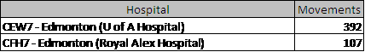

- How much in capital investment has ECCA received since 1995 and what are the long range plans for Capital Investment in 2009 – 2014 and 2014 – 2019.

Response (prepared by Edmonton Airports)
- Since 1996, Edmonton Airports has invested $13.2M to maintain the City Centre Airport. At time of transfer, the City provided an Airport Reserve Fund of $3.8M which was spent in the two years following transfer on pavement, drainage rehabilitation, equipment and buildings. An additional $600K was also received and used to repair runways. In summary, of the $13.2M expended, the City provided $4.4M. Our current five year capital plan for the airport is $14.5M. The longer term capital plan provides for the $35M in capital requirements as previously outlined.

Response (prepared by administration)
- Since 1995 the City has invested about $3M in stormwater infrastructure for the ECCA Lands. The Drainage Utility will need to recover these investments from benefiting development.

55. We have heard that the ECCA should have scheduled flights. Explain what the rationale is for not permitting scheduled flights as well as any legal and lease implications.

Response (prepared by Edmonton Airports)
- EIA served a record 6.4 million passengers in 2008 and has been Canada’s fastest-growing major airport for the past three years. From 2004 to 2008, EIA served over two million more passengers, leaping from 4.1 million to 6.4 million passengers – a more than 50 per cent growth rate. Growth has outpaced both Edmonton Region population growth and Alberta GDP growth, indicating that consolidation has stimulated air service and passenger growth beyond what could be attributed to a strong local and regional economy. Consolidation has also allowed Edmonton to better realize its market potential. As a result of consolidation, the Edmonton region’s air service has grown tremendously. With scheduled service to 50 non-stop destinations, including 10 U.S. hubs, and the best air service in our region’s history.

- Airline margins are slim; even a few passengers 'leaked' to other markets/airports can make or break the viability of a service, with a cascading effect on other destinations, due to airlines not hubbing traffic through EIA. Airlines are increasingly focused on deploying their primary resource (aircraft) only to routes with the highest yield and the least risk.

- ERAA Board of Directors and Management have developed a five-year strategic plan, which includes a $1 billion capital program, based on consolidation remaining in place.

- Edmonton Airports has strongly affirmed its position on consolidation of scheduled air services.

- The City of Edmonton has provided documentation recognizing and reassuring Edmonton Airports’ lenders of restrictions on passenger services (see Attachment 8 to Report 2009DCM032).

Councillor Krushell

Legal Analysis Attachment 1

56. It has been suggested that it is not a problem or a big deal to allow 19 passenger scheduled air service at the ECCA. Based on the legal analysis provided is it not a fact that any scheduled air service is an issue?

Response (prepared by administration)
- EA has promised to operate an airport at the ECCA providing general aviation services, and the City acknowledged that EA intends restricting scheduled air passenger service during the term of the Lease (all as contained in Article 6 of the lease). It is submitted that EA is charged under the lease with operating and managing the ECCA, and is best equipped to determine how much, if any, scheduled passenger service should utilize the ECCA and the specifications of such scheduled passenger service.

57. It was suggested by more then one speaker at the Public Hearing meeting that City Council should force development of existing sites such as the Downtown Quarters instead of developing the ECCA site. The challenge as I see it is that the City owns the ECCA site where as in many other cases the City does not own all of the land. On what legislative basis can the City require developers to develop land?

Response (prepared by administration)
- The City cannot require developers to develop land. The City’s options to get development moving is to become the developer and set the standards, pace and potential, or as done in the Downtown and are intending to do in the Quarters, provide incentives to encourage redevelopment and revitalization of areas of the city. The incentives may take many forms from monetary ($ per unit or investment in streetscape/infrastructure), to enhanced development opportunity, tax relief, etc.

Impact Assessment Final Report Attachment 2

58. On page 6 of the report under E3 6th bullet “A Transportation Node including the Medevac (Helipad) facility – I assume this bullet statement referred only to incorporating a helipad facility since Medivac requires fixed wing planes and a runway? From the assessment completed was any work done to determine whether there were any Transport Canada issues around keeping a helipad for STARS and EPS on the ECCA lands as part of an overall development plan?

Response (prepared by Mark Huberman, Bunt and Associates)
- Yes, the helipad facility is for helicopters only not fixed wing airplanes. There was not a significant amount of detailed assessment completed in regards to Transport Canada design related requirements. At this level of planning, it was assumed that the proposed location for a helipad would be accessible as is the airport. The helipad site was located adjacent to existing low rise development and away from the proposed high elevation development associated with the demonstration plan. It was also moved to a location whose attributes included direct access to an arterial roadway which would improve access from the helipad (via ground transfer) to hospitals.

59. Page 10 “Future Market Value” A 12% discount was included in the assumptions this assumed the land would be sold to developers to develop it was any work done to look at these numbers if the City were to develop it?

Response (prepared by Gordon Easton, Colliers)
- Colliers hypothetically assumed that the site would be sold to a third party who would then develop the site. Given a time horizon of 28 years and the magnitude of the project a conservative discount rate of 12% was utilized. In the scenario where the City was the developer, they would likely use a lower discount rate. The impact of this is that the Present value of the project (all other things being equal) would increase. The other factor to consider is that if the City were to undertake the development, they would not require the developer's profit so when we remove that cost the value is as follows:
  - 7% discount $60.9M
  - 8% discount $60.4M
  - 9% discount $59.9M
  - 10% discount $59.4M
  - 11% discount $59M
  - 12% discount $58.5M
- The use of 12% is considered conservative.

60. Page 59 - The 10 million cost referred to for realignment of the Yellowhead Trail west of 107 Street is based on what?

Response (prepared by Mark Huberman, Bunt and Associates)
- The cost estimate was based on a concept and estimated on a per lineal meter cost of removal and replacement. This estimate was developed at a concept level of planning and is within a 40% range of confidence.

61. Regarding Schedule B of the “CN Yellowhead Agreement”, which specific stretch of the Yellowhead will need to be realigned should CN exercise their option, and how far south will it be moved? In their news release date June 19, 2009, the Alberta Enterprise Group claims the CN Yellowhead realignment will take up 25% of the developable land at ECCA? Is this correct? If not, do you know the correct amount it will affect? Source: http://www.albertaenterprisegroup.com/Item.cfm?ItemClass=CityCentreAirport&ItemID=119

Response (prepared by Mark Huberman, Bunt and Associates)
- It is the portion of Yellowhead Trail that swings north about 150m west of 107 Street and then west 700m. It would affect approximately 3.0 ha of land.

62. Why did you include a cost of 12 million for an LRT station but did not include the costs for track?

Response (prepared by Mark Huberman, Bunt and Associates)
- The LRT station cost was identified because without the land development there is not a need for a station. The rail cost would be consistent with or without the land development generally speaking, although the redevelopment may provide a better alignment opportunity which may translate into cost savings.

63. Can you provide some examples of how ensuring flexibility in the overall design of the development of the ECCA lands would help reduce costs for environmental remediation?

Response (prepared by Mark Huberman, Bunt and Associates)
- Environmental remediation is dependant on the type of development to be constructed over the potential contamination. Business commercial would be less restrictive then residential. The demonstration plan provides an example of this where the old fuel tank farm is located between 121 Street and Airport Road just north of Kingsway and is designated as general business.

64. Page 59 item 5.3.7 Medevac (Helipad) Facility when referring to the Helipad facility is this also including EPS helicopter and was a fuel station contemplated as part of this to service the helicopters? (Mark)

Response (prepared by Mark Huberman, Bunt and Associates)
- The site identified in the demonstration plan is large enough to accommodate both EPS and STARS if required and is located by an existing industrial use and separated from residential use by the arterial roadway (121 Street) so could easily allow fuel storage.

Medevac Attachment 5

65. In the report there are references made to all of the stakeholders that were contacted in order to develop the report. It notes that Alberta Health and Wellness was contacted. Was Alberta Health notified about the fact that City Council was debating the ECCA issue and did they have any response?

Response (prepared by Donna Towers, Donna L Towers Inc)
- The consultant interviewed staff within the Emergency Services of Alberta Health Services as part of the consultant’s report. The staff interviewed knew the report was for City Council and noted at the time of the interview that a letter was to be sent from the Minister of Health to the Mayor. The consultant is not aware if this letter was sent.

Dialogue Report Attachment 7

66. It was brought up during the presentation on this item that while there were many areas of disagreement regarding open or closure there was consensus that status-quo was not acceptable. Can you describe what was meant by status-quo and why people participating did not see status-quo as a viable option?

Response (prepared by Stephani Roy McCallum, Dialogue Partners Inc)
- In the public involvement process, status quo meant a continuation of the City Centre Airport Lands and operations as they exist today, without any changes. Over 2500 persons participated in the public involvement process.

- There was consensus that land use and operations as they exist today are not serving the needs of residents as a whole, nor of airport users or supporters. Concerns and ideas for improvement regarding governance, economic impact and benefits, environmental impact, transportation and community character were all expressed. Please note that while some participants expressed comments about air service, these comments were documented, but not analyzed in the development of the final report. In essence, Option 1 that was presented for consideration by Executive Committee reflects a summary of the views of those who support the continuation of the City Centre Airport, but do not support the status quo.

- A short summary of the views and vision for the City Centre Airport Lands expressed by participants in Option 1 and Option 2 is provided below:

Option 1 – Operational Airport with Aviation Centre of Excellence & Transportation Links
- Participants who supported this view saw the Airport as a viable and vital part of Edmonton’s history and future. They suggested that a light rail link be developed to link to the City Centre airport, Yellowhead Trail be improved, and that the proximity of the airport to downtown be actively promoted. They suggested that screening and greening of the property be improved, and that users and businesses at the airport be encouraged to use more environmentally friendly/newer planes.

- Some questions and concerns about the extent of environmental contamination need to be answered, and if the problems exists, then a plan and funding sources for clean up need to be developed.

- Maintaining the airport as a landing site for medevac should be promoted and maximized, and ideas of promoting a “health care centre of the north” on site and in partnership with health care organizations were proposed.

- Participants suggested that the best way to maximize the viable and vital role of the airport in Edmonton’s future is to develop a comprehensive economic development strategy that focuses on existing businesses, attracts new aviation related business to the area, and promotes aviation training and education, creating a “centre of excellence”.

- Concerns about urban sprawl and infill development were acknowledged, but participants suggested that development focus shift to other vacant property, and that some consideration be given to higher density development, where possible, in surrounding communities.

- Ongoing support to the Aviation Museum in conjunction with an operational airport was seen as a benefit. Participants also identified that issues related to cost recovery, maximum revenue generation and economic benefit for the entire City remained unresolved in this option.

Option 2 – Mixed Use Transit Oriented and Sustainable Community
- Participants who supported this view saw the Airport lands as a prime site for development of a “world class” community.

- They suggested the creation of a multi-modal transportation hub that includes Via Rail, light rail, bus and improved roadways, and that the proximity of new places of work and living to downtown could be activity promoted.

- They suggested that natural clean up technologies and best practices in environmental remediation could be used if required, and that diversification of energy sources and implementation of green infill building would create an environmentally friendly sustainable community and reduce urban sprawl.

- Careful, phased development over time was seen as optimal, and ideas like NAIT expansion, wellness and education centres, recreation and sports uses could provide opportunities that all residents could appreciate. Positive comments about improved air quality, safety and reduced noise with the absence of an operational airport were made.

- Potential revenue generation through sale of land, development fees and tax revenue were seen as a positive economic benefit to all residents of Edmonton.

- Participants noted that the costs of breaking leases, relocation and/or potential job loss would need to be addressed fairly and thoughtfully if this vision is implemented. It was suggested that the needs of northern communities would need to be addressed so that innovative solutions could be explored, and that their concerns about access, health care and service be taken into account.

- Support and appreciation was expressed for the Aviation Museum and recognition of the historic role of the airport would need to be addressed. Participants expressed confidence that alternate arrangements for medevac be developed.

General Questions:

67. Can an analysis be provided both on the Ascend report submitted by the AEG Group and an analysis on the critique provided by Frost and Associates of the Colliers report that was submitted as part of Attachment 6?

Response
- An analysis of the ASCEND report prepared by Darryl Howery of Applications Management is provided in the response to Question 31 by Councillor Leibovici.

Response (prepared by Gordon Easton, Colliers)
- The Frost report basically concurs with the analysis by Colliers and acknowledges the thoroughness of their work. He has identified four areas of concern:
  - the possibility of contaminated material – which was addressed at Council by Administration indicating previous testing reveals nothing has been found to date that indicates a concern. It was also indicated that if there was contamination, the City is responsible with or without the development of the land, and therefore was not considered as cost reflective on the land development;
  - the cost associated with existing leases – The staging of development can be reflected by leases as they expire, some of the lessees may wish to renegotiate the length of their leases due to moving of the airport, would be speculative to assume high costs for buying out leases;
  - cost of infrastructure outside the boundaries of the site – this was examined for underground services (PAC costs etc) and for transportation costs it established the existing system could accommodate the development;
  - developer profit of 25 to 30 % instead of 20 to 30% - they appear to be in the a little smaller range than Colliers, with the same top end.

68. Without scheduled air service what revenue opportunities are there for continuing the operations at the ECCA? Would landing fees have to increased, and by how much?

Response (prepared by Edmonton Airports)
- If all current scheduled service were discontinued, the annual decrease in revenue would be approximately $500,000. Assuming no other changes, fees would have to be increased to make up for this loss – the most significant impact would be to the landed seat fee, which would likely have to increase from $12 to $15. Revenue opportunities for developing the remaining three parcels of land all have severe restrictions, including access and proximity to runways, and the impact of the Indy Race. Once the Northland’s agreement for the Indy is concluded, if these lands could be fully developed, the additional revenue potential is estimated to be in the range of $500,000 annually. This does not include the cost to develop and to service the lands

69. Is it feasible to close one of the runways down? If runway 12-30 was closed what does that do regarding reduction in the APO? How much capital dollars are required for upgrades to this runway and what are the timelines? For runway 16-34 how much upgrades are needed and is it possible to move the ILS to runway 12-30? It is my understanding that the ILS is old how much more time before it needs to be replaced? How effective is GPS and what are the costs to install this system? Is it possible to close runway 16-34 and operate on runway 12-30 and what are the advantages and disadvantages as per the APO requirements and the expansion of NAIT? I would also like to know if metal mass is an issue with GPS and any new ILS system? I recall when the NAIT recreation facility was being considered that a metal mass study was required to ensure that any expansion would not inadvertently interfere with the ILS system.

Response (prepared by Edmonton Airports)
One Runway Operations:
- Edmonton City Centre Airport can operate on one runway; many airports do (for example Kelowna International Airport and Gatwick International Airport).

Runway 16/34:
- Runway 16/34 is the Instrument runway (Instrument Landing System: ILS) and is the runway requiring the most cost. The current electrical systems on Runway 16/34 require replacement ($250k) and the runway infrastructure requires a complete overlay at an approximate cost of $6 million.

- Runway 16/34 has the most significant impact on development restrictions, off-airport and for NAIT.

- Runway 16/34 is the most noise sensitive for Edmonton residents.

Runway 12/30:
- The outer edges of Runway 12/30 were paved two years ago, and the centre portion is due for overlay in the next five years. There are investment costs required ($1.5-$2.0 million), but they are not the most immediate.

- Runway 12/30 is the primary runway at ECCA due to winds; it is used 60-65% of the time.

- Yes, if runway 16/34 were closed, operations would be viable on runway 12/30. Installation of a GPS approach on runway 12/30 would also allow for lower minima (more ability for aircraft to land/take off) during extreme weather.

APO:
- With regards to the outer limits at the airport, regardless of which runway is closed, an aeronautical study by NAV CANADA, in conjunction with EA and Transport Canada, would be required to determine to what extent the restrictions can be reduced. Runway 16/34 has the greatest impact on the downtown core due to development restrictions.

ILS:
- The Instrument Landing System (“ILS”) cannot be moved to Runway 12/30 as the runway displacement (shorter runway) makes it non-viable for ILS. It is also expected that the landing approaches are compromised by buildings (which would interfere with the navigational systems). Discussions with NAV Canada have confirmed that this is not an alternative.

- Related to this, metal mass does create issues for ILS. For example, when the Jefferson Armouries building was developed, the developer had to construct a skeleton building out of scaffold and wire prior to building in order to test the impacts on the ILS. The test skeleton cost approx $100k and was successful, which allowed for the development of the building. NAIT requested a parkade to go on top of their existing sports field which was turned down due to the location and proximity to the ILS.

- The current ILS and Automated Weather system at ECCA are both due for replacement and NAV Canada has deferred both upgrades until the City makes a decision regarding ECCA.

- A GPS is an alternative to ILS, providing navigational aids in poor weather; however, not to the level of an ILS. The minima for aircraft would change, which means there may be some periods of time in extreme weather when aircraft cannot land/take off. However, regardless of the sophistication of technology, all ‘winter airports’ experience some periods of time when extreme weather does not permit aircraft to take off and/or land. For example, Edmonton International and Calgary International both closed this past winter due to weather conditions.

- Approximate costs of a GPS are $75-100k.

70. If City Council chooses to close the ECCA what would the suggested timelines and plans for proceeding be?

Response (prepared by Administration)
- The Demonstration Plan and all supporting analysis assumed that aviation operations would continue until the end of 2015 and then demolition would occur in a staged fashion over 15 years. Development would start in 2017 and continue for 25 years, with the assumption that NAIT development would start in 2018 and continue for 10 years.

- In the terms immediate timelines for proceeding, the Alternative Course of Action contained in Report 2009DCM032 (page 6 of 7) suggests that the City Manager would commence negotiations for the surrender of the head lease and return to Council by January 2010 with a status report on activities and planning for the closure and redevelopment of the Edmonton City Centre Airport.

71. From the 2005 Intervistas report, can we break down the economic impact between aviation and non-aviation? Also, do we have updated numbers that account for the changes among tenants at the ECCA since 2005?

Response (prepared by Darryl Howery, Applications Management Inc)
- By definition, all activity (employment, GDP, etc.) estimated in the InterVistas report is associated with the operation of the airport. ("The scope of this study is the locally based employment impact of on-going operations at ECCA (i.e. the total number of jobs created in the Edmonton region directly attributable to ECCA." Page 4 - The Economic Impacts of Edmonton City Centre Airport – FINAL REPORT, InterVistas November 8, 2005).

- There is some employment associated with the operation of the ECCA that can not reasonably be classified as "aviation" although, InterVistas has concluded it is associated with the operation of the airport. The following table (from Appendix 6 - The Economic Impacts of Edmonton City Centre Airport – FINAL REPORT, InterVistas November 8, 2005) provides a breakdown of employment by type of business. Clearly the Car Rental and Hotel categories are not "aviation" and account for 51 person years of employment. Several other categories may include some employment that is also not "aviation", such as Government Agency (34 person years), Contract Firms and Employment (18 person years) and Other (149 person years). How much of the employment in these categories is "aviation" related is not known. It can probably be concluded that most or almost all is "aviation" related, or it would not be included in the analysis. At a minimum, if you subtracted all the "possible" non aviation activity from the 910 person years of employment associated with operations of the airport, it would leave a "minimum" of 658 person years (or 72 percent of the total).

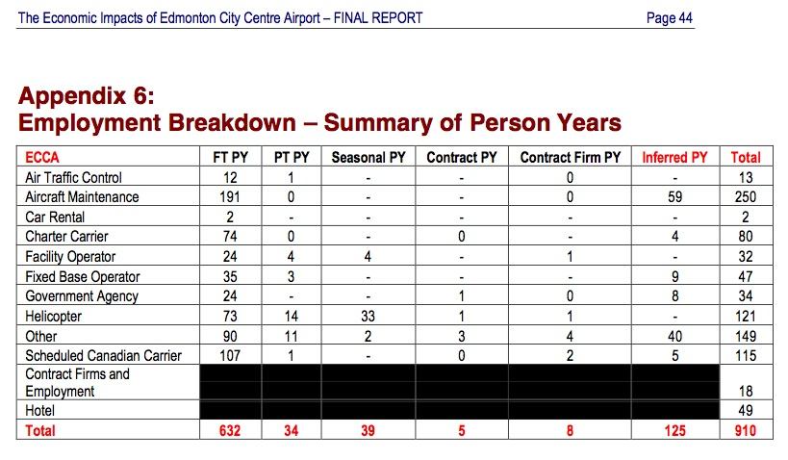

- Indirect Employment/Economic Activity: This is activity that is used as an input to the direct economic activity. ("Indirect employment is employment in down-stream industries that results from the presence of ECCA. For example, suppliers of food to fixed based operators at ECCA would be considered indirect employment. Indirect employment is generated in industries that supply or provide services to the airport employers." Page 6 - The Economic Impacts of Edmonton City Centre Airport – FINAL REPORT, InterVistas November 8, 2005). It can be expected that most of the business in this category will be "non-aviation".

- Induced Employment/Economic Activity: This activity is associated with the income that is generated from both the direct and indirect activity categories. ("Induced employment is employment generated from expenditures by individuals employed indirectly or directly. For example, if an airline maintenance firm employee at ECCA decides to expand or re-model his/her home, this would result in additional (induced) employment hours in the general economy. The home renovation project would support hours of induced employment in the construction industry, the construction materials industry, etc." Page 6 - The Economic Impacts of Edmonton City Centre Airport – FINAL REPORT, InterVistas November 8, 2005). It can be expected that most of the business in this category will be "non-aviation".

- Regarding the updated figures for the tenants at the Airport, Edmonton Airports would be in the best source of this information.

72. Aside from taxi service and private automobile, what options for transportation (ie. Shuttles) are available for travel from Edmonton to the Edmonton International Airport? What are the frequencies and fares of these options? What possibilities exist for public transportation to serve the Edmonton International Airport?

Response (prepared by Edmonton Airports)
- In addition to taxis and automobiles, two other transportation options exist. Limousines also offer service to and from the airport. Currently, Prestige limousine is licensed at the airport to provide service upon arrival for guests, however there are numerous other companies in Edmonton which regularly provide pre-arranged service for airport users.

- Additionally, the Sky Shuttle service provides service to 22 Edmonton hotels on a scheduled basis. They provide service to hotels in the downtown, west end and south side, and have plans to expand their service to more hotels in Edmonton and surrounding communities in the near future. In addition, they also service an additional 48 hotels based on a call in request for service. Service to the 22 scheduled sites sees them make stops approximately every 20 minutes to the major hotels. Based on their current schedule, this accounts for 919 stops per day.

- The current rate structure is $15.00 for adults one way, $7.00 for children 4 - 12, under 3 is free.

- However, no form of public transportation is available to EIA. Public transportation including bus and LRT service would further increase the level of service for citizens of Edmonton.

- Administration notes that Regional Transit Committee of the Capital Region Board will be examining the issue of public transit to the Edmonton International Airport.

73. Of the expected $35 million in necessary maintenance and capital upgrades at ECCA in the coming decade, what share is the City of Edmonton responsible for?

Response (prepared by Edmonton Airports)
- The City’s proportion of these total costs has not as yet been determined but for example, in the case of the storm systems improvements, up to $10M is expected to be funded by the City.

Response (prepared by administration)
- Any improvements to the drainage services for the ECCA lands would be determined in accordance with the terms of lease with Edmonton Airports and the City's policies for utility funding. The Drainage utilities expect new development or redevelopment projects to fund any drainage assessments, new infrastructure and any upgrading required downstream

74. How would buying out the leaseholders at ECCA proceed? Who would be responsible for the costs?

Response (prepared by administration)
- The process envisioned is a negotiated surrender of aviation subleases to EA by EA’s aviation subtenants, and then a concurrent assignment of non-aviation leases to the City by EA with a surrender of EA’s lease of the ECCA to the City. The City would then be landlord to the non-aviation tenants located at the ECCA. This process is based on fundamental legal principles and simple assumptions, not a negotiation with EA. Administration has not been empowered to negotiate the surrender of the ECCA lease. Responsibility for surrender costs is a matter to be negotiated and has not therefore been pursued at this point.

75. From the 37 environmental tests we have conducted, do we have an idea of whether the entire 217 ha site will need environmental remediation, or if only specific portions will? How long would it take to conduct a comprehensive examination of soil contamination to determine the full costs?

Response (prepared by administration)
- The Environmental Site Assessments completed to date primarily relate to the leases of various buildings around the perimeter of the site. Those assessments represent a small portion of the total site area. A comprehensive assessment of the entire site would likely take approximately one year to complete, but this assessment has only a two year shelf life and if development does occur within the two years, the assessments would be repeated.
- In the event that any portion of the site was to be sold, it is normal business practice for the purchaser to undertake their own site assessments for financing purposes.
- Regardless of undertaking a comprehensive environmental assessment, possible contamination can still be found at the time of construction.

Edmonton City Centre Airport 2007 Annual Report

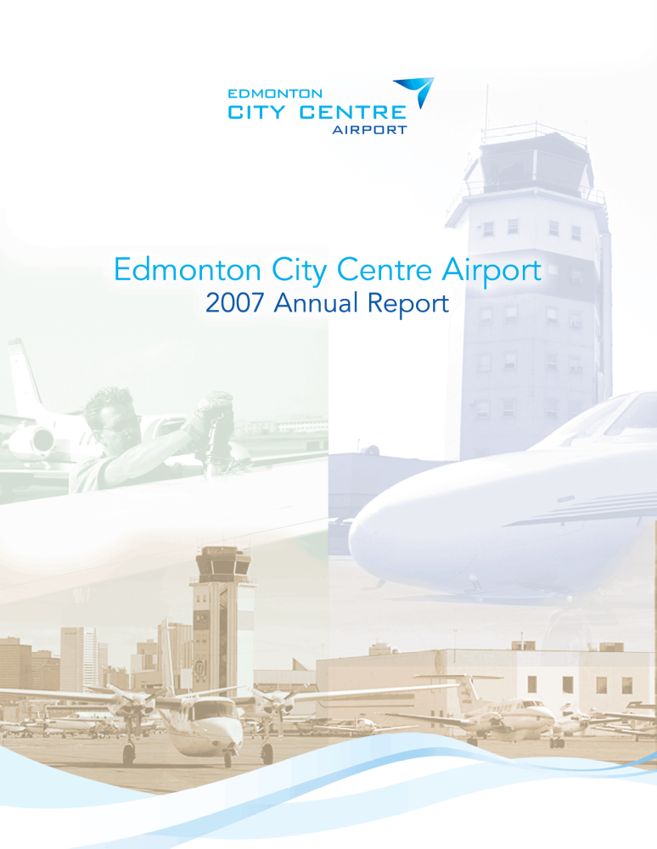

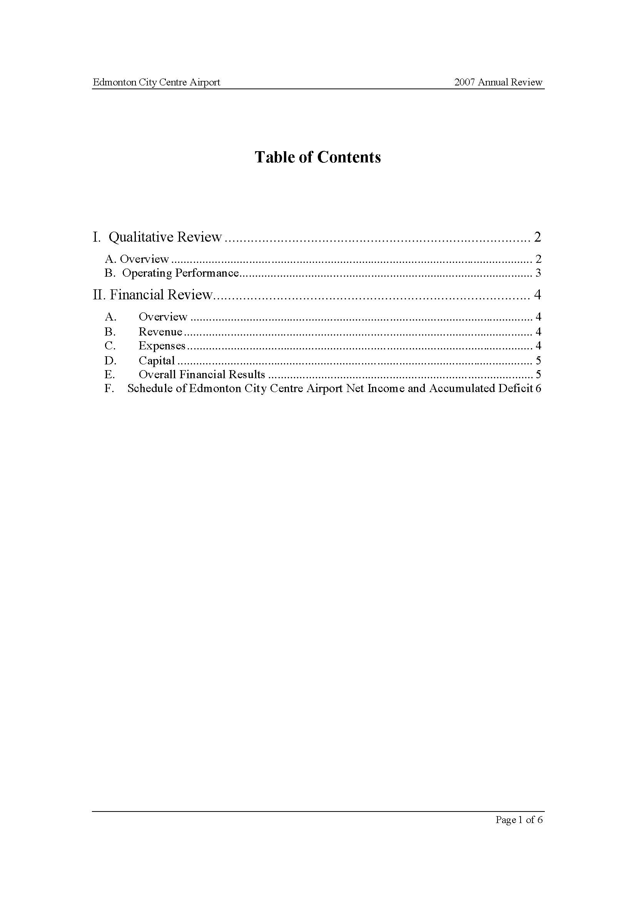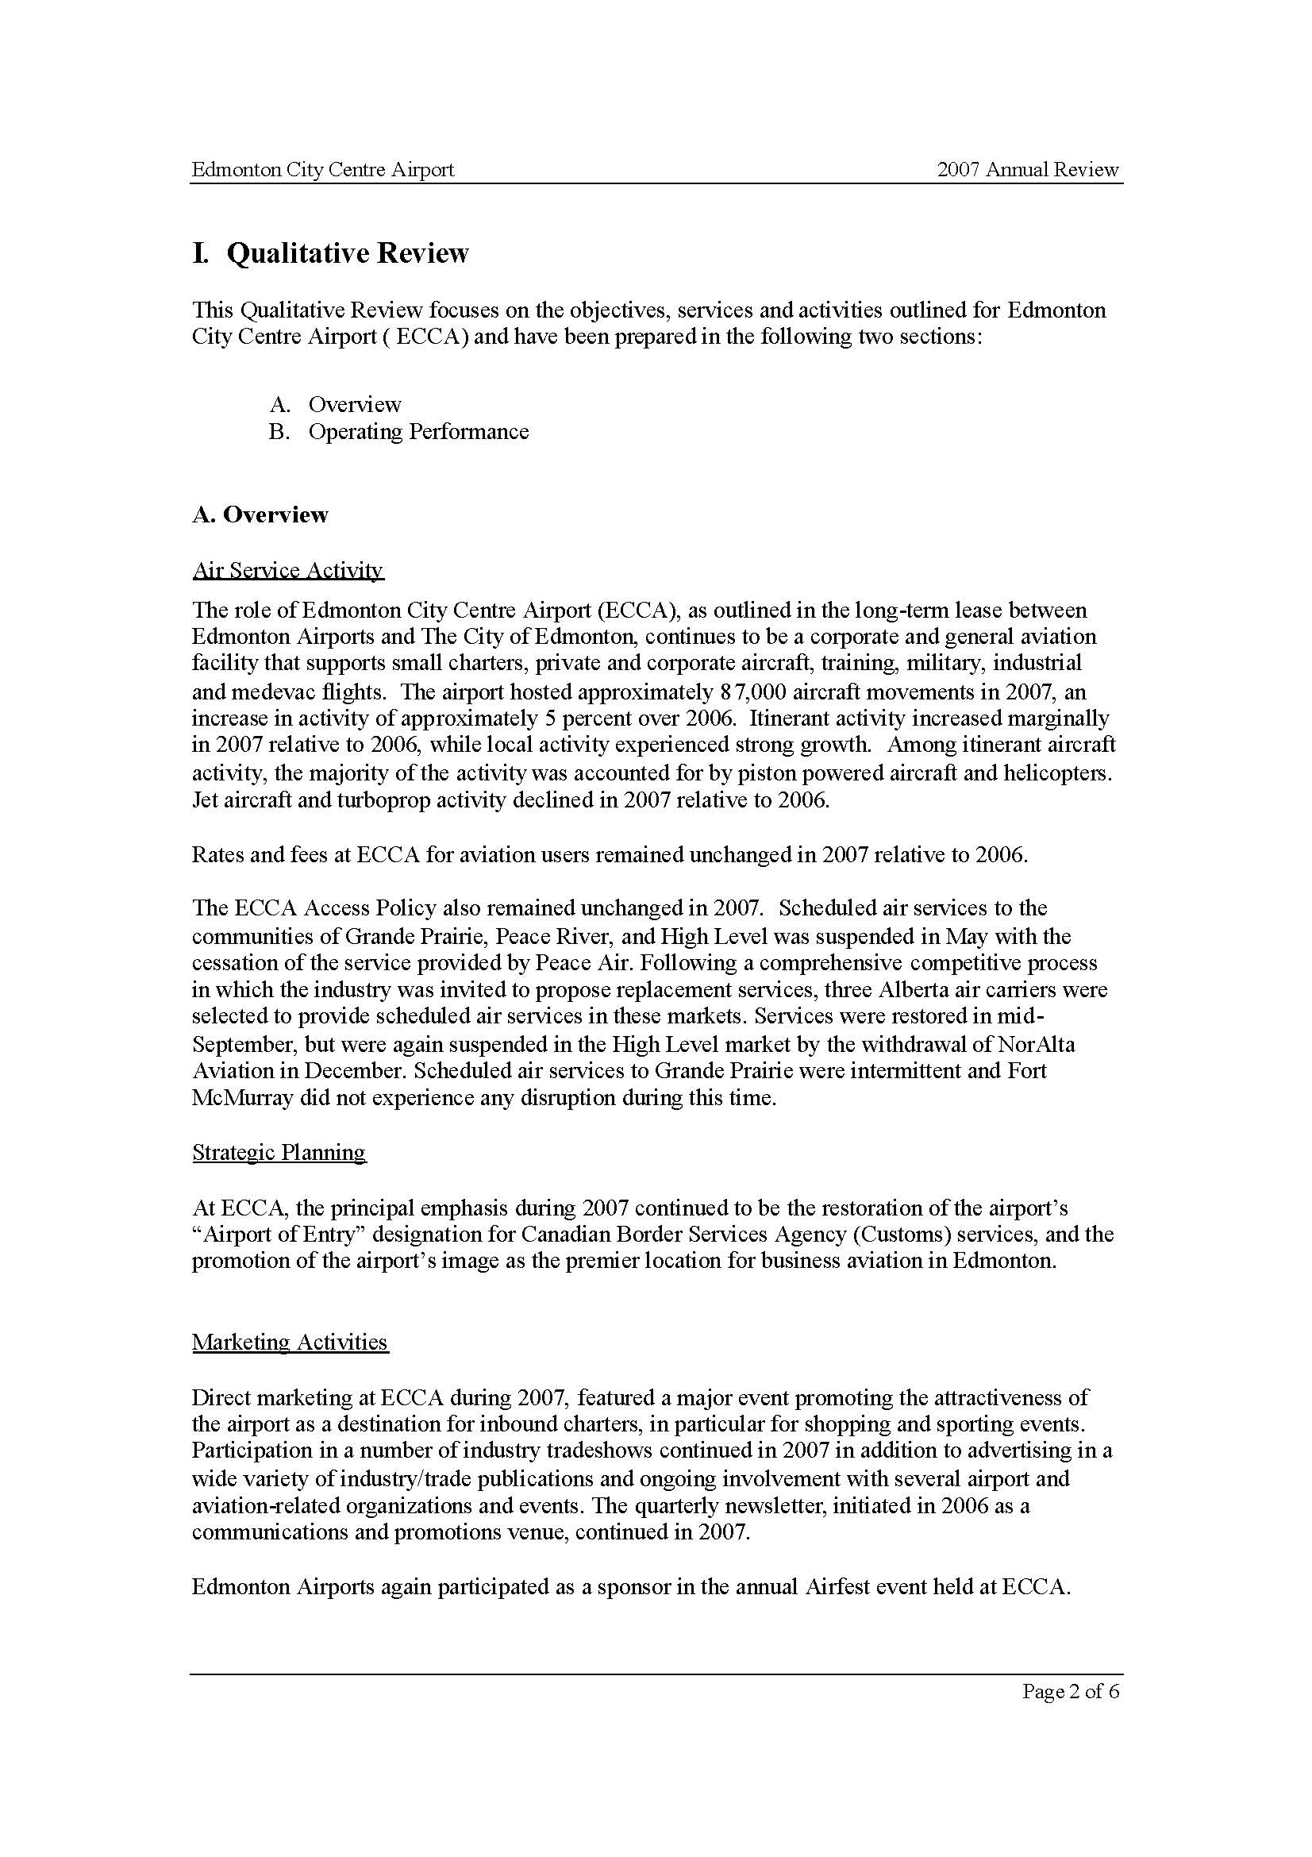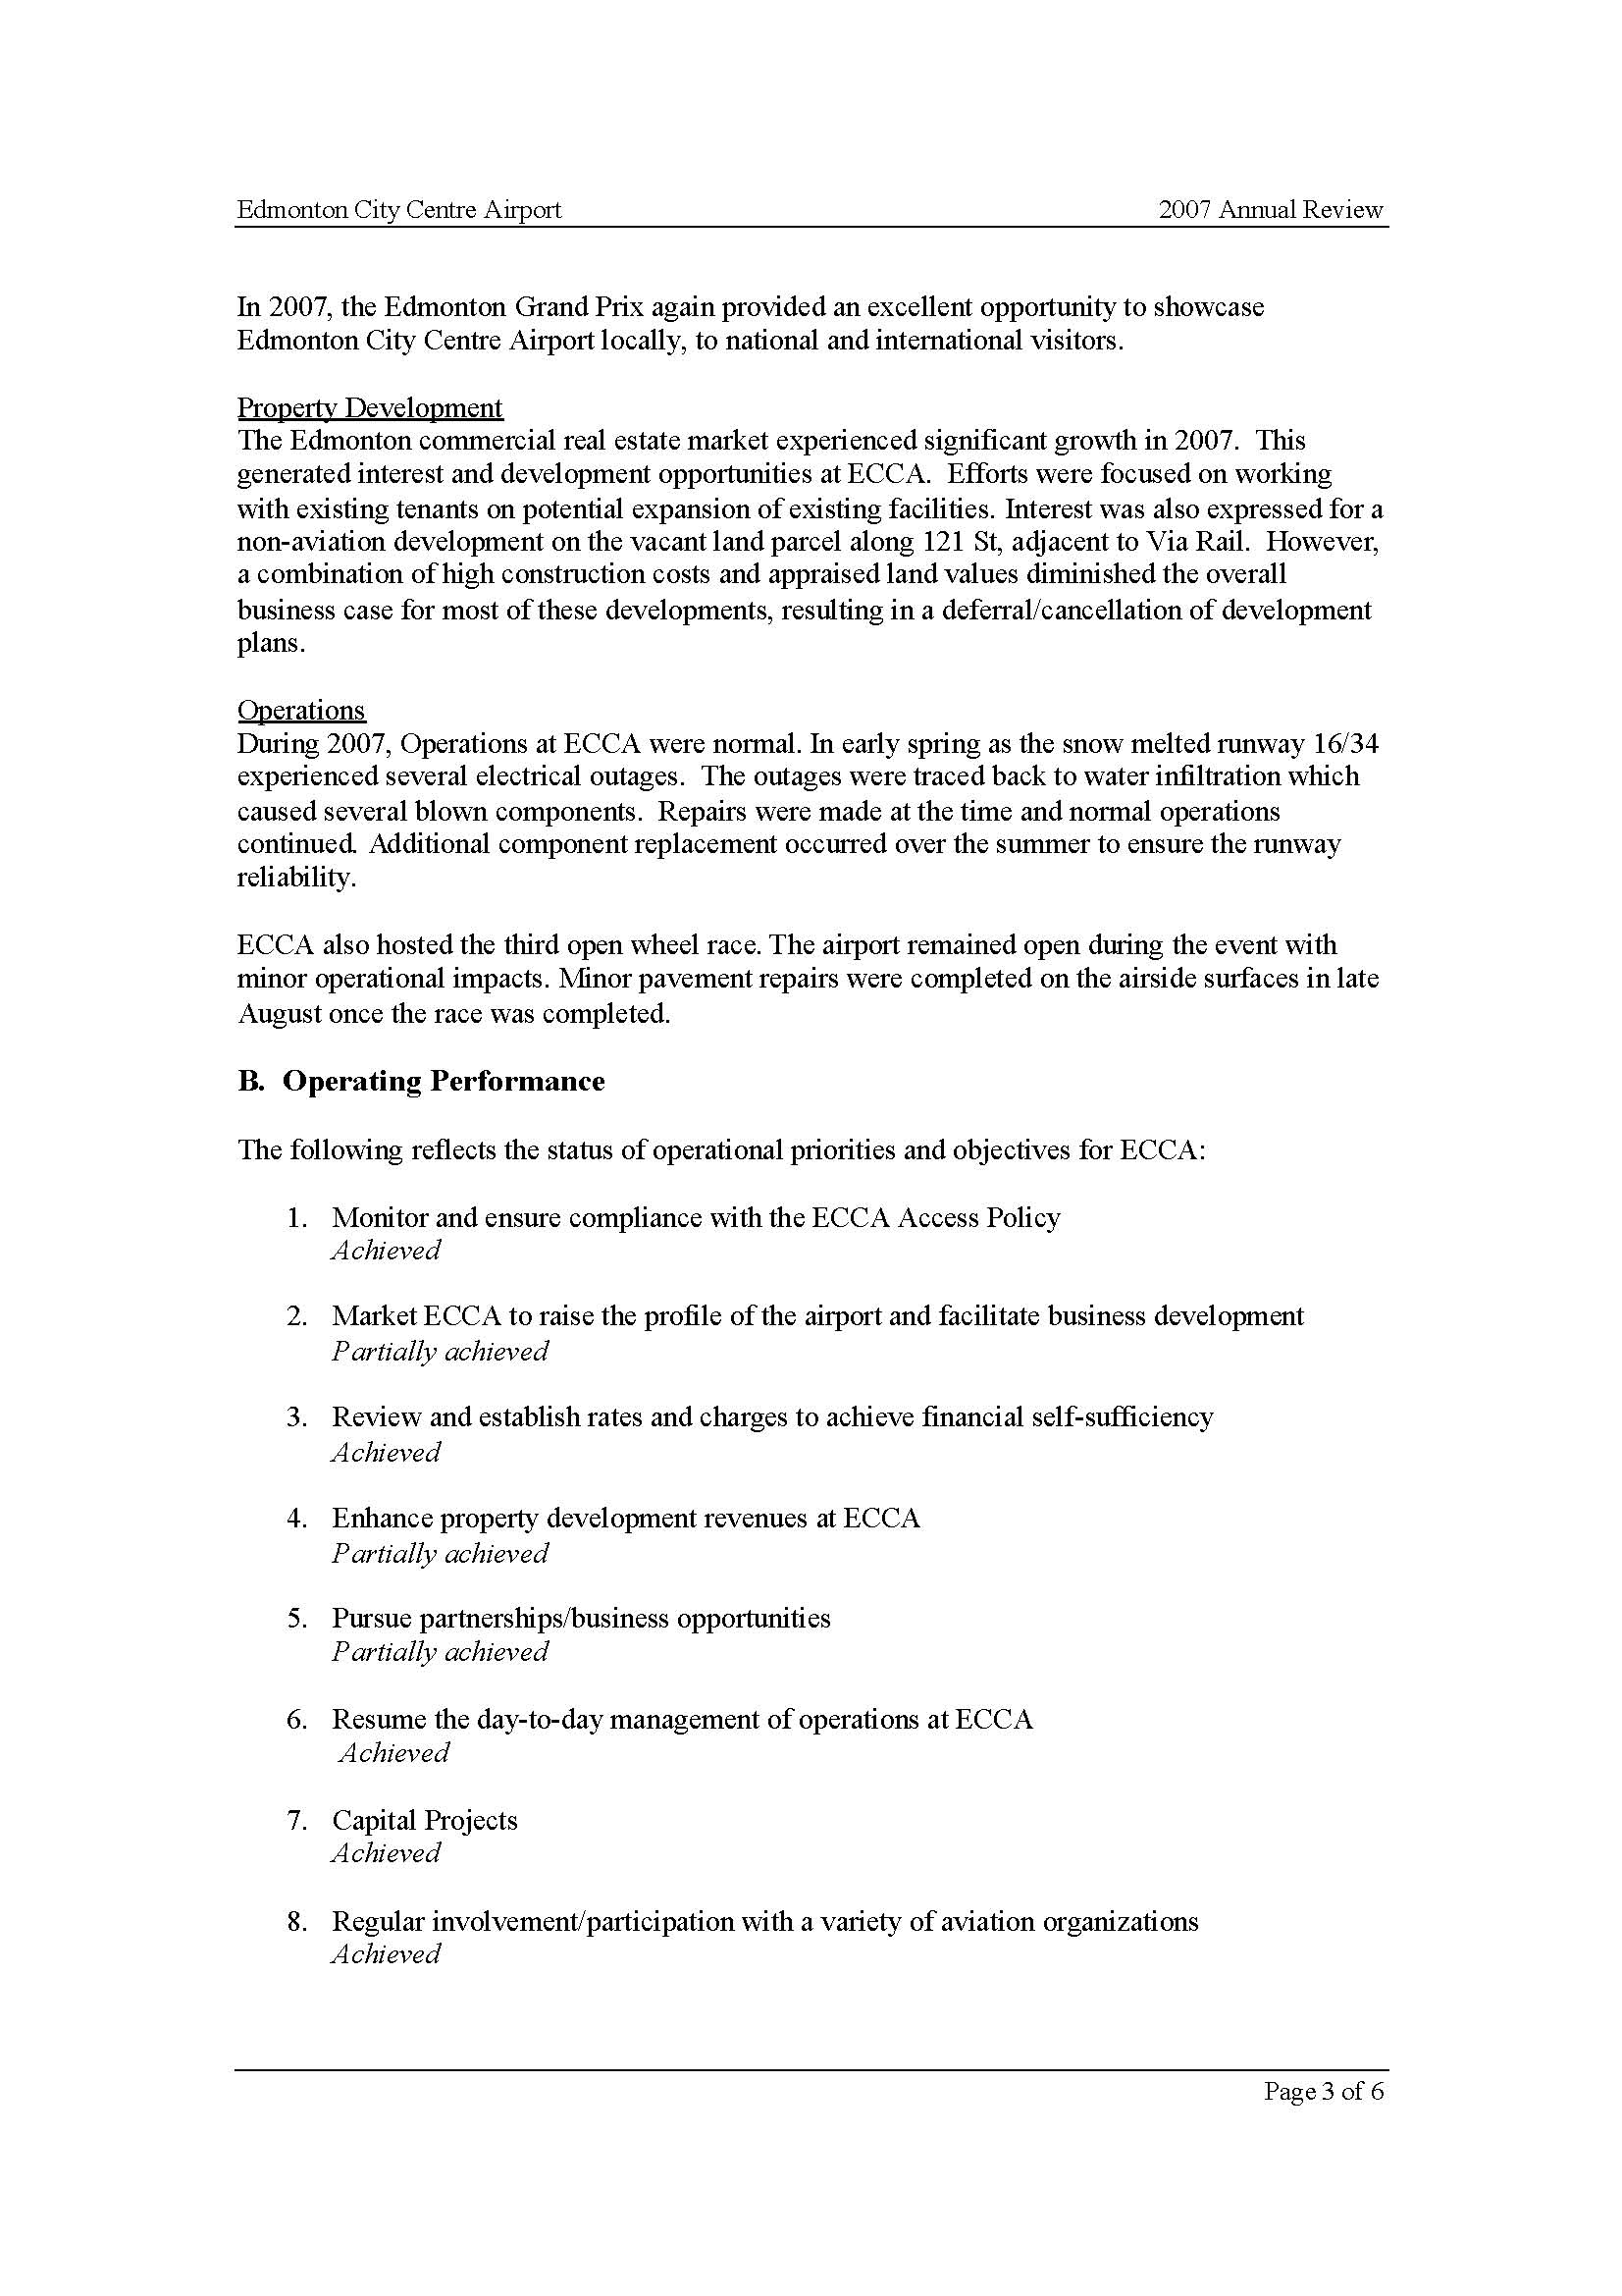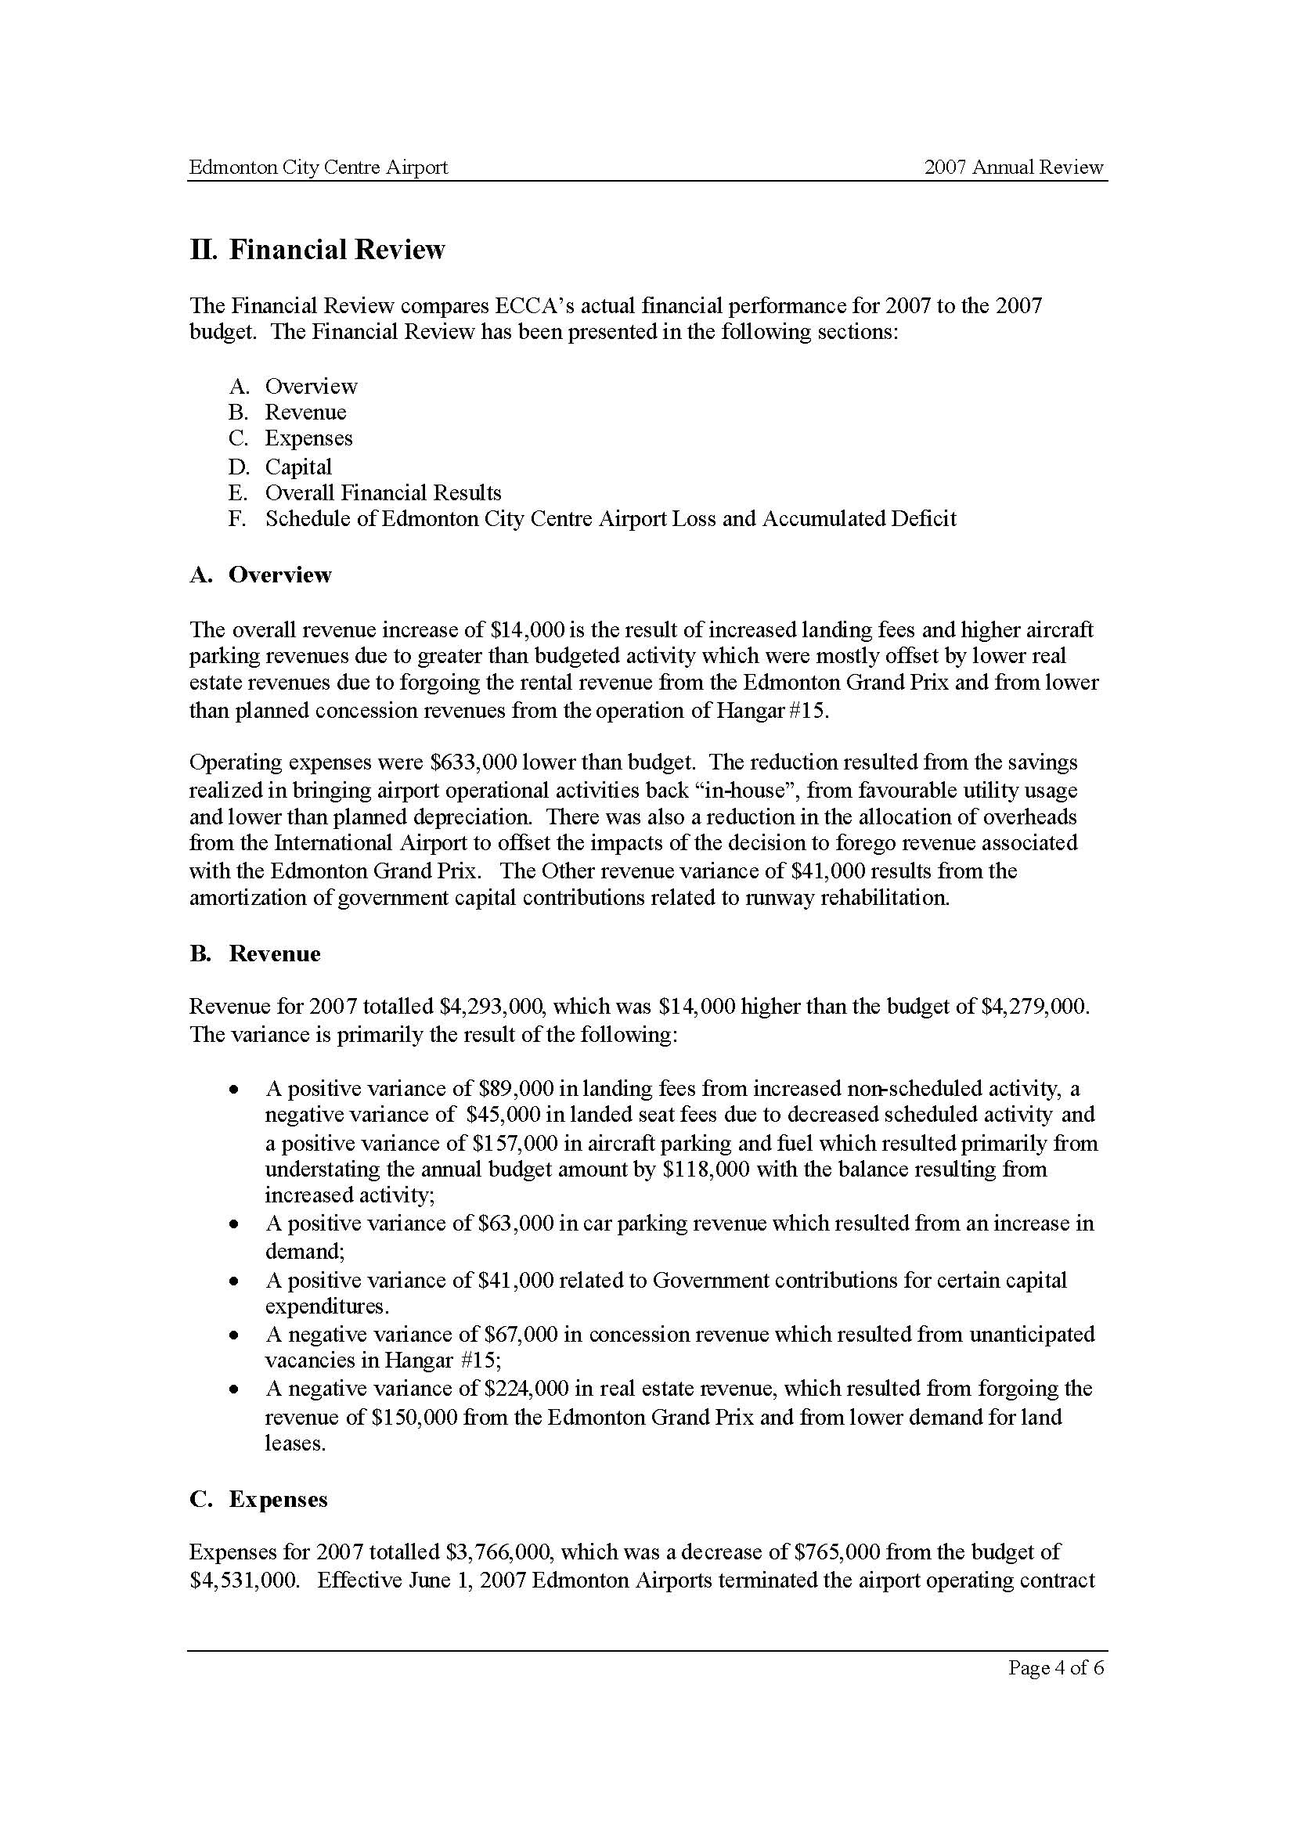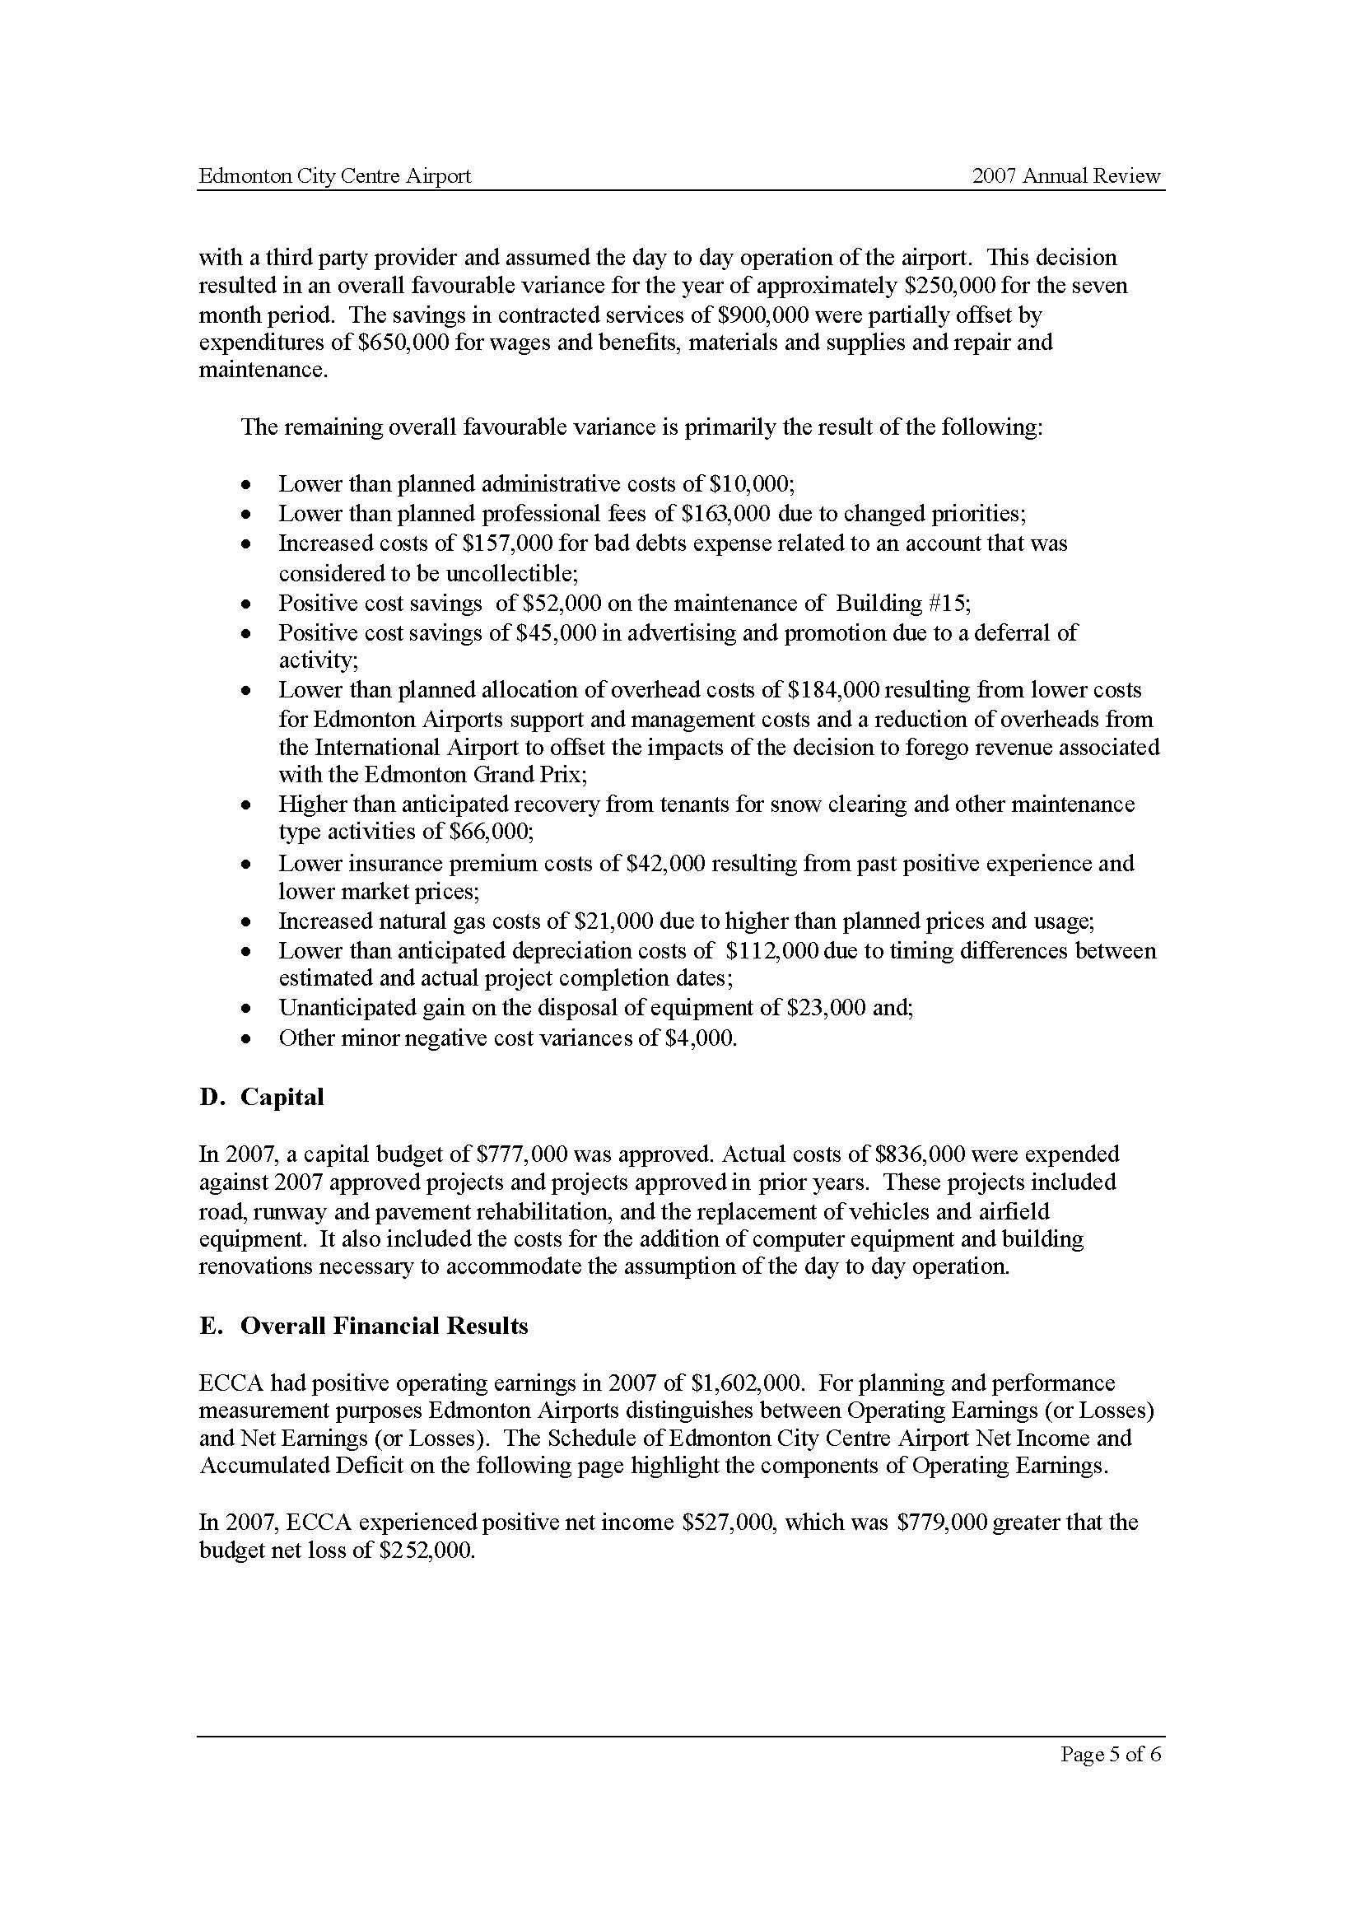
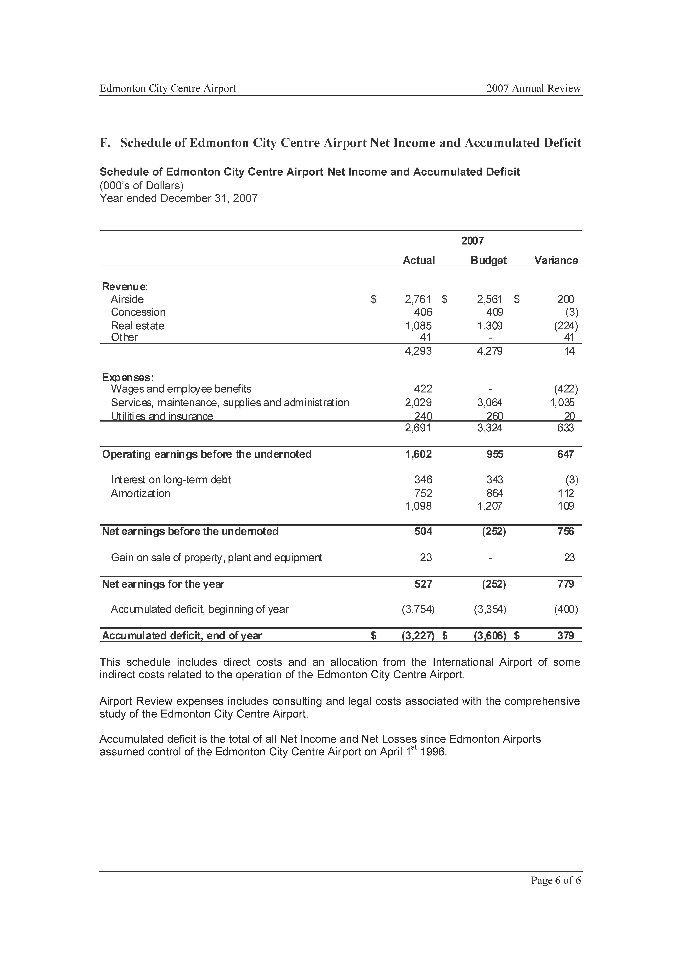

ECCA Aviation Land Tenants


