The Attraction and Retention of Immigrants
to Edmonton

Tracey Derwing, Harvey Krahn, Jennifer Foote
& Lori Diepenbroek

Prairie Centre of Excellence for Research on Immigration & Integration
The University of Alberta

A Report Submitted to Edmonton City Council and Citizenship and Immigration Canada, November 7, 2005

Table of Contents

Acknowledgements 3

Executive Summary 4

Final Recommendations 5
Introduction 9

Why Should Edmonton Attempt to Attract More Immigrants? 11

Previously Published Research on Attracting and Retaining Immigrants 12

Survey of Immigrants Residing in Edmonton and Calgary in 2005 13

A Proposal for an Immigrant-Friendly City of Edmonton Website 19

Website Appendices 22

Stakeholder Meetings Report 46
Stakeholder Attendees and Contact Information 52

Immigrant Questionnaire Form (Edmonton) 60

Annotated Bibliography 61

Acknowledgements

The research team would like to thank Councillors Michael Phair and Terry Cavanaugh for their support and interest in this project. Sheila Troppman, Marlene Mulder and Lenise Levesque of the Prairie Centre of Excellence for Research on Immigration and Integration were most helpful. We are grateful to all those individuals who took time out of their busy schedules to attend one or both of the stakeholder meetings. Thanks are also due to Anna DeLuca, Dean of Language Training and Adult Literacy, and the ESL teachers at NorQuest for allowing us access to several classes of students. Similarly, Mary Davison and Sharon George, as well as the ESL teachers at Bow Valley, were most accommodating. Thanks, too, to all of the students who shared their experiences with us. Finally, we appreciate the funding and services provided by Citizenship and Immigration Canada and the Prairie Centre.

Executive Summary

In response to a request from the City of Edmonton for a study on the attraction and retention of immigrants, we recommend more aggressive and targeted promotion of the City of Edmonton to attract immigrants, and more efforts to make Edmonton an even more welcoming city in order to retain immigrants. There is no question that Edmonton will suffer economically because of labour shortages in the coming years if it is unable to attract more people, both Canadian-born and immigrants, to live and work in the city.

A literature review, two focus group meetings with stakeholders (representatives of immigrant-serving agencies, school boards, ethno-cultural organizations, etc.), and a survey of over 200 relatively new immigrants to Edmonton and Calgary were conducted. Furthermore, an extensive examination of relevant websites was undertaken.

The majority of immigrants heard about Edmonton through friends or family, but approximately one-third gained information about the city through the Internet prior to moving here. The City website is not immigrant-friendly, however. We have made a series of detailed recommendations for a new website, based on the information found on exemplary websites designed explicitly for newcomers (Province of Manitoba, Cities of Toronto and Vancouver). The website report was shared with both the Office of Diversity and Inclusion and with Edmonton Economic Development in mid-September.

The primary recommendation for retention stemming from the stakeholder group meetings and the survey data is the suggestion that the City work towards ensuring that immigrants feel accepted in Edmonton, in the workplace, in classrooms and in neighbourhoods. In some instances, close collaboration with both provincial and federal departments is necessary to achieve this goal, but a number of specific recommendations are within municipal responsibilities.

The City of Edmonton wants to attract more immigrants and retain those who choose to come here (or who are sent here, as refugees). Immigrant service providers want to improve the quality of life for immigrants already settled in Edmonton. These goals might seem to be somewhat different, but they intersect in two key ways. First, immigrants may not stay in Edmonton if the quality of life and employment opportunities are inferior. Second, immigrants are not isolated individuals / families. Rather, they are typically in contact with other potential immigrants in their home countries or elsewhere in Canada. If they have positive experiences in Edmonton, they will tell others. If not, they will tell others about their negative experiences. In other words, future flows of immigrants to Edmonton are dependent on the quality of life experienced by current stocks of immigrants.

Recommendations

After a comprehensive review of the existing literature on attraction and retention of immigrants, the survey of 200 newcomers to Edmonton and Calgary, an extensive review of websites, and two stakeholders’ meetings in June and September, we have developed a list of recommendations.

In order to attract more newcomers to Edmonton, we recommend the following:

Promoting Edmonton

1. Send representatives of the City to provincial immigrant trade shows overseas, armed with information about Edmonton as a potential destination.

2. When it is released in late November, the City should consult the Toolbox for Attracting Immigrants to Small Communities (a CIC publication written by Tom Denton of the Winnipeg Council for Refugees, Winnipeg, MB).

3. Given the importance of educational opportunities for immigrants and potential immigrants, the City should work with school boards and public post-secondary institutions in Edmonton to develop a strategy that includes both marketing and welcoming.

4. Develop a comprehensive website specifically designed for potential residents, highlighting appealing features of Edmonton, such as the wide range of high quality educational institutions; the success rates in K-12 on international achievement tests; and the fact that Edmonton, like all Canadian cities, is a safe city. The site should indicate that we have clean air and nature in the heart of the city; furthermore, there should be a positive statement about weather, dispelling unwarranted concerns, and indicating that Alberta was recently declared the province with the best weather in Canada. The cost of living in Edmonton is relatively low compared to most other Canadian cities (housing prices are markedly lower than in Calgary, for example). Cultural aspects of Edmonton should be mentioned on the site – there is a strong arts community, a strong sporting community, excellent recreational facilities, and Edmonton is home to many festivals throughout the year.

The website should also have information that will help an immigrant family settle. Both the City of Toronto and the Province of Manitoba have informative websites that include necessary information; they could be used as reference points in designing Edmonton’s website.

The website should provide a brief description of the main settlement agencies with links to their sites. It should be made clear that these agencies are open to people of all backgrounds and religions (Catholic Social Services and the Mennonite Centre for Newcomers are not restricted to Catholics and Mennonites but cater to immigrants of all backgrounds).

Similarly, there should be links to the three school boards, but it should be made clear that all three are publicly funded, and that the Catholic Board welcomes students who are not Catholic.

The website should have promotional material in the languages of the largest immigrant communities – and immigrants who are already here should be encouraged to write about their own experiences in Edmonton.

Finally, the website should promote Edmonton as a friendly, welcoming city, which brings us to our second set of recommendations – these are aimed at keeping immigrants in Edmonton by ensuring a good quality of life.

Making Edmonton a More Welcoming City to Retain Newcomers

5. The City should examine its own services for cross-cultural awareness. There should be cultural sensitivity training for bus drivers, receptionists, and all other city employees who come into contact with members of the public. The police in particular should be provided with additional resources to work with ethno-cultural communities to build trust.

6. The City should undertake an inventory of the services for newcomers that already exist (this could be carried out in conjunction with representatives of ethno-cultural groups). The services on the inventory should then be assessed for their accessibility by immigrants.

7. Useful services that already exist should be promoted. For example, at a stakeholder meeting, it was suggested that libraries bring in books written in languages other than English and French. In fact, the libraries have had other language materials for years, but many people are unaware of this.

8. The City should ensure that interpreters are both trained and paid.

9. Equitable hiring practices should be in place such that the employees of the City reflect the ethnic composition of Edmonton residents.

10. City managers should be evaluated on their ability to integrate immigrants into their departments.

11. The City should lobby the province whose responsibility it is to work with professional bodies, unions, post-secondary institutions and employers to remove credential recognition barriers for immigrants.

12. Develop an internship program to provide a specific number of immigrants each year with Canadian work experience. This could be done in conjunction with other employers in the Alberta Capital Region, or with the City. A potential model is Career Bridge (www.careerbridge.ca).

13. The City should develop a social marketing campaign to improve public awareness of the benefits of immigrants. For example, the campaign could focus on immigrants in Edmonton who have been successful and who have made a contribution to the quality of life in Edmonton – not only for their own ethno-cultural community but for all citizens.

14. The City should institute an event such as Celebrating the Welcoming City: Edmontonians who Make a Difference, in which both Canadian-born and immigrant citizens would be honoured. At the same time, the City should continue to support the RISE awards (coordinated by the Mennonite Centre for Newcomers) which are focused primarily on immigrants and immigrant serving agencies.

15. The City should partner with large employers such as Syncrude or Telus on a publicity campaign about the need for workers (the current unemployment rate is 4.6% and there is a tremendous shortage of skilled labour – if Edmonton and Alberta are to grow economically, we need more people).

16. The City should bring together employers who champion immigrant workers to talk to other employers about their experiences in venues such as the Chamber of Commerce, Rotary Clubs, etc.

17. The City should develop an anti-racism campaign that focuses on all Edmontonians – Aboriginal people, immigrants and Canadian-born.

18. Newcomers need easily accessible information on how to find accommodation.

19. More low income housing that can accommodate large families and more housing coops should be made available.

20. Improved transportation options, particularly east-west LRT connections and improved bus connections, are necessary.

21. The City should actively lobby the Department of Education on a number of points that affect the children of many immigrants, including the following:
More funds are needed for ESL students in K-12 – currently it takes 69 students to hire one FTE ESL teacher.

School boards should be made accountable for the expenditure of designated ESL funds.

The age cap for high school ESL immigrant students should either be extended or a satisfactory alternative should be put in place to ensure that students aren’t forced out of school.

The City should urge the provincial government and ATA to require that all ESL teachers have specialized ESL training, cultural competency and anti-racism education.

Similarly, the City should lobby the provincial government and ATA to develop professional regulations that mandate cultural competency for all school personnel. The City could also pressure the province to work with school boards to develop and implement educational programs that promote active parental participation of immigrant families

In general, the province needs to be reminded that education is a priority in any knowledge-intensive society, and that more funding and services for education in general, and immigrants in particular, is necessary for the long-term benefits of both Edmonton and Alberta.

22. Encourage public post-secondary institutions to develop action plans to make their institutions more welcoming of immigrants. This would include components such as assessment of international credentials, student services, mentoring programs, cross-cultural competency training for all personnel and instructors, as well as supports for immigrant teaching staff.

23. In conjunction with the province and local settlement agencies, the City of Edmonton should determine what materials about laws and bylaws affecting immigrants is already available. The City should help with the distribution of these materials.

24. Where there are gaps, the City should produce pamphlets in a range of languages on pertinent bylaws (landlord/tenant rights; home owners’ responsibilities; and other city bylaws that may be quite different from the norm in immigrants’ home countries).

25. The City should ensure that landlords are aware of their responsibilities.

26. The City should work more closely with existing agencies and ethno-cultural communities. There are organizations that have already established strong communication connections within immigrant communities and they can be a very useful two-way conduit of information for the City. Ethno-cultural communities should be provided with core information regarding life in Edmonton (housing, tenant rights, bylaws, recreational services and so on) because many independent and family sponsored newcomers will not access traditional sources of information. Furthermore, if the City were to establish a committee with representatives from these organizations, new needs could be addressed as they arise.

27. The City should work with neighbouring communities such as St. Albert, Sherwood Park, Leduc, Spruce Grove, Devon and Stony Plain to encourage them to engage in similar welcoming activities, particularly with their own civic employees.
Introduction

Early in 2005, Mayor Mandel publicly stated his goal of making Edmonton more attractive and welcoming to immigrants. Councillors Michael Phair and Terry Cavanaugh were asked to devise a plan to attract more immigrants to the city and to ensure that they stayed after they arrived. In the spring of 2005, Councillor Michael Phair approached the Prairie Centre of Excellence for Research on Immigration and Integration (PCERII) to conduct a small research project on the attraction and retention of immigrants to the City of Edmonton. The regional office of CIC in Winnipeg agreed to fund the project.

Four different approaches were taken to conduct the search for this project. The first phase consisted of a thorough review of previously published North American research on the attraction and retention of immigrants to specific communities. A survey of recent immigrants living in Edmonton and Calgary was the second component of the research. The third aspect involved two group meetings with key stakeholders in Edmonton (representatives of ethno-cultural organizations, immigrant service providers such as settlement agencies, school boards and other interested parties). The final phase was an evaluation of municipal, provincial, and national government websites that could be used by immigrants seeking information about Edmonton or other cities.

The first stakeholder meeting was held in June to identify the issues that seemed most important to the community. The discussions were organized around the salient topics identified in the literature review, but participants were encouraged to add anything that they thought was missing. In June and July, data were collected from 100 ESL students at NorQuest College in Edmonton and 100 ESL students at Bow Valley College in Calgary. They were questioned about their choice of city, and whether they would stay in their current city of residence. In September, a second stakeholder meeting was conducted at City Hall. The participants were asked to respond to a summary of the results of the literature search, the first stakeholder meeting, the newcomer survey, and a list of prioritized recommendations. The researchers asked the stakeholders to identify any gaps and to indicate whether they agreed with the prioritization or whether there were other issues that should take higher priority.

In addition to the preceding, the research team conducted a web search to determine what difficulties potential immigrants abroad might have in locating information relevant to a move to Edmonton. They also undertook an extensive survey of other websites to locate sites that had features that would be useful to prospective newcomers. This report was shared with the Office of Diversity and Inclusion, City of Edmonton and Edmonton Economic Development in late September, 2005.

In this report we present recommendations for the City of Edmonton, based on all the data collected. It should be noted that in both stakeholder group meetings and in the survey data, participants sometimes identified needs that are not a municipal responsibility. There were also some suggestions for programs or policies that are already in place. In view of the recently announced provincial immigration policy and the renewed interest in immigration issues at the federal level, the timing for the City of Edmonton to get involved with immigrant-related affairs is ideal. A collaborative approach with other levels of government to deal with many of the factors that affect newcomers’ settlement will likely enhance their experience.
Why Should Edmonton Attempt to Attract and Retain More Newcomers?

There are two primary reasons for attracting more immigrants to Edmonton. The first has to do with the economic prosperity of the region. The provincial government estimates that in the next ten years, Alberta will be short 100,000 workers. The unemployment rate in Alberta for the month of October 2005 was 4.0% -- the lowest in the country (the national average was 6.1%). Calgary and Edmonton are two of the top three cities in Canada in terms of employment, and unemployment rates are uniformly low all over Alberta. Many companies are already at the point where labour shortages are seriously hurting business, in part because the oil patch is pulling workers out of other industries. Every commercial street in Edmonton has ‘help wanted’ signs by the dozens.

However, there is a group of potential workers who are underemployed, namely, immigrants. According to the federal government’s longitudinal survey of immigrants to Canada (LSIC), only 83% of immigrants who intended to work are working after two years in this country. Fully seventeen percent of those who want to work aren’t working. Only 42% of immigrants are working in their intended occupation: credential recognition is a major stumbling block to employment. However, both the provincial and federal governments are working with stakeholders to start removing these and other barriers.

The other reason for wanting more immigrants in Edmonton is the clear connection between the overall vibrancy of a city and its immigrant population. As both Florida (2002) and Jacobs (1992) have noted, the cities in North America that are the most attractive sites are cities such as San Francisco, Austin, New York, Toronto and Vancouver – cities that are appealing to the “creative class”. Each shares certain characteristics, including a large and growing immigrant population. Calgary is fast becoming a city that will be able to attract immigrants in the same way that Toronto and Vancouver do, without actually trying, but Edmonton is not a city of destination for many. In fact, over the last fifteen years, Edmonton has gradually been losing out in this competition, while Calgary has been pulling ahead. At one time, both cities attracted the same numbers of newcomers annually, but in 2004, 56.5% of all immigrants to the province went to Calgary, while only 29.2% came to Edmonton. This puts the capital city at a distinct disadvantage for growth.

Previously Published Research on Attracting and Retaining Immigrants

An extensive review of previously published research papers and reports on the issue of attraction and retention of immigrants revealed one prominent and consistent finding – employment opportunities are central to immigrants’ choices to move or stay in a community. Not surprisingly, studies conducted in Alberta showed that both Edmonton and Calgary were seen by immigrants as having the best employment opportunities in the province, although it is also clear that immigrants quickly learn about the “hot” labour markets of resource-based communities such as Fort McMurray and Grande Prairie, and even smaller centres like Brooks. That said, it is apparent that immigrants often arrive in new communities with insufficient or inadequate information about the local labour market.

The literature review also highlighted many other employment barriers faced by immigrants, including problems with credential recognition (i.e., degrees or diplomas from other countries are often not recognized by Canadian employers or accreditation associations), lack of Canadian experience, which many employers appear to believe is necessary, and lack of information about access to the informal networks often used to find good jobs by Canadian-born job-seekers. Despite very low unemployment rates in both Edmonton and Calgary over the past several years, the same types of employment barriers were encountered by immigrants to these cities.

Along with employment opportunities, other aspects of community life are also important in attracting and retaining immigrants, according to the review published research. Central to the attraction and retention equation is the availability of affordable quality housing. The irony for many immigrants is that the stronger the local labour market, the more costly and scarce the housing market.

The presence in the host community of family and friends, or simply others from the immigrant’s own ethnic background is a crucial factor in the attraction of newcomers. If such ethno-cultural communities already exist, it is much easier to attract and retain immigrants. If such communities are absent, they can sometimes be “planted” by encouraging a large group of individuals and families from the same source country/region to settle in a specific community. At the same time, it is extremely important that residents of the host community make strong efforts to welcome newcomers in their midst and to let them know that they are seen as an essential part of the community’s strategy for economic growth and social and cultural development.

The availability of a wide range of well-resourced settlement agencies is also a core element of successful immigrant retention and attraction. Of particular concern for many immigrants in recent years has been the availability of a range of educational opportunities for English language training, for job training and retraining, and for college/university programs (for both the immigrants themselves and their children). In addition, information about access to health, social and other community services is essential for the successful settlement of newcomers.

Survey of Immigrants Residing in Edmonton and Calgary in 2005

Given limited resources (both time and money) for this study, it was not possible to undertake a great deal of original research. However, the research team felt that it was essential to hear from recent immigrants to Edmonton, rather than simply relying on previous research findings (only some of which involved immigrants living in Edmonton). Since Calgary is Edmonton’s main competitor for immigrants arriving in Alberta, obtaining the perspective of individuals who recently chose to settle in that city was also seen as important. After considering a number of other options, the research team decided to survey immigrants enrolled in English as a Second Language (ESL) courses in Norquest College (Edmonton) and Bow Valley College (Calgary).

After obtaining research ethics approval for the study from a University of Alberta Research Ethics Board, NorQuest and Bow Valley, and with the full cooperation of administrators and instructors in both colleges, members of the research team met with students in several classes in each institution and invited them to complete a short paper and pencil questionnaire asking about how and why they had chosen their current city of residence and about their perceptions of its positive and negative features (see page 60).
A ten – fifteen minute discussion was held with each class following the survey.

Profile of Study Participants

Over two hundred recent immigrants participated in the study, 101 in Edmonton and 103 in Calgary. Almost two-thirds were women (Table 1), and most were between 25 and 44 years of age. Over half of the survey participants were independent class immigrants, and the vast majority had been in Canada for only one or two years.

Edmonton respondents were a bit younger, on average, and a larger proportion had been in Canada for only a few years (Table 1). Two out of three Calgary study participants belonged to the independent class. In contrast, the Edmonton sub-sample was a bit more diverse in terms of immigrant status.
Table 1: Profile of Survey Participants *
 | Edmonton (%) | Calgary (%)
Female | 62 | 64
Male | 38 | 36
< 25 years of age | 12 | 7
25 – 34 | 32 | 35
35 – 44 | 48 | 46
45 or older | 8 | 12
Ind. immigrant | 55 | 67
Refugee | 17 | 11
Family class | 21 | 20
Other | 7 | 2
< 1.5 years in Canada | 61 | 46
1.5 – 2.5 years | 22 | 29
2.5 – 3.5 years | 12 | 10
3.5 or more years | 5 | 15
* Source: Survey of immigrants enrolled in Norquest College (Edmonton) and Bow Valley College (Calgary) ESL courses.

Reflecting the typical profile of recent immigrants to Canada, sample members in both cities were typically well educated and highly skilled (results not shown in table). A full 43% (in both cities) reported at least 16 years of formal education (equivalent to a university degree). More than two-thirds had worked in professional or managerial occupations in their home country (72% of Edmonton respondents and 65% of Calgary study participants).

How Immigrants Chose Edmonton or Calgary

The recent immigrants were asked how they had found out about Edmonton (or Calgary) before arriving. The questionnaire invited them to check one or more possible sources of information including immigration offices, brochures (or other printed material), the Internet, and family / friends. Most survey respondents identified only one source of information.

As Figure 1 reveals, among immigrants living in both cities, family and friends were clearly the most common source of information about the new city. However, almost one-third of the new Edmonton residents had learned about their new home via the Internet, along with one in five Calgary survey participants. Although one in eight (13%) of the Edmonton survey participants had obtained information about the city from immigration offices (presumably in their home countries), it is clear that such offices and the printed material provided through them is not how potential immigrants typically seek out new communities. If a host community would like to influence the choices of potential immigrants, the best ways to do so are via their family and friends already resident in the community or via the Internet.
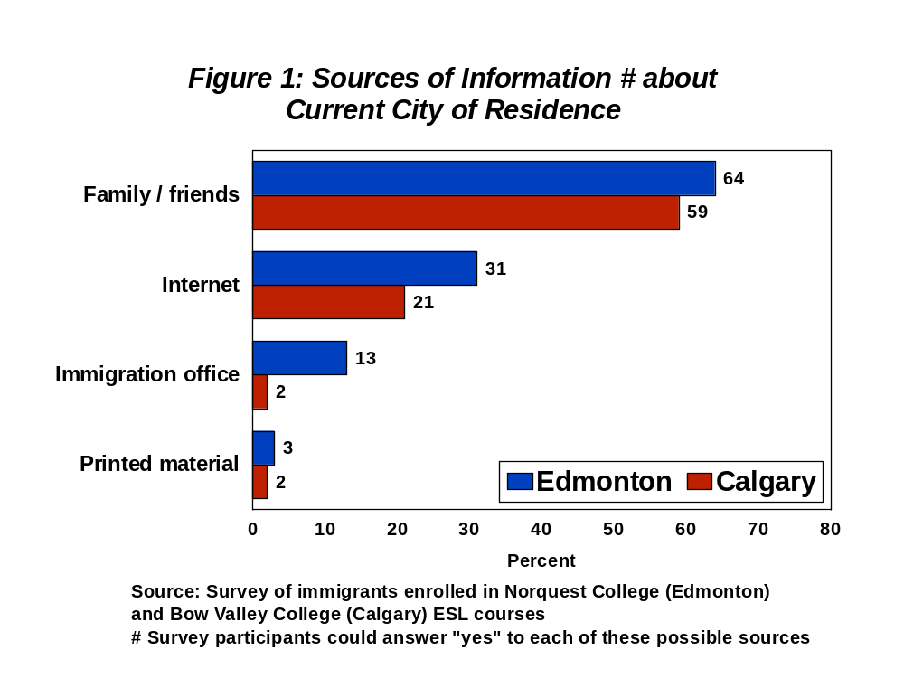

Why Immigrants Chose Edmonton or Calgary

Survey participants were also asked “why did you move to Edmonton (or Calgary)?” Almost all of the respondents wrote an answer to this question, and about half listed several answers. Reflecting the conclusions drawn in other studies, economic factors (e.g., jobs, a strong economy) were mentioned most often (34% of all reasons given). Family and friends were mentioned as “pull” factors almost as often (29% of all answers), followed by quality of life reasons such as climate, city size, and access to social services (24%), and educational opportunities (e.g., ESL, post-secondary opportunities) which comprised 13% of all answers listed by survey participants.

Figure 2 shows that, even though Calgary has attracted more job-seeking immigrants in the past few years, Edmonton residents were somewhat more likely to mention economic reasons for choosing their city. This is probably because immigrants who settled in Calgary were more likely to note that family and friends already living in Calgary (no doubt attracted by the city’s “hot” economy) had convinced them to settle there.
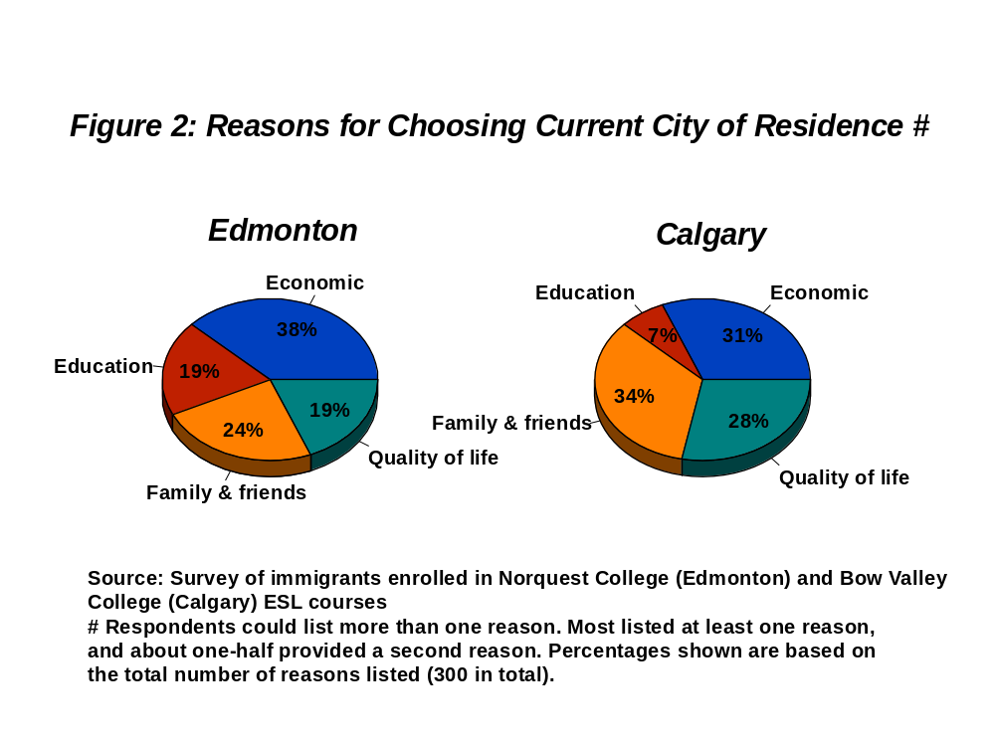

However, it is also interesting to observe that educational opportunities had attracted more Edmonton residents (19%) than Calgary residents (7%). Calgary may be able to attract more immigrants because of its strong economy, and larger ethno-cultural communities, but Edmonton appears to have a recruiting advantage in the education sector.

Best Things About Living in Edmonton / Calgary

Survey participants were also asked to identify the best things about living in their city. Most wrote something on their questionnaire, and well over half wrote several answers. Quality of life reasons such as good climate and a welcoming social environment were mentioned most often (48% of all answers), followed by economic factors (31%), and educational resources (19%). While almost one-third of the reasons provided for coming to their current city (see above) had involved the presence of family and friends, almost no one (only 2%) mentioned family and friends as among the best things about living in their city. It would appear, then, that while friends and family attract new immigrants, the quality of life and the work and education opportunities within the host city play a much larger part in retaining them.

Although more Edmonton residents had mentioned economic reasons for choosing their city (see above), Calgary residents were somewhat more likely to mention jobs and a strong economy as the best thing about living in their city (Figure 3). However, once again, Edmonton residents were much more likely (31% compared to only 8% of Calgary residents) to emphasize access to educational resources as “best things” about their city. Calgary residents were more inclined to comment on quality of life factors. For example, 23 said something about Calgary’s good climate, compared to only 2 Edmonton residents who felt that the climate was one of the best things about their city.
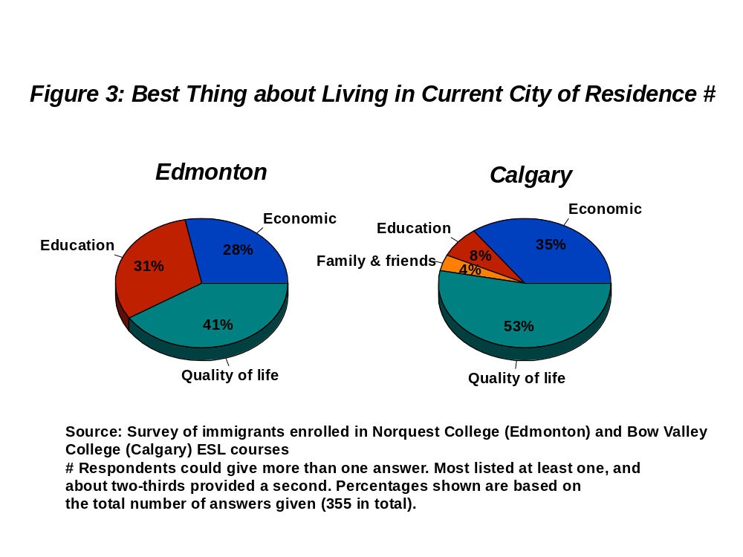

Biggest Problems About Living in Calgary / Edmonton

When asked about the “biggest problems” they encountered in their new community, 41% of all the answers provided by survey respondents focused on economic problems (e.g., not being able to find a good job). Ironically (but not all that surprisingly given what other studies have revealed), potential employment opportunities attract immigrants to new communities and employment barriers discourage them after they arrive.

However, job problems are not immigrants’ only problems. Quality of life concerns such as a difficult climate, poor public transport, and limited social services were mentioned almost as often (37% of all answers). The third largest category (19%) involved problems encountered because of limited command of the English language. Only a small number of answers to this question (3%) focused on the absence of family and friends in the city.

Immigrants who had settled in Edmonton and Calgary answered this question quite similarly. However, when we look more closely within the “quality of life” category, we see that Calgary residents were more likely to mention that city’s climate as a problem (19 answers versus only 7 from Edmonton). Thus, very few new residents of Edmonton talked about their city’s climate as either a good thing or a bad thing. In Calgary, climate figured a bit more prominently in newcomers’ assessments of the city, although opinions about the climate were clearly mixed.

Looking to the Future

Eight out of ten of the recent immigrants now living in Edmonton answered “yes” in response to a question about whether they would encourage friends and relatives to live in Edmonton (this question was omitted from the Calgary questionnaire). A similar proportion (79%) indicated that they were personally planning to stay in Edmonton (compared to 85% of the Calgary respondents). Thus, despite the employment barriers many immigrants encountered, and despite the settlement and adjustment difficulties they faced in their new home, the vast majority of recent immigrants remained positive about their choice of Edmonton. In their words:

“In spite of all problems, it still is a very good city to live. We as immigrants want to contribute and on the other hand need our children to grow in a good manner, so it is a good city to live”

“I want my kids to grow up here and complete their education in University.”

“It is not expensive for immigrants [in Edmonton]”

“Because there are more working chances, and there is a possible to buy a house, government support ESL program.”

“Now this is my country, my city and I'm sure stay here. I don't have any idea to move.”

“I love this city.”
A Proposal for an Immigrant-Friendly City of Edmonton Website

Introduction

When potential immigrants are choosing a place in Canada to live, the Internet is a natural place to look for information. For this reason the amount and type of information available on the Internet has the potential to play a large role in attracting immigrants to a city or province. We conducted an extensive Internet search in order to find out what sort of information was available for newcomers and potential newcomers to Canada. Our search included the Government of Canada’s federal website, as well as provincial websites for Alberta, Manitoba, and Ontario. Several municipal websites were examined, including: Edmonton, Calgary, Vancouver, Winnipeg, Ottawa, Montreal, and Toronto. Finally, we searched for websites produced by non-governmental organizations such as settlement agencies and ethno-cultural groups. There was a huge disparity in the amount of information provided for newcomers. With a couple of exceptions, there was little that we could locate that was designed for immigrants or potential immigrants to Edmonton (see the end of this section for a description of Fan Yang’s website intended for potential immigrants from China to Edmonton).

Some websites in other municipalities and provinces have exemplary websites that provide useful information for immigrants and portray those cities and provinces as being very immigrant-friendly. We will discuss the best of these websites: Toronto, Vancouver, and Manitoba. Recommendations will be made for making an Edmonton website for newcomers as effective as possible.

Toronto

Toronto’s official website contains a website designed for new immigrants. The main problem with this site is the difficulty a web surfer may have actually finding it (see Website Appendix A for homepage). To find the page, go to the city of Toronto’s main website and click Living in Toronto, followed by Diversity, then Information for new immigrants. Most of links were not easy to find and the wording was not explicitly connected to immigrants. However, once one locates the website for immigrants he or she will find a welcome page with an introduction, topics of interest, and a menu with links to further information in fourteen areas including housing, employment, and education. Clicking one of the links in the menu on the immigration website will take the user to a page with information on that topic. The pages provide some information directly as well as many links to external websites that are relevant to the topic. For example, the page on employment has several relevant subtopics such as “How to look for work in Canada” and “Education credentials”. Clicking on these subtopics or scrolling down will lead the user to a small section on that subtopic with relevant links to places such as job banks and educational bridging programs (See Website Appendixes B and C for examples of the housing and employment sites). Outside the immigrant-specific site there is a section of the Toronto website with facts about Toronto that would also be very useful for potential immigrants (Website Appendix D). This site can be accessed both through the pages for immigrants and through the menu “Living in Toronto” on the main page. There is a link on of this site that leads to facts about diversity (Website Appendix E). The diversity section provides information on the multicultural aspects of Toronto. This information is presented in a pro-immigrant manner.

Vancouver

The city of Vancouver has a very good guide for immigrants. Like the Toronto site, however, it is somewhat difficult to find. It can be accessed by clicking on Residents on the main page, then New to Vancouver. This leads to a page with a link to the Newcomer’s Guide. The Newcomer’s Guide is designed for anyone new to Vancouver but is clearly geared towards immigrants (Website Appendix F). The Newcomer’s Guide can be downloaded in whole or by section as a PDF file. The PDF version is available in several languages. The information can also be accessed in HTML web format by going to the site map (Website Appendix G). The Newcomer’s Guide contains all sorts of information from how to use 911 (Website Appendix H) to accessing community services such as immigrant serving agencies (Website Appendix I).

Manitoba

Manitoba’s website has a lot of immigrant specific information that is easy to find. From the government’s main website there is a clearly visible link on the left side of the main page for people Coming to Manitoba. This link leads to a page with information for anyone planning on coming to Manitoba. It has several links specifically for immigrants under the headings Immigration and Newcomer Services. (See Website Appendix J) Most of the links for immigrants on the “Coming to Manitoba” page lead to pages on a website created by Immigration and Multiculturalism, a branch of Manitoba Labour and Immigration. This website has a lot of information for newcomers which is divided into five categories represented as pull-down tabs at the top of the page. They are: immigration, learning English, newcomer services, multiculturalism, and info centre. (Website Appendix K). Much of this information can be accessed either by navigating the Immigration and Multiculturalism website, or by linking directly to specific pages through the options listed on the “Coming to Manitoba” website. The main page of the “immigration” portion of the Immigration and Multiculturalism website acts as an advertisement for Manitoba (Website Appendix L). In fact much of the information presented on this website seems like it is designed to encourage potential newcomers to choose Manitoba. The immigration section of the website also has a link called “Community Profiles,” which leads to second page with a menu on the left that lists all of the regions in Manitoba (Website Appendix M). Clicking on one of these regions leads to a map of the region and a list of all communities in that region (Website Appendix N). Clicking a community then takes the user to a description, and sometimes a picture of that community, including its biggest attractions (Website Appendix O). This feature is very useful for attracting immigrants to communities they have likely never heard of before.

Recommendations

It is clear that there are several excellent examples of effective websites for newcomers in different parts of Canada. In order to make website for newcomers to Edmonton as helpful as possible, the following recommendations are provided:

- A website for immigrants should be easily accessible from Edmonton’s homepage. Without easy access to the website from the City of Edmonton’s homepage, potential newcomers may assume there is nothing to find.

- The website for newcomers should be welcoming and act as an advertisement for Edmonton. There are many features of Edmonton that should be highlighted including: excellent educational opportunities, the high level of safety, clean air, parks and nature, good weather, low cost of living, strong arts community, strong sporting community, many recreational services, and the large number of festivals.

- The website should be available in several languages. This is important both to allow more people to read the material and to give readers the feeling that the city or province they are moving to is willing to make an effort to communicate with them.

- The website should link to settlement agencies, the three school boards, and other websites/organizations that may be helpful. There should also be some information provided about these organizations, especially in areas where newcomers may have misunderstandings. For example some newcomers may not realize that all three school boards are publicly funded and organizations such as Catholic Social Services and The Mennonite Centre for Newcomers are welcoming to people of all religious backgrounds.

- Edmonton’s website should be linked to the federal immigration portal (to be in operation in January, 2006) and to the Alberta Human Resources and Employment Immigration website.

Creating websites for newcomers that are welcoming, informative, and easy to find is becoming increasingly important as people become more inclined to find information on the Internet. The examples and guidelines provided here should be useful in the creation of a new website.

Websites

Toronto: http://www.city.toronto.on.ca
Vancouver: http://vancouver.ca
Manitoba: http://www.gov.mb.ca
Website Appendices


A. City of Toronto: Information for new Immigrants (http://www.city.toronto.on.ca/immigration/index.htm)

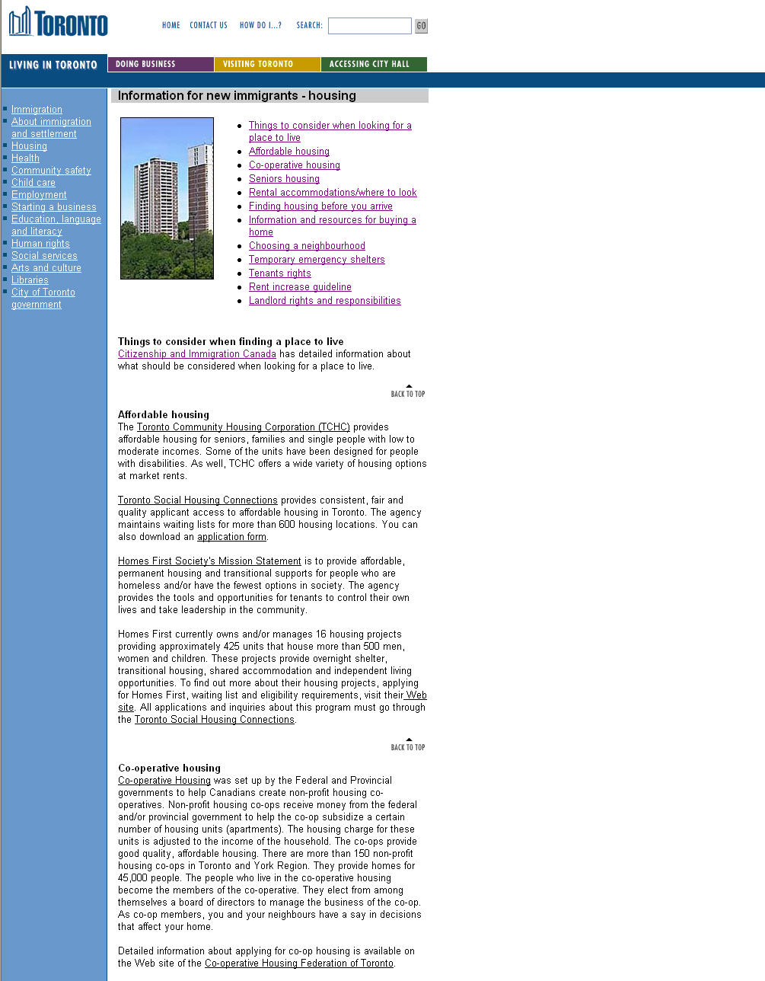
B. City of Toronto: Information for New Immigrants: Housing

Cont…
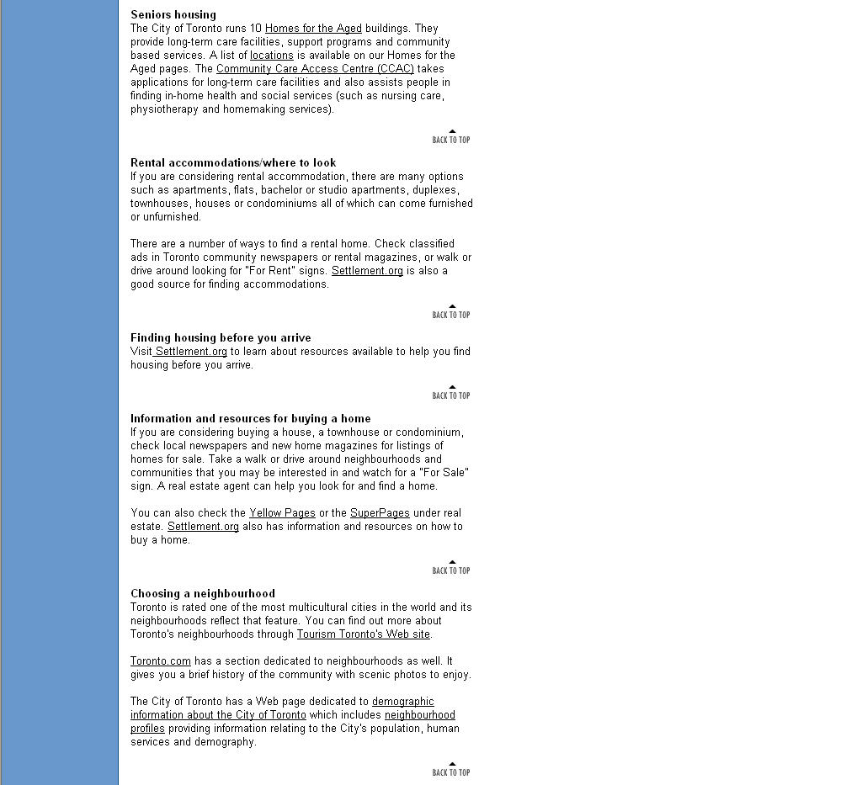


Cont…


C. City of Toronto: Information for New Immigrants: Employment

Cont…

Cont…

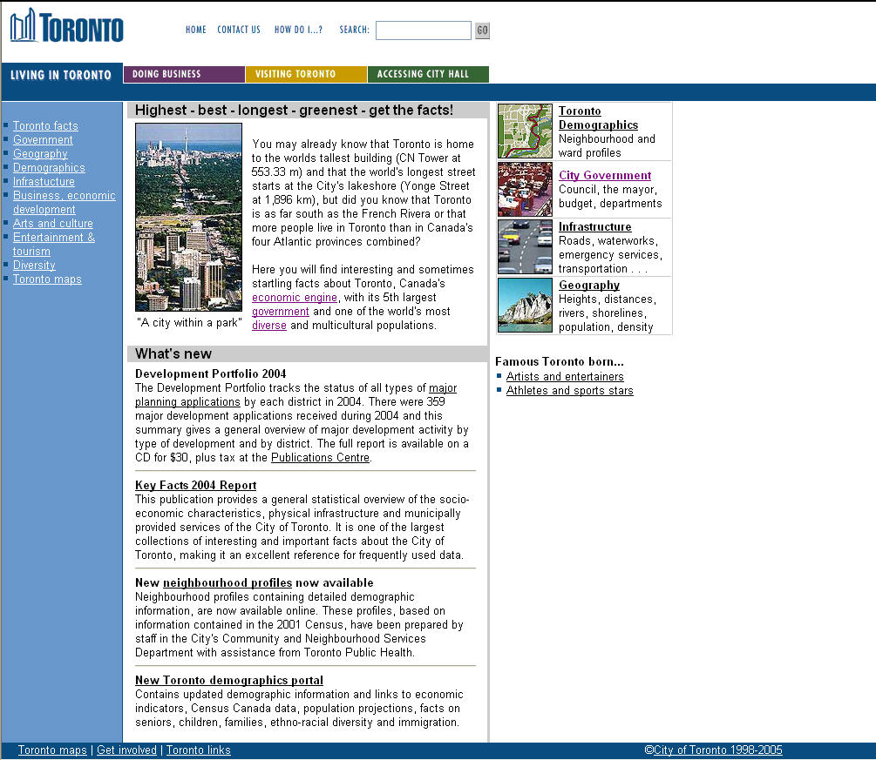
D. Toronto Facts
(http://www.city.toronto.on.ca/toronto_facts/index.htm)


E. Toronto Facts: Diversity
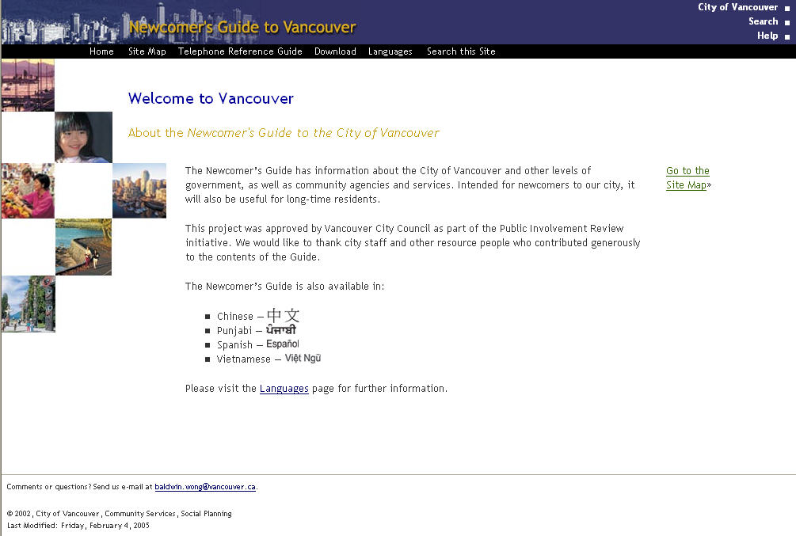
F. Vancouver: Newcomer’s Guide: Main Page

G. Vancouver: Newcomer’s Guide: Site Map
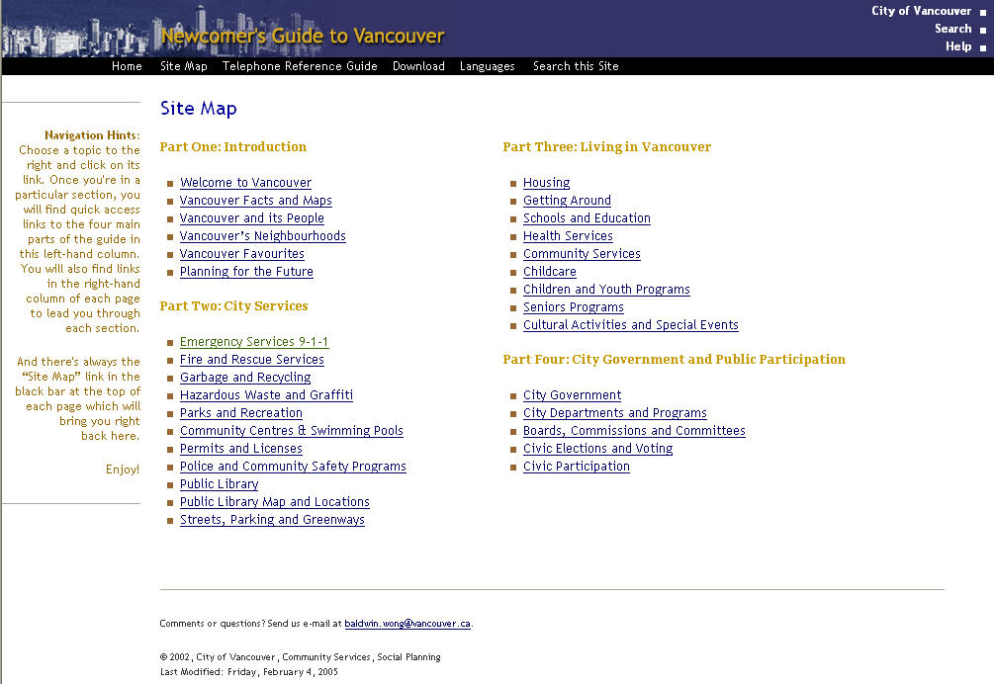


H. Vancouver: Newcomer’s Guide: 911 Information Site

I. Vancouver: Newcomer’s Guide: Community Services


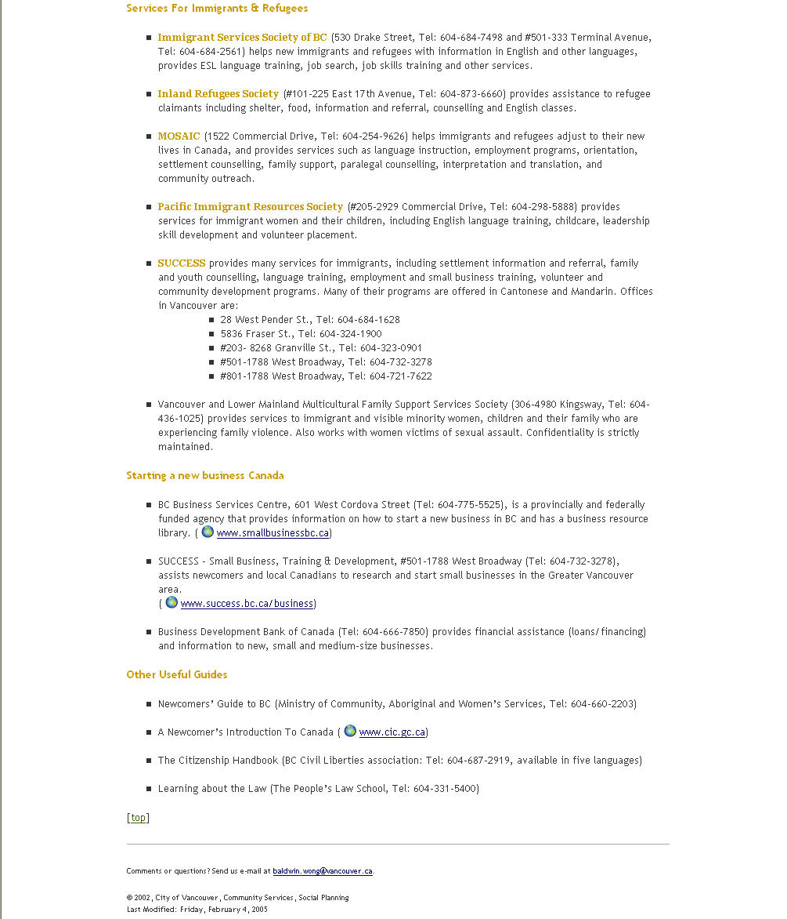

J. Manitoba: Coming to Manitoba
(http://www.gov.mb.ca/comingtomb.html)

Cont…
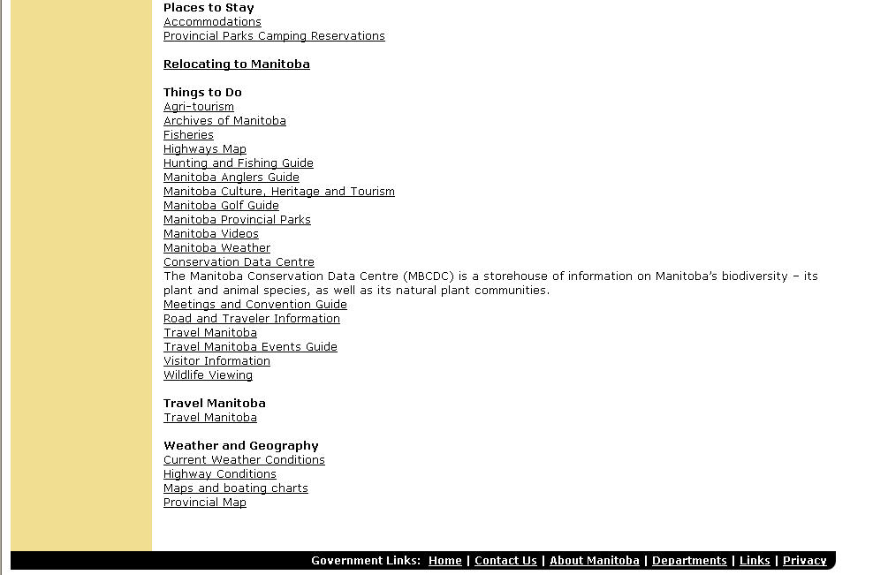

K. Manitoba: Immigration and Multiculturalism: Main Website.
(www.immigratemanitba.com)
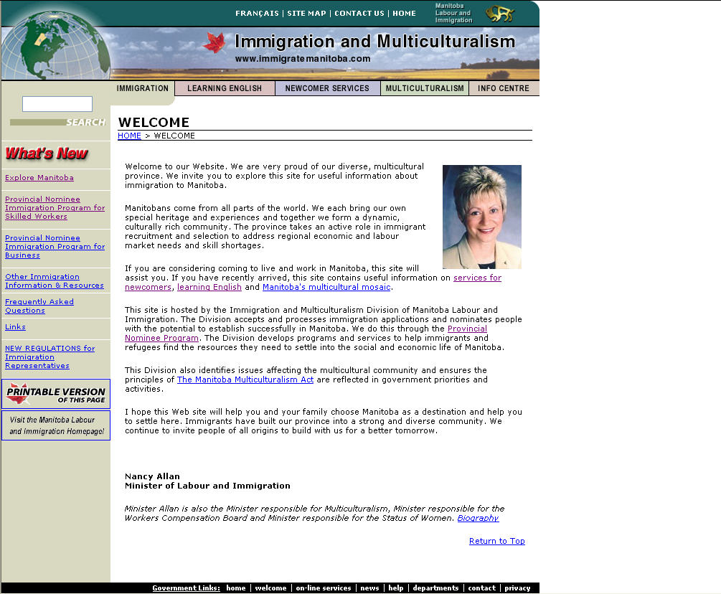

L. Manitoba: Immigration and Multiculturalism: Immigration
(http://www.gov.mb.ca/labour/immigrate/immigration/1.html)
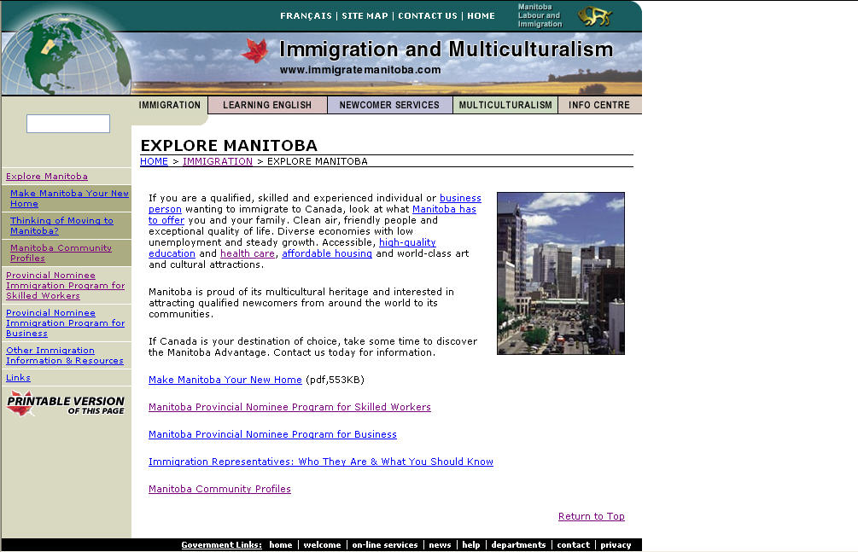

M. Immigration and Multiculturalism: Manitoba Community Profiles


N. Immigration and Multiculturalism: Community Profiles: Winnipeg Capital Region
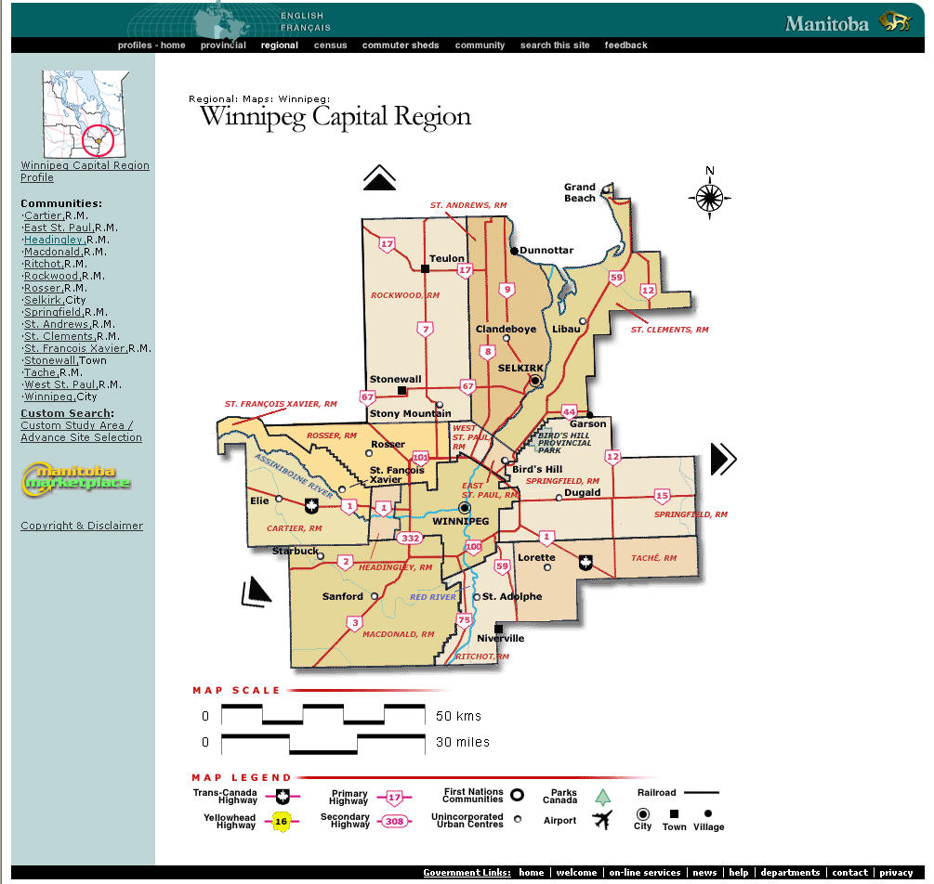

O. Manitoba: Immigration and Multiculturalism: Community Profiles: Winnipeg Capital Region.
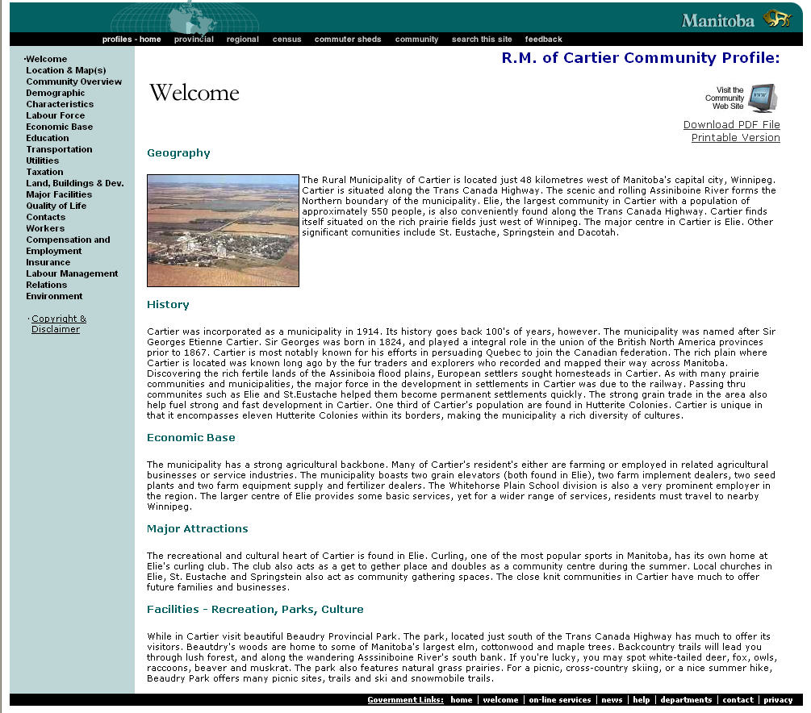

Fan Yang’s Chinese Website for Potential Immigrants to Edmonton
Different ways to attract new immigrants to settle down in Edmonton
By Fan Yang, EMIS (Edmonton Mandarin Immigrant Society)
In April 2004, our family landed in Montreal. Actually, before we made the choice, we decided to land in Edmonton because we had friends there. However, we needed more information about this city that our friends could not provide. The most effective way to get this kind of information, we believe, could be obtained from the website. Unfortunately, we simply found some official website in English. Even worse, there was no forum in these websites. That meant we were not able to get interaction from these websites, even if we had so much urgent and detail questions which need to be answered. In the following days, we found some helpful Chinese forums in many big cities in Canada, such as Toronto, Vancouver, Montreal and Calgary. Through the information provided by these forums, we changed our mind and landed in Montreal. After living in Montreal for two months, we recognized we were not suitable for this city, so we made up our minds to move to Edmonton. Surprisingly, I first knew that Edmonton was an ideal city to settle down for new immigrants and I've made the right choice.
At that time, I started to think about that there were must be many people, "just like me, who wanted to find Edmonton information through internet. Perhaps they had to give up this city after they failed to get what they wanted. Basing on this point, I was willing to create a website with forum to help people knowing useful information about Edmonton.
After the website worked, people gradually found it and began to ask many questions. I answered all of these questions as possible as I could. Sometimes it was difficult to describe something in words, I figured out many ways to let the people get what they required, for example, sometimes I put the pictures on the website, sometimes I asked some "experts" to solve some difficult questions. This website in no time became famous among the coming
immigrants. More and more people began to browse this forum everyday. In only 15 months, the creation from this website, hundreds families believed Edmonton was a beautiful and suitable city to live, so they came to Edmonton without hesitation any more, some of them moved from other cities, some of them came directly from China. They are not disappointed living in Edmonton because they seemed to know everything about this city and made a lot of
friends through Edmontonchina.com even before they arrived.
There are so many questions that people can not find in the government website:
What kind of pan or wok should I bring with me?
What does the outlet look like?
Do I have to notarize your marriage license, birth certificate or degree, etc?
Can I still use my telephone that was made and used in China?
How much is the monthly expense for necessities?
Do I need curtains or drapes in the apartments?
Where is the best choice to rent a house or apartment if I want to go to NorQuest?
When I go to Edmonton, which is better to bring with me, US dollars or Canadian dollars?
Which is better for new immigrants, CISC or BMO?
Do I need to bring my child car seat used in China?
Does it work if I only bring my computer base unit, without the monitor, with me?
Who has had the experience of shipping some stuff to Edmonton?
How much does it cost to ship from Vancouver to Edmonton?
What does a forth-grade student need to prepare for school in Edmonton?
If the wife is pregnant, for example, for five months, where can she have and medical benefit right away?
Can I change your landing cities?
Is that any wool thread for knitting sweaters? Do you need it?
I have heard lately from many people that Edmonton is cold and dirty. Is it true?
After landing, do I need physicals to get the health card?
How much is the service charge to exchange US to Canadian currency?
Is transcript required if a child needs to attend elementary school in Edmonton?
Does the rent have to be paid at the end of each month?
When/which month does ESL classes start each year?
How is the temperature like inside? Is it comfortable to just wear thin clothes?
Question: if I have not taken all the money with me when I first land, when should I declare it?
Question: how should I manage or deal with the housing property and stocks in China if I don't want to sell them before I leave?
Is there any way that I can buy a car to drive ahead of time?
Am I allowed to land in other cities if I am?
Is there any bed or furniture in the rental house or apartment?
Is there any Dollar Store in Edmonton?
Is it hard to develop or own a big farm in Canada?
There were a lot of questions such as those listed above which had been answered patiently and
carefully in detail.
For example, some people were worrying about the cold winter in Edmonton, so we collected the weather data of the whole year in Edmonton and compared them to the data in Montreal and Toronto, which helped people to know that there were no big difference between these cities.
Some people were worrying about the driver's license. I looked for the materials about the exams and put them on the website in order that they could learn the rules even in China and could pass the exam once they came to Edmonton.
I also summarized the experience to pass the road tests and many people thought that was really helpful.
Some people didn't know how to select a good condition car, I could help them to find the related information or even bought the car for them. (Dongsheng Lu)
Some people were looking for a job urgently, I provided some job information to them in time. (Gang Jiang)
Some new immigrants could not able to get their credit card, mortgage. I contacted managers in TD bank to help them to solve this problem. (Tao Chen)
Some people asked me to rent apartments for them in advance, I selected the locations and paid the deposit for them. (Bing Wang)
Some people had no any friends and relatives in Edmonton, I helped them to find the temporary home to live and picked them up in the airport. (Jun Zhang)
Some people wanted to made more friends, so I usually organized party, giving opportunities to let people get to know each other. (Haihua Yun)
Someone wanted to buy fresh and cheaper lamb, so I contacted one farm and organized many people bought lambs several times. (Lilian Gu)
Someone didn't understand how to declare the tax, so I found some volunteers to help them. (Hong Zhou)
Someone hoped they could have more opportunities to attend local activities, so I suggested them to be volunteers in Heritage Festival. I also organizedmany friends to pick up garbage and clean parks in the spring as volunteers.(Lingjuan Wang)
When traditional Chinese festivals were coming, some Chinese felt homesick, so I organized Celebrating Chinese Mid-Autumn Festival. (Min Li)

I also offered lecture about knowledge of law in Canada to help Chinese familiarize rules in the new country. (Chun Yuan)
I provided some training classes to help immigrants to get information of employment. (Xiansen Lu)
I collected a lot of materials and information about family doctors to solve the difficulties about finding a suitable doctors for new immigrants. (Juhua Liu)
Someone are not interested in reading local news in English, so I often translated some news into Chinese.
Someone felt so hard to move, so I gave them hands free. (Vi Wang)
Someone thought buying their own houses, I provided related information or even took them to visit the house they wanted. (Haiwei Yang)
There were so many things like that. Most memberships benefited from this website. They extremely appreciated what they got and they felt that the relationships between friends whom they knew each other on the internet was so close and real. People on the internet are not visional any longer, actually, they are like neighbours and relatives. Being attracted by the friendly membership and me, hundreds of Chinese families have chosen Edmonton to
land. Some immigrants even told me:" We come here because you are here. We believe we'll be happy living here since you and many friends can help us in case something happens. (Dongguang Vin)
For instance, one woman, who lived in Toronto before she moved to Edmonton, suddenly was seriously sick when she came here less than 3 months. She has no relatives except her husband in Edmonton so her husband asked me for help. I informed this news on the internet and wished some people could give their hands. Consequently, people arranged the schedule to take care of the patient in the hospital everyday. When the woman recovered, she and her husband did not know how to express their appreciation. They thought they were definitely not get this kind of care in Toronto. They said: Law Young is notonly establish a forum, he has created a big family in which every one is willing to help each other and all Chinese people here are like an integer.
(Xiuhua Chen)
Above is the part of my experience about attracting new immigrants to settle down in Edmonton.
Submitted by Law Young (Fan Yang)

Stakeholder Meetings Report

Results of First Stakeholder Meeting, June 21, 2005

Participants (providers of immigrant services and representatives of school districts and ethno-cultural groups) were told of the information available about Edmonton on the internet. The websites of the City of Edmonton and the Province of Alberta were compared with websites from other cities and provinces from the perspective of a potential newcomer: how easy was it to find information, what kind of information was available, etc. Overall, information about settling in Edmonton is difficult to find and very limited. The participants made some suggestions for information that should be made explicit on the City of Edmonton website.

After a brief review of the barriers to attraction and retention of immigrants as well as recommendations drawn from the literature, stakeholders had a chance to discuss and evaluate them. The main issues discussed were employment, ho
using, and public opinion. Many agreed that two key employment issues are those of accreditation and Canadian work experience. These are not, however, problems specific to Edmonton. Participants suggested that the city could improve the employment situation by becoming a leader in employment practices and thus setting an example. The group suggested that the City could educate employers about the role of immigrants and their contributions, and bring together “employers who are champions of immigrants” who can spread the word about the advantages of hiring newcomers.

Another key problem identified was affordable housing. In addition to long waiting lists, some landlords discriminate against newcomers. One example given was the evictions some families face for having too many people living in their space. The City could help by educating landlords.

Public perception was the final key issue discussed. Many people, including some at higher levels of government, do not recognize the contribution that newcomers make. Participants agreed that the City could stage a public awareness campaign that would help make newcomers feel welcome while at the same time dispelling some of the myths about them. The City could also identify and promote its advantages (such as relatively low cost of living, safety, educational opportunities). Many potential immigrants are unaware that Edmonton exists. Finally, the stakeholders noted that there is a perception among some ethno-cultural groups that currently the city is uninvolved, since most support programs are either provincially or federally funded.

Participants agreed that the City should not focus on issues that are the primary responsibility of other levels of government. They should focus on matters within their jurisdiction and make sure they do those things well. It was recommended that the City undertake an audit of its own practices and services offered, as a means of identifying weaknesses, but also to identify programs and services already in place which are deserving of additional promotion.

Results of Second Stakeholder Meeting, September 16, 2005

The second stakeholder meeting was broader than the first; the participants from the first meeting and a number of people identified by Councillor Michael Phair were invited. The researchers presented the results of the last focus group meeting and asked the participants to identify any gaps and to determine whether there are some recommendations that should take priority over others. A wide-ranging discussion took place, and several individuals recounted their own experiences on arriving in Edmonton.

Credential recognition and recognition of previous work experience were identified several times as two areas related to employment that must be addressed if immigrants are to achieve their potential. The persistent problem of underemployment continues to be faced by many newcomers, although this problem was first recognized decades ago. A model internship program was suggested as a possibility for the City. Career Bridge (www.careerbridge.ca) is a working group of the Toronto Region Immigrant Employment Council (TRIEC). The program is funded by the Ontario Government. The City of Calgary will be funding a pilot internship program offered by Career Bridge in Calgary.

The problem of racism within the immigrant community was also raised. One participant suggested that since most immigrants come from homogeneous settings, they are unaccustomed to mixing with other groups. This individual suggested that ethno-cultural groups should not be allowed to have separate schools because such schools would preclude integration.

Education was discussed for much of the meeting. One individual suggested that the City should lobby school districts and the provincial government to develop differentiated programs for ESL students who have experienced educational gaps, particularly junior high and high school students who have limited literacy in their first language. It was also suggested that the City work with school boards and post-secondary institutions to develop a strategy that includes both marketing and welcoming.

Several people had suggestions for an immigrant-friendly website, such as information about the freedom to practice one’s religion, the lack of religious conflict in Edmonton, the fact that buildings and houses are warm in winter, despite the cold temperatures outside, and the need for many pictures of Edmonton on the website.

Affordable housing for large families was another issue that was discussed. There must be places for people to live if they are going to be attracted to Edmonton from elsewhere.

One participant raised the issue of long delays on the part of Citizenship and Immigration in processing applications to come to Canada.

Another issue raised by a stakeholder had to do with Children’s Services and their treatment of immigrant families.

One participant advocated that the City fund research on culture and how culture impacts on cultural groups. Finally, the participant indicated that the researchers themselves should be representatives of the immigrant groups in question.

Two participants indicated that there is a need for better interpretation services in the city. It was suggested that the City should have a training procedure that would facilitate the recognition of skill level.

It was recommended that any measures the City takes should be shared with bordering communities such as St. Albert, Sherwood Park, Leduc, Devon, Spruce Grove and Stony Plain.

Individuals Invited to the June 21, 2005 Stakeholder Meeting

Indo-Canadian Women's Association
335 Tower II Millbourne Mall
Edmonton AB T6K 3L2
Tel: 780-462-6924
Fax: 780-466-6594

Nora Abou-Absi
Executive Director
Canadian Arab Friendship Association
#18, 9228 144 Avenue
Edmonton AB T5E 2H7
Tel: 780-473-7214
Fax: 780-475-1039
Email: general@cafaedmonton.ca

Jalal Barzanji
Director
Canadian Kurdish Friendship Association
9931 178 Avenue
Edmonton AB T5X 5X2
Tel: 780-457-5081
Fax: 780-457-5081
Email: ckfa_barzanji@hotmail.com

Sonia Bitar
Executive Director
Changing Together…
A Centre for Immigrant Women
3rd Floor, 10010 105 Street
Edmonton AB T5J 1C4
Tel: 780-421-0175
Fax: 780-426-2225
Email: changing@interbaun.com

Jane Cheung
Outreach Worker
ASSIST Community Service Centre
9653 105A Avenue
Edmonton AB T5H 0M3
Tel: 780-429-3111
Fax: 780-424-7837
Email: info@assistcsc.org

Percy Cummins
Manager
Immigration, Human Resources
& Employment
6th Floor, 10808 99 Avenue
Edmonton AB T5K 0G5
Tel: 780-422-9595
Fax: 780-422-0274
Email: percy.cummins@gov.ab.ca

Emilie DeCorby
Principal, International Education
Edmonton Catholic Schools,
Learning Support Services
7330 113 Street
Edmonton AB T6G 1L6
Tel: 780-989-3014
Fax: 780-989-3049
Email: decorbye@ecsd.net

Anna DeLuca
Coordinator, Language Training Division
NorQuest College
10215 - 108 Street
Edmonton AB T5J 1L6
Tel: 780-427-5102
Email: anna.deluca@norquest.ca

Kirk Ferguson
ESL Consultant
Edmonton Public Schools
One Kingway
Edmonton AB T5H 4G9
Tel: 780-498-8763
Fax: 780-426-0098
Email: kirk.ferguson@epsb.ca

Mary Gallivan
Supervisor, Immigration
Catholic Social Services
10709 105 Street
Edmonton AB T5H 2X3
Tel: 780-424-3545
Fax: 780-425-6627
Jim Gurnett
Executive Director
Edmonton Mennonite Centre for Newcomers
#100, 10010 107A Avenue
Edmonton AB T5H 4H8
Tel: 780-424-7709
Fax: 780-424-7736
Email: jgurnett@emcn.ab.ca

Charlene Hay
Executive Director
Northern Alberta Alliance on Race Relations
#218, 9624 108 Avenue
Edmonton AB T5H 1A4
Tel: 780-425-4644
Fax: 780-425-6244
Email: naarr@compusmart.ab.ca

Dhiaa Hussen
Edmonton, AB
Telecommunications, NAIT
Edmonton, AB T5G 3H1
Tel: 780-378-5245
Email: dhiaah@nait.ab.ca

Liz Karra
Projects Coordinator, ESL
Grant MacEwan College
10050 MacDonald Drive
Edmonton AB T5J 2B7
Tel: 780-497-4075
Email: karral@macewan.ca

Barbara Leung
Director, Community Programs
Alberta Advanced Education
8th Floor, Commerce Place
Edmonton AB T2J 4L5
Tel: 780-427-5718
Fax: 780-422-1297
Email: barbara.leung@gov.ab.ca

Joseph Luri
Secretary General
Sudanese Community
#1 11732 124 Street
Edmonton, AB T5K 0K9
Tel: 780-455-7413

Christina Nsaliwa

Executive Director

Edmonton Immigrant Services Association
#201, 10720 113 Street
Edmonton AB T5H 3H8
Tel: 780-474-8445
Fax: 780-477-0883
Email: eisa@compusmart.ab.ca

Lucenia Ortiz
Co-Executive Director
Edmonton Multicultural
Health Brokers' Co-operative
10867 97 Street
Edmonton AB T5H 2M6
Tel: 780-430-6253
Fax: 780-428-2748
Email: mchb@interbaun.com

Rexhep Pllana
Kosovar Community
Edmonton, AB
Email: pllanas@slatetraining.com

Shukrije Pllana
Kosovar Community
Edmonton, AB
Email: pllanas@slatetraining.com

Dulari Prithipaul
Board Member
Association Multiculturelle
Francophone de L'Alberta
#12, 8925 82 Avenue
Edmonton AB T6C 0Z2
Tel: 780-440-0719
Fax: 780-440-0744
Email: amfa@compusmart.ab.ca

Helen Rusich
Manager
Millwoods Welcome Centre for Immigrants
335 Tower II Millbourne Mall
Edmonton AB T6K 3L2
Tel: 780-462-6924Fax: 780-466-6594
Email: hrusich@mwci.ca

Mebrat Seyoum
Eritrean Community
10603 107 Avenue
Edmonton, AB
Tel: 780-424-9929

Invitation List to the Second Stakeholder Group Meeting, September 16, 2005

Nora Abou-Absi
Executive Director
Canadian Arab Friendship Association
#18, 9228 144 Avenue
Edmonton, AB T5E 2H7
Tel: 780-473-7214
Fax: 780-475-1039
Email: general@cafaedmonton.ca

Gus Ahmad
FCSS Advisory Committee
4208 Ramsey Road
Edmonton, AB T6H 5R2
Tel: 780-430-6994
Email: gusahmad@shaw.ca

Hassan Ali
Somali Canadian Cultural
Society of Edmonton
#138, 14424 88A Street
Edmonton, AB T5E 5Y4
Tel: 780-423-5093
Email: hassan@somaliedmonton.com

Jun Angeles
Council of Edmonton
Filipino Association
Edmonton, AB
Tel: 780-988-8889

Jeanette Austin-Odina
Metro Continuing Education
English Language Institute
Council of Canada of African & Caribbean Heritage
Edmonton, AB
Email: jeanette.austin-odina@epsb.ca

Tesfaye Ayalew
1850 Garrett Way
Edmonton, AB
Tel: 780-485-4073
Email: a_tesfaye@yahoo.com

Dubravka Babic
Croatian Bosnian Community
Senior Consultant, Prog. Services, Alberta Advanced Education
9th Floor, 9940 106 Street
Edmonton, AB T5K 2V1
Tel: 780-415-0846
Fax: 780-422-4517
Email: dubravka.babic@gov.ab.ca

Jalal Barzanji
Director
Canadian Kurdish
Friendship Association
9931 178 Avenue
Edmonton, AB T5X 5X2
Tel: 780-457-5081
Fax: 780-457-5081
Email: ckfa_barzanji@hotmail.com

Nyambura Belcourt
Executive Director
Edmonton Multircultural Society
#602 Sir Winston Churchill Square
Edmonton, AB T5J 2V5
Tel: 780-420-6866
Fax: 780-420-6832
Email: emsedm@telus.net

Naresh Bhardwaj
4328 38A Avenue
Edmonton, AB T6L 6Z5
Email: Nareshbhardwaj59@hotmail.com

Sonia Bitar
Executive Director
Changing Together…
A Centre for Immigrant Women
3rd Floor, 10010 105 Street
Edmonton, AB T5J 1C4
Tel: 780-421-0175
Fax: 780-426-2225
Email: changing@interbaun.com

Winnie Bogosoff
Borneo Cultural Association of Alberta
15016 115 Street
Edmonton, AB T5X 1J1
Tel: 780-456-7258
Fax: (C)780-951-6288
Email: winniebogosoff@hotmail.com

Lewis Cardinal
1725 Tomlinson Common
Edmonton, AB T6R 2W8
Tel: 780-288-0314
Email: lewiscardinal@shaw.ca

Terry Cavanaugh
Councillor
City of Edmonton
2nd Floor, Sir Winston Churchill Square
Edmonton, AB T5J 2R7
Tel: 780-496-8100
Email: terry.cavanagh@edmonton.ca

Ms. Jane Cheung
Outreach Worker
ASSIST Community Service Centre
9653 105A Avenue
Edmonton, AB T5H 0M3
Tel: 780-429-3111
Fax: 780-424-7837
Email: info@assistcsc.org

Yvonne Chiu
Edmonton Multicultural
Health Brokers' Cooperative
10867 97 Street
Edmonton, AB T5H 2M6
Tel: 780-430-6253
Fax: 780-428-2748
Email: yvonnechiu@shaw.ca

Alice Colak
Catholic Social Services
10709 105 Street
Edmonton, AB T5H 2X3
Tel: 780-424-3545
Fax: 780-425-6627
Email: alice.colak@catholicsocialservices.ab.ca

Percy Cummins
Manager
Immigration, Human Resources
& Employment
6th Floor, 10808 99 Avenue
Edmonton, AB T5K 0G5
Tel: 780-422-9595
Fax: 780-422-0274
Email: percy.cummins@gov.ab.ca

Wendy Danson
McCuaig Desrochers Law
#2401, 10088 102 Avenue
Edmonton, AB T5J 2Z1
Tel: 780-426-4660
Fax: 780-426-0982

Gita Das
Vice-President
Indo-Canadian Women's Association
11724 38 A Avenue
Edmonton, AB
Tel: 780-490-0477

Satya Das
Cambridge Strategies Inc.
#208, 10080 Jasper Avenue
Edmonton, AB T5J 1V9
Tel: 780-420-0505
Fax: 780-420-1256
Email: satya@cambridgestrategies.com

Emilie DeCorby
Principal, International Education
Edmonton Catholic Schools
Learning Support Services
7330 113 Street
Edmonton, AB T6G 1L6
Tel: 780-989-3014
Fax: 780-989-3049
Email: decorbye@ecsd.net

Anna DeLuca
Dean, Language Training
& Adult Literacy Division
NorQuest College
10215 - 108 Street
Edmonton, AB T5J 1L6
Tel: 780-644-6705
Email: anna.deluca@norquest.ca

Ranjit Deol
809 Twin Brooks Close
Edmonton, AB T6J 7G4
Tel: 780-965-7390
Fax: 780-965-7390

Manuel Echevarria
11733 78 Street
Edmonton, AB T5B 2J2
Tel: 780-479-7400
Fax: (C)780-907-8866
Email: edmontonazucar@yahoo.ca

Kirk Ferguson
ESL Consultant
ESL Support Centre
Edmonton Public Schools
10930 107 Street
Edmonton, AB T5H 2Z4
Tel: 780-441-2204
Fax: 780-426-0098
Email: kirk.ferguson@epsb.ca

Aurelio Fernandes
Honorary Consul of Portugal
13915 96 Street
Edmonton, AB T5E 5Z1
Tel: 780-476-9099

Chris Ford
Action for Healthy Communities
16109 108 Street
Edmonton, AB T5X 4Z8
Tel: 780-457-3642
Fax: (C)780-914-9142
Email: hakjoe@yahoo.com

Mary Gallivan
Supervisor, Immigration
Catholic Social Services
10709 105 Street
Edmonton, AB T5H 2X3
Tel: 780-424-3545
Email: mary.gallivan@catholicsocialservices.ca

Randy Gurlock
Area Director
Citizenship & Immigration Canada
#240 9700 Jasper Avenue
Edmonton, AB T5J 4C3
Tel: 780-495-2386
Fax: 780-495-2581
Email: randy.gurlock@cic.gc.ca

Jim Gurnett
Executive Director
Edmonton Mennonite
Centre for Newcomers
#100, 10010 107A Avenue
Edmonton, AB T5H 4H8
Tel: 780-424-7709
Fax: 780-424-7736
Email: jgurnett@emcn.ab.ca

Michael Haan
Assistant Professor
Dept. of Sociology
University of Alberta
Edmonton, AB T6G 2H4
Tel: 780-492-0487
Fax: 780-492-7196
Email: mhaan@ualberta.ca

Charlene Hay
Executive Director
Northern Alberta
Alliance on Race Relations
#218, 9624 108 Avenue
Edmonton, AB T5H 1A4
Tel: 780-425-4644
Fax: 780-425-6244
Email: naarr@compusmart.ab.ca

Chantal Hitayezu
Multicultural Community
9792 182 Street
Edmonton, AB T5T 3B3
Tel: 780-484-8015
Email: chitzyezu@emcn.ab.ca

Jeff Huang
ASSIST Community Service Centre
9653 105A Avenue
Edmonton, AB T5H 0M3
Tel: 780-429-3111
Fax: 780-424-7837
Email: info@assistcsc.org

Dhiaa Hussen
Telecommunications, NAIT
Edmonton, AB T5G 3H1
Tel: 780-378-5245
Email: dhiaah@nait.ab.ca

Dawit Isaac
Grace Multicultural Community Church
10575 114 Street
Edmonton, AB T5K 3J6
Tel: (780) 420-6969
Email: disaac@telusplanet.net

Jim Jacuta
Chief Executive Officer
Canadian Institute of Ukranian Studies
8622 108A Street
Edmonton, AB
Tel: 780-492-4544
Email: j.jacutaj@ualberta.ca

Teresa Johnson
Recreation Coordinator
Multicultural Community Services
City of Edmonton
Edmonton, AB
Tel: 780-496-7846
Email: teresa.johnson@edmonton.ca

Liz Karra
Projects Co-ordinator, ESL
Grant MacEwan College
10050 MacDonald Drive
Edmonton, AB
Edmonton, AB T5J 2B7
Tel: 780-497-4075
Email: karral@macewan.ca

Wade King
Consultant
Office of Diversity & Inclusion
City of Edmonton
5th Floor, Chancery Hall
Edmonton, AB T5J 2C3
Tel: 780-496-3170
Email: wade.king@edmonton.ca

Mike Kroening
Manager, Office of Diversity & Inclusion
City of Edmonton
5th Floor, Chancery Hall
Edmonton, AB T5J 2C3
Tel: 780-496-1525
Email: mike.kroening@edmonton.ca

Frank Langer
Senior Director of Planning
Capital Health Authority
1J2 8440 112 Street
Edmonton, AB T6G 2B7
Email: capitalnews@cdha.nshealth.ca

Eloisa Lau
607 Butchart Wynd
Edmonton, AB T56R 1R6
Tel: 780-868-2843
Email: ronel@telupolanet.net

Barbara Leung
Director, Community Programs
Alberta Advanced Education
8th Floor, Commerce Place
Edmonton, AB T5J 4L5
Tel: 780-427-5718
Fax: 780-422-1297
Email: barbara.leung@gov.ab.ca

Karen Link
Cluster Program Manager
Business Development
Edmonton Economic
Development Corporation
4th Floor, 9990 Jasper Avenue
Edmonton, AB T5J 1P7
Tel: 780-917-7634
Fax: 780-426-0535
Email: klink@edmonton.com

Neil Loomer
Executive Director
Beth Shalom Synagogue
11916 Jasper Avenue
Edmonton, AB T5K 0N9
Tel: 780-488-6333
Email: neil@e-bethshalom.org

Joseph Luri
Secretary General
Sudanese Community
#1 11732 124 Street
Edmonton, AB T5K 0K9
Tel: 780-455-7413

Stephen Mandel
Mayor
City of Edmonton
2nd Floor, 1 Sir Winston
Churchill Square
Edmonton, AB T5J 2R7
Tel: 780-496-8100
Fax: 780-496-8292
Email: stephen.mandel@edmonton.ca

Shannon Marchand
Alberta Human Resources
& Employment
7th Floor, 10808 99 Avenue
Edmonton, AB T5K 0G5
Tel: 780-422-9595
Email: shannon.marchand@gov.ab.ca

David McCalla
10056 101A Avenue
Edmonton, AB T5J 0C8
Tel: 780-428-1107
Email: dmccalla@csb-law.com

Waleed Najmeddine
Director
Edmonton Council of
Muslim Communities
14727 122 Street
Edmonton, AB T5X 1V8
Tel: 780-454-4573
Email: Waleed1@telus.net

Melanie Nakatsui
1207 Wershof Road
Edmonton, AB T6M 2M2
Tel: 780-487-3683
Email: mnakatsui@drnakatsui.com

Christina Nsaliwa
Executive Director
Edmonton Immigrant
Services Association
#201, 10720 113 Street
Edmonton, AB T5H 3H8
Tel: 780-474-8445
Fax: 780-477-0883
Email: eisa@compusmart.ab.ca

Phil O'Hara
Research & Policy Analysis Coordinator
Edmonton Social Planning Council
Edmonton, AB T5H 1A4
Tel: 780-493-2031
Email: philohara@edmspc.com

Tessie Oliva
Philippine Community
Multicultural Coalition
11415 148 Avenue
Edmonton, AB T5X 1B3
Tel: 780-456-4727
Email: tessie@ecn.ab.ca

Lucenia Ortiz
Co-Executive Director
Edmonton Multicultural
Health Brokers' Co-operative
10867 97 Street
Edmonton, AB T5H 2M6
Tel: 780-430-6253
Fax: 780-428-2748
Email: mchb@interbaun.com

Hermo Pagtakhan
Filipino Community
#1150, 10180 101 Street
Edmonton, AB T5J 3S4
Tel: 780-465-6611
Fax: (C)780-905-9288
hermopagtakhanlaw@hotmail.com

Larry Pana
Director, Economic Immigration
4th Floor, 10155 102 Street
Edmonton, AB T5J 4L6
Tel: 780-427-6764
Fax: 780-427-6560
Email: Larry.Pana@gov.ab.ca

Ralph Paufler
Edmonton Mennonite
Centre for Newcomers
#100, 10010 107A Avenue
Edmonton, AB T5H 4H8
Tel: 780-424-7709
Fax: 780-424-7736
Email: rpaufler@emcn.ab.ca

Ivon Pereira
Action for Healthy Communities
#223 9624 108 Avenue
Edmonton, AB T5H 1A4
Tel: 780-944-4687
Fax: 780-425-6244
Email: actionip4@telus.net

Michael Phair
Councillor
City of Edmonton
2nd Floor, 1 Sir Winston
Churchill Square
Edmonton, AB T5J 2R7
Tel: 780-496-8146
Fax: 780-496-8113
Email:

Shukrije Pllana
Kosovar Community
Edmonton, AB
Email: pllanas@slatetraining.com

Rexhep Pllana
Kosovar Community
Edmonton, AB
Email: pllanas@slatetraining.com

Dulari Prithipaul
Board Member
Association Multiculturelle
Francophone de L'Alberta
#12, 8925 82 Avenue
Edmonton, AB T6C 0Z2
Tel: 780-440-0719
Fax: 780-440-0744
Email: amfa@compusmart.ab.ca

Stephanie Robinson
Citizenship & Immigration Canada
Email: Stephanie.robinson@CIC.gc.ca

Helen Rusich
Manager
Millwoods Welcome
Centre for Immigrants
335 Tower II Millbourne Mall
Edmonton, AB T6K 3L2
Tel: 780-462-6924
Fax: 780-466-6594
Email: hrusich@mwci.ca

Ximena Ramos Salas
Centre for Promotion Studies
University of Alberta
718 Hendra Crescent
Edmonton, AB T6R 1S5
Email: ximenars@shaw.ca

Allan Scott
President & CEO
Edmonton Economic
Development Corporation
4th Floor, 9990 Jasper Avenue
Edmonton, AB T5J 1P7
Tel: (780) 424-9191
Fax: (780) 426-0535
Email: info@edmonton.com

Mandy Servito
Council of Edmonton
Filipino Association
Edmonton, AB
Tel: 780-444-6988

Mebrat Seyoum
Eritrean Community
10603 107 Avenue
Edmonton, AB
Tel: 780-424-9929

Frank Spadafora
10030 164 Street
Edmonton, AB T5P 4Y3
Tel: 780-484-4247
Fax: 780-470-0039

Teresa Spinelli
Italian Centre
10878 95 Street
Edmonton, AB T5H 2E4
Tel: 780-424-4869
Email: Teresa.Spinelli@ItalianCentre.ca

Brad Stromberg
Communication & Policy Advisor
Mayor's Office
City of Edmonton
Edmonton, AB T5J 2R7
Tel: 780-496-8100
Fax: 780-496-8292
Email: brad.stromberg@edmonton.ca

Lisa Talavia
Consultant
Office of Diversity & Inclusion, City of Edmonton
5th Floor, Chancery Hall
Edmonton, AB T5J 2C3
Tel: 780-644-6492
Fax: 780-496-8854
Email: lisa.talavia@edmonton.ca

Khalid Tarabain
Edmonton Council
of Muslim Communities
13070 113 Street
Edmonton, AB T6V 1B5
Tel: 780-451-6694
Fax: 780-909-1275
Email: tarabain@shawcable.com

Miriam Thomas
Indo-Canadian Women's Association
335 Tower II Millbourne Mall
Edmonton, AB T6K 3L2
Tel: 780-462-6924
Fax: 780-466-6594

Hang Vinh
Truc Lam Monastery
(Meditation Centre)
11328 97 Street
Edmonton, AB T5G 1X4
Tel: 780-686-2777
Email: hangvinh@telus.net

Jean Walrond Patterson
Council of Canadians
of African and Caribbean Heritage
University of Alberta
Edmonton, AB
Email: jwalrond@ualberta.ca

Sheila Weatherill
President & CEO
Capital Health Authority
8440 112 Street
Edmonton, AB T6G 2B7
Tel: 780-407-8008
Email: sweather@cha.ab.ca

Edy Wong
School of Business
University of Alberta
3-23 Business Building Edmonton, AB T6G 2R6

Fan Yang
Edmonton Mandarin Immigrant Society
14827B Riverbend Rd
Edmonton, AB T6H 5A9
Tel: 780-431-9273
Email: fanyang_ect@hotmail.com

Tin Yip
Mayor's Multicultural Advisory Council
18627 72 Avenue
Edmonton, AB T5T 5T5
Tel: 780-644-4206
Email: yipti@rocketmail.com

Immigrating to Edmonton Questionnaire

Age: Home Country: Sex: Male Female

Immigration class: refugee independent immigrant family class other:_______

Occupation in home country? ______________________________
Number of years of education before coming to Canada? ___

1. When (month and year) did you arrive in Edmonton?

2. Was Edmonton your first destination in Canada? Yes/No

If no, where (what city) did you go first? _______________________ Why did you leave this other city?
3. How did you find out about Edmonton before you came here? (Check all that apply)
Immigration office______ Internet________
Brochures/printed information ________ Family/friends ________
Other (please explain) ____________________________________________

4. Where did you get the most useful information about Edmonton? Why was it useful?

5. Why did you move to Edmonton? What made you choose Edmonton?

6. At the time, did you consider moving to Calgary instead? Yes____ No _____
If yes, what attracted you to Calgary?

7. What are the best things about living in Edmonton?

8. What are the biggest problems you face living in Edmonton?

9. Would you encourage friends and relatives to live n Edmonton? Yes ___ No___
Why or why not?

10. Are you planning on staying in Edmonton? Yes ____ No ____
Why or why not?
If you are planning to leave, where (what city) will you go?
Annotated Bibliography

Aizmer, J. (2005). Improving immigration: A policy approach for western Canada. Calgary: Canada West Foundation.

The Canada West Foundation undertook a yearlong study to provide a series of recommendations for improving the immigration experience in western Canada. Immigrants fill much needed population and labor force needs. By meeting with professionals and immigrants from a variety of backgrounds in five major western cities, the foundation sought to identify the main policy issues, primary local immigration needs, and changes to immigration policy that would address those needs. They also looked at unique western Canadian immigration trends that influence policy development.
Several Barriers are identified. These include: the role immigration plays in meeting the labor market shortage is not really understood by most Canadians, the amount and accuracy of information available to people before immigrating is poor, Canadians are often not welcoming, minimum wage is low, employment specific language training is not readily available, bridging to work programs are not used enough, there is no central location for potential and future immigrants to get information, employers are not engaged in the immigration process, there is a lack of affordable housing, there is a lack of access to early supports (e.g. transitional housing), and there are delays in both the recognition and approval of previous education and experience and in acquiring new training.
Recommendations include (as taken directly from the report): research and promote contributions of immigrants, develop new measures by which to evaluate immigrant success, provide employer education and information on the positive economic value of foreign experience and training, make advanced language training more available, centralize information for immigrants regarding employment, education and regulation, provide basic needs, cultural opportunities, collaboration between various levels of government, invest in building local capacities to welcome, integrate and retain immigrants, enhance policy focus on the needs of refugee immigrants in western Canada, and use provincial nominee programs to encourage more immigration in high need areas.

Alberta Learning. (2002). Provincial Perspectives on Immigration and Research.

Alberta is the 4th largest immigrant-receiving province. Alberta plays a partnership role with the federal government in developing programs and policies, but does not have an Immigration Agreement with the federal government. It has also not been part of a settlement re-alignment agreement, though it does have a statement of understanding with CIC that defines the partnership in the delivery of services. In Alberta, responsibilities are divided among different ministries, mainly Learning and Economic Development. The Provincial Nominee Program as a pilot will begin in 2001, which allows the provincial government control over selection criteria. CIC is still responsible for health and security checks, awarding points, and approving admissions. Human Resources and Employment and Community Development ministries are also involved. There are three projects led by the federal government that Alberta is very interested in: Settlement Allocation Models (how federal funds can be fairly distributed to provinces), Longitudinal Survey of Immigrants, and Performance Measurement Accountability (collecting information from service recipients in ways that will not over-burden service providers, but will provide meaningful data).
Barriers identified include Alberta wanting to ensure the new Immigration Act will not harm the province, problems in recognizing international qualifications (even though there is a need in the compulsory trades and health professions), lack of research on the settlement experiences of children and youth, and lack of accessible and affordable services in smaller towns.
Alberta is also interested in five research questions, provided by the Metropolis federal partners. What policies and programs are needed to ensure the rapid integration of immigrants and minority youth? What are the most effective strategies to removing the labor market barriers for specific immigrant groups? What are the comparative advantages of various language-teaching models? What approaches should be developed for newcomers with little education or first language literacy? What factors affect federal and provincial abilities to recruit and retain skilled workers?

Anisef, P. & Murphy Kilbride, K. (2001). Policy – Sessions 1- 3. Proceedings of the fourth national Metropolis conference. Toronto: CERIS.

A Canadian regional immigration policy is needed for the following reasons: to lighten the load on the typical receiving cities, to make up for demographic changes going on in Canada, to deal with the urban-rural divide, to share national values, and to develop programs to address specific needs in specific regions. The role of, players in, and implications of, such policy should be explored. Migration patterns were discussed, focusing specifically on Montreal’s experience. Legal considerations of restricting mobility were also discussed, along with alternate suggestions for ensuring immigrant populations are spread out. Australia’s experiences with offering incentives to even out distribution were included. There is relatively little information on business immigrants, and future research is needed to understand how well they adapt and how they should be selected, though some early research suggests that they are quite successful.
The author recommends that rather than regulating location, immigrant skills and regions could be better matched, or processing time could be reduced in order to get immigrants with the right qualifications to vacant jobs. As in Australia, a database could be made available for employers to nominate candidates. As well, immigrants could be allowed to sponsor skilled family members (to whom preference would be given) and immigrants who would open businesses could be allowed to qualify with fewer points.

Bateman, M., Dycj, J., & Nelson, R. (2005). A Window of Opportunity: Listening to Community Learning Concerns.

The authors discuss major themes that emerged from a stakeholder’s meeting hosted by the Hon. David Hancock, Minister of Advanced Education, about how to transform post secondary education in Alberta into a learning system marked by accessibility, affordability and quality. Ideas and strategies were discussed that could make “advanced learning a part of our culture and move us towards a learning society” (p. 1). Learning is not only a key to participation in the economy, but also a means of “developing our potential as persons, communities and as a province” (p. 2). Groups discussed what major initiatives should be implemented in order to increase the access Albertans have to opportunities for advanced learning. They also discussed what things are of little value but use a good deal of energy and resources, and therefore should be changed. Ideas are discussed for the province in general, however several issues specific to immigrants are also identified.
Recommendations (taken from p. 6 and 7 of report) include: having greater flexibility in recognizing previous experience and credentials, reviewing how foreign credentials and prior learning and experience are assessed (IQAS does not go far enough), helping immigrants get the training they need without having to re-do what they’ve done elsewhere, waiving the 3 month residency requirement for ESL training and provide more ESL training, as well as waiving the one year out of school rule before becoming eligible for further funding, recognizing that literacy in a second language requires different approaches from literacy in one’s native language, developing a provincial strategy to address ESL, literacy and work skills, allocating more funding to family literacy, providing more appropriate funding for ESL and literacy programs (the voluntary model not sufficient), raising the profile of literacy, allowing more leeway to coordinators of literacy programs, providing support and training for students who are not yet computer literate, providing child care and travel assistance to adults with low literacy to increase their accessibility to programs, increasing the threshold for student financial assistance and changing the age cap for school completion for older immigrant youth.

Beaujot, R., & Rappak, J. (1990). The evolution of immigrant cohorts. In Halli, S.S., Trovato, F., & Dreidger, L. (Eds), Ethnic Demography (pp 111-140). Ottawa: Carlton University Press.

Census information seems to indicate that despite the initial barriers that immigrants face, “one need not worry about the disadvantages of immigrants: time will take care of things” (p. 11). The authors examine immigrant cohorts through 1971, 1981 and 1986 census information, and try to find out if arrival status dictates immigrants position later on. They also take into account place of origin. Geographic distribution, language, education, labor force involvement, total income and employment income are considered. The authors conclude that the “lack of transitions in the relative position of immigrants implies that their status at the time of arrival is key to their subsequent situation, at least in the medium term. Therefore, the relative selectivity of immigrants, along with the receptivity of the host society, are important to their subsequent progress” (p. 139).

Beshiri, R. (2004). Immigrants in rural Canada: 2001 update. Statistics Canada. Rural and Small Town Canada Analysis Bulletin. 5(4). (Catalogue No. 21-006-XIE)

Statistical information indicates that rural regions attracted 12,000 immigrants in 2001 and 2002 (each), down from a recent peak of 23,000 in 1993. Twenty-eight percent (28%) of the population in urban regions is made up of immigrants, compared to six percent (6%) in rural regions. Rural regions attract immigrants for different reasons. In Manitoba, Mennonite communities may attract immigrants of a Mennonite tradition, and they have a growing manufacturing sector that provides jobs. In Alberta, Brooks has a thriving international community and jobs to offer in beef slaughter. Fort McMurray offers jobs in the oils sands.
In terms of education, new immigrants in all types of regions are more likely to have a university degree. Immigrants in rural regions tend to be better educated than the Canadian born from those regions. A greater share of immigrant women than immigrant men have a high school diploma, but immigrant men are more likely to have a university degree than immigrant women.
Employment and wage data suggests that overall, within rural regions, immigrants are more likely to be employed than Canadian born, although male-female gaps exist. New immigrants in all types of regions report lower earnings. In rural non-metro adjacent regions, one quarter of the new immigrants are working in primary sector occupations. In all regions, immigrant groups were more likely to be employed in sales and service occupations (except more established immigrants). Immigrants in rural northern regions are more educated and report higher earnings and higher employment rates and are more likely to be employed in professional services.
Studies show that immigrants base their locations first on family and cultural ties, and then on potential employment opportunities. Other factors influencing location choice include the social services available and the attitude of the receiving community.

Citizenship and Immigration Canada. (2001). Towards a More Balanced Geographic Distribution of Immigrants. Retrieved April 17, 2004 from http://www/cic.gc.ca/english/research/papers/geographic/geographic-toc.html.

Section 1:
Historically, economic opportunities have been the greatest factor influencing where immigrants settle. This paper explores whether immigrants can be drawn to centres outside of the Big 3 (Toronto, Montreal, and Vancouver), what suitable alternatives are, how immigrants can be directed to other places, and what economic outcomes could be expected from such policies. Economic theories suggest that human resources are more of an enabling factor than a driving force in economic growth. Therefore, while various regions wish to attract immigrants in order to increase their population, and therefore their economic growth, clearly the presence of immigrants alone is not enough to foster growth. Regions will also need to “crank up their economic engines to generate jobs for a growing population” (p. 9).

Section 2:
Several ideas are explored that deal with attracting immigrants with professional occupations such as doctors, nurses, and mining engineers to rural locations. However, these ideas are not practical for a number of reasons, including that medical personnel shortages are a matter of specialized services and that financial incentives offered only to immigrants are not permissible under the Charter. A newcomer’s decision to avoid a rural area may be because in smaller areas professionals may have to work alone, face a greater range of issues, and be more in the public eye. Immigrant professionals in rural areas may lack opportunities for professional development and advancement, and there may be a lack of opportunities for their spouses.

Section 3:
Rates of settlement and migration are explored, with the majority of immigrants settling in the Big 3. Immigrants who move inter-provincially favor Ontario and BC as destinations. Immigrant entrepreneurs, as well as immigrant investors and the self employed are of specific interest, as they create their own employment opportunities and may contribute to the economic success of other immigrants in their areas. However, these immigrants show a high rate of inter-provincial migration (more than 25% - the highest of any of the classes). The conclusion is that immigrants, for various reasons, prefer larger centres, not least of which is the attraction of a community of people with the same origin.

Section 4:
Refugees, though initially dispersed throughout the country, tend to settle in Ontario or BC. Refugees also move within provinces. Employment, kin, ethnic groups, quality of life, and settlement services are the main reasons they move.

Section 5:
Patterns of movement among refugees in the United States reflect similar patterns to those in Canada. One researcher found that states that do not reach a critical density of refuges tend to gain fewer refugees and lose more, while states above a critical threshold take off in a cycle of self sustained growth.
Britain had success in the model they first used with Bosnia refugees. They sent the refugees to cluster areas that had been chosen based on the availability of accommodations, the availability of support for the refugees and where the appropriate language was spoken.
Sweden has experienced some success in moving much of responsibility for settlement to local governments (although they subsidize the costs). The grants they receive encourage smaller communities to accept refugees and ensure that adequate services are provided. They have found the assistance the smaller centres provide newcomers is effective and leads to employment. Sweden has also encouraged municipalities to develop better websites for immigrants. It is, however, too early to measure the success of these measures.

Section 6:
Australia makes no attempt to direct immigrants away from big cities. All immigrants under regional categories are sponsored, and most programs apply only to designated areas and are intended to increase the number of skilled immigrants settling in those areas (Section 6, p. 2). There are several different programs by which immigrants can come, under different government jurisdictions. Quebec has sought to implement practices that will disperse immigrants away from Montreal. Their focus is on matching employment with skills. Manitoba has used the provincial nominee program to the fullest extent possible to attract immigrants.

Section7:
Attitudes within Canada reveal that non-metropolitan areas show the lowest support for immigration, and levels vary with province and year. Attitudes seem largely influenced by immigration’s perceived effect on unemployment. A large influx of immigrants may also contribute to negative public perception. Studies suggest that smaller urban areas may be more receptive to immigrants.

Section 8:
Influencing where immigrants end up living in Canada is not all that easy. Regions will have to be successful at economic development. While urban centres are more promising for economic opportunities, places like Manitoba have demonstrated that as long as there are jobs, they can attract immigrants to smaller towns. Clustering is important for creating a critical mass of immigrants as well making services easier to provide (e.g. translation, counseling, etc). Financial incentives have only a limited scope for use.
Specific barriers identified are that smaller centres may not be able to offer the same access to employment opportunities, and the opportunities they can offer are not as appealing or sustainable. Most newcomers want to live in the big cities, especially in Ontario or BC. Refugees are often assigned to places where they lack employment opportunities, ethnic communities, feel the quality of life is lacking, or lack appropriate settlement services, and therefore wish to relocate. Public perception in some areas and times (such as times of high unemployment) is that immigration has a negative impact on jobs
Recommendations include giving refugees more information about their destination and encouraging them to express preferences for a location, as well as creating a standard for the information given in order to better convey what life in their destination city is like. Websites should be set up that can give a fuller picture of employment opportunities and services in various regions. Refugees from larger cities, those with professional qualifications, and young single people are likely to be drawn to larger cities and should be sent there. Employment should be the main factor in deciding where to send refugees. Smaller urban centres seem to have positive attitudes towards immigration, so increase dispersal to these areas (but not too rapidly). However, regions must focus on, and be successful in, economic development to attract immigrants. Better use should be made of the provincial nominee program. Clustering should also be a technique used in deciding where to send refugees.

Clermont, P.P. (2000). The role of immigration in regional development: The Quebec experience. Paper presented at the 5th Metropolis Conference, Vancouver.

This presentation was a summary of what Quebec has done with its immigration and regionalization practices. Quebec shares authority over immigration with the federal government. It can select independent immigrants and some refugees from overseas (50% of newcomers) and have full responsibility for welcoming and integrating them. Typically, most settle in Montreal. To promote a “regional welcome structure” (p. 11), offices were established outside Montreal, partnerships with socio-economic stakeholders were developed, emphasis was placed on the “francization of services” (p. 11) and integration centres were set up “with an approach centred on living environments” (p.11). These were primarily backed by the Fonds de developpement de l’immigration en region, their socio-economic partners, and NGO grant programs. Immigrants still seem to prefer to live in and around Montreal, however, there have been some positive outcomes. People in the targeted regions are more aware of immigrants and their positive contributions, regional partners are increasing their involvement, regional structures are set up and able to handle increased immigration, and about 15 towns have become centres for immigration. Quebec has a three-year plan (2001-2003), which will increase immigration overall and in the regions. It hopes to increase the number of immigrants settling outside Montreal from 13% to 25%, focusing on the regions and on Quebec City. To accomplish their goals it will establish integration centres, focus overseas selection on regional economic needs, focus on secondary migration from Montreal, create new specific agreements, have more efficient funding instruments, and use diversified incentives (p. 19).

Cook, D. & Pruegger, V. (2003). Attraction and retention of immigrants: Policy implications for the City of Calgary. Working Paper No. WP02-03. Edmonton: PCERII.

The importance of immigration on population and economic growth is growing. The City of Calgary is used to demonstrate why immigration is important and how other small to mid size centres can “leverage immigration to their advantage with the right tools, practices and policies” (p. 2). Cities need to be able to attract and retain immigrants for economic growth. There are four factors that influence the growth of the immigrant population: national immigration, local share of national immigration, secondary migration and mortality. Several scenarios (high, med and low forecasts) are explored, and although local communities may not ultimately control immigration rates, they can influence attraction and retention rates.

Barriers (in this case, factors that affect secondary migration) include individual factors such as age (25-44), education (higher education), immigrant class (skilled workers and refugees), and the lack of social supports. Community factors such as presence of ethnic community, economic opportunities, educational opportunities, employment opportunities, access to services, community receptivity, and general quality of life are also significant. Another problem is that local governments have focused on provision of economic opportunities without consideration of specific needs necessary to access those opportunities, nor other locational attributes. (p. 10)

Recommendations include recognizing that local communities have no control over personal factors but can influence community factors. They can provide funding and other supports to local ethnic communities to foster their development, ensure adequate representation of immigrant communities within community groups and advisory and political structures, provide adequate funding for immigrant services and strategies to address barriers to accessing established services, pursue opportunities for inter-governmental and community collaboration to promote coordinated service delivery and identify service gaps, provide economic opportunity and ensure that there is a tight job market (lessens systematic discrimination), and focus on successful integration – not just economic opportunities. Also, since local governments are where citizens look for services and provision of opportunities, participation in projects such as CITIES and the Provincial Nominee Program “offer municipalities a voice in labor and economic policy development” (p. 12). Local governments can also take a leadership role in addressing the systemic and other barriers to full economic participation through funding or coordination of employment services for immigrants, “establishing community advisory groups involving immigrant communities, the business sector, the education sector and service providers to develop strategies for enhancing integration as well as engaging in public education” (p. 12). They can also review their own human resource practices, adopt strategies that foster diversity to serve as an example for the community, provide affordable housing, develop anti-racism and oppression policies and make them visible, provide cultural and leisure opportunities, create guidelines for culturally sensitive planning and development policies and practices, and formally track in and out migration along with other indicators of community receptiveness.

Denton, T.R. (2002). Understanding private refugee sponsorship in Manitoba. Winnipeg: Business Council of Manitoba.

Private refugee sponsorship has dropped off since the 70’s and 80’s, though official government targets show a desire for increase. Local sponsorship groups are declining in numbers, even though the number of Sponsorship Agreement Holders (SAH) has gone up. A discussion follows of the roles and responsibilities of the SAHs, government and partnering constituent groups/families that works under the umbrella of the SAH and acts as their agent. Winnipeg brings in more refugees per capita than any other Canadian city, and is only second to Toronto in absolute numbers. This is largely due to the “coordinated approach the city’s faith based sponsoring groups have taken” (p. 7), the reputation that Winnipeg has for being cohesive and insular, and positive public attitudes towards immigrants. Despite the positive numbers, “there are elements of coincidence lying behind them that do not guarantee future achievement” (p. 9). Currently Manitoba’s immigration and refugee strategy is “built on a fragile foundation” (p. 9). About one-third of government sponsored refugees leave the province within three years.
The barriers they face include a decline of the numbers of local sponsoring groups (such as churches), slow processing overseas which contributes to start-stop propensities of the sponsoring groups, and that principal sponsors are few and can’t be relied upon to produce regular totals. There is also concern in family linked sponsorships that the link may fail, or that if the situation is unusual they may not have enough resources to handle it. There is also a lack of funds for administrative support.
Some recommendations are included. The federal government is responsible for the lack of staff that process the large number of refugee applications. The provincial government needs to bring this and its relation to regional dispersion to their attention, as well as the way Manitoba is positioned to “take advantage of the private refugee sponsorship program in this regard” ( p. 16). They also need to renew the grant money for the Sponsorship Initiative Program, but since the since it is not fully guaranteed, establish guaranteed funds for the unusual cases where the “link” fails. Since the administrative work involved in each file is large, there should be revenue from each file. Although charging refugees is not feasible or right, perhaps the people who nominate the refugee could be charged (an administrative fee to cover costs such as postage and photocopying), and the fee be given to the Constituent Group rather than the Sponsorship Agreement Holder; or the government could pay the fee instead.

Doyle, B. (2002). New program addresses skills shortage. Retrieved November 12, 2002 from http://www.canada.com/search/story.aspx?id=02e23626-a9995-2909-8acc-06d3f2576e03

Skilled international students in BC are being encouraged to stay and work there. The BC government is trying to meet a skill shortage by fast tracking their applications, cutting the processing time from 2 years to 6 months. Employers can nominate graduate and post-graduate students of pure and applied sciences, computer sciences, and various types of engineering, showing that they are hiring for current or future shortage needs. They must offer permanent, full time jobs.

Florida, R.L. (2002). The rise of the creative class: and how it’s transforming work, leisure, community and everyday life. New York: Basic Books

Florida’s books discuss importance of having a city with creative people. Creative cities have three main things: talent, technology, and tolerance. A key to being a creative class city is diversity. Cities are diverse and have talented people will attract business and jobs. He sees the rise of the creative class changing the way we live and work. If a city wants to thrive it needs to make itself tolerant, open, and diverse. In the U.S.A he cites San Francisco and Austin as being the top two creative cities.

The Government of Alberta. (2004). Integrating Skilled Immigrants into the Alberta Economy. Alberta: Government of Alberta

This paper presents a strategy created by the Government of Alberta aimed at integrating skilled immigrants into the Alberta labour market more successfully. This strategy is the result of a cross-ministry group including: Alberta Learning, Alberta Human Resources and Employment, Alberta Health and Wellness, Alberta Community Development, and Alberta Economic Development. This group gathered information from over forty stakeholder groups mainly consisting of educational institutions and professional bodies. This document acknowledges that skilled immigrants are not having success finding work in their fields and identifies an economic need for integrating skilled immigrants into the economy more effectively.

There were several recommendations given to the Alberta by stakeholder groups (p. 8). These groups said that the government should play a role in: setting strategic policy direction, facilitating change, working with the federal government, funding identified priorities, and coordinating responses among the many stakeholders. They also suggested the government coordinate processes to: build on best practices and lessons learned in Alberta and nationally, increase coordination within Alberta, facilitate multi-stakeholder input and encourage information-sharing, determine and communicate common goals, priorities and strategies, and finally, monitor, report and account for progress.
Several barriers (referred to as challenges) are given in six key areas: Information, Assessment, Specialized Advise and Counseling. Bridging to Fill Gaps, Welcoming Workplaces, and Coordination. A barrier in the area of Information is that occupation-specific information about credentials and the labour market needs to be more accessible (p. 12). Some of the challenges in the area of Assessment include: professional regulatory bodies, colleges and associations may either lack the resources or initiative to improve their assessment capabilities, prior learning assessment practices are slow to be implemented, some immigrants cannot afford the assessment and examination fees which can total thousands of dollars, and finally educational assessments, trade assessments, and English language assessments are available but greater availability and scope is needed (p. 13).

Challenges are also identified in the area of Specialized Advice and Counseling such as: specialized expertise is required to counsel skilled immigrants on how to find success in their fields (p. 14). Under the heading Bridging to fill gaps (p. 15) several challenges are identified. First, the current demand for occupation-specific bridging programs for skilled immigrants exceeds supply. Also, Financial barriers prevent some immigrants from accessing the required programming; for example, immigrants may not meet the residency criteria to apply for student loans. Finally, there is limited accessibility in post-secondary institutions to partial programs of study.
Under the heading Welcoming Workplace challenges are identified relating to employers having potential difficulties assessing skills of immigrants due to a lack of knowledge about international credentials (p. 16). It is also mentioned that some employers may need to learn more about having a culturally diverse workplace.
Under the heading Coordination there are two barriers identified (p. 17). First, current programs for skilled immigrants are largely ad hoc or project-based. Second, there is no mechanism currently in place to determine and address priorities and ensure accountability among the different stakeholder groups.
Recommendations are also given under the previous 6 headings. These represent actual plans more than just recommendations. Under the heading of Information (p. 12) it was recommended that information be provided to skilled immigrants including a website. Under the heading Assessment (p. 13) recommendations were made to continue increasing the capacity of IQAS to provide information on credential recognition and to work with different levels of government and organizations to improve assessment at a national level. It was also recommended that the federal government should be encouraged to improve the assessment of credentials of immigrants before the immigrants come to Canada.
Under the heading Specialized Advice and Counseling (p.14) it was recommended that the progress and effectiveness of counseling services for skilled immigrants be monitored and that good ideas and practices should be shared through newsletters, conferences, etc. It was also recommended that the government use the settlement allocation model to increase funding to immigrant services. Under the heading Bridging to fill gaps it was recommended that language-training programs that integrate employability components should receive more funding (p. 15). It was also recommended that the federal government be encouraged to increase both the number of programs available to people not funded by Employment insurance and the funding for labour market training. Finally, it was recommended that the government work with key stake holders to create more bridging programs.
Under the heading Welcoming Workplace it was recommended that government continue to develop programs and resources, and promote inclusive workplaces and continue to work with all levels of government, communities, and stakeholders to develop strategies to improve inclusiveness (p. 16). And finally, develop a plan for increasing community and business involvement in initiatives that help immigrants feel welcome. Under the last heading, Coordination, it was recommended that a mechanism be put in place to help foster information sharing, planning, and reporting mechanisms with stakeholders (p. 17).

Government of Canada. (2005). New website launched to help speed immigrant job accreditation. Western Economic Diversification Canada. Retrieved May 23rd 2005 from www.wd.gc.ca/mediacentre/2005/27-01a_e.asp

Western Economic Diversification Canada (WD) has put 50,000 into a website designed to help newcomers to Manitoba have their credentials recognized. The web site will offer information for immigrants about how to have their credentials assessed as well as other useful employment related information.

Government of Saskatchewan (2002). Meeting needs and making connections: Saskatchewan Immigrant and Refugee Settlement Needs and Retention Study. Regina: Saskatchewan Government Relations and Aboriginal Affairs.

The Government of Saskatchewan undertook a study called Meeting Needs and Making Connections to find out about the unmet service needs of immigrants in Saskatchewan and the causes of the high rate of secondary migration out of Saskatchewan. It face two central challenges. The first is meeting the wide range of service and support needs that newcomers have. The second is strengthening relationships between the various agencies that work with newcomers, as well as the relationships between newcomers and their new communities. Federally funded programs (LINC, ISAP, Host Program and RAP) are not enough to settle and integrate immigrants.
The paper identifies many barriers but only a few will be listed here. The province has limited immigration tools to influence the class and number of immigrants that will come to Saskatchewan. Regarding employment, there is a lack of career opportunities, especially at appropriate levels. There is little opportunity for advancement or skills training, and little financial support when such opportunities do exist. There is a lack of recognition of foreign credentials. Limited support networks place immigrants at a disadvantage in terms of learning about employment opportunities, and settlement agencies do not help with finding employment and/or have limited knowledge of the labor market. Regarding education, immigrants may exit the LINC program having used their allotted hours but not really having adequate language skills for success in Canada. Canadian citizens are not eligible for LINC, but many still need it. Finally, there are limited resources for volunteer based programs. Key support services are insufficient in scope and flexibility (housing, transportation, child and health care, counseling, etc.). There is a need for better intake and assessment procedures. Finally, communities need to be welcoming, aware of immigrant issues, and involved.
The study goes on to recommend that the province review their immigration policy objectives and adopt new strategies to attract and retain immigrants. They need to define their objectives, promote Saskatchewan locally and abroad, use proactive recruitment (targeted recruitment), provide incentives to settle (defray accreditation costs, allocate points for settling in Saskatchewan), and collaborate with the federal government to improve refugee-destining practices. They also need to strengthen services for immigrants by ensuring adequate funding, strengthen the capacity of community-based organizations, and make access to funding simpler. They need to provide better information about employment and take a more proactive approach to labor market integration by facilitating credential recognition, providing better information on accreditation processes, providing better information on credential assessment services, engaging other levels of government in the process, and providing funding to newcomers to help with accreditation costs. They need to improve employment services with various types of job related training, provide better information regarding the labor market, improve work experience opportunities, provide on the job support for newcomers (coaches and mentors), encourage employers to be more proactive in supporting newcomers, engage employers in finding support and incentives to hire, train and retain newcomer employees, and promote self employment by improving access to small business loans and micro-enterprise training. They can improve language training by making LINC exit based on competency, making the goal of LINC to be more than just basic language training, and making language training and employment training more integrated. They must improve support services by increasing affordable housing, providing better information on landlord-tenant rights, increasing access to public transportation, improving access to childcare services and counseling, providing adequate income assistance, and providing other support services such as legal advice. They can help rebuild support networks interrupted by immigration by encouraging the formation of cultural communities, encouraging communities to be more visibly welcoming to newcomers, providing more opportunities for formal and informal interaction, making community information more available to newcomers, encouraging employers to be more welcoming and supportive, improving orientation services – especially on laws and regulations on the Canadian way of life and normative behaviors in the community, raising public awareness of the benefits of immigration, and providing cross cultural training. They can improve cooperation between government, service providers and communities. Finally, they can create single entry point programs, designate contact persons within organizations and cultural communities, and increase awareness of the work of settlement agencies.

Haines, D.W. (1996). Patterns in refugee resettlement and adaptation. In Haines, D.W. (ed), Refugees in America in the 1990s (pp 28-59). Westport, Connecticut and London: Greenwood Press.

General characteristics of the refugee population in America, such as average age, are first explored. In general, refugees tend to have higher education levels and come from more white-collar, professional and technical occupations. Values, religious beliefs and expectations can affect adjustment positively or negatively. Family groups will also affect adjustment for better or for worse (strong extended family ties may encourage several generations to work towards economic success; large extended families may have trouble finding housing or financing education). Typical refugee exodus and transit experiences are also discussed. Reception of refugees has depended heavily on social, political and economic contexts as well as the characteristics of the smaller communities where they settle.
Many barriers are explored. The exodus and resettlement process may negatively affect health. Housing may not be available or affordable. For many newcomers, there is a lack of understanding and awareness of social services. Learning the rules of American society is difficult. Employment opportunities do not match education or experience, and there are problems with having degrees and credentials recognized and licensing restrictions. Public assistance is increasingly restricted and may be a reflection of increasing anti-immigrant feeling (and the net cost of public assistance is hard to determine as the contributions of newcomers are difficult to measure). Refugees have tremendous “extra” hurdles to overcome (they may have undergone psychological trauma, their social and cultural lives have been disrupted severely, and they did not have time to prepare in advance for resettlement). Mental health problems are high among refugees, and may not be properly understood. Many can only find minimum wage jobs or have to support many dependents on insufficient wages. Shifts in family roles may cause strain (e.g. if the mother has to work outside the home). Children are caught between different cultures. It may be difficult to reconcile their political and religious background with America’s.
There were very few recommendations, however two were offered. Generational tension can be eased somewhat when the elderly members of the family have their own activities to compliment their family interaction. Also, the ethnic community can function as mediator between refugees and American society and provide practical support

Health Canada. (n.d.) Driving Social Inclusion.

Health Canada funded a study “to explore how the concept of social inclusion and the intersections of the social determinants of health affect racialized communities…It seeks to provide tools and solutions for institutions, communities and individuals who are in the pursuit of achieving social change” (p. 1). Historical processes are an important aspect of social inclusion. Existing inequalities have been embedded over generations and will take time to change. Historical and current experiences of exclusion should encourage structures and process that promote inclusion. Power differentials are another important component of social inclusion. Policy development at the community level is just as important as at other levels of government and “by closing the gap between policy makers and society, power levels shift towards a more inclusive process that not only engages the affected community, but more importantly, enhances and strengthens the democratic process. By strengthening the democratic process, a community becomes less isolated and becomes more active” (p. 6). Resources must also be re-distributed and re-allocated.
The project implies that the application of an inclusive process was as much the point as the outcomes of the research. The end result is a tool-kit that outlines conditions and steps for negotiating change. Core principals required for negotiating difference are participation/mobilization, self-determination/self-actualization, empowerment, re-distribution and equity. The minimum conditions for success are: individual/community developed capacity to mobilize for participation, to identify barriers to inclusion, to prescribe and implement specific measures to overcome those barriers, and there is space for diverse individuals/communities to negotiate their differences and learn from each other. Some underlying assumptions are that society is inherently unequal and historically hegemonic along race and class lines, the individual is the centre of any change process that must be created (implies communities), the change process of the core principals are sequential, the minimum conditions must be met, community experience is holistic and organic, the model needs to be flexible, non ideological, grounded in self-critical, temporal and spatial experiential practice, and progressive.
With these conditions met and understood, the individual and community can then identify specific factors of exclusion, identify the best mobilization strategy for addressing those factors (within the community, which must have the capacity to create avenues of participation so that individuals and communities feel empowered enough to start creating change), and engage in negotiating differences collaboratively. Any mutually negotiated plan is meaningful only if the commitment at the level of institution and policy allow the communities to shape the change for inclusion. The process will have a re-distributive element of power and resources, and will produce mutually negotiated action plans.

Holton, R. & Lanphier, M. (1994). Public opinion, immigration and refugees. In Adelman, H, Borowski, A, Burstein, M & Foster, L. Immigration and refugee policy: Australia and Canada compared (pp. 3-30). Toronto & Buffalo: University of Toronto Press.

What is the relationship between immigration policy and public opinion? An underlying assumption is the idea of entitlement, which must have public consent or compliance to work. There are three different groups that make up the public: the active public (involved first hand with immigrants), the interested public (immigration is a salient but not predominant concern) and the general public (not very involved in immigration issues). Immigration as a public issue will stand out more in most people’s minds when events in the country draw attention to it (such the Sikh man in the RCMP who requested to wear his turban instead of the traditional hat). In Canada, polls reveal that attitudes are hardening towards immigration, in particular towards refugees and Asians. It should be noted that “public opinion is not uniformly hostile” (p. 147). Research shows that in Canada, 23% are protagonists, 22% are concerned supporters, 21% are indifferent and 19% are reactionaries. The relationship between public opinion and policy is often hard to define. However, the government seems to be falling behind public opinion on immigration, and they are forced to balance competing viewpoints. There is a potential for “backlash” which would see the erosion of immigration services, public opinion even further, and an eventual self-fulfilling prophecy: that new comers do not adapt. Although multiculturalism in theory is supported, it is less so in practice.
Barriers with regards to public opinion include that in times of economic recession, immigrants are seen as a complicating factor, and may be seen as a fiscal drain or competitors for social services (unemployment). Immigrants may not be seen as social contributors. The public is uniformed that the impact on immigration economically is generally a positive one and attitudes are generally not based on actual experience. There are concerns that immigrants tax the environment and contribute to overcrowding. The media at times can portray immigrant issues in a simplistic, unrealistic, and negative way. Public servants are cautious in handling immigration issues. Television portrayals vary in accuracy – while some are some discriminatory, others give the impression that racial barriers and structural impediments no longer exist. Cultural heritage is seen as less and less relevant, so there is pressure for culture to be more passive and private. Finally, there is confusion in the public about the difference between multiculturalism as a form of separatist cultural pluralism and multiculturalism as part of social citizenship (not at odds with social cohesion).

Hou, F. (2005). The initial destinations and redistribution of Canada’s major immigrant groups: Changes over the past two decades (Statistics Canada Catalogue No. 11F0019MIE,. No.254). Ottawa, Ontario: Business and Labor Market Analysis.

Hou, F. (2005). Summary of: The initial destinations and redistribution of Canada’s major immigrant groups: Changes over the past two decades (Statistics Canada Catalogue No. 11F0019MIE,. No.255). Ottawa, Ontario: Business and Labor Market Analysis.

This study observes how “Canada’s major immigrant groups arriving over the past two decades have altered their geographic concentration through time, comparing immigrants arriving in the 1970s, 1980s and 1990s” (p. 3). The effect of the size of the ethno-cultural community on geographic distribution is examined in three ways: “how successive cohorts of immigrants from a source country differ in their choices of initial destination…the role of pre-existing immigrant communities by tracing changes in the geographic distribution of immigrants in the years following their arrival…and…it statistically isolates the effects of the size of the pre-existing immigrant communities from other locational attributes” (from Summary paper, p. 3). Patterns of settlement and redistribution are discussed, as well as changes in source countries.
Refugees who are assigned an initial destination have very high mobility and tend not to stay in non-gateway regions, however most did remain for quite some time at their initial destination (10-15 years). Overall the scale of redistribution is small for most immigrant groups. Large, non-gateway cities appear to have high retention rates. The size of the immigrant community does not seem to have a strong effect on newcomer’s choices once locational attributes are accounted for. “The size of pre-existing immigrant communities correlates very strongly with size of the city of settlement, and the latter is virtually collinear with presence of amenities and opportunities” (p. 10).

The Edmonton Social Planning Council. (2005) Inclusive Cities: Canada-Edmonton: Community Voices, Perspectives and Priorities. Report of The Edmonton Civic panel. A partner of Inclusive Cities Canada: A Cross-Canada Civic Initiative. Edmonton: Inclusive Cities Canada

This document is a report on the inclusiveness of Edmonton by the Edmonton Civic Panel. It is based on data gathered from focus groups, feedback forums, soundings, and electronic surveys, all of which were organized by The Edmonton Social Planning Council. About 200 Edmontonians were consulted. The study focused on five keys areas of municipal inclusiveness: diversity, human development, civic engagement, living conditions, and community services. Several weaknesses were identified in relation to inclusiveness in Edmonton. Some of these have a direct effect on newcomers to Canada and are given below. The report also outlined key recommendations for creating a more inclusive Edmonton.
Barriers from focus groups under the heading of diversity include the City not promoting inclusiveness, and a funding cut by CIC for language training. Barriers identified under the heading of Human Development include: a lack of childcare for the working poor, provincial special needs funding ends up labeling students, college and university screening processes tend to exclude marginalized people, large class sizes create difficult educational settings for teachers, and traditional recreational activities may exclude immigrants communities. Under the heading Civic Engagement, it is noted that some immigrants may want to interact with other people but not identify with the neighbourhood they live in.
Several problems are identified under the category of Living Conditions including underemployment and professional exclusion due to credential recognition problems and ethic and racial groups being ghettoized. Under the heading Community Safety it is noted that there is a perception that police are not responding to concerns in some communities, and that things such as Neighborhood Watch, Citizens on Patrol and racial profiling lead to exclusion because anyone who is different is treated with suspicion. Finally under the heading community services it is indicated that more translation services and culturally sensitive services need to be made available.
Other barriers were identified by sounding boards. These include: negative stereotypes, perceptions of discrimination, a lack of recognition for ethno-cultural artistic communities, a lack of recognition of foreign credentials, and a denial of the value of diversity.
Recommendations included: stakeholders adopting education policies and strategies, professional associations reforming foreign credential policies, improving relations between police and ethno cultural groups, supporting artists from diverse cultures and backgrounds, and fostering a sense of cultural inclusion in the education system.

Inglis, C., Birch, A. & Sherington, G. (1994). An overview of Australian and Canadian migration patterns and policies. In Adelman, H, Borowski, A, Burstein, M & Foster, L. Immigration and refugee policy: Australia and Canada compared (pp. 3-30). Toronto & Buffalo: University of Toronto Press.

An overview of immigration in Canada and Australia reveals that the geopolitical context of both societies has led to differences in their immigration policies. Immigration in Australia has been at the forefront, while in Canada it has often been secondary to issues involving French and English Canadians. Australia has had more steady growth, while Canada’s levels have been offset by emigration. Australian immigrants tend to be more evenly dispersed. In both countries immigration levels have fluctuated. In both countries, there are increasing numbers of immigrants from countries that have not traditionally been source countries, which has impacted societal patterns as well as immigration policies. Both countries have tried to restrict the number and type of immigrants they receive, due to the effect on population policy, human resources development, economic growth and foreign affairs. Both have three main bases for selection: family ties, humanitarian need and economic skills/resources, although they are applied quite differently. Illegal immigrants are seen as a growing problem in both countries.
Barriers identified in both countries include that immigration policies may not be appropriate for the future. Countries are moving away from an open door policy to a “fortress policy” to prevent people from overstaying in a country illegally. Even though a goal is to attract skilled immigrants to help build knowledge based economies, the challenge is to use the skills and capital brought by immigrants. Deciding which people should be selected on humanitarian grounds when there are so many needs is also a challenge. Finally, the nation may find that its identity is being challenged with the influx of newcomers.
The article makes several recommendations. The selection process must fair, humane and as quick as possible. There must be a balance so that both the individual and the nation can achieve their goals. As policies are revised and developed, services and supports and the benefits received from them must not be lost. Tolerance must exist in the receiving community, and the composition of newcomers must include more professionals and skilled workers

Jacobs, J. (1992). The death and life of great America cities. (Rev. ed.) NewYork: Vintage Books
Originally published in 1962, Jacobs books on focuses on the problems of poor city planning. She argues that cities should be diverse with different types of buildings, people etc. Each district of a city should have “mixed primary uses” with “people who are in the place for different purposes” (p. 152). Diversity, in Jacobs view, is the key to a safe, vibrant, and vital city. While some of the responsibility for building diversity rests in the hands of government “[t]he main responsibility of city planning and design should be to develop…cities that are congenial places for this great range of unofficial plans, ideas and opportunities to flourish, along with the flourishing of public enterprises (p. 241).

Krahn, H., Derwing, T., & Abu-Laban, B. (2003). The retention of newcomers in second- and third- tier Canadian cities. (Working Paper WP01-03). Edmonton: PCERII.

Most immigrants choose Toronto, Montreal, and Vancouver when they come to Canada, however, smaller centres would like to attract and retain more immigrants. The paper goes into a short history of immigration patterns in Canada and then examines the mobility patterns of newcomers. A study was carried out that looked at how many refugees stay in the cities to which they are assigned and how many move, how size of community relates to mobility rates, how newcomer mobility rates compare to native Canadians, whether or not mobile refugees tend to leave smaller communities for larger ones, the factors that influence the decision for newcomers to stay or move as well and why, and the policy implications of the findings.
Barriers (in this case, reasons why people left their original Canadian city) include lack of employment (45%), limited educational opportunities (12%), quality of life factors such as size of community, reception of residents, housing, climate, etc. (22%), lack of family and friends (12%) and lack of services (9%). The attractions of other communities (the pull factor – 69%) outweigh dissatisfaction with the original community (the push factor – 31%).
The article outlines recommendations as follows: Newcomers could be encouraged to stay by offering incentives such as extra points for applicants willing to locate outside of first tier cities, tax incentives, clustering of particular ethnic groups, improved promotion in the source countries, fast tracking the process for international students under the provincial nominee program to obtain permanent resident status, and dealing with the problem of credential recognition. As well, matching skilled workers and professionals to appropriate jobs is key (p. 24).

Krahn, H., Derwing, T., Mulder, M., & Wilkinson, L. (2000). Educated and underemployed: Refugee integration into the Canadian labor market. Journal of International Migration and Integration, 1(1), 59-84.

Some groups (such as visible minorities) face systemic disadvantages when trying to get ahead in their careers, despite their qualifications. This particular study looks at the experiences of refugees.
Barriers listed include labor market barriers such as limited language proficiency, discrimination, visible minority status, lack of work experience in Canada, and licensing bodies that are reluctant to recognize foreign education and experience. While most have no trouble finding employment, it is not at an appropriate level to their education and prior experience. Many find jobs that are part time or temporary. Managerial and professional refugees experience the highest rates of downward mobility (as opposed to clerical/sales/service/technical/blue collar). Regarding credential recognition, professional associations and trade unions have strict control over accreditation and can restrict entry into the better jobs, making it easier for those already employed as they face less competition. Even though bodies have been established to assess credentials, it is difficult to measure and compare educational and practical experiences; verifying a newcomer’s documents does not necessarily put them further ahead, as other bodies are responsible for accepting them. Some refugees may not have their documentation.
Canadian work experience is another problem. Some immigrants volunteer to gain experience but end up being exploited. Employment programs are in place to help people re-enter the market, however, in order to be eligible, they have to be eligible for EI (requires 420-700 insurable hours). Programs exist that institutionalize downward mobility (e.g. programs that offer a fast track nursing program to former physicians), and they assume that foreign credentials are inferior. LINC training is not enough, but there are limited advanced language training programs.
The article recommends that policies be put in place that address the foreign credential problems. Governments must take the lead in addressing the problem with unions, professional organizations, and licensing bodies needs to improve their methods of assessing credentials. There need to be more employment related support programs. The restrictions on employment insurance should be removed and there needs to be a greater emphasis on linking language and job training.

Lim, A. et al. (2005). Newcomers Services in the Greater Toronto Area: An Exploration of the Range and Funding Sources of Settlement Services. CERIS Working Paper 35: Toronto: CERIS

This report provides an overview of the services available to newcomers in the Greater Toronto Area (GTA). It describes services available, immigrant settlement patterns, and funding available for settlement services. Key services described include: advocacy, counseling and support groups, education, emergency food services, employment, ESL, form filling, health/medical, housing, information and referral, legal, orientation, recreation and leisure, and translation and interpretation.
While this document is specific to the GTA, and it does not specifically identify any barriers or make recommendations, there are several noteworthy items. Lists of settlement services are easily accessible through two main websites (211toronto.ca and settlement.org). They are designed for use by immigrants and settlement service workers and provide a centralized, almost comprehensive list of services available in a wide array or areas. Note that some agencies rely on word of mouth and are not listed on the web, but they are the minority. It is also noteworthy that it was difficult for the researchers to find information on funding, and different regions had access to different amounts and levels of funding

Martin, A. (2000). Thoughts on the regionalization of immigration based on the collaborative experiences between the Montreal region and other regions in Quebec. Paper presented at the Fifth International Metropolis Conference, Vancouver, BC

Regionalization is the process which “aims to sensitize immigrants to the existence of other living environments and other employment possibilities” (p. 1), in this case, outside of Montreal, and of “sensitizing the inhabitants of the regions to the issues involved in the integrating people who came out of the immigration process” (p. 1). Good cooperation between various agencies both in Montreal and in the receiving community is required. The overall needs of the immigrant must be considered. New intervention strategies are emerging, such as job placements, group visits to job sites, exploratory visits to regions outside Montreal, and paid placements. Immigrants should be made aware up front of the intentions of these interventions and be willing to settle elsewhere. In turn communities must be willing to welcome the immigrants. Certain questions must be answered: Must we limit or direct recruitment for immigration regionalization to French speaking candidates? Must we recruit, taking into account the willingness of the region to host, and the mechanisms in place, hoping that with time and example the region will be ready to welcome people without discrimination? Must we limit ourselves to regionalizing immigration on the sole basis of employability?
The article recommends that the employment factors not be the only ones considered. Quality of life issues should also be considered. Regional partnerships, which make use of the knowledge and expertise of the partner organization, must be fostered in order for the processes to be effective. Partners must meet certain requirements: they must have time, a code of ethics, build trust, define roles and powers, and develop joint action skills. Local and regional socio-economic partners must play an increasing role in promoting retention and awareness. Employers must be made aware of the necessity of having the recruited immigrant sponsored throughout the process of his adaptation and in turn be open to learn from the immigrant. Citizens must be aware of the concept of “welcome”; acceptance of difference and of other people often comes through interpersonal relationships. Government departments must be sensitized; immigration should not come under a single department

Moore, E.G., Ray, B.K., & Rosenberg, M.W. (1990). The redistribution of immigrants in Canada. Employment and Immigration (no. IM 092/9/90).

The net effects of redistribution may indicate there is no cause for concern, however even small changes can be indicators of significant shifts in underlying behavior that could have long-term impacts. There is little research on why and where immigrants move. There is a high level of urbanization among immigrants. Concentrations of immigrants in the major metropolitan areas are much higher than Canadian born in those same areas. Canadian born patterns show modest shifts in inter-metropolitan redistribution, immigrant shifts are quite dramatic. Toronto seems consistently gain immigrants from every area.
Immigrants seem to be more sensitive to changes in the regional economic conditions than the Canadian-born. Patterns of migration are explored by various decades, ethnic groups, and length of time in Canada (p. 38). Age, sex ratios, marital status are considered and compared to Canadian born characteristics, however they shed little light on post arrival experiences of immigrants. Income and occupation experiences are also explored. In general, income levels appear to improve as length of residence increases and that income levels are similar to Canadian born levels, however there are variations. Education is key in the levels of attainment. A strong relationship is evident between level of education and likelihood of moving. Employment, kinship and ethnic ties are important factors. Certain ethnic groups in certain time periods also seem more prone to move. Housing is another factor. However, all of these aspects need to be looked at more closely.
Rates of retention of different groups in different provinces are explored (p. 74). Compared to the national average, Ontario had a higher retention rate while the Atlantic, Quebec and the Prairies had lower rates. Retention of immigrants (from 1981-1985) for Canada overall were at about 80%, although there is no way to tell where these immigrants went, or how accurate this number is, as enumeration in high density urban environments is difficult.

Newbold, B. (1996). Internal migration of the foreign-born in Canada. International Migration Review, 30, 728-747.

1986 census information is analyzed for interprovincial migration patterns. Most literature uses the ethnic effect hypothesis (differences in migration can be explained by ethnic variables which reveal ethnic social organization) and the characteristics effect hypothesis (migration differences can be explained by socio-demographic factors, not ethnic ones), and there is support for both. Their findings are as follows: the foreign born are more mobile than primary migrants; Ontario and BC tend to attract and retain the foreign born, possibly due to their large ethnic populations; Quebec tended to have lower out migration, Alberta had high out migration, likely due to declines in the oil and gas industry, and economically depressed regions such as Atlantic Canada have high out migration rates; both the foreign born and Canadian born migrants are attracted to places with high employment rates, high income levels and similar cultural makeup and are deterred by distance, climate, and high unemployment; both the foreign born and Canadian born display similar patterns when it comes to age, sex level of education and family; onward and foreign born migrants were greatly affected by economic effects. The evidence supports the characteristic effect hypothesis. When departure and destination patterns and choices are considered, ethnicity seemed to influence departure choices more than economics, although economic opportunities influenced the destination choice – the two effects may be “mutually reinforcing” (p. 745).

Nogle, J.M. (1994). Internal migration for recent immigrants to Canada. International Migration Review, 28, 31-48.

Immigrants may make migration decisions “under conditions of extreme uncertainty and limited information” (p. 32). They may lack the language skills, access to settlement services, and access to information about locations and opportunities, yet based on the information they have, moving is a rational choice. This paper examines how much internal migration among recent immigrants is “affected and constrained by characteristics related to admission” (p. 32). Analyzing migration patterns is important for three reasons: migration causes and constraints have not been well researched, those who migrate frequently may not be able to firm social ties with the other segments of the population and may impede their economic prospects (lose seniority and on the job training) and because of their impact on labor, social welfare and immigration policy applications and “services can be disrupted if people do not maintain a stable residence” (p. 33). Human capital characteristics and unemployment were found to have a strong impact on migration. Admission characteristics lost their strength over time. The authors conclude that “migration is not solely the result of income-maximizing economic behavior” (p. 45). In this study, accurate information provided before immigration, official promises of support, family ties and destination after immigration were all found to have important influences on internal migration. Of special note are immigrants from Southern Europe and Central or South America, who, possibly due to the strength and cohesiveness of Catholic communities, tended not to move.
Barriers and factors that affect migration are broken down in to obstacles and contributors. Obstacles to migration are cost, personal ties, physical barriers, life cycle stage, human capital endowments, economic experiences, marriage/presence of a family, and gender (more males migrate). Contributors to migration are age (younger), completion of formal education, entering labor market, starting family, higher education, unemployment, lack of ties to community, experience already with international migration, dissatisfaction with job opportunities, desire to be closer to relatives or improve accommodations, and ability to speak English on arrival. Recent immigrants may be more likely to move as part of their settlement process, because of lack of accurate information prior to immigration, and fluency in French or English.
The article recommends that future research should focus on the transitions experienced as recent immigrants adjust. Focusing on the initial arrival period may shed light on the adjustment experience. There should be research on factors that affect immigrants’ decision-making and behavioral transitions over time.

Oberai, A.S. (1983). Introduction. In Oberai, A.S. (ed.), State Policies and Internal Migration (pp. 3-26). London & Canberra: Croom Helm; New York: St. Martin’s Press.

Urban populations around the world have been growing due to migration. Some reasons that people are leaving rural areas for the cities are unequal land distribution, higher education (rural schools are opened, making students aware of opportunities outside of rural life or wanting to further their education), better education and entertainment facilities, and state policies, such as the preference of the government to invest in urban areas. Many believe that government intervention is necessary. Governments have tried to deal with the problem in several ways. First, by trying to prohibit migration (such as legal controls and police registration). This seems almost impossible unless there are very tight controls that are not compatible with freedom of movement, and have had little success except in China and Poland. Second, they may redirect migrants to other areas. In some areas, they have done so by making land available or by offering incentives of other sorts. This strategy has had limited success, but in general has many weaknesses, such as the expense and social tensions that arise. Third, governments may try to reduce the flow of migration through rural development programs, tenancy reforms and wage legislation. Fourth, they may implement policies to encourage/discourage migration to urban centres. Some places have tried to restrict access to housing and education for migrants. Other places have taken steps to accommodate migrants to urban areas and ensure that problems do not arise. The final two strategies also have had limited success. Overall, the strategies have not been successful due to a lack of high level government commitment, focusing on “encouragement of decentralization…overlooking the fact that other nation policies exert much stronger countervailing pressures” (p. 25) and a focus on the symptoms rather than the roots of the problem.

Omidvar, R. & Richmond, T. (2005) Immigrant settlement and social inclusion in Canada. CERIS Policy Matters Series, 16, 1-5. Note: description taken directly from paper’s abstract.

This paper argues that changes need to occur in Canada’s settlement policies. According to this paper the current system is in a state of crisis. It is necessary for Canadian
society to be more inclusive and embracing of diversity. The paper presents policy reforms but suggests that for real change to occur there needs to be a shift in thinking beyond settlement policy into the larger society.

Organization for Economic Cooperation and Development. (2002). International Mobility of the Highly Skilled. Retrieved September 13, 2005 from http://www.oecd.org/searchResult/0,2665,en_2649_201185_1_1_1_1_1,00.html

Highly skilled workers (e.g. nurses, IT specialists, researchers, business executives, intra-company transferees) are increasingly migrating internationally, whether it be temporary or permanent. Data show that high numbers are moving, in particular from Asia, to the United States, Canada and Australia. In Canada, 43% of the immigrants who came intending to work were highly skilled workers. In general, motivations for migrating include economic opportunities, changes in migration policies, intellectual pursuits and opportunities, the spread of multinationals, or involuntary reasons. Benefits include the “stimulation of innovation”, “increase in stock of human capital”, and “the international dissemination of knowledge” (p. 4). Sending countries may also benefit in the short and long term, as it may increase investment in training and the “inflow of foreign currency” (p. 4). Countries also profit from the tuition that foreign students pay and create “a potential reserve of highly qualified labor that is familiar with the prevailing rules and conditions in the host country” (p. 5).
The article recommends that policy goals include: “i) to respond to market shortages ii) to increase the stock of human capital and iii) to encourage the circulation of the knowledge in highly skilled workers and promote innovation” (p. 5). To these ends, governments and businesses need to work together to balance each other’s interests. Governments also need to consider science and innovation policies and attune them with migration policies. Such integration of policies can create the environment that will attract highly skilled workers.

Piche, V., Renaud, J. & Gingras, L. (1999). Comparative immigrant economic integration. In Hall, S.S. & Driedger, L. (Eds.), Immigrant Canada: Demographic, economic and social challenges (pp. 185-211). Toronto: University of Toronto Press.

Economic integration and success varies among immigrant groups. The authors hypothesize that even after individual circumstances and human capital factors are considered, integration will still be influenced by nation of origin. They measure two dimensions to test this: “length of access to first employment” and “income and socio-economic status after twenty-six weeks of residence in Quebec” (p. 185). Key factors in integration are those related to the global context (economic, political, etc) in sending and receiving countries, those related to the context in sending societies (such as economic development, education levels and pre-migration characteristics) and those related to the context in receiving societies (such as immigration policies, pluralism and post-migration characteristics). They conclude that national origin does not have much of an impact on access to a first job, largely because most immigrants “are hard pressed to find a job quickly” (p. 208), and will take what they can find even if they are over-qualified. National origin does play a major role in income and socio-economic status, however. It appears that “certain groups are being discriminated against based on, amongst other factors, the difficulty in translating human capital experiences for those coming from less economically developed societies…We suggest that discrimination operates through differential recognition of labor market qualifications in a discriminatory credentialing process” (p. 209).
Barriers and challenges certain groups face to “negotiate their qualifications in the labor market” (p. 186) include discrimination, factors such as age (younger), gender (male), class of immigrant (family or independent), and previous work experience. When all other factors are taken into account, “it appears as though the “ethnic” factor comes into play with respect to job opportunities only for immigrants from sub-Saharan Africa” (p. 201). In general, those from Europe and North America do better than those from South America and the Caribbean, which in turn do better than those from the Middle East, North Africa and Asia.

Quell, C. (2002). Official language and immigration: Obstacles and opportunities for immigrants and communities. Retrieved September 13, 2005 from the Office of the Commissioner of Official Languages web site: http://www.ocol-clo.gc.ca/archives/sst_es/2002/obstacle/obstacle_e.htm#chap3

The focus of the study was on “communities where an official language is spoken in a minority context and where there are currently too few immigrants compared with the national average” (p. 2). Interviews were done which helped identify some of the obstacles immigrants face when they settle into such a community. Chapter 1 discusses the points system and the rewards given for official language abilities. It also examines the “immigrant richness” of various provinces. Smaller communities need immigrants to ensure their vitality. Chapter 2 identifies the process of immigration in 4 phases: selection, settlement, adaptation and contribution. Three important dimensions at any stage are language, employment and community. Chapter 3 discusses some strategies for governments and communities.
The special barriers that newcomers to such communities face are the frustration they feel that the minority language communities don’t accept them. Communities feel frustrated when they help an immigrant settle, and the immigrant in turn leaves the community or integrates with a majority community. Those who settle in minority communities still need official language skills. Minority communities may not “realize the extent to which their bilingualism facilitates their lives” (p. 12), may see the majority language as a danger, and may not understand the viewpoint of the immigrant who may want or need to function in that language. This in turn can create a backlash on the part of the immigrant. A community may help an immigrant in the settlement phase, but the immigrant may not be able to get a job where they would like and can feel disillusioned with Canada, and may withdraw from a minority community. Integrating into a minority community is perhaps more difficult than integrating into the majority community (e.g. Becoming Canadian vs. becoming Acadian). Diversity in such communities may be seen as threatening.

Recommendations made in the article suggest that in the selection phase, immigrants and communities should be in contact with each other and provide realistic information. During the settlement phase, the community should ensure the immigrant’s basic needs are provided for, even if it means going outside to the majority community. The immigrant should receive language instruction that allows them “functional bilingualism” (p. 14). Communities need to assist in finding basic employment, and business owners in the minority community should take the lead in hiring immigrants. In the adaptation phase, career counseling should be provided, and communities should make sure that the immigrant is not falling through the cracks (p. 16). Minority communities need a strategy to integrate immigrants, and need to be intentional in opening up their social structures. They may need to redefine their membership not based on ethnic origin but on language. The government should set targets for numbers of francophone immigrants, and the number that remain in the communities should be monitored. Minority communities have to offer services that rival those in larger centres and should network with other minority communities and share their experiences. Other recommendations, as noted in other articles, include an increase use of Provincial nominee Programs, offering of employment incentives to encourage geographic dispersion, and work on qualification recognition to ensure immigrants are economically integrated more quickly. Information for immigrants on accreditation and licensing needs to be more clear (who is the authority that approves them, etc.).

Rogers, A. & Henning, S. (1999) The Internal Migration Patterns of the Foreign-Born and Native-Born Populations in the United States: 1975-80 and 1985-90. International Migration Review, 33, 403-429.

This study examined the internal migration patterns of foreign-born and native-born individuals in the United States from 1975-80 and from 1985-90. The study also compared the migration patterns of both groups based on census regions and compared the foreign-born populations based on their place of origin. The study found that foreign-born people were more likely “to leave the Midwest, to migrate to the West, or to stay in the West” While native-born people were more likely “to leave the Northeast, to migrate to the South, or to stay in the South.” (p. 427). It should be noted, however, that over time the West became slightly less attractive to immigrants and the Northeast more likely to attract and retain immigrants. Differences also existed among sub groups of immigrants. For example, European-born immigrants were the “most likely to leave the South, and the least likely to leave the Northeast or West.” (p. 427). Latin American born and Asian born have the highest levels of spatial concentration, which the researchers attribute to the overall composition of immigration and the trend for recent immigrants to rely on others from their place of origin for support when they arrive.

NOTE: No barriers or recommendations were mentioned in the article

Sadiq, K. (2004). The two tiered settlement system: A review of current newcomer settlement services in Canada. CERIS Working Paper No. 34. Toronto: CERIS.

The article poses the question: “does immigrant settlement policy produce a spatial mismatch between the location of immigrant settlement agencies (ISA) and the residential location of newcomers?” (p. 2), specifically in Ontario. The author argues that the “Canadian settlement system has evolved into… a parallel system…that delivers settlement services formerly supplied by provincially run public agencies…characterized by a two tier system” (p. 2). Large multi-service ISAs, which depend on state contracts, are the first tier. Small, ethno-specific ISAs, which depend on the multi-service ISAs for funding, are the second tier. It is this two-tier system that plays a role in the spatial mismatch between newcomers’ residential locations and location of ISAs.
There are several barriers, or problems, with this system. The funding formula used does not distribute funds evenly, and are not always a stable source of dollars due to their short-term nature. As well, the government’s control over settlement agencies affects larger ISAs by restricting their locations. In Toronto, newcomers do not live in the communities where the ISAs exist. Large ISAs serve many groups, and cannot relocate, while small ISAs often lack the funds to locate where their communities live. Larger ISAs are often difficult to access by public transit, are housed in unfriendly buildings. Cutbacks in 1995 have weakened settlement services (many smaller ISAs had to close, others had to cut back their services). In order to stay alive, some smaller ISAs have often had partner with larger ones. Collaborations can be positive, since partnerships may strengthen smaller ISAs, but there are also negative aspects. Smaller ISAs may feel that their distinctiveness is hard to maintain through collaboration. Mainstream services often “lack linguistically and culturally appropriate services, tend to adopt a Euro-centric orientation, and have poor linkages to ethnic communities” (p. 12). Those that don’t partner may suffer due to a lack of resources. Small ethno-specific groups often lack funds and staff and can’t provide specialized services. Agencies have trouble attracting and keeping qualified staff due to low salaries and unstable employment. Smaller agencies may be staffed by volunteers and may provide lower quality services. New funding policies require bookkeeping, case management and reporting procedures that are labor intensive, and smaller ISAs don’t have the resources to devote to these procedures. Costs cover administration rather than services.
The article recommends that funding arrangements provide ISAs with the ability to choose how best to serve their communities. Direct funding should go to ethno-specific groups. The state should “establish accountability guidelines that govern collaborative relationships and ensure that small ISAs receive the resources they need to provide effective services” (p. 30). Accountability measures should not detract from smaller agencies’ abilities to provide services. There should be more long term contracts to promote stability. Some funds should specifically go to administrative costs (bookkeeping, reporting, etc). Salaries in smaller ISAs should be competitive. Ultimately, “a transformative course of action should be followed that restores core funding to settlement agencies, maintains a continuity of services, allows for service relocation when required, and establishes job security within the sector” (p. 30).

Sandberg, A. (1998). Integratoinene arenor. En studie av flytkingmottagande, arbete, bonende, forenings- och forsamlingsliv I tre kommuner. (Arenas of integration: A study of refugee policy, employment, housing and social community affiliations in three Swedish municipalities). Unpublished doctoral dissertation, Uppsala University, Sweden.

The question this paper seeks to answer is: what effects do differing local environmental factors have on the ability of immigrating peoples to integrate into society? Three municipalities are studied. Integration is how existing conditions – work, areas of residence and social/community affiliations – foster “natural and frequent encounters between immigrants and Swedish born people”.
Despite high levels of education underemployed remains a barrier. In most cities, the immigrants are not spread out in the work force – they are working in specified segments. Residential neighborhoods are ethnically segregated. In social and community organizations, foreign-born participants were mostly children and teenagers.
The authors note that contacts with native-born residents in one or more areas (work, areas of residence and social/community affiliations) strengthened contacts in the others. For example, contacts in athletic, religious and community organizations can often lead to better contacts and opportunities in employment. Living in a less segregated neighborhood can also “strengthen the unemployed refugee’s position in the labor market”. The authors conclude that even in a weaker labor market, the relationships between the three arenas seem to compensate to a degree.

Starr, P.D., & Roberts, A.E. (1982). Community structure and Vietnamese refugee adaptation: the significance of context. International Migration Review, 16(3), 595-618.

Social/psychological problems and patterns of employment have been the main focus in research on refugees’ experiences in adjustment. Such research is important, but has shortcomings. Focusing on the psycho-social problems has meant that information pertains more to seriously troubled persons, not necessarily reflecting the experiences of the group as a whole. Research on participation in the workforce tends to focus on the desire for refugees to support themselves and not be a burden on the social systems, rather than on a “comprehensive description of the occupational adjustments of refugees in general” (p. 597). Some research has been done on the refugees’ experiences (as opposed to immigrant), however little has been done on the both the positive and negative effects of being a refugee. In this study, the authors look at micro-level data such as social and psychological variables, as well as macro-level data, such as the larger social context. Interviews were done with refugees from Vietnam and included biographical info, language, economic adjustment, attitudes towards American and Vietnamese culture, perceptions on quality of life, use of social services, health, discrimination, past migration, perception of their own success and future goals, among others.
The article identifies several barriers. In general, there was “downward social mobility of most professionals and many who had middle echelon jobs” (p. 604). Factors that related to poorer adjustment include a stronger attachment to traditional Vietnamese point of view, higher the levels of education (of the refugee), higher levels of education in a receiving community and the level of unemployment in a community. Factors related to better adjustment are also identified. To a small degree, the number of past difficulties seemed to have “ ‘inoculated’ them against the negative and comparatively minor difficulties of adapting to life in America” (p. 605). Higher the status of employment, monthly income and English skills, and more heterogeneous communities also contributed to better adjustment. Other factors, such as social status in Vietnam and living in an “ethnic enclaves” (p. 607) did not seem to influence adjustment one way or another.
The article recommends weighing individual characteristics, and the characteristics of the receiving community to try and match refugees. Refugees need to have “better synchronization with their receiving community” (p. 608) to facilitate adjustment.

Trovato, F. (1988). The interurban mobility of the foreign born in Canada, 1976-1981. International Migration Review, 22(3), 58-86.

Three possible explanations are evaluated: a) the urban/ethnic affinity thesis which predicts that immigrants will settle in large urban centres because they have stronger ethno-cultural communities and provide more social and economic opportunities b) that those with “English linguistic affiliation” (p. 60) will be more migratory than other language groups such as French, and that foreign born individuals have less reservations about moving and c) migration to urban centres will increase the “linguistic heterogeneity…thus enhancing the multicultural character of the large cities” (p. 60). The authors consider how ethnic importance is reflected in mobility patterns (i.e. “a manifestation of or decline in the importance of ethnicity” p. 61). Mobility may also affect the distribution of linguistic communities.
Barriers (or in this case, factors that affect migration) are listed. The smaller the ethnic group in an area, the more likely the individuals will have interaction with the majority group, which could threaten the strength of the ethnic group. However, better established ethnic communities are more successful in helping newcomers adjust and strong ethnic communities tend to dissuade out-migration by providing alternative opportunities.

Vineberg, R. (2004). Regional Immigration Strategies: A Policy-Research Perspective. Presented at Citizenship and Immigration meeting, Edmonton, AB

CIC has committed to work to spread out (geographically) the benefits of immigration in the short term by looking at existing mechanism to see if they can be improved, and in the long term to devise new methods based on community interest and initiative. Immigration is a driver of population and labor force growth, but most immigrants move to Toronto, Montreal and Quebec, while the Prairie’s share has declined from 1982 to 2002 from 21% to 9%, although in 2003 the share rose slightly. The federal government needs to take on the role of facilitator, promoter and partner. Respect for mobility rights as well as flexibility towards differing regional needs must guide the planning.
Barriers for smaller centres (taken directly from page 4) include the draw to bigger cities, lack of competitive services & infrastructure, need for development of community capacity, the need for partnership, the need for information and promotion and the need to dispel “myths” about communities smaller than 1 million.
The article recommends (taken directly from page 11 and 12) that researchers look at “what’s hot” for policy makers, i.e. regionalization of immigration. Policy makers need to know what works. They must compare provincial nominee programs, assess effectiveness of municipal initiatives, and examine pilot projects. They need to study/evaluate programs and pilot projects and share what works.

Zavodny, M. (1999) Determinants of Recent Immigrants Locational Choice. International Migration Review, 33, 1014-1030.

This article examines the reasons why American Immigrants chose their states of residence within the United States between the years of 1989 and 1994. Data from the Immigration and Naturalization Service (INS) and the Office of Refugees Resettlement (ORR) were used to complete the study. The data showed that the most important factors influencing where immigrants chose to go were the overall population of a state, with higher populations attracting more immigrants, and the size of the foreign-born population within each state. Of the different immigration classes (eg. family sponsored and employment-based) only new refugees and refugee/asylees were more likely to move to a state because of potential welfare benefits. Economic conditions also play a relatively small role in determining which state an immigrant would choose. The authors believe this may be due to the fact that employment-based immigrants make up a relatively small part of overall immigration to the United States. The article suggests that the government at all levels may not be able to effect settlement choices of immigrants, “unless government policies affect where earlier immigrants live.” (p. 1027).

