

CITY OF EDMONTON

BYLAW 8993

124 street and area business revitalization zone bylaw

(consolidated on DECEMBER 11, 2007)
the city of edmonton

bylaw 8993
124 Street and Area Business Revitalization Zone Bylaw

WHEREAS the Municipal Council of the City of Edmonton received a request, appended hereto and forming Appendix "A" to this Bylaw, pursuant to the Municipal Government Act, R.S.A. 1980, c. M-26, as amended, to:

(a) designate an area as a Business Revitalization Zone and prescribe its boundaries;

(b) establish a Board of Directors for the Business Revitalization Zone and incorporate the said Board of Directors;
(S.1(a), Bylaw 10966, June 6, 1995)

AND WHEREAS pursuant to Section 171.2 (2) of the Municipal Government Act, R.S.A. 1980, c. M-26, notice of the intention of Council to pass this Bylaw was mailed to every person who was shown on the then current assessment roll of the City as being assessed for business taxes within the boundaries of the Business Revitalization Zone;
(S.1(b), Bylaw 10966, June 6, 1995)

AND WHEREAS no petition objecting to the passing of this Bylaw was received by the Municipal Council of the City:
(S.1(c), Bylaw 10966, June 6, 1995)

NOW THEREFORE, the Municipal Council of the City of Edmonton, duly assembled, enacts as follows:

part I - purpose, definitions and interpretation

definitions | 1 In this bylaw, unless the context otherwise requires:  (a) “Board” means all Directors of the business revitalization zone as appointed by Council from time to time;  (b) “City” means the municipal corporation of the City of Edmonton;  (c) “Council” means the municipal council of the City of Edmonton;  (d) “Director” means a person appointed by Council pursuant to section 6 of this bylaw;  (e) “Member” means a business assessed for business taxes within the Zone;  (f) “MGA” means the Municipal Government Act, S.A. 2000, c. M-26;  (g) “Person” includes an individual, partnership, association, corporation, trustee, executor, administrator or legal representative; and  (h) “Zone” means the Edmonton 124 Street and Area Business Revitalization Zone designated in section 2 of this bylaw.  (S.3, Bylaw 13917, April 19, 2005)
designation of the zone | 2 That area, the boundaries of which are outlined and shaded on the map attached hereto as Appendix "B" and forming part of this Bylaw, is hereby designated as the "Edmonton 124 Street and Area Business Revitalization Zone".  (S.4, Bylaw 13917, April 19, 2005)
establishment of the association | 3 (1) The Board of Directors of the Zone is hereby established as a corporation under the name "124 Street and Area Business Association".  (2) The Corporation hereby established shall consist of Directors appointed from time to time in accordance with Section 6 hereof.  (S.5, Bylaw 13917, April 19, 2005)
purposes of the zone | 4 The objects or purposes for which the Zone are established are:  (a) improving, beautifying and maintaining property in the Zone;  (b) developing, improving, and maintaining public parking; and  (c) promoting the Zone as a business or shopping district.
powers of association | 5 (1) Subject to the provisions of this bylaw and every other applicable bylaw of the City or statute or regulations of the Province, the Zone shall have the power to do all things necessarily incidental to the attainment of its objects.  (2) Nothing in this bylaw shall be construed as giving the Zone the power to borrow money or otherwise pledge its assets without the express direction of Council.
directors | 6 (1) The Board of the Zone shall consist of fifteen Directors appointed by Council.  (2) At the recommendation of the Board, Council may appoint fewer than fifteen Directors.  (3) Each appointment made by Council is for a term of one year with no maximum number of terms.  (4) No person shall be appointed as a Director unless that person:  (a) has been nominated in writing, submitted to the Board before close of nominations, for appointment as a Director, by any person in the Zone who is shown on the current assessment roll of the City as being assessed for business taxes with respect to a business carried on within the Zone, and  (b) has consented to act as a Director, in writing submitted to the Board prior to that person’s appointment.
 | (5) A majority of existing, appointed members constitutes quorum.
remuneration | 7 (1) The position of a Director is voluntary, and no remuneration will be paid for services as a Director.  (2) Directors shall be reimbursed for expenses necessarily incurred in the performance of duties as a Director.
procedures for the board | 8 (1) The Board shall manage the business and affairs of the Zone.  (2) The Board shall meet at least quarterly and may meet more frequently, as it sees fit, for the dispatch of business.  (3) The Directors shall:  (a) elect one of their number as Chair of the Board to preside at all meetings of the Board, and  (b) determine the period for which that person is to hold office.
(4) If the Chair is not present within fifteen (15) minutes from the time fixed for the holding of any meeting, the Directors present shall choose one of their number to be the Chair of the meeting.
(5) A motion is lost when the vote is tied.
(6) The Board may delegate any of the Board's powers to a committee or committees consisting of one or more Directors.
financial matters | 9 (1) The financial year of the Board is the calendar year.  (2) The Board may appoint such officers of the Zone as the Board sees fit and may specify the powers and duties of such officers and, subject to the provisions of this bylaw, may delegate to any officer such of the powers of the Board as the Board thinks fit.  (3) If a Director or a Director’s family member, as defined within the MGA, has a pecuniary interest in a matter before the Board, the Director shall be precluded from voting or participating in the discussion.  (4) The Zone may have a corporate seal, which seal may be adopted or changed from time to time by the Board and on which the name of the Zone shall appear.  (5) The banking business of the Zone shall be transacted with such banks or financial institutions as the Board may from time to time designate, and shall be transacted in accordance with such agreements, instructions, and delegations of power as the Board may from time to time prescribe.  (6) The Board shall cause true accounts to be kept of the sums of money received and expended by the Zone and the matter or matters in respect of which such receipts and expenditures take place, all acquisitions and dispositions of property of the Association, and all the assets and liabilities of the Zone.  (7) The books of account of the Zone shall be kept at such place or places as the Board thinks fit, and no person, other than a Director, an officer, the City Auditor, or an officer, accountant, or other person, whose duty to the Zone or to the Council require that person to do so, shall have any right to inspect any account or book or document of the Zone except as may be authorized by the Board, by Council, or by statute.  (8) The Board shall, in each year at the time and in the form prescribed by the Council, submit to the Council, for its approval, estimates of revenues and expenditures expected to be received and made by the Zone for the next fiscal year.  (9) The Board shall present and review these estimates with its Members at the annual general meeting and subsequently revise, if necessary, and approve them prior to their submission to Council.  (10) The Board shall notify by mail, personal delivery, or a combination of the two, all businesses within the Zone listed in the current assessment roll of the proposed budget, and of the date and place when Council will consider approval of the proposed budget.
annual general meetings and special meetings of the board | 10 (1) In each calendar year, prior to submitting its estimates of revenues and expenditures to Council, the Board shall hold an annual general meeting of all Members.  (2) Written notice of the annual meeting shall be sent by mail, personal delivery, or a combination of the two, to all Members, at least fourteen (14) days prior to the meeting date.  (3) At the annual meeting the Board shall:  (a) review with Members its estimates of revenues and expenditures for the next calendar year;  (b) review with Members any nominations for new Directors from the Members for the next calendar year received by the Board prior to the meeting;  (c) seek any additional nominations for new Directors for the next calendar year; and  (d) close the nomination period permanently for new Directors for the next calendar year.
(4) For the purposes of any vote of the membership during the annual meeting or a special meeting, the following voting procedures shall apply:
(a) Each Member shall be entitled to one vote;
(b) In order to be eligible to vote, each representative shall present to the Board upon arrival at the meeting, an original signed statement giving the bearer permission to represent the Member in any vote at that meeting; and
(c) Motions are passed by a majority of the votes cast by the Members present at the meeting.
(S.6(4.0 – 10.4), Bylaw 13917, April 19, 2005)
annual report | 11 The Board shall prepare and submit to Council an annual report of the activity of the Zone at the time specified by Council, together with an audited financial statement of the Zone comprised of an income and expenditure account and a balance sheet and any other statements and reports required by Council.

part II - general

effective date | 12 This bylaw takes effect beginning on the date on which this bylaw is passed and signed.
 | 13 Bylaw 8993 is hereby consolidated into one Bylaw by incorporating this amendment and Amendment Bylaws 10812, 10966 and 12912.

(NOTE: Consolidation made under Section 69 of the Municipal Government Act, R.S.A. 2000, c.L-21 and Bylaw No. 12005, and printed under the City Manager’s authority)

Bylaw No. 8993 passed by Council December 14, 1988

Amendments:

Bylaw 10812 - July 12, 1994
Bylaw 10966 - June 6, 1995
Bylaw 12912 – December 18, 2001
Bylaw 13917, April 19, 2005
Bylaw 14781, December 11, 2007

Schedule “A”

Appendix “B”
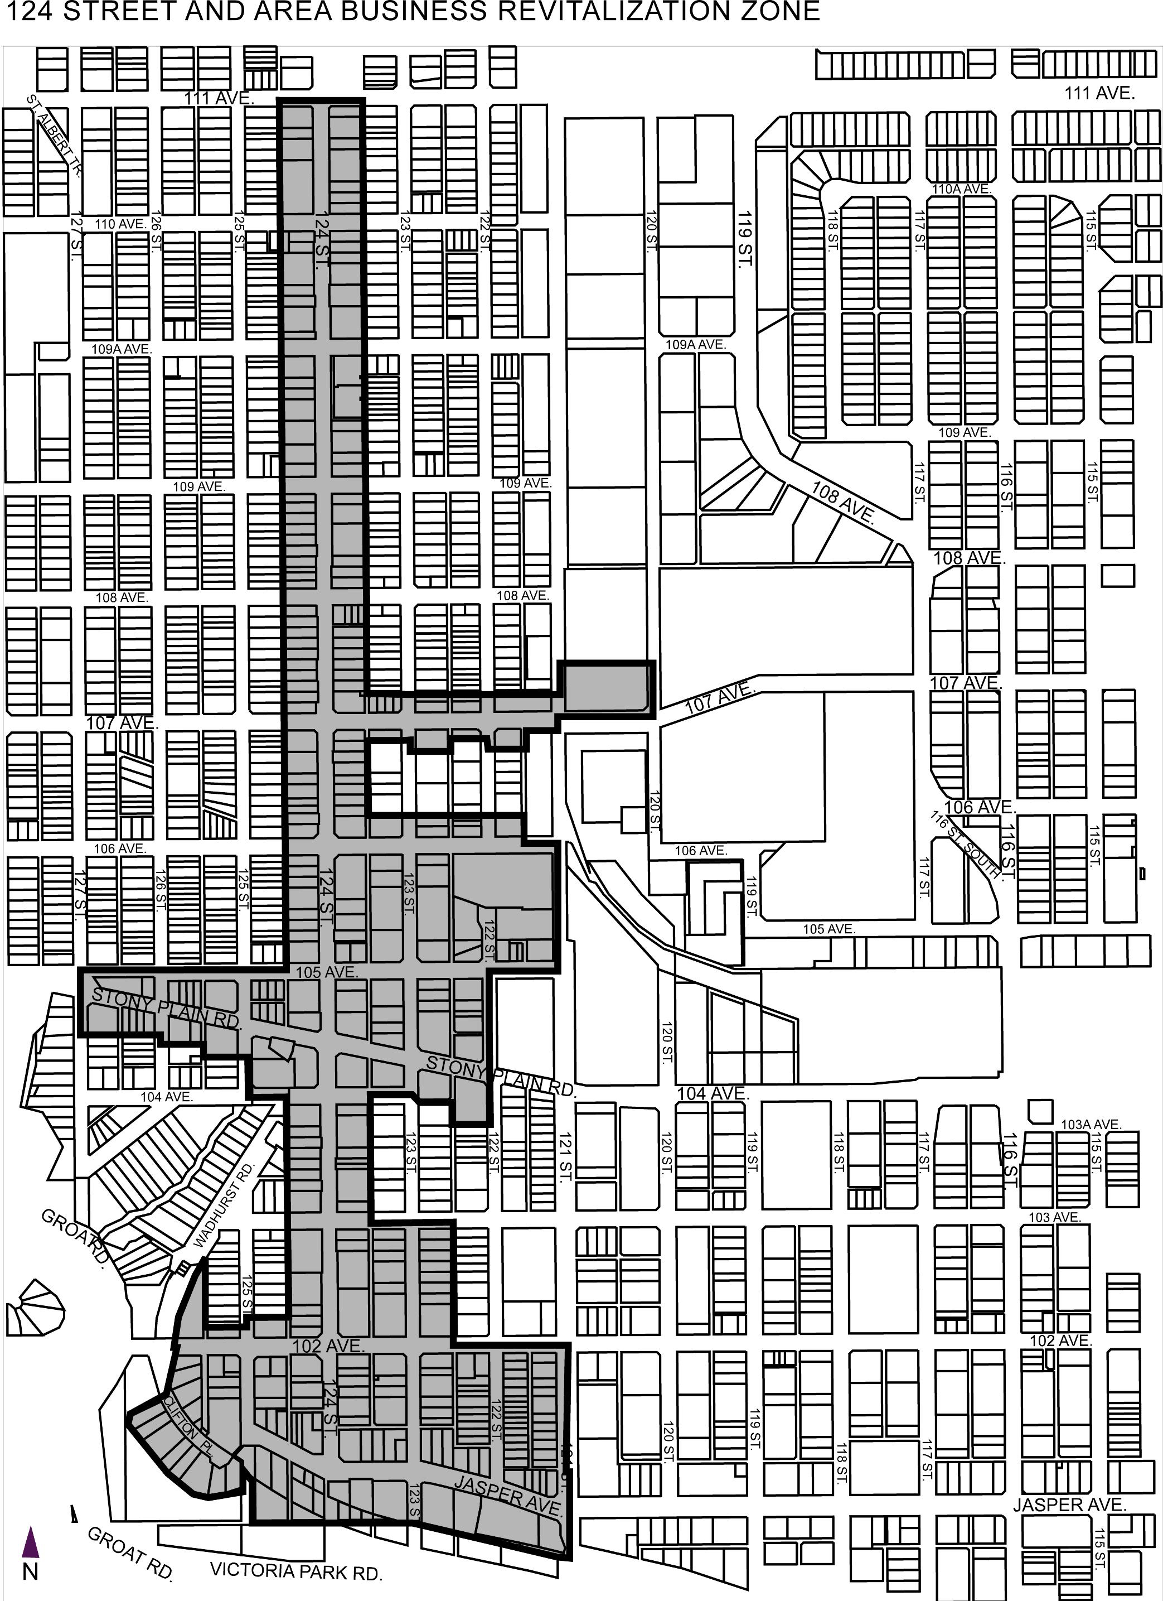
124 Street and Area Business Revitalization Zone

Schedule “B”
Appendix “C”

BOUNDARIES OF THE EDMONTON
124 STREET AND AREA BUSINESS REVITALIZATION ZONE

The Edmonton 124 Street and Area Business Revitalization Zone shall consist of all lots lying within the following boundaries:

On the North – Originating at 111 Avenue and the north-south lane east of 124 Street, west along 111 Avenue to the north-south lane west of 124 Street.

On the West – Originating at 111 Avenue at the north-south lane west of 124 Street, south on the north-south lane west of 124 Street to 105 Avenue, west to 127 Street, south to the southern boundary of the first lot south of Stony Plain Road (Lot 18, Block 51, Plan 7920282), east along the southern boundary of this lot (Lot 18, Block 51, Plan 7920282) to the north-south lane east of 127 Street, east along the east-west lane south of Stony Plain Road to 126 Street, south to the first east-west lane south of Stony Plain Road and east of 126 Street, east along this east-west lane to the north-south lane east of 126 Street, south to the southern boundary of the first lot south of Stony Plain Road (Lot 12, Block 42, Plan RN22B), east along the southern boundary of this lot (Lot 12, Block 42, Plan RN22B) to 125 Street, south to 104 Avenue, east to the north-south lane west of 124 Street, south to the first east-west lane north of 102 Avenue, west along this lane to 125 Street, south to the northern boundary of the first lot north of 102 Avenue (Lot 2, Block 40, Plan RN22B), west along the northern boundary of this lot (Lot 2, Block 40, Plan RN22B) to the north-south lane west of 125 Street, north to the northern boundary of Lot 1, Block 40, Plan RN22B, south along the western boundary of this lot (Lot 1, Block 40, Plan RN22B) then south along Clifton Place to the northeastern boundary of Lot 1, Block B, Plan 2955EO on the northwest side of Clifton Place, west to the northwestern boundary of this lot (Lot 1, Block B, Plan 2955EO), southeast along the southwestern boundary of this lot (Lot 1, Block B, Plan 2955EO) then continuing southeast along the southwestern boundary of the first lots southwest of Clifton Place (Lots 2/3/4/5/6/7/8, Block B, Plan 2955EO) to the southeastern boundary of Lot 14, Block 39, Plan 577MC, north to the southern boundary of Lot 13U, Block 39, Plan 577MC, east along the southern boundary of this lot (Lot 13U, Block 39, Plan 577MC) to the southeast boundary of Lot 12, Block 39, Plan 577MC, south along the western boundary of Lot 17, Block 35, Plan RN22B to the east-west lane south of Jasper Avenue.

On the South – Originating at the east-west lane south of Jasper Avenue at the southwestern boundary of Lot 17, Block 35, Plan RN22B, east along the east-west lane south of Jasper Avenue to 123 Street, southeast along the southern boundary of the first blocks/lots south of Jasper Avenue (Block 40, Plan 8321881; Block 1, Plan 0726886; Block 340, Plan 8122243; Lot E, Plan 5861MC) to 121 Street.

On the East – Originating at the southeastern corner of Lot E, Plan 5861MC at 121 Street, north along 121 Street to 102 Avenue, west to the north-south lane west of 122 Street, north to 103 Avenue, west to the north-south lane east of 124 Street, north to 104 Avenue, east along 104 Avenue and the east-west lane east of 123 Street to the north-south lane east of 123 Street, south to the southern boundary of the first lot south of Stony Plain Road and west of 122 Street (Lot F, Block 3, Plan 2806RS), east along the southern boundary of this lot (Lot F, Block 3, Plan 2806RS) to 122 Street, north to 105 Avenue, east to 121 Street, north to 106 Avenue, west to the north-south lane west of 121 Street, north to the northern boundary of the second lot north of 106 Avenue (Lot 9, Block 2, Plan RN22), west along the northern boundary of this lot (Lot 9, Block 2, Plan RN22) and continuing west along the northern boundaries of Lot 12, Block 7, Plan RN22; Lot 9, Block 7, Plan RN22; and Block 1, Plan 0722386 to the north-south lane east of 124 Street, north to the southern boundary of the first lot south of 107 Avenue and west of 123 Street (Lot 20, Block 24, Plan RN22), east along the southern boundary of this lot (Lot 20, Block 24, Plan RN22) and continuing east along the southern boundaries of Lot 2, Block 7, Plan RN22; Block 1, Plan 9424121; and Lot 2A, Block 2, Plan 0023206 south of 107 Avenue to the north-south lane east of 122 Street, north to 107 Avenue, east to 120 Street, north to the northern boundary of the first lot north of 107 Avenue (Lot 1, Block 20, Plan 9223242), west along the northern boundary of this lot (Lot 1, Block 20, Plan 9223242) to 121 Street, south to the northern boundary of the first lot north of 107 Avenue (Lot 21, Block 3, Plan 8821662), west along the northern boundary of this lot (Lot 21, Block 3, Plan 8821662) and the second lots north of 107 Avenue (Lot 12, Block 6, Plan RN22; Lot 9, Block 6, Plan RN22) to 123 Street, west along the first east-west lane north of 107 Avenue to the north-south lane east of 124 Street, north to 111 Avenue.

