Attachment 1

Bylaw 15011
Being a Bylaw to Designate the Wallbridge Residence as a Municipal Historic Resource

WHEREAS the Historical Resources Act, R.S.A. 2000, c. H-9, as amended, permits the municipal council of a municipality to designate any historic resource within the municipality whose preservation it considers to be in the public interest together with any specified land in or on which it is located, as a Municipal Historic Resource; and

WHEREAS it is deemed in the public interest to designate the building located at 12606 - 104 Avenue NW known as the Wallbridge Residence and the land on which the building is situated as a Municipal Historic Resource; and

NOW THEREFORE the Municipal Council of the City of Edmonton, having complied with the Historical Resources Act, and duly assembled, hereby enacts as follows:

1. BUILDING AND LANDS DESIGNATED AS A MUNICIPAL HISTORIC RESOURCE
The building known as the Wallbridge Residence (specifically described in Schedule “A”) (the “Building”) and the land on which the building is located being legally described as Plan 5393AH, Block 51, Lots A and B, excepting thereout all mines and minerals (the “Land”) are hereby designated as a Municipal Historic Resource.
2. PERMITTED REPAIRS AND REHABILITATION
Subject to Section 3 hereof, the Building and Land shall not be removed, destroyed, disturbed, altered, rehabilitated, repaired or otherwise permanently affected, other than in accordance with the terms of Schedule "A" attached, and the General Guidelines for Rehabilitation attached as Schedule "B", to this Bylaw.

3. ADMINISTRATOR
The General Manager of the Planning and Development Department is hereby appointed to administer the implementation of any matters arising from the matters set out in this Bylaw, and the Schedules attached hereto, including, without limitation, the Rehabilitation and Maintenance Incentive Agreement as set out in Schedule “C”.

4. EFFECTIVE DATE
This Bylaw shall come into effect on the date on which this bylaw is passed by Council.

READ a first time this day of , A.D. 2008;
READ a second time this day of , A.D. 2008;
READ a third time this day of , A.D. 2008;
SIGNED and PASSED THIS day of , A.D. 2008.

THE CITY OF EDMONTON

________________________
MAYOR

________________________
CITY CLERK

SCHEDULE "A"

THE IDENTIFICATION OF REGULATED PORTIONS OF THE
WALLBRIDGE RESIDENCE, 12606 - 104 AVENUE NW

The purpose of this Schedule is to identify by written description and photographs, those portions of the Building known as the Wallbridge Residence, which shall be regulated by the “General Guidelines for Rehabilitation” (Schedule “B”) and must be preserved (‘the Regulated Portion”).

The Regulated Portion of the Building includes all the historic exterior facades. This includes the cedar cladded façades and verandahs and as described below under each façade section. The Regulated Portion of the Building also includes select historic interior elements including woodwork and fireplaces as outlined below. These features of the Building shall be rehabilitated in accordance with the “Rehabilitation Proposal” which is part of Schedule “B”.

Non-regulated portions of the Building, being all other portions of the Building not specifically identified as a Regulated Portion, may be rehabilitated, altered, repaired or otherwise permanently affected in any manner provided that such rehabilitation, alteration or repair does not impact on the regulated historic features of the Building. Any development or alterations considered to be non-regulated portions of the Municipal Resource however must meet the Guidelines for the Rehabilitation of Designated Historic Resources. Any development of any portion of the Land shall be undertaken in a manner that is sympathetic to the historic facades of the Wallbridge Residence.

The following architectural elements must be retained:

NORTH FAÇADE:
- The 1911 north façade with the 1942 alterations
- Stucco cladding on upper storey
- Beveled wood siding on lower storey
- Exposed red brick chimney with corbelling
- Sawn cedar shingle clad, gabled roof dormer with entrance to third storey unit
- Nine timber framed sash windows and storm windows (1 over 1)
- Two timber framed basement windows (2 over 2)
- Hipped roof clad in sawn cedar shingle
- Exterior staircases leading to units on second storey and third storeys

WEST FAÇADE:
- The 1911 west facade
- Exposed red brick chimney with corbelling
- Hipped roof clad in sawn cedar shingle
- Exterior staircase leading to unit on the second level with cedar clad landing
- One timber framed window (10 over 10)
- Five timber framed single hung sash windows and storm windows (1 over 1)
- Two single pane fixed timber framed windows
- Two sawn cedar shingle clad shed roof dormers
- Beveled wood siding on lower storey
- Stucco cladding on upper storey
- Sawn cedar shingle cladding on the main and second floor verandas at the south end of the west façade

EAST FAÇADE:
- The 1911 east façade with the 1942 alterations
- Hipped roof clad in sawn cedar shingle
- Exposed red brick chimney with corbelling
- Stucco cladding on upper storey
- Beveled wood siding on lower storey
- Sawn Cedar shingle cladding on the main and second floor verandas at the south end of the east facade
- Nine timber framed single hung sash windows and storm windows (1 over 1)
- Two sawn cedar shingle clad shed roof dormers

SOUTH FAÇADE:
- The 1911 south façade with the 1942 alterations
- Hipped roof dormer with three timber framed windows
- Sawn cedar shingle cladding
- Bevelled wood siding on walls of verandahs
- Seven timber framed 1/1 single hung sash windows with storm windows
- Exposed brick chimney on east main floor verandahs
- Four verandahs (2 on main and 2 on second storey) clad in cedar shingle and supported by paired square tapered wood columns
INTERIOR
- Wood trim throughout house around windows, doors and baseboards
- Built in wooden hutch and upper cabinetry with curved brackets in the dining room on the main floor with decorative leaded glass doors
- Fireplace in main floor study
- Hardwood floors throughout
- Fireplace in main living room with built in side cabinets with beveled glass doors
- Two fireplaces on the second floor
- Fireplace on the third floor

GARAGE
- 1911 two car garage with pyramid roof.
PHOTOGRAPHIC/ ARCHITECTURAL DETAILS

Photo #1 - North Elevation

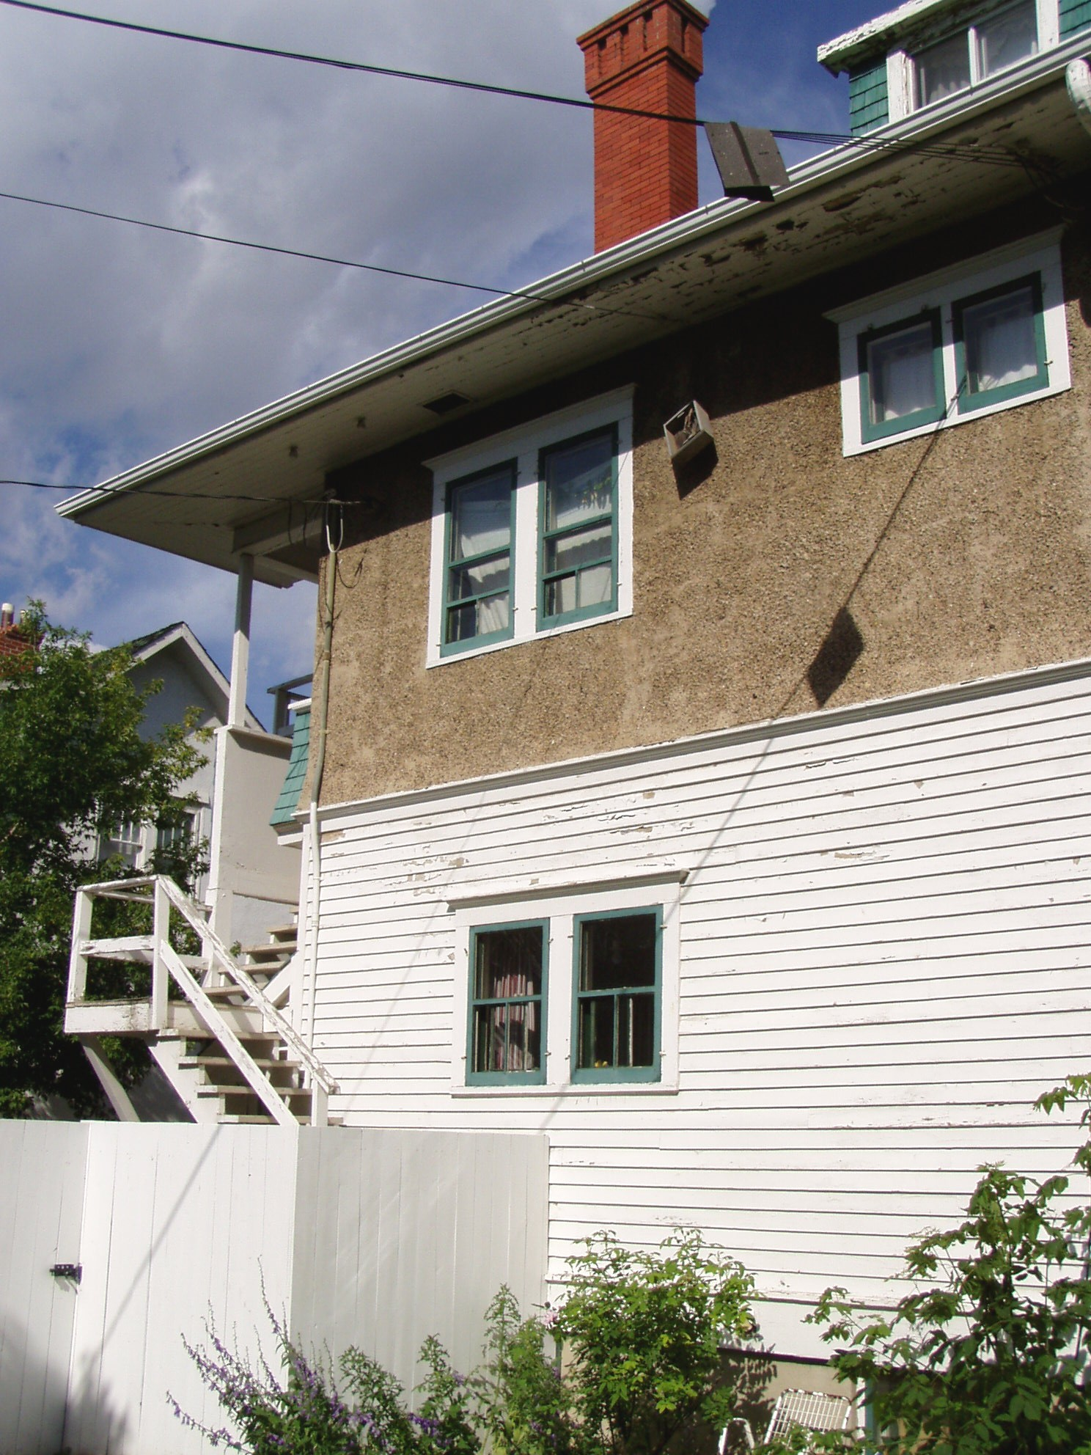

Photo #2 - East Elevation

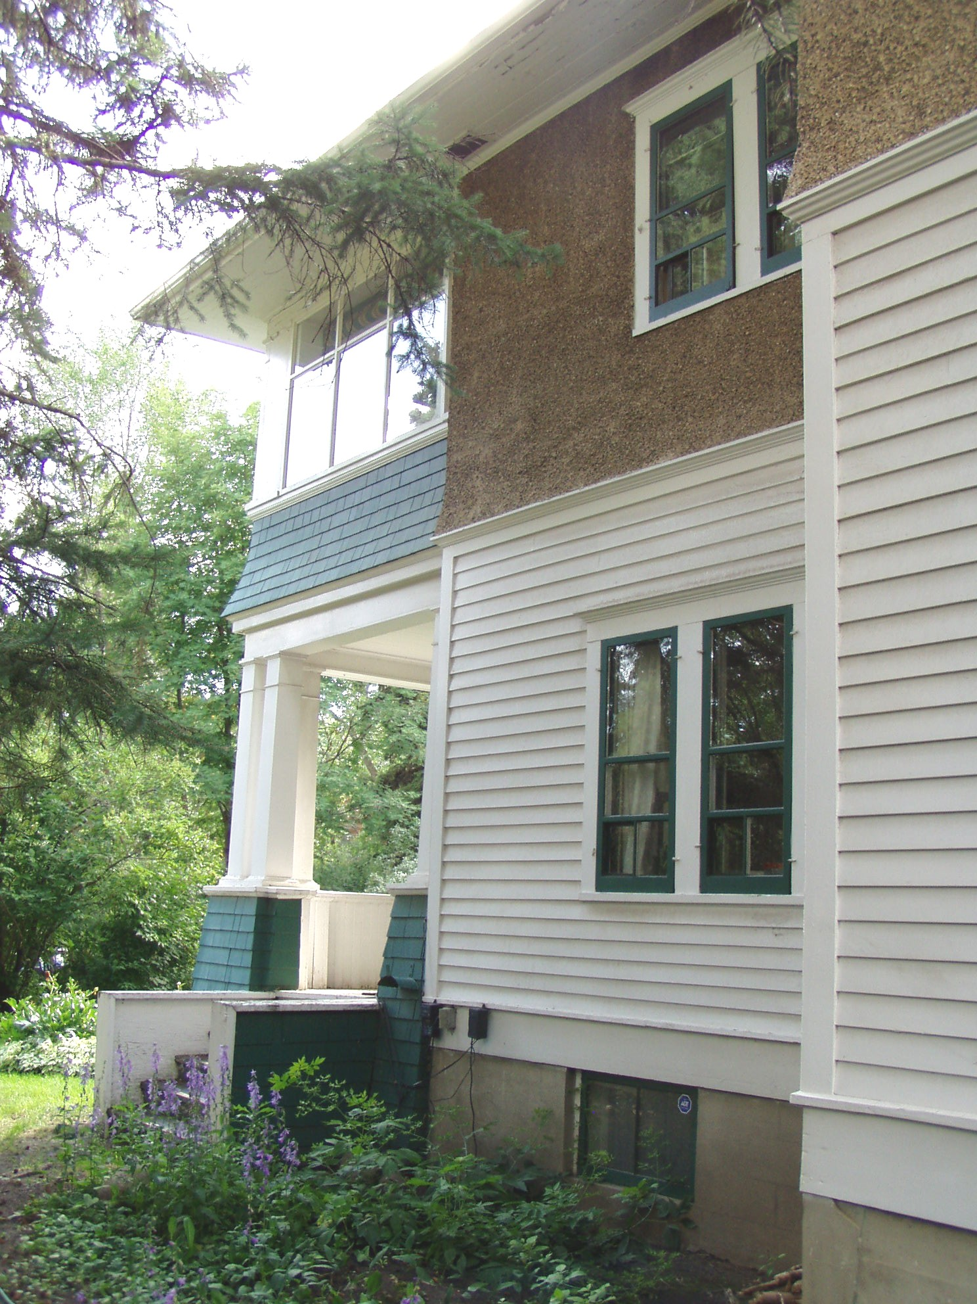

Photo #3 - South Elevation

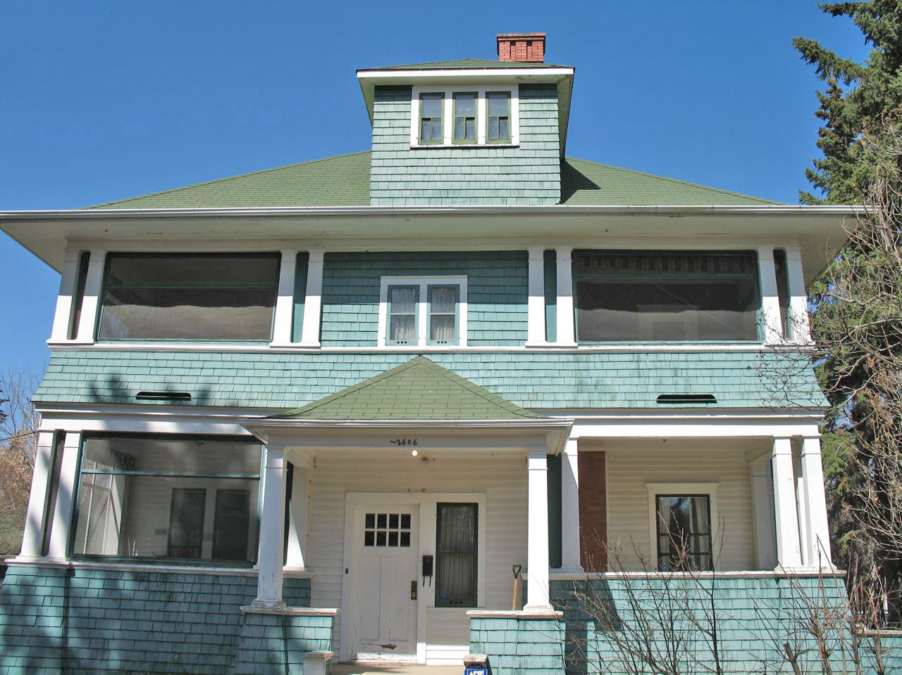
Photo #4 - West Elevation

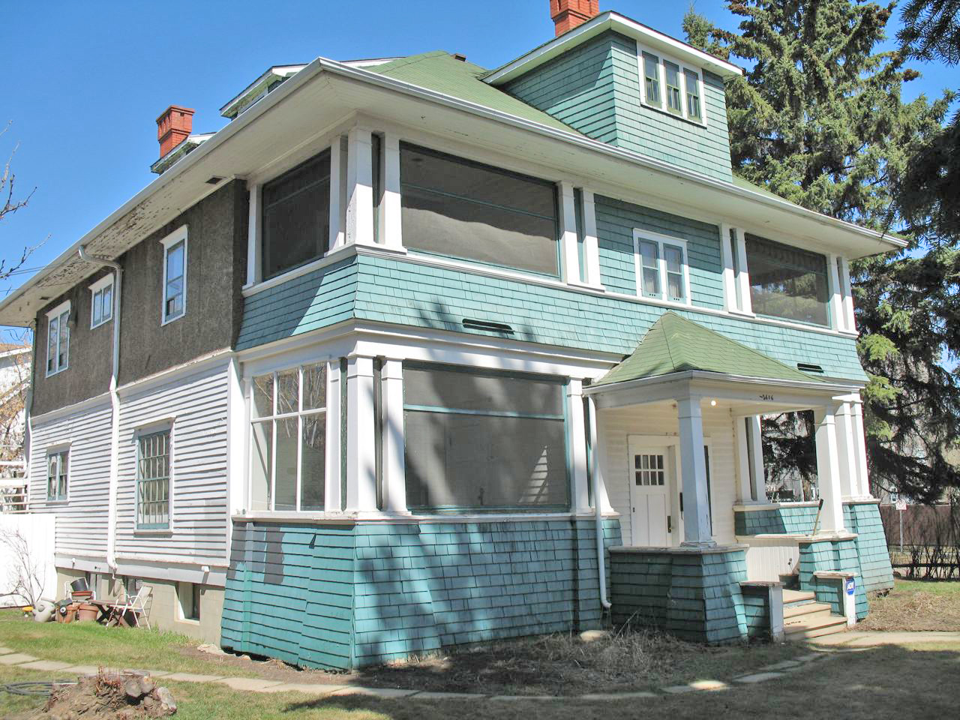
Photo #5 - Interior Built in Cabinetry

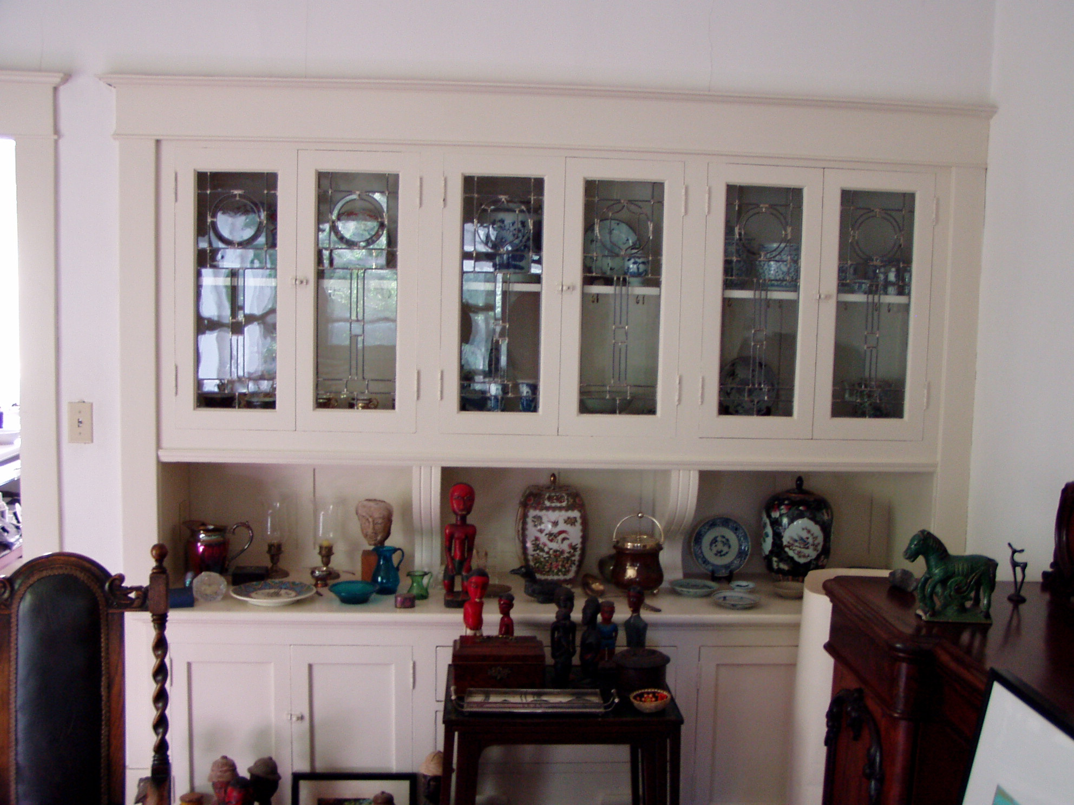
Photo #6 - Interior Fireplace

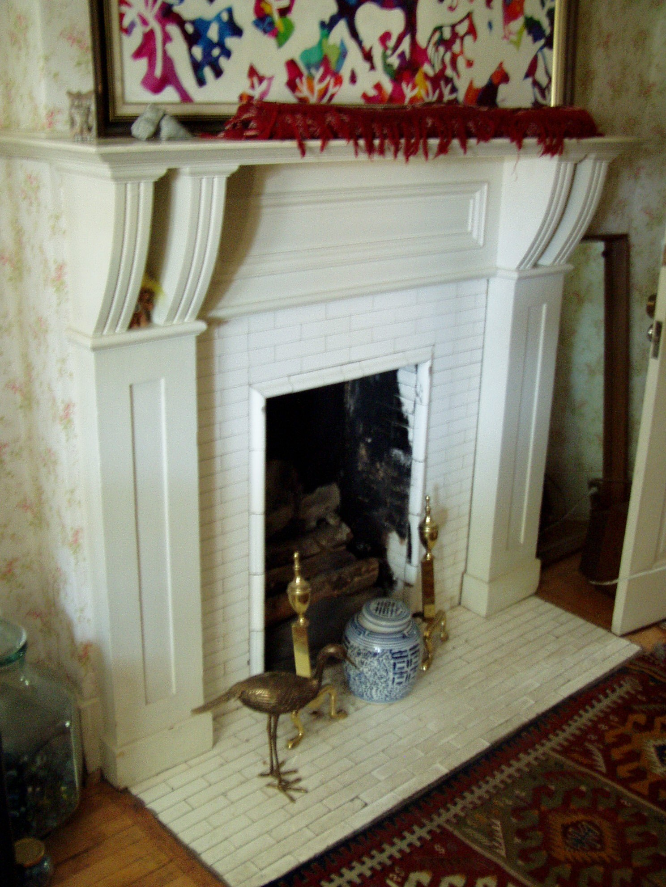
Photo #7 - Interior Trim and Details

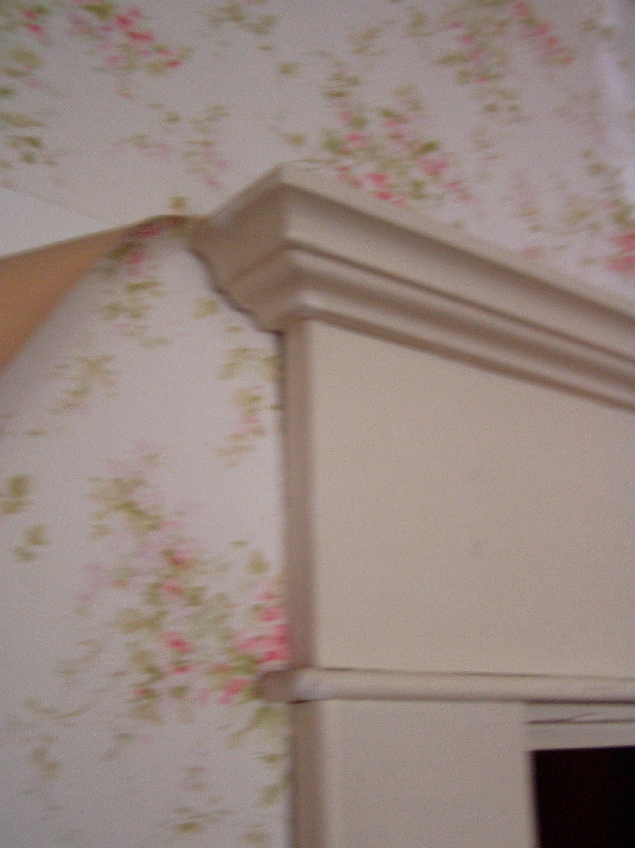

Photo #8 - Interior Fireplace

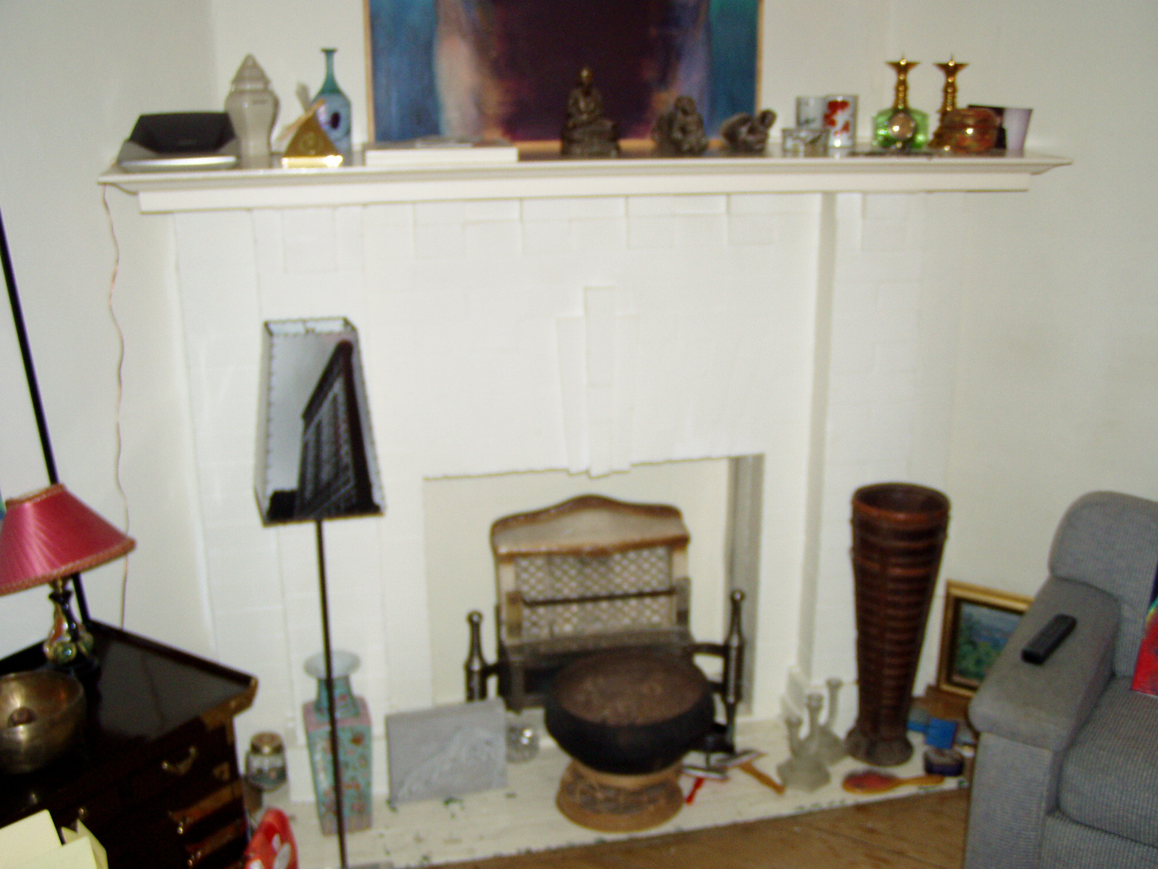

LOCATION PLAN

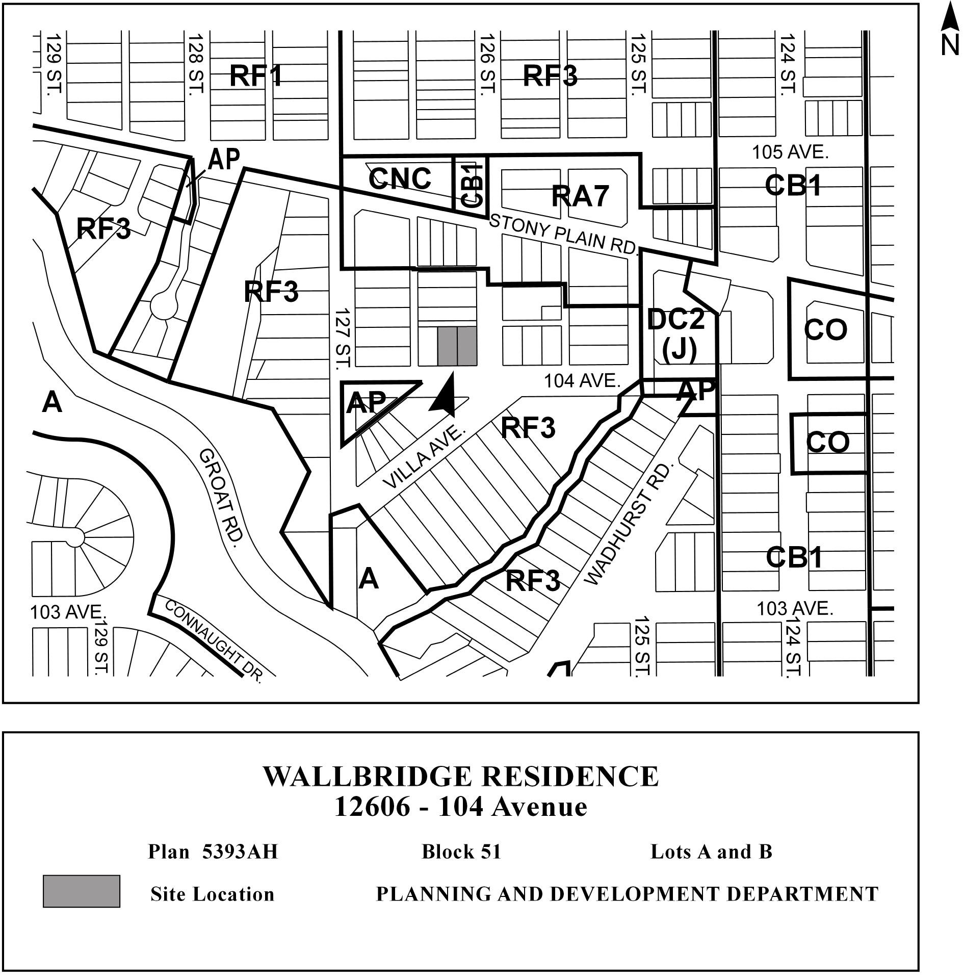
SCHEDULE "B"

GENERAL GUIDELINES FOR REHABILITATION

The General Guidelines for Rehabilitation are intended to assist in applying accepted principles and practices to the conservation of historic resources. The guidelines are set out in the “Standards and Guidelines for the Conservation of Historic Places in Canada”. In a manner consistent with accepted practice, City Policy C-450A requires that the standards be used in conjunction with the guidelines to ensure that the basis for a clear and consistent interpretation of the guidelines is provided to assist owners of historic resources throughout the rehabilitation process. The following guidelines and the referenced standards shall apply to the Wallbridge Residence (the “Municipal Historic Resource”) and any rehabilitation or maintenance work undertaken with respect to the Municipal Historic Resource at any time.

- Compatible Uses:

Wherever possible, the uses proposed for the Municipal Historic Resource shall be compatible with the existing Building such that only minimal changes are required to the Building. The use of the Municipal Historic Resource for its original purpose is desirable.

- Original Character:

The original distinctive qualities and character of the Municipal Historic Resource shall not be destroyed. The removal or alteration of any historical materials or features shall be avoided whenever possible.

- The Historic Period:

The Municipal Historic Resource should be recognized as a product of its own time. Alterations which are not based on historical fact or which recreate an earlier or a later appearance shall be discouraged.

- Witness to Change:

Changes to the Municipal Historic Resource may have occurred over time. These alterations are evidence of the history and development of the Building. Because this evolution may have acquired a significance in its own right, alterations to the original Building should be recognized and respected where indicated.

- Style and Craftsmanship:

Distinctive stylistic features and examples of skilled craftsmanship of the Municipal Historic Resource shall be preserved and treated sensitively.

- Repair and Replacement:

Deteriorated architectural features shall be repaired rather than replaced whenever possible. Where replacement is necessary, the new material should match the original as to material composition, colour, texture, design, etc. The repair or replacement of architectural features shall be based on a sound knowledge of the original characteristics of the feature. Such knowledge shall be based on historical or pictorial evidence and not upon conjecture.

- Cleaning:

In all cases, surface cleaning shall be undertaken with the gentlest means available. Sandblasting and other cleaning methods that damage historic buildings shall not be undertaken without thorough testing prior to use on a building. Sandblasting is NOT recommended on brick, stone or wood. In all instances, it should be ascertained that a building exterior is really in need of cleaning prior to undertaking the work.

- Reversibility of Intervention:

When the introduction of new elements or materials are necessary to stabilise or preserve the Municipal Historic Resource, alterations shall be undertaken such that the new materials, should they fail, may be removed at a later date without damage to the original fabric of the Municipal Historic Resource. Where this is not possible (i.e. use of epoxy or other permanent interventions) only those methods and materials which have been thoroughly tested and found satisfactory in situ, shall be used.
9. Recording:

Prior to undertaking any alterations, particularly in cases where alterations may threaten the Building fabric (underpinning, moving structures), the applicant/owner shall provide notice to the City Planning Department’s Heritage Program to enable measures to be taken to provide a complete and accurate record of the architectural features of the Municipal Historic Resource. Measured drawings and photographs of details may prove invaluable if major features are damaged or lost during the subsequent repair work. Any historic resource, which is the subject of an application to unsympathetically alter or demolish such resource, shall be professionally recorded.

- Original Construction Details:

In some historic structures, poor construction details or inappropriate materials resulted in rapid deterioration of certain building elements. In these instances, accurate reconstruction of the original detail will inevitably result in the failure of the element. Therefore, reconstruction should be undertaken in such a fashion as to duplicate the original appearance as closely as possible while using details based on sound construction practice.

- Codes:

At no time should the life and safety of occupants of a Municipal Historic Resource be deemed of lesser importance than the preservation of the original fabric of the Municipal Historic Resource. The required life and safety standards are those required by the current Alberta Building Code. However, notwithstanding these Code requirements, where the essential character of the structure is threatened by changes for Code reasons, every effort shall be made to achieve an equivalent safety standard by alternate means so as to minimise the impact on the historic fabric.

- Rehabilitation:

Prior to undertaking any rehabilitation work, the scope of work and a schedule of alterations should be prepared. This schedule should include phasing of alterations where necessary due to program or budget restrictions. The type and timing of both short and long term maintenance work shall also be included.

- Signs:

As a general rule signs should be limited to signs which were originally present on the Building. In instances where new uses or interpretive functions dictate the use of additional signs, these new elements should be integrated into the general design of the project. The size, typeface, graphics, and materials should be chosen to suit the period of the Municipal Historic Resource wherever possible. Avoid installing new signs such that the repair, replacement or removal of the signs damages the original fabric of the structure.

- Alterations and Additions to Historic Resources:

Contemporary design for alterations and additions to existing historic resources shall not be discouraged when such alterations and additions do not diminish the overall historic character of the resource and such design is compatible with the size, scale, colour, material and character of the resource, neighbourhood or environment.
SCHEDULE “C”

THIS REHABILITATION, INCENTIVE AND MAINTENANCE AGREEMENT
made this day of 2008
BETWEEN:
FRANK CALDER and KNUT VIK
(the “Owner”)
OF THE FIRST PART,
-and-

THE CITY OF EDMONTON
(the “City”)
OF THE SECOND PART.

WHEREAS:

- The Owner is the registered owner of land municipally described as:
12606 - 104 Avenue NW
Edmonton AB

and legally described as: Plan 5393AH, Block 51, Lots A and B, excepting thereout all mines and minerals (“the Lands”), and the building known as the Wallbridge Residence located thereon (the “Building”).

- On July 23, 2008, City Council authorized the service of a Notice of Intention to Designate the Lands and Building as a Municipal Historic Resource in accordance Historical Resources Act, R.S.A. 2000, c. H-9, as amended (“the Act”).
- The Building is in need of rehabilitation to ensure its long-term integrity and the Owner has agreed with the City to rehabilitate and maintain the Building in accordance with the covenants and conditions in this Agreement.

- A condition or covenant relating to the preservation or restoration of any land or building, entered into by the owner of the land and the council of a municipality, may be registered with the Registrar of Land Titles, and may be enforced whether the condition or covenant is positive or negative in nature notwithstanding that the grantee may not have an interest in any land that would be accommodated or benefited by the condition or covenant.

- In anticipation that the Municipal Council of the City shall designate the Building as a municipal historic resource, the City wishes to pay the Owner money in satisfaction of the Owner’s right to compensation under the Act and as an incentive to rehabilitate and maintain the Building, and the Owner agrees to accept such money in lieu of compensation under the Act.

THEREFORE, for good and valuable consideration, the receipt and sufficiency of which is hereby acknowledged by the Owner, the parties agree as follows:

- CONDITION PRECEDENT:

  - This Agreement is conditional upon Council passing a bylaw to designate the Lands and the Building a Municipal Historic Resource (the “Designating Bylaw”) by October 29, 2008, or such later date as the parties may agree to in writing. If the Designating Bylaw is not passed by October 29, 2008, and the parties have not agreed to extend the time for satisfaction of the condition precedent, this Agreement shall be of no force and effect.

- DEFINITIONS:

In this Agreement:

  - “Act” means the Historical Resources Act, R.S.A. 2000, c. H-9;

  - “Certification” means the written confirmation provided by the Owner to the City in a form satisfactory to the City certifying that the Phase or Phases of the Rehabilitation Work has been completed, or a Deficiency List has been remedied, which shall include the following:

    - receipts for all materials, supplies, labour and services and any other relevant documentation or other documents satisfactory to the City, and

    - receipts or other documents satisfactory to the City indicating that all supplies and contractors involved in performing that Phase of the Rehabilitation Work or remedy of the Deficiency List have been paid in full for their goods or services;

  - “Council” means the municipal council of the City of Edmonton;

  - “Deficiency List” means a description of the particulars given by the City to the Owner that specifies how the Rehabilitation Work or the Certification is inadequate or deficient;

  - “Designating Bylaw” means a Bylaw passed by Council under the authority of Section 26 of the Act relating to the Land and Building;

  - “Maximum Incentive” means the amount set forth within Section 6.1 of this Agreement;

  - “Owner” includes the current Owner and all future registered owners of the Land at the North Alberta Land Registration District;

  - “Rehabilitation Work” means the work set out in Section 4.1 of this Agreement to be completed by the Owner.

- OWNER’S WAIVER OF RIGHTS:

  - The Owner hereby expressly agrees to waive all rights to claim additional or alternative compensation beyond the Maximum Incentive for any cause, whether arising in common law, equity or by statute, because of the City’s designation of the Lands and Building as a Municipal Historic Resource or the City’s issuance of the Notice of Intention to Designate.

  - The Owner waives any rights the Owner may have to dispute the sufficiency of the Notice of Intention to Designate and hereby releases the City, its agents and employees from any deficiencies of the Notice of Intention to Designate or the issuance thereof.

- REHABILITATION WORK:
  - Upon the passage of the Designating Bylaw, the Owner shall commence the work as set out in the table below (the “Rehabilitation Work”):

Phase | Description of City Funded Work | Amount Allocated
1 | Roof Repairs: Remove and dispose of asphalt shingles and install new cedar shingles. | $37, 000
2 | Windows: Remove and replace 5 slider windows on third floor with double hung wood frame windows. Repair and restore exterior window trim and replace where necessary. Remove, repair and clean storm window units. | $20,000
3 | Cladding: Repair and restore areas of existing shingle siding where possible. Replace wood rot boards supporting shingle wall finish as required. Replace shingles at front ground level south elevation.  Front Entry: Reconstruct front entry porch decking with 1x3, V-joint exterior wood plank flooring.  Exterior Stairs: Repair and restore exterior staircases where possible. Construct new railing systems on all stair units.  Veranda Stair Unit: Repair and reconstruct veranda stair unit complete with side wall returns at front of house. | $35,000
4 | Paint and Stain: Clean and pressure wash exterior to prep for painting. Paint all exterior surfaces of the house including all exterior windows/storm windows and doors. Stain all required areas including front entry porch. | $26,000
5 | Trim and Doors: Repair and restore trim (baseboards, mouldings) and wood doors throughout the house.  Interior Painting: paint all wood trim, doors and built-in cabinets (dining room and living room). | $15,000
6 | Flooring: Uncover and restore hardwood floors throughout the house | $17,000

  - The Owner shall complete the Rehabilitation Work by September 30, 2011.

  - In undertaking the Rehabilitation Work the Owner shall follow the General Guidelines for Rehabilitation in the Designating Bylaw and the “Standards and Guidelines for the Conservation of Historic Places in Canada”.

- PAYMENT OF REHABILITATION INCENTIVE:

  - The City and the Owner agree that the sums described in the table contained in section 4.1 of this Agreement in the column “Amount Allocated” are estimated amounts of the Maximum Incentive allocated to each phase of the Rehabilitation Work (a “Phase”), to be paid to the Owner by the City pursuant to the provisions of Article 6 of this Agreement.

  - Upon completing a Phase or Phases or remedying a Deficiency List, the Owner shall provide the City with a Certification.

  - Within fourteen (14) days of receiving a Certification, the City may inspect the Building and either:

    - issue a Notice of Completion, stating that the Phase or Phases of the Rehabilitation Work has been performed or a Deficiency List remedied to the satisfaction of the City and including receipt by the City of a satisfactory Certification related thereto; or

    - give the Owner a Deficiency List.

  - If the City issues a Deficiency List, the Owner shall forthwith commence remediation of the deficiencies described in the Deficiency List.

  - In calculating the cost of performing the Rehabilitation Work, the Owner and the City shall only include the cost of labour and building materials specifically associated with the Rehabilitation Work. The Owner and the City shall not include other costs, including but not limited to, for example, the interruption of use of the Building or the Lands or the cost of repairing damage to the Building while the Rehabilitation Work was underway.

- PAYMENT:

  - The City shall not be liable to pay the Owner more than the sum of $150,000 described in the table contained in section 4.1 of this Agreement, as the total compensation payable by the City pursuant to this Agreement and the Designating Bylaw (the “Maximum Incentive”), and only upon completion of all Rehabilitation Work in accordance with the provisions of this Agreement, which sum shall be payable in yearly installments as described below.

  - Notwithstanding anything else herein contained, the City shall not be obligated to pay any portion of the Maximum Incentive until the City is satisfied, in its sole discretion, as to the registration of the Designating Bylaw and this Agreement against the title to the Lands.

Payment in the First Year

  - On or before December 31, 2009, the City shall pay the owner the lesser of:

    - a maximum payment of $150,000; or

    - one half the value of all the Rehabilitation Work for which the City has issued Notices of Completion up to and in 2009.

If by December 31, 2009, the Owner has not completed enough Rehabilitation Work (verified by Notices of Completion) to qualify for the full Maximum Incentive, the difference shall be applied to payments in 2010 and 2011.

If by September 30, 2011, the Owner has not completed enough Rehabilitation Work (verified by Notices of Completion) to qualify for the Maximum Incentive, the City shall not be obligated to pay the difference to the Owner in that year or in any future years. Notwithstanding the foregoing, the City may agree with the Owner in writing to carry forward some or all of the unpaid Maximum Incentive. The Owner expressly agrees, however, that payment of any or all of the Maximum Incentive is conditional upon completion of the Rehabilitation Work strictly in accordance with this Agreement.

  - The City may in its absolute discretion provide for partial payment of any amount up to the Maximum Incentive for any Phase(s) notwithstanding that a Notice of Completion for the Phase(s) has not yet been issued.

- MAINTENANCE:

  - In January of the (5th) fifth year after the issuance of the Notice of Completion for the final Phase or Phases of the Rehabilitation Work, and every five years after that, the Owner shall allow the City’s heritage planner or designate (the “Inspector”) to conduct an inspection of all regulated portions of the Building.

  - Within sixty (60) days of his inspection, the Inspector shall prepare a written report setting out recommendations for remedial or maintenance work on the Building, including a proposed schedule for the work and suggestions as to methods and materials to be used.

  - The Owner and the City shall meet within fourteen (14) days of the receipt of the Inspector’s report and establish the remedial work that shall be carried, out the timing for the completion of such remedial work, and the manner in which such remedial work shall be undertaken (the “Remedial Work Plan”).

  - The Owner shall promptly carry out the Remedial Work Plan and notify the City on completion.

  - On receipt of notice that the Remedial Work Plan has been completed, the City may inspect and identify any deficiencies in writing to the Owner. The Owner shall correct the deficiencies and provide the City notice that such corrective action has been carried out, and the City may then re-inspect.

  - Notwithstanding any other provision of this Agreement, if at any time the Owner or the City become aware of any disrepair that may endanger the Building, the Owner and the City shall meet and the Owner shall prepare and submit to the City a plan for repairs. Nothing herein shall be deemed or construed, however, to limit the City’s ability to rely on or enforce laws or bylaws relating to real property which is unsafe, dangerous or unsightly.

  - In addition to inspections permitted pursuant to the Remedial Work Plan, the City may on reasonable notice to the Owner and no more than four (4) times a year, inspect the Building at the City’s own expense.

  - The Owner shall be solely responsible for ensuring that the Building and Lands and any improvements thereto comply with all applicable federal, provincial and municipal laws, regulations, bylaws, codes and guidelines. The Owner acknowledges and agrees that nothing in this Agreement shall be deemed or construed as an obligation on or duty of the City to ensure compliance with this section or advise the Owner of deficiencies in the Owner’s compliance with this section.

  - If the Owner fails to perform any obligation under this Article or made pursuant to this Article, the City may give notice of the breach to the Owner and at the expiration of twenty-one (21) days after service of the notice, the City may without further notice, take all steps as the City may in its absolute and uncontrolled discretion deem necessary to remedy the Owner’s breach Any monies expended by the City in remedying the said breach, together with a surcharge of fifteen (15%) percent, shall be paid by the Owner to the City. This amount shall be recoverable by the City from the Owner within thirty (30) days of the Owner receiving a written demand and summary of costs from the City, failing which, such amount payable shall be a charge on the Lands and the City is at liberty to register such charge on title to the Lands. The rights of the City under this clause shall be in addition to and not substitution of any other rights of the City against the Owner whether by way of damages for breach of covenant or otherwise.

  - The failure of the City at any time to require performance by the Owner of any of the Owner’s covenants shall in no way affect the City’s right to enforce such covenant, nor shall the waiver by the City of the performance of any covenant be taken or be held to be a waiver of the performance of that covenant or any other covenant hereunder at any later time.

  - The Owner hereby releases the City, its agents and employees, from any liability whatsoever that the City may have to the Owner arising out of or related to the City’s performance of such obligations, save for any such liability as may be due to the City’s negligence. The Owner hereby agrees to cooperate with the City and allows the City such necessary access to the Building and the Lands as is requisite for the City to fulfill the requirements of this section.

  - Pursuant to and in accordance with Section 29 of the Act this Agreement shall be registered on title to the Lands and the conditions and covenants herein shall run with the Lands and shall bind the Owner and subsequent owners and successors in title to the Owner.

- REZONING:

  - Within one year of the execution of this Agreement, the Owner shall apply to the City to have the Lands re-zoned to DC1 (Direct Development Control Provision). Nothing in this Agreement fetters Council’s discretion to approve or reject the Owners re-zoning application.

  - Notwithstanding any other provision in this Agreement, the City may, in its sole and absolute discretion, hold back the Incentive grant until the Planning and Development Department has received a valid application to rezone the Lands to DC1 (Direct Development Control Provision).

- INSTALLATION OF PLAQUES:

  - The Owner shall permit the placement of two plaques in a visible location on or in proximity to the Building upon, or anytime after, the passing of the Designating Bylaw. One plaque shall be created and installed by the City at the City’s sole expense to a design and specification solely within the City’s discretion identifying the Building and the Land as a Municipal Historic Resource. A second plaque shall be created and installed by the Edmonton Historic Board (the “Board”) as an interpretative plaque, to a design and specification solely within the Board’s discretion. The location of the City’s and the Board’s plaques shall be mutually agreed to by the Owner and the City, both parties acting reasonably. For greater clarity, the City or the Board shall have no obligation to create and install such plaques, and the decision to do so shall be solely within each of the City’s and the Board’s discretion. The Owner shall not and shall not permit or cause the removal, disturbance or obscuring of such plaques.

- FEDERAL CANADIAN REGISTER OF HISTORIC PLACES:

10.1 The Owner consents to having the property listed on the Canadian Register of Historic Places which will at minimal entail having the address, historic descriptions, statements of significance, and photographs available for public viewing, in print or electronic format.

- INSURANCE

  - The Owner will maintain all risks broad form property insurance on the Building and Lands.

  - The limits of such policy will insure the structure to full replacement value.

  - In the event of a loss, the Owner shall make every effort to replace, repair or restore the Building to conserve the characteristics of the Building which give it its historical significance. Parts of the Building designated as being historical shall be restored, as closely as possible, to the details and characteristics of the original dwelling so designated as being historical.

  - Any exceptions to this insurance provision must be approved by the designated Heritage Planner for the City.

- DISPUTE RESOLUTION:

  - If a dispute arises between the City and the Owner as to the proper interpretation or effect of any of the terms or conditions of this Agreement, such dispute shall be resolved in accordance with the following procedure:

    - The party requesting that the matter in dispute be resolved in accordance with the provisions of this Dispute Resolution Article (the "Disputing Party") shall notify the other party (the "Defending Party") in writing of the details of the nature and extent of the dispute (the "Arbitration Notice").

    - Within seven (7) days of the receipt of the Arbitration Notice, the Defending Party shall by written notice advise the Disputing Party that it disputes all matters referred to in the Arbitration Notice except those for which the Defending Party admits responsibility and proposes to take remedial action.

    - The terms of reference for arbitration shall be those areas of dispute referred to in the Arbitration Notice with respect to which the Defending Party has not admitted or proposes to take remedial action.

    - The Defending Party and the Disputing Party shall within ten (10) days after the date of receipt by the Disputing Party of the Defending Party's notice, appoint an arbitrator who shall be acceptable to both parties (the "Arbitrator"). In the event that the parties shall fail to appoint the Arbitrator, then either party may, on written notice to the other, apply to the President of the Alberta Arbitration and Mediation Society to name the Arbitrator.

    - Not later than twenty (20) days after the appointment of the Arbitrator, the Arbitrator shall make his written decision, and shall give it to the parties immediately.

    - Unless the Arbitrator orders otherwise, the City and the Owner shall equally bear the costs of the arbitration.

    - The decision of the Arbitrator is final and binding on the parties and there shall be no appeal of the decision to the courts.

    - Except as modified by this Agreement, the provisions of the Arbitration Act R.S.A. 2000 c. A-43, as amended, shall apply.

- NOTICE:

  - Any notice given pursuant to the terms of this Agreement shall be sufficiently given:

    - in case of notice to the City, if such notice is sent by prepaid registered mail, or personally delivered, in an envelope addressed to:

General Manager, Planning and Development Department
5th Floor, 10250 - 101 Street NW
Edmonton, AB T5J 3P4

and also to:

Corporate Services Department, Law Branch
9th Floor Chancery Hall
#3 Sir Winston Churchill Square NW

Edmonton, AB T5J 2C3

    - in case of notice to the Owner, if such notice is sent by prepaid registered mail, or personally delivered, in an envelope addressed to:

Frank Calder & Knut Vik
12606 - 104 Avenue NW
Edmonton, AB T5N 0V7

  - Notice given as aforesaid, if posted, other than during an actual or threatened postal disruption, shall conclusively be deemed to have been given on the fifth (5th) business day following the date on which the notice is mailed. Any notice personally delivered or sent by telecopier or other form of facsimile transmission shall be deemed to have been given on the date of actual delivery.

  - Either party may, at any time, give notice in writing to the other of any change of address of the party giving such notice and, from and after giving of such notice, the address therein specified shall be deemed to be the address of the party for the giving of notice hereunder.

- GENERAL PROVISIONS:

  - The parties to this Agreement shall execute and deliver to the other all such further assurances and documents which may reasonably be deemed necessary by the solicitors for either of them to give full force and effect to the Agreement. The Agreement is not intended and shall not be deemed nor construed to nullify, replace, circumvent, extend or modify any existing statutes, bylaws or permit conditions, which govern development or construction within the City.

  - If any portion of this Agreement is found to be unenforceable, the remaining portions of this Agreement shall be given full force and effect.

  - The Designating Bylaw shall be registered on title to the Land by the City. Notwithstanding any other provisions of this Agreement, the Owner shall forthwith upon execution of this Agreement use reasonable efforts to have the Designating Bylaw placed as a registration prior to any security interest on the title to the Lands.

  - No amendments to this Agreement are valid unless they are in writing and signed by both parties to this Agreement.

  - Time is of the essence in this Agreement.

  - Everything herein contained shall inure to the benefit of and be binding upon the parties hereto, their administrators, successors and assigns respectively.

IN WITNESS WHEREOF the parties have signed this Agreement on the day and year first above written.

A P P R O V E D THE CITY OF EDMONTON
as represented by the General Manager of the Planning and Development Department
As to Form _____________________________ Per: ______________________

Corporate Services Department, Law Branch

As to Content
Head of Department 12606 - 104 Avenue NW
Edmonton, AB T5N 0V7
Witness________________________________ Per ______________________
Frank Calder

Per ______________________
Knut Vik

