Bylaw 14653

A Bylaw to amend Bylaw 12800, as amended,

The Edmonton Zoning Bylaw
Amendment No. 828

WHEREAS Lots 1 to 11, inclusive, Block 2; Lots 1-26, inclusive, Block 8; Lots 7 to 10, inclusive, Lot A, Block 11, all in Plan 3600U; Lots 1 to 7, inclusive, Block 1; Lots 30 to 39, inclusive, Block 2; Lots 14 to 24, inclusive, Block 7; Lots 1 to 22, inclusive, Block 8; Block 8, all in Plan 2552S, Lots 1, 2 and 3U, Block W, Plan 4885KS; Lot 12A, Block 2, Plan 5689RS; Lots 1 to 4, inclusive, 13 and OT, Block 7, Plan 224KS; Lot 14A, Block 15, Plan 042 5555, a portion of Lot 53, Block RLY, Plan 4217S and portions of NW 14-53-24-4 and all the roads closed in Bylaw 14652; located between 62 and 66 Streets NW, at Fort Road, Belvedere, Edmonton, Alberta, are specified on the Zoning Map as (AP) Public Parks Zone, (CNC) Neighbourhood Convenience Commercial Zone, (CB1) Low Intensity Business Zone, (CO) Commercial Office Zone; and

WHEREAS an application was made to rezone the above described property to (DC1) Direct Development Control Provision, (AP) Public Parks Zone and (PU) Public Utility Zone;

NOW THEREFORE after due compliance with the relevant provisions of the Municipal Government Act RSA 2000, ch. M-26, as amended, the Municipal Council of the City of Edmonton duly assembled enacts as follows:

- The Zoning Map, being Part III to Bylaw 12800 The Edmonton Zoning Bylaw is hereby amended by rezoning the lands legally described as Lots 1 to 11, inclusive, Block 2; Lots 1-26, inclusive, Block 8; Lots 7 to 10, inclusive, Lot A, Block 11, all in Plan 3600U; Lots 1 to 7, inclusive, Block 1; Lots 30 to 39, inclusive, Block 2; Lots 14 to 24, inclusive, Block 7; Lots 1 to 22, inclusive, Block 8; Block 8, all in Plan 2552S, Lots 1, 2 and 3U, Block W, Plan 4885KS; Lot 12A, Block 2, Plan 5689RS; Lots 1 to 4, inclusive, 13 and OT, Block 7, Plan 224KS; Lot 14A, Block 15, Plan 042 5555, a portion of Lot 53, Block RLY, Plan 4217S and portions of NW 14-53-24-4 and all the roads closed in Bylaw 14652; located between 62 and 66 Streets NW, at Fort Road, Belvedere, Edmonton, Alberta, which lands are shown on the sketch plan annexed hereto as Schedule “A”, from (AP) Public Parks Zone, (CNC) Neighbourhood Convenience Commercial Zone, (CB1) Low Intensity Business Zone and (CO) Commercial Office Zone to (DC1) Direct Development Control Provision, (AP) Public Parks Zone and (PU) Public Utility Zone.
2/80

2. The uses and regulations of the aforementioned DC1 Provisions are annexed hereto as Schedule “B”.

READ a first time this day of , A. D. 2007;
READ a second time this day of , A. D. 2007;
READ a third time this day of , A. D. 2007;
SIGNED and PASSED this day of , A. D. 2007.

THE CITY OF EDMONTON
____________________________________
MAYOR

____________________________________
CITY CLERK

3/80
SCHEDULE “A”

14653_SchA.pdf
4/80
SCHEDULE “B”

(DC1) DIRECT DEVELOPMENT CONTROL PROVISION
(AREA A)

- Area of Application

The site is located along the southeast side of Fort Road generally between 63rd Street and 129 Avenue, designated as Area A and shown on Appendix 1.

- Rationale

To accommodate a large scale, comprehensive, transit-oriented development/high density residential mixed use development that creates a liveable “urban village” environment and the introduction of a diversity of housing types within walking distance to the Belvedere LRT Station. Commercial uses will be developed on the ground floor of a number of the buildings as part of this development project.

- Uses

- Apartment Housing
- Major Home Based Business
- Minor Home Based Business
- Residential Sales Centre
- Row Housing
- Bars and Neighbourhood Pubs, for less than 100 occupants and 120 m² of Public Space
- Business Support Services
- Child Care Services
- Convenience Retail Stores
- General Retail Stores, not to exceed 3000 m², excepting grocery stores which may not exceed 4000m²
- Health Services
- Major and Minor Amusement Establishment as an accessory use to a restaurant
- Minor Alcohol Sales
- Personal Service Shops
- Professional, Financial, and Office Support Services, excluding loan offices and similar financial uses
- Restaurants, for less than 200 occupants and 240 m² of Public Space
- Specialty Food Services, for less than 100 occupants and 120 m² of Public Space
- Fascia On-premises Signs
- Projecting On-premises Signs
5/80

- Temporary Freestanding On premises Signs, limited to project identification, building construction identification and real estate advertising signs during construction and initial sale and excluding portable signs.

- Development Regulations

- The Developer shall provide proof satisfactory to the Development Officer, in consultation with the Alberta Environment, and the Transportation and Streets Department that the lands have been remediated to allow the intended use prior to the issuance of a development permit.
- Development applications for new buildings and major additions are required to go before the Edmonton Design Committee prior to the issuance of a development permit.
- A detailed noise and vibration study shall be prepared by a qualified, registered Professional Engineer, to the satisfaction of the Development Officer in consultation with the Transportation Department, prior to the issuance of a Development Permit.
- A berm and fence or such other barrier wall as agreed to by CN shall be built along the CN rail line prior to or concurrent with any residential development.
- A 30 m building setback shall be maintained from the existing CN Rail property line, at the time of zoning approval and, as shown in Appendix I.
- The overall Site development shall be in accordance with the urban design criteria established herein and in the Fort Road Old Town Urban Design Plan for this Area.
- Residential and residential related uses shall be located as shown in Appendix I.
- Only Commercial Uses shall be located on the first (ground) floor in the area identified on Appendix I.
- The maximum Floor Area Ratio of Area A shall be 4.9.
- The maximum Density shall be 370 Dwellings/ha.
- The maximum building area for commercial and commercial related uses in Area A shall not exceed 1,800 m².
- The maximum height for mid rise apartments shall not exceed 5 storeys or 18.0 m. Area A shall contain 2 High Rise Apartment buildings. The maximum permitted height for high rise apartment buildings shall be 18 stories or 58 m.
- The minimum separation distance between any two towers shall be 25 m.
- All mechanical equipment, including roof mechanical units, shall be concealed by screening in a manner compatible with the architectural character of the building or concealed by incorporating it within the building and is not included in building height.
6/80

- The maximum Height for Row Housing shall not exceed 3 Storeys nor 12.0 m.
- A Minimum Private Outdoor Amenity Area of 7.5 m² per Dwelling for Dwellings no part of which is contained in the lowest Storey shall be provided.
- The second floor in the areas identified for Commercial Uses, as shown on Appendix I, may be used exclusively for either Residential Uses or Commercial Uses, excluding Restaurants, Bars and Neighbourhood Pubs.
- All commercial and commercial related uses shall not be developed above the second storey of the building and shall be located as shown in Appendix I.
- A minimum of 3 storeys residential development shall be provided above any commercial development.
- Apartment housing with Commercial Uses on the ground floor shall have access at Grade that is separate from the Commercial premises.
- A Major Home Based Business shall only be allowed in Row Housing Dwelling units and shall comply with section 75 of the Zoning Bylaw.
- Landscaping shall contain at least 10% more trees and shrubs within any Yard or Setback than are required under Section 55 of the Zoning Bylaw.
- The landscape plan required through Section 55.3 of the Zoning Bylaw shall include landscaping as it relates to the design of special feature areas identified in the Urban Design Plan. Outdoor amenity spaces shall be landscaped for the purpose of achieving pedestrian connectivity, opportunities for play and social interaction. Furthermore outdoor amenity spaces should create a sense of place, character and identity. In addition to landscaping, this shall be achieved through the use of park benches, pedestrian level lighting, waste receptacles and other means integrated with the landscaping and placed along public walking routes through the site to the satisfaction of the Development Officer in consultation with the Parks Branch at Asset Management and Public Works.
- Loading, storage, and trash collection areas shall be located in such a manner to be screened from view from adjacent sites, public roadways, and Light Rail Transit lines in accordance with the provisions of Section 55 of the Zoning Bylaw. If the Rear or Sides of a Site are used for surface vehicular parking, it shall be screened in accordance with the provisions of Section 55 of the Zoning Bylaw.
- Access to vehicular Parking Garages will be from the internal roadway system, no direct access to parking will be permitted from Fort Road.
- All residential parking shall be underground or in a structure, visitor parking and customer parking may be provided at grade to a maximum of 30 stalls.

7/80

- Driveway ramps for underground parkades must not exceed a slope of 6% for the first 4.5 m from the property line and the ramp must be at Grade at the property line, to the satisfaction of the Transportation Department.
- Vehicular Parking on the site shall be developed in accordance with Section 54, Schedule 1 of the Edmonton Zoning Bylaw, except that:
- For Professional, Financial and Office Support Services at grade, parking shall be provided on the basis of 1.1 parking spaces per 100 m² of Floor Area and no parking spaces shall be required for this Use on upper floors;
- for Specialty Food Services, Restaurants, and Bars and Neighbourhood Pubs, parking shall be provided on the basis of one parking space per 4.8 m² of Public Space;
- for all other Commercial Use Classes, parking shall be provided on the basis of 1.1 parking spaces per 100 m² of Floor Area;
- For all Residential Use Classes, parking shall be provided on the basis of a minimum of 1 parking space per residential unit;
- The parking requirements may be further relaxed, at the discretion of the Development Officer in consultation with the Transportation Department, should initiatives which reduce parking demand be implemented. Such initiatives include but are not limited to dedicated car share/car pool stalls, universal bus pass programmes, or shared parking between commercial, commercial related, residential, and residential related uses; and
- Vehicular parking shall be located at the rear of the building.
- Bicycle Parking spaces shall be provided in accordance with Section 54 of the Edmonton Zoning Bylaw.
- The owner shall submit a Crime Prevention Through Environmental Design (CPTED) Assessment that shall be reviewed and accepted by the Development Officer prior to the issuance of a Development Permit to ensure that development on the Site provides a safe urban environment in accordance with the guidelines and principles established in the Design Guide for a Safer City.
- Signs in the areas identified for Commercial Uses shall comply with Schedule 59E of the Zoning Bylaw, with the intent to complement the pedestrian oriented commercial environment, except that:
- a maximum Height of a Temporary Freestanding Sign shall be 6.0 m;
- a Projecting Sign may be used to identify businesses that are located entirely at the second Storey level; and
- the top Projecting Sign on a building two Storeys or higher shall not extend more than 75 cm above the floor of the second or third storey nor higher than the windowsill level of the second or third Story.
8/80

- In the areas identified for Commercial Uses a Comprehensive Sign Plan and Schedule, consistent with the overall intent of subsection 59.3 of the Zoning Bylaw, shall be prepared for the development and submitted, with the Development Application, to be approved by the Development Officer.
- Signs in the areas identified for Residential Frontage, in Appendix I, shall comply with Schedule 59B of the Zoning Bylaw.

- Urban Design Regulations
Site Planning
- Mid rise apartment buildings shall be located along Fort Road, 129 Avenue, the internal public road, the public park and the multi-use trail corridor.
- Row housing shall be located along the internal public road and multi-use trail corridor.
- Buildings along the internal public road shall address the street, maximize frontage and contribute towards a predominantly residential character.
- Surface parking for visitors and customers shall be located to the rear of any building fronting onto Fort Road, 129 Avenue and screened from the internal public street and the public park by appropriate orientation of the built form and enhanced landscaping measures.
- No surface vehicular parking areas are permitted abutting any public roadway, other than a Lane.
- Enhanced landscaping measures shall be used if surface parking areas front the multi-use trail corridor.
- A mid block mews is encouraged for development along 129 Avenue at the intersection with Fort Road to break up massing and provide a safe and inviting route for pedestrians.
- Buildings shall address the public park and provide at least one common entrance fronting the park to enhance accessibility to the park.
- When commercial uses front the public park, a minimum building setback of 3 m shall be applied.

Street Wall
- The maximum Frontage for Sites abutting a commercial shopping street shall be 10.06 m or consistent with the Frontage of other existing Sites abutting the shopping street and, where the Frontage for Sites abutting the commercial shopping street exceeds 10.06 m or the consistent development pattern for the street, the front façade of the building shall be designed to break the appearance
9/80
into 10.06 m sections or modules consistently sized with other buildings on the shopping street.
- Blank walls (with or without windows) of vehicular Parking Garages shall not be developed adjacent to, or visible from any public roadway.

Towers

- Tower Base Zone [see illustration after (c)iv. for interpretive visualization]:
    - The tower base zone shall be integrated with mid rise apartments or row housing and shall be no higher than 6 storeys.
- Mid Tower Zone [see illustration after (c)iv. for interpretive visualization]:
- The maximum floor plate for the Mid-Tower Zone shall be square in shape and shall not exceed 743 m²;
- The mid tower zone shall step back from the tower base zone by a minimum of 3.0 m; and
- No one side shall be greater than 30 m.
- Top Tower Zone [see illustration after (c)iv. for interpretive visualization]:
  - The Top Tower Zone shall be 2 to 4 storeys in height;
  - The tower top zone shall step back from the Mid-Tower zone by a minimum of 1.5 m from the faces of the tower;
  - The maximum typical floor plate area of the Top Tower zone shall be a minimum of 10% smaller than the Mid-Tower floor plate area; and
  - Special architectural detailing, variation in materials, and special lighting is required to create an interesting skyline.
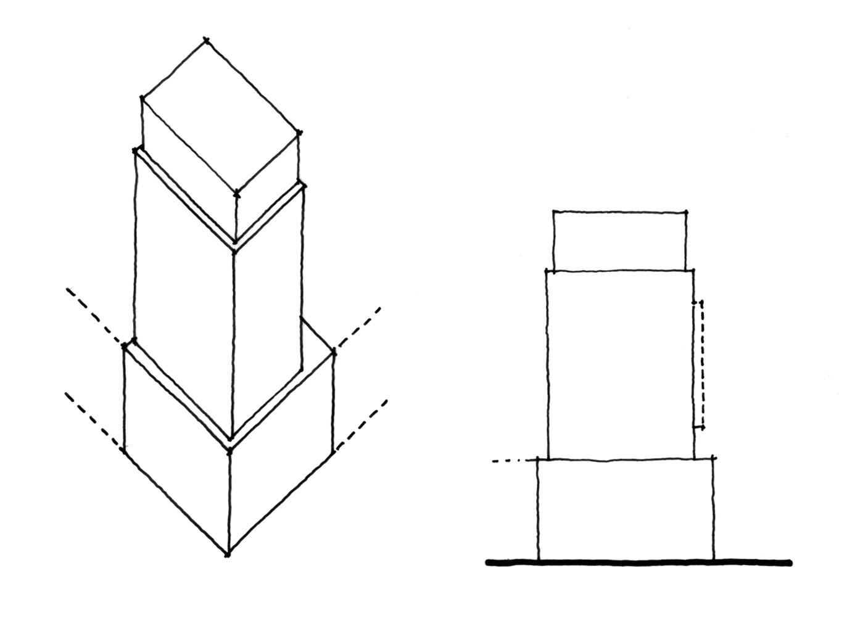

Tower Top Zone

Tower Base Zone

Mid – Tower Zone

10/80

Mid rise Apartments and Row Housing

- Buildings shall address all adjacent public roadways, other than Lanes, with individual entrances that are clearly visible to lend a sense of occupancy to the street. Buildings on corner Sites shall address both the street and avenue and shall distinguish the street intersection to give it prominence.

Building Setbacks

- Where the ground floor of any development is designed for Commercial Uses, buildings shall be built to the front and side property lines. The Development Officer may allow a maximum of 50% of the building to be setback by 1 m from the property line. This shall be done to create visual interest in the building. The Development Officer may allow an additional building setback, only to accommodate street related activities such as sidewalk cafes, colonnades, arcades or plazas.
- Where the ground floor of any development is designed for Residential Uses, the building shall contain a Landscaped Yard of 3 m. The Development Officer may allow staircases to project up to 2.0 m from the building wall. A combination of hard and soft landscaping shall be provided within the 3 m setback.

Building Stepbacks

- Where Residential Uses are located above Commercial Uses in a building the residential portion of the building above the second floor shall be setback a minimum 3 m from the lower portion of the building adjacent to Fort Road and 129 Avenue, as illustrated in the following diagram for interpretive purposes.

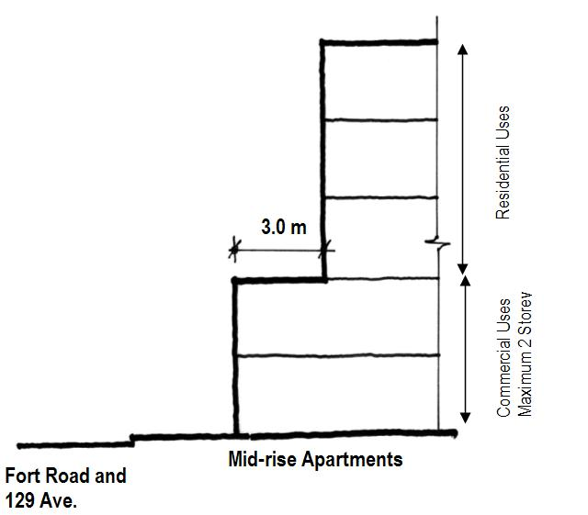

11/80
- Where Residential Uses are located above Commercial Uses in a building, the residential portion of the building above the second floor shall be setback a minimum 2 m from the lower portion of the building adjacent to the internal public street, as illustrated in the following diagram for interpretive purposes.

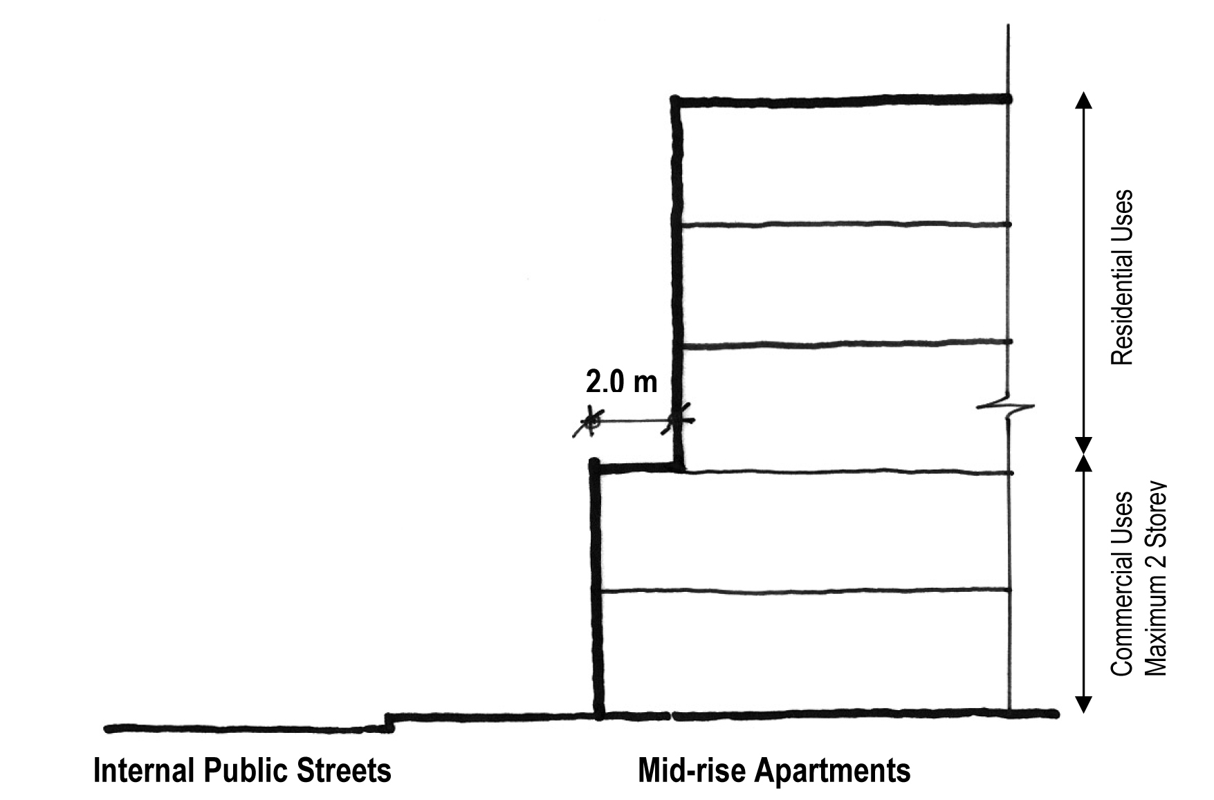
- High Rise Apartments shall be integrated with Row Housing, mid rise apartments or commercial uses at the ground (first) floor to provide a pedestrian-scaled building edge. The high rise apartment buildings shall provide a minimum stepback of 3 m from the top storey of all commercial uses, row housing, or mid rise apartments, as illustrated in the following diagram for interpretive purposes.

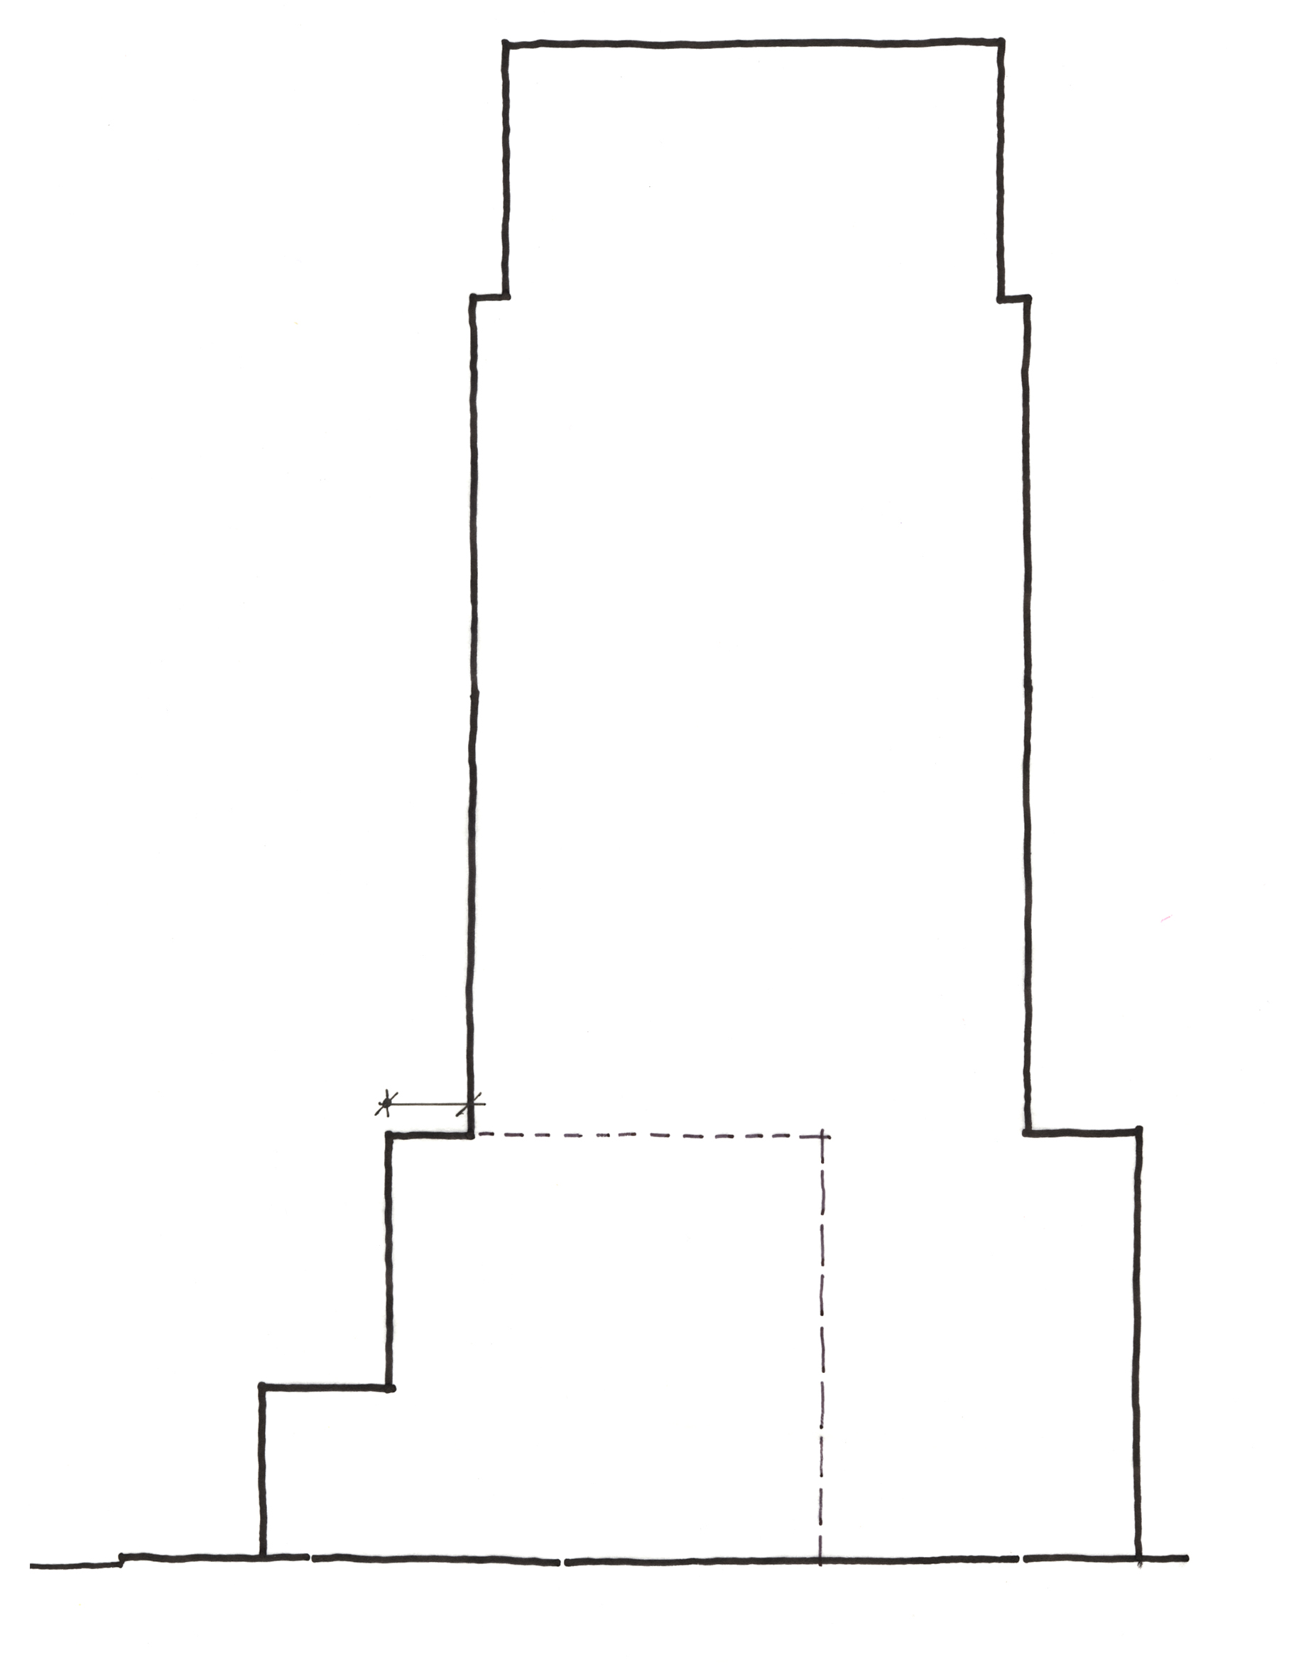
Mid-rise
Apartment
Residential
Tower
- The ground floor of any commercial development shall have a minimum of 50% of its floor space dedicated to commercial activity where all activity must abut the street frontages and be a depth of at least 10 m.
12/80
(e) If parking uses front on the public street in any portion of the podium above first and/or second storey level of the mid-rise apartment building then:
- An enhanced architectural façade treatment, harmonious with the adjacent commercial or residential frontage, shall be provided on the podium portion to the satisfaction of the development officer in consultation with the Urban Design Group; and
- Parking areas above second storey of the podium shall not be visible from the public street.

Entrances

- Where a Dwelling unit is provided at ground level abutting a public roadway, other than a Lane, the principal entrance to the unit shall have direct external access to the adjacent public sidewalk.
- Main building entrances for any Use shall be designed for universal accessibility. Level changes from the sidewalk to entrances of buildings shall be minimized. Sidewalk furniture and other elements shall be located out of the travel path to ensure they are not obstacles to building access.
- The first floor of any residential frontage, including associated entranceway, may have a maximum grade separation of 1 metre from any adjacent public sidewalk.
- The first floor of commercial frontage and entranceways shall be at grade with the property line.
- A separate and prominent access to residential buildings from Fort Road is required for any building whose podium portion fronts onto Fort Road and 129 Avenue.

Weather Protection

- Where Commercial Uses are developed on the ground (first) floor of a building, weather protection in the form of a canopy at least 2.0 m wide or any other method suitable to the architectural style of the building or street theme, shall be provided one Storey above sidewalk level to provide a comfortable environment for pedestrians.

Architectural Control

- The finishing of the podium portion of any development shall consist of a combination of materials such as glass and glazed window wall systems, brick, stone, architectural concrete, and/or pre-cast coloured concrete.
- Special architectural treatment of building faces shall be provided as per Appendix I.
13/80
- The use of stucco as a finishing material is not permitted on the podium portion of any development. The use of stucco on the tower portion of any development shall be limited to a maximum of 30% of the exterior surface area of the tower.
- Where a Commercial Use is provided at ground level abutting a public roadway, other than a Lane, the principal entrance to the unit shall have direct external access to the adjacent public sidewalk. A minimum of 70% of the ground (first) floor level portion of the façade abutting a public roadway, other than a Lane, shall be comprised of clear, non-reflective glazing to promote pedestrian interaction and safety.
- Development on a Site shall incorporate functional and decorative lighting to highlight the building’s architectural features and enhance the appearance of the building during the winter months.

Public Art

- Public art shall be provided on site and must:

    - Be provided by the developer to a value of 1% of construction costs as estimated at the development permit stage, to a maximum of $100,000;
    - Incorporated into the architecture, streetscape, and spread throughout the site to the satisfaction of the Development Officer in consultation with the Urban Design Group;
    - Favour local Edmonton or Alberta artists; and
    - Be installed on site with completion of the street level commercial structures, unless the artwork is to be integrated with the building’s architecture.

Sun-Shadow Impact and Wind Impact Study

- Buildings shall be designed through their massing and location, to avoid adverse microclimatic effects such as wind tunnelling, snow drifting, rain sheeting, shadowing, and loss of sunlight, both on and off-site. The Development Officer may require the submission of a Wind Impact Statement or Study, and/or a Sun Shadow Impact Study, prepared by a qualified, registered Professional Engineer to determine that proposed development achieves these objectives. The Development Officer will have the opportunity to require modifications to the conceptual building layouts/designs identified in the building design plans to address specific issues that may be identified by these Studies.

- Development Guidelines

  - The developer is encouraged to incorporate a minimum of 10% adaptable dwelling units and to ensure universal accessibility.
14/80
  - The maximum Height opportunity presented in this Provision should be utilized to develop high rise buildings that reduce the impact of the upper levels of the building above the podium portion of the building to maintain view corridors, maximize solar penetration, and reduce adverse microclimatic effects related to wind and shadowing.
  - All building facades should use compatible and harmonious exterior finishing materials.
  - Where feasible, developments should provide gardens or patios on the top of the podium level and building rooftops to improve rooftop aesthetics and provide additional amenity space.
  - Where feasible, Dwellings and other elements of the development should be sited and oriented to minimize their impact on other Dwellings considering such things as daylight, sunlight, ventilation, quiet, visual privacy and views.
  - Development in this Area should, to the greatest extent possible, utilize infrastructure practices, site designs and building developments that reduce the consumption of water, energy, and materials consistent with sustainability programs such as Built Green Alberta or Leadership in Energy and Environmental Design (LEED) accreditation.
  - Landscaping of Sites in this Area should consider the use of plant materials that provide colour throughout the year to enhance their appearance during the winter months.
  - Parking, loading and passenger drop-off areas should be easily accessible and designed to minimize pedestrian-vehicle conflicts.
  - A variety of residential housing forms should be encouraged throughout this area to support an enhanced pedestrian environment.
Appendix I
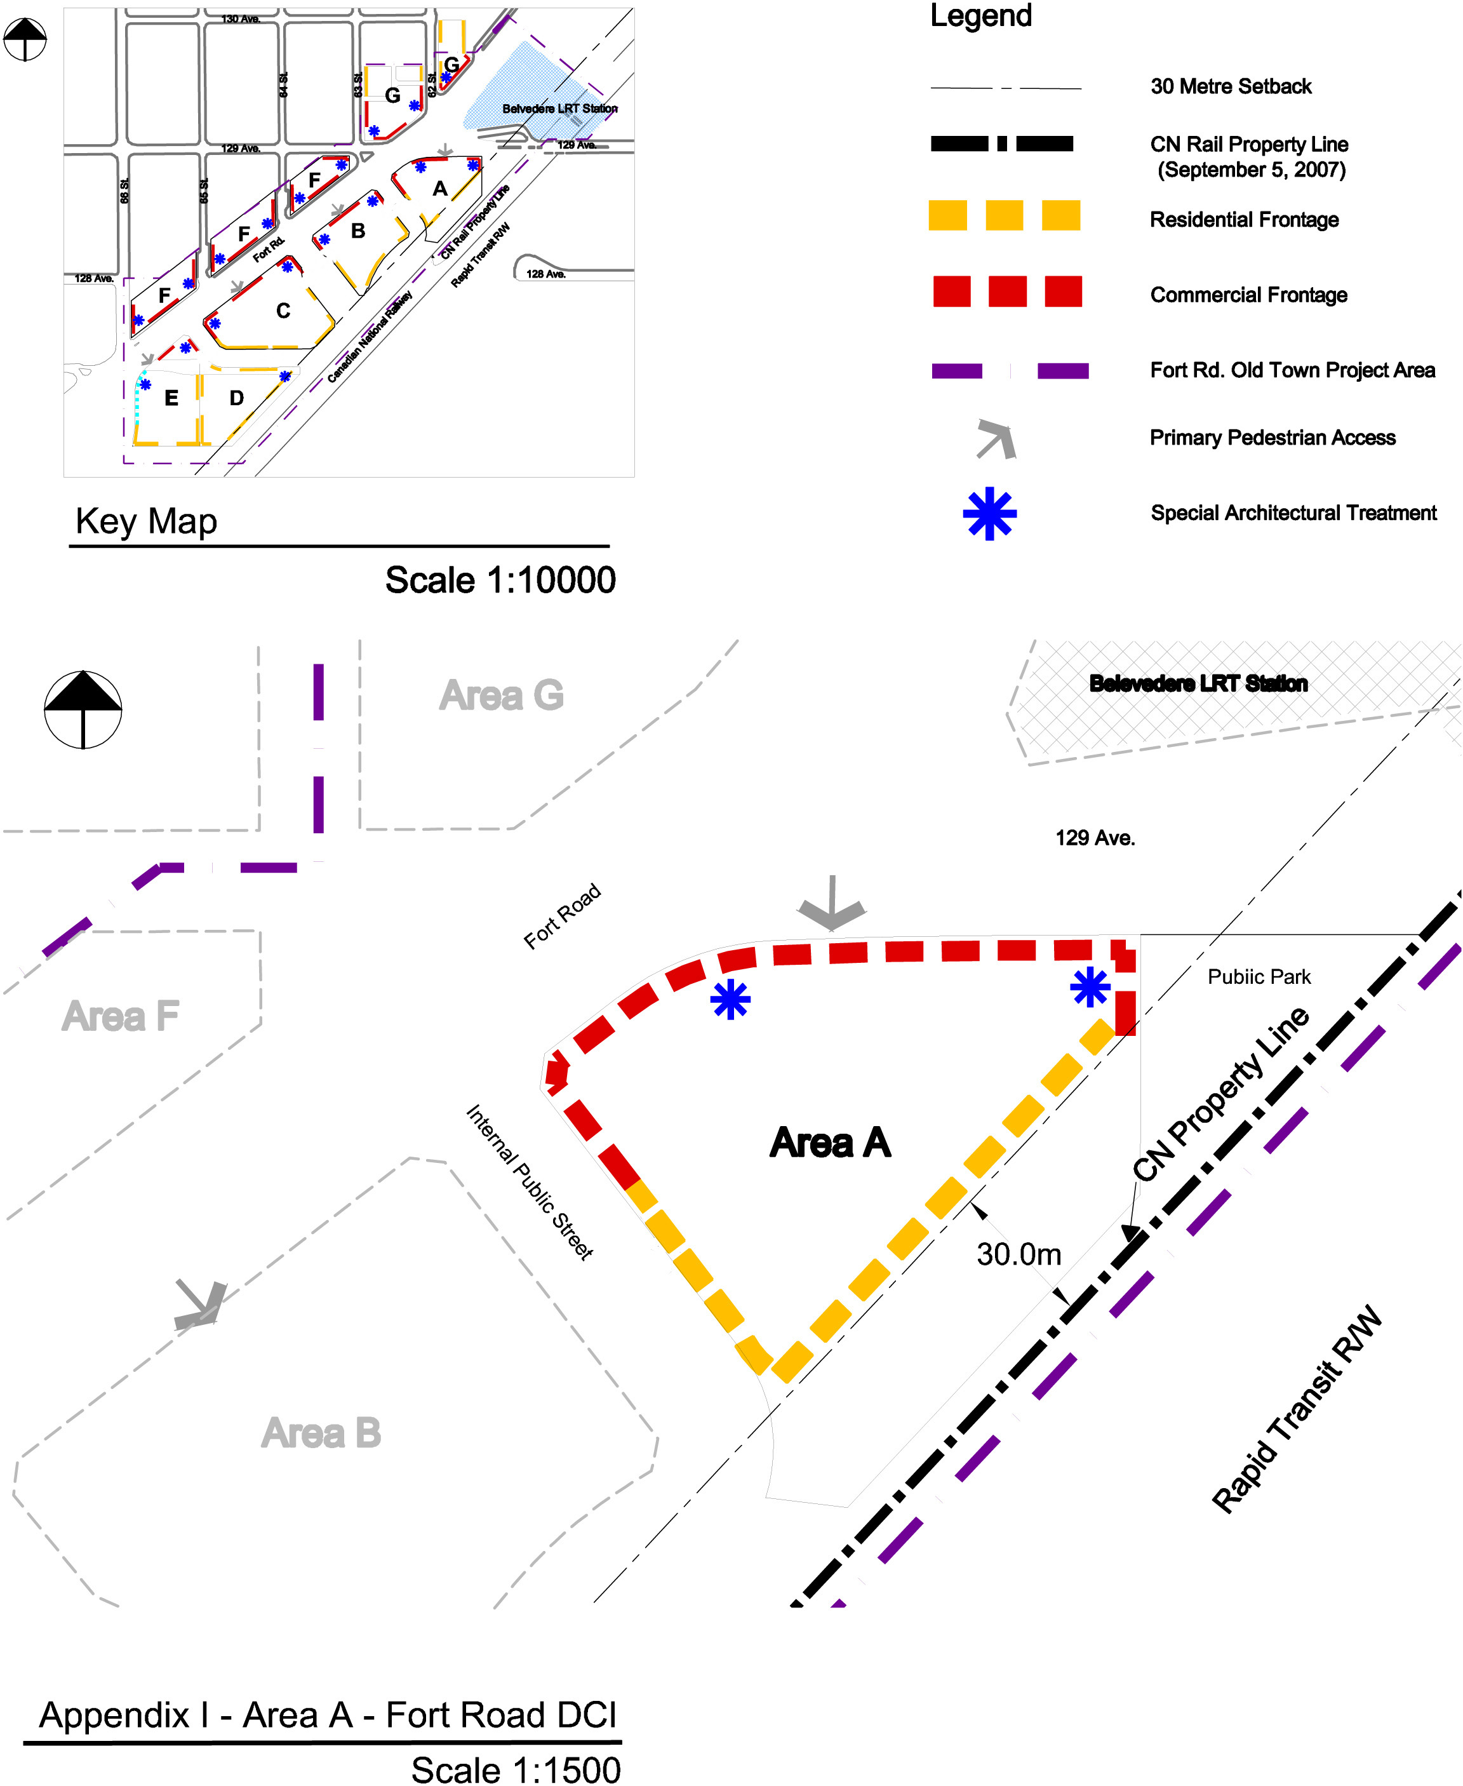
16/80

(DC1) DIRECT DEVELOPMENT CONTROL PROVISION
(AREA B)

- Area of Application

The site is located along the southeast side of Fort Road generally between 64th Street and 63rd Street, designated as Area B and shown on Appendix 1.

- Rationale

To accommodate a large scale, comprehensive, transit-oriented development/high density residential mixed use development that creates a liveable “urban village” environment and the introduction of a diversity of housing types within walking distance to the Belvedere LRT Station. Commercial uses will be developed on the ground floor of a number of the buildings as part of this development project.

- Uses

- Apartment Housing
- Boarding and Lodging Houses, for seniors housing only
- Extended Medical Treatment Services, limited to nursing homes
- Major Home Based Business
- Minor Home Based Business
- Residential Sales Centre
- Row Housing
- Bars and Neighbourhood Pubs, for less than 100 occupants and 120 m² of Public Space
- Business Support Services
- Child Care Services
- Convenience Retail Stores
- Flea Market, limited to outdoor farmers market involving the sale of items such as local meat, produce and handicrafts
- General Retail Stores, not to exceed 3000 m², excepting grocery stores which may not exceed 4000m²
- Health Services
- Major and Minor Amusement Establishment as an accessory use to a restaurant
- Minor Alcohol Sales
- Personal Service Shops
- Professional, Financial, and Office Support Services, excluding loan offices and similar financial uses
- Restaurants, for less than 200 occupants and 240 m² of Public Space
- Specialty Food Services, for less than 100 occupants and 120 m² of Public Space
- Fascia On-premises Signs
17/80
- Temporary Freestanding On premises Signs, limited to project identification, building construction identification and real estate advertising signs during construction and initial sale excluding portable signs
- Projecting On-premises Signs

- Development Regulations

- The Developer shall provide proof satisfactory to the Development Officer, in consultation with Alberta Environment, and the Transportation and Streets Department that the lands have been remediated to allow the intended use prior to the issuance of a development permit.
- A detailed noise and vibration study shall be prepared by a qualified, registered Professional Engineer, to the satisfaction of the Development Officer in consultation with the Transportation Department, prior to the issuance of a Development Permit.
- Development applications for new buildings and major additions are required to go before the Edmonton Design Committee prior to the issuance of a development permit.
- The overall Site development shall be in accordance with the urban design criteria established herein and in the Fort Road Old Town Urban Design Plan for this Area.
- Residential and residential related uses shall be located as shown in Appendix I.
- Only Commercial Uses shall be located on the first (ground) floor in the area identified on Appendix I.
- The maximum Floor Area Ratio of Area B shall be 3.2.
- The maximum Density shall be 250 Dwellings/ha.
- The maximum building area for commercial and commercial related uses in Area B shall not exceed 1,800 m².
- The maximum height for mid rise apartments shall not exceed 5 storey or 18.0 m. Area B shall contain one high rise apartment building. The maximum permitted height for this high rise apartment building shall be 16 storeys or 52 m.
- The minimum separation distance between any two towers shall be 25 m.
- All mechanical equipment, including roof mechanical units, shall be concealed by screening in a manner compatible with the architectural character of the building or concealed by incorporating it within the building and is not included in building height.
- The maximum Height for Row Housing shall not exceed 3 Storeys nor 12.0 m.
- A Minimum Private Outdoor Amenity Area of 7.5 m² per Dwelling for Dwellings no part of which is contained in the lowest Storey shall be provided.
18/80
- The second floor in the areas identified for Commercial Uses, as shown on Appendix I, may be used exclusively for either Residential Uses or Commercial Uses, excluding Restaurants, Bars and Neighbourhood Pubs.
- All commercial and commercial related uses shall not be developed above the second storey of the building and shall be located as shown in Appendix I.
- A minimum of 3 storeys residential development shall be provided above any commercial development.
- Apartment housing with Commercial Uses on the ground floor shall have access at Grade that is separate from the Commercial premises.
- A Major Home Based Business shall only be allowed in Row Housing Dwelling units and shall comply with section 75 of the Zoning Bylaw.
- Landscaping shall contain at least 10% more trees and shrubs within any Yard or Setback than are required under Section 55 of the Zoning Bylaw.
- The landscape plan required through Section 55.3 of the Zoning Bylaw shall include landscaping as it relates to the design of special feature areas identified in the Urban Design Plan. Outdoor amenity spaces shall be landscaped for the purpose of achieving pedestrian connectivity, opportunities for play and social interaction. Furthermore outdoor amenity spaces should create a sense of place, character and identity. In addition to landscaping, this shall be achieved through the use of park benches, pedestrian level lighting, waste receptacles and other means integrated with the landscaping and placed along public walking routes through the site to the satisfaction to the Development Officer in consultation with the Parks Branch at Asset Management and Public Works.
- Loading, storage, and trash collection areas shall be located in such a manner to be screened from view from adjacent sites, public roadways, and Light Rail Transit lines in accordance with the provisions of Section 55 of the Zoning Bylaw. If the Rear or Sides of a Site are used for surface vehicular parking, it shall be screened in accordance with the provisions of Section 55 of the Zoning Bylaw.
- Access to vehicular Parking Garages will be from the internal roadway system, no direct access to parking will be permitted from Fort Road.
- All residential parking shall be underground or in a structure, visitor parking and customer parking may be provided at grade to a maximum of 40 stalls.
- Driveway ramps for Apartment underground parkades must not exceed a slope of 6% for the first 4.5 m from the property line and the ramp must be at Grade at the property line, to the satisfaction of the Transportation Department.
- Vehicular Parking on the site shall be developed in accordance with Section 54, Schedule 1 of the Edmonton Zoning Bylaw, except that:
19/80
- For Professional, Financial and Office Support Services at grade, parking shall be provided on the basis of 1.1 parking spaces per 100 m² of Floor Area and no parking spaces shall be required for this Use on upper floors;
- for Specialty Food Services, Restaurants, and Bars and Neighbourhood Pubs, parking shall be provided on the basis of one parking space per 4.8 m² of Public Space;
- for all other Commercial Use Classes, parking shall be provided on the basis of 1.1 parking spaces per 100 m² of Floor Area;
- For all Residential Use Classes, parking shall be provided on the basis of a minimum of 1 parking space per residential unit;
- The parking requirements may be further relaxed, at the discretion of the Development Officer in consultation with the Transportation Department, should initiatives which reduce parking demand be implemented. Such initiatives include but are not limited to dedicated car share/car pool stalls, universal bus pass programmes, or shared parking between commercial, commercial related, residential, and residential related uses; and
- Vehicular parking shall be located at the rear of the building;
- Bicycle Parking spaces shall be provided in accordance with Section 54 of the Edmonton Zoning Bylaw.
- The owner shall submit a Crime Prevention Through Environmental Design (CPTED) Assessment that shall be reviewed and accepted by the Development Officer prior to the issuance of a Development Permit to ensure that development on the Site provides a safe urban environment in accordance with the guidelines and principles established in the Design Guide for a Safer City.
- Signs in the areas identified for Commercial Uses shall comply with Schedule 59E of the Zoning Bylaw, with the intent to complement the pedestrian oriented commercial environment, except that:
- a maximum Height of a Temporary Freestanding Sign shall be 6.0 m;
- a Projecting Sign may be used to identify businesses that are located entirely at the second Storey level; and
- the top Projecting Sign on a building two Storeys or higher shall not extend more than 75 cm above the floor of the second or third storey nor higher than the windowsill level of the second or third Story;
- In the areas identified for Commercial Uses a Comprehensive Sign Plan and Schedule, consistent with the overall intent of subsection 59.3 of the Zoning Bylaw, shall be prepared for the development and submitted, with the Development Application, to be approved by the Development Officer.
- Signs in the areas identified for Residential Frontage, in Appendix I, shall comply with Schedule 59B of the Zoning Bylaw.
20/80
- Urban Design Regulations
Site Planning
- Mid rise apartment buildings shall be located along Fort Road, and the internal public road.
- Row Housing shall be located along the internal public road.
- Buildings along the internal public road shall address the street, maximize frontage and contribute towards a predominantly residential character.
- Surface parking for visitors and customers shall be located to the rear of any building fronting onto Fort Road and screened from the street by appropriate orientation of the built form and enhanced landscaping measures.
- No surface vehicular parking areas are permitted abutting any public roadway, other than a Lane.
- A mid block mews is encouraged for development along Fort Road to break up massing and provide a safe and inviting route for pedestrians.
- The mid block mews and parking area shall be designed to offer flexibility so that those areas may be used for flea market/farmer's market uses.
Street Wall
- The maximum Frontage for Sites abutting a commercial shopping street shall be 10.06 m or consistent with the Frontage of other existing Sites abutting the shopping street and, where the Frontage for Sites abutting the commercial shopping street exceeds 10.06 m or the consistent development pattern for the street, the front façade of the building shall be designed to break the appearance into 10.06 m sections or modules consistently sized with other buildings on the shopping street.
- Blank walls (with or without windows) of vehicular Parking Garages shall not be developed adjacent to, or visible from any public roadway.
Towers
- Tower Base Zone [see illustration after (c)iv. for interpretive visualization]:
- The tower base zone shall be integrated with mid rise apartments or row housing and shall be no higher than 6 storeys;
- Mid Tower Zone [see illustration after (c)iv. for interpretive visualization]:
    - The maximum floor plate for the Mid-Tower Zone shall be square in shape and shall not exceed 743m²;
    - The mid tower zone shall step back from the tower base zone by a minimum of 3.0 m; and
    - No one side shall be greater than 30 m.
21/80

- Top Tower Zone [see illustration after (c)iv. for interpretive visualization]:
  - The Top Tower Zone shall be 2 to 4 storeys in height;
  - The tower top zone shall step back from the Mid-Tower zone by a minimum of 1.5 m from the faces of the tower;
  - The maximum typical floor plate area of the Top Tower zone shall be a minimum of 10% smaller than the Mid-Tower floor plate area;
  - Special architectural detailing, variation in materials, and special lighting is required to create an interesting skyline.

Tower Top Zone

Tower Base Zone

Mid – Tower Zone

22/80
Mid Rise Apartments and Row Housing
- Buildings shall address all adjacent public roadways, other than Lanes, with individual entrances that are clearly visible to lend a sense of occupancy to the street. Buildings on corner Sites shall address both the street and avenue and shall distinguish the street intersection to give it prominence.

Building Setbacks
- Where the ground floor of any development is designed for Commercial Uses, buildings shall be built to the front and side property lines. The Development Officer may allow a maximum of 50% of the building to be setback by 1 m. This shall be done to create visual interest in the building. The Development Officer may allow an additional building setback, only to accommodate street related activities such as sidewalk cafes, colonnades, arcades or plazas.
- Where the ground floor of any development is designed for Residential Uses, the building shall contain a Landscaped Yard of 3 m. The Development Officer may allow staircases to project up to 2.0 m from the building wall. A combination of hard and soft landscaping shall be provided within the 3 m setback.

Building Stepbacks

- Where Residential Uses are located above Commercial Uses in a building, the residential portion of the building above the second floor shall be setback a minimum 3 m from the lower portion of the building adjacent to Fort Road, as illustrated in the following diagram for interpretive purposes.

23/80

- Where Residential Uses are located above Commercial Uses in a building, the residential portion of the building above the second floor shall be setback a minimum 2 m from the lower portion of the building adjacent to the internal public street, as illustrated in the following diagram for interpretive purposes.

- High Rise Apartments shall be integrated with Row Housing, mid rise apartments or commercial uses at the ground (first) floor to provide a pedestrian-scaled building edge. The high rise apartment buildings shall provide a minimum stepback of 3 m from the top storey of all commercial uses, row housing, or mid rise apartments, as illustrated in the following diagram for interpretive purposes.

Mid-rise
Apartment
Residential
Tower
24/80

- The ground floor of any commercial development shall have a minimum of 50% of its floor space dedicated to commercial activity where all commercial activity must abut the street frontages and be a depth of at least 10 m.
(e) If parking uses front on the public street in any portion of the podium above the first and/or second storey level of the mid-rise apartment building then:
- An enhanced architectural façade treatment, harmonious with the adjacent commercial or residential frontage, shall be provided on the podium portion to the satisfaction of the development officer in consultation with the Urban Design Group; and
- Parking areas above second storey of the podium shall not be visible from the public street.

Entrances

- Where a Dwelling unit is provided at ground level abutting a public roadway, other than a Lane, the principal entrance to the unit shall have direct external access to the adjacent public sidewalk.
- Main building entrances for any Use shall be designed for universal accessibility. Level changes from the sidewalk to entrances of buildings shall be minimized. Sidewalk furniture and other elements shall be located out of the travel path to ensure they are not obstacles to building access.
- The first floor of any residential frontage, including associated entranceway, shall have a maximum grade separation of 1 metre from any adjacent public sidewalk.
- The first floor of commercial frontage and entranceways shall be at grade with the property line.
- A separate and prominent access to residential buildings from Fort Road is required for any building whose podium portion fronts onto Fort Road.

Weather Protection

- Where Commercial Uses are developed on the ground (first) floor of a building, weather protection in the form of a canopy at least 2.0 m wide or any other method suitable to the architectural style of the building or street theme, shall be provided one Storey above sidewalk level to provide a comfortable environment for pedestrians.

25/80

Architectural Control

- The finishing of the podium portion of any development shall consist of a combination of materials such as glass and glazed window wall systems, brick, stone, architectural concrete, and/or pre-cast coloured concrete.
- Special architectural treatment of building faces shall be provided as per Appendix I.
- The use of stucco as a finishing material is not permitted on the podium portion of any development. The use of stucco on the tower portion of any development shall be limited to a maximum of 30% of the exterior surface area of the tower.
- Where a Commercial Use is provided at ground level abutting a public roadway, other than a Lane, the principal entrance to the unit shall have direct external access to the adjacent public sidewalk. A minimum of 70% of the ground (first) floor level portion of the façade abutting a public roadway, other than a Lane, shall be comprised of clear, non-reflective glazing to promote pedestrian interaction and safety.
- Development on a Site shall incorporate functional and decorative lighting to highlight the building’s architectural features and enhance the appearance of the building during the winter months.

Public Art

- Public art shall be provided on site and must :
- Be provided by the developer to a value of 1% of construction costs as estimated at the development permit stage, to a maximum of $100,000;
- Incorporated into the architecture, streetscape, and spread throughout the site to the satisfaction of the Development Officer in consultation with the Urban Design Group;
- Favour local Edmonton or Alberta artists; and
- Be installed on site with completion of the street level commercial structures, unless the artwork is to be integrated with the building’s architecture.

Sun-Shadow Impact and Wind Impact Study

- Buildings shall be designed through their massing and location, to avoid adverse microclimatic effects such as wind tunnelling, snow drifting, rain sheeting, shadowing, and loss of sunlight, both on and off-site. The Development Officer may require the submission of a Wind Impact Statement or Study, and/or a Sun Shadow Impact Study prepared by a qualified, registered Professional Engineer to determine that proposed development achieves these objectives. The Development Officer will have the opportunity to require modifications to the conceptual building layouts/designs identified in the building design plans to address specific issues that may be identified by these Studies.
26/80
- Development Guidelines

- The developer is encouraged to incorporate a minimum of 10% adaptable dwelling units and to ensure universal accessibility.
- The maximum Height opportunity presented in this Provision should be utilized to develop high rise buildings that reduce the impact of the upper levels of the building above the podium portion of the building to maintain view corridors, maximize solar penetration, and reduce adverse microclimatic effects related to wind and shadowing.
- All building facades should use compatible and harmonious exterior finishing materials.
- Where feasible, developments should provide gardens or patios on the top of the podium level and building rooftops to improve rooftop aesthetics and provide additional amenity space.
- Where feasible, Dwellings and other elements of the development should be sited and oriented to minimize their impact on other Dwellings considering such things as daylight, sunlight, ventilation, quiet, visual privacy and views.
- Development in this Area should, to the greatest extent possible, utilize infrastructure practices, site designs and building developments that reduce the consumption of water, energy, and materials consistent with sustainability programs such as Built Green Alberta or Leadership in Energy and Environmental Design (LEED) accreditation.
- Landscaping of Sites in this Area should consider the use of plant materials that provide colour throughout the year to enhance their appearance during the winter months.
- Parking, loading and passenger drop-off areas should be easily accessible and designed to minimize pedestrian-vehicle conflicts.
- A variety of residential housing forms should be encouraged throughout this Area to support an enhanced pedestrian environment.

27/80
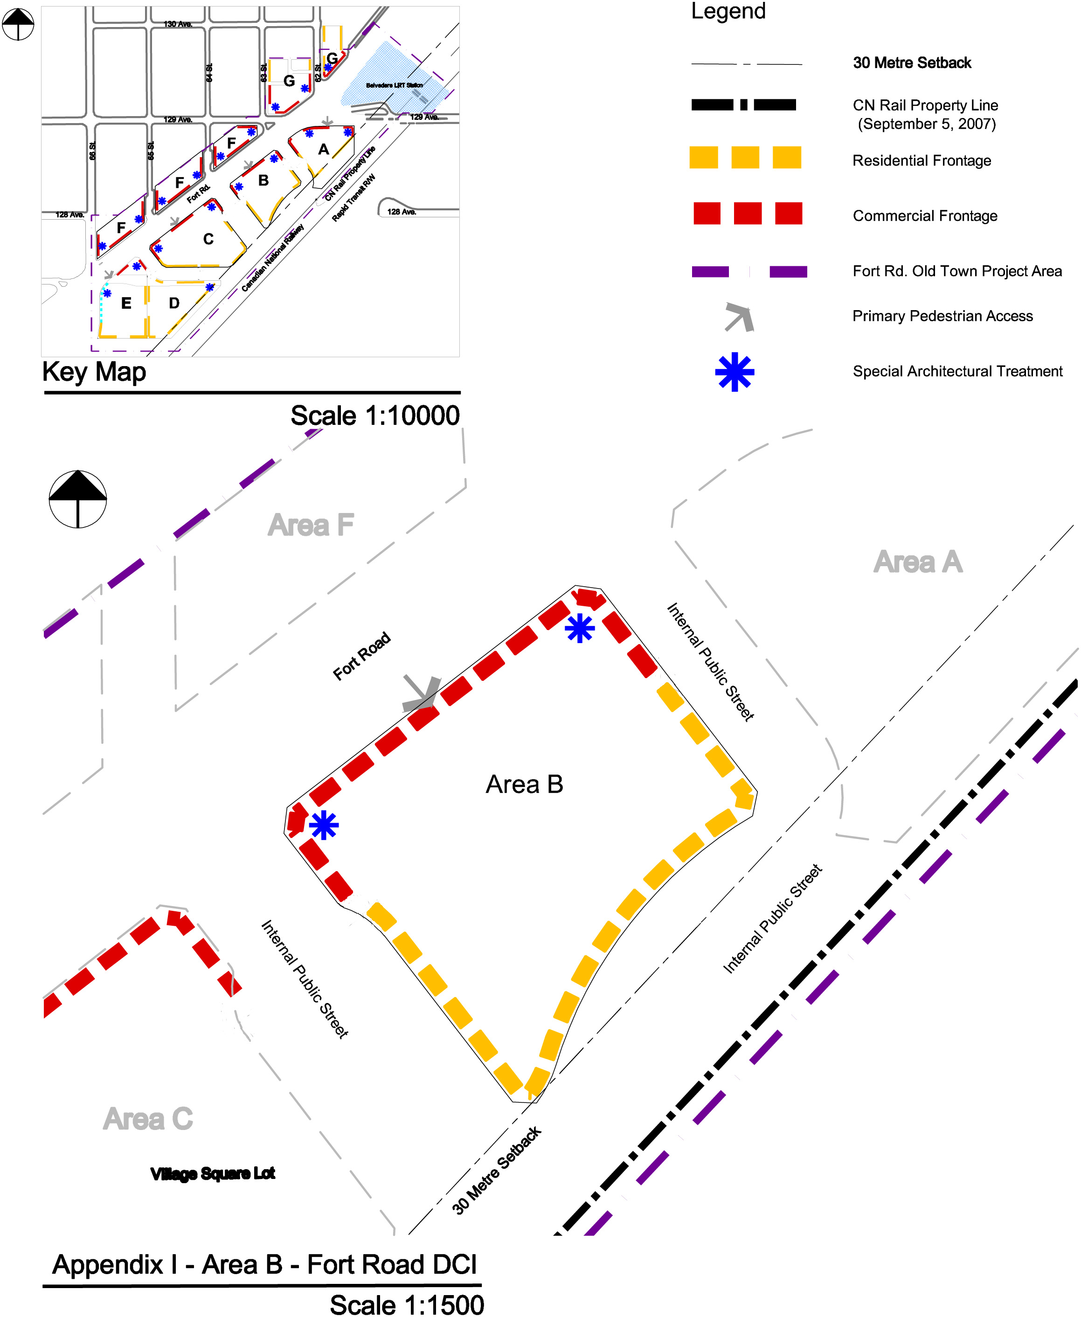
Appendix I
28/80

(DC1) DIRECT DEVELOPMENT CONTROL PROVISION
(AREA C)
- Area of Application

The site is located along the southeast side of Fort Road and generally between 65 Street and 64 Street, designated as Area C and shown on Appendix 1.

- Rationale

To accommodate a large scale, comprehensive, transit-oriented development/high density residential mixed use development that creates a liveable “urban village” environment and the introduction of a diversity of housing types within walking distance to the Belvedere LRT Station. Commercial uses will be developed on the ground floor of a number of the buildings as part of this development project.

- Uses

- Apartment Housing
- Boarding and Lodging Houses, for seniors housing only
- Extended Medical Treatment Services, limited to nursing homes
- Major Home Based Business
- Minor Home Based Business
- Residential Sales Centre
- Row Housing
- Bars and Neighbourhood Pubs, for less than 100 occupants and 120 m² of Public Space
- Business Support Services
- Child Care Services
- Convenience Retail Stores
- Flea Market, limited to an outdoor farmers market involving the sale of items such as local meat, produce and handicrafts
- General Retail Stores, not to exceed 3000 m², excepting grocery stores which may not exceed 4000m²
- Health Services
- Major and Minor Amusement Establishment as an accessory use to a restaurant
- Minor Alcohol Sales
- Personal Service Shops
- Professional, Financial, and Office Support Services, excluding loan offices and similar financial uses
- Restaurants, for less than 200 occupants and 240 m² of Public Space
- Specialty Food Services, for less than 100 occupants and 120m² of Public Space
- Fascia On-premises Signs
29/80

- Temporary Freestanding On premises Signs, limited to project identification, building construction identification and real estate advertising signs during construction and initial sale excluding portable signs.
- Projecting On-premises Signs

- Development Regulations

- The Developer shall provide proof satisfactory to the Development Officer, in consultation with Alberta Environment, and the Transportation and Streets Department that the lands have been remediated to allow the intended use prior to the issuance of a development permit.
- A detailed noise and vibration study shall be prepared by a qualified, registered Professional Engineer, to the satisfaction of the Development Officer in consultation with the Transportation Department, prior to the issuance of a Development Permit.
- Development applications for new buildings and major additions are required to go before the Edmonton Design Committee prior to the issuance of a development permit.
- The overall Site development shall be in accordance with the urban design criteria established herein and in the Fort Road Old Town Urban Design Plan for this Area.
- Residential and residential related uses shall be located as shown in Appendix I.
- Only Commercial Uses shall be located on the first (ground) floor in the area identified on Appendix I.
- The maximum Floor Area Ratio of Area C shall be 2.57.
- The maximum Density shall be 280 Dwellings/ha.
- The maximum building area for commercial and commercial related uses in Area C shall not exceed 2,600 m².
- The maximum height for mid rise apartments shall not exceed 5 storey or 18.0 m. Area C shall contain one high rise apartment building. The maximum permitted height for this high rise apartment building shall be 16 storey or 52 m.
- The minimum separation distance between any two towers shall be 25 m.
- All mechanical equipment, including roof mechanical units, shall be concealed by screening in a manner compatible with the architectural character of the building or concealed by incorporating it within the building and is not included in building height.
- The maximum Height for Row Housing shall not exceed 3 Storeys nor 12.0 m.
30/80
- A Minimum Private Outdoor Amenity Area of 7.5 m² per Dwelling for Dwellings no part of which is contained in the lowest Storey shall be provided.
- The second floor in the areas identified for Commercial Uses, as shown on Appendix I, may be used exclusively for either Residential Uses or Commercial Uses, excluding Restaurants, Bars and Neighbourhood Pubs.
- All commercial and commercial related uses shall not be developed above the second storey of the building and shall be located as shown in Appendix I.
- A minimum of 3 storeys residential development shall be provided above any commercial development.
- Apartment housing with Commercial Uses on the ground floor shall have access at Grade that is separate from the Commercial premises.
- A Major Home Based Business shall only be allowed in Row Housing Dwelling units and shall comply with section 75 of the Zoning Bylaw.
- Landscaping shall contain at least 10% more trees and shrubs within any Yard or Setback than are required under Section 55 of the Zoning Bylaw.
- The landscape plan required through Section 55.3 of the Zoning Bylaw shall include landscaping as it relates to the design of special feature areas identified in the Urban Design Plan. Outdoor amenity spaces shall be landscaped for the purpose of achieving pedestrian connectivity, opportunities for play and social interaction. Furthermore outdoor amenity spaces should create a sense of place, character and identity. In addition to landscaping, this shall be achieved through the use of park benches, pedestrian level lighting, waste receptacles and other means integrated with the landscaping and placed along public walking routes through the site to the satisfaction fot he Development Officer in consultation with the Parks Branch at Asset Management and Public Works.
- Loading, storage, and trash collection areas shall be located in such a manner to be screened from view from adjacent sites, public roadways, and Light Rail Transit lines in accordance with the provisions of Section 55 of the Zoning Bylaw. If the Rear or Sides of a Site are used for surface vehicular parking, it shall be screened in accordance with the provisions of Section 55 of the Zoning Bylaw.
- Access to vehicular Parking Garages will be from the internal roadway system, no direct access to parking will be permitted from Fort Road.
- All residential parking shall be underground or in a structure, visitor parking and customer parking may be provided at grade to a maximum of 50 stalls.
- Driveway ramps for underground parkades must not exceed a slope of 6% for the first 4.5 m from the property line and the ramp must be at Grade at the property line, to the satisfaction of the Transportation Department.
31/80
- Vehicular Parking on the site shall be developed in accordance with Section 54, Schedule 1 of the Edmonton Zoning Bylaw, except that:
- For Professional, Financial and Office Support Services at grade, parking shall be provided on the basis of 1.1 parking spaces per 100 m² of Floor Area and no parking spaces shall be required for this Use on upper floors;
- for Specialty Food Services, Restaurants, and Bars and Neighbourhood Pubs, parking shall be provided on the basis of one parking space per 4.8 m² of Public Space;
- for all other Commercial Use Classes, parking shall be provided on the basis of 1.1 parking spaces per 100 m² of Floor Area;
- For all Residential Use Classes, parking shall be provided on the basis of a minimum of 1 parking space per residential unit;
- The parking requirements may be further relaxed, at the discretion of the Development Officer in consultation with the Transportation Department, should initiatives which reduce parking demand be implemented. Such initiatives include but are not limited to dedicated car share/car pool stalls, universal bus pass programmes, or shared parking between commercial, commercial related, residential, and residential related uses; and
- Vehicular parking shall be located at the rear of the building.
- Bicycle Parking spaces shall be provided in accordance with Section 54 of the Edmonton Zoning Bylaw.
- The owner shall submit a Crime Prevention Through Environmental Design (CPTED) Assessment that shall be reviewed and accepted by the Development Officer prior to the issuance of a Development Permit to ensure that development on the Site provides a safe urban environment in accordance with the guidelines and principles established in the Design Guide for a Safer City.
- Signs in the areas identified for Commercial Uses shall comply with Schedule 59E of the Zoning Bylaw, with the intent to complement the pedestrian oriented commercial environment, except that:
- the maximum Height of a Temporary Freestanding Sign shall be 6.0 m;
- a Projecting Sign may be used to identify businesses that are located entirely at the second Storey level; and
- the top Projecting Sign on a building two Storeys or higher shall not extend more than 75 cm above the floor of the second or third storey nor higher than the windowsill level of the second or third Story
- In the areas identified for Commercial Uses a Comprehensive Sign Plan and Schedule, consistent with the overall intent of subsection 59.3 of the Zoning Bylaw, shall be prepared for the development and submitted, with the Development Application, to be approved by the Development Officer.
32/80
- Signs in the areas identified for Residential Frontage, in Appendix I, shall comply with Schedule 59B of the Zoning Bylaw.

- Urban Design Regulations
Site Planning
- Mid rise apartment buildings shall be located along Fort Road, and the internal public road.
- Row Housing shall be located along the internal public road.
- Buildings along the internal public road shall address the street, maximize frontage and contribute towards a predominantly residential character.
- Surface parking for visitors and customers shall be located to the rear of any building fronting onto Fort Road, and screened from street by appropriate orientation of the built form and enhanced landscaping measures.
- No surface vehicular parking areas are permitted abutting any public roadway, other than a Lane.
- A mid block mews is encouraged for development along Fort Road to break up massing and provide a safe and inviting route for pedestrians.
- The mid block mews and parking area shall be designed to offer flexibility so that those areas may be used for flea market/farmer's market uses.

Street Wall
- The maximum Frontage for Sites abutting a commercial shopping street shall be 10.06 m or consistent with the Frontage of other existing Sites abutting the shopping street and, where the Frontage for Sites abutting the commercial shopping street exceeds 10.06 m or the consistent development pattern for the street, the front façade of the building shall be designed to break the appearance into 10.06 m sections or modules consistently sized with other buildings on the shopping street.
- Blank walls (with or without windows) of vehicular Parking Garages shall not be developed adjacent to, or visible from any public roadway.

Towers
- Tower Base Zone [see illustration after (c)iv. for interpretive visualization]:
- The tower base zone shall be integrated with mid rise apartments or row housing and shall be no higher than 6 storeys.
- Mid Tower Zone [see illustration after (c)iv. for interpretive visualization]:
- The maximum floor plate for the Mid-Tower Zone shall be square in shape and shall not exceed 743m²;
33/80

- The mid tower zone shall step back from the tower base zone by a minimum of 3.0 m; and
- No one side shall be greater than 30 m.

- Top Tower Zone [see illustration after (c)iv. for interpretive visualization]:
- The Top Tower Zone shall be 2 to 4 storeys in height;
- The tower top zone shall step back from the Mid-Tower zone by a minimum of 1.5 m from the faces of the tower;
- The maximum typical floor plate area of the Top Tower zone shall be a minimum of 10% smaller than the Mid-Tower floor plate area; and
- Special architectural detailing, variation in materials, and special lighting is required to create an interesting skyline.
Tower Top Zone

Tower Base Zone

Mid – Tower Zone

34/80

Mid Rise Apartments and Row Housing
- Buildings shall address all adjacent public roadways, other than Lanes, with individual entrances that are clearly visible to lend a sense of occupancy to the street. Buildings on corner Sites shall address both the street and avenue and shall distinguish the street intersection to give it prominence.

Building Setbacks
- Where the ground floor of any development is designed for Commercial Uses, buildings shall be built to the front property lines. The Development Officer may allow a maximum of 50% of the building to be setback by 1 m from the property line. This shall be done to create visual interest in the building. The Development Officer may allow an additional building setback, only to accommodate street related activities such as sidewalk cafes, colonnades, arcades or plazas.
- Where the ground floor of any development is designed for Residential Uses, the building shall contain a Landscaped Yard of 3m. The Development Officer may allow staircases to project up to 2.0 m from the building wall. A combination of hard and soft landscaping shall be provided within the 3 m setback.

Building Stepbacks

- Where Residential Uses are located above Commercial Uses in a building, the residential portion of the building above the second floor shall be setback a minimum 3 m from the lower portion of the building adjacent to Fort Road, as illustrated in the following diagram for interpretive purposes.

35/80

- Where Residential Uses are located above Commercial Uses in a building, the residential portion of the building above the second floor shall be setback a minimum 2 m from the lower portion of the building adjacent to the internal public street, as illustrated in the following diagram for interpretive purposes.

- High Rise Apartments shall be integrated with Row Housing, mid rise apartments or commercial uses at the ground (first) floor to provide a pedestrian-scaled building edge. The high rise apartment buildings shall provide a minimum stepback of 3 m from the top storey of all commercial uses, row housing, or mid rise apartments, as illustrated in the following diagram for interpretive purposes.
36/80

Mid-rise
Apartment
Residential
Tower

- The ground floor of any commercial development shall have a minimum of 50% of its floor space dedicated to commercial activity where all activity must abut the street frontages and be a depth of at least 10m.
(e) If parking uses front on the public street in any portion of the podium above first and/or second storey level of the mid-rise apartment building then:
    - An enhanced architectural façade treatment, harmonious with the adjacent commercial or residential frontage, shall be provided on the podium portion to the satisfaction of the development officer in consultation with the Urban Design Group; and
    - Parking areas above second storey of the podium shall not be visible from the public street.
Entrances

- Where a Dwelling unit is provided at ground level abutting a public roadway, other than a Lane, the principal entrance to the unit shall have direct external access to the adjacent public sidewalk.
- Main building entrances for any Use shall be designed for universal accessibility. Level changes from the sidewalk to entrances of buildings shall be minimized. Sidewalk furniture and other elements shall be located out of the travel path to ensure they are not obstacles to building access.
- The first floor of any residential frontage, including associated entranceway, shall have a maximum grade separation of 1 m from any adjacent public sidewalk.
37/80
- The first floor of commercial frontage and entranceways shall be at grade with the property line.
- A separate and prominent access to residential buildings from Fort Road is required for any building whose podium portion fronts onto Fort Road.

Weather Protection

- Where Commercial Uses are developed on the ground (first) floor of a building, weather protection in the form of a canopy at least 2.0 m wide or any other method suitable to the architectural style of the building or street theme, shall be provided one Storey above sidewalk level to provide a comfortable environment for pedestrians.

Architectural Control

- The finishing of the podium portion of any development shall consist of a combination of materials such as glass and glazed window wall systems, brick, stone, architectural concrete, and/or pre-cast coloured concrete.
- Special architectural treatment of building faces shall be provided as per Appendix I.
- The use of stucco as a finishing material is not permitted on the podium portion of any development. The use of stucco on the tower portion of any development shall be limited to a maximum of 30% of the exterior surface area of the tower.
- Where a Commercial Use is provided at ground level abutting a public roadway, other than a Lane, the principal entrance to the unit shall have direct external access to the adjacent public sidewalk. A minimum of 70% of the ground (first) floor level portion of the façade abutting a public roadway, other than a Lane, shall be comprised of clear, non-reflective glazing to promote pedestrian interaction and safety.
- Development on a Site shall incorporate functional and decorative lighting to highlight the building’s architectural features and enhance the appearance of the building during the winter months.

Public Art

- Public art shall be provided on site and must:
  - Be provided by the developer to a value of 1% of construction costs as estimated at the development permit stage, to a maximum of $100,000;
  - Incorporated into the architecture, streetscape, and spread throughout the site to the satisfaction of the Development Officer in consultation with the Urban Design Group;
  - Favour local Edmonton or Alberta artists; and
38/80

  - Be installed on site with completion of the street level commercial structures, unless the artwork is to be integrated with the building’s architecture.

Sun-Shadow Impact and Wind Impact Study

- Buildings shall be designed through their massing and location, to avoid adverse microclimatic effects such as wind tunnelling, snow drifting, rain sheeting, shadowing, and loss of sunlight, both on and off-site. The Development Officer may require the submission of a Wind Impact Statement or Study, and/or a Sun Shadow Impact Study prepared by a qualified, registered Professional Engineer to determine that proposed development achieves these objectives. The Development Officer will have the opportunity to require modifications to the conceptual building layouts/designs identified in the building design plans to address specific issues that may be identified by these Studies.

- Development Guidelines

- The developer is encouraged to incorporate a minimum of 10% adaptable dwelling units and to ensure universal accessibility.
- The maximum Height opportunity presented in this Provision should be utilized to develop high rise buildings that reduce the impact of the upper levels of the building above the podium portion of the building to maintain view corridors, maximize solar penetration, and reduce adverse microclimatic effects related to wind and shadowing.
- All building facades should use compatible and harmonious exterior finishing materials.
- Where feasible, developments should provide gardens or patios on the top of the podium level and building rooftops to improve rooftop aesthetics and provide additional amenity space.
- Where feasible, Dwellings and other elements of the development should be sited and oriented to minimize their impact on other Dwellings considering such things as daylight, sunlight, ventilation, quiet, visual privacy and views.
- Development in this Area should, to the greatest extent possible, utilize infrastructure practices, site designs and building developments that reduce the consumption of water, energy, and materials consistent with sustainability programs such as Built Green Alberta or Leadership in Energy and Environmental Design (LEED) accreditation.
39/80
- Landscaping of Sites in this Area should consider the use of plant materials that provide colour throughout the year to enhance their appearance during the winter months.
- Parking, loading and passenger drop-off areas should be easily accessible and designed to minimize pedestrian-vehicle conflicts.
- A variety of residential housing forms should be encouraged throughout this Area to support an enhanced pedestrian environment.

40/80
Appendix I
41/80

(DC1) DIRECT DEVELOPMENT CONTROL PROVISION
(AREA D)

- Area of Application

The site is located southeast of Fort Road generally between 65th Street and 64th Street and adjacent to the LRT railway line, designated as Area D and shown on Appendix 1.

- Rationale

To accommodate a large scale, comprehensive, transit-oriented development/high density residential mixed use development that creates a liveable “urban village” environment and the introduction of a diversity of housing types within walking distance to the Belvedere LRT Station.

- Uses

Residential and Residential Related Uses

- Apartment Housing
- Boarding and Lodging Houses, for seniors housing only
- Extended Medical Treatment Services, limited to nursing homes
- Major Home Based Business
- Minor Home Based Business
- Residential Sales Centre
- Row Housing
- Fascia On-premises Signs
- Temporary Freestanding On premises Signs, limited to project identification, building construction identification and real estate advertising signs during construction and initial sale excluding portable signs.
- Projecting On-premises Signs

- Development Regulations

- The Developer shall provide proof satisfactory to the Development Officer, in consultation with Alberta Environment, and the Transportation and Streets Department that the lands have been remediated to allow the intended use prior to the issuance of a development permit.
- Development applications for new buildings and major additions are required to go before the Edmonton Design Committee prior to the issuance of a development permit.
42/80
- A detailed noise and vibration study shall be prepared by a qualified, registered Professional Engineer, to the satisfaction of the Development Officer in consultation with the Transportation Department, prior to the issuance of a Development Permit.
- A berm and fence or such other barrier wall as agreed to by CN shall be built along the CN rail line prior to or concurrent with any residential development.
- A 30 m building setback shall be maintained from the existing CN Rail property line, at the time of zoning approval and, as shown in Appendix I.
- The overall Site development shall be in accordance with the urban design criteria established herein and in the Fort Road Old Town Urban Design Plan for this Area.
- Residential and residential related uses shall be located as shown in Appendix I.
- The maximum Floor Area Ratio of Area D shall be 2.5.
- The maximum Density shall be 220 Dwellings/ha.
- The maximum height for mid rise apartments shall not exceed 5 storey or 18.0 m. Area D shall contain one high rise apartment building. The maximum permitted height for this high rise apartment building shall be 18 storeys or 58 m.
- The minimum separation distance between any two towers shall be 25 m.
- All mechanical equipment, including roof mechanical units, shall be concealed by screening in a manner compatible with the architectural character of the building or concealed by incorporating it within the building and is not included in building height.
- The maximum Height for Row Housing shall not exceed 3 Storeys nor 12.0 m.
- A Minimum Private Outdoor Amenity Area of 7.5 m² per Dwelling for Dwellings no part of which is contained in the lowest Storey shall be provided.
- A Major Home Based Business shall only be allowed in a Row Housing Dwelling units and shall comply with section 75 of the Zoning Bylaw.
- Landscaping shall contain at least 10% more trees and shrubs within any Yard or Setback than are required under Section 55 of the Zoning Bylaw.
- The landscape plan required through Section 55.3 of the Zoning Bylaw, shall include landscaping as it relates to the design of special feature areas identified in the Urban Design Plan. Outdoor amenity spaces shall be landscaped for the purpose of achieving pedestrian connectivity, opportunities for play and social interaction. Furthermore outdoor amenity spaces should create a sense of place, character and identity. In addition to landscaping, this shall be achieved through the use of park benches, pedestrian level lighting, waste receptacles and other means integrated with the landscaping and placed along public walking routes through the site to the satisfaction of the Development Officer in consultation with the Parks Branch at Asset Management and Public Works.
43/80
- Loading, storage, and trash collection areas shall be located in such a manner to be screened from view from adjacent sites, public roadways, and Light Rail Transit lines in accordance with the provisions of Section 55 of the Zoning Bylaw. If the Rear or Sides of a Site are used for surface vehicular parking, it shall be screened in accordance with the provisions of Section 55 of the Zoning Bylaw.
- Access to vehicular Parking Garages will be from the internal roadway system, no direct access to parking will be permitted from Fort Road.
- All residential parking shall be underground or in a structure, visitor parking and customer parking for Areas D and E may be provided at grade to a maximum of 30 stalls.
- Driveway ramps for underground parkades must not exceed a slope of 6% for the first 4.5 m from the property line and the ramp must be at Grade at the property line, to the satisfaction of the Transportation Department.
- Vehicular Parking on the site shall be developed in accordance with Section 54, Schedule 1 of the Edmonton Zoning Bylaw, except that.
- Vehicular parking shall be located at the rear of the building;
- For all Residential Use Classes, parking shall be provided on the basis of a minimum of 1 parking space per residential unit; and
- The parking requirements may be further relaxed, at the discretion of the Development Officer in consultation with the Transportation Department, should initiatives which reduce parking demand be implemented. Such initiatives include but are not limited to dedicated car share/car pool stalls, universal bus pass programmes, or shared parking between commercial, commercial related, residential, and residential related uses.
- Bicycle Parking spaces shall be provided in accordance with Section 54 of the Edmonton Zoning Bylaw.
- The owner shall submit a Crime Prevention through Environmental Design (CPTED) Assessment that shall be reviewed and accepted by the Development Officer prior to the issuance of a Development Permit to ensure that development on the Site provides a safe urban environment in accordance with the guidelines and principles established in the Design Guide for a Safer City.
- Signs in the areas identified for Residential Frontage, in Appendix I, shall comply with Schedule 59B of the Zoning Bylaw, except that the maximum height of a Temporary Freestanding Sign shall be 6.0m.
44/80
- Urban Design Regulations
Site Planning
  - Row Housing and Mid rise apartments buildings shall be located along the internal public road and multi-use trail corridor.
  - Buildings along the internal public road shall address the street, maximize frontage and contribute towards a predominantly residential character.
  - Surface parking for visitors and customers shall be located to the rear of any building fronting onto Fort Road and screened from the street, the public utility lot, and multi-use trail corridor by appropriate orientation of the built form and enhanced landscaping measures.
  - No surface vehicular parking areas are permitted abutting any public roadway, other than a Lane.
  - Enhanced landscaping measures shall be used if surface parking areas front the multi-use trail corridor.
  - Buildings shall address the multi-use trail corridor and provide at least one common entrance fronting these areas to enhance accessibility.

Street Wall
- The maximum Frontage for Sites abutting the public street shall be 10.06 m or consistent with the Frontage of other existing Sites abutting the public street and, where the Frontage for Sites abutting the public street exceeds 10.06 m or the consistent development pattern for the street, the front façade of the building shall be designed to break the appearance into 10.06 m sections or modules consistently sized with other buildings on the shopping street;
- Blank walls (with or without windows) of vehicular Parking Garages shall not be developed adjacent to, or visible from any public roadway;

Towers

- Tower Base Zone [see illustration after (c)iv. for interpretive visualization]:
- The tower base zone shall be integrated with mid rise apartments or row housing and shall be no higher than 6 storeys.
- Mid Tower Zone [see illustration after (c)iv. for interpretive visualization]:
  - The maximum floor plate for the Mid-Tower Zone shall be square in shape and shall not exceed 743 m² ;
  - The mid tower zone shall step back from the tower base zone by a minimum of 3.0 m; and
  - No one side shall be greater than 30 m.
45/80
- Top Tower Zone [see illustration after (c)iv. for interpretive visualization]:
- The Top Tower Zone shall be 2 to 4 storeys in height;
- The tower top zone shall step back from the Mid-Tower zone by a minimum of 1.5 m from the faces of the tower;
- The maximum typical floor plate area of the Top Tower zone shall be a minimum 10% smaller than the Mid-Tower floor plate area; and
- Special architectural detailing, variation in materials, and special lighting is required to create an interesting skyline.

Tower Top Zone

Tower Base Zone

Mid – Tower Zone

Mid rise Apartments and Row Housing

- Buildings shall address all adjacent public roadways, other than Lanes, with individual entrances that are clearly visible to lend a sense of occupancy to the street. Buildings on corner Sites shall address both the street and avenue and shall distinguish the street intersection to give it prominence.

Building Setbacks

- Where the ground floor of any development is designed for Residential Uses, the building shall contain a Landscaped Yard of 3 m. The Development Officer may allow staircases to project up to 2.0 m from the building wall. A combination of hard and soft landscaping shall be provided within the 3 m setback.
46/80

Building Stepbacks

- High Rise Apartments shall be integrated with Row Housing and mid rise apartments uses at the ground (first) floor to provide a pedestrian-scaled building edge. The high rise apartment buildings shall provide a minimum stepback of 3 m from the top storey of row housing, and mid rise apartments, as illustrated in the following diagram for interpretive purposes.

Mid-rise
Apartment
Residential
Tower

- The ground floor of any residential development shall have a minimum of 50% of its floor space dedicated to residential uses where all uses must front onto the street and be a depth of at least 10 m.
(c) If parking uses front on the public street in any portion of the podium above first and/or second storey level of the mid-rise apartment building then:
- An enhanced architectural façade treatment, harmonious with the adjacent commercial or residential frontage, shall be provided on the podium portion to the satisfaction of the development officer in consultation with the Urban Design Group; and
- Parking areas above second storey of the podium shall not be visible from the public street.

Entrances

- Where a Dwelling unit is provided at ground level abutting a public roadway, other than a Lane, the principal entrance to the unit shall have direct external access to the adjacent public sidewalk.
47/80
- Main building entrances for any Use shall be designed for universal accessibility. Level changes from the sidewalk to entrances of buildings shall be minimized. Sidewalk furniture and other elements shall be located out of the travel path to ensure they are not obstacles to building access.
- The first floor of any residential frontage, including associated entranceway, shall have a maximum grade separation of 1 m from any adjacent public sidewalk.

Architectural Control

- The finishing of the podium portion of any development shall consist of a combination of materials such as glass and glazed window wall systems, brick, stone, architectural concrete, and/or pre-cast coloured concrete.
- Special architectural treatment of building faces shall be provided as per Appendix I.
- The use of stucco as a finishing material is not permitted on the podium portion of any development. The use of stucco on the tower portion of any development shall be limited to a maximum of 30% of the exterior surface area of the tower.
- Development on a Site shall incorporate functional and decorative lighting to highlight the building’s architectural features and enhance the appearance of the building during the winter months.

Public Art

- Public art shall be provided on site and must:
- Be provided by the developer to a value of 1% of construction costs as estimated at the development permit stage, to a maximum of $100,000;
- Incorporated into the architecture, streetscape, and spread throughout the site to the satisfaction of the development officer in consultation with the Urban Design Group;
- Favour local Edmonton or Alberta artists; and
- Be installed on site with completion of the street level commercial structures, unless the artwork is to be integrated with the building’s architecture.

Sun-Shadow Impact and Wind Impact Study

      - Buildings shall be designed through their massing and location, to avoid adverse microclimatic effects such as wind tunnelling, snow drifting, rain sheeting, shadowing, and loss of sunlight, both on and off-site. The Development Officer may require the submission of a Wind Impact Statement or Study, and/or a Sun Shadow Impact Study prepared by a qualified, registered Professional Engineer to determine that proposed development achieves these objectives. The Development Officer will have the opportunity to require modifications to the
48/80
conceptual building layouts/designs identified in the building design plans to address specific issues that may be identified by these Studies.
- Development Guidelines

- The developer is encouraged to incorporate a minimum of 10% adaptable dwelling units and to ensure universal accessibility.
- The maximum Height opportunity presented in this Provision should be utilized to develop high rise buildings that reduce the impact of the upper levels of the building above the podium portion of the building to maintain view corridors, maximize solar penetration, and reduce adverse microclimatic effects related to wind and shadowing.
- All building facades should use compatible and harmonious exterior finishing materials.
- Where feasible, developments should provide gardens or patios on the top of the podium level and building rooftops to improve rooftop aesthetics and provide additional amenity space.
- Where feasible, Dwellings and other elements of the development should be sited and oriented to minimize their impact on other Dwellings considering such things as daylight, sunlight, ventilation, quiet, visual privacy and views.
- Development in this Area should, to the greatest extent possible, utilize infrastructure Development in this Area should, to the greatest extent possible, utilize infrastructure practices, and site designs and building developments that reduce the consumption of water, energy, and materials consistent with sustainability programs such as Built Green Alberta or Leadership in Energy and Environmental Design (LEED) accreditation.
- Landscaping of Sites in this Area should consider the use of plant materials that provide colour throughout the year to enhance their appearance during the winter months.
- Parking, loading and passenger drop-off areas should be easily accessible and designed to minimize pedestrian-vehicle conflicts.
- A variety of residential housing forms should be encouraged throughout this Area to support an enhanced pedestrian environment.

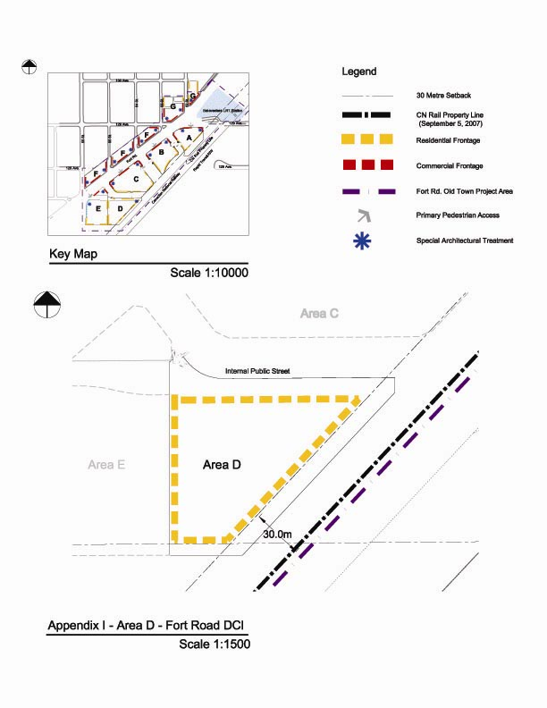
49/80
Appendix I
50/80

(DC1) DIRECT DEVELOPMENT CONTROL PROVISION
(AREA E)

- Area of Application

The site is located along the southeast side of Fort Road generally between 66 Street and 65 Street, designated as Area E and shown on Appendix 1.

- Rationale

To accommodate a large scale, comprehensive, transit-oriented development/high density residential mixed use development that creates a liveable “urban village” environment the introduction of a diversity of housing types within walking distance to the Belvedere LRT Station. Commercial uses will be developed on the ground floor of a number of the buildings as part of this development project.

- Uses

- Apartment Housing
- Boarding and Lodging Houses, for seniors housing only
- Extended Medical Treatment Services, limited to nursing homes
- Major Home Based Business
- Minor Home Based Business
- Row Housing
- Residential Sales Centre
- Bars and Neighbourhood Pubs, for less than 100 occupants and 120 m² of Public Space
- Business Support Services
- Child Care Services
- Convenience Retail Stores
- General Retail Stores, not to exceed 3000 m²
- Health Services
- Major and Minor Amusement Establishment as an accessory use to a restaurant
- Minor Alcohol Sales
- Personal Service Shops
- Professional, Financial, and Office Support Services, excluding loan offices and similar financial uses
- Restaurants, for less than 200 occupants and 240 m² of Public Space
- Specialty Food Services, for less than 100 occupants and 120m² of Public Space
- Fascia On-premises Signs
51/80
- Temporary Freestanding On premises Signs, limited to project identification, building construction identification and real estate advertising signs during construction and initial sale excluding portable signs
- Projecting On-premises Signs

- Development Regulations

- The Developer shall provide proof satisfactory to the Development Officer, in consultation with Alberta Environment, and the Transportation and Streets Department that the lands have been remediated to allow the intended use prior to the issuance of a development permit.
- Development applications for new buildings and major additions are required to go before the Edmonton Design Committee prior to the issuance of a development permit.
- A detailed noise and vibration study shall be prepared by a qualified, registered Professional Engineer, to the satisfaction of the Development Officer in consultation with the Transportation Department, prior to the issuance of a Development Permit.
- A berm and fence or such other barrier wall as agreed to by CN shall be built along the CN rail line prior to or concurrent with any residential development.
- A 30 m building setback shall be maintained from the existing CN Rail property line, at the time of zoning approval and, as shown in Appendix I.
- The overall Site development shall be in accordance with the urban design criteria established herein and in the Fort Road Old Town Urban Design Plan for this Area.
- Residential and residential related uses shall be located as shown in Appendix I.
- Only Commercial Uses shall be located on the first (ground) floor in the area identified on Appendix I.
- The maximum Floor Area Ratio of Area E shall be 2.6.
- The maximum Density shall be 200 Dwellings/ha.
- The maximum building area for commercial and commercial related uses in Area E shall not exceed 1,900 m².
- The maximum height for mid rise apartments shall not exceed 5 storey or 18.0 m. Area E shall contain one high rise apartment building. The maximum permitted height for this high rise apartment building shall be 18 storey or 52 m.
- The minimum separation distance between any two towers shall be 25 m.
- All mechanical equipment, including roof mechanical units, shall be concealed by screening in a manner compatible with the architectural character of the building or concealed by incorporating it within the building and is not included in building height.
52/80
- The maximum Height for Row Housing shall not exceed 3 Storeys nor 12.0 m.
- A Minimum Private Outdoor Amenity Area of 7.5 m² per Dwelling for Dwellings no part of which is contained in the lowest Storey shall be provided.
- The second floor in the areas identified for Commercial Uses, as shown on Appendix I, may be used exclusively for either Residential Uses or Commercial Uses, excluding Restaurants, Bars and Neighbourhood Pubs.
- All commercial and commercial related uses shall not be developed above the second storey of the building and shall be located as shown in Appendix I.
- A minimum of 3 storeys residential development shall be provided above any commercial development.
- Apartment housing with Commercial Uses on the ground floor shall have access at Grade that is separate from the Commercial premises.
- A Major Home Based Business shall only be allowed in a Row Housing Dwelling units and shall comply with section 75 of the Zoning Bylaw.
- Landscaping shall contain at least 10% more trees and shrubs within any Yard or Setback than are required under Section 55 of the Zoning Bylaw.
- The landscape plan required through Section 55.3 of the Zoning Bylaw shall include landscaping as it relates to the design of special feature areas identified in the Urban Design Plan. Outdoor amenity spaces shall be landscaped for the purpose of achieving pedestrian connectivity, opportunities for play and social interaction. Furthermore outdoor amenity spaces should create a sense of place, character and identity. In addition to landscaping, this shall be achieved through the use of park benches, pedestrian level lighting, waste receptacles and other means integrated with the landscaping and placed along public walking routes through the site to the satisfaction of the Development Officer in consultation with the Parks Branch at Asset Management and Public Works.
- Loading, storage, and trash collection areas shall be located in such a manner to be screened from view from adjacent sites, public roadways, and Light Rail Transit lines in accordance with the provisions of Section 55 of the Zoning Bylaw. If the Rear or Sides of a Site are used for surface vehicular parking, it shall be screened in accordance with the provisions of Section 55 of the Zoning Bylaw.
- Access to vehicular Parking Garages will be from the internal roadway system, no direct access to parking will be permitted from Fort Road.
- All residential parking shall be underground or in a structure, visitor parking and customer parking for Areas E and D may be provided at grade to a maximum of 30 stalls.
- Driveway ramps for underground parkades must not exceed a slope of 6% for the first 4.5 m from the property line and the ramp must be at Grade at the property line, to the satisfaction of the Transportation Department.
53/80
- Vehicular Parking on the site shall be developed in accordance with Section 54, Schedule 1 of the Edmonton Zoning Bylaw, except that;
- For Professional, Financial and Office Support Services at grade, parking shall be provided on the basis of 1.1 parking spaces per 100 m² of Floor Area and no parking spaces shall be required for this Use on upper floors;
- for Specialty Food Services, Restaurants, and Bars and Neighbourhood Pubs, parking shall be provided on the basis of one parking space per 4.8 m² of Public Space;
- for all other Commercial Use Classes, parking shall be provided on the basis of 1.1 parking spaces per 100 m² of Floor Area;
- For all Residential Use Classes, parking shall be provided on the basis of a minimum of 1 parking space per residential unit;
- The parking requirements may be further relaxed, at the discretion of the Development Officer in consultation with the Transportation Department, should initiatives which reduce parking demand be implemented. Such initiatives include but are not limited to dedicated car share/car pool stalls, universal bus pass programmes, or shared parking between commercial, commercial related, residential, and residential related uses; and
- Vehicular parking shall be located at the rear of the building.
- Bicycle Parking spaces shall be provided in accordance with Section 54 of the Edmonton Zoning Bylaw.
- The owner shall submit a Crime Prevention Through Environmental Design (CPTED) Assessment that shall be reviewed and accepted by the Development Officer prior to the issuance of a Development Permit to ensure that development on the Site provides a safe urban environment in accordance with the guidelines and principles established in the Design Guide for a Safer City.
- Signs in the areas identified for Commercial Uses shall comply with Schedule 59E of the Zoning Bylaw, with the intent to complement the pedestrian oriented commercial environment, except that:
- a maximum Height of a Temporary Freestanding Sign shall be 6.0 m;
- a Projecting Sign may be used to identify businesses that are located entirely at the second Storey level; and

54/80
  - the top Projecting Sign on a building two Storeys or higher shall not extend more than 75 cm above the floor of the second or third storey nor higher than the windowsill level of the second or third Story.
  - In the areas identified for Commercial Uses a Comprehensive Sign Plan and Schedule, consistent with the overall intent of subsection 59.3 of the Zoning Bylaw, shall be prepared for the development and submitted, with the Development Application, to be approved by the Development Officer.
  - Signs in the areas identified for Residential Frontage, in Appendix I, shall comply with Schedule 59B of the Zoning Bylaw.

- Urban Design Regulations

Site Planning

- Mid rise apartment buildings shall be located along Fort Road and the multi-use trail corridor.
- Row housing shall be located along the multi-use trail corridor.
- Buildings along the internal public road shall address the street, maximize frontage and contribute towards a predominantly residential character.
- Surface parking for visitors and customers shall be located to the rear of any building fronting onto Fort Road, and screened from the internal public street, the public utility lot, and the multi-use trail corridor by appropriate orientation of the built form and enhanced landscaping measures.
- No surface vehicular parking areas are permitted abutting any public roadway, other than a Lane.
- Enhanced landscaping measures shall be used if surface parking areas front the multi-use trail corridor.
- A mid block mews is encouraged for development along Fort Road to break up massing and provide a safe and inviting route for pedestrians.
- Buildings shall address the multi-use trail corridor and provide at least one common entrance fronting the multi-use trail corridor to enhance accessibility.
Street Wall

- The maximum Frontage for Sites abutting a commercial shopping street shall be 10.06 m or consistent with the Frontage of other existing Sites abutting the shopping street and, where the Frontage for Sites abutting the commercial shopping street exceeds 10.06 m or the consistent development pattern for the
55/80
street, the front façade of the building shall be designed to break the appearance into 10.06 m sections or modules consistently sized with other buildings on the shopping street.
- Blank walls (with or without windows) of vehicular Parking Garages shall not be developed adjacent to, or visible from any public roadway.
Towers

- Tower Base Zone [see illustration after (c)iv. for interpretive visualization]:
- The tower base zone shall be integrated with mid rise apartments or row housing and shall be no higher than 6 storeys.
- Mid Tower Zone [see illustration after (c)iv. for interpretive visualization]:
- The maximum floor plate for the Mid-Tower Zone shall be square in shape and shall not exceed 743 m²;
- The mid tower zone shall step back from the tower base zone by a minimum of 3.0 m; and
- No one side shall be greater than 30 m.
- Top Tower Zone [see illustration after (c)iv. for interpretive visualization]:
- The Top Tower Zone shall be 2 to 4 storeys in height;
- The tower top zone shall step back from the Mid-Tower zone by a minimum of 1.5 m from the faces of the tower;
- The maximum typical floor plate area of the Top Tower zone shall be a minimum of 10% smaller than the Mid-Tower floor plate area; and
- Special architectural detailing, variation in materials, and special lighting is required to create an interesting skyline.
Tower Top Zone

Tower Base Zone

Mid – Tower Zone

56/80

Mid rise Apartments and Row Housing

- Buildings shall address all adjacent public roadways, other than Lanes, with individual entrances that are clearly visible to lend a sense of occupancy to the street. Buildings on corner Sites shall address both the street and avenue and shall distinguish the street intersection to give it prominence.

Building Setbacks

- Where the ground floor of any development is designed for Commercial Uses, buildings shall be built to the front and side property lines. The Development Officer may allow a maximum of 50% of the building to be setback 1 m from the property line. This shall be done to create visual interest in the building. The Development Officer may allow an additional building setback, only to accommodate street related activities such as sidewalk cafes, colonnades, arcades or plazas.
- Where the ground floor of any development is designed for Residential Uses, the building shall contain a Landscaped Yard of 3m. The Development Officer may allow staircases to project up to 2.0 m from the building wall. A combination of hard and soft landscaping shall be provided within the 3 m setback.

Building Stepbacks

- Where Residential Uses are located above Commercial Uses in a building, the residential portion of the building above the second floor shall be setback a minimum 3 m from the lower portion of the building adjacent to Fort Road, as illustrated in the following diagram for interpretive purposes.

57/80

- Where Residential Uses are located above Commercial Uses in a building, the residential portion of the building above the second floor shall be setback a minimum 2 m from the lower portion of the building adjacent to the internal public street, as illustrated in the following diagram for interpretive purposes.

- High Rise Apartments shall be integrated with Row Housing, mid rise apartments or commercial uses at the ground (first) floor to provide a pedestrian-scaled building edge. The high rise apartment buildings shall provide a minimum stepback of 3 m from the top storey of all commercial uses, row housing, or mid rise apartments, as illustrated in the following diagram for interpretive purposes.

Mid-rise
Apartment
Residential
Tower

58/80
- The ground floor of any commercial development shall have a minimum of 50% of its floor space dedicated to commercial activity where all activity must abut the street frontages and be a depth of at least 10 m.
- If parking uses front on the public street in any portion of the podium above the first and/or second storey level of the mid-rise apartment building then:
- An enhanced architectural façade treatment, harmonious with the adjacent commercial or residential frontage, shall be provided on the podium portion to the satisfaction of the development officer in consultation with the Urban Design Group; and
- Parking areas above second storey of the podium shall not be visible from the public street.

Entrances

- Where a Dwelling unit is provided at ground level abutting a public roadway, other than a Lane, the principal entrance to the unit shall have direct external access to the adjacent public sidewalk.
- Main building entrances for any Use shall be designed for universal accessibility. Level changes from the sidewalk to entrances of buildings shall be minimized. Sidewalk furniture and other elements shall be located out of the travel path to ensure they are not obstacles to building access.
- The first floor of any residential frontage, including associated entranceway, shall have a maximum grade separation of 1 m from any adjacent public sidewalk.
- The first floor of commercial frontage and entranceways shall be at grade with the property line.
- A separate and prominent access to residential buildings from Fort Road is required for any building whose podium portion fronts onto Fort Road.

Weather Protection

- Where Commercial Uses are developed on the ground (first) floor of a building, weather protection in the form of a canopy at least 2.0 m wide or any other method suitable to the architectural style of the building or street theme, shall be provided one Storey above sidewalk level to provide a comfortable environment for pedestrians.

Architectural Control

- The finishing of the podium portion of any development shall consist of a combination of materials such as glass and glazed window wall systems, brick, stone, architectural concrete, and/or pre-cast coloured concrete.
59/80
- Special architectural treatment of building faces shall be provided as per Appendix I.
- The use of stucco as a finishing material is not permitted on the podium portion of any development. The use of stucco on the tower portion of any development shall be limited to a maximum of 30% of the exterior surface area of the tower.
- Where a Commercial Use is provided at ground level abutting a public roadway, other than a Lane, the principal entrance to the unit shall have direct external access to the adjacent public sidewalk. A minimum of 70% of the ground (first) floor level portion of the façade abutting a public roadway, other than a Lane, shall be comprised of clear, non-reflective glazing to promote pedestrian interaction and safety.
- Development on a Site shall incorporate functional and decorative lighting to highlight the building’s architectural features and enhance the appearance of the building during the winter months.

Public Art

- Public art shall be provided on site and must:
- Be provided by the developer to a value of 1% of construction costs as estimated at the development permit stage, to a maximum of $100,000;
- Incorporated into the architecture, streetscape, and spread throughout the site to the satisfaction of the development officer in consultation with the Urban Design Group;
- Favour local Edmonton or Alberta artists; and
- Be installed on site with completion of the street level commercial structures, unless the artwork is to be integrated with the building’s architecture.

Sun-Shadow Impact and Wind Impact Study

- Buildings shall be designed through their massing and location, to avoid adverse microclimatic effects such as wind tunnelling, snow drifting, rain sheeting, shadowing, and loss of sunlight, both on and off-site. The Development Officer may require the submission of a Wind Impact Statement or Study, and/or a Sun Shadow Impact Study prepared by a qualified, registered Professional Engineer to determine that proposed development achieves these objectives. The Development Officer will have the opportunity to require modifications to the conceptual building layouts/designs identified in the building design plans to address specific issues that may be identified by these Studies.
60/80

- Development Guidelines

- The developer is encouraged to incorporate a minimum of 10% adaptable dwelling units and to ensure universal accessibility.
- The maximum Height opportunity presented in this Provision should be utilized to develop high rise buildings that reduce the impact of the upper levels of the building above the podium portion of the building to maintain view corridors, maximize solar penetration, and reduce adverse microclimatic effects related to wind and shadowing.
- All building facades should use compatible and harmonious exterior finishing materials.
- Where feasible, developments should provide gardens or patios on the top of the podium level and building rooftops to improve rooftop aesthetics and provide additional amenity space.
- Where feasible, Dwellings and other elements of the development should be sited and oriented to minimize their impact on other Dwellings considering such things as daylight, sunlight, ventilation, quiet, visual privacy and views.
- Development in this Area should, to the greatest extent possible, utilize infrastructure practices, site designs and building developments that reduce the consumption of water, energy, and materials consistent with sustainability programs such as Built Green Alberta or Leadership in Energy and Environmental Design (LEED) accreditation.
- Landscaping of Sites in this Area should consider the use of plant materials that provide colour throughout the year to enhance their appearance during the winter months.
- Parking, loading and passenger drop-off areas should be easily accessible and designed to minimize pedestrian-vehicle conflicts.
- A variety of residential housing forms should be encouraged throughout this Area to support an enhanced pedestrian environment.

61/80
Appendix I

62/80
(DC1) DIRECT DEVELOPMENT CONTROL PROVISION
(AREA F)

- Area of Application

The area is located along the northwest side of Fort Road generally between 66 Street and 63 Street, designated as Area F and shown on Appendix 1.

- Rationale

To accommodate a infill and intensification of the existing Fort Road commercial area as part of a transit-oriented, residential mixed use development that creates a liveable “urban village” environment through the retention of identified heritage structures, use of urban design regulations, and the introduction of a diversity of housing types within walking distance to the Belvedere LRT Station. Commercial uses will be developed on the ground floor of a number of the buildings as part of this development project.

- Uses

- Apartment Housing
- Minor Home Based Business
- Residential Sales Centre
- Bars and Neighbourhood Pubs, for less than 100 occupants and 120 m² of Public Space.
- Business Support Services
- Convenience Retail Stores
- General Retail Stores, not to exceed 3000 m²
- Health Services
- Hotels, limited to the existing Transit Hotel
- Major and Minor Amusement Establishment as an accessory use to a restaurant
- Minor Alcohol Sales
- Personal Service Shops
- Professional, Financial, and Office Support Services, excluding loan offices and similar financial uses
- Restaurants, for less than 200 occupants and 240 m² of Public Space
- Specialty Food Services, for less than 100 occupants and 120m² of Public Space
- Fascia On-premises Signs
- Temporary Freestanding On premises Signs, limited to project identification, building construction identification and real estate advertising signs during construction and initial sale excluding portable signs.
- Projecting On-premises Signs
63/80
- Development Regulations

- The Developer shall provide proof satisfactory to the Development Officer, in consultation with Alberta Environment, and the Transportation and Streets Department that the lands have been remediated to allow the intended use prior to the issuance of a major development permit.
- Development applications for new buildings and major additions are required to go before the Edmonton Design Committee prior to the issuance of a development permit.
- The overall Site development shall be in accordance with the urban design criteria established herein and in the Fort Road Old Town Urban Design Plan for this Area.
- Only Commercial Uses shall be located on the first (ground) floor in the areas identified on Appendix I.
- The maximum Floor Area Ratio for Lots within Area F shall be 2.0.
- The maximum Height for mid rise apartments shall not exceed 5 Storeys nor 18.0 m.
- The maximum Height for buildings adjacent to Fort Road shall not exceed 5 Storeys nor 18 m.
- All mechanical equipment, including roof mechanical units, shall be concealed by screening in a manner compatible with the architectural character of the building or concealed by incorporating it within the building and is not included in building height.
- A 2.0 m building Setback shall be provided at the Rear of the building. Landscaping shall be provided within the 2.0 m building Setback to provide an improved appearance of the Lane.
- A Minimum Private Outdoor Amenity Area of 7.5 m² per Dwelling for Dwellings no part of which is contained in the lowest Storey shall be provided.
- The second floor in the areas identified for Commercial Uses, as shown on Appendix I, may be used exclusively for either Residential Uses or Commercial Uses, excluding Restaurants, Bars and Neighbourhood Pubs.
- All commercial and commercial related uses shall not be developed above the second storey of the building and shall be located as shown in the Appendix I.
- A minimum of 3 storeys residential development shall be provided above any commercial development.
- Apartment Housing with Commercial Uses on the ground floor shall have access at Grade that is separate from the Commercial premises.
- Landscaping shall contain at least 10% more trees and shrubs within any Yard or Setback than are required under Section 55 of the Zoning Bylaw.
64/80
- The landscape plan required through Section 55.3 of the Zoning Bylaw, shall include landscaping as it relates to the design of special feature areas identified in the Urban Design Plan. Outdoor amenity spaces shall be landscaped for the purpose of achieving pedestrian connectivity, opportunities for play and social interaction. Furthermore outdoor amenity spaces should create a sense of place, character and identity. In addition to landscaping, this shall be achieved through the use of park benches, pedestrian level lighting, waste receptacles and other means integrated with the landscaping and placed along public walking routes through the site to the satisfaction of the Development Officer in consultation with the Parks Branch at Asset Management and Public Works.
- Loading, storage, and trash collection areas shall be located in such a manner to be screened from view from adjacent sites, public roadways in accordance with the provisions of Section 55 of the Zoning Bylaw. If the Rear or Sides of a Site are used for surface vehicular parking, it shall be screened in accordance with the provisions of Section 55 of the Zoning Bylaw.
- Access to vehicular Parking Garages will be from the internal roadway system, no direct access to parking will be permitted from Fort Road.
- All residential parking shall be underground or in a structure, visitor and customer parking may be provided at grade.
- Driveway ramps for underground parkades must not exceed a slope of 6% for the first 4.5 m from the property line and the ramp must be at Grade at the property line, to the satisfaction of the Transportation Department.
- Vehicular Parking on the site shall be developed in accordance with Section 54, Schedule 1 of the Edmonton Zoning Bylaw, except that:
    - For Professional, Financial and Office Support Services at grade, parking shall be provided on the basis of 1.1 parking spaces per 100 m² of Floor Area and no parking spaces shall be required for this Use on upper floors;
    - for Specialty Food Services, Restaurants, and Bars and Neighbourhood Pubs, parking shall be provided on the basis of one parking space per 4.8 m² of Public Space;
    - for all other Commercial Use Classes, parking shall be provided on the basis of 1.1 parking spaces per 100 m2 of Floor Area;
    - For all Residential Use Classes, parking shall be provided on the basis of a minimum of 1 parking space per residential unit;
    - The parking requirements may be further relaxed, at the discretion of the Development Officer in consultation with the Transportation Department, should initiatives which reduce parking demand be implemented. Such initiatives include but are not limited to dedicated car share/car pool stalls, universal bus pass programmes, or shared parking between commercial, commercial related, residential, and residential related uses; and
65/80
    - Vehicular parking shall be located at the rear of the building.
- Bicycle Parking spaces shall be provided in accordance with Section 54 of the Edmonton Zoning Bylaw.
- The owner shall submit a Crime Prevention Through Environmental Design (CPTED) Assessment that shall be reviewed and accepted by the Development Officer prior to the issuance of a Development Permit to ensure that development on the Site provides a safe urban environment in accordance with the guidelines and principles established in the Design Guide for a Safer City.
- Signs in the areas identified for Commercial Uses shall comply with Schedule 59E of the Zoning Bylaw, with the intent to complement the pedestrian oriented commercial environment, except that:
- a maximum Height of a Temporary Freestanding Sign shall be 6.0 m;
- a Projecting Sign may be used to identify businesses that are located entirely at the second Storey level; and
- the top Projecting Sign on a building two Storeys or higher shall not extend more than 75 cm above the floor of the second or third storey nor higher than the windowsill level of the second or third Story.

- In the areas identified for Commercial uses, a Comprehensive Sign Plan and Schedule, consistent with the overall intent of subsection 59.3 of the Zoning Bylaw, shall be prepared for the development and submitted, with the Development Application, to be approved by the Development Officer.

- Urban Design Regulations

Site Planning
- Surface parking for visitors and customers shall be accessed off the lane, located to the rear of each building fronting onto Fort Road and screened from the street by appropriate orientation of the built form and enhanced landscaping measures.
- In the case of future redevelopment of the site no surface vehicular parking areas are permitted abutting any public roadway, other than a Lane.

Street Wall
- The maximum Frontage for Sites abutting a commercial shopping street shall be 10.06 m or consistent with the Frontage of other existing Sites abutting the shopping street and, where the Frontage for Sites abutting the commercial shopping street exceeds 10.06 m or the consistent development pattern for the street, the front façade of the building shall be designed to break the appearance
66/80
into 10.06 m sections or modules consistently sized with other buildings on the shopping street.
- Blank walls (with or without windows) of vehicular Parking Garages shall not be developed adjacent to, or visible from, any public roadway.
Mid Rise Apartments
- Buildings shall address all adjacent public roadways, other than Lanes, with individual entrances that are clearly visible to lend a sense of occupancy to the street. Buildings on corner Sites shall address both the street and avenue and shall distinguish the street intersection to give it prominence.
Building Setbacks
- Where the ground floor of any development is designed for Commercial Uses, buildings shall be built to the front and side property lines. The Development Officer may allow a maximum of 50% of the building to be setback by 1 m from the property line. This shall be done to create visual interest in the building. The Development Officer may allow an additional building setback, only to accommodate street related activities such as sidewalk cafes, colonnades, arcades or plazas.
Building Stepbacks
- Where Residential Uses are located above Commercial Uses in a building, the residential portion of the building above the second floor shall be setback a minimum 3 m from the lower portion of the building adjacent to Fort Road, as illustrated in the following diagram for interpretive purposes.

67/80

- Where Residential Uses are located above Commercial Uses in a building, the residential portion of the building above the second floor shall be setback a minimum 2 m from the lower portion of the building adjacent to a public roadway, other than a Lane, as illustrated in the following diagram for interpretive purposes.

- All developments shall provide a minimum 7.5 m building Setback from the Rear property line above the podium level of the building.
- The ground floor of any commercial development shall have a minimum of 50% of its floor space dedicated to commercial activity where all activity must abut the street frontages and be a depth of at least 10m.
- If parking uses front on the public street in any portion of the podium above the first and/or second storey level of the mid-rise apartment building then:
- An enhanced architectural façade treatment, harmonious with the adjacent commercial or residential frontage, shall be provided on the podium portion to the satisfaction of the development officer in consultation with the Urban Design Group; and
- Parking areas above second storey of the podium shall not be visible from the public street.

Entrances
- Main building entrances for any Use shall be designed for universal accessibility. Level changes from the sidewalk to entrances of buildings shall be minimized. Sidewalk furniture and other elements shall be located out of the travel path to ensure they are not obstacles to building access.
- The first floor of any residential frontage, including associated entranceway, shall have a maximum grade separation of 1 m from any adjacent public sidewalk.
68/80
- The first floor of commercial frontage and entranceways shall be at grade with the property line.
- A separate and prominent access to residential buildings from Fort Road is required for any building whose podium portion fronts onto Fort Road.

Weather Protection
- Where Commercial Uses are developed on the ground (first) floor of a building, weather protection in the form of a canopy at least 2.0 m wide or any other method suitable to the architectural style of the building or street theme, shall be provided one Storey above sidewalk level to provide a comfortable environment for pedestrians.

Architectural Control
- The finishing of the podium portion of any development shall consist of a combination of materials such as glass and glazed window wall systems, brick, stone, architectural concrete, and/or pre-cast coloured concrete.
- The use of stucco as a finishing material is not permitted on the podium portion of any development.
- Special architectural treatment of building faces shall be provided as per Appendix I.
- Where a Commercial Use is provided at ground level abutting a public roadway, other than a Lane, the principal entrance to the unit shall have direct external access to the adjacent public sidewalk. A minimum of 70% of the ground (first) floor level portion of the façade abutting a public roadway, other than a Lane, shall be comprised of clear, non-reflective glazing to promote pedestrian interaction and safety.
- Development on a Site shall incorporate functional and decorative lighting to highlight the building’s architectural features and enhance the appearance of the building during the winter months.

- Development Guidelines

- The developer is encouraged to incorporate a minimum of 10% adaptable dwelling units and to ensure universal accessibility.
- All building facades should use compatible and harmonious exterior finishing materials.
- Where feasible, developments should provide gardens or patios on the top of the podium level and building rooftops to improve rooftop aesthetics and provide additional amenity space.
69/80
- Where feasible, Dwellings and other elements of the development should be sited and oriented to minimize their impact on other Dwellings considering such things as daylight, sunlight, ventilation, quiet, visual privacy and views.
- Development in this Area should, to the greatest extent possible, utilize infrastructure practices, site designs and building developments that reduce the consumption of water, energy, and materials consistent with sustainability programs such as Built Green Alberta or Leadership in Energy and Environmental Design (LEED) accreditation.
- Landscaping of Sites in this Area should consider the use of plant materials that provide colour throughout the year to enhance their appearance during the winter months.
- Parking, loading and passenger drop-off areas should be easily accessible and designed to minimize pedestrian-vehicle conflicts.

- Historic Resources
- The identified structures in Appendix II, should be retained and incorporated into any redevelopment, so that their historic façades and those elements of merit in the first 5 m become an integral part of the development, to the satisfaction of the Development Officer in consultation with the Heritage Officer.
- Any development behind or above should be set back from the principal façade of the identified historic structures and shall be complimentary in its design.
- Any redevelopment of the Transit Hotel should be to the rear of the original structure, such that the original structure be restored and maintained in appearance.
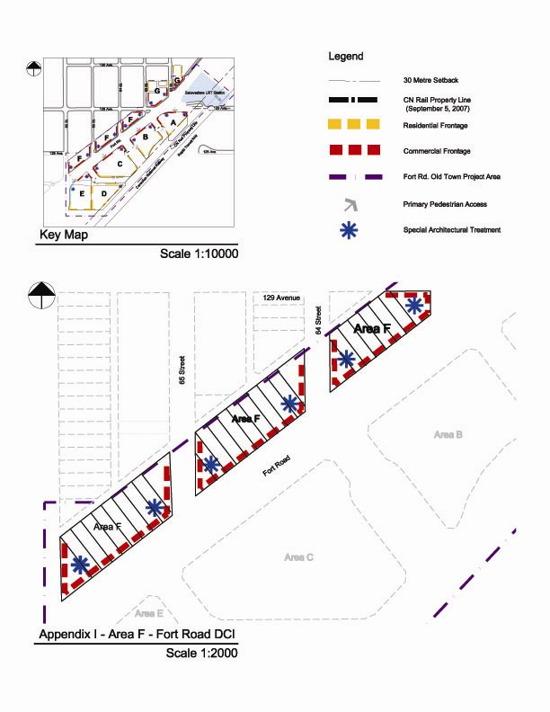
70/80
Appendix I
71/80
APPENDIX II
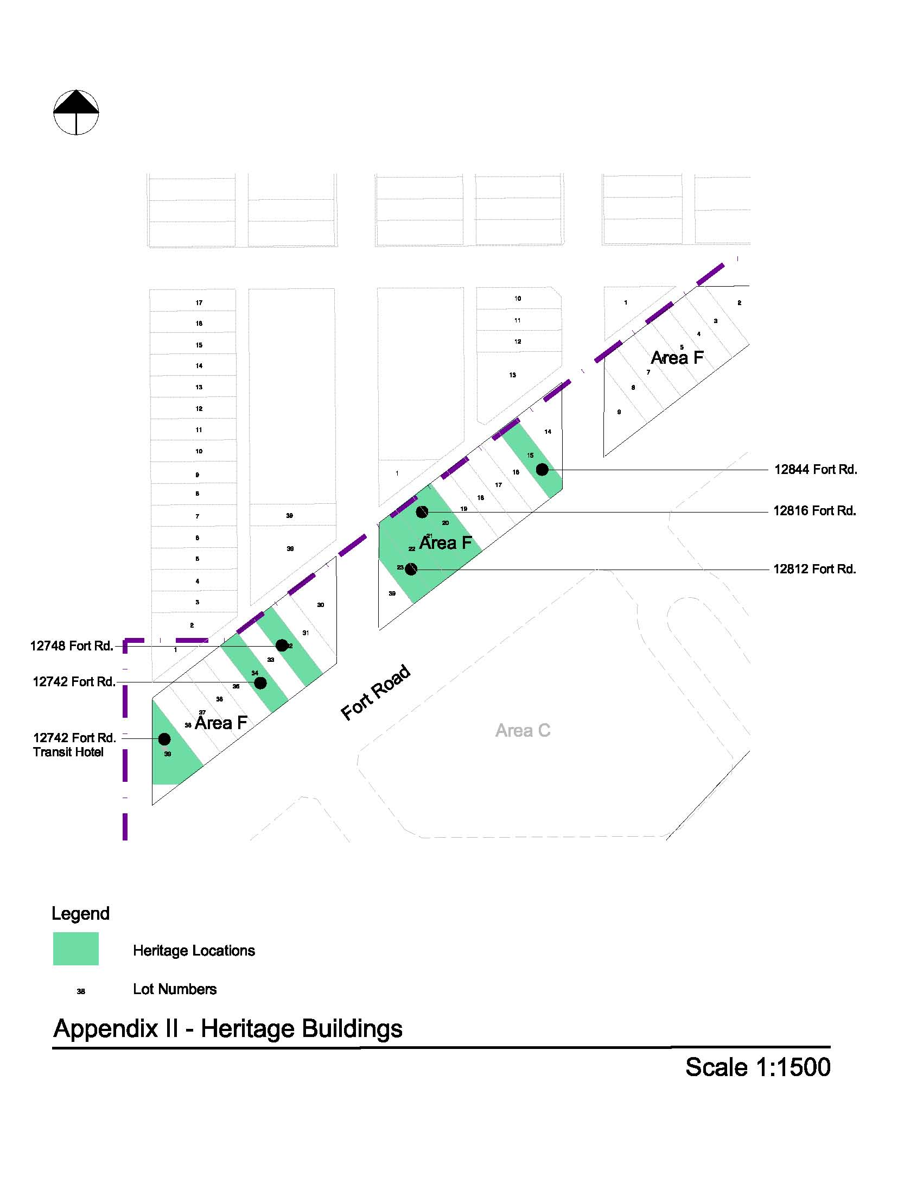
72/80

(DC1) DIRECT DEVELOPMENT CONTROL PROVISION
(AREA G)

- Area of Application

The area is located along the northwest side of Fort Road generally between 63 Street and 61 Street, designated as Area G and shown on Appendix 1

- Rationale

To accommodate a infill and intensification of the existing Fort Road commercial area as part of a transit-oriented, residential mixed use development that creates a liveable “urban village” environment and the introduction of a diversity of housing types within walking distance to the Belvedere LRT Station. Commercial uses will be developed on the ground floor of a number of the buildings as part of this development project.

- Uses

Residential and Residential Related Uses

- Apartment Housing
- Major Home Based Business
- Minor Home Based Business
- Row Housing
- Residential Sales Centre
- Bars and Neighbourhood Pubs, for less than 100 occupants and 120 m² of Public Space
- Business Support Services
- Child Care Services
- Convenience Retail Stores
- General Retail Stores, not to exceed 3000 m²
- Health Services
- Major and Minor Amusement Establishment as an accessory use to a restaurant
- Minor Alcohol Sales
- Personal Service Shops
- Professional, Financial, and Office Support Services, excluding loan offices and similar financial uses
- Restaurants, for less than 200 occupants and 240 m² of Public Space
- Specialty Food Services, for less than 100 occupants and 120m² of Public Space
- Fascia On-premises Signs
- Temporary Freestanding On premises Signs, limited to project identification, building construction identification and real estate advertising signs during construction and initial sale excluding portable signs.
73/80
- Projecting On-premises Signs

- Development Regulations

- The Developer shall provide proof satisfactory to the Development Officer, in consultation with Alberta Environment, and the Transportation and Streets Department that the lands have been remediated to allow the intended use prior to the issuance of a major development permit.
- Development applications for new buildings and major additions are required to go before the Edmonton Design Committee prior to the issuance of a development permit.
- The overall Site development shall be in accordance with the urban design criteria established herein and in the Fort Road Old Town Urban Design Plan for this Area.
- Residential and residential related uses at shall be located as shown in Appendix I.
- Only Commercial Uses shall be located on the first (ground) floor in the areas identified on Appendix I.
- The maximum Floor Area Ratio for Lots within Area G shall be 2.0.
- The maximum Height for mid rise apartments shall not exceed 5 Storeys nor 18.0 m.
- The maximum Height for buildings adjacent to Fort Road shall not exceed 5 Storeys nor 18 m.
- All mechanical equipment, including roof mechanical units, shall be concealed by screening in a manner compatible with the architectural character of the building or concealed by incorporating it within the building.
- The maximum Height for Row Housing shall not exceed 3 Storeys nor 12.0 m.
- A 2.0 m building Setback shall be provided at the Rear of a building. Landscaping shall be provided within the 2.0 m building Setback to provide an improved appearance of the Lane.
- A Minimum Private Outdoor Amenity Area of 7.5 m² per Dwelling for Dwellings no part of which is contained in the lowest Storey shall be provided.
- The second floor in the areas identified for Commercial Uses, as shown on Appendix I, may be used exclusively for either Residential Uses or Commercial Uses, excluding Restaurants, Bars and Neighbourhood Pubs.
- All commercial and commercial related uses shall not be developed above the second storey of the building and shall be located as shown in the Appendix I.
- A minimum of 3 storeys residential development shall be provided above any commercial development.
- Apartment Housing with Commercial Uses on the ground floor shall have access at Grade that is separate from the Commercial premises.
74/80
- Major Home Based Businesses shall only be allowed in a Row Housing Dwelling unit.
- Landscaping shall contain at least 10% more trees and shrubs within any Yard or Setback than are required under Section 55 of the Zoning Bylaw.
- The landscape plan required through Section 55.3 of the Zoning Bylaw shall include landscaping as it relates to the design of special feature areas identified in the Urban Design Plan. Outdoor amenity spaces shall be landscaped for the purpose of achieving pedestrian connectivity, opportunities for play and social interaction. Furthermore outdoor amenity spaces should create a sense of place, character and identity. In addition to landscaping, this shall be achieved through the use of park benches, pedestrian level lighting, waste receptacles and other means integrated with the landscaping and placed along public walking routes through the site, to the satisfaction of the Development Officer in consultation with the Parks Branch at Asset Management and Public Works.
- Loading, storage, and trash collection areas shall be located in such a manner to be screened from view from adjacent sites, public roadways, and Light Rail Transit lines in accordance with the provisions of Section 55 of the Zoning Bylaw. If the Rear or Sides of a Site are used for surface vehicular parking, it shall be screened in accordance with the provisions of Section 55 of the Zoning Bylaw.
- Access to vehicular Parking Garages will be from the internal roadway system, no direct access to parking will be permitted from Fort Road.
- All residential parking shall be underground or in a structure, visitor and customer parking may be provided at grade.
- Driveway ramps for underground parkades must not exceed a slope of 6% for the first 4.5 m from the property line and the ramp must be at Grade at the property line, to the satisfaction of the Transportation Department.
- Vehicular Parking on the site shall be developed in accordance with Section 54, Schedule 1 of the Edmonton Zoning Bylaw, except that:
- For Professional, Financial and Office Support Services at grade, parking shall be provided on the basis of 1.1 parking spaces per 100 m² of Floor Area and no parking spaces shall be required for this Use on upper floors;
- for Specialty Food Services, Restaurants, and Bars and Neighbourhood Pubs, parking shall be provided on the basis of one parking space per 4.8 m² of Public Space;
- for all other Commercial Use Classes, parking shall be provided on the basis of 1.1 parking spaces per 100 m² of Floor Area;
- For all Residential Use Classes, parking shall be provided on the basis of a minimum of 1 parking space per residential unit;

75/80
- The parking requirements may be further relaxed, at the discretion of the Development Officer in consultation with the Transportation Department, should initiatives which reduce parking demand be implemented. Such initiatives include but are not limited to dedicated car share/car pool stalls, universal bus pass programmes, or shared parking between commercial, commercial related, residential, and residential related uses; and
- Vehicular parking shall be located at the rear of the building.

- Bicycle Parking spaces shall be provided in accordance with Section 54 of the Edmonton Zoning Bylaw.
- The owner shall submit a Crime Prevention Through Environmental Design (CPTED) Assessment that shall be reviewed and accepted by the Development Officer prior to the issuance of a Development Permit to ensure that development on the Site provides a safe urban environment in accordance with the guidelines and principles established in the Design Guide for a Safer City.
- Signs in the areas identified for Commercial Uses shall comply with Schedule 59E of the Zoning Bylaw, with the intent to complement the pedestrian oriented commercial environment, except that:
- a maximum Height of a Temporary Freestanding Sign shall be 6.0 m;
- a Projecting Sign may be used to identify businesses that are located entirely at the second Storey level; and
- the top Projecting Sign on a building two Storeys or higher shall not extend more than 75 cm above the floor of the second or third storey nor higher than the windowsill level of the second or third Story.
- In the areas identified for Commercial Uses a Comprehensive Sign Plan and Schedule, consistent with the overall intent of subsection 59.3 of the Zoning Bylaw, shall be prepared for the development and submitted, with the Development Application, to be approved by the Development Officer.
- Signs in the areas identified for Residential Frontage, in Appendix I, shall comply with Schedule 59B of the Zoning Bylaw.

- Urban Design Regulations

Site Planning

- Mid rise apartment buildings shall be located along Fort Road.
- Row Housing shall be located along 63 Street, 62 Street and the lane.
- Buildings along 63 Street, 62 Street and the lane shall address the street, maximize frontage and contribute towards a predominantly residential character.
76/80
- Surface parking for visitors, customers, and residents shall be accessed off the lane, screened from Fort Road, 63 Street, and 62 Street by appropriate orientation of the built form and enhanced landscaping measures and be located to the rear of buildings fronting onto Fort Road.
- In the case of future redevelopment of the site no surface vehicular parking areas are permitted abutting any public roadway, other than a Lane.

Street Wall

- The maximum Frontage for Sites abutting a commercial shopping street shall be 10.06 m or consistent with the Frontage of other existing Sites abutting the shopping street and, where the Frontage for Sites abutting the commercial shopping street exceeds 10.06 m or the consistent development pattern for the street, the front façade of the building shall be designed to break the appearance into 10.06 m sections or modules consistently sized with other buildings on the shopping street.
- Blank walls (with or without windows) of vehicular Parking Garages shall not be developed adjacent to, or visible from, any public roadway.

Mid Rise Apartments and Row Housing

- Buildings shall address all adjacent public roadways, other than Lanes, with individual entrances that are clearly visible to lend a sense of occupancy to the street. Buildings on corner Sites shall address both the street and avenue and shall distinguish the street intersection to give it prominence.

Building Setbacks

- Where the ground floor of any development is designed for Commercial Uses, buildings shall be built to the front and side property line. The Development Officer may allow a maximum of 50% of the building to be setback by 1 m from the property line. This shall be done to create visual interest in the building. The Development Officer may allow an additional building setback, only to accommodate street related activities such as sidewalk cafes, colonnades, arcades or plazas.
- Where the ground floor of any development is designed for Residential Uses, the building shall contain a Landscaped Yard of 3m. The Development Officer may allow staircases to project up to 2.0 m from the building wall. A combination of hard and soft landscaping shall be provided within the 3m setback.

Building Stepbacks

- Where Residential Uses are located above Commercial Uses in a building, the residential portion of the building above the second floor shall be setback a
77/80

minimum 3 m from the lower portion of the building adjacent to a public roadway, other than a Lane, as illustrated in the following diagram for interpretive purposes.

- Where Residential Uses are located above Commercial Uses in a building, the residential portion of the building above the second floor shall be setback a minimum 2 m from the lower portion of the building adjacent to a public roadway, other than a lane, as illustrated in the following diagram for interpretive purposes.

- All developments shall provide a minimum 7.5 m building Setback from the Rear property line above the podium level of the building;
78/80
- The ground floor of any commercial development shall have a minimum of 50% of its floor space dedicated to commercial activity where all activity must abut the street frontages and be a depth of at least 10m;
- If parking uses front on the public street in any portion of the podium above second storey level of the mid-rise apartment building then:
- An enhanced architectural façade treatment, harmonious with the adjacent commercial or residential frontage, shall be provided on the podium portion to the satisfaction of the development officer in consultation with the Urban Design Group; and
- Parking areas above second storey of the podium shall not be visible from the public street.
Entrances

- Where a Dwelling unit is provided at ground level abutting a public roadway, other than a Lane, the principal entrance to the unit shall have direct external access to the adjacent public sidewalk.
- Main building entrances for any Use shall be designed for universal accessibility. Level changes from the sidewalk to entrances of buildings shall be minimized. Sidewalk furniture and other elements shall be located out of the travel path to ensure they are not obstacles to building access.
- The first floor of any residential frontage, including associated entranceway, shall have a maximum grade separation of 1 m from any adjacent public sidewalk.
- The first floor of commercial frontage and entranceways shall be at grade with the property line.
- A separate and prominent access to residential buildings from Fort Road is required for any building whose podium portion fronts onto Fort Road.

Weather Protection

- Where Commercial Uses are developed on the ground (first) floor of a building, weather protection in the form of a canopy at least 2.0 m wide or any other method suitable to the architectural style of the building or street theme, shall be provided one Storey above sidewalk level to provide a comfortable environment for pedestrians.

Architectural Control

- The finishing of the podium portion of any development shall consist of a combination of materials such as glass and glazed window wall systems, brick, stone, architectural concrete, and/or pre-cast coloured concrete.
79/80
- The use of stucco as a finishing material is not permitted on the podium portion of any development.
- Special architectural treatment of building faces shall be provided as per Appendix I.
- Where a Commercial Use is provided at ground level abutting a public roadway, other than a Lane, the principal entrance to the unit shall have direct external access to the adjacent public sidewalk. A minimum of 70% of the ground (first) floor level portion of the façade abutting a public roadway, other than a Lane, shall be comprised of clear, non-reflective glazing to promote pedestrian interaction and safety.
- Development on a Site shall incorporate functional and decorative lighting to highlight the building’s architectural features and enhance the appearance of the building during the winter months.

- Development Guidelines

- The developer is encouraged to incorporate a minimum of 10% adaptable dwelling units and to ensure universal accessibility.
- All building facades should use compatible and harmonious exterior finishing materials.
- Where feasible, developments should provide gardens or patios on the top of the podium level and building rooftops to improve rooftop aesthetics and provide additional amenity space.
- Where feasible, Dwellings and other elements of the development should be sited and oriented to minimize their impact on other Dwellings considering such things as daylight, sunlight, ventilation, quiet, visual privacy and views.
- Development in this Area should, to the greatest extent possible, utilize infrastructure practices, site designs and building developments that reduce the consumption of water, energy, and materials consistent with sustainability programs such as Built Green Alberta or Leadership in Energy and Environmental Design (LEED) accreditation.
- Landscaping of Sites in this Area should consider the use of plant materials that provide colour throughout the year to enhance their appearance during the winter months.
- Parking, loading and passenger drop-off areas should be easily accessible and designed to minimize pedestrian-vehicle conflicts.
- A variety of residential housing forms should be encouraged throughout this Area to support an enhanced pedestrian environment.

80/80
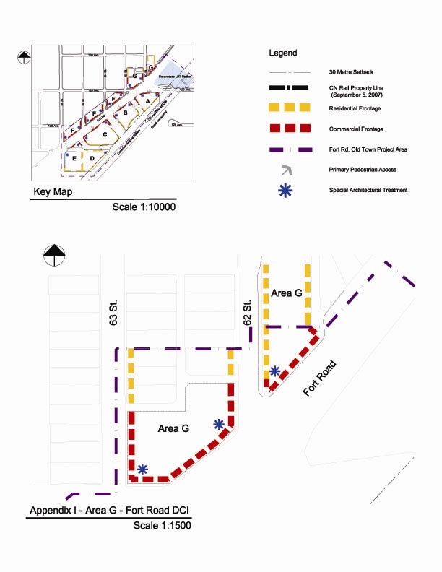
Appendix 1

