Recommendation:
That the September 5, 2006, Corporate Services Department report 2006COH035 be received for information.
Report Summary
This report provides information on public and private health and dental coverage available to Councillors when they leave office.
Previous Council/Committee Action
At the July 17, 2006, Council Services Committee meeting, the following motion was passed:
That Administration prepare a report comparing the City of Edmonton’s health and dental plans available to Councillors with selective private sector plans that might be available after the Councillor leaves office, including the Alberta Health Care Plan available to those over the age of 65.
Report
- Currently, Members of Council participate in the health and dental plans provided to the City’s management and out-of-scope staff. The supplementary health plan provides coverage for drugs, ambulance and paramedical services. The dental plan provides coverage for basic, restorative and orthodontic services. The specific coverage provided under these two plans is detailed in the Benefits at a Glance for each plan, which have been included as Attachments 1 and 2.
- Alberta Health and Wellness contract with Alberta Blue Cross to provide premium-free Coverage for Seniors for health-related services not covered by the Alberta Health Care Insurance Plan. This coverage is available to all Albertans 65 years of age and older and their dependants. This program does not provide travel coverage.
I
1
b

- Under Coverage for Seniors, a senior is only required to pay 30 percent of the total cost, to a maximum of $25, for each drug prescribed. There are some circumstances where the senior may have to pay more than the $25 co-payment maximum.
- The Coverage for Seniors plan also provides coverage for ambulance services, clinical psychological services, home nursing services, prosthetic and orthotic benefits and mastectomy prosthesis. A brochure explaining the Coverage for Seniors plan is included in Attachment 3.
- The Government of Alberta offers a Non-Group Coverage plan to ensure all Albertans under age 65 have access to a supplementary health benefits plan which provides coverage for a variety of health related services not covered by the Alberta Health Care Insurance Plan. The non-subsidized quarterly premium rate is $61.50 for single coverage and $123 for family coverage. An application form must be completed to obtain Non-Group Coverage. A brochure explaining the Non-Group Coverage plan is included in Attachment 4.
- Human Resources is not an expert in private health and dental plans. There are a number of private providers who provide supplementary coverage on a medically underwritten basis. The cost of private coverage is dependent on the level of coverage chosen, the age of the applicant, the age of the spouse (if applicable) and the number and age of any dependent children.
- Human Resources was able to obtain some pricing illustrations from Alberta Blue Cross and Alberta Motor Association, which are outlined in Attachments 5 and 6, respectively. These pricings are for illustration purposes only and the actual cost may differ based on the individual Councillor’s circumstances.
Background Information Attached
- Benefits at a Glance, Supplementary Health Care – Management and Out-of-Scope
- Benefits at a Glance, Dental Plan – Management and Out-of-Scope
- Coverage For Seniors
- Non-Group Coverage
- Alberta Blue Cross - Private Plan Coverage and Pricing Illustrations
- Alberta Medical Association – Private Plan Coverage and Pricing Illustrations

Coverage | Coverage
Hospital | - Semi-private hospital room accommodation
Deductible | - $30 per calendar year –The amount of covered expenses that must be incurred and paid by the employee each year before benefits become payable under the Plan.
Claim Submission Deadline | - All claims must be received by the Plan Adjudicator (i.e. Alberta Blue Cross) no later than April 30 of the year following the year the expenses are incurred.
Drugs  - Direct Bill  - 80% reimbursement of the drug cost based on Least Cost Alternative  - 100% reimbursement of the Dispensing Fee Cap to a certain maximum | - Drugs that require a prescription under Provincial or Federal law, prescribed by a physician or dentist and dispensed by a licensed pharmacist and included in the drug formulary.  - New drugs that meet the criteria above will be reviewed to determine if the new drug product will be added to formulary.  - Drugs that can be purchased over-the-counter are not eligible under the plan.  - Reimbursement is based on the Least Cost Alternative (LCA) drug. LCA drugs have the same active ingredients as other drug products (e.g. brand name) but are less costly.  - The amount that is paid for a prescription drug includes the cost of the drug product, inventory allowance and a dispensing fee. The dispensing fee charged varies between pharmacies. The Plan will reimburse 100% of the dispensing fee to a certain maximum. The maximum amount reimbursed is based on the cost of the drug including any amount charged for inventory allowance, as described below.
 | Drug Cost | Maximum Dispensing Fee
 | $0.00 - $74.99 | $5.00 reimbursement
 | $75.00 - $149.00 | $7.50 reimbursement
 | $150.00 or greater | $10.00 reimbursement
Smoking Cessation  - 80% coverage | - Prescription smoking cessation products for one continuous course of treatment per lifetime per covered person.

* Per calendar year per single or family coverage
Coverage | Benefit Description
Ambulance  - 80% coverage | - Charges incurred in Canada for professional ambulance services to an active treatment hospital when required due to illness or injury.
Artificial Limbs/Breast Prosthesis  - 80% coverage  - $2000 Maximum*  - Physician written order required | - Artificial limbs (excluding myoelectric-controlled prosthesis)  - Artificial eyes  - Braces which incorporate a rigid support of metal or plastic Trusses  - Cervical collars  - Breast prosthesis as a result of a mastectomy  - All appliances must be required to treat an existing medical condition.  - The repair or replacement of a breast prosthesis does not require the written order of a physician, however such replacement or repair shall be limited to once in twenty-four (24) months.
Home Nursing  - 80% coverage  - Maximum of $2000 *  - Physician written order required | - Nursing care provided in the home by a practical or registered nurse where the covered person is suffering a chronic or debilitating condition.  - Home-making services are not eligible.
Clinical Psychology/Masters Social Work  - 50% of the cost of a treatment session  - Maximum of $1000 * | - Treatment must be provided by a psychologist registered with the Psychologists’ Association of Alberta (PAA) or a Masters in Social Work.  - Coverage is not provided for counselling sessions provided by practitioners who are not registered with PAA or who do not hold a Masters in Social Work.  - Coverage is not provided for assessments.
Respiratory Equipment  - 80% coverage  - Maximum of $1000 *  - Physician written order required | - Oxygen and related supplies (including compressors, nebulizers, masks, aerochambers, and tubing).  - Reimbursement for CPAP machines limited to once per lifetime.
Colostomy/Ileostomy Supplies  - 80% coverage  - Physician written order required | - Colostomy Supplies  - Ileostomy Supplies | - Urostomy Supplies  - Adult Incontinence Supplies
Diabetes Supplies  - 80% coverage  - Physician written order required | - Lancets/Penlets  - Lancing Devices  - Blood Glucose Test Strips | - Urine Test Strips  - Syringes  - Insulin Pen Needles
* Per calendar year per single or family coverage
Coverage | Benefit Description
Physiotherapy  - 80% coverage | Services of a qualified physiotherapist in excess of those paid by the Regional Health Authority’s Community Rehabilitation Program (CRP).
- Maximum of $1000 * | - Each covered person must satisfy a $250 deductible per benefit year prior to being eligible to receive reimbursement from the plan for any visits not covered by the CRP program.
Chiropractor  - 75% of the cost of a treatment session  - Maximum of $1000 * | - The plan will pay for chiropractic services once all allowable limits have been reached under Alberta Health Care.  - A letter from Alberta Health Care stating the date the maximum was reached must be submitted with the claim.
Podiatry  - 80% coverage  - Maximum of $500 * | - The plan will pay for podiatry services once all allowable limits have been reached under Alberta Health Care.  - A letter from Alberta Health Care stating the date the maximum was reached must be submitted with the claim.
Acupuncture  - 50% of cost of a treatment session  - Maximum of $500 *  - Reason for treatment must be noted on the receipt | - Acupuncture administered as a pain reliever or anesthetic.
Hearing Aids  - 50% coverage  - Maximum of $1000 * in any 5 consecutive calendar years  - Physician written order required | - Purchase and repair of hearing aids.  - Maintenance, batteries and recharging devices are not covered.
Eye Exams  - 80% coverage to a maximum of $50 per covered person in any two consecutive calendar years | - Reimbursement in excess of amounts not paid by Alberta Health Care.

The Major Medical Plan is not provided through a contract of insurance. For this Plan, the benefits are payable from premiums, interest or investment earnings and an excess of revenue over expenditures.

This summary provides general information only. For some benefits the first payer will be a government program or another plan. For more information or to confirm coverage call Alberta Blue Cross Customer Services at 498-8000 or the City's Employee Service Centre at 496-6300, option 1.

July 20, 2006

* Per calendar year per single or family coverage

Coverage | Benefit Description
Basic Services  - 100% coverage of Usual and Customary Fees | - diagnostic, preventive, minor restorative and certain oral surgical services, periodontics (treatment of gum disease), endodontics (root canal work), removable prosthodontics (removable dentures)  - oral examinations once every 2 years  - recall exams for adults once a year  - recall exams for dependents under age 18 once every 6 months  - complete series of x-rays once every 2 years  - bite-wing x-rays once every 12 months (under 18 years every 6 months)  - cleaning or scaling and fluoride treatments once every 12 months (under 18 years every 6 months)  - extractions and other oral surgery including pre and post operative care  - amalgam, synthetic porcelain and plastic fillings  - diagnostic and treatment procedures for root canal therapy  - diagnostic and treatment procedures for treatment of tissues supporting the teeth  - partial or full-removable dentures  - replacement dentures limited to once every 5 years unless existing dentures cannot be made serviceable
Restorative Services  - 80% coverage for the repair of existing crowns and bridges  - 50% coverage for new crowns, bridges and major restorative benefits | - repair of existing crowns and bridges including recementing of inlays/onlays and crowns, removal of crowns and inlays/onlays, and retentive pre-formed posts  - new crowns and bridges, inlays and onlays  - fixed bridgework  - replacement of bridgework limited to once every 5 years unless existing bridgework cannot be made serviceable
Orthodontic Services  - 50% coverage  - Maximum of $2,000 per covered person per lifetime | - procedures for the correction of malposed teeth
Exclusions  - Some examples of the types of items not covered | - replacement of mislaid, lost or stolen appliances  - crowns, bridges, or dentures for which impressions were made prior to the effective date of coverage  - charges for broken appointments or completion of claim forms  - experimental or cosmetic procedures  - orthodontic services or treatment prior to the effective date of coverage for orthodontic benefits  - services or supplies intended for sport or home use (e.g. mouth guards)
Pre-Authorizations | - pre-authorization must be obtained for treatment or services expected to exceed $500

The Dental Plan is not provided through a contract of insurance. For this Plan, the benefits are payable from premiums, interest or investment earnings and an excess of revenue over expenditures.
This summary provides general information only. For more information, call Alberta Blue Cross at 498-8000 or the City of Edmonton Employee Service Centre at 496-6300, option 1. September 15, 2003
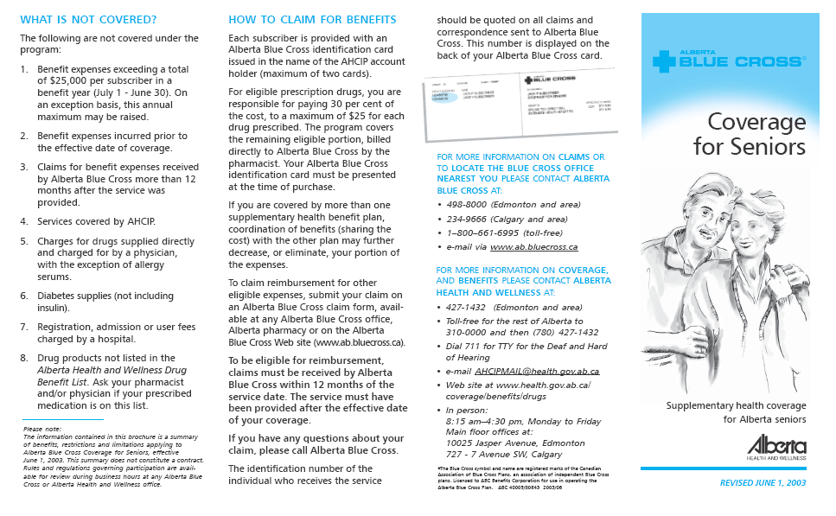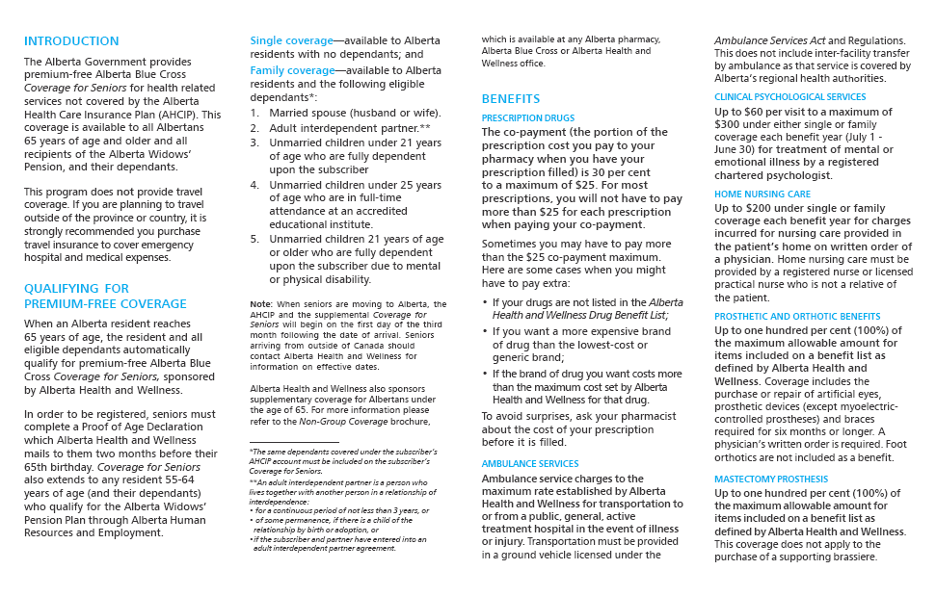
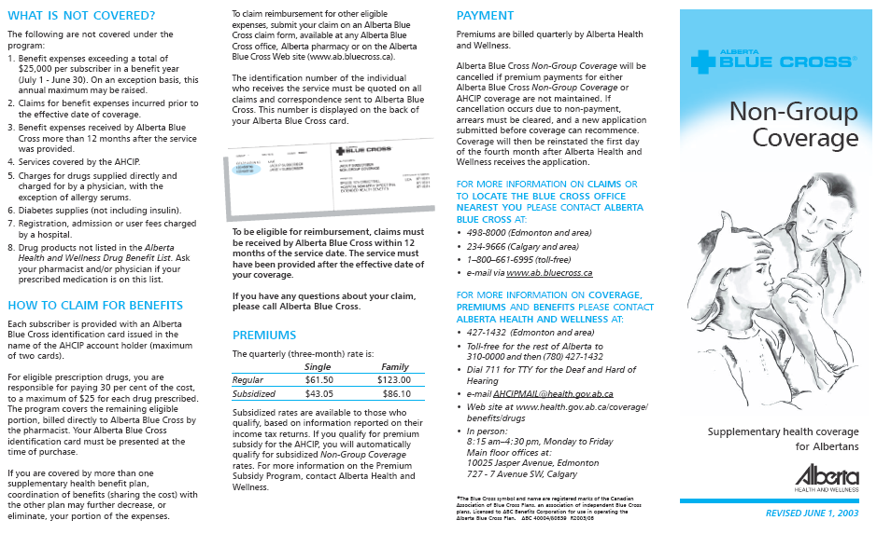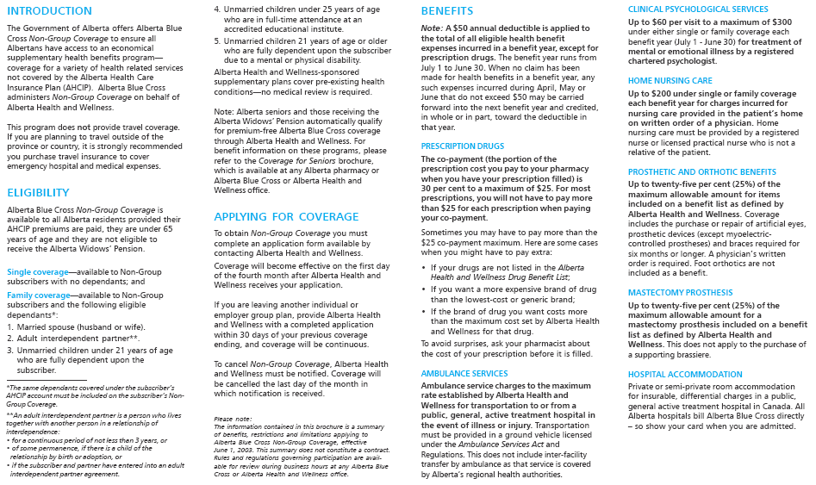

Introduction

Alberta Blue Cross offers the Personal Choice Plans and Seniors Plus Plans. Personal Choice Plans are available to persons under the age of 65. Within the Personal Choice bank of products, three different plan designs are available (Plans A, B and C). The Seniors Plus Plans are available to persons over the age of 65 and there are also three different designs available (Plans A, B and C).

Benefit Details

Personal Choice Plan A

- Basic extended health coverage (includes ambulance services, psychologist, accidental dental care)
- 70% reimbursement prescription drug coverage
- 100% coverage for standard dental check-ups and cleanings, and 80% coverage for fillings, extractions, and root canals
- $10,000 accidental death benefit

Personal Choice Plan B

- Enhanced extended health coverage (includes ambulance, accidental dental care, semi-private and private hospital rooms, home nursing care and more)
- 70% direct bill prescription drug coverage
- 100% coverage for standard dental check-ups and cleanings, and 80% coverage for fillings, extractions, and root canals
- 50% periodontics and dentures
- Vision Care
- $10,000 accidental death benefit

Personal Choice Plan C

- Enhanced extended health coverage (includes ambulance, accidental dental care, semi-private and private hospital rooms, home nursing care and more)
- 80% direct bill prescription drug coverage
- 100% coverage for standard dental check-ups and cleanings, and 90% coverage for fillings, extractions, and root canals
- 50% periodontics and dentures
- 50% crowns and bridges
- 50% orthodontics
- Vision Care
- $10,000 accidental death benefit

Seniors Plus Plan A

- Basic extended health coverage (semi-private and private hospital rooms, paramedical services)
- 65% basic dental coverage to a maximum of $500 per participant per year
- Vision care up to a maximum of $100 per participant every three years
- $10,000 accidental death benefit

Seniors Plus Plan B

- Enhanced extended health coverage (semi-private and private hospital rooms, paramedical services, blood testing monitor, diabetic supplies)
- 65% basic dental coverage to a maximum of $500 per participant per year
- 65% extensive dental coverage up to a maximum of $750 per participant per year
- Vision care up to $150 per participant every three years
- $15,000 accidental death benefit

Seniors Plus Plan C

- Enhanced extended health coverage with increased coverage levels over Plans A and B
- 65% basic dental coverage to a maximum of $600 per participant per year
- 65% extensive dental coverage to maximum $1000 per participant per year
- Vision care up to a maximum of $200 per participant every three years
- $20,000 accidental death benefit

Introduction

The AMA Health and Dental Plans offer access to member-exclusive health and dental benefits. Members can build a plan that suits their needs. The plans are underwritten by The Manufacturers Life Insurance Company of Canada (Manulife Financial).

Members start with Extended Health Care benefits and then have an option to add on drug or dental coverage or a combination of both. Members wishing to add drug and/or dental coverage have three levels of drug and dental coverage to choose from. Some of the drug and dental options can be added onto the primary Extended Health Care coverage without medical underwriting.

Benefit Details

Extended Health Care

Description | Extended Health Care (EHC) | Enhanced EHC  (available only with Drug 3)
Lifetime Maximum | $100,000 | $250,000
Ambulance Services  Covers trips to hospitals in a licensed ground ambulance and covers charges up to the amount between what your provincial health plan covers and what is reasonable and customary. | Unlimited ground transportation, including in-province air ambulance to a maximum of :  - Year 1: $4,000  - Year 2: $4,000  - Year 3: $4,000  - Year 4+: $5,000 | Unlimited ground transportation, including in-province air ambulance to a maximum of:  - Year 1: $4,000  - Year 2: $4,000  - Year 3: $4,000  - Year 4+: $5,000
Accidental Dental  Covers dental treatment required as a result of an accidental blow to the head or mouth. Treatment must be sought within the 90 day period following the accident. | Maximum per year for natural teeth:  - Year 1: $2,000  - Year 2: $2,500  - Year 3: $3,000  - Year 4: $3,000  - Year 5: $3,500 | Maximum per year for natural teeth:  - Year 1: $2,000  - Year 2: $2,500  - Year 3: $3,000  - Year 4: $3,000  - Year 5: $3,500
Registered Specialists and Therapists  Includes visits to Acupuncturists, Chiropractors, Osteopaths, Podiatrists, Naturopaths, Chiropodists, Registered Massage Therapists, Physiotherapists, Psychologists and Speech Therapists.  Registered Specialists and Therapists*  *Benefits are only payable after yearly maximum allowed under your provincial health insurance plan has been reached, if applicable. | Maximum claims paid per specialist/therapist:  - Year 1: $300  - Year 2: $300  - Year 3+: $400  - Maximum per visit - $20  - Maximum per year for Chiropractic x-rays - $35 | Combined yearly maximums of:  - Year 1: $750  - Year 2: $750  - Year 3: $800  - Year 4: $800  - Year 5+: $850  - Maximum per year for Chiropractic x-rays - $35
Description | Extended Health Care (EHC) | Enhanced EHC  (available only with Drug 3)
Registered Specialists and Therapists (cont)  Psychologist | - Maximum per first visit - $80  - Maximum per subsequent visit - $60  - Maximum visits per year – 10 | - Maximum per first visit - $80  - Maximum per subsequent visit - $60  - Maximum visits per year – 12
Registered Specialists and Therapists (cont)  Speech Therapist | - Maximum per first visit - $65  - Maximum per subsequent visit - $40  - Maximum visits per year – 10 (15 for seniors) | - Maximum per first visit - $65  - Maximum per subsequent visit - $40  - Maximum visits per year – 12 (15 for seniors)
Homecare and Nursing, Prosthetic Appliances and Durable Medical Equipment  Covers the services of registered health professionals including Registered Nurse, Registered Nursing Assistant or healthcare aid; includes surgical bandages and dressings and the purchase or rental of medically necessary equipment such as crutches, non-electric wheelchairs and hospital beds, oxygen and other equipment recommended by your physician and approved by Manulife Financial. Also includes prosthetic appliances such as artificial limbs, eyes, splints, casts and breast prosthesis following mastectomies. Payment will be coordinated where benefits are available through the Assistive Devices Program. | Maximum per year for each of: Homecare and Nursing; Prosthetic Appliances; and Durable Medical Equipment:  - Year 1: $1,000  - Year 2: $1,300  - Year 3: $1,500  - Year 4: $2,000  - Year 5+: $3,000  Seniors maximums:  - Year 1: $1,100  - Year 2: $1,500  - Year 3: $1,700  - Year 4: $2,500  - Year 5+: $3,500 | Combined yearly maximums:  Homecare and Nursing; Prosthetic Appliances; and Durable Medical Equipment:  - Year 1: $8,500  - Year 2: $9,000  - Year 3: $9,500  - Year 4: $9,500  - Year 5+: $9,500  Seniors combined yearly maximums of:  - Year 1: $9,500  - Year 2: $9,500  - Year 3: $10,000  - Year 4: $10,000  - Year 5+: $10,000
Homecare and Nursing, Prosthetic Appliances; and Durable Medical Equipment (cont) | - $225 per year for custom-made orthotics (which is part of Durable Medical Equipment) | - $225 per year for custom-made orthotics (which is part of Durable Medical Equipment)
Hearing Aids  Covers the cost to purchase and/or repair up to the allowed maximum. | Maximum for every 4 benefit years:  - Year 1: $400  - Year 2: $400  - Year 3: $400  - Year 4: $400  - Year 5+: $450 | Maximum for every 4 benefit years:  - Year 1: $500  - Year 2: $500  - Year 3: $500  - Year 4: $500  - Year 5+: $600
Description | Extended Health Care (EHC) | Enhanced EHC  (available only with Drug 3)
Hearing Aids (cont.) | Seniors maximums for every 4 benefit years:  - Year 1: $500  - Year 2: $500  - Year 3: $500  - Year 4: $500  - Year 5+: $600 | Seniors maximums for every 4 benefit years:  - Year 1: $600  - Year 2: $600  - Year 3: $600  - Year 4: $600  - Year 5+: $700
Accidental Death and Dismemberment  Payment for a loss directly resulting from accidental bodily injury, including loss of life, where the loss occurs within a year of the date of the accident. | Maximum payment for adults:  - Year 1: $10,000  - Year 2: $15,000  - Year 3: $15,000  - Year 4: $20,000  - Year 5: $25,000  Maximum payment for children and seniors (persons age 65 years or over):  - Year 1: $10,000  - Year 2: $10,000  - Year 3: $10,000  - Year 4: $10,000  - Year 5: $10,000 | Maximum payment for adults:  - Year 1: $20,000  - Year 2: $30,000  - Year 3: $40,000  - Year 4: $50,000  - Year 5: $75,000  Maximum payment for children and seniors (persons age 65 years or over):  - Year 1: $10,000  - Year 2: $15,000  - Year 3: $20,000  - Year 4: $25,000  - Year 5: $37,500
Vision Care  Covers the costs to purchase prescription lenses and frames, contact lenses or laser eye surgery. Also includes eyeglass repair warranty. This benefit does not include industrial safety glasses. | Maximum per 2 benefit years:  - Year 1: $100  - Year 2: $100  - Year 3: $150  - Year 4: $150  - Year 5+: $200  - $30 for optometrist visits | Maximum per 2 benefit years:  - Year 1: $300  - Year 2: $300  - Year 3: $350  - Year 4: $350  - Year 5+: $400  - $30 for optometrist visits
Best Doctors® Solutions Services  Upon suspicion or diagnosis of a serious illness or injury, you can receive an evaluation of your medical records by world-class specialists who confirm the initial diagnosis and recommend appropriate treatment options. This fast, yet indepth review can reduce potentially serious complications from a misdiagnosis and help your local physician determine the proper course of action. | - Covered | - Covered
Description | Extended Health Care (EHC) | Enhanced EHC  (available only with Drug 3)
Survivor Benefit  Provides continuous coverage for  1 year, following the death of an adult Insured. | - Covered | - Covered
LIFELINE® RESPONSE SERVICE  Designed to get help to you when you need it. For people coping with medical problems at home and wanting to live more independent lives. | - Not offered | - Covered

Drug

Description | Drug 1 | Drug 2 | Drug 3
PRESCRIPTION DRUGS  Drug Coverage**  **Birth control medication and fertility drugs are not covered under Drug Plan 1 or Drug Plan 2. | 70% co-payment for generic drugs ** for claims submitted to a maximum of :  - Year 1: $300  - Year 2: $350 | 75% co-payment for generic drugs ** for claims submitted to a maximum of :  - Year 1: $3,000  - Year 2: $4,000  - Year 3+: $5,000 | 90% co-payment for generic drugs ** for claims submitted to a maximum of :  - Year 1: $6,000  - Year 2: $7,500  - Year 3+: $10,000
PRESCRIPTION DRUGS  Seniors Benefit  **Birth control medication and fertility drugs are not covered under Drug Plan 1 or Drug Plan 2. | 100% for generic drugs** for claims submitted to a maximum of $350 | 100% for generic  drugs** on the first $500; 75% on the next  - Year 1: $2,500  - Year 2: $3,500  - Year 3+: $4,500 | 100% for brand-name  drugs on the first $500; 90% on the next  - Year 1: $5,500  - Year 2: $7,000  - Year 3+: $9,500
PRESCRITPION DRUGS  Shared Dispensing Fee | $6.50 | - Covered | - Covered
HOSPITAL BENEFITS  Preferred hospital accommodation in excess of the standard ward room rate made by a general (acute care) hospital. Also included is a cash benefit in lieu of the room cost for | - Not offered | - Unlimited semi-private or private room accommodation | - Unlimited semi-private or private room accommodation
each day you are not able to obtain preferred accommodation. |  | (up to a maximum of $150 a day.) $50 per day if a preferred room is not obtainable from first day (up to $1,200 per year) | (up to a maximum of $150 a day.) $50 per day if a preferred room is not obtainable from first day (up to $1,200 per year)

Dental

Description | Dental 1 | Dental 2 | Dental 3
DENTAL SERVICES  Covers basic services such as examinations fillings and cleanings, x-rays, extractions and oral surgery. Paid at a percentage of the current Dental Association Fee Schedule. | - 70% co-payment for exams, cleanings, fillings, diagnostic and other basic dental services | - 80% co-payment for exams, cleanings, fillings, diagnostic and other basic dental services | - 80% co-payment in year 1  - 100% in Year 2+ for exams, cleanings, fillings, diagnostic and other basic dental services
DENTAL SERVICES  Endodontics/Periodontics/Oral Surgery | - Not covered | - 60% co-payment on extensive services including endodontics, periodontics and dental services | - 60% co-payment in year 1 & 2  - 80% in Year 3+ on extensive services including endodontics, periodontics and dental services
DENTAL SERVICES  Anniversary Year Maximums | - Year 1: $350  - Year 2: $550  - Year 3+: $700 | - Year 1: $500  - Year 2: $700  - Year 3+: $900 | - Year 1: $700  - Year 2: $900  - Year 3+: $1,200
DENTAL SERVICES  Major restorative | - Not covered | - Not covered | - 60% co-payment beginning in 3rd year with a maximum of $750 for every 3 year period including dentures, crowns and orthodontics
DENTAL SERVICES  Recall | - 9 months | - 9 months | - 6 months

Pricing Illustrations

Demographic Information | Coverage Chosen | Monthly Premium Payable
Male Member Age 61  Spouse Age 61  No dependent Children | Extended Health Care  Drug 1  Dental 1 | $72.95
Male Member Age 61  Spouse Age 61  No dependent Children | Extended Health Care  Drug 3  Dental 3 | $142.70
Male Member Age 57  Spouse Age 57  1 Dependent Child | Extended Health Care  Drug 1  Dental 1 | $160.40
Male Member Age 57  Spouse Age 57  1 Dependent Child | Extended Health Care  Drug 3  Dental 3 | $347.15
Female Member age 53  Spouse Age 53  2 Dependent Children | Extended Health Care  Drug 1  Dental 1 | $189.80
Female Member age 53  Spouse Age 53  2 Dependent Children | Extended Health Care  Drug 3  Dental 3 | $415.70
Female Member age 39  Spouse Age 39  No Dependents | Extended Health Care  Drug 1  Dental 1 | $95.60
Female Member age 39  Spouse Age 39  No Dependents | Extended Health Care  Drug 3  Dental | $215.60

